
AI Internship Assignment – Task 16
End-to-End Machine Learning Pipeline Project
Submitted By: Eman Ansar
Domain: AI & Software Development
Date: 24-7-2026

Task 16 – End-to-End Machine Learning Pipeline Project
Objective:
Develop a complete end-to-end machine learning solution by applying concepts learned throughout the internship. Build a complete ML pipeline from data preparation to model development, evaluation, and project documentation.
Total Marks: 100
Part A – Dataset Selection & Data Preparation (25 Marks)
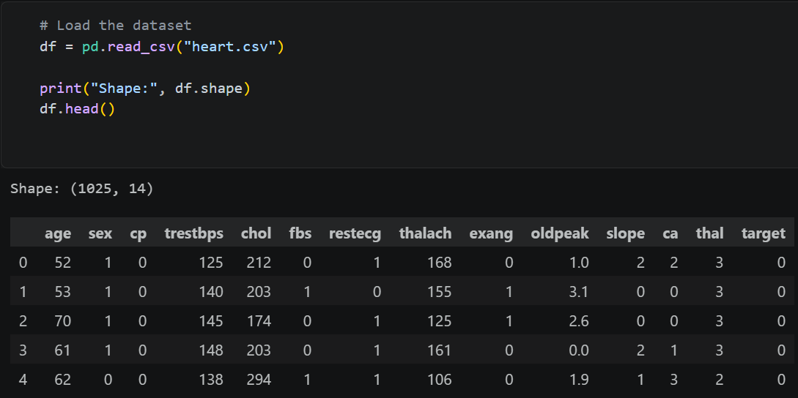

2. Describe the dataset, features, and target variable.
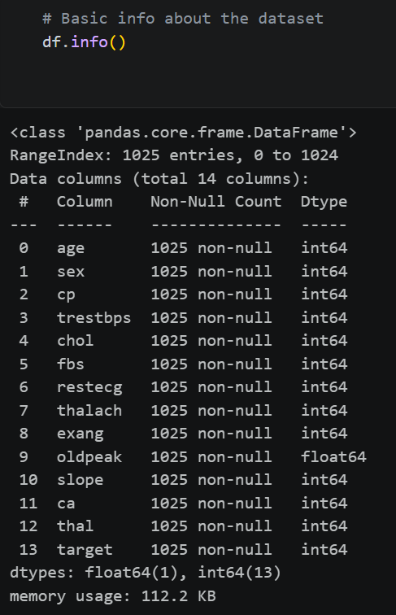
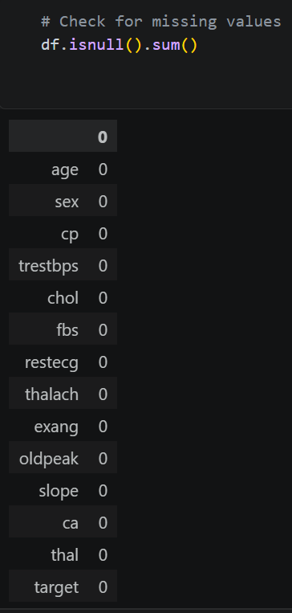
3. Perform data cleaning, preprocessing, feature engineering, and exploratory data analysis.
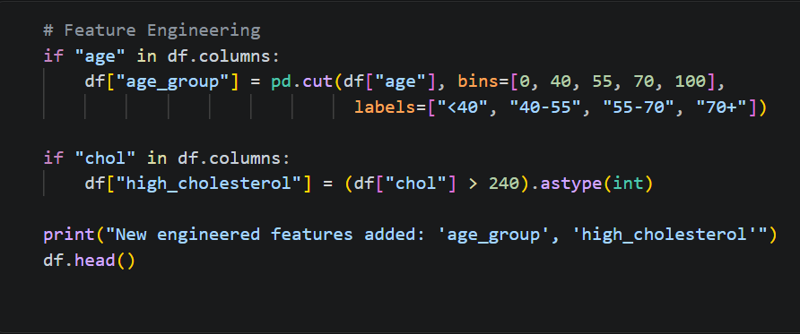
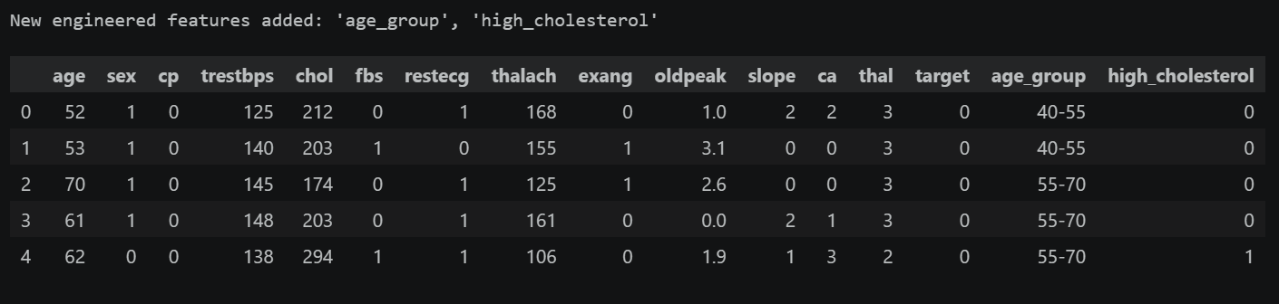

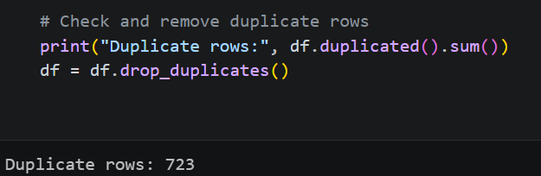

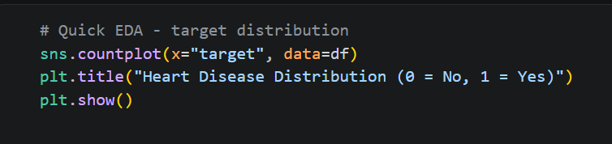
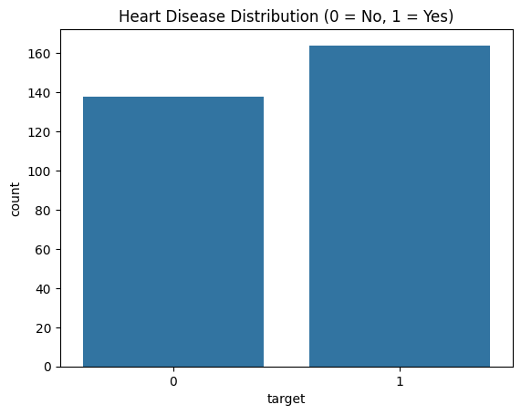
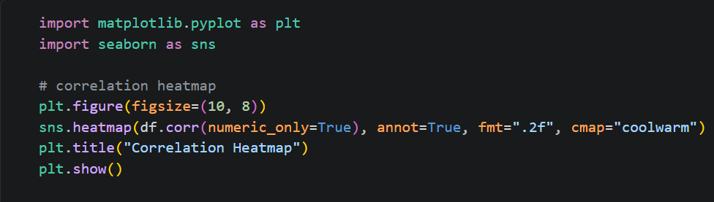
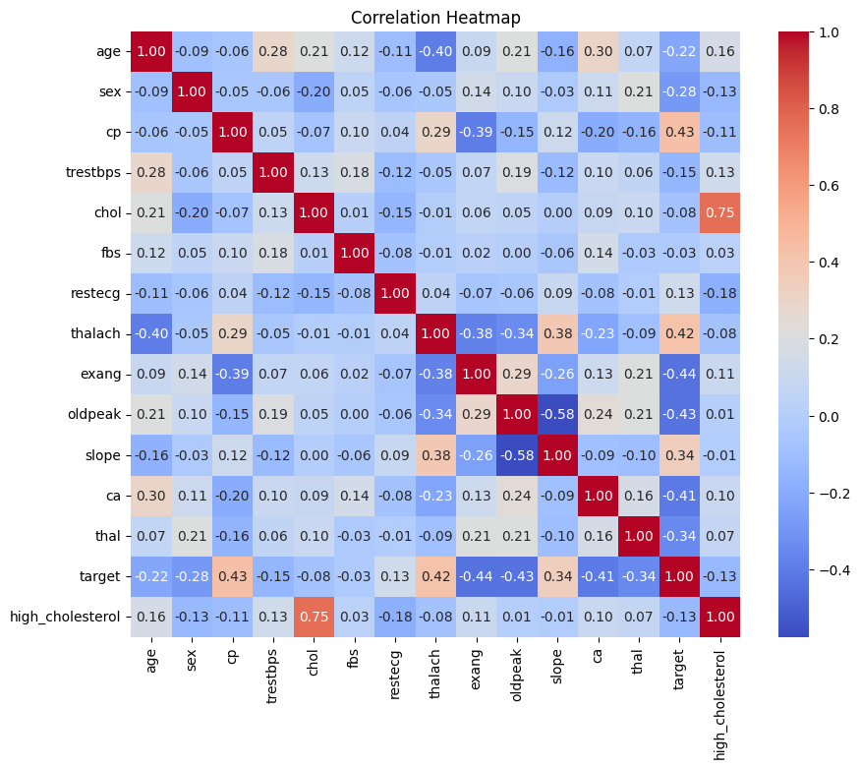
Part B – Model Development (35 Marks)
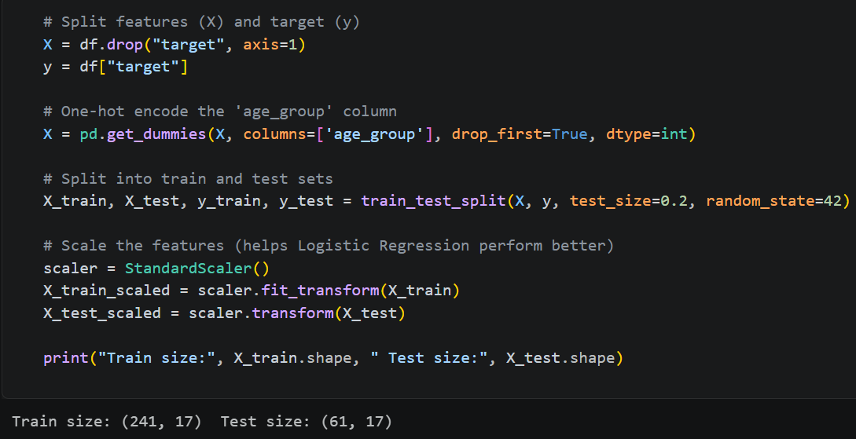
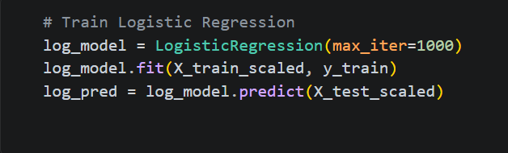
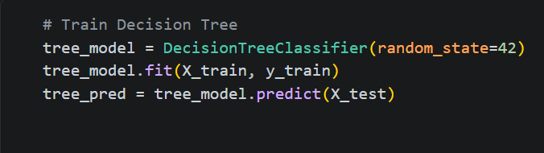
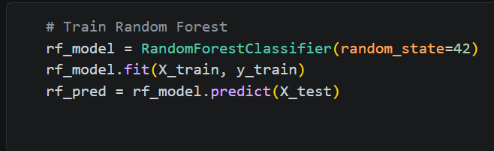
Part C – Model Evaluation (20 Marks)
1. Evaluate the final model using suitable performance metrics.
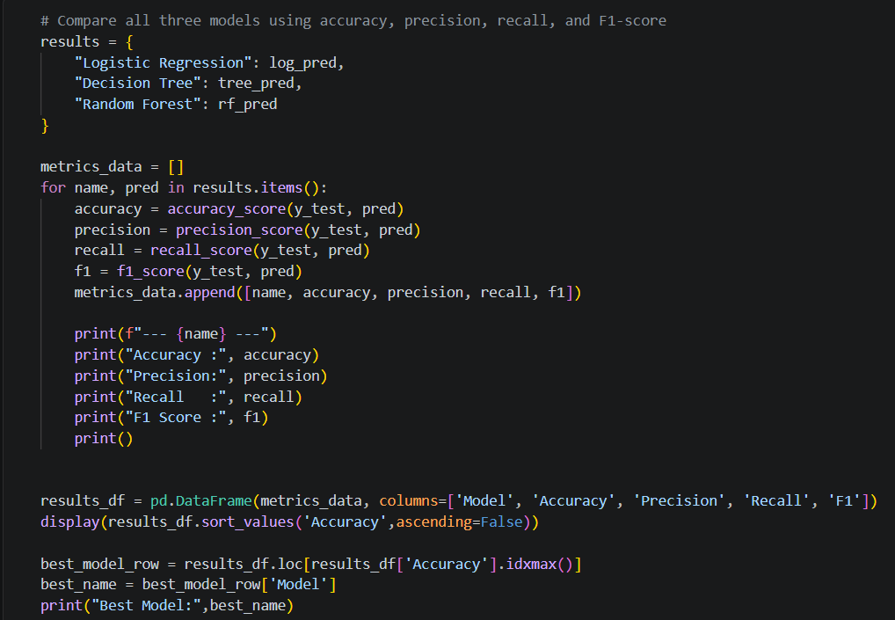
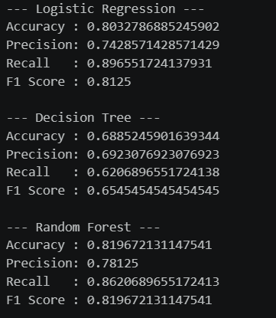

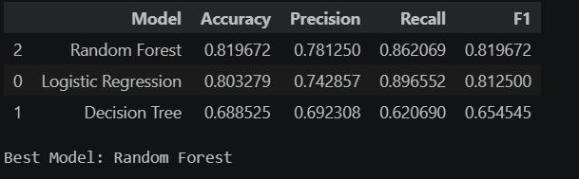
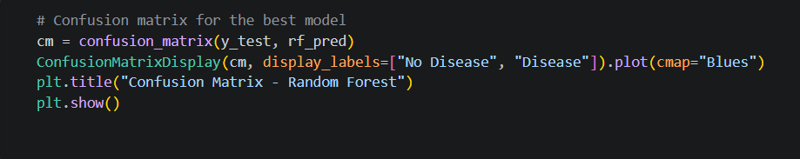
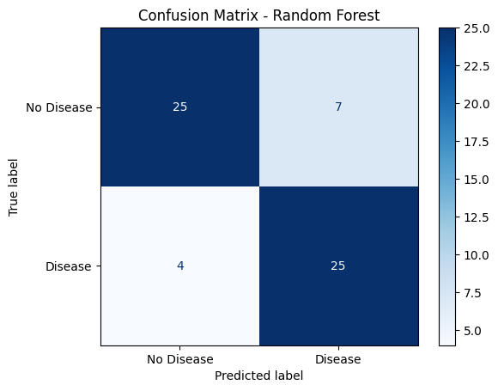

2. Interpret the results and discuss strengths and limitations.
Interpretation of results
- The tuned Random Forest was the strongest model reaching 96% accuracy.
- The features driving predictions the most were concave points, perimeter, radius, and area (mean/worst versions). That lines up with clinical intuition: larger, more irregularly-shaped cell nuclei tend to signal malignancy.
Strengths
- Cross-validation accuracy and test accuracy were close so there is no sign of major overfitting the pipeline generalizes.
- Tree-based ensembles (Random Forest) handle the dataset's heavily correlated features (radius/perimeter/area at mean, se, and worst levels) gracefully without needing manual feature selection.
- Feature importance gives interpretability, which is valuable in a clinical context where "why did the model say this" matters.
Limitations
- The dataset is small (569 samples) and moderately imbalanced (63% benign / 37% malignant), so performance may not hold up as well on a larger or more diverse population.
- Hyperparameter tuning used a small grid for efficiency, so there's likely headroom left if a broader search were run.

Part D – Project Documentation (20 Marks)

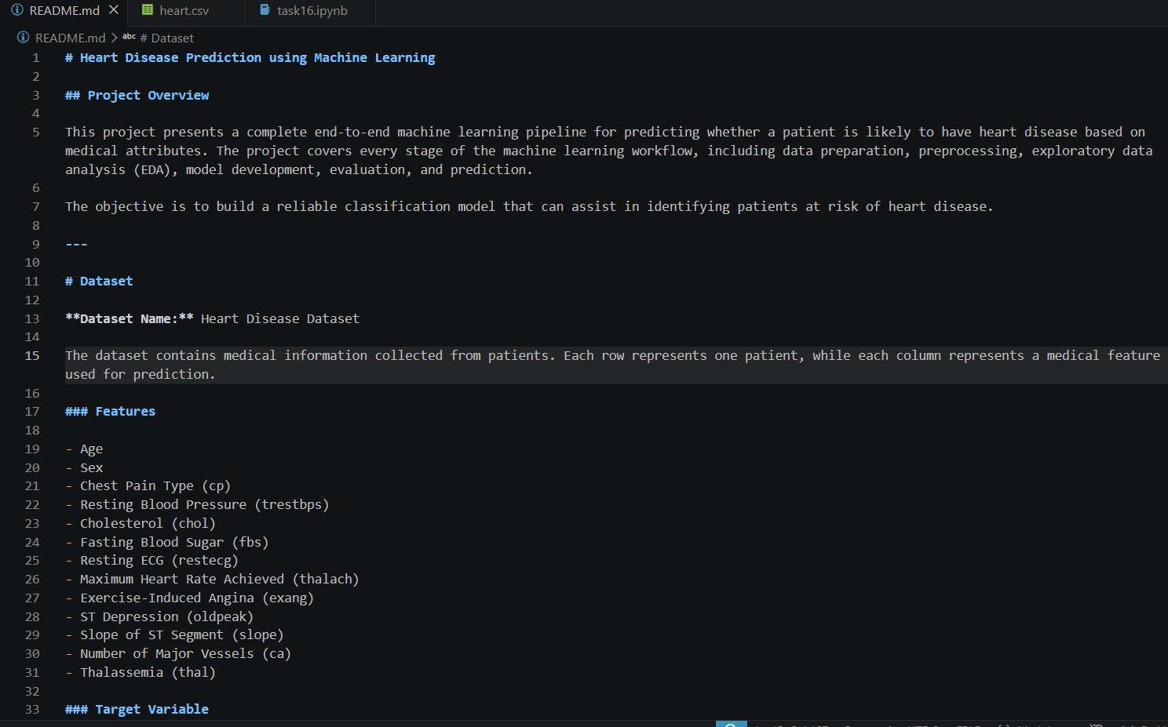

Github Repository Link: https://github.com/63852-EmanAnsar/ai-internship-emanansar

