IBM NAAN MUDHALVAN

ARTIFICIAL INTELLIGENCE

## PROJECT

## CREATE A CHATBOT IN PYTHON

(PHASE 1)

PROJECT SUBMITTED BY: THEJASRI. H (au411521104117)

I

Problem Definition:

The challenge is to create a Chatbot in Python that provides expectional customer service, answering user queries on a website or application. The objective is to deliver high-quality support to users, ensuring a positive user experience and customer satisfaction .

Design Thinking:

Functionality:

The future scope of chatbots is vast and varied, as they are already becoming increasingly popular and are being adopted by various industries. Here are some potential areas where chatbots may be used in the future:

* Customer service: Chatbots can provide instant assistance to customers, which can help reduce wait times and improve customer satisfaction. In the future, chatbots may become even more sophisticated and be able to handle more complex customer service interactions.
* Healthcare: Chatbots have the potential to help patients manage their health by providing guidance on medication, answering questions about symptoms, and providing support for mental health issues.
* Education: Chatbots can be used to provide personalized learning experiences, answering student questions and helping them progress through their studies.
* Financial services: Chatbots can provide assistance with financial planning, help with banking tasks, and provide advice on investments.
* Human resources: Chatbots can help streamline the recruitment process by answering candidate questions, scheduling interviews, and providing information about job openings.
* Personal assistants: Chatbots can serve as virtual personal assistants, helping users manage their schedules, make appointments, and complete tasks.

2

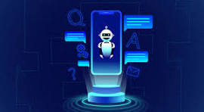

* As technology continues to advance, chatbots are likely to become even more sophisticated, with the ability to understand and respond to natural language, recognize emotional cues, and provide more personalized interactions.
* Additionally, chatbots may be integrated with other technologies such as artificial intelligence and machine learning, which could enable them to learn from user interactions and provide even better support over time.
* Overall, the future scope of chatbots is promising, and they are likely to play an increasingly important role in various industries and aspects of our daily lives.

User friendly:

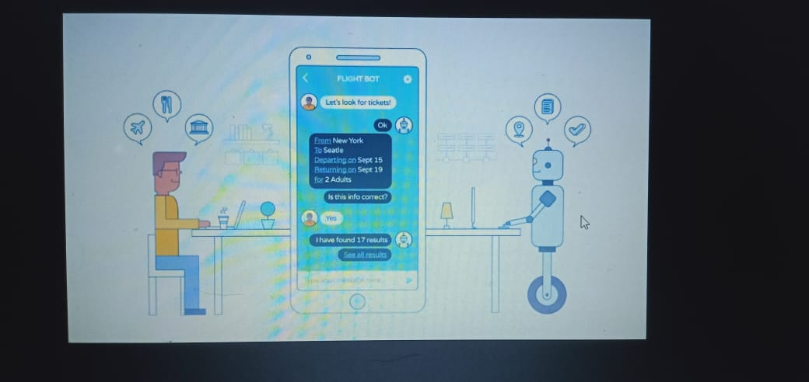

The best chatbot UIs are designed with the user in mind, and they make it easy for users to access the features or information they need. Responsive. Creating a consistent experience across all devices is an important aspect of chatbot UI/UX design.

3

## What is a Chatbot?

The term “chatterbot” came in existence in 1994 when Michael Mauldin created his first chatbot named “Julia”. As per the Oxford Dictionary, a chatbot is defined as “A computer program designed to simulate conversation with human users, especially over the internet.” It can be looked upon as a virtual assistant that communicates with users via text messages and helps businesses in getting close to their customers. It is a program designed to imitate the way humans communicate with each other. It can be done through a chat interface or by voice call. Developers usually design chatbots so that it is difficult to tell for users whether they are communicating with a person or a robot.

Chatbots helps any business/organization in accomplishing the following goals:

* Increases operational efficiency.
* Automating customer request fulfillment.
* Handling basic queries, which in turn free employees to work for complex & higher value inquiries.
* Offers Multi-language support.
* Saves time & effort by automating customer support.
* Improves the response rate as well as customer engagement.
* Personalization of communication

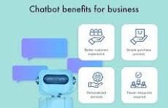

4

Requirements:

* Pip
* NumPy
* random
* nltk
* tenserflow

Building a Chatbot using Chatterbot

Let's begin by installing the chatterbot library. For creating chatbot also need to install chatterbot corpus. Corpus - literal meaning is a collection of words. This contains a corpus of data that is included in the chatterbot module. Each corpus is nothing but a prototype of different input statements and their responses. These corpus are used by bots to train themselves. The most recommended method for installing chatterbot and chatterbot_corpus is by using pip.

Installation commands for terminal:

pip install chatterbot

pip install chatterbot_corpus

Installation commmands for Jupyter Notebook:

!pip install chatterbot

!pip install chatterbot_corpus

## Conclusion:

* Chatbot Python development may be rewarding and exciting.
* Using the ChatterBot library and the right strategy, you can create chatbots for consumers that are natural and relevant.
* By mastering the power of Python's chatbot-building capabilities, it is possible to realize the full potential of this artificial intelligence technology and enhance user experiences across a variety of domains.
* Simplilearn's postgraduate program in Machine Learning and AI, in collaboration with Purdue University and IBM will help you learn in-demand skills such as deep learning, reinforcement learning, NLP, computer vision, generative AI, explainable AI, and many more.