MTConnect Fanuc Installation

User Guide

Draft

Friday, January 17, 2014

# Table of Contents

Table of Contents 2

Revision History 3

FANUC SHDR INSTALLATION 3

Installation Requirements 4

Installation Steps 5

UnInstallation Steps 12

Boeing Specific Details 13

Followup 14

# Revision History

**Date Description Author Version**

|  |  |  |  |  |
| --- | --- | --- | --- | --- |
| **Date** | **Description** | **Author** | | **Version** |
| 1/17/2014 | Initial MTConnect Agent SDK | | NIST – rough draft of MSI Windows installation for Fanuc MTConnect Adapter. Could use Ethernet or HSSB interface from Focas to CNC. Two separate MSI one for Ethernet, and one for HSSB are required. | 1.0 |

# FANUC SHDR INSTALLATION

Installing the MTConnect Agent for the Fanuc CNC, involves installing a SHDR Adapter and a MTConnect Agent with the SHDR Adapter back end (which is typical of open source MTConnect Agents). The MTConnect Fanuc Adapter generates MTConnect blessed “SHDR” text that is supported by the open source MTConnect Agent (and is easier to go thru firewalls): Example of SHDR text is:

2011-03-01T16:31:59.0617|power|ON|execution|EXECUTING|controllermode|AUTO

Note the timestamp, tags and values delimited by “|”.

This section describes installing a custom SHDR Adapter developed for Fanuc iSeries (18, 21, 30, 31 models etc) that uses a Focas DLL library to retrieve data from a compatible Fanuc CNC. The Focas library *must* match it the controller and connection, that is, the type be it 15B, 15I or iSeries and the connection, beit HSSB or Ethernet. In addition, 32 bit and 64 bit DLL possibilities are now present in Focas DLLs.

The setup is quote/unquote straightforward, as there is a MSI (Microsoft installation) program to install the SHDR adapter program. There is no configuration as this is actually confusing with all the alternative Fanuc Focas options.

Figure 1 shows the MTConnect components involved (Device, Front End PC, Client Application). In the Boeing example, the CTLM Device is a Fanuc iSeries CNC. Because it is known that the open source C++ Adapter (not Agent) works for both 32 bit and 64 bit, the Adapter is compatible with Windows XP and Windows 7. Of note, if Windows 7 logging files will require increased folder permissions (and there is a batch script to enable this.)

NOTE it is very important that you know what Focas library is connecting to your Fanuc CNC. If you assume HSSB and its Ethernet or vice versa, IT WILL NOT WORK.



Figure 1 Fanuc Installation Overview

## Installation Requirements

The Fanuc software installation requirements were:

1. Focas library must be installed and located in the system Path so MTConnect can gather data and then output into SHDR format. It expects this DLL in the path, and if not will fail miserably. Since Fanuc charges for the DLL it cannot be distributed with the installer.
2. Ability to install programs, possibility to increase to folder’s permissions (on Windows 7/8)
3. Ability to run MTConnect program as service. MTConnect has ability to install Adapter as service that will automically run, test for running CNC and monitor TCP connections as well.
4. How do I upgrade the MTConnect Agent service?

Stop the service. Upgrade the Exe, and the Restart the Service.

1. Make sure telnet is installed on PC. (Look up on your favorite search engine)
2. Insure that Visual C++ 9.0 CRT (x86) DLL is installed. (Should be installed with setup script). If not Download vcredist_x64.exe or vcredist_x86.exe depending on whether you are on 32 or 64 bit windows machine.

.

## Installation Steps

1. If Ethernet connection from Rename FanucSetupEthernet.msx to FanucSetupEthernet.msi FanucShdrStartup.msi from ftp://ftp.isd.mel.nist.gov/pub/MTConnect
2. Run MSI, and you should see an Install Wizard step. You should safely just Next, Next, … , Finish

Installation

1. Run FanucSetup.msi The first installation page you should see is:

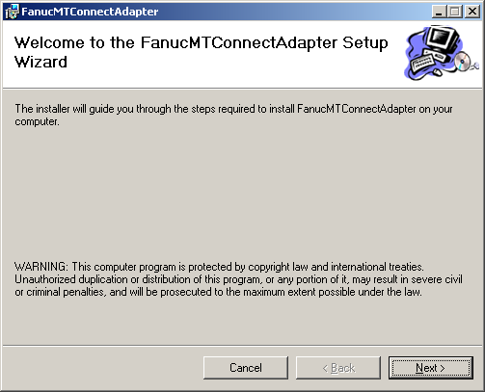

1. Ignore where to install but make sure everyone is checked:

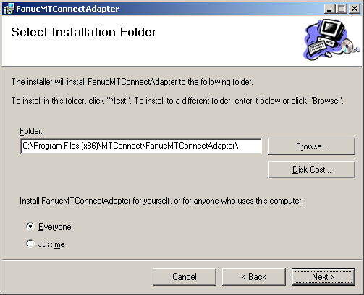

1. Installation of Ethernet (or HSSB) depending on MSI not MSI pages:

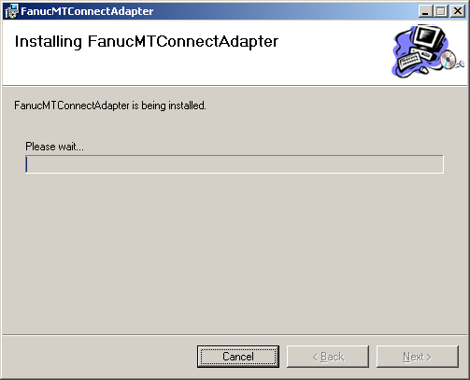

1. IF you receive this type of notification, the folder in which the MSI is located does NOT have permission to write.

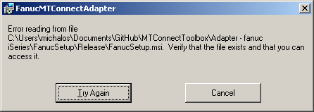

1. A superuser.bat script is run and a Dialog popup alerts you to this event:

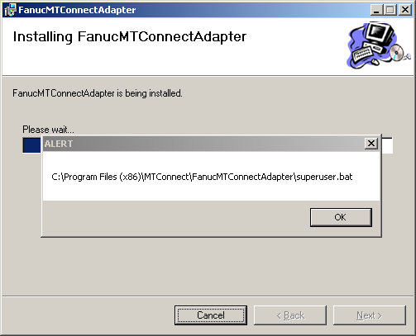

1. A superuser.bat script is run to reset the folder persmissions on windows 7 machines. (Already ok on windows xp). You should see fwlib32.dll. YOU MAY NEED TO REMOVE THIS.

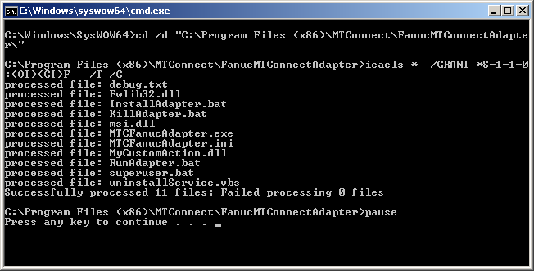

1. The Fanuc MTConnect adapter is added to the Windows Service Control Manager (and started) and a pop up Dialog alerts you to this event:

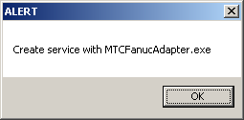

1. The final Installation Complete Dialog is issued to user. If you see this rejoice.

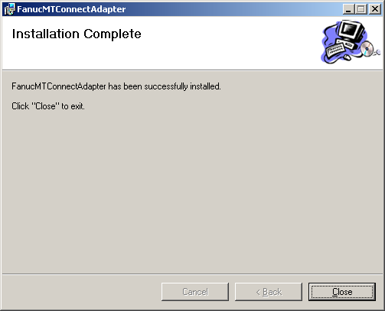

1. Once installed into the windows service control manager (SCM) you need to verify that the MTConnect Adapter has indeed been installed. The software developers only work a little on this, so should NEVER trust them. Open the service: right click manage on the Computer icon. (It will ask for UAC permission by asking for admin user/password on windows 7/8) You should see MTCFanucAdapter, Its state could be manual or automatic, started or stopped. If manual, make automatic. If stopped, start. If not there, you may need to install “by hand” which requires going to

“C:\Program Files (x86)\MTConnect\FanucInstall” and running the batch InstallAdapter.bat which will hopefully install the adapter into the Windows SCM. If not, please contact [john.michaloski@nist.gov](mailto:john.michaloski@nist.gov)

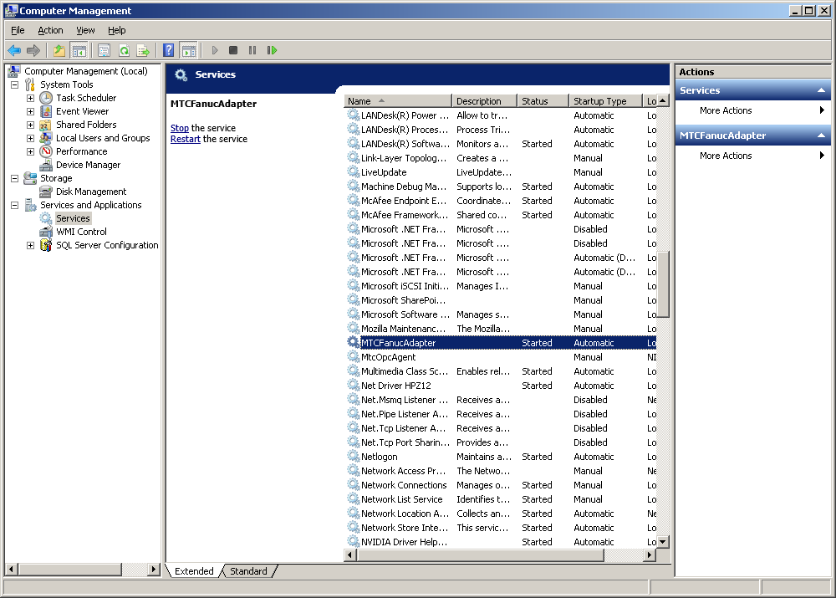

1. Now, you can see the properties of MTCFanucAdapter which should show you the location of the program (exe) in “C:\Program Files (x86)\MTConnect\FanucInstall”. Startup type should be automatic, so that every time you boot the PC, it will start the MTConnect Adapter. It should also give you service status of “Started” with Stop highlighted. If not start the service, please contact [john.michaloski@nist.gov](mailto:john.michaloski@nist.gov)

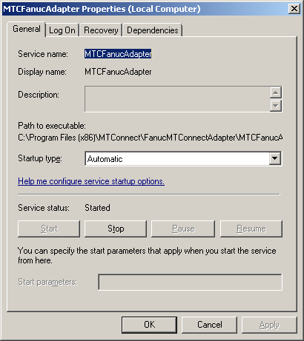

## UnInstallation Steps

1. Bring up control panel and remove programs
2. Uninstall ***FanucMTConnectAdapter***
3. Please note, this has to stop and remove a windows service
4. You will need UAC privileges to allow you to uninstall on window 7 or 8.

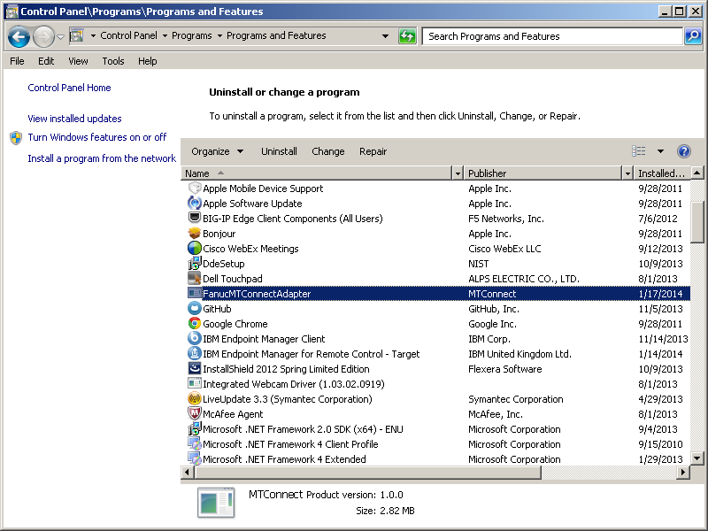

# Followup

Since the Fanuc MTConnect Adapter is a service, and already hand configured (if any configuration) you can navigate to the folder:

C:\Program Files (x86)\MTConnect\FanucInstall

stop the service fron the Windows SCM (right click Manage on My Computer and navigate to services, specifically MTCFanucAdapter),

replace the EXE

C:\Program Files (x86)\MTConnect\FanucInstall\MTCFanucAdapter.exe

and then start the service.

# Boeing Specific Details



**Questions about architecture:**

1. Is connection from PartDownload PC (or FEPC) local Ethernet (preferred) or HSSB (ouch)?
2. Is 30i 32 or 64 bit? It will effect Focas DLL (most likely) as 64 bit machine has separate DLL that is currently untested (but should only need test not redevelopment)

