|  |  |  |
| --- | --- | --- |
| GameItem |  | land |
| +g_body : b2Body*  +g_pixmap : +QGraphicsPixmapItem  + g_size : QsizeF  +g_world : b2world *  +g_worldsize : static QsizeF  +g_windowsize : static QsizeF |  |
| +GameItem(world : b2World *)  +~GameItem()  +setGlobalSize(worldsize : QSizeF, windowsize: QSizeF)  +<<slots>>paint() : void | +Bird ( x: float, y :float,  w :float, h: float,  pixmap :QPixmap,  world :b2World*,  scene :QGraphicsScene *) |

|  |
| --- |
| mainwindow |
| QGraphicsScene *scene;  b2World *world;  QList<GameItem *> itemList;  QTimer timer;  Land: *land;  Slingshot: *slingshot1;  beginy: int beginx: int right:int endx: int endy: int diffx: int diffy: int which: int;  int score;  wood:*build[3];  rival :*rival1[2];  Bird :*birdie[4]; |
| GameSet():void  tick():void  QUITSLOT():void  quitGame():void  *showEvent*(QShowEvent *) : void  *eventFilter*(QObject *, event: QEvent *) :bool  *closeEvent*(QCloseEvent *): void |

|  |
| --- |
| yellow |
| +yelow(x: float, y :float, radius :float, timer :QTimer *,  pixmap: QPixmap, world :b2World *,scene :QGraphicsScene *)  + set_linear_velocity(b2Vec2 velocity): void |

|  |
| --- |
| bird |
| +Bird(x: float, y :float, radius :float, timer :QTimer *,  pixmap: QPixmap, world :b2World *,scene :QGraphicsScene *)  + set_linear_velocity(b2Vec2 velocity): void |

|  |
| --- |
| orange |
| +orange(x: float, y :float, radius :float, timer :QTimer *,  pixmap: QPixmap, world :b2World *,scene :QGraphicsScene *)  + set_linear_velocity(b2Vec2 velocity): void |

|  |
| --- |
| blue |
| +blue(x: float, y :float, radius :float, timer :QTimer *,  pixmap: QPixmap, world :b2World *,scene :QGraphicsScene *)  + set_linear_velocity(b2Vec2 velocity): void |

|  |
| --- |
| wood |
| +wood(float x, float y, float w, float h, QTimer *timer, QPixmap pixmap, b2World *world, QGraphicsScene *scene); |

|  |
| --- |
| rival |
| +rival(float x, float y, float radius, QTimer *timer, QPixmap pixmap, b2World *world, QGraphicsScene *scene) |

|  |
| --- |
| slingshot |
| +shot(Bird *bird): void  +slingshot(int x, int y, QPixmap pixmap, b2World *world, QGraphicsScene *scene) |

Wood，slongshot，rival均繼承於gameitem

遊戲開始:按L鍵離開，按R鍵重新

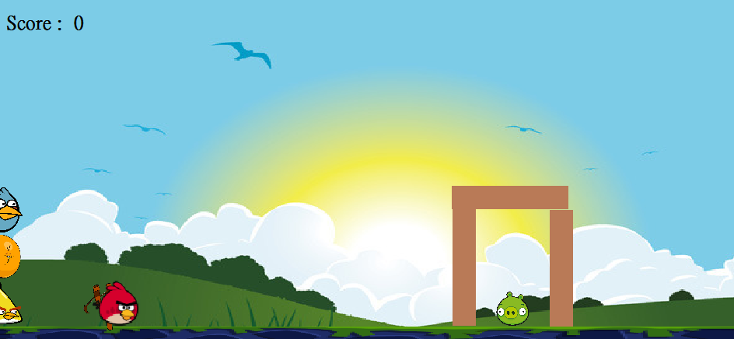

左上角有計分，一隻一分

