
Unit Title: Advanced Cryptography
Unit Code: BIT4138
Creative Task done:
1. Classical Cipher Simulator Demonstration
Demonstration 1: Python Random Numbers
Demonstration 2: Linear Congruential Generator (LCG)
Demonstration 3: XOR Stream Cipher
Demonstration 4: OTP Simulation

Name: Ahmed Aden Noor Jama - BSCCS/2024/55880

Contents
Week 1: Practical Task 3
Classical Cipher Simulator Demonstration 3
Weaknesses 3
Week 2: &3 Task 4
Demonstration 1: Python Random Numbers 4
Demonstration 2: Linear Congruential Generator (LCG) 5
Demonstration 3: XOR Stream Cipher 6
Demonstration 4: OTP Simulation 7
Task 1: Modify XOR Program 9

Week 1: Practical Task

Classical Cipher Simulator Demonstration
Simulator Used: 8gwifi.org Classical Cipher Studio
URL: https://8gwifi.org/ciph.jsp
Caesar Cipher Result
Operation | Input | Keys | Output
Encryption | SECURITY | 4 | WIGYVMXC
Decryption | WIGYVMXC | 4 | SECURITY

Weaknesses
- Only 25 possible keys (Brute force feasible)
- Letters ‘S’ always maps to ‘W’ (fixed substitution)
- Frequency analysis reveals plaintext structure

Vigenère Cipher Results
Operation | Input | Keys | Output
Encryption | NETWORK | Key | XIRGSPU
Decryption | XIRGSPU | Key | NETWORK

Weaknesses
- Short key “KEY” repeats every 3 letters
- Kasiski examination reveals key length
- Each key position acts as weak Caesar cipher

Week 2: Task

Demonstration 1: Python Random Numbers
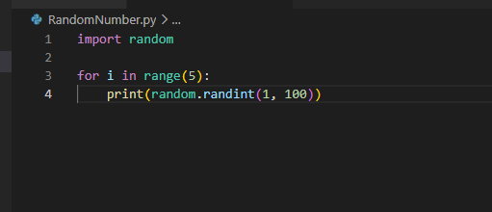

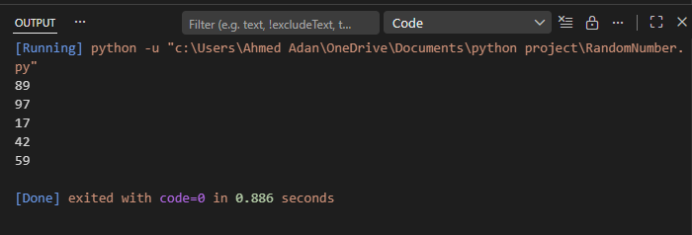

Demonstration 2: Linear Congruential Generator (LCG)
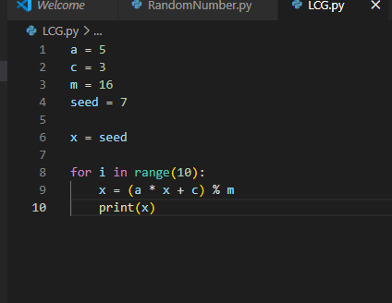

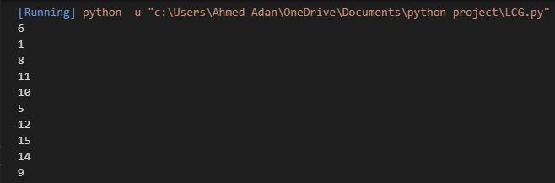

Explanation
The sequence appears random but eventually repeats because the generator is deterministic.

Demonstration 3: XOR Stream Cipher
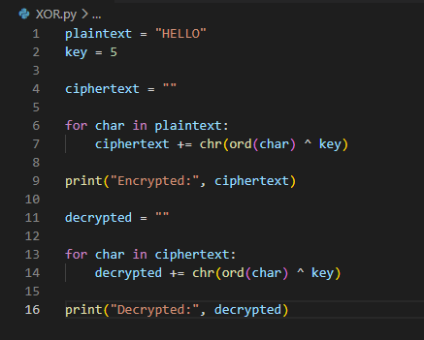

Output
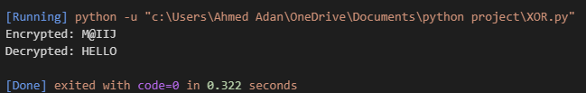

Explanation
- Encryption uses XOR with key 5.
- Applying XOR again with the same key restores the original message.

Demonstration 4: OTP Simulation
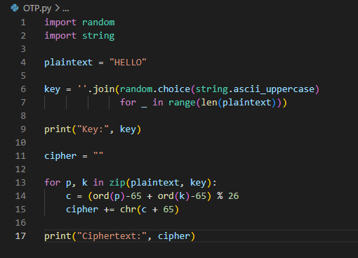

Output
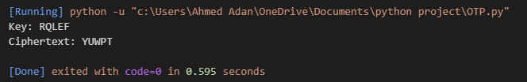

Assignment 1
Develop a pseudorandom sequence generator in Python.
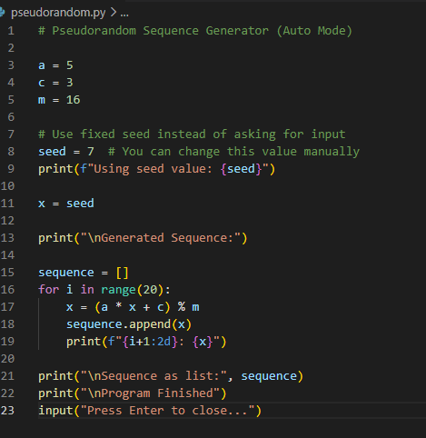

output
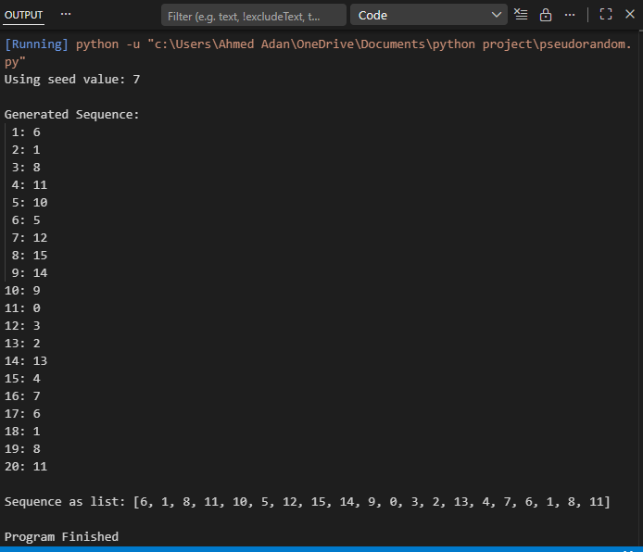

Task 1: Modify XOR Program
