

Unit Title: Ethical Hacking and Counter measures
Unit Code: BIT4139
Creative Task Done:
1. Checking Nmap Installation version & Finding the Ip Address of mku website
2. Scanning Version Detection
3. Scanning vulnerabilities
4. Exploitation
5. Foot printing (Passive Reconnaissance)

Name: Ahmed Aden Noor Jama - BSCCS/2024/55880

Contents
1
Introduction 3
Step 1: Checking Nmap Installation version using kali Linux 3
Step 2: Finding the Ip Address of mku website 4
Step 3: Basic Scan 4
Step 4: Version Detection (Service Version Detection) 5
step 5: Scan Specific Ports Only 5
Step 6: Save Scan Results 6
Step 7: Finding name servers 6
Steps 8: Foot printing 7
Student Evaluation 7

Introduction
As part of the Ethical Hacking and Countermeasures course, I carried out this hands-on exercise to show how to use Nmap for basic network reconnaissance tasks including port scanning, service detection, and OS system identification. I utilised the publicly available Mount Kenya University (MKU) website as a reference target to demonstrate the ideas and directives involved in information collection for educational and research objectives. The exercises were restricted to non-intrusive methods designed to improve my comprehension of how security experts evaluate systems that are accessible to the public.
There was no attempt to take advantage of weaknesses, get unauthorised access, or disrupt the regular functioning of the university's systems. I was able to obtain hands-on experience with network security assessment tools and methodologies through this exercise, which was conducted fully within the ethical guidelines of cybersecurity education.

Assignment: identify and installing Nmap and Vulnerability Scanning a website

Step 1: Checking Nmap Installation version using kali Linux
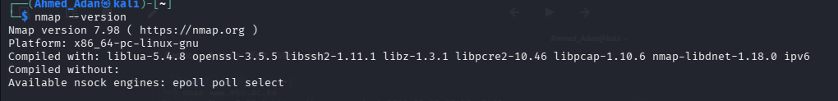

Step 2: Finding the Ip Address of mku website
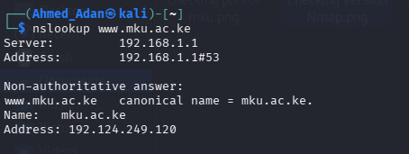

Step 3: Basic Scan
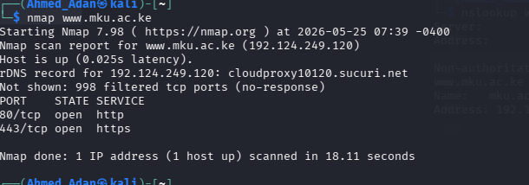

Step 4: Version Detection (Service Version Detection)
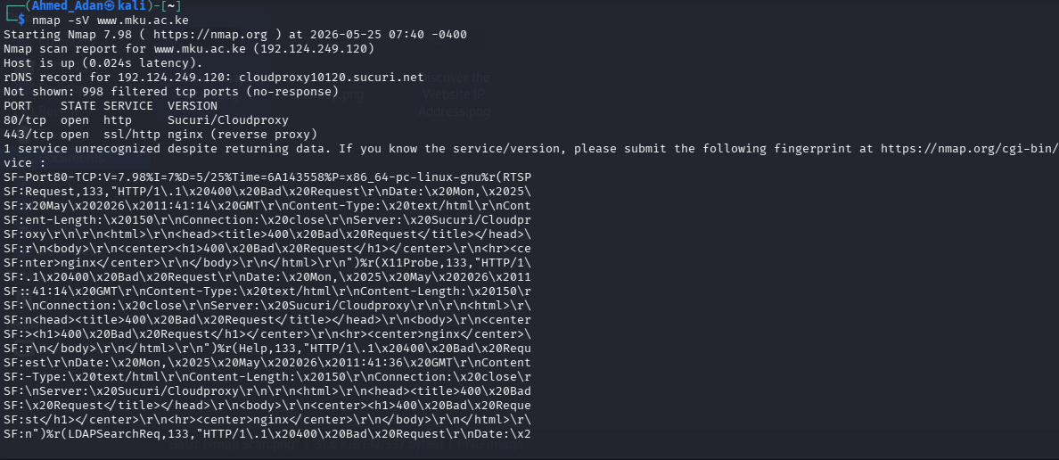

Purpose:
identify service/software versions

step 5: Scan Specific Ports Only
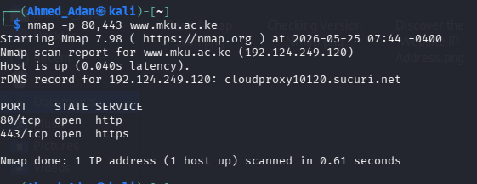

Step 6: Save Scan Results
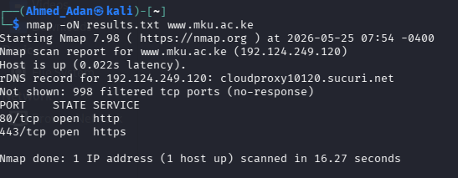

Step 7: Finding name servers
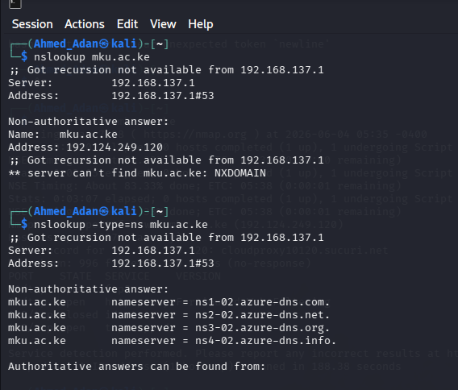

Steps 8: Foot printing
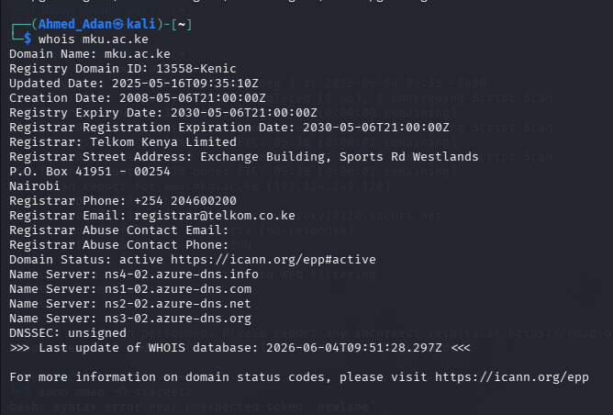

Student Evaluation
I had actual expertise with the Nmap tool for network reconnaissance and security evaluation during this activity. I gained knowledge about how to do basic port scanning, determine the versions of services that are currently running, and try operating system detection on approved targets. I was also aware of the significance of ethical issues and the necessity of getting authorisation before performing any security tests on actual systems.
Understanding the proper Nmap syntax was one of the difficulties I had, but after practice and debugging, I was able to properly run the necessary commands. My comprehension of ethical hacking principles and the function of vulnerability assessment in enhancing system security has increased as a result of this activity.

