KHALID BOSHNAK & MOHAMMAD (KBM) TECHNOLOGY PIPELINE
KBM TenderScout™ Platform
User Guide & Operational Manual
دليل المستخدم والتشغيل لمنظومة رصد وتتبع المناقصات والممارسات الحكومية والنفطية
Cloud Production URL: | https://kbm-tenderscout.azurewebsites.net (Azure Hosted)
Source Code Repository: | https://github.com/6439144/KBM_TenderScout (GitHub Master)
Marketing Leadership: | Eiman Ashkanani (Marketing Manager - Government & Oil Sector)
Automated Daily Schedule: | 08:00 AM Kuwait Time (05:00 UTC) Daily Sync
Target Users: | KBM Account Managers, Bidding Team, Technology Sales & Management

1. Executive Overview & System Architecture
KBM TenderScout™ is an intelligent procurement tracking platform built specifically for KBM to monitor, analyze, and match Kuwaiti government and oil-sector public tenders and practices (ممارسات ومناقصات). The system replaces manual tracking with automated scrapers, deep natural language parsing, and strategic account manager mapping directly reflecting the updated organizational structure led by Eiman Ashkanani.
The platform aggregates two authoritative state channels:
• Central Agency for Public Tenders (CAPT / الجهاز المركزي للمناقصات العامة) - All opening and active public tenders.
• Official Kuwait Gazette (Kuwait Al-Yawm / جريدة الكويت اليوم - ملحق المناقصات) - Full downloadable PDF supplements with extracted tender scopes, technical specifications, closing dates, pre-tender meetings, and bid bonds.
📌 High Precision & Deep Scope Parsing
Zero Missing Data Guarantee: Incomplete entries with generic placeholder text ('LOADING...') have been completely purged.
Every tender in the system contains authentic client entity names, detailed scope descriptions (e.g. Cisco core switches, IBM Maximo, enterprise servers), accurate closing dates, and official reference numbers.

2. Accessing the Platform
The application is accessible 24/7 without requiring software installation or local setups on employee machines:
1. Live Cloud Portal: https://kbm-tenderscout.azurewebsites.net
Hosted on Microsoft Azure App Service Free Tier (zero recurring cloud infrastructure cost).
2. Browser Compatibility: Fully tested and responsive on Google Chrome, Microsoft Edge, Mozilla Firefox, and Apple Safari (desktop, tablet, and mobile).
3. Local Fallback (Optional): Can be launched locally on the office network via http://127.0.0.1:8000 using the provided startup script.
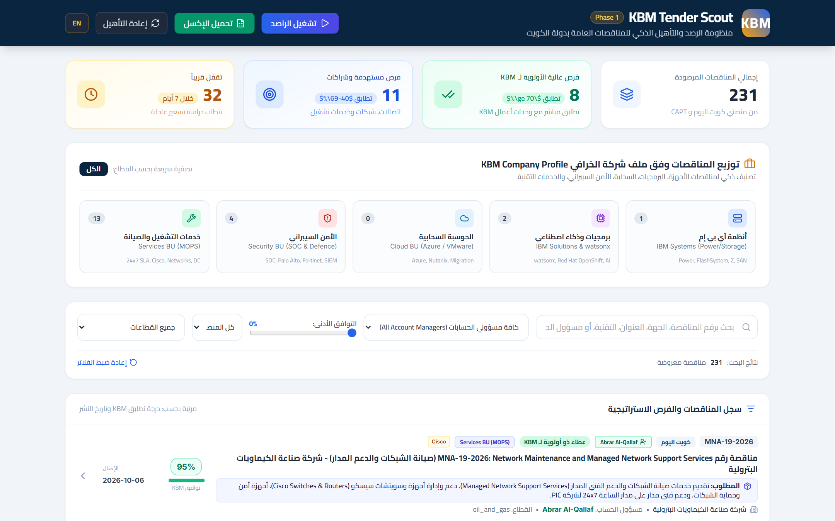
Figure 1: KBM TenderScout Main Executive Dashboard Overview
3. Step-by-Step User Workflow & Features
3.1 KPI Metrics & Real-time Filter Bar
The top summary section provides instantaneous situational awareness across all active opportunities:
• Total Monitored: Total count of canonical opportunities in the database (231 active tenders).
• Strategic Matches: Tenders specifically matched to KBM core technology offerings (Cisco, IBM, HPE/Dell, Cyber, Cloud, Infrastructure).
• Approaching Deadlines: Opportunities closing within the next 14 days, flagged in urgent amber/red.
• Source Breakdown: Real-time counter of CAPT portal listings vs Kuwait Al-Yawm Gazette listings.
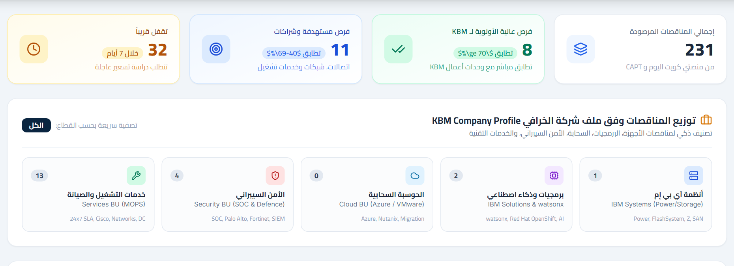
Figure 2: Real-time KPI Statistics Cards and Multi-Criteria Filtering Controls
Filtering Controls Available:
1. Keyword Search: Type any keyword in Arabic or English (e.g., 'Cisco', 'خوادم', 'شبكات', 'PIC', 'وزارة الدفاع'). Results filter instantly.
2. Account Manager Filter: Dropdown selector allowing each sales representative to isolate tenders relevant to their designated portfolio.
3. Status Filter: Toggle between Active, Closing Soon, Closed, or Pending Inquiry.
4. Source Filter: Filter by CAPT or Kuwait Al-Yawm specifically.
5. Reset Filters: Instantly restores the default comprehensive view.
3.2 Strategic Opportunity Identification & Scope Badges
The list view emphasizes high-yield opportunities by displaying technology tags and client badges directly on the card header. This allows the bidding team to scan through hundreds of tenders in seconds.
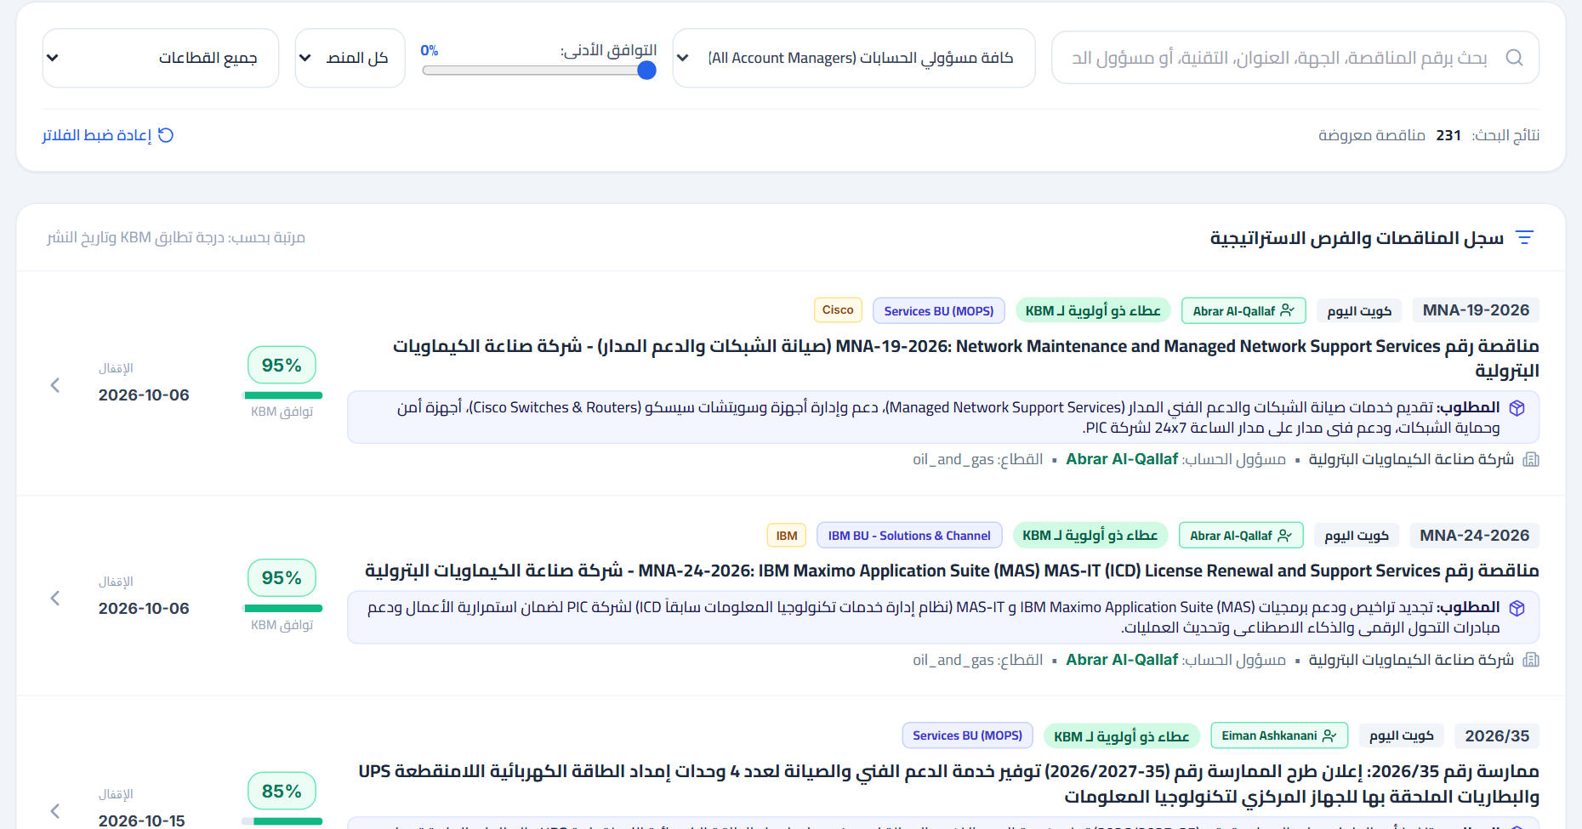
Figure 3: Strategic Tenders List with Technology Badges & Assigned Account Owners
3.3 Deep Scope Modal & Tender Requirements Analysis
Clicking 'عرض التفاصيل والاشتراطات' (View Details) opens the comprehensive Tender Deep-Dive Modal. Unlike generic portals that only show a brief title, TenderScout provides the full operational context:
• Official Issuing Entity: (e.g. Petrochemical Industries Company PIC, Ministry of Defence, Ministry of Health).
• Technology Scope & KBM Fit: Specific equipment models, manufacturer requirements (Cisco, IBM Maximo, Dell/HPE), and managed service expectations.
• Commercial & Bidding Milestones: Closing date, Pre-tender technical meeting date, and Inquiry deadline.
• Financial Requirements: Bid bond amount (الكفالة الأولية) and document purchase fee (ثمن الوثائق).
• Submission Channel & Location: Exact tender box number, gate location, or online e-procurement link.
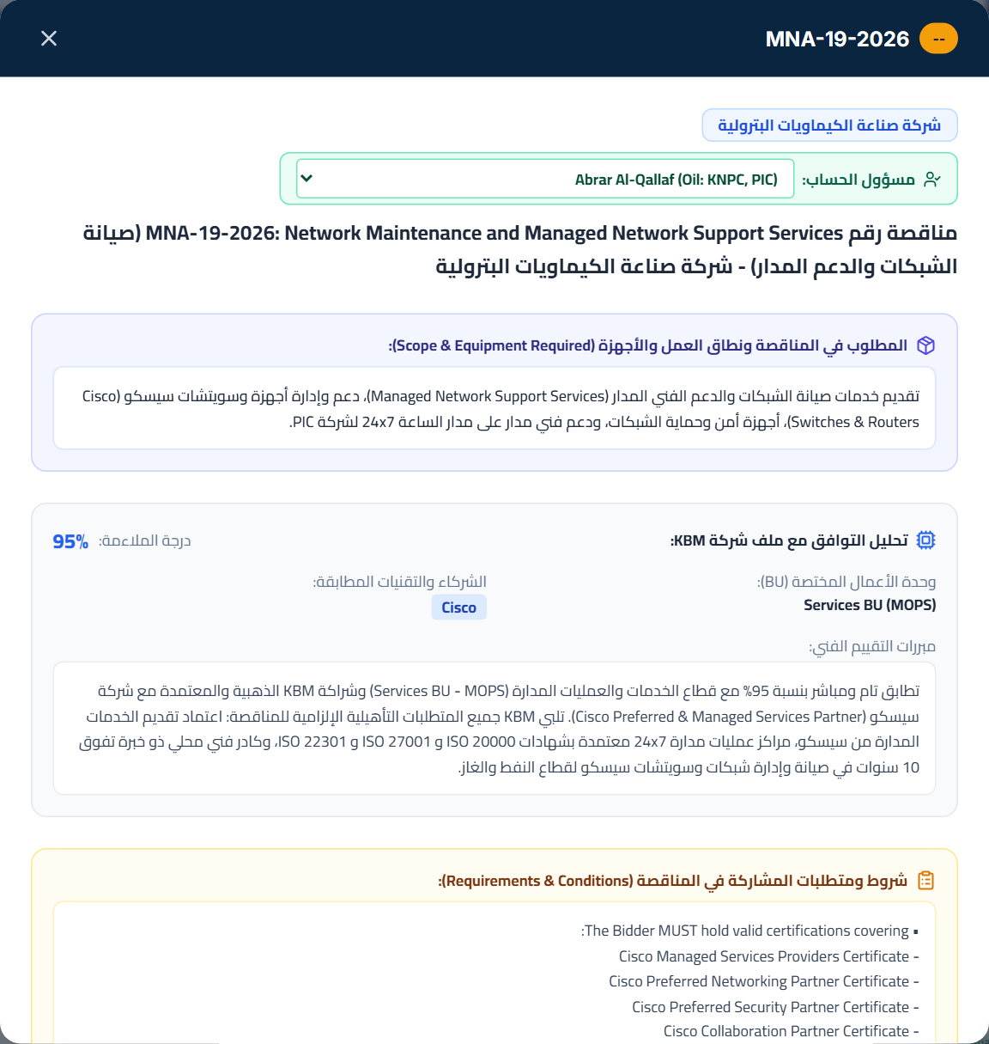
Figure 4: Modal View - PIC Tender MNA/19/2026 for Cisco Managed Network Services
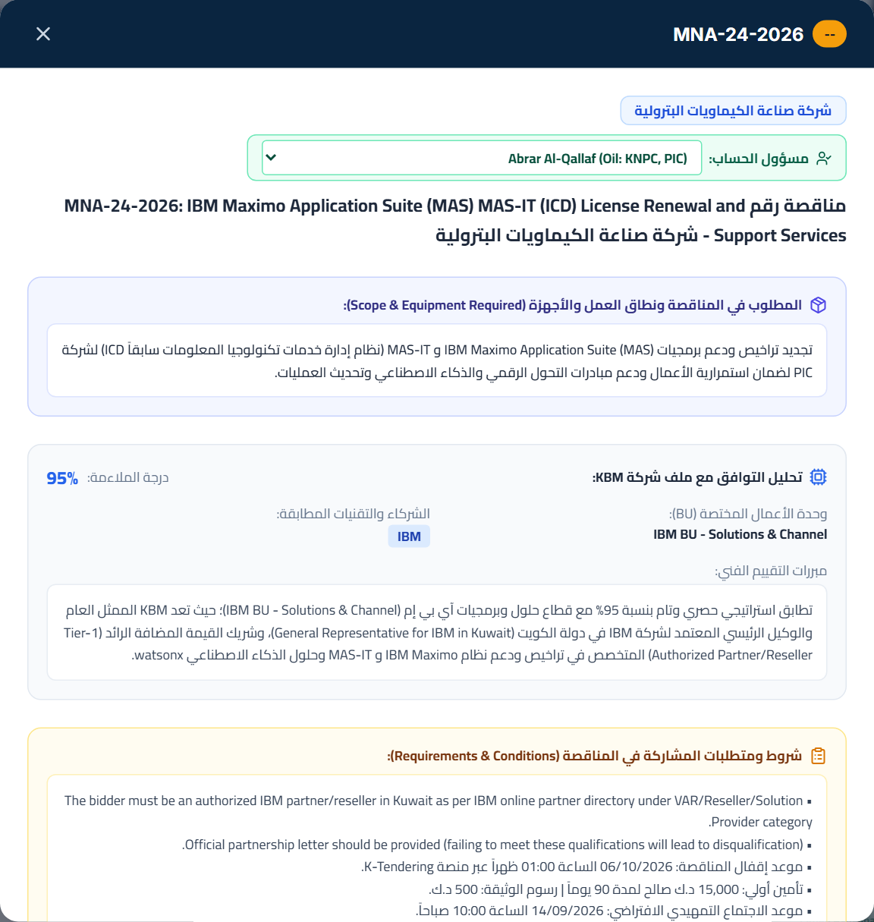
Figure 5: Modal View - PIC Tender MNA/24/2026 for IBM Maximo Enterprise Asset Management
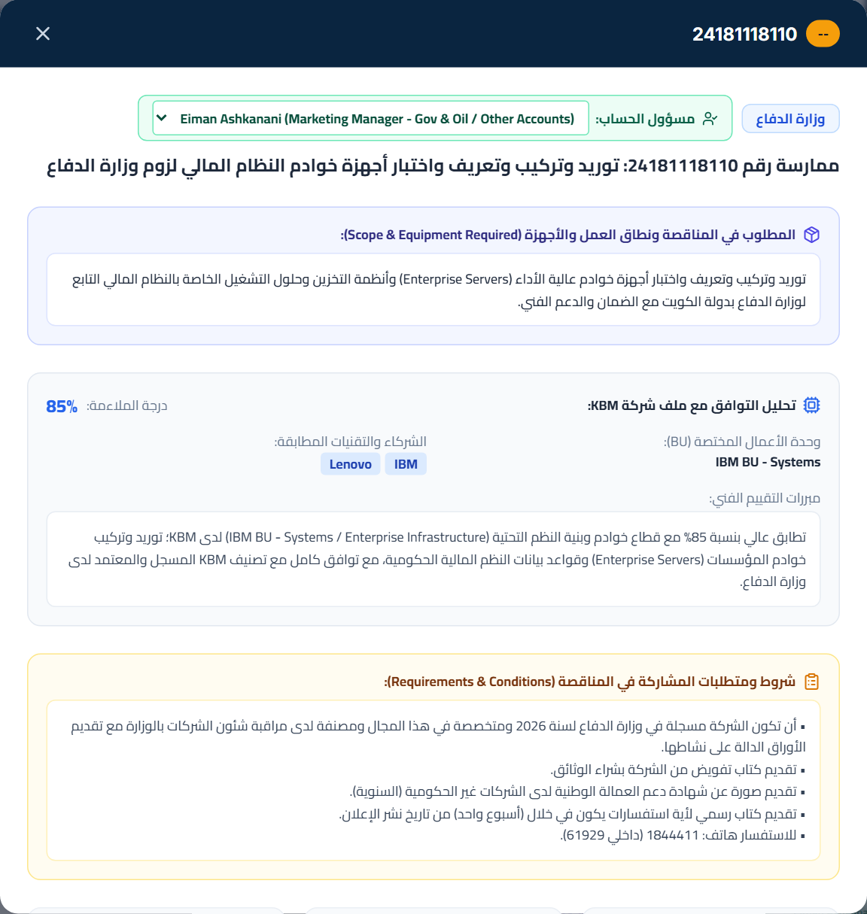
Figure 6: Modal View - Ministry of Defence Practice 24181118110 for Enterprise Servers
3.4 Account Manager Portfolio Filtering & Owner Reassignment
Every tender is automatically mapped to the appropriate KBM Account Manager according to the official portfolio allocation. Sales reps can filter by their name to view only their portfolio (e.g., Abrar Al-Qallaf for KNPC & PIC, Ahmed Habib for KOC & KOTC, Jana Al-Obaid for MOH & PIFSS, Raed Obeid for MEW & PACI, Khaled Alabdallah for MOI, and Eiman Ashkanani for Ministry of Defence and all other strategic accounts).
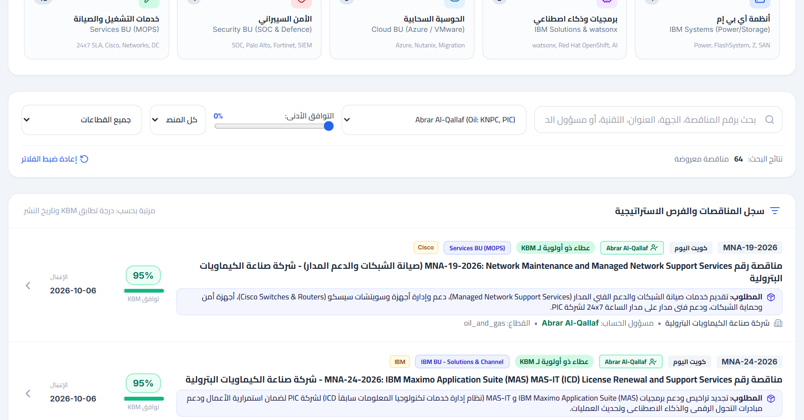
Figure 7: Filtered View for Account Manager Abrar Al-Qallaf showing Assigned Strategic Pipeline
Reassigning Account Ownership:
The interface includes a quick reassignment feature. If an account manager changes or an opportunity falls under another team member's domain, authorized team members can update the assigned owner directly in the database with immediate synchronization.
4. Official Account Management Hierarchy (Government & Oil Sectors)
In accordance with executive management directives, the account management structure for the Government and Oil Sectors is led by Marketing Manager Eiman Ashkanani, structured as follows:
Sector | Team Member | Assigned Key Accounts | Active Tenders Count
Gov & Oil Leadership | Eiman Ashkanani  (Marketing Manager) | MOD (Defence), PAHW (Housing), MPW (Public Works), KM (Municipality), KPC, KIPIC, KUFPEC, KGOC, KAFCO, KPI, MOF, MOE, KU, PAI, KNG, KISR, KFAS, and all other public/oil accounts | 93 Tenders
Government | Jana Al-Obaid | PIFSS (Social Security), PADA (Disability Affairs), Nazaha (Anti-Corruption), MOH (Ministry of Health) | 40 Tenders
Government | Raed Obeid | MEW (Ministry of Electricity & Water), PACI (Civil Information) | 20 Tenders
Government | Khaled Alabdallah | MOI (Ministry of Interior / الداخلية) | 9 Tenders
Oil Sector | Ahmed Habib | KOC (Kuwait Oil Company), KOTC (Kuwait Oil Tanker Company) | 5 Tenders
Oil Sector | Abrar Al-Qallaf | KNPC (Kuwait National Petroleum Company), PIC (Petrochemical Industries Company) | 64 Tenders

5. Automated Daily Refresh Schedule
To ensure zero lag between government gazette publication and sales pipeline action, the system executes an automated morning scan every day:
1. Schedule: 08:00 AM Kuwait Time (05:00 UTC) every morning.
2. Cloud Automation Engine: GitHub Actions Scheduled Cron Workflow (.github/workflows/daily_scan.yml).
3. Gazette Sync: Authenticates with Kuwait Al-Yawm, inspects latest gazette issues, downloads the tenders supplement PDF, and extracts text using pdfplumber.
4. CAPT Sync: Scrapes the live opening and active tenders board from capt.gov.kw.
5. Smart Incremental Merging: New tenders are seamlessly inserted with strategic tags; existing tenders receive updated closing dates; customized account owner assignments remain preserved.
6. On-Demand Manual Refresh: Users can click 'Refresh Data' in the portal header or trigger a manual run on GitHub Actions at any time.
6. System Governance & Support
For system support, feature requests, or new account mapping rules, please contact the KBM Technology Platform Team:
• Production Platform: https://kbm-tenderscout.azurewebsites.net
• Codebase & Issue Tracker: https://github.com/6439144/KBM_TenderScout
• Platform Architecture: Python 3.12, FastAPI, Playwright Headless, Azure App Service (F1 Linux)
📌 Best Practice Recommendation / توصيات الاستخدام الأمثل
Please bookmark the Azure URL in your daily browser favorites.
Account managers are requested to review their filtered view each morning at 08:15 AM to capture upcoming bids well ahead of the pre-tender meeting deadlines.

