KBM Platform — Functional Scenarios & User Journeys
End-to-End Execution Walkthroughs, Business Validation Rules & Technical Contracts
Aligned with Kuwait Public Tenders Law No. 49/2016 & MOI BRD v0.1
📌 Scenario Walkthrough Metadata
• Document Reference: KBM-FSD-SCENARIOS-2026
• Scope: 4 Core End-to-End Business Scenarios
• Target Systems: Staff Portal, Vendor Portal, Tenant Admin Portal, KNET Gateway, Azure Cosmos DB
• Date of Release: August 2026 | Status: Approved

1. Scenario 1: Tender Request Intake & Registration Cycle
This scenario covers the end-to-end process of originating, validating, and registering procurement requests from government sectors. The platform supports both automated electronic intake via Raslni G2G (FR-002) and paper General Manager letters with mandatory scanned attachments (FR-012).
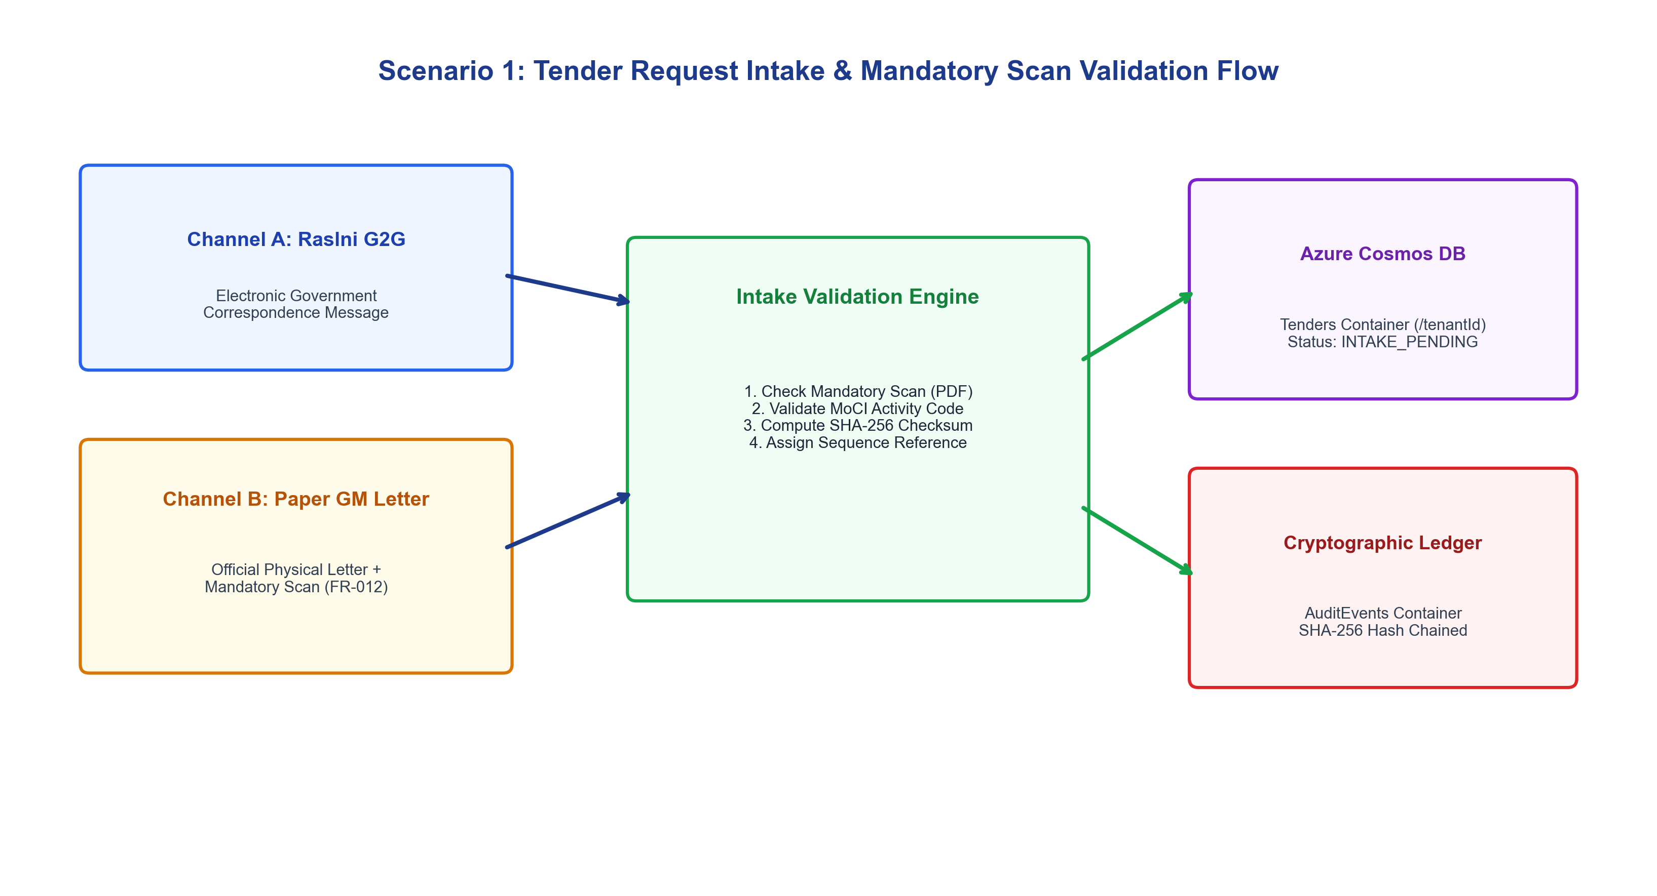
Figure 1: Scenario 1 - Tender Request Intake & Mandatory Scan Validation Flow

Step | Actor | Action / Screen | Business Validation Rule | Cosmos DB State Change
1.1 | Requesting Officer | Staff Portal: New Intake Screen | Selects Channel: Paper Letter or Raslni G2G. | Form initialized with tenant context.
1.2 | Requesting Officer | Fills Title, Budget, Attaches Scanned GM Letter | FR-012 Mandatory Check: If scanned letter missing, submit is rejected with HTTP 400. | Blob: kbmbootstrapsa/scans/req-xxxx.pdf
1.3 | Procurement Engine | POST /api/requests | MIME validation (PDF/JPEG allowlist), SHA-256 payload checksum calculation. | Tenders container: status: INTAKE_PENDING
1.4 | Audit Store | Append Audit Event | SHA-256 Hash Chaining (previousHash -> hash). | AuditEvents container: new block appended
1.5 | Tender Committee Staff | Intake Review & Classification | Selects MoCI activity codes (IT-SYS-01) and sets grade rule (SECOND_AND_ABOVE). | Tenders container: status: PUBLISHED

2. Scenario 2: Vendor Registration, 3-Grade Classification & Subscription
Commercial enterprises apply through the Vendor Portal by submitting commercial licenses and MoCI activity registrations. The Tenant Admin evaluates the technical capacity and assigns a grade (First, Second, or Third Grade). The vendor then activates an annual 1-year KNET subscription.
Step | Phase | Operational Description | Statutory Rule / BRD Reference | Cosmos DB Outcome
2.1 | Registration | Vendor submits company profile, CR number, civil IDs, and commercial activity codes. | FR-015: Online registration with dossier upload. | Vendors: status: PENDING_APPROVAL
2.2 | Grading Evaluation | Tenant Admin evaluates past projects and capital, assigning Grade FIRST, SECOND, or THIRD. | FR-009 & FR-016: 3-tier classification hierarchy. | Vendors: grade: FIRST, status: APPROVED
2.3 | KNET Subscription | Vendor completes 1-year subscription checkout via KNET (100 KWD/yr). | FR-017: 1-Year KNET subscription validity. | Vendors: subscriptionExpiresAt: +365d
2.4 | Fee Exemption | Admin can grant fee exemptions to designated SME entities. | FR-018: Fee exemption bypasses checkout. | Vendors: isFeeExempt: true
2.5 | Suspension & Auto-Restore | Admin sets temporary date-range block (blockedUntil). System automatically restores access on expiry. | FR-013 & FR-014: Date-range suspension with auto-reinstatement. | Vendors: isBlocked: false when now > blockedUntil

3. Scenario 3: Tender Discovery, Server-Side Eligibility & KNET Purchase
Vendors discover tenders matching their registered commercial activities. The platform enforces server-side eligibility checks (FR-020 & SEC-006), displays dynamic anti-screenshot canvas watermarking (SEC-001), and generates official branded purchase receipts (DOC-002) upon successful KNET checkout.
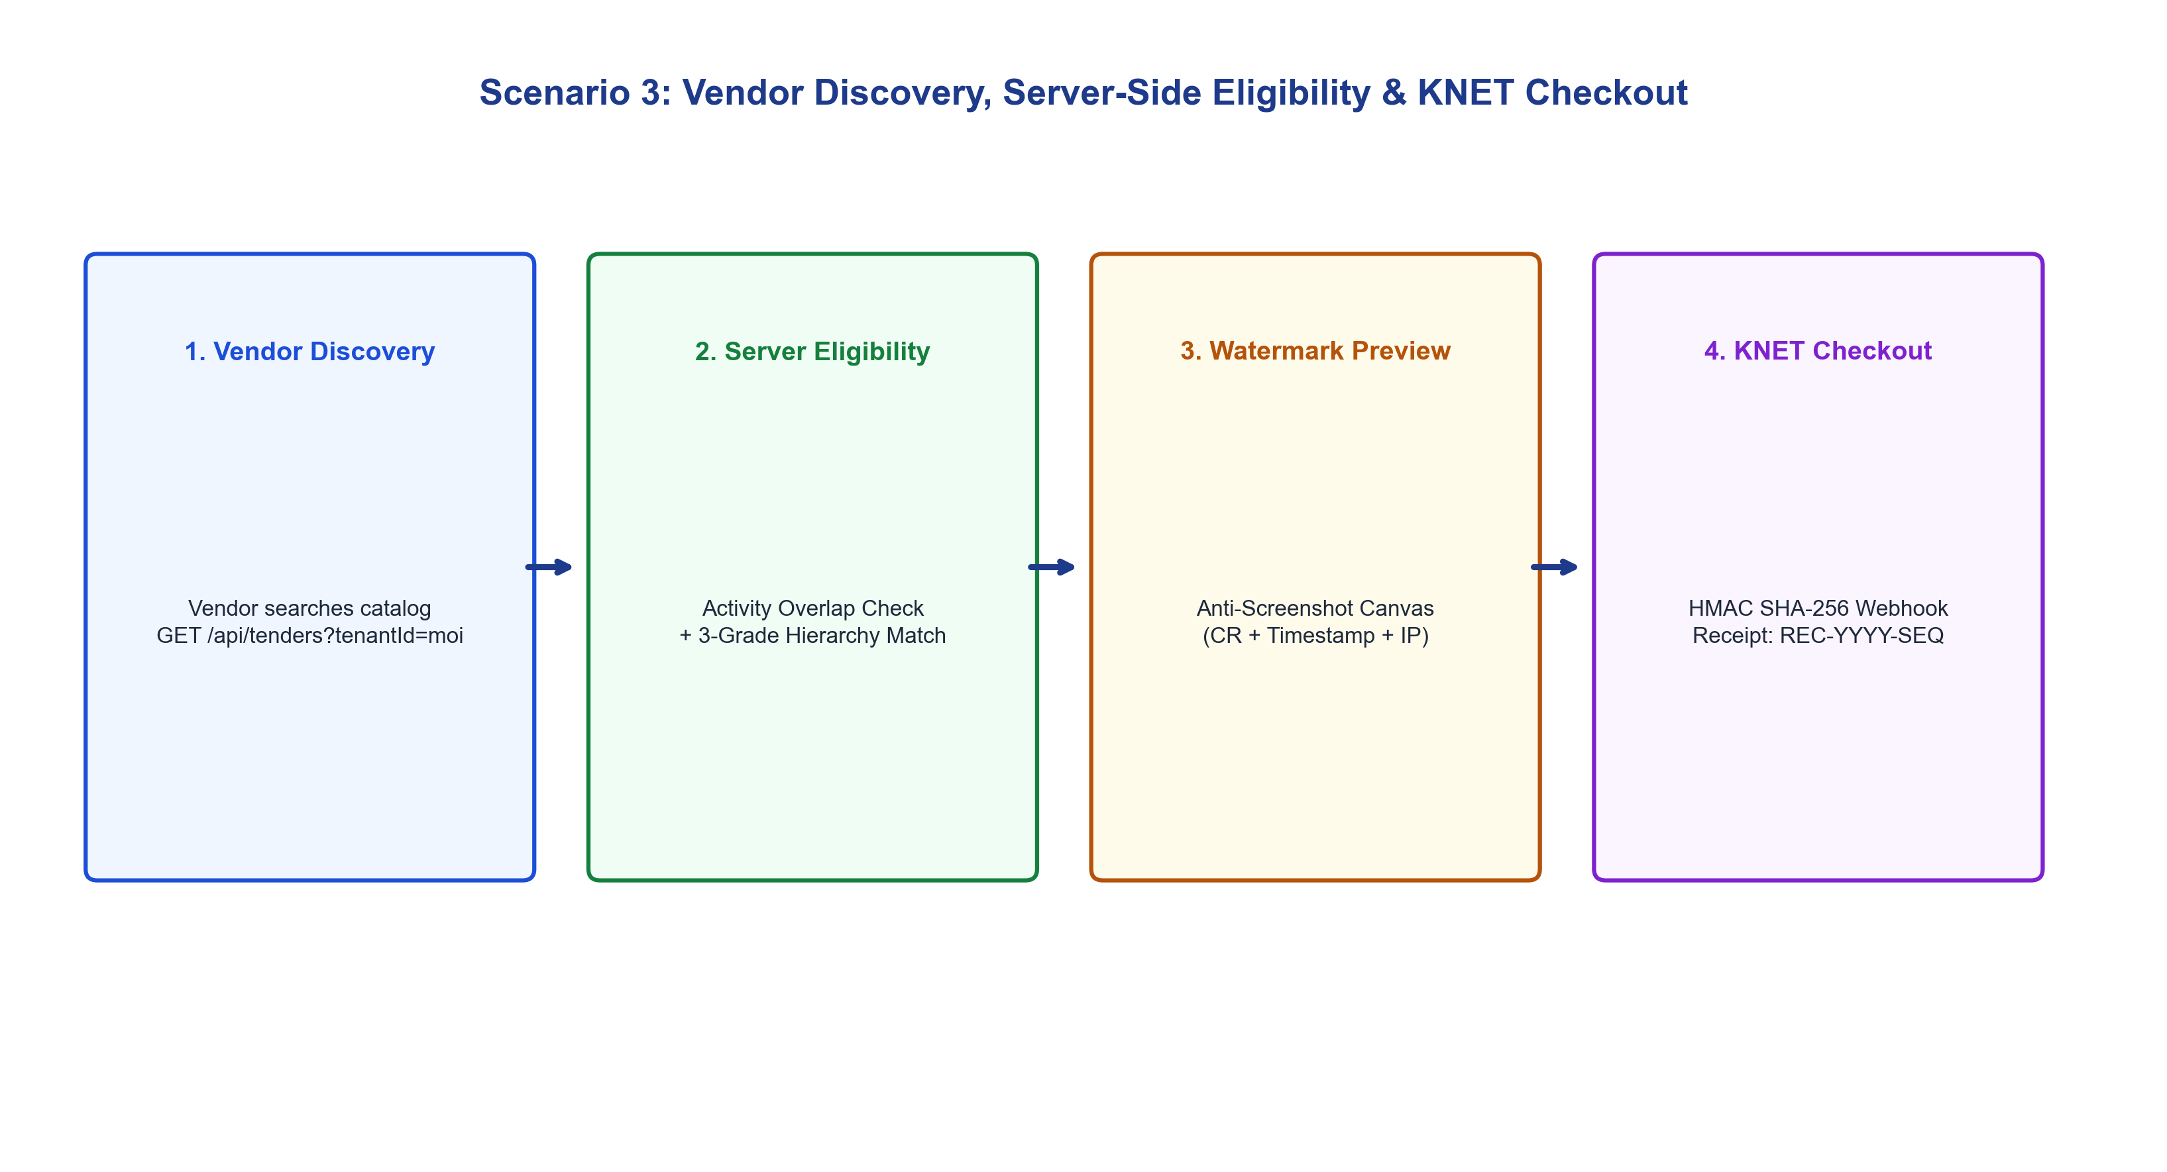
Figure 2: Scenario 3 - Vendor Discovery, Server-Side Eligibility & KNET Checkout Flow

Vendor Grade | Tender Target Grade | Matching Rule | Eligibility Result | System Enforcement
First Grade (FIRST) | Second Grade (SECOND) | GRADE_AND_ABOVE | ELIGIBLE (PASS) | Full booklet preview enabled; KNET purchase active.
Third Grade (THIRD) | Second Grade (SECOND) | GRADE_AND_ABOVE | INELIGIBLE (BLOCKED) | HTTP 403: Vendor grade does not meet minimum threshold.
First Grade (FIRST) | Second Grade (SECOND) | EXACT_GRADE | INELIGIBLE (BLOCKED) | HTTP 403: Exact grade match required for targeted tender.
Any Grade | Any Grade | No Activity Overlap | INELIGIBLE (HIDDEN) | Tender hidden from catalog; direct API access rejected.

4. Scenario 4: Statutory Approval Workflow & State Audit Bureau Oversight
KBM manages the 35-step statutory approval state machine for public tenders, tracking SLA deadlines, return-for-correction loops, and pre-contract statutory oversight by the State Audit Bureau (ديوان المحاسبة) before Undersecretary contract signing.
Workflow Milestone | Responsible Authority | Statutory Task Action | SLA Threshold | Regulatory Output
Milestone 1: Intake & CAIT | Requesting Dept & CAIT | Needs survey, cost estimation, project code assignment. | 5 Business Days | CAIT Portal Entry Number
Milestone 2: Legal Review | Fatwa & Legislation Dept | Legal review of tender conditions and penalty clauses. | 10 Business Days | Official Legal Review Seal
Milestone 3: CAPT Approval | Central Agency for Public Tenders | Board authorization and Kuwait Alyawm gazette publication. | 14 Business Days | Official Gazette Notice Ref
Milestone 4: Pre-Audit Oversight | State Audit Bureau (ديوان المحاسبة) | Statutory pre-contract audit review (الرقابة المسبقة). | 15 Business Days | Pre-Audit Approval Letter
Milestone 5: Contract Execution | Undersecretary (وكيل الوزارة) | Final contract signing 100% and bank guarantee deposit. | 3 Business Days | Cosmos DB SHA-256 Audit Seal

