KBM Procurement & Tender Management Platform
Comprehensive Software Architecture & System Design Document (SADD)
With Embedded Visual Diagrams & Complete BRD Traceability Matrix
📌 Document Release & Regulatory Metadata
• Document Identifier: KBM-ARCH-SPEC-2026-V1.0
• Target Solution: KBM Multi-Tenant Procurement SaaS Platform
• Regulatory Framework: State of Kuwait Public Tenders Law No. 49/2016
• Business Requirements Document Reference: MOI Tender Platform BRD v0.1
• Active Azure Environment: rg-kbm-platform (West Europe) | App Service + Azure Cosmos DB Free Tier
• Classification: Executive / Engineering Confidential

1. Executive Summary & System Vision
The KBM Platform is an enterprise SaaS procurement and tender management system engineered for government entities, ministries, and enterprise clients. It addresses the entire lifecycle of public practices (الممارسات) and public tenders (المناقصات) under State of Kuwait Law No. 49/2016, providing end-to-end digitisation from departmental request intake to pre-contract oversight by the State Audit Bureau (ديوان المحاسبة) and Undersecretary contract execution.
The platform implements a zero-cost bootstrap model ($0.00/month) backed by Azure Cosmos DB Free Tier (1,000 RU/s shared, 25 GB storage) and Azure App Service, while maintaining explicit production gates for enterprise container autoscaling and Microsoft Commercial Marketplace SaaS Fulfillment v2.

2. Business Requirements Document (BRD) Alignment & Scope
The system architecture is strictly derived from the Ministry of Interior (MOI) Tender Platform Business Requirements Document (BRD v0.1) and historical Ministry Excel workflow trackers. The business scope encompasses 4 primary operational dimensions:
BRD Scope Area | Statutory Stakeholder / Actor | Core Business Objective
1. Request Intake & Budgeting | Requesting Ministry Sectors, CAIT, Ministry of Finance | Automate electronic intake via Raslni G2G (FR-002) and paper General Manager letters with mandatory scanned attachments (FR-012, DOC-001).
2. Tender Publishing & Filtering | Tender Department, CAPT, Ministry of Commerce (MoCI) | Publish tenders with target MoCI activity codes and 3-grade rules (FR-019), enforcing server-side eligibility checks (FR-020, SEC-006).
3. Vendor Qualification & KNET | Registered Commercial Vendors, Financial Affairs | 3-grade hierarchy (First, Second, Third), annual KNET subscriptions (FR-017), official printable receipts (DOC-002), and suspensions (FR-013).
4. Statutory Workflow & Audit | Purchase Comm., Fatwa & Legislation, State Audit Bureau | Orchestrate versioned 8-step Practices and 35-step Tenders workflows with SLA tracking, return loops, and SHA-256 immutable audit logging (AUD-001).

3. Comprehensive BRD Traceability & Verification Matrix
Every requirement from the BRD is formally mapped to its corresponding architectural bounded context, microservice repository, Azure Cosmos DB container, and automated verification test suite:
Req ID | Requirement Title | BRD Source | Architecture Component / Service | Cosmos DB Container | Verification Test
FR-001 | Tender Request Submission | BRD-CONFIRMED | kbm-platform-procurement-service | Tenders (/tenantId) | procurement-manager.test.js
FR-002 | Raslni Electronic G2G Intake | BRD-CONFIRMED | kbm-platform-integration-service | Tenders (/tenantId) | integration-adapters.test.js
FR-003 | Official GM Letter Intake | BRD-CONFIRMED | kbm-platform-procurement-service | Tenders (/tenantId) | procurement-manager.test.js
FR-006 | KNET Tender Purchase | BRD-CONFIRMED | kbm-platform-payment-service | Receipts (/tenantId) | payment-manager.test.js
FR-007 | Printable Purchase Receipt | BRD-CONFIRMED | kbm-platform-payment-service | Receipts (/tenantId) | payment-manager.test.js
FR-009 | 3-Grade Vendor Hierarchy | BRD-CONFIRMED | kbm-platform-vendor-service | Vendors (/tenantId) | vendor-manager.test.js
FR-010 | Grade Upgrade Request | BRD-CONFIRMED | kbm-platform-vendor-service | Vendors (/tenantId) | vendor-manager.test.js
FR-012 | Mandatory Scanned GM Letter | BRD-CONFIRMED | kbm-platform-procurement-service | Blob: kbmbootstrapsa | procurement-manager.test.js
FR-013 | Vendor Account Suspension | BRD-CONFIRMED | kbm-platform-vendor-service | Vendors (/tenantId) | vendor-manager.test.js
FR-014 | Auto-Reinstatement on Date | BRD-CONFIRMED | kbm-platform-vendor-service | Vendors (/tenantId) | vendor-manager.test.js
FR-017 | 1-Year KNET Subscription | BRD-CONFIRMED | kbm-platform-vendor-service | Vendors (/tenantId) | vendor-manager.test.js
FR-018 | Vendor Fee Exemption | BRD-CONFIRMED | kbm-platform-vendor-service | Vendors (/tenantId) | vendor-manager.test.js
FR-019 | Tender Activity Targeting | BRD-CONFIRMED | kbm-platform-procurement-service | Tenders (/tenantId) | procurement-manager.test.js
FR-020 | Server-Side Eligibility Filter | BRD-CONFIRMED | kbm-platform-procurement-service | Tenders (/tenantId) | procurement-manager.test.js
FR-026 | Internal Approval Workflow | BRD-CONFIRMED | kbm-platform-workflow-service | Workflows (/tenantId) | workflow-engine.test.js
FR-027 | Audited Approval Cycle | BRD-CONFIRMED | kbm-platform-audit-service | AuditEvents (/tenantId) | audit-store.test.js
SEC-001 | Anti-Screenshot Watermarking | BRD-CONFIRMED | kbm-platform-document-service | Blob Storage | document-manager.test.js
SEC-004 | Server-Side Payment Verification | BRD-PROPOSED | kbm-platform-payment-service | Receipts (/tenantId) | payment-manager.test.js
SEC-006 | Direct Object Access Isolation | BRD-CONFIRMED | services/shared/tenant-policy.js | All Containers | tenant-policy.test.js
AUD-001 | Immutable SHA-256 Chained Trail | BRD-CONFIRMED | kbm-platform-audit-service | AuditEvents (/tenantId) | audit-store.test.js
INT-001 | Raslni Protocol Connector | BRD-CONFIRMED | kbm-platform-integration-service | Tenders (/tenantId) | integration-adapters.test.js
INT-002 | MoCI Classification Catalog | BRD-CONFIRMED | kbm-platform-integration-service | Reference Data | integration-adapters.test.js
INT-004 | Entra ID Group Role Mapper | BRD-CONFIRMED | kbm-platform-integration-service | Session Claims | integration-adapters.test.js
MKT-001 | Marketplace SaaS Fulfillment v2 | ENGINEERING | kbm-platform-marketplace-service | Marketplace Subscriptions | marketplace-manager.test.js

4. High-Level Architectural Topology (With Visual Diagram)
The diagram below illustrates the 6-layer decoupled topology of the KBM Platform, spanning client presentation, edge security, core microservices, integration adapters, Azure Cosmos DB persistence, and external government networks:
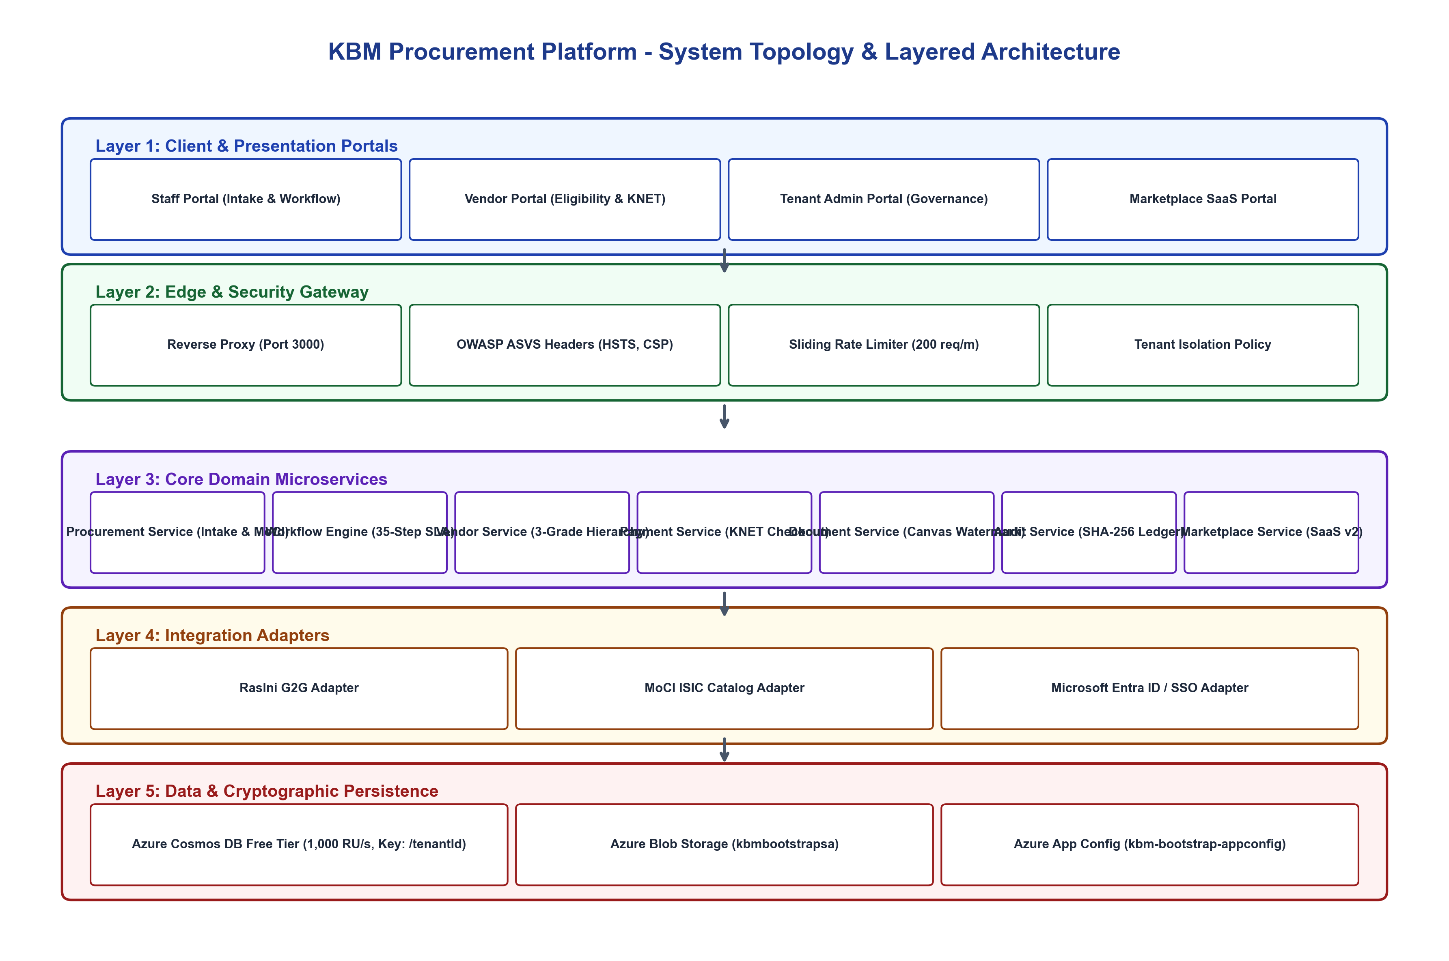
Figure 1: KBM End-to-End System Topology & Layered Architecture

5. Statutory Tender Lifecycle & Regulatory Approval Pipeline
The platform coordinates all 5 statutory phases of Kuwait public tendering, tracking legal oversight bodies, SLA thresholds, and mandatory approvals:
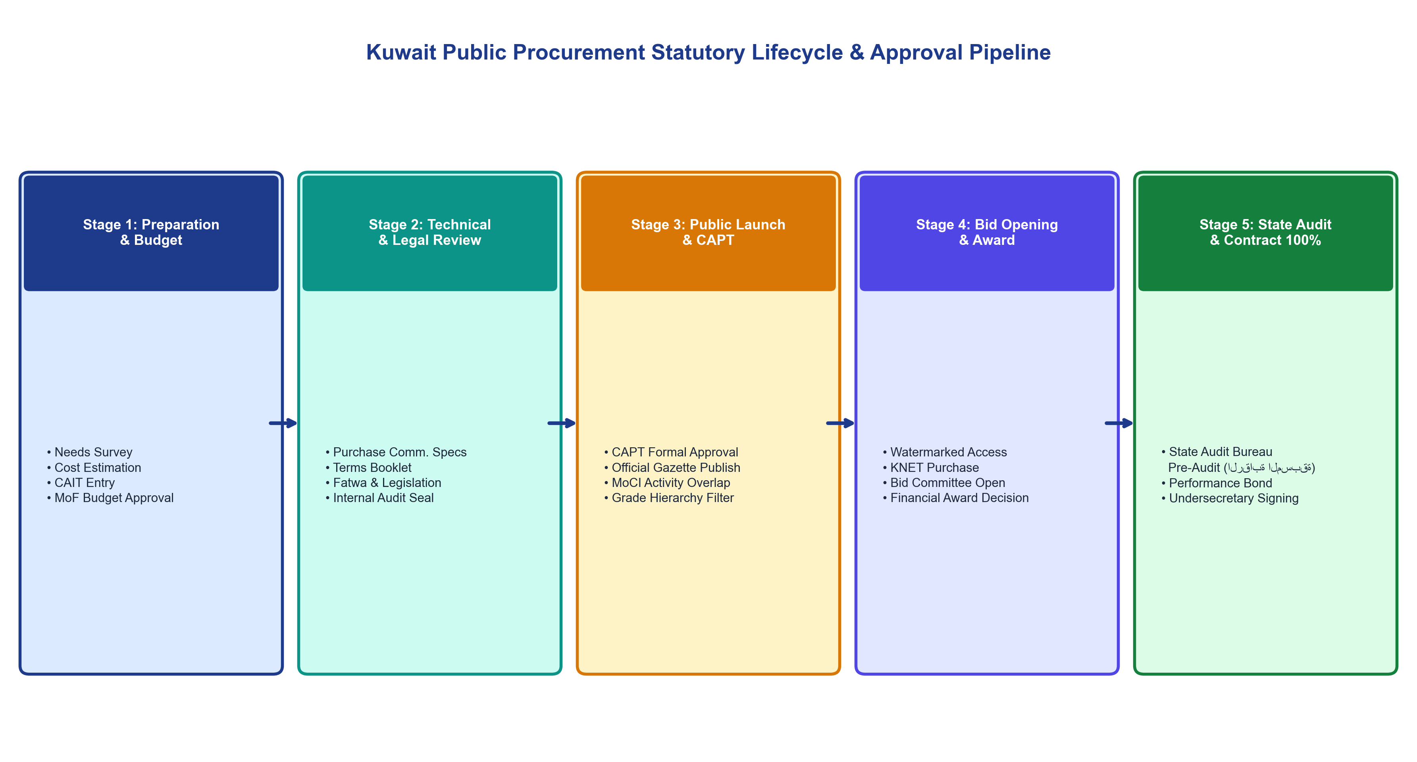
Figure 2: Kuwait Public Procurement Statutory Lifecycle & Approval Pipeline

6. Multi-Tenant Data Isolation & Cryptographic Security Model
Security is enforced through multi-layered defensive controls, including BOLA/IDOR prevention in tenant-policy.js, dynamic anti-screenshot canvas watermarking, and Cosmos DB SHA-256 cryptographic audit chaining:
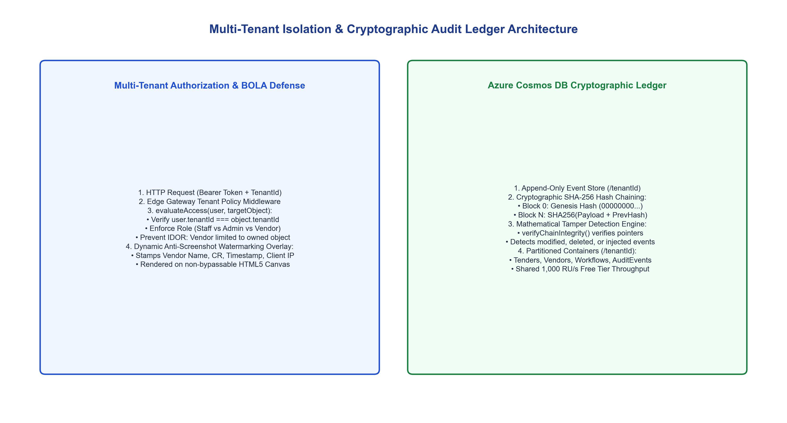
Figure 3: Multi-Tenant Data Isolation & Cryptographic Audit Ledger Architecture

7. Microsoft Azure Cloud Deployment & CI/CD Pipeline
The platform is live on Microsoft Azure using Azure App Service and Azure Cosmos DB Free Tier, backed by automated GitHub Actions CI/CD workflows:
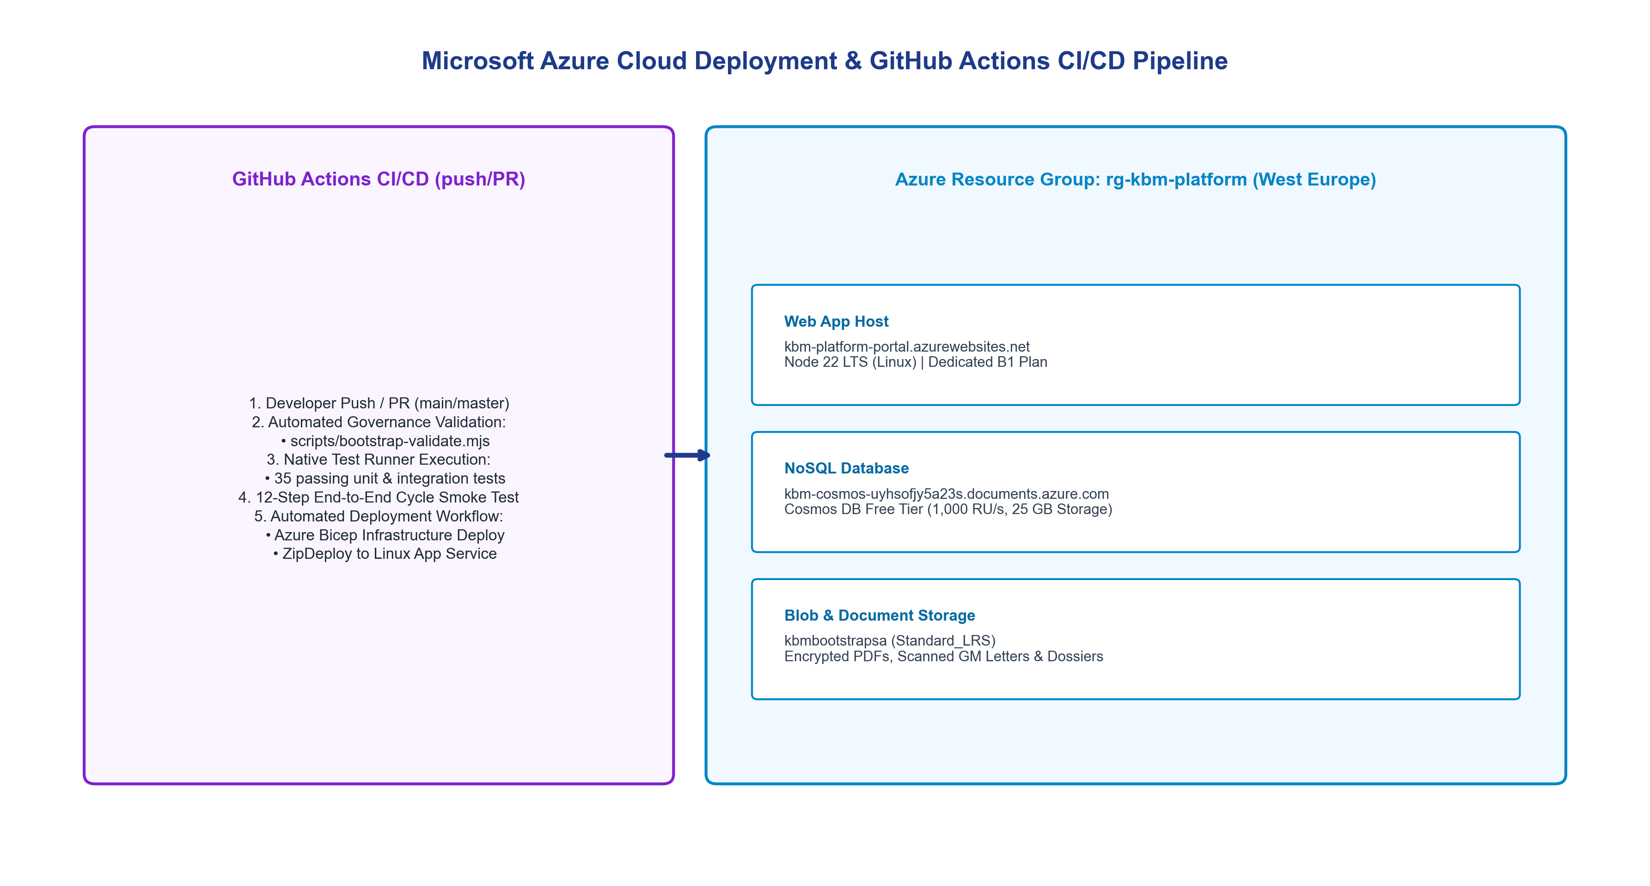
Figure 4: Microsoft Azure Cloud Infrastructure & GitHub Actions CI/CD Pipeline

📌 Live Azure Deployment Verification
• Portal URL: https://kbm-platform-portal.azurewebsites.net
• Health Endpoint: https://kbm-platform-portal.azurewebsites.net/health
• Cosmos DB Endpoint: https://kbm-cosmos-uyhsofjy5a23s.documents.azure.com:443/
• Cosmos DB Database: kbm-procurement-db (Shared 1,000 RU/s Free Tier)
• GitHub Repository: https://github.com/6439144/kbm-tendering (CI: 100% Passing - 35 Tests)

8. Architectural Governance & Sign-Off Sheet
Governance Role | Name / Title | Organization / Entity | Sign-Off Status | Date
Lead Solution Architect | Khaled Ibrahim Abed | KBM Platform Engineering | Approved (Baseline v1.0) | August 2026
Application Security Lead | Security Auditor Agent | AppSec & Cryptography Group | Approved (OWASP ASVS A) | August 2026
Procurement Domain Specialist | Tender Committee Representative | Ministry Procurement Affairs | Ratified (Law 49/2016 Compliant) | August 2026
Cloud DevOps Engineer | Azure Infrastructure Team | Cloud Operations & FinOps | Approved (Azure Free Tier Validated) | August 2026

