COMS W4903: Machine Learning for Data Science

Homework 4

jc4609

1.

a).

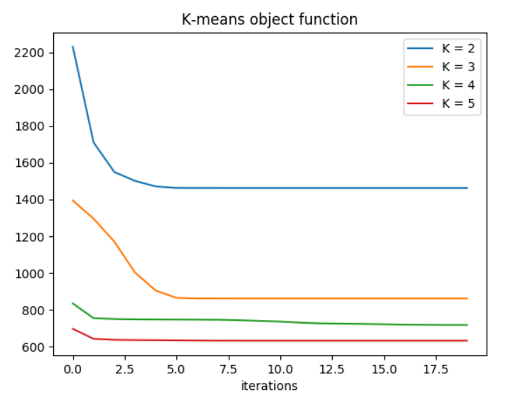

b).

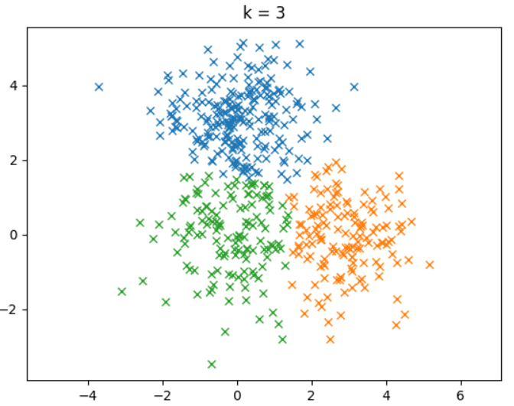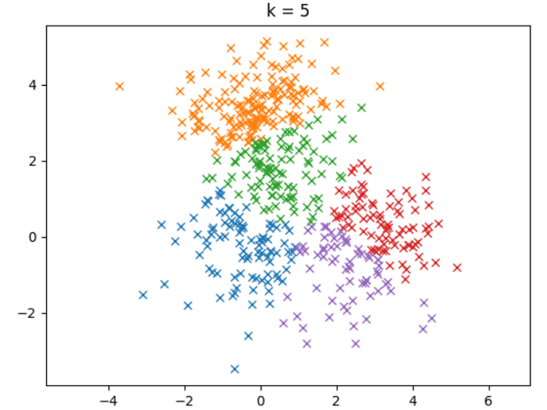

2.

a).

objective value RMSE

[[ -9.09233067e+04 1.08149261e+00]

[ -9.09645468e+04 1.11108698e+00]

[ -9.09794822e+04 1.09597505e+00]

[ -9.09852177e+04 1.11245291e+00]

[ -9.10825776e+04 1.10229931e+00]

[ -9.10842867e+04 1.12442738e+00]

[ -9.11341702e+04 1.09863701e+00]

[ -9.11675335e+04 1.15922809e+00]

[ -9.13103879e+04 1.12415439e+00]

[ -9.14192655e+04 1.11960750e+00]]

b).

Star Wars:

|  |  |
| --- | --- |
| Movie name | Distance |
| Empire Strikes Back, The (1980) | 0.08023623 |
| Return of the Jedi (1983) | 0.36698259 |
| Raiders of the Lost Ark (1981) | 0.37362356 |
| Princess Bride, The (1987) | 0.67948257 |
| Blues Brothers, The (1980) | 0.72254196 |
| Indiana Jones and the Last Crusade (1989) | 0.84997649 |
| Leading Man, The (1996) | 0.87601577 |
| Fish Called Wanda, A (1988) | 0.93956176 |
| Gandhi (1982) | 1.00621683 |
| Back to the Future (1985) | 1.00815685 |

My Fair Lady:

|  |  |
| --- | --- |
| Movie name | Distance |
| Mary Poppins (1964) | 0.60856493 |
| Sabrina (1954) | 0.61733097 |
| Cinderella (1950) | 0.75279217 |
| SubUrbia (1997) | 0.89672923 |
| Return of Martin Guerre, The (Retour de Martin Guerre, Le) (1982) | 0.91152718 |
| Sound of Music, The (1965) | 0.98645379 |
| Snow White and the Seven Dwarfs (1937) | 1.0126714 |
| Emma (1996) | 1.03246604 |
| Babe (1995) | 1.06123973 |
| Jungle Book, The (1994) | 1.08572685 |

Goodfellas:

|  |  |
| --- | --- |
| Movie name | Distance |
| Once Upon a Time in the West (1969) | 0.15551964 |
| Casino (1995) | 0.29174291 |
| Full Metal Jacket (1987) | 0.45282384 |
| Shining, The (1980) | 0.53413304 |
| Donnie Brasco (1997) | 0.62710969 |
| Body Snatcher, The (1945) | 0.64848554 |
| Raising Arizona (1987) | 0.6648835 |
| 'Cool Hand Luke (1967) | 0.69473626 |
| Bonnie and Clyde (1967) | 0.73234339 |
| Apocalypse Now (1979) | 0.74259553 |