
■ INTERNAL TEAM GUIDE
ScopeIQ: Telecom Scoping Explained for the Build Team
What Ericsson does today, what every telecom term means, and exactly what we are building to automate it
Audience: Innosquares developers, data engineers, QA and analysts (no telecom background assumed)
Program: Ericsson pre-construction scoping RFP, carrier 5G builds, United States
Classification: Internal. Do not share outside Innosquares.
Version: 1.0, September 2026

1. Read this first
Ericsson builds and upgrades cell sites for US carriers such as T-Mobile and AT&T. Before a construction crew can climb a tower, someone has to read a stack of engineering documents, work out exactly what equipment is being added, removed or moved, and produce a precise bill of materials (BOM) and scope of work. That desk work is called scoping. Today it is done by people with spreadsheets.
We are building ScopeIQ, a Snowflake-based platform that reads those documents once, works out the changes, and generates the BOM, service drivers, cost and timeline automatically. Our scoping team then reviews and approves the output. We are paid per site when Ericsson gives Final BOM Approval (FBA).
The three rules that matter most. (1) We never change the engineering design; we only read it, check it and flag problems. (2) Every number we output must trace back to a page in a source document. (3) Nothing goes to Ericsson without a named person approving it.

How this guide is organized
- Sections 2 to 5 teach the telecom world: the site, the people, the documents and today's process.
- Sections 6 to 10 describe what we build: the pipeline, a worked example, the architecture, the data model and the rules engine.
- Sections 11 to 13 cover quality, the sprint plan and the guardrails every engineer must follow.
- Section 14 is a glossary of every acronym you will meet. Keep it open while you work.

2. The business in one page
Ericsson is the prime contractor: the carrier pays Ericsson to deliver finished, working sites. Ericsson hires specialist suppliers for each part of the job. This RFP is for the scoping part. It has three separately priced services, each billed per site:
Stream | What the customer gets | When we are paid
Site Design Scoping | Design documents checked and redlined, discrepancies logged, site-specific design (SSD) package submitted | Per site, at completion
Site Build BOM Scoping | A validated, approved bill of materials (REV 1 to FBA) and scope of work agreed with the construction crew | At Final BOM Approval (FBA)
Network Deployment Scoping | Final equipment changes, construction service drivers, crane and safety needs, cycle-time estimate, quote | Per site, at quote processing

We bid two ways. I1 is services plus platform: our India-based scoping team does the work using ScopeIQ. I2 is platform only: Ericsson's own people use ScopeIQ. The same software serves both.
Ericsson's own pricing assumptions tell us where the pain is: about 70% of sites need redlining (the documents disagree), about 40% of sites need rework (something changes after approval), and rework caused by our own mistakes is free. Automation that gets things right the first time is how we make money.

3. Telecom primer: what is on a cell site
A macro cell site is a tall structure (tower, pole or rooftop) carrying radio antennas that provide mobile coverage over several kilometers. A 5G upgrade usually means adding or swapping antennas and radios on an existing site, not building a new tower.
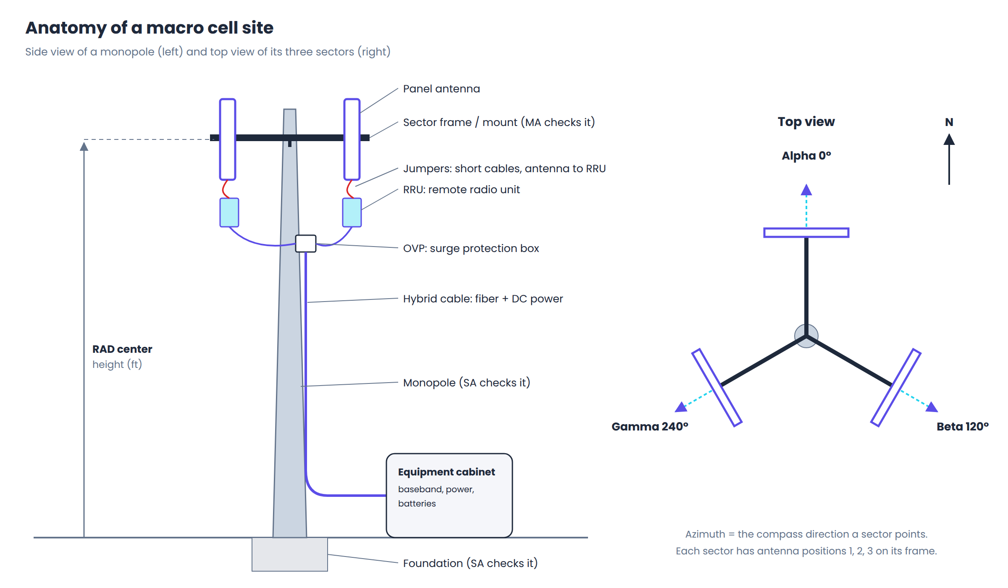
Figure 1. Parts of a monopole cell site and the three-sector layout

3.1 The physical parts
Part | What it is | Why we care
Structure | The thing holding everything up: monopole (single steel pole), self-support (lattice tower on three or four legs), guyed (thin mast held by cables) or rooftop. | Structure type and height drive crane needs, structural checks and cost.
Sector | A slice of the circle the site covers. Most sites have three sectors, named Alpha, Beta, Gamma (or A, B, C). | Equipment is always listed per sector. Our data model is keyed by sector.
Azimuth | The compass direction a sector's antennas point, in degrees from north (0°, 120°, 240° is typical). | A mismatch in azimuth between documents is a discrepancy we must flag.
Position | A mounting slot on a sector's frame (Position 1, 2, 3...). | We compare existing versus proposed equipment position by position.
Panel antenna | The flat rectangular box that sends and receives the radio signal. Has a model number, size, weight and number of ports. | Main BOM item. Adding one changes weight and wind load on the tower.
RAD center | Radiation center: the height above ground of the middle of the antenna, in feet. | Must match across RFDS and CD; used for cable lengths and structural checks.
RRU / RRH | Remote Radio Unit (or Head): the radio electronics, mounted near the antennas. | Main BOM item; each needs power, fiber and jumpers.
Jumpers | Short cables connecting antenna ports to RRU ports. | Quantity depends on port counts; a classic kitting rule.
Hybrid cable | A trunk cable running up the structure carrying both fiber (data) and DC power to the RRUs. | Length comes from the drawings. We must never guess it.
OVP | Over-voltage protection box: surge and lightning protection where the hybrid cable splits to RRUs. | BOM item triggered by new power runs.
Mount / sector frame | The steel frame (T-arm, platform, sector frame) holding antennas to the structure. | Checked by the Mount Analysis; may need a modification.
Equipment cabinet | Ground-level cabinet with baseband (the site's computer), rectifiers and batteries. | Sometimes changes in a 5G upgrade; in the BOM when it does.
Grounding | Copper bonding that protects equipment from lightning. | Small BOM items that are easy to miss.

3.2 The work on site
Construction crews (the CX SP) climb the structure or use a lift to install, remove or relocate equipment. Heavy or high work needs a crane or man-lift. Lifting anything on a tower follows a formal rigging plan under the ANSI/TIA-322 standard. Safety issues go to Ericsson's EH&S (environment, health and safety) managers. All of this is priced through service drivers, the construction equivalent of line items.

4. Who's who
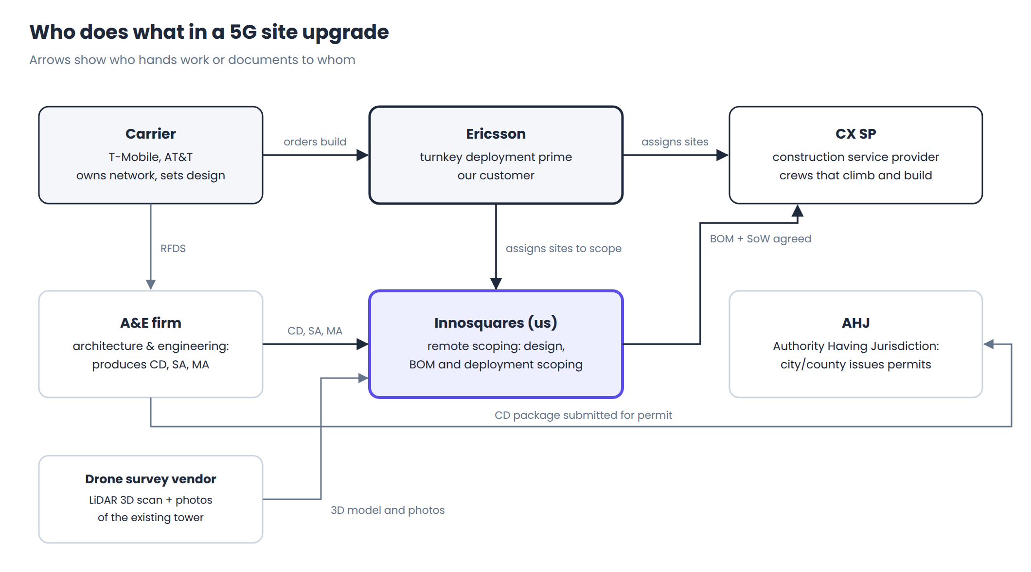
Figure 2. The parties involved in a site upgrade
Party | Role | What they give or take from us
Carrier (T-Mobile, AT&T) | Owns the network and decides the radio design. | Their build standards become our rule sets. We never talk to them directly unless Ericsson authorizes it.
Ericsson | Prime contractor and our customer. | Assigns sites, provides documents and tools access, approves BOMs (FBA) and pays us.
A&E firm | Architecture and engineering firm that produces CDs, SA and MA. | Receives our redlines and issues new document revisions.
CX SP | Construction service provider: the crews who build. | Agrees the BOM and scope with us in the handshake; sends a quote.
AHJ | Authority Having Jurisdiction: the city or county permit office. | Receives the CD package for permits. Not our direct contact.
Drone survey vendor | Flies a drone with LiDAR to capture the tower in 3D with photos. | Provides the as-built reality we compare against.

5. The documents
Everything we do starts from documents. Engineering flows in a fixed order: RFDS (design intent) → Structural and Mount Analysis (feasibility and safety) → Construction Drawings (final blueprint). The drone survey tells us what is really on the tower today.
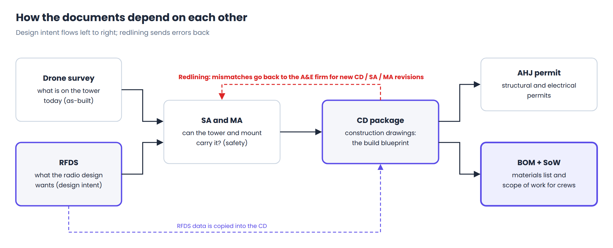
Figure 3. How the documents depend on each other
Document | What it contains | What we extract | Typical format
RFDS  Radio Frequency Data Sheet | Antenna radiation and spatial parameters (models, azimuths, tilts, RAD centers per sector and position) and the plumbing and hardware layout (RRUs, cables, connections). Comes as preliminary, then final. | Proposed configuration per sector and position; radios; cable types; revision number and date. | Spreadsheet or PDF export
Drone survey | LiDAR 3D point cloud of the existing tower with stitched photos, plus a vendor report. | Existing equipment, positions, heights, mount type. We ingest the vendor's measurements and report, not the raw point cloud. | PDF report, CSV measurements, images
SA  Structural Analysis | Whether the whole structure and its foundation can carry the new load (weight and wind). | Pass or fail, the RFDS revision it was run on, the equipment loading it assumed. | PDF
MA  Mount Analysis | Whether the specific mount holding the antennas can carry them; may require a mount modification. | Pass, fail or modification required; assumed loading; RFDS revision. | PDF
CD  Construction Drawings | The permit-ready blueprint package: sheets with elevations, antenna plans, equipment and cable schedules, grounding, notes. Built from the RFDS. | Existing and proposed equipment tables, cable lengths, mount modifications, sheet references. | Multi-sheet PDF
PCD | Preliminary construction drawings, used in Site Design Scoping. | Same as CD, earlier revision. | PDF
BOM REV 0 | Ericsson's preliminary bill of materials. | Material codes and quantities to validate. | Spreadsheet
SoW | Scope of work: what the crew will do, in Ericsson's scoping template. | We generate it. | Template
RFI | Request for information: a formal question when documents are missing or conflict. | We draft it; Ericsson sends it. | Template

5.1 Redlining
Redlining means marking up a document where it disagrees with another document or with reality, then sending it back to the A&E firm for a corrected revision. Field technicians look at the RFDS and the CD side by side on the tower, so they must match exactly before anyone climbs. About 70% of sites need some redlining.
Developer takeaway: documents come in revisions (rev 1, rev 2...). The same site can have several revisions of each document in flight. Our ingestion must detect the latest applicable revision, and our checks must compare the right revisions against each other.

6. Today's process, stream by stream
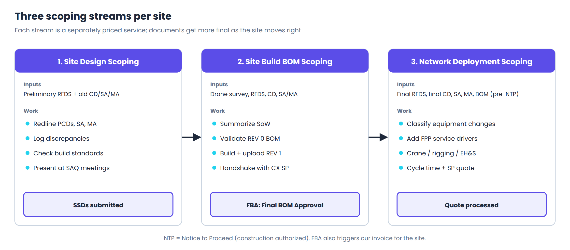
Figure 4. The three scoping streams for one site
The tables below list each activity from Ericsson's RFP and what ScopeIQ does with it. Items marked Excluded are not our job and we must not do them.

6.1 Site Design Scoping
RFP activity | Manual today | ScopeIQ
Download documentation | Pull preliminary RFDS and historical CD, MA, SA; request missing history from the Ericsson GND group | Shared-folder pickup; document registry shows what is missing
SoW summary | Populate the design scoping document; redline PCD, MA, SA; check customer build standards | Consistency checks and carrier rule sets produce the redline list
Redlining | Mark up CDs, RFDS, MA, SA; document issues; return to A&E | Discrepancy log and redline pack generated; scoper confirms
SoW submission | Submit SSDs to tool of record and SharePoint | SSD package exported in Ericsson's format
Tool of record update | Update status, forecast and actual dates, notes | Status and dates exported automatically
Excluded | RFDS promotion or demotion; ordering drone surveys | Not built

6.2 Site Build BOM Scoping
RFP activity | Manual today | ScopeIQ
Download documentation | Pull drone survey, RFDS, CDs, MA/SA | Shared-folder pickup and extraction
SoW summary | Summarize scope in the scoping template | Generated from the equipment delta
Create BOM | Validate REV 0; create REV 1; upload to Ericsson tool | REV 0 compared line by line; REV 1 generated by kitting rules; upload file exported
SoW and BOM submission / CX SP handshake | Meetings with the SP to agree the BOM | SP comments captured as change requests on a new revision
BOM approval | Final approval in the tool of record | Locked FBA revision; export
Excluded | Creating REV 0; cost negotiations; building SP assignments | Not built

6.3 Network Deployment Scoping
RFP activity | Manual today | ScopeIQ
Documentation review and validation | Identify existing vs proposed configuration; classify each item; cross-check; raise RFIs; pick the latest revisions | Equipment delta engine; consistency rules; RFI drafts; revision selection
Add FPP service drivers | Build the scope; add service drivers | Driver rules map each change to driver codes and quantities
Requirements identification (DPP) | Crane or man-lift, rigging, third-party services, safety issues | Site requirement rules; EH&S alerts
Time estimate | Fill the cycle-time calculator template | Cycle-time model; template exported
SP quote negotiation and submission | Desktop review with SPs; process quote | Quote pack and variance check against driver-based estimate
Excluded | RF or design changes; assuming cable lengths without documentation; approving discrepancies | Never automated; flagged for humans

7. How ScopeIQ automates it
The platform runs the same nine-step pipeline for every site. Steps 1 to 6 are automated. Steps 7 to 9 are human decision gates.
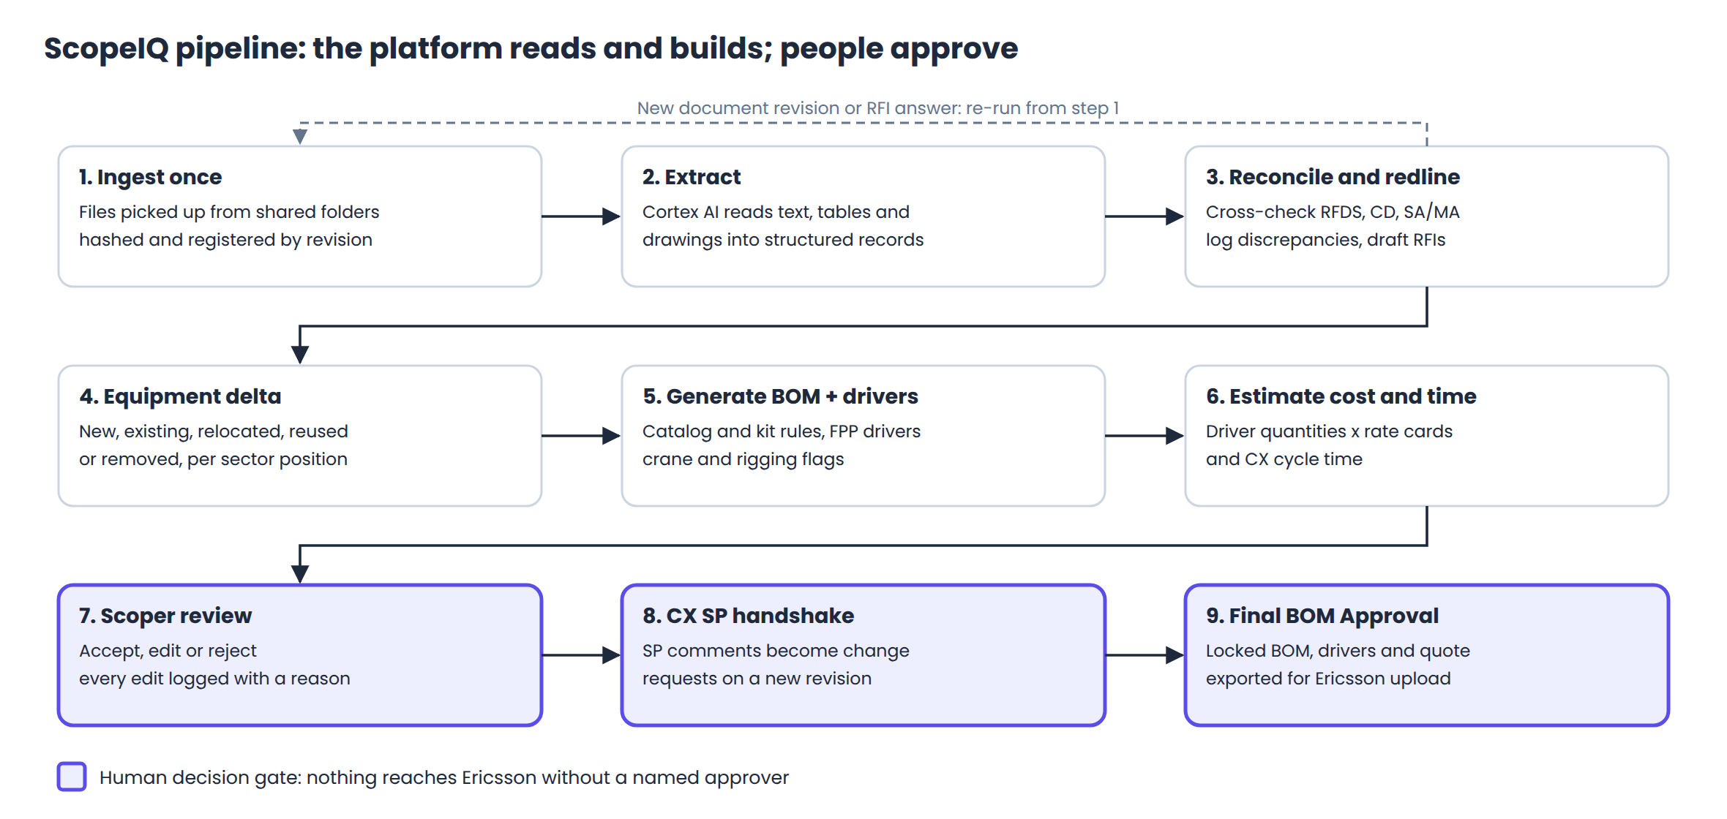
Figure 5. The ScopeIQ pipeline
Step | Input | Logic | Output | Watch out for
1. Ingest | Files in the agreed shared folder | Sync to a Snowflake stage; Snowpipe registers each file; hash for duplicates; parse site ID, document type and revision from name and content | DOCUMENT rows | Bad file names; duplicate uploads; superseded revisions
2. Extract | PDF, spreadsheet, image | AI_PARSE_DOCUMENT for layout and tables; AI_EXTRACT with a schema per document type; confidence per field | EXTRACTED_FIELD rows | Scanned drawings; per-A&E layouts; values below the confidence threshold go to review
3. Reconcile | Extracted fields for all documents of a site | Consistency rules (Section 10) | DISCREPANCY rows, redline list, RFI drafts | Comparing the wrong revisions
4. Delta | Existing config (CD, drone) and proposed config (RFDS) | Match by sector, position and model | EQUIPMENT_DELTA rows | Relocations look like a removal plus an addition
5. Generate | Delta rows and reference tables | Kitting, cable, driver and requirement rules | BOM_LINE, DRIVER_LINE, site requirements | Missing cable lengths must raise a discrepancy
6. Estimate | Driver lines, rate cards, history | Quantity times rate; cycle-time model | Estimate rows | Rate card by market and SP
7. Review | Everything above | Scoper accepts, edits or rejects in Streamlit | Approved revision | Every edit needs a reason code
8. Handshake | Approved revision | SP comments become change requests | New revision | Keep the SP's words in the audit trail
9. FBA | Final revision | Lock; export upload file and status | Locked FBA revision | An FBA revision can never be edited

8. Worked example
Here is one sector of one fictional site, from documents to BOM. All model names are made up.
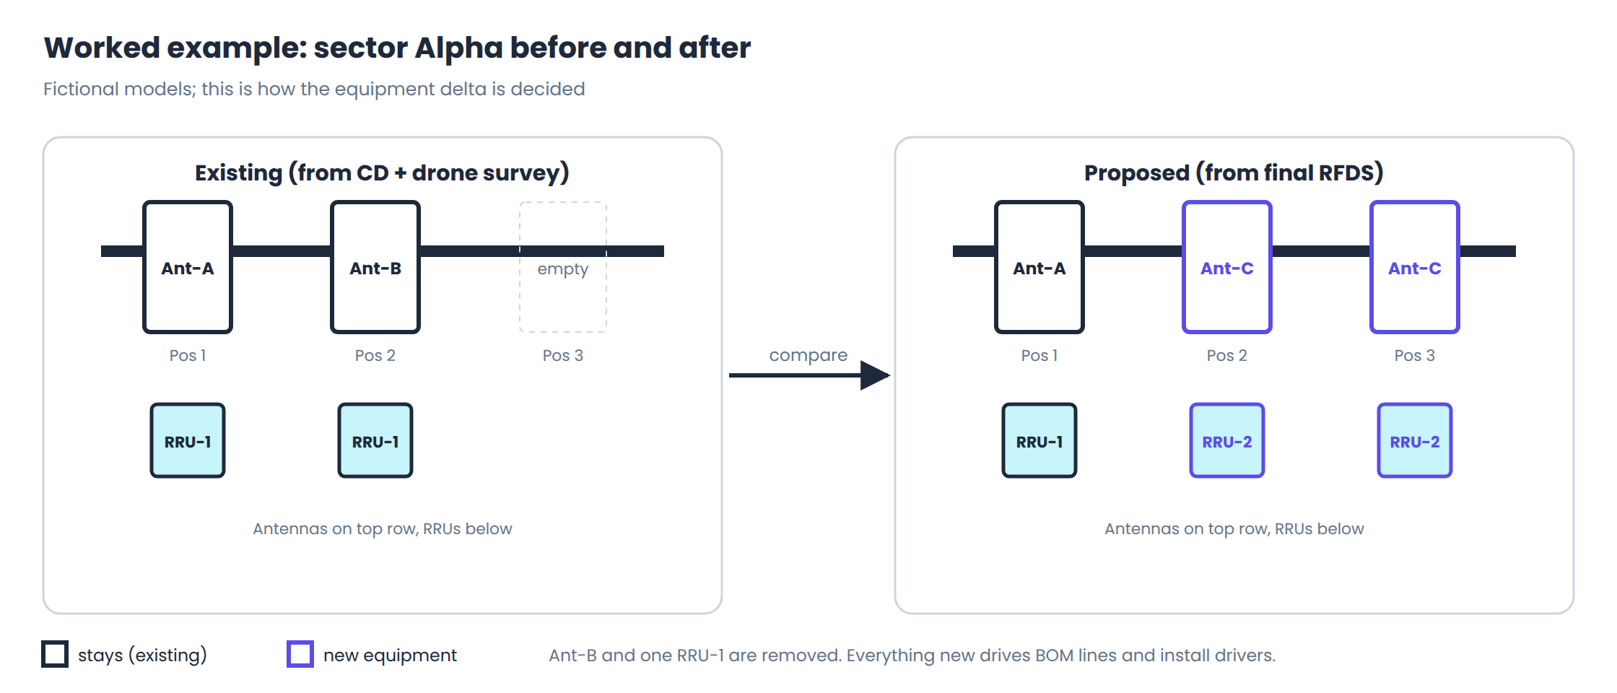
Figure 6. Sector Alpha before and after the upgrade

Step 4: the equipment delta
Sector | Pos | Existing (CD, drone) | Proposed (final RFDS) | Action
Alpha | 1 | Ant-A, RRU-1 | Ant-A, RRU-1 | Existing (no work)
Alpha | 2 | Ant-B, RRU-1 | Ant-C, RRU-2 | Remove Ant-B and RRU-1; install new Ant-C and RRU-2
Alpha | 3 | empty | Ant-C, RRU-2 | New

If the RFDS had moved Ant-A from Position 1 to Position 3, the action would be relocated, not a removal plus a new install. If a removed RRU-1 were reinstalled elsewhere on the site, it would be reused. Getting these right matters because they are priced differently.

Step 5: BOM lines generated for sector Alpha
Material (fictional) | Qty | Rule | Traced to
Panel antenna Ant-C | 2 | KIT-ANT: one per new antenna | RFDS rev 3, page 4, Alpha positions 2 and 3
Mounting pipe kit | 2 | KIT-ANT: one per new antenna | Same
RF jumpers | 16 | KIT-ANT: 8 ports per Ant-C | RFDS rev 3, page 5
RRU-2 | 2 | KIT-RRU: one per new radio | RFDS rev 3, page 6
Fiber and power jumper pack | 2 | KIT-RRU | RFDS rev 3, page 6
Hybrid cable | per CD | CBL-LEN: length from CD only | CD rev 2, sheet A-3, note 4

Step 5: service drivers and requirements
Driver (illustrative) | Qty | Why
Remove antenna | 1 | Ant-B removed
Remove RRU | 1 | RRU-1 at Position 2 removed
Install antenna | 2 | Two new Ant-C
Install RRU | 2 | Two new RRU-2
Install hybrid cable, length band | 1 | New power and fiber run
Crane or climb | flag | From structure type, height and new load

Step 3: discrepancies that would stop the line
- The SA was run on RFDS rev 2, but the current RFDS is rev 3. The analysis may not cover the new load, so we flag it as stale and draft an RFI.
- The MA says the mount needs a modification, but the CD shows none. We redline the CD and warn the SP.
- The hybrid cable length for Gamma is on neither the CD nor the RFDS. We do not guess; we raise a missing-data discrepancy.

9. Architecture
Everything runs inside one Innosquares-hosted Snowflake account in a US region. Ericsson places files in agreed shared folders (SFTP or a synced SharePoint library). Direct API integration with Ericsson's systems is a later goal, not part of this program.
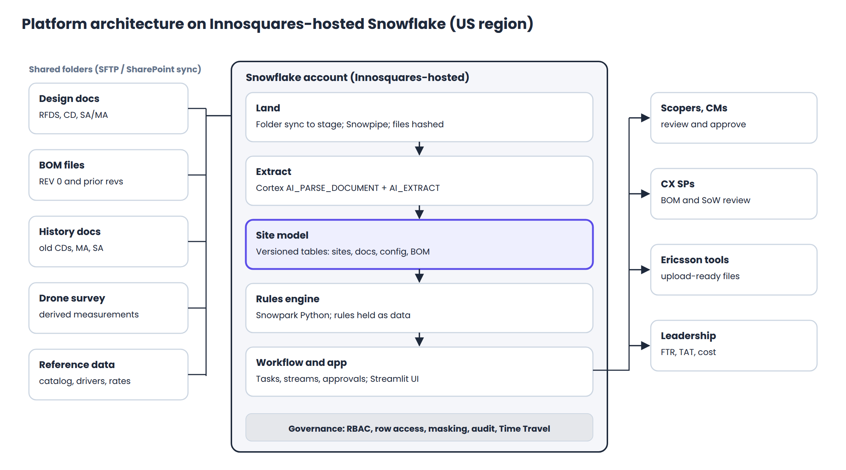
Figure 7. ScopeIQ on Snowflake
Layer | Snowflake features | What we build
Land | Internal or external stage, directory tables, Snowpipe | Folder sync job; file registry with hash, site ID, document type, revision
Extract | Cortex AI_PARSE_DOCUMENT (layout mode) and AI_EXTRACT | One extraction schema per document type and A&E template; confidence scoring; review queue
Site model | Standard tables, streams, Time Travel | The versioned tables in Section 10
Rules engine | Snowpark Python stored procedures | Rule executor that reads rule definitions from tables and writes results with the rule ID
Workflow | Tasks, streams, stored procedures | State machine per site; approval records; exports
App | Streamlit in Snowflake | Scoper workbench, SP review view, dashboards
Governance | RBAC, row access policies, masking, access history | Roles: scoper, reviewer, SP, Ericsson viewer, admin; market-level row access

Useful limits to know: AI_PARSE_DOCUMENT accepts files up to 100 MB and 2,000 pages; AI_EXTRACT handles up to 125 pages per call, so split large CD packages by sheet range.

10. Data model and rules engine
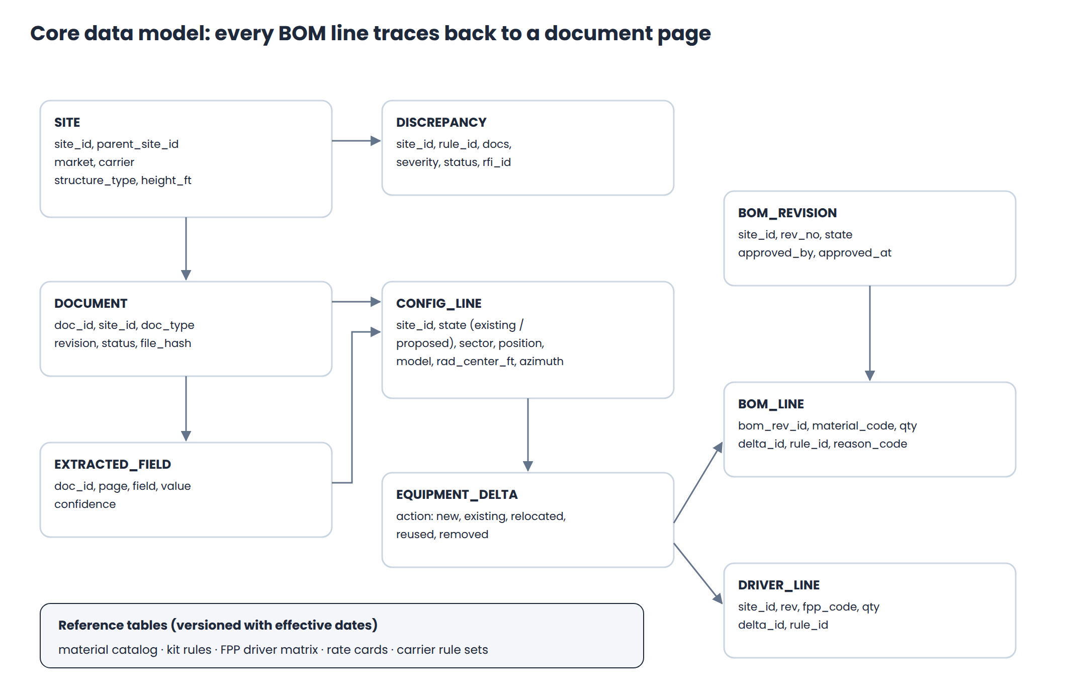
Figure 8. Core tables and how they link

10.1 Design rules for the data model
- Traceability: every BOM line and driver line stores the delta row, rule ID and source document page that produced it.
- Immutability: documents and approved revisions are never updated in place. Changes create new rows with a new revision number.
- Parent and child sites: Ericsson builds one BOM per parent site, including its child sites; standalone sites get their own BOM.
- Reference data is versioned: catalog, kit rules, driver matrix and rate cards carry effective dates, so a site is always costed on the rules in force when it was scoped.

10.2 Rules as data
Rules live in tables, not in code, so analysts can change a carrier's build standard without a release. The Snowpark executor reads the active rules and applies them.
Rule family | Example | Result
Revision currency | SA or MA references an RFDS revision older than the current one | Stale-analysis discrepancy and RFI draft
Loading match | Antenna or RRU count or model in SA/MA loading differs from proposed RFDS | Discrepancy and SA/MA redline
Mount result | MA requires a modification that the CD does not show | CD redline and SP flag
RFDS vs CD | Model, RAD center, azimuth, count, RRUs or cables differ | Redline items by sheet and sector
Delta | Match existing to proposed by sector, position, model | New, existing, relocated, reused, removed
Kitting | Each new antenna or radio pulls its catalog kit | BOM lines
Cable | Lengths only from documented values | BOM line or missing-length discrepancy
Service driver | Each delta action maps to an FPP driver code by equipment class | Driver lines
Site requirement | Structure type, height and load decide climb, man-lift or crane, and the rigging class | Requirement flags; EH&S alerts

Split of responsibilities: AI reads (extraction, and matching labels written differently by different A&E firms). Deterministic rules decide (delta, BOM, drivers, requirements). That keeps outputs repeatable and auditable.

10.3 BOM revision lifecycle
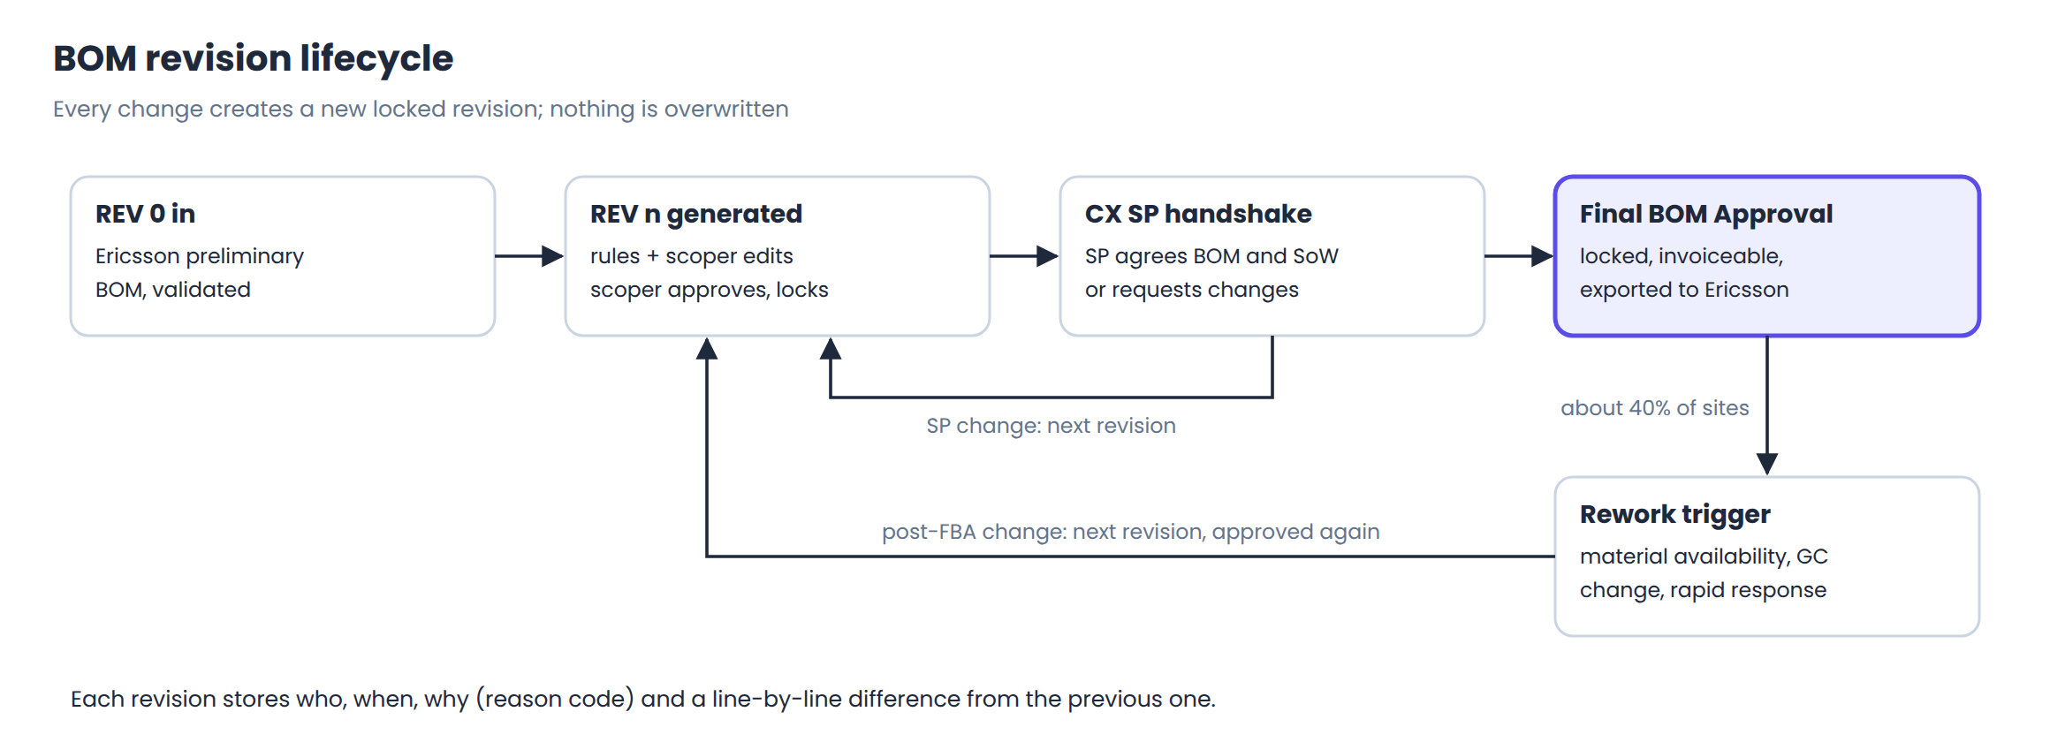
Figure 9. States a BOM moves through

11. Quality and how we are measured
Measure | Definition | How the platform supports it
First Time Right (FTR) | Share of sites approved without rework caused by us; Ericsson samples it monthly | Traceability, consistency rules and reason codes show whose error caused a change
Turnaround time (TAT) | Time from site assignment to scoping complete and FBA | State changes are time-stamped automatically
Extraction accuracy | Share of fields read correctly, by document type and template | Measured against a gold set of scoped sites
BOM match rate | Share of generated lines that match an expert's BOM | The G2 gate at the end of the pilot

Testing approach
- Build a gold set of 50 closed sites in Discovery: documents plus the BOM and drivers experts actually approved.
- Every rule change runs against the gold set in CI; a drop in match rate blocks the release.
- In the pilot, run in shadow mode: the platform scopes the same sites as the manual team and we compare.

12. Sprint plan
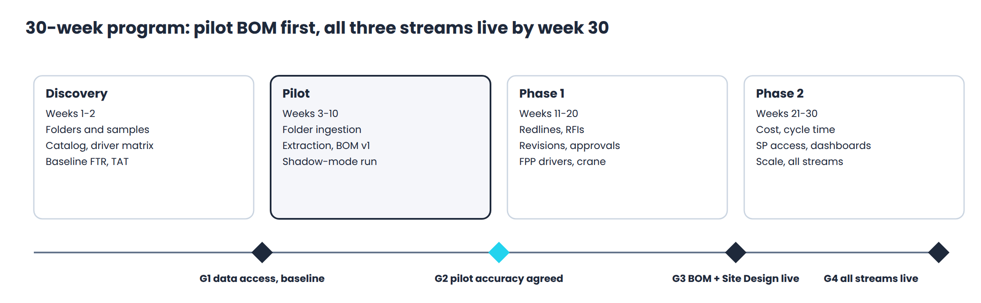
Figure 10. Program phases and gates
Sprint | Weeks | Goal | Exit criteria
S0 | 1-2 | Confirm scope, data and baseline; hosted account provisioned | G1: data access and baseline signed off
S1 | 3-4 | Shared-folder ingestion and document registry | New files register within 15 minutes
S2 | 5-6 | Extraction v1 for RFDS and CD | Accuracy measured on sample sites
S3 | 7-8 | Equipment delta, kitting rules, REV 1 BOM, review screen | REV 1 end to end on sample sites
S4 | 9-10 | Shadow-mode pilot and accuracy report | G2: pilot accuracy threshold met
S5 | 11-12 | Consistency engine | Rules validated on pilot sites
S6 | 13-14 | Redlines, RFIs, SA/MA extraction, Site Design stream | Site Design stream end to end
S7 | 15-16 | Revision ledger, approvals, audit trail | REV 0 to FBA demonstrated
S8 | 17-18 | Service drivers, crane and rigging, EH&S flags | Drivers match manual on test sites
S9 | 19-20 | Harden; go live for BOM and Site Design streams | G3: streams 1 and 2 live
S10 | 21-22 | Cost estimator and rate cards | Estimates reconcile to sample quotes
S11 | 23-24 | Cycle-time model; Deployment stream quote pack | Deployment stream end to end
S12 | 25-26 | SP review access and quote variance check | Handshake done in platform
S13 | 27-28 | Dashboards; carrier rule sets; second market | Second market configured
S14 | 29-30 | Load test, security review, runbooks, hypercare | G4: all three streams live

13. Guardrails for every engineer
- Never change the design. RF engineering, design changes and approval of discrepancies are excluded from our scope. We flag; humans decide.
- Never assume a value. If a cable length, weight or model is not in a document, the output is a discrepancy, not a default.
- Carrier data stays in the US region. Offshore access is through virtual desktops and row access policies only. No site data on laptops, in email or in chat tools.
- Cite the source. Every generated row carries its source document, page and rule ID.
- Respect revisions. Always resolve the latest applicable revision, and record which revision each check used.
- Log every human edit with who, when and a reason code. Rework caused by our errors is free, so the audit trail protects our margin.

14. Glossary
Terms marked (confirm) are Ericsson-internal; their exact meaning will be confirmed in Discovery.
Term | Meaning
A&E | Architecture and engineering firm that prepares CDs, SA and MA
AHJ | Authority Having Jurisdiction: local permit office
Azimuth | Compass direction a sector points, degrees from north
BOM | Bill of materials: every item and quantity needed to build
CD / PCD | Construction drawings / preliminary construction drawings
CM / PM | Construction manager / project manager
CX | Construction
CX SP | Construction service provider: the crews who build
Cycle time | Expected construction duration for a site
DPP | Ericsson's requirements-identification step (crane, rigging, third-party, safety) (confirm)
Drone survey | LiDAR 3D point cloud of the existing tower with stitched photos
EH&S | Environment, health and safety
FBA | Final BOM Approval; triggers our invoice
FPP | Ericsson's service-driver framework for construction pricing (confirm)
FTR | First Time Right
GC | General contractor
GND group | Ericsson group that holds historical site documents (confirm)
Hybrid cable | Trunk cable carrying fiber and DC power up the structure
IWM, ESR, United Script | Ericsson internal tools named in the RFP (confirm)
LiDAR | Laser scanning that measures distances to build a 3D model
MA | Mount Analysis: can the mount carry the antennas
Man-lift | Mobile elevated work platform
NTP | Notice to Proceed: construction is authorized
OVP | Over-voltage protection box
RAD center | Height of an antenna's radiation center above ground
Redline | Marked-up correction sent back to the document owner
REV 0 / REV 1 / REV n | BOM revisions: preliminary, first scoped, later changes
RFDS | Radio Frequency Data Sheet: the radio design intent
RFI | Request for information
Rigging | Planned lifting of equipment on a structure (ANSI/TIA-322)
RRU / RRH | Remote radio unit / head
SA | Structural Analysis: can the whole structure and foundation carry the load
SAQ | Site acquisition (the team that secures rights to use the site)
Sector | Slice of coverage, usually Alpha, Beta, Gamma
Site Tracker | Project management system used as a tool of record
SoW | Scope of work
SSD | Site-specific design package submitted in Site Design Scoping (confirm)
TAT | Turnaround time
Tool / database of record | Ericsson's system holding the official site status and documents

