**Incident/Hazard Report Form**

|  |  |  |  |  |
| --- | --- | --- | --- | --- |
| **Date** | **17/10/2017** | | **Time** | **3:30 PM** |
| **Name** | **David Park** | | **Sex** | **Female** |
| **Staff  Contractor  Volunteer  General Public** | | | | |
| **Department/**  **Company Name** | Sales&Marketing | Administration | **Location** | **On the stairway of 3rd floor** |
| Executive | Operations |
| Dispatch | Logistics |
| Or ( ) | |
| **Incident/hazard**  **Type** | Accident  Injury  Assault  Machine fault  Mechanical failure | | **Persons involved** | **None** |
| **Description**  **of**  **Incident/hazard** | He fell off from the stairway | | | |
| **Witnesses** | Sid | | **Injury**  **Type** | Minor  Superficial  Moderate  Serious |
| **Description**  **of**  **Injuries** | Fortunately, he’s okay aside from little pain on the back. | | | |
| **Description**  **of**  **Actions taken** | He was sent to a chiropractor soon after he’d fell off by Sid. | | | |

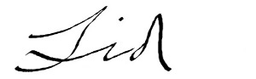

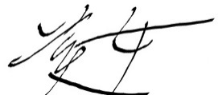 **Submitted by Sid**

**Approved by Beauty**