# Assessment 4: Case study: Part B: Conference plan

# **Conference plan instructions...**

## **Scope**

**Inclusions**

1. We focus on introducing the difference of our coffee machine from others in the current market.
2. Promoting brand awareness to people related in coffee industry in Sydney.
3. Boost sales with promotional price.

**Exclusions**

1. Don’t worry about facilities, equipment, and all things needed for conference. The venue will provide them by their own.
2. Don’t need to prepare security staff and the cases of emergency patient. The Shangri-la hotel has their own system and staff for them.
3. Don’t need to prepare anything for dinner. The hotel will provide dinner buffet for our clients.

#### Reporting

#### Constraints

Cost : upto $25,000

Attendees : upto 60 people (the function hall’s capacity is for 100 pax)

Legislation : a duty of care to the health and safety of your staff, customers and the general public as per the [Work Health and Safety Act 2011](https://www.legislation.qld.gov.au/LEGISLTN/CURRENT/W/WorkHSA11.pdf).

* Health, safety and environment issues include [workers' compensation](https://www.business.qld.gov.au/running-business/employing/workers-comp), [food handling and safety](https://www.business.qld.gov.au/industries/hospitality-tourism-sport/food/food-beverage/regulations), safety related to construction sites, ergonomic requirements and security issues.

#### Venue

**Location**

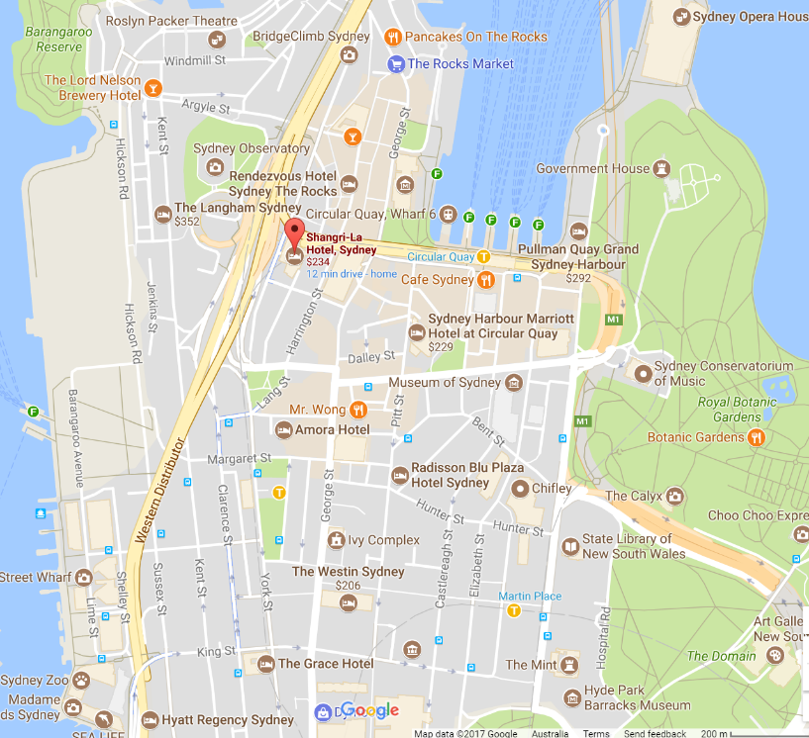

**By foot from the Wynyard Station**

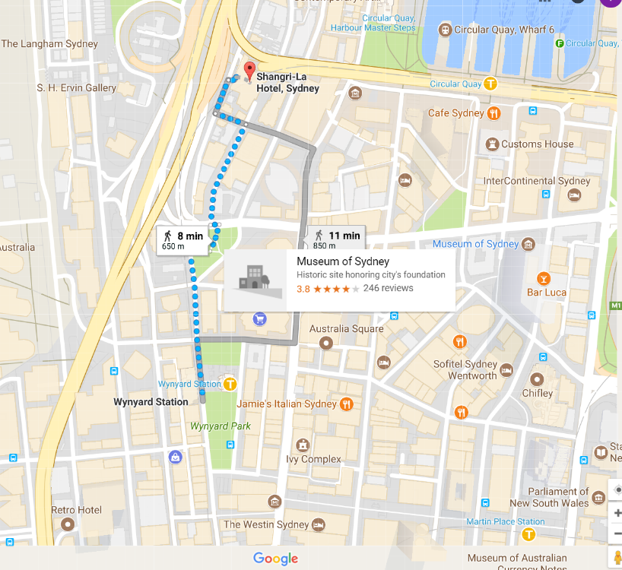

#### Program and purpose

|  |  |  |
| --- | --- | --- |
| **Program** | **Responsibility** | **Time (PM)** |
| Opening speech | Hired comedian | 3:00 – 3:20 |
| Product introduction | Hired comedian/Marketing staff | 3:20 – 4:00 |
| Demonstration how to use good coffee with the machine | World Barista Championship Winner | 4:00 – 4:30 |
| Distribute free sample | Hired staff/Marketing staff | 4:30 – 4:45 |
| Tea break | Hired staff/Marketing staff | 4:45 – 5:30 |
| Question period | Marketing staff | 5:30 – 6:00 |
| Closing speech | Comedian/Marketing boss | 6:00 – 6:20 |
| Dinner time | Hired staff/Hotel staff | 6:20 – 7:20 |

#### Timeline

#### Speakers

Standing comedian who lives around Sydney will be hired. We don’t want him/her to have prevalent knowledge of coffee since we will give him a script to promote our product and will hire a special expert as well. We want a comedian to make conference energetic, and be in good mood. Budget for them is estimated as $10,000 based on 6 times events.

#### Target Audience

The owners and managers of retail coffee shops around Sydney.

#### Budget

|  |  |  |
| --- | --- | --- |
| Item | Description/purpose | Cost |
| Income | *Entry fee* | $20,000 |
|  | Sponsors | $10,000 |
| Expenses | | |
|  | *Marketing cost(inc. Advertisement, some events)* | $8,000 |
|  | *The rental fee for the venue including dinner buffet, facilities, equipment, and all others for the conference* | $15,000 |
|  | Hiring a speaker, the winner of the World Barista Championship | $10,000 |
|  | *Hiring temporary staff* | $2,000 |
|  | *Printing brochures/flyers* | $600 |
|  | *Reserve fund* | $6,000 |
| **Total expenses** | | $41,600 |
| **Surplus/deficit** | | -$11,600 |

#### Risk management

|  |  |  |  |  |
| --- | --- | --- | --- | --- |
| Risk | Type | Mitigation | Contingency | Level(L,M,H) |
| Fire | Hazard | Ask maintenance staff for hotel check the facilities and equipment before rehearsal/Place fire extinguishers around the function hall area. | Post evacuation plans to walls of the function hall/Have staff be well-informed of evacuation plan in advance. | M |
| Cost overrun | Financial | Ensure all future expenses expected and give some extra budget in the stage of budget planning/Strictly keep the record all expenses/All expenses require approval of Marketing Boss | Reserve fund will cover unexpected expenses. If it can’t be covered, the company will | M |
| Low participation rate | Strategic | Promote the conference well to the owners/managers of retail coffee shops around Sydney, Marketing strategy will be organised by marketing staff/Get RSVP and entry fee earlier as soon as possible | Shorten contract-term with the hotel/Reduce entry fee/Turn it into free conference. | H |
| Supply issue | Operational | Check all stocks of tea and etc before rehearsal begin/Check all products’ expired date properly | Store extra stocks in case of high participation rate/Limit the amount of supply which is given to each participant. | M |
| Speaker no show | Operational | There will be high compensation in case of a breach of the contract with a speaker/one or two of our staff will be trained to be alternatives though it is not going to be perfect for our events | One staff will lead a conference in place of a speaker | L |
| Poor service of the venue | Operational | Ensure the quality of service from the venue in the stage of the contract/Ask feedback from participants by each event done/Keep monitoring the service quality/Ask one CS staff from the company | Prepare some free gifts in case of complaints (vouchers/gift card) | M |

#### Promotional strategy

1. Distribute flyers including information of the conference and the coffee machine to cafes around Sydney.
2. Hold a free coffee distribution event announcing the conference in the crowded street on the city to get attention of people.
3. Advertise there is a chance to get free machine for all participants by drawing lots.
4. Put an internet advertisement on the well-known coffee website.

**Monitoring**

1. First of all, all plans for the conference require approval of marketing boss before it’s decidedly set up.
2. General manager supervises all progress of the preparation and submit a weekly report to the marketing boss
3. Marketing manager supervises all progress of the management and the promotion before the event and submit a weekly report to the marketing boss
4. General manager keeps his eyes on the expenses record and communicate with the finance department of company to have it on track.
5. Hold a meeting fortnightly to discuss the plan and progress before event begins.

# Assessment 5: Conference problems

Respond to the following issues:

1. During registration, 30 minutes before the start of proceedings, a delegate mentions that they had forgotten to inform us of their peanut allergy. They inform us that it is a severe allergy (anaphylactic shock), and that they cannot even shake hands with someone who has touched peanuts without an immediate reaction. You must ensure that all access and equity issues are clearly addressed for all delegates and that the delegate's privacy is respected.

* Before opening speech, I will announce that there are some who have a severe peanut allergy. And ask people who ate peanuts earlier not to shake the hands of others or touch. If we have enough time to collect peanuts from our tea time snacks, collect them then give that to only people who want to have that. Since there is enough time before tea break, I think we can carry it on.

1. During registration, with 18 minutes remaining until proceedings commence, you receive an SMS from a member of your team who was scheduled to drive the main guest presenter to the conference. The presenter has slept in and will take at least 90 minutes to get ready. You must ensure that delegates are affected as little as possible and that the presenter is not embarrassed by this slip-up.

* We have alternative speaker one of our staff in case of this, he/she will take the main guest presenter’s place for around 72 minutes until the main guest presenter comes.

1. With. just 13 minutes until proceedings are to commence, you are still on the phone to the team member from the previous issue, the MC discovers that there is no VGA cable at the lectern to plug in a laptop for presenters to show their presentations, and the data projector currently available in the conference room is roof mounted

* This kind of case won’t happen since we are going to have rehearsal, but if it happened, I would try to use ‘airplay’ or ‘mirroring’. And if the projector is very old one which has no these features. I will go buy a converter VGA to HDMI or to other port the lectern has. It will not take for long, speaker will cover delayed time for it with his comedy.

1. With four minutes to go, an assistant rushes up to you and informs you the venue has set up one table less than required, and you are seven seats short of conference seating requirements (each table seats eight).

* Ask the venue staff to set it up first, and distribute brochures, which supposed to be placed on the table of the entrance, to people for giving the staff some time to do it.

1. Seven minutes after the proceedings have started; a late delegate arrives and wants to pay for their registration with cash. The team member at the registration desk has no cash till, as delegates were asked to pay by VISA card or company cheque.

* Let him get in the conference without the payment. And kindly ask him to pay the entry fee when it’s tea break via mobile phone, or laptop.