**Evaluation Report**

<Wise Shopping> Campaign on Facebook

(21/5/2018 ~ 5/6/2018)

By Yangha Park [Social Media Marketing Department]

1. Content detail

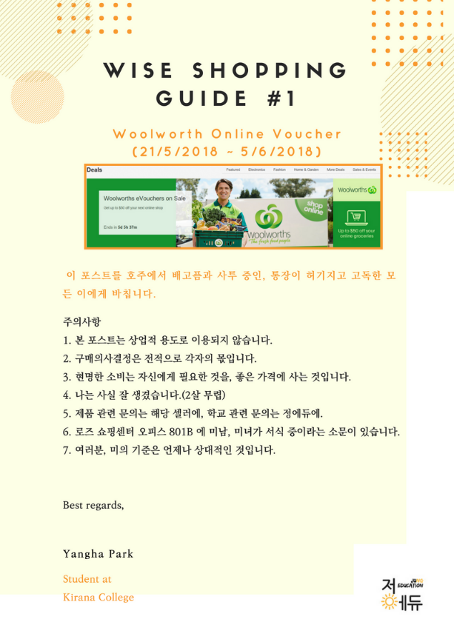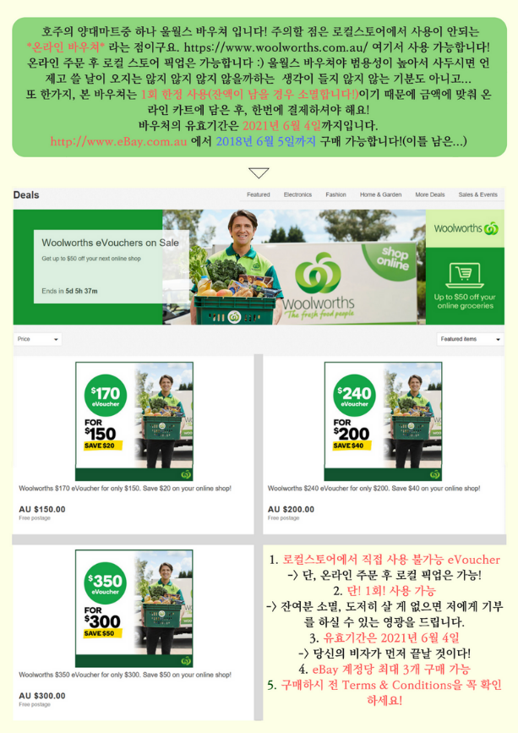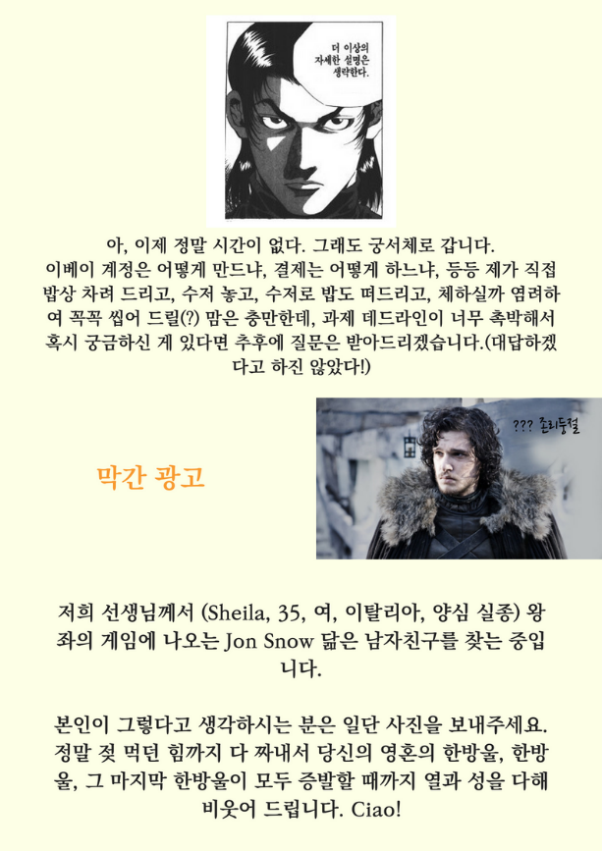

1. Summary
2. KPIs
3. Shares
4. Likes
5. Increasing number of followers during campaign
6. Increasing number of enquiries via online during campaign
7. Increasing number of calls during campaign
8. Increasing sales point during campaign
9. Budget
10. Facebook Boost Ads - $1,000(max)
11. Conclusion
12. KPI accomplishment
13. Shares – 24
14. Likes – 208
15. Increasing number of followers during campaign – 26
16. Increasing number of enquiries via online – 35
17. Increasing number of calls during campaign - 22
18. Increasing sales point during campaign - 8
19. Expenses
20. Facebook Boost Ads - $1,000
21. Return on investment
22. Net Profit $1,117 increased. (111.7% vs investment)

**Evaluation Report**

<Photo Contest> Campaign on Facebook

(5/6/2018~1/7/2018)

By Yangha Park [Social Media Marketing Department]

1. Content detail

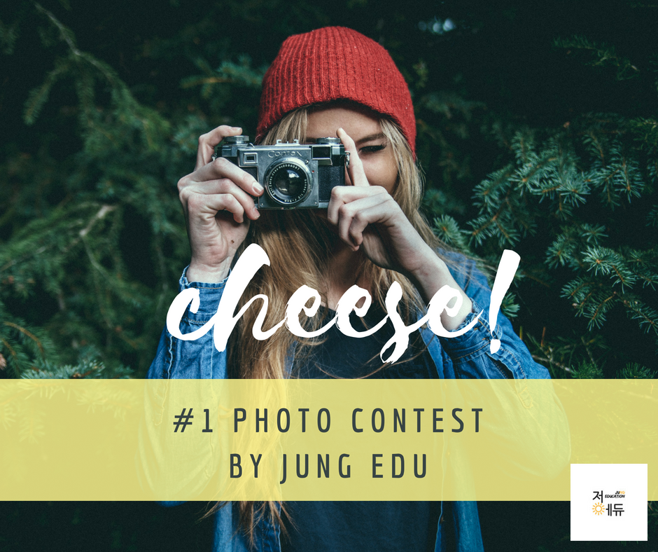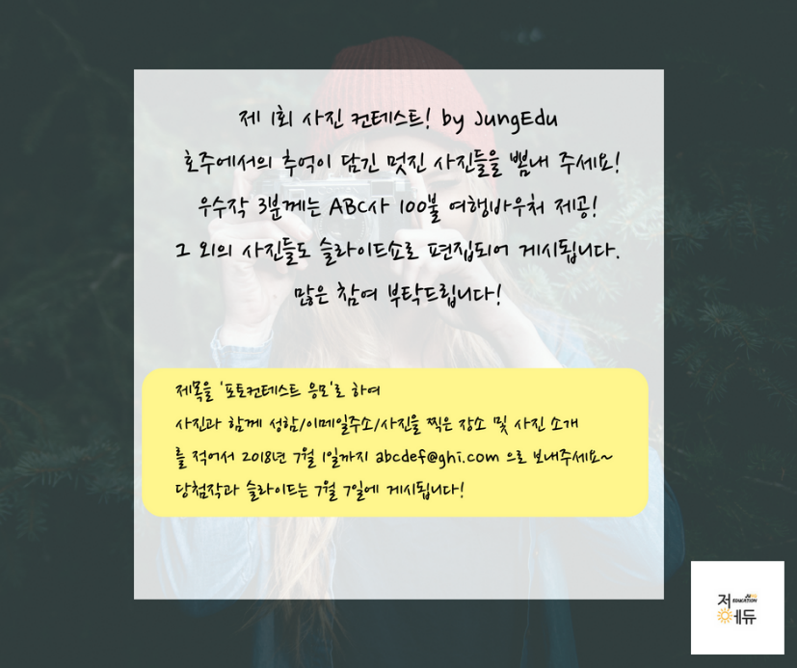

1. Summary
2. KPIs
3. Shares
4. Likes
5. Increasing number of followers during campaign
6. Increasing number of enquiries via online during campaign
7. Increasing number of calls during campaign
8. Increasing sales point during campaign
9. Budget
10. Facebook Boost Ads - $500(max)
11. Conclusion
12. KPI accomplishment
13. Shares – 20
14. Likes – 124
15. Increasing number of followers during campaign – 5
16. Increasing number of enquiries via online – 1
17. Increasing number of calls during campaign - 0
18. Increasing sales point during campaign - 0
19. Expenses
20. Facebook Boost Ads - $500
21. Return on investment
22. Net Profit $933 increased. (93.3% vs investment)