**Atroute46’s Social Media Campaign Report**

*24/9/2018*

*Yangha Park*

**PROJECT : Essay posting**

* Strategic initiative
  1. Increase Brand awareness.
     1. Provide professional and unique writing style.
     2. Keep posting writings regularly
  2. Increase followers and likes.
     1. Be communicative with readers.
     2. Discuss a lot with readers especially at tumblr.
* Type of Content & Frequency
  + 1. Blog – Wordpress(2-3 times per month)
    2. Post – Wordpress blog will be shared automatically on Facebook, tumblr, linkedin.
    3. Blog – On Naver Blog (2-3 times per month)
* 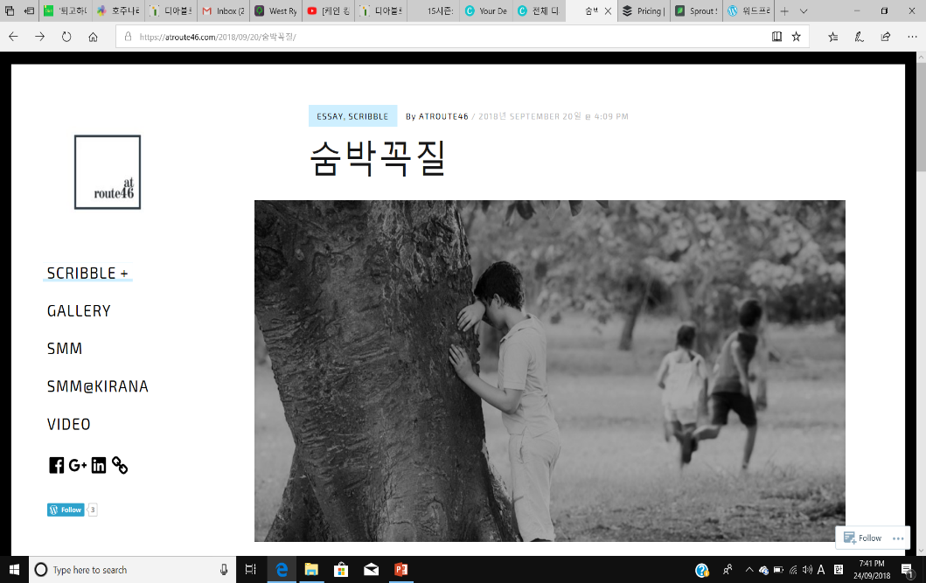KPI Target (per month)
  + 1. Shares
    2. Followers
    3. Likes
    4. Comments

**SOCIAL MEDIA MARKETING BUDGET REPORT**

|  |  |  |  |  |  |
| --- | --- | --- | --- | --- | --- |
| **Campaign** | **Expense Category** | **Expense Item** | **Forecasted Budget** | **Actual Spend** | **Variance** |
| Overall | Strategy | Strategy making | $0 | $0 | 0% |
| Management/ measurement | Wordpress analytics | $0 | $0 | 0% |
| Essay posting | Content creation | Copywriter | $0 | $0 | 0% |
|  | Distribution | Wordpress, Facebook, Linkedin, Tumblr, Naver Blog | $120 | $120 | 0% |
| Community Management | Management | Social media listening tool | $0 | $0 | 0% |

**SOCIAL MEDIA MARKETING SCORECARD**

|  |  |  |  |  |  |  |  |
| --- | --- | --- | --- | --- | --- | --- | --- |
| **Strategy** | **Campaign/ Always on** | **KPI** | **KPI Target**  **(per mth)** | **Actual Result** | **Variance** | **Comments** | **Additional Media Mentions / KPI Achievements** |
| Essay posting | Always on | * Followers * Shares * Likes * Comments | * 5 followers * 5 shares * 5 likes * 5 comments | * 3 followers * 0 shares * 6 likes * 0 participants | * -40% * -100% * 20% * -100$ | I am not surprised as it is very first trial | N/A |

**Social Media Marketing Campaign Evaluation Report**

**#Essay posting**

As I expected at the first, I’ve just started my blogging and it is hard to evaluate it at this moment. By the way, I strongly believe that everything will be better if I keep on posting my writings on the blog. I have nothing to judge in this stage, I will celebrate myself that I made a first step for the influencer on the internet.