Professional Development Policy Form
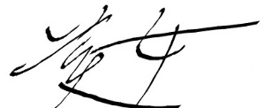
Application Date | 18/10/2017
Applicant Name | David Park
Department | ☐ Sales & Marketing  ☒ Administration  ☐ Executive | ☐ Operations  ☐ Dispatch  ☐ Logistics
Professional Development Type | ☐ Job specific  ☐ Updating skills  ☐ Up-skilling  ☒ New equipment | ☒ New systems  ☐ Information Technology  ☐ Personal
Description of Professional Development Activity | To make our office more progressive, I suggest to install cutting edge system. In this activity, I will introduce up-to-date technology of recent office. This new equipment helps us to save the cost of documents with its electric document based system. And we do not need to worry about losing some significant information, it automatically backups all document we work, and the security of confidential documents will be safer than before. Every secret information and customers' personal information will be encrypted and only authorised person can access those documents. And it also gives us easy-sharing system. We can respond quickly to a request from other department with this equipment. This should increase work efficiency dramatically.
Benefit for Applicant Activity | Acquiring knowledge
Expected Outcomes from Activity | Getting know how it’s effective for increasing work efficiency, Quick interact among all staff in the company, Cutting off the cost, Stronger security of documents.
Post-activity Report from Applicant | ☐ Verbal report  ☒ Written report  ☐ Journal | ☐ Staff profile update  ☐ Staff information article  ☐ Group debriefing
Authorised by :
Signature of Individual Engages
Name | Signature | Date | Department
David | 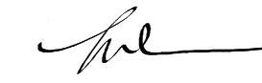 | 18/10/2017 | Administration
Sid | 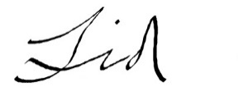 | 18/10/2017 | Executive
Tsuyoshi | 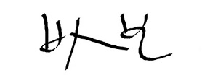 | 18/10/2017 | Dispatch
Spiderman | 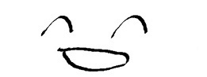 | 18/10/2017 | Dispatch
Hulk | 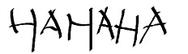 | 18/10/2017 | Logistics
Doctor Slump | 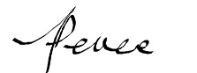 | 18/10/2017 | Operations
Goku | 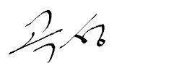 | 19/10/2017 | Administration
Mori Kogoro | 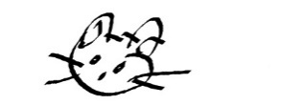 | 19/10/2017 | Administration
Victor | 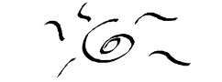 | 20/10/2017 | Sales & Marketing
Johnson | 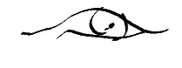 | 21/10/2017 | Sales & Marketing

