Evaluation Report
<Wise Shopping> Campaign on Facebook
(21/5/2018 ~ 5/6/2018)
By Yangha Park [Social Media Marketing Department]

- Content detail
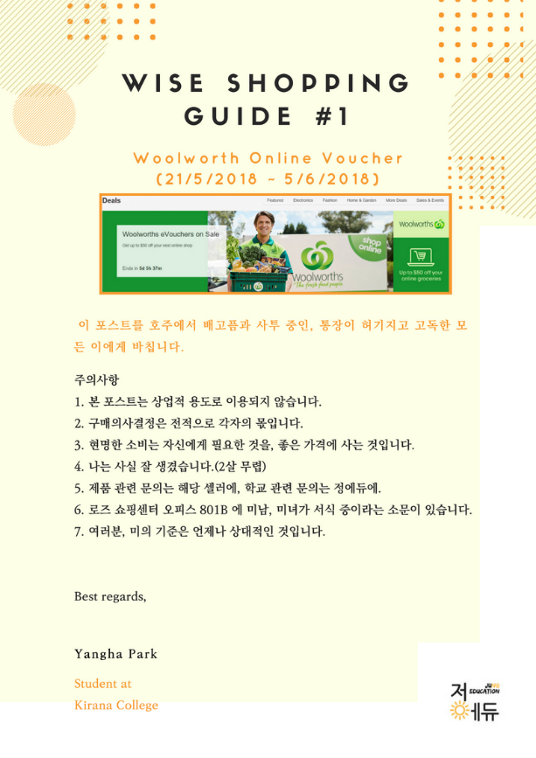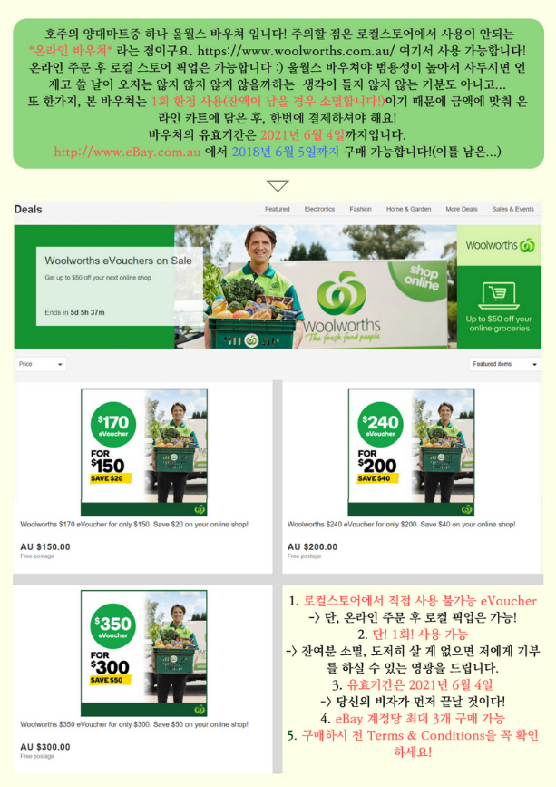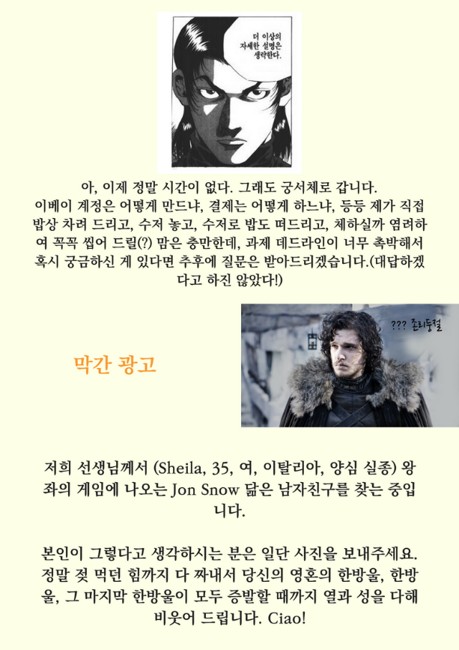

- Summary

- KPIs
- Shares
- Likes
- Increasing number of followers during campaign
- Increasing number of enquiries via online during campaign
- Increasing number of calls during campaign
- Increasing sales point during campaign

- Budget
- Facebook Boost Ads - $1,000(max)

- Conclusion

- KPI accomplishment
- Shares – 24
- Likes – 208
- Increasing number of followers during campaign – 26
- Increasing number of enquiries via online – 35
- Increasing number of calls during campaign - 22
- Increasing sales point during campaign - 8

- Expenses
- Facebook Boost Ads - $1,000

- Return on investment
- Net Profit $1,117 increased. (111.7% vs investment)

Evaluation Report
<Photo Contest> Campaign on Facebook
(5/6/2018~1/7/2018)
By Yangha Park [Social Media Marketing Department]

- Content detail
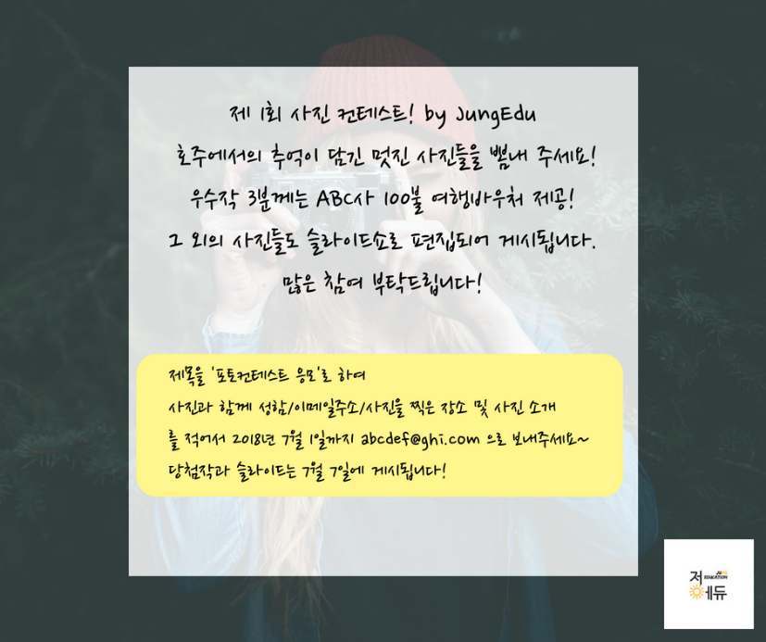

- Summary

- KPIs
- Shares
- Likes
- Increasing number of followers during campaign
- Increasing number of enquiries via online during campaign
- Increasing number of calls during campaign
- Increasing sales point during campaign

- Budget
- Facebook Boost Ads - $500(max)

- Conclusion

- KPI accomplishment
- Shares – 20
- Likes – 124
- Increasing number of followers during campaign – 5
- Increasing number of enquiries via online – 1
- Increasing number of calls during campaign - 0
- Increasing sales point during campaign - 0

- Expenses
- Facebook Boost Ads - $500

- Return on investment
- Net Profit $933 increased. (93.3% vs investment)

