Atroute46’s Social Media Campaign Report

24/9/2018
Yangha Park
PROJECT : Essay posting
- Strategic initiative
  - Increase Brand awareness.
    - Provide professional and unique writing style.
    - Keep posting writings regularly
  - Increase followers and likes.
    - Be communicative with readers.
    - Discuss a lot with readers especially at tumblr.

- Type of Content & Frequency
    - Blog – Wordpress(2-3 times per month)
    - Post – Wordpress blog will be shared automatically on Facebook, tumblr, linkedin.
    - Blog – On Naver Blog (2-3 times per month)

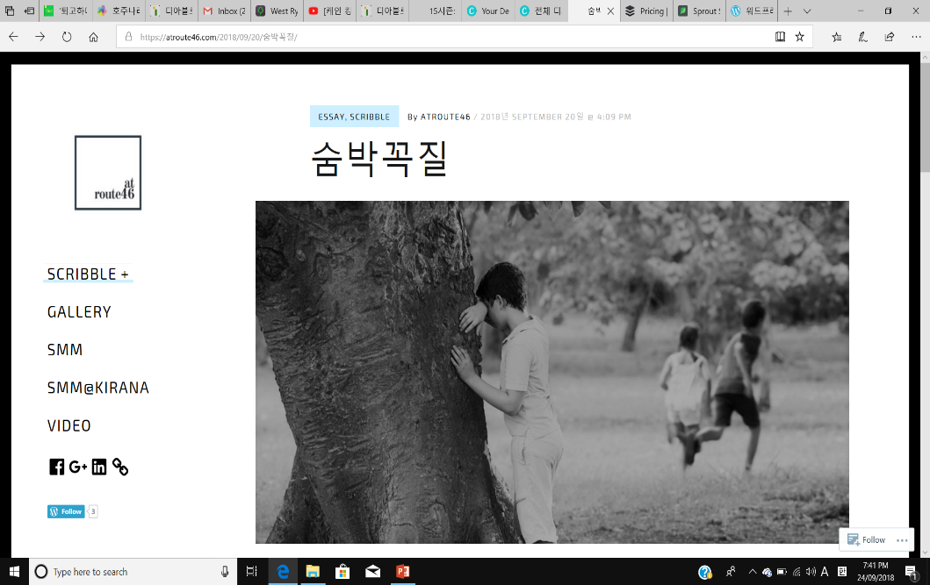
- KPI Target (per month)
    - Shares
    - Followers
    - Likes
    - Comments
SOCIAL MEDIA MARKETING BUDGET REPORT
Campaign | Expense Category | Expense Item | Forecasted Budget | Actual Spend | Variance
Overall | Strategy | Strategy making | $0 | $0 | 0%
 | Management/ measurement | Wordpress analytics | $0 | $0 | 0%
Essay posting | Content creation | Copywriter | $0 | $0 | 0%
 | Distribution | Wordpress, Facebook, Linkedin, Tumblr, Naver Blog | $120 | $120 | 0%
Community Management | Management | Social media listening tool | $0 | $0 | 0%

SOCIAL MEDIA MARKETING SCORECARD
Strategy | Campaign/ Always on | KPI | KPI Target  (per mth) | Actual Result | Variance | Comments | Additional Media Mentions / KPI Achievements
Essay posting | Always on | - Followers  - Shares  - Likes  - Comments | - 5 followers  - 5 shares  - 5 likes  - 5 comments | - 3 followers  - 0 shares  - 6 likes  - 0 participants | - -40%  - -100%  - 20%  - -100$ | I am not surprised as it is very first trial | N/A

Social Media Marketing Campaign Evaluation Report

#Essay posting

As I expected at the first, I’ve just started my blogging and it is hard to evaluate it at this moment. By the way, I strongly believe that everything will be better if I keep on posting my writings on the blog. I have nothing to judge in this stage, I will celebrate myself that I made a first step for the influencer on the internet.

