Evaluation Report | - Yangha Park

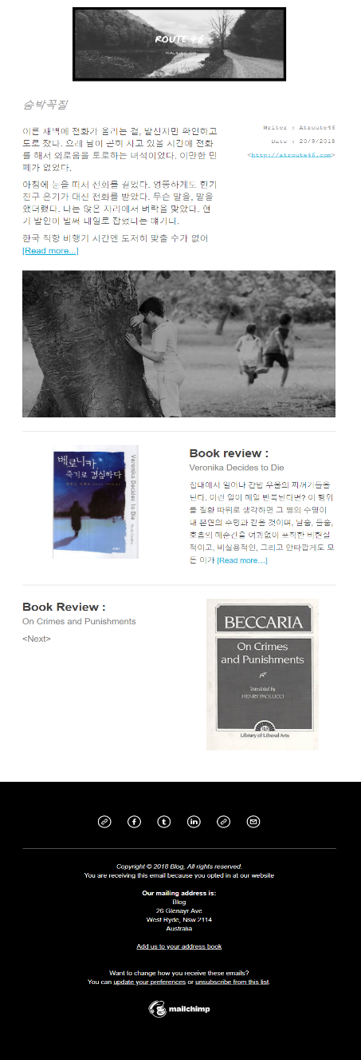
Project Name: E-mail marketing campaign #1
Date 25/11/2018
- On track | - Low
- Moderate | - At Risk

KPIs | - Open rate  - Clickthrough rate  - Bounce rate  - Number of email forwards  - Number of social media shares  - Positive email replies  - Negative email replies  - Sales as a direct result of the email campaign
Goals  (1/11/2018 ~ 31/11/2018) | - Open rate (50%)  - Clickthrough rate (30%)  - Bounce rate (10%)  - Number of email forwards (2)  - Number of social media shares (2)  - Positive email replies (2)  - Negative email replies (2)  - Sales as a direct result of the email campaign (0)
Actual  (25/11/2018) | - Open rate (42.9%)  - Clickthrough rate (4.8%)  - Bounce rate (0%)  - Number of email forwards (0)  - Number of social media shares (0)  - Positive email replies (0)  - Negative email replies (0)  - Sales as a direct result (0)
Overall  (25/11/2018) | This campaign is totally off track.

Conclusion
This campaign has gone far away from our expectation. The main reason for this is lack of subscribers who are interested with Korean literature, and our most subscribers can’t even read Korean. Therefore, we need to gather right subscribers primarily, otherwise, it is impossible to figure out properly how our e-mail marketing works. For this, Facebook geometry-targeted ads could be a good solution. And we have to organize relationships with other writers and reviewers. Tumblr is good platform to do it as many Korean writers and reviewers use it actively.
And template design looks little bit messy, and especially its mood is too dark as it’s all covered by black color.
I would like to suggest change the theme color by the atmosphere of the main article or writing. (i.g. when the ambience of writing is funny or happy, use light color for the template.)

Project Abstract
- This campaign is off track since the marketing target was wrong.
- Facebook geometry ads are recommended to find right subscribers.
- To be active on Tumblr is needed to build relationships with other influencers.
- Changing color of template by the atmosphere of the text is recommended.

