E-mail marketing strategy report
(Objectives : Stockholm university, University of Canberra, UTS)
29-10-2018

1. Stockholm University(http://www.su.se)

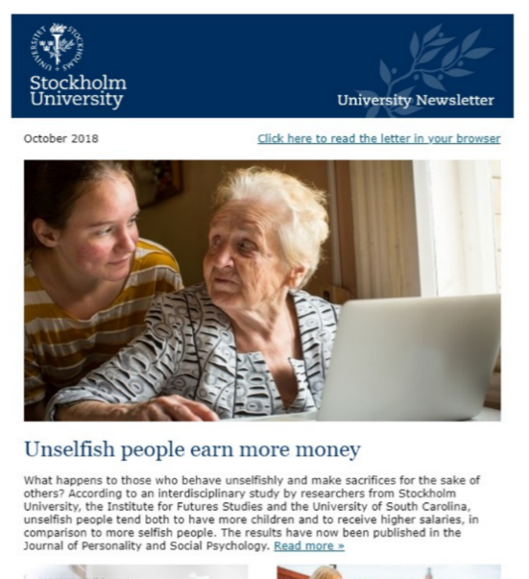
In the newsletter, they introduce some interesting articles, education service information, and a research of their own.
It has a beautiful design, and article choice seems like good enough to stimulate people to read.
The most fascinating thing is that they provide an opportunity to contact their alumni in each course. People who have a question for a course selection or other, can ask it to alumni and I believe that they will get very practical answer from them.

2. University of Canberra(http://www.canberra.edu.au)

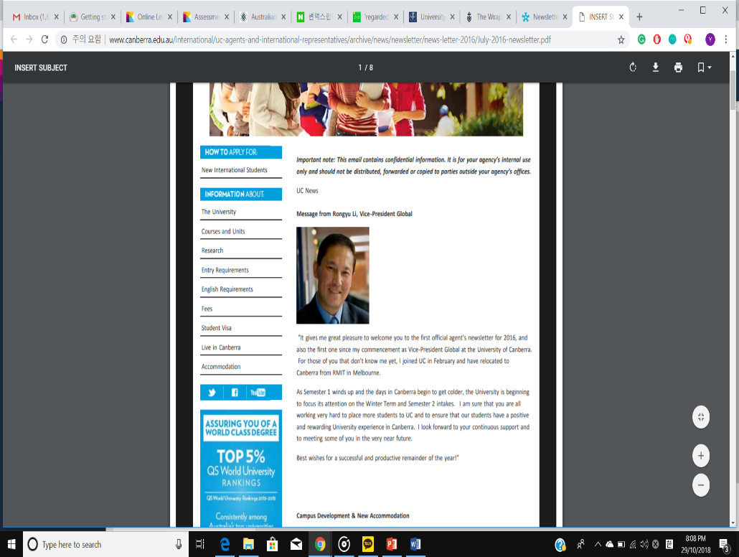
Their newsletter looks like a website that have many direct links to their website. They introduce their new education courses, campus news, and new accommodation information.
They try to give as much as many information in a newsletter, but that information is only about their service, or some other related to their service.
The newsletter is merely designed for the profit of themselves.

3. UTS(https://www.uts.edu.au)

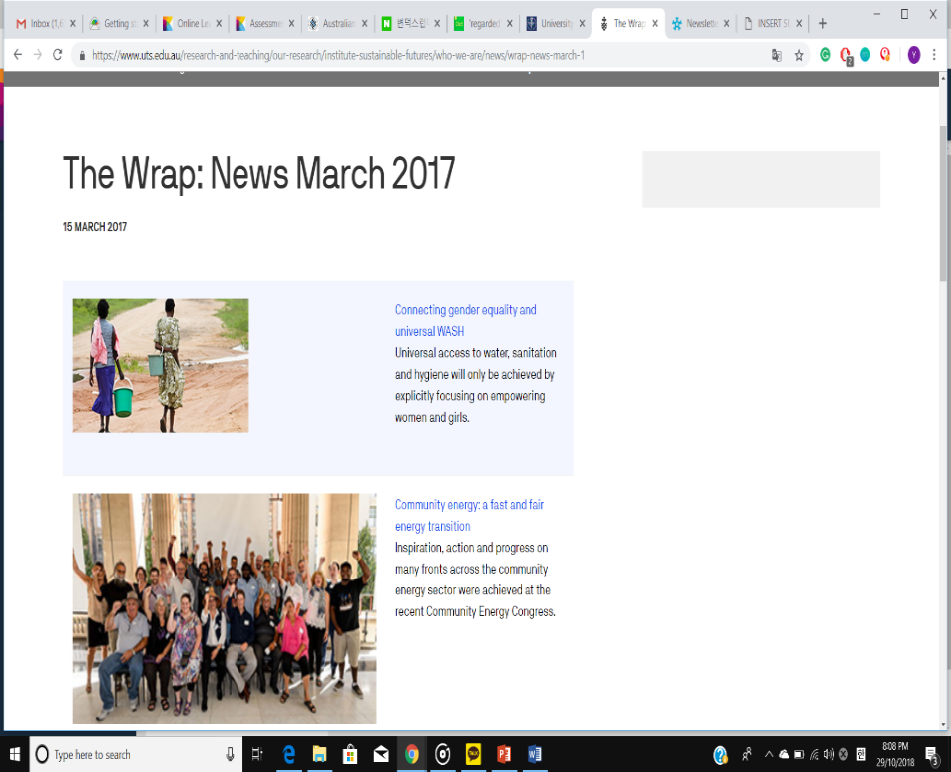
This newsletter has a couple of articles related to social issues like environmental issue, or community news. I think their newsletter’s target audience is not only their students, and potential customers but anyone else.
Even though, the newsletter itself has a poor design, their articles are brilliant enough to cover it. And in fact, their all articles are basically related to their education course on closer inspection.

