Asian Legacy Library · ALL Translation Tool
The Fifteen Panes
One application, one shared dictionary core — captured live, August 2026.
──────────────────── ❖ ────────────────────
1 Overlay
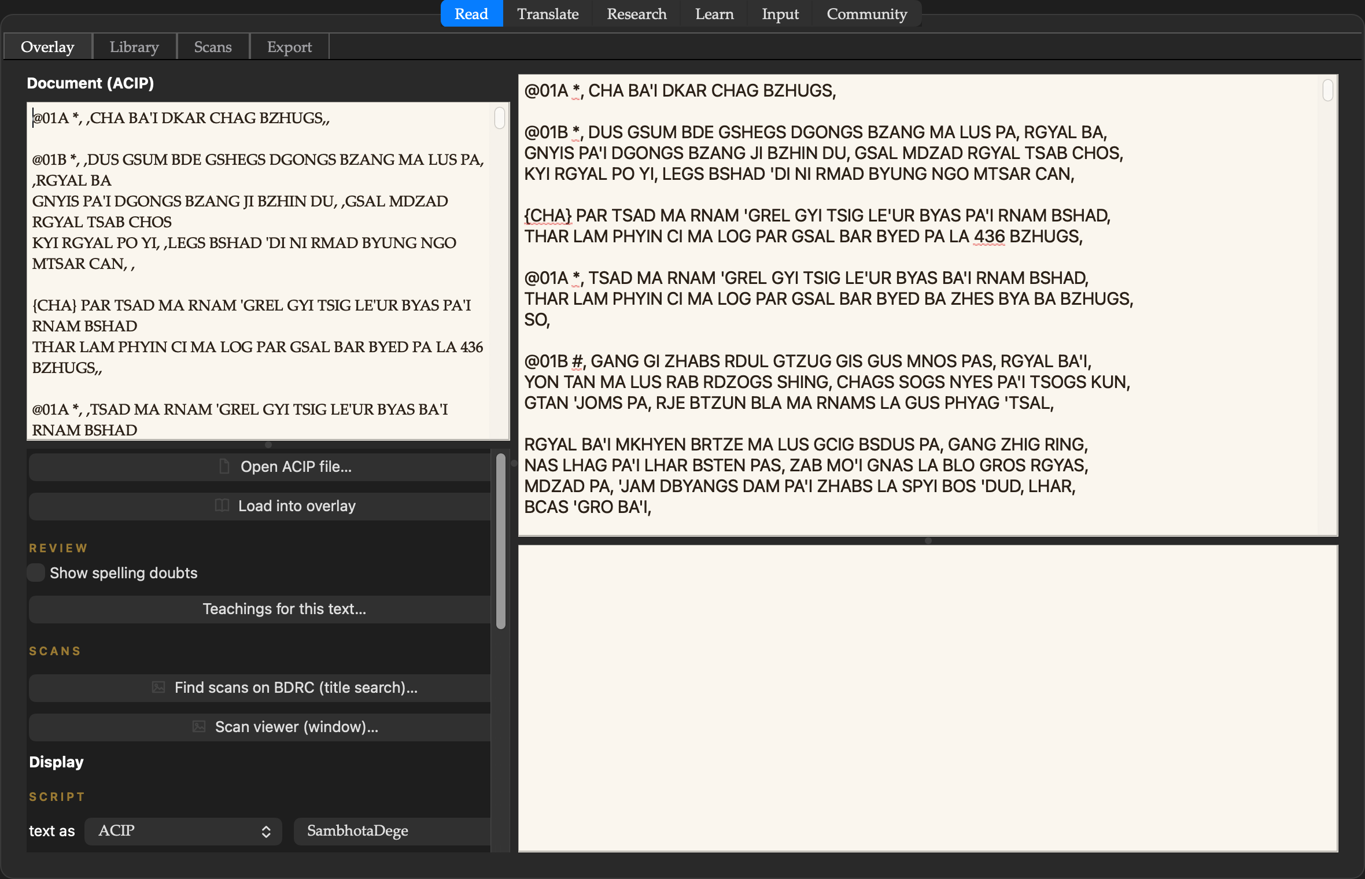
The flagship reading pane: every word and phrase the dictionary knows, clickable — the longest known phrase lights up, the card answers below, the woodblock scan can follow along. Arrow keys walk the text; five display scripts including both pronunciation conventions.
2 Library
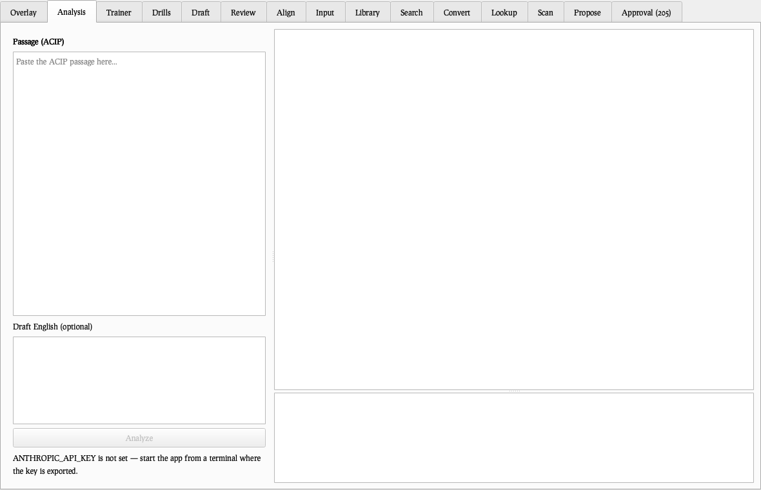
The preserved canon close at hand: the current Kangyur, Tengyur, and Sungbum releases, decoded catalog identities, English titles, one click into the Overlay — and a Maintenance menu that checks asianlegacylibrary.org for collection updates and installs them in place.
2 Library
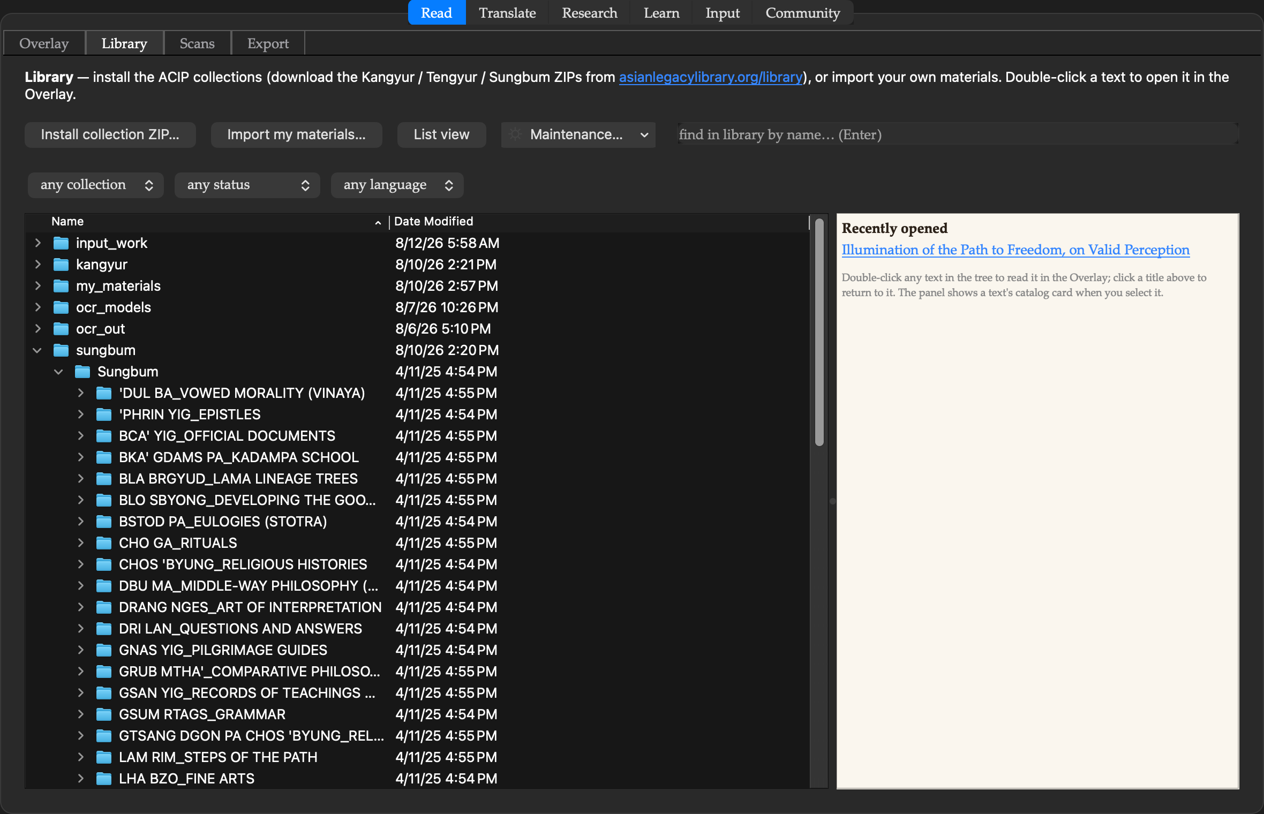
The preserved canon close at hand: the current Kangyur, Tengyur, and Sungbum releases, decoded catalog identities, English titles, one click into the Overlay — and a Maintenance menu that checks asianlegacylibrary.org for collection updates and installs them in place.
3 Scans
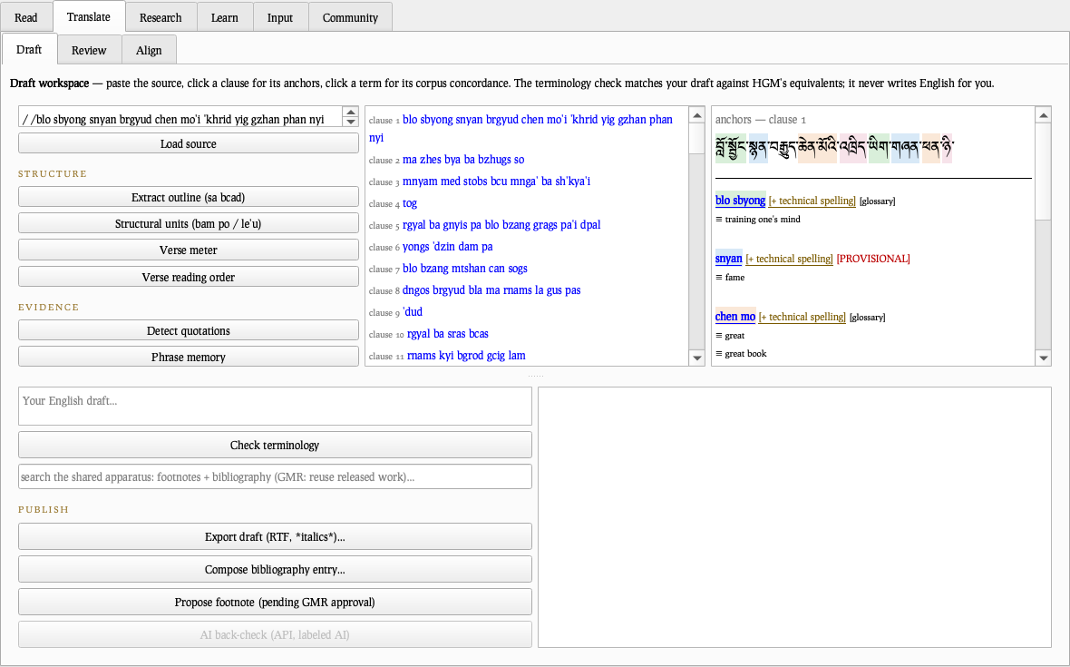
The woodblock tools for the loaded text: BDRC scan linking, whole-volume illustration galleries, and the four-layer folio view (scan · OCR · e-text · attested English).
3 Scans
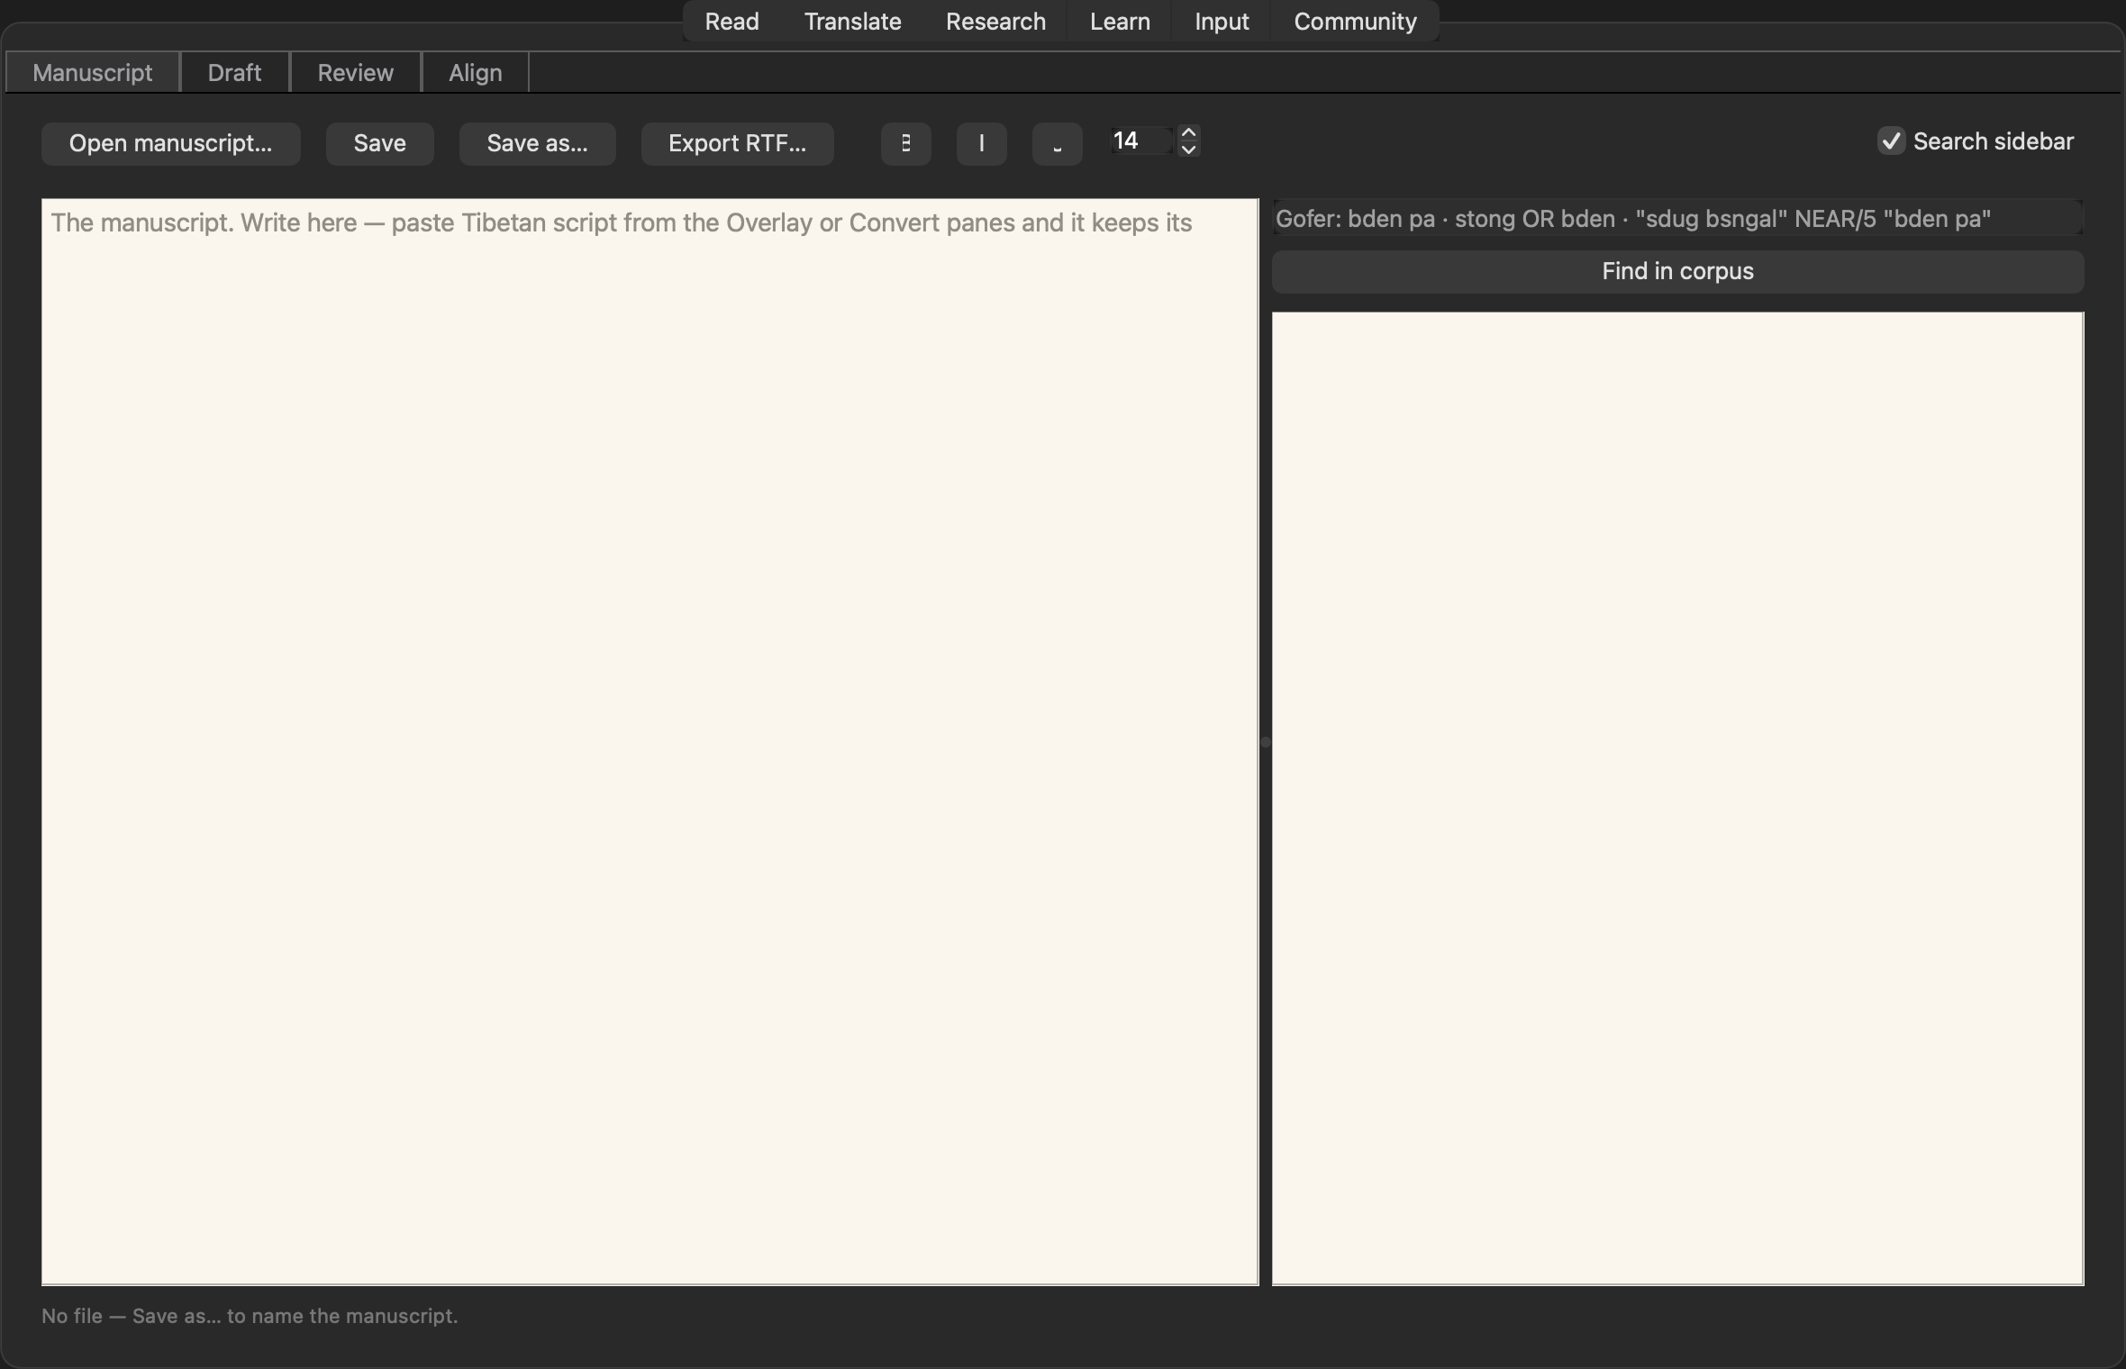
The woodblock tools for the loaded text: BDRC scan linking, whole-volume illustration galleries, and the four-layer folio view (scan · OCR · e-text · attested English).
3 Scans
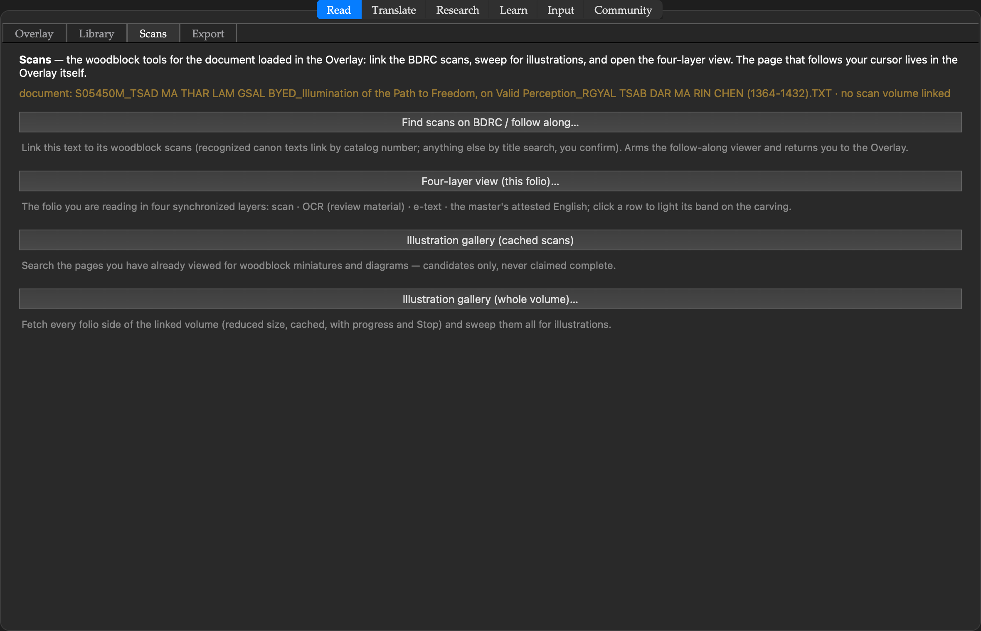
The woodblock tools for the loaded text: BDRC scan linking, whole-volume illustration galleries, and the four-layer folio view (scan · OCR · e-text · attested English).
3 Scans
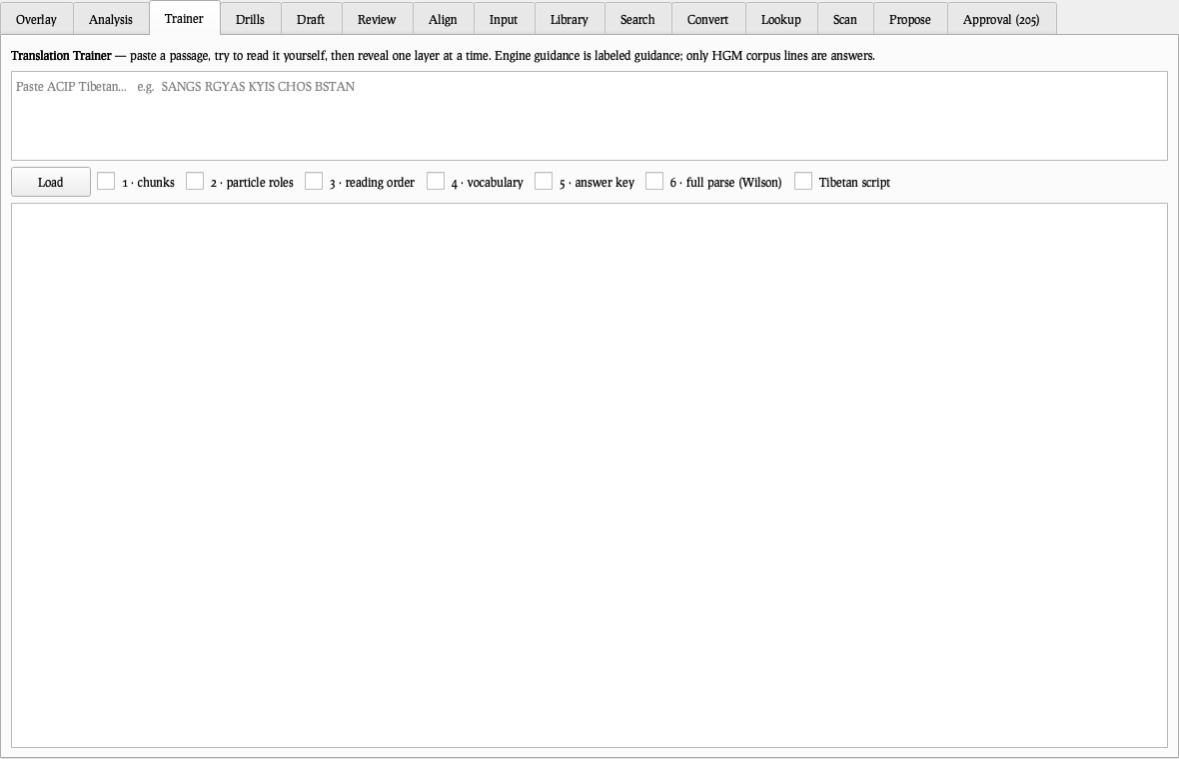
The woodblock tools for the loaded text: BDRC scan linking, whole-volume illustration galleries, and the four-layer folio view (scan · OCR · e-text · attested English).
4 Export
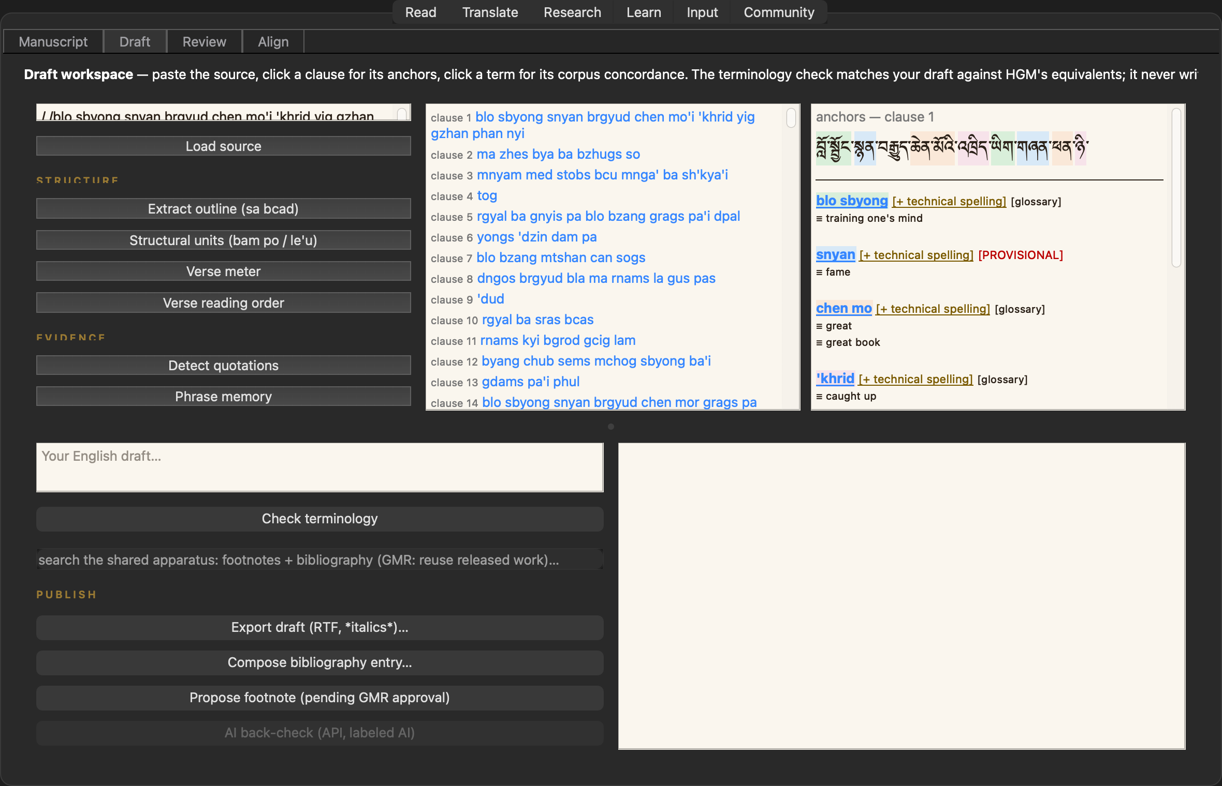
The publishing station: translation-prep format, the Pecha Maker (title folio, ya-yig, Degé measures, verse lineation, two-up imposition, batch mode), and print-ready Tibetan Unicode.
4 Export
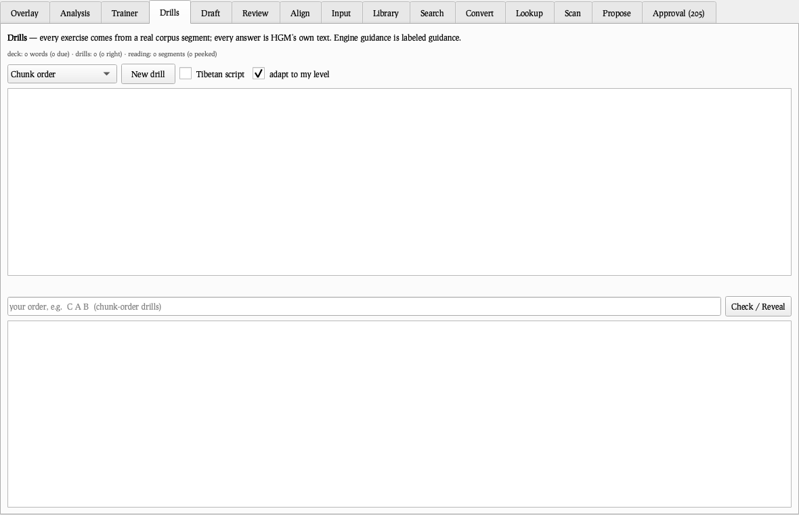
The publishing station: translation-prep format, the Pecha Maker (title folio, ya-yig, Degé measures, verse lineation, two-up imposition, batch mode), and print-ready Tibetan Unicode.
4 Export
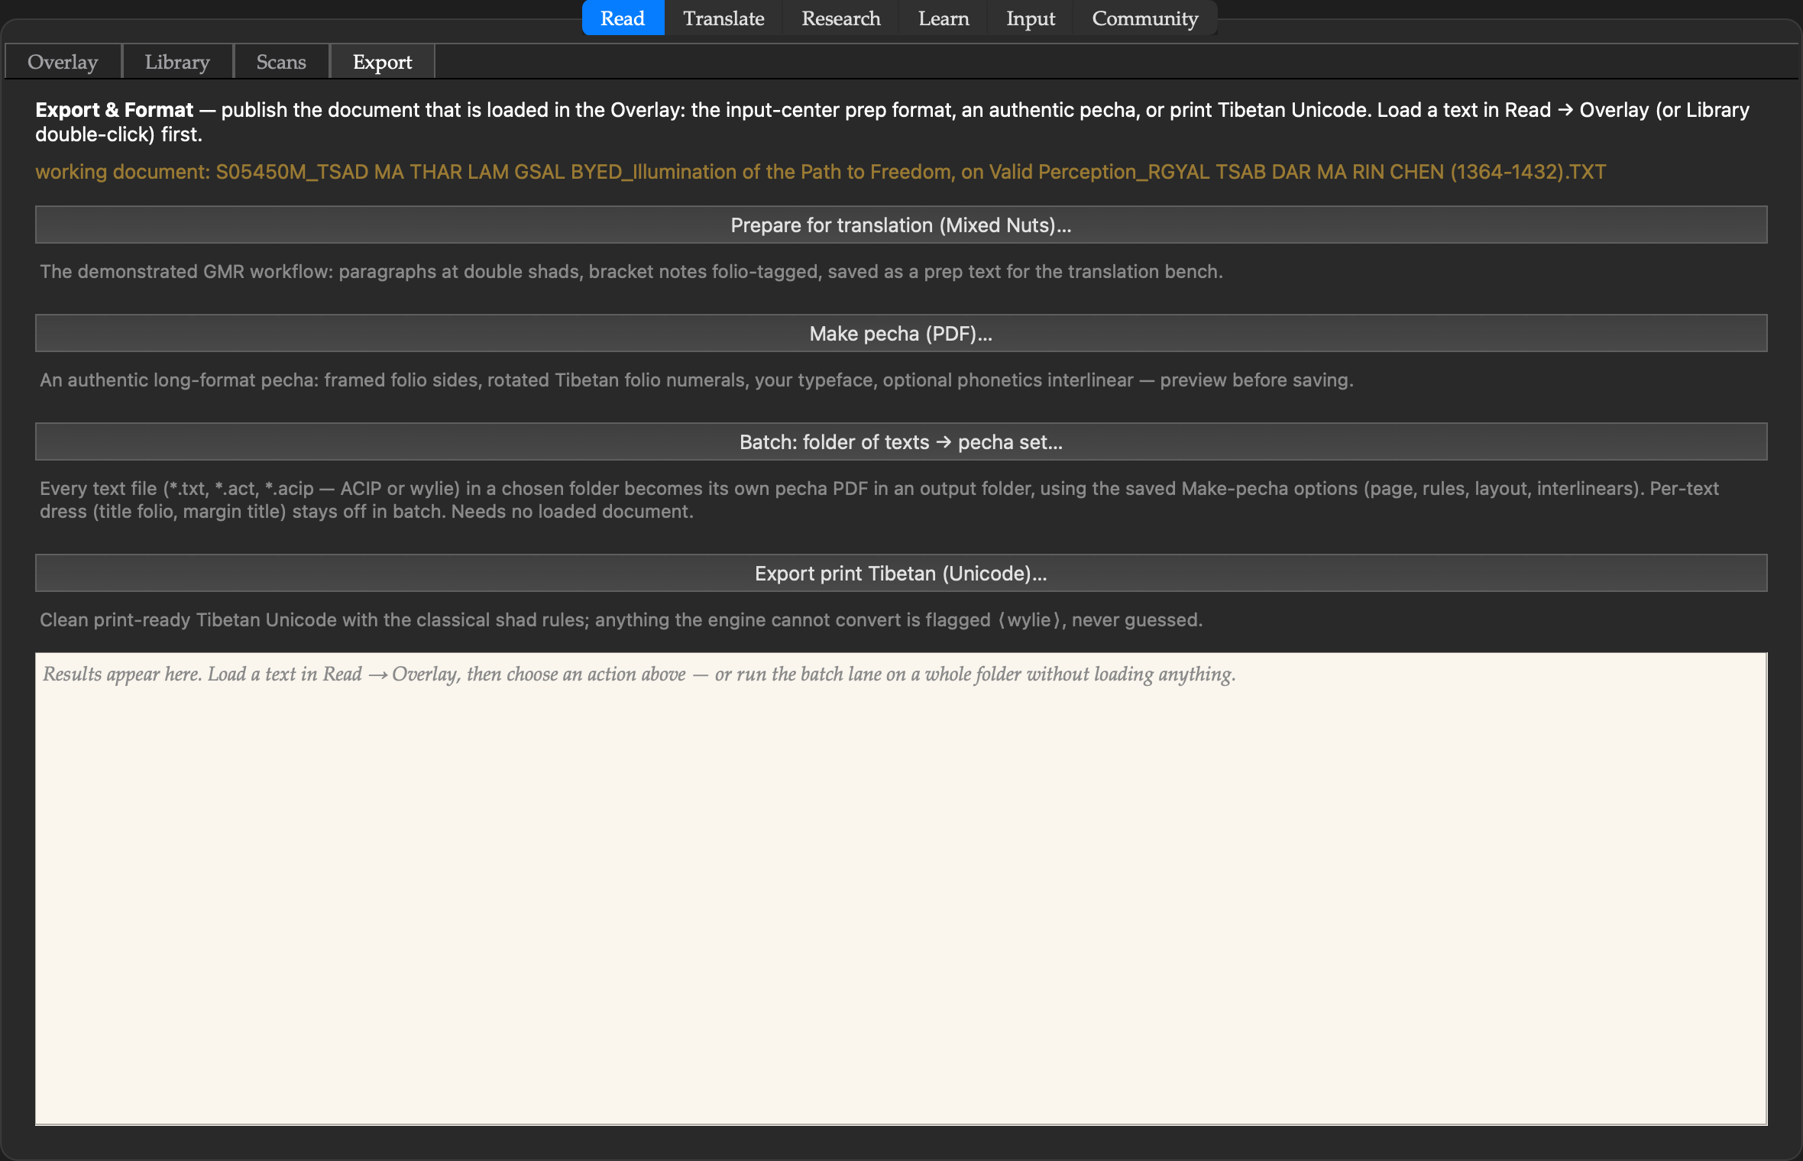
The publishing station: translation-prep format, the Pecha Maker (title folio, ya-yig, Degé measures, verse lineation, two-up imposition, batch mode), and print-ready Tibetan Unicode.
4 Export
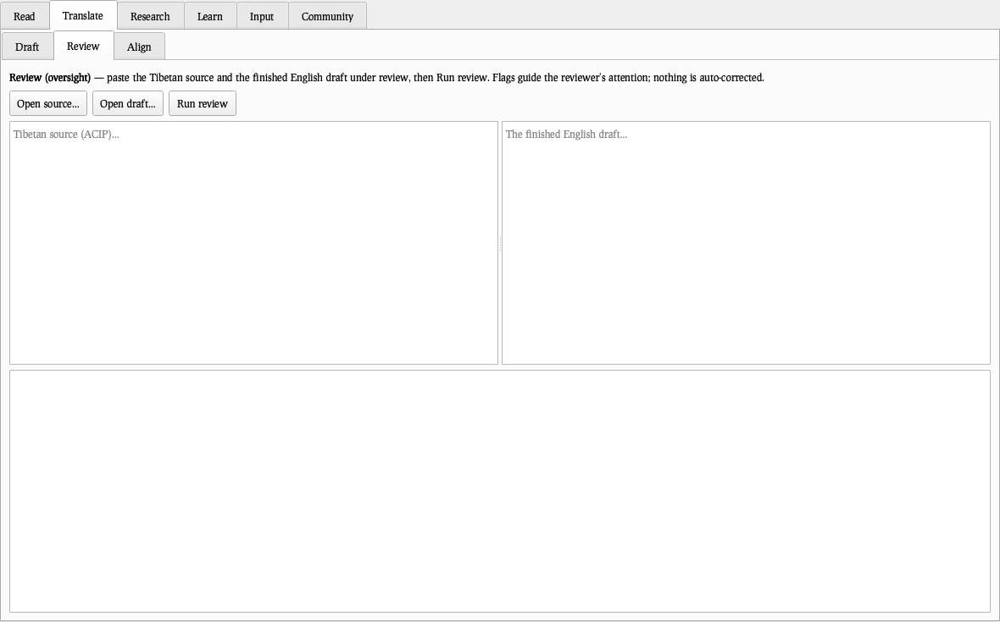
The publishing station: translation-prep format, the Pecha Maker (title folio, ya-yig, Degé measures, verse lineation, two-up imposition, batch mode), and print-ready Tibetan Unicode.
5 Draft
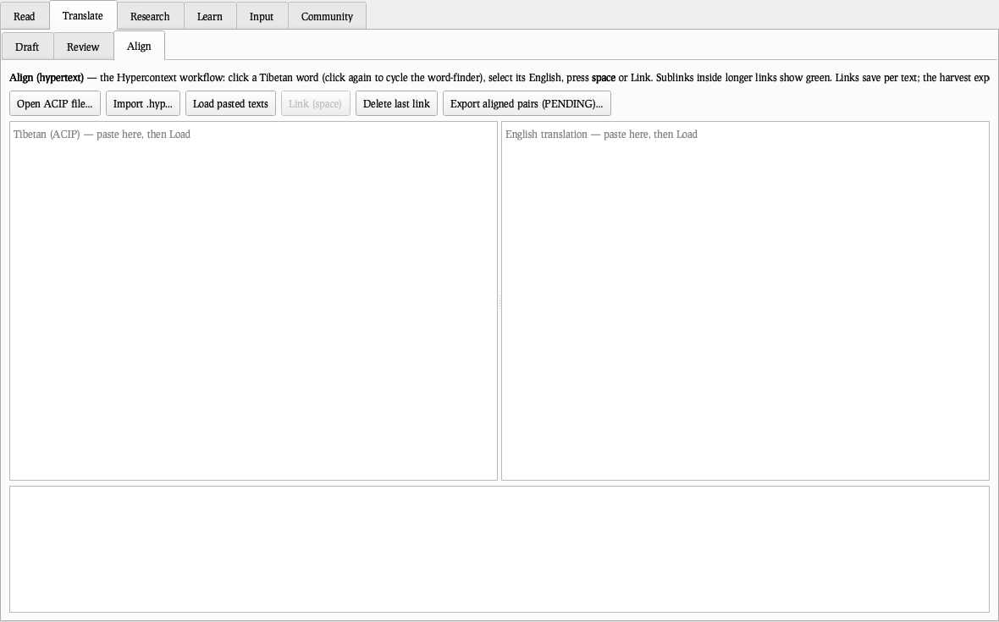
The working translator’s bench: source and draft side by side, the Evidence Ribbon following the cursor, established terms anchored, quotations detected, phrase memory, a live terminology guard as you type.
5 Draft
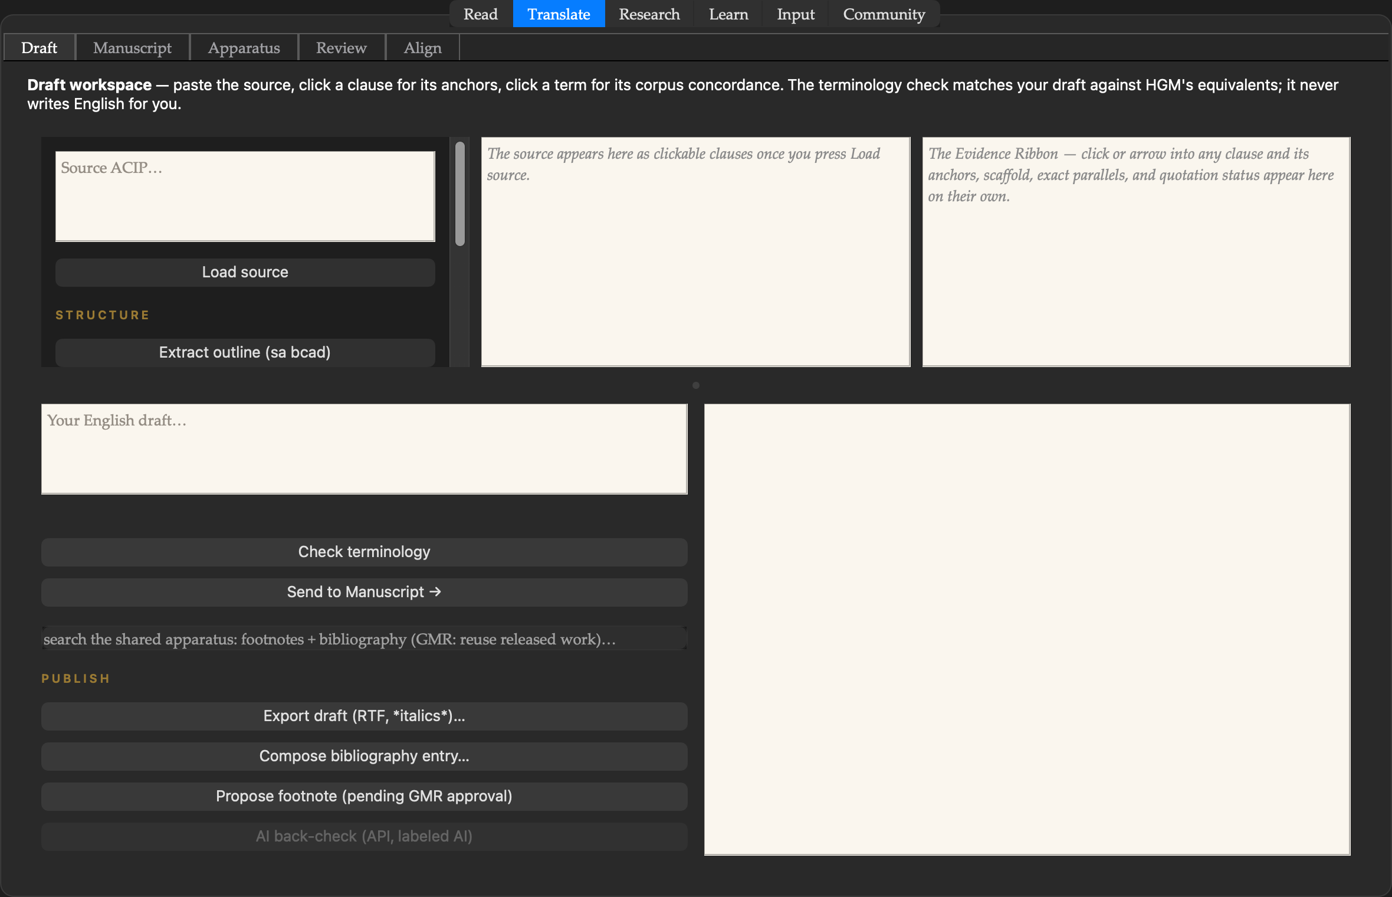
The working translator’s bench: source and draft side by side, the Evidence Ribbon following the cursor, established terms anchored, quotations detected, phrase memory, a live terminology guard as you type.
5 Draft
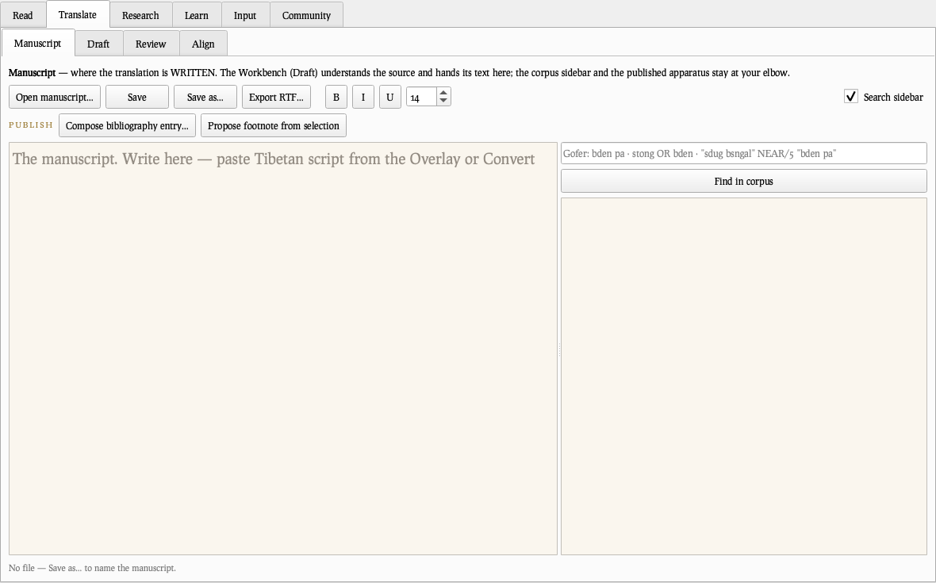
The working translator’s bench: source and draft side by side, the Evidence Ribbon following the cursor, established terms anchored, quotations detected, phrase memory, a live terminology guard as you type.
5 Draft
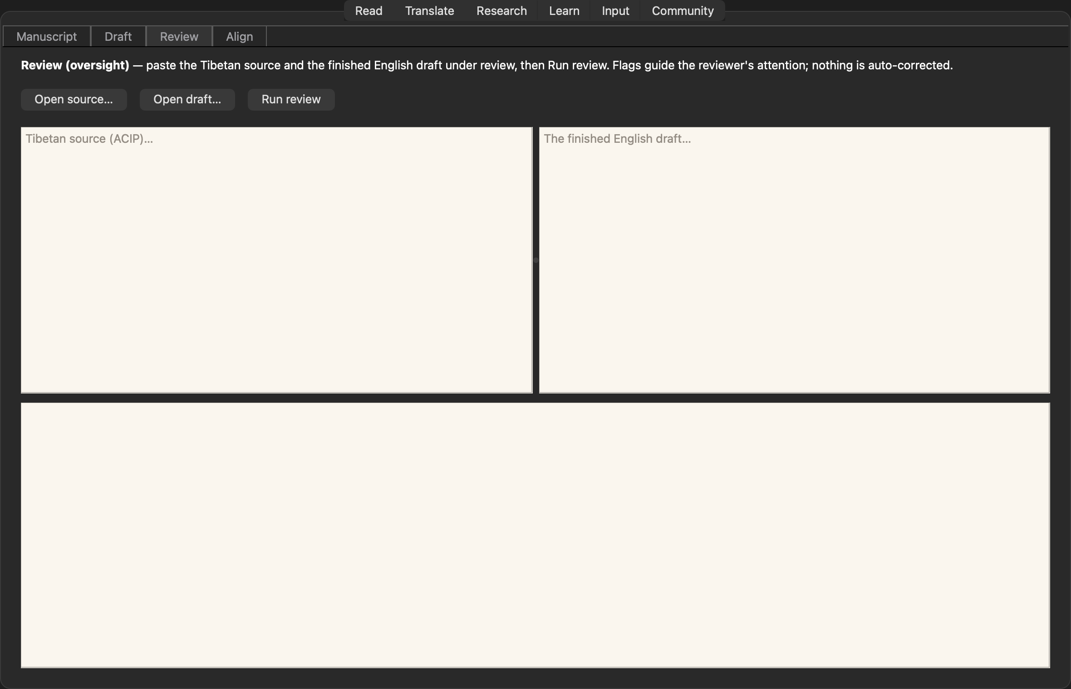
The working translator’s bench: source and draft side by side, the Evidence Ribbon following the cursor, established terms anchored, quotations detected, phrase memory, a live terminology guard as you type.
6 Manuscript
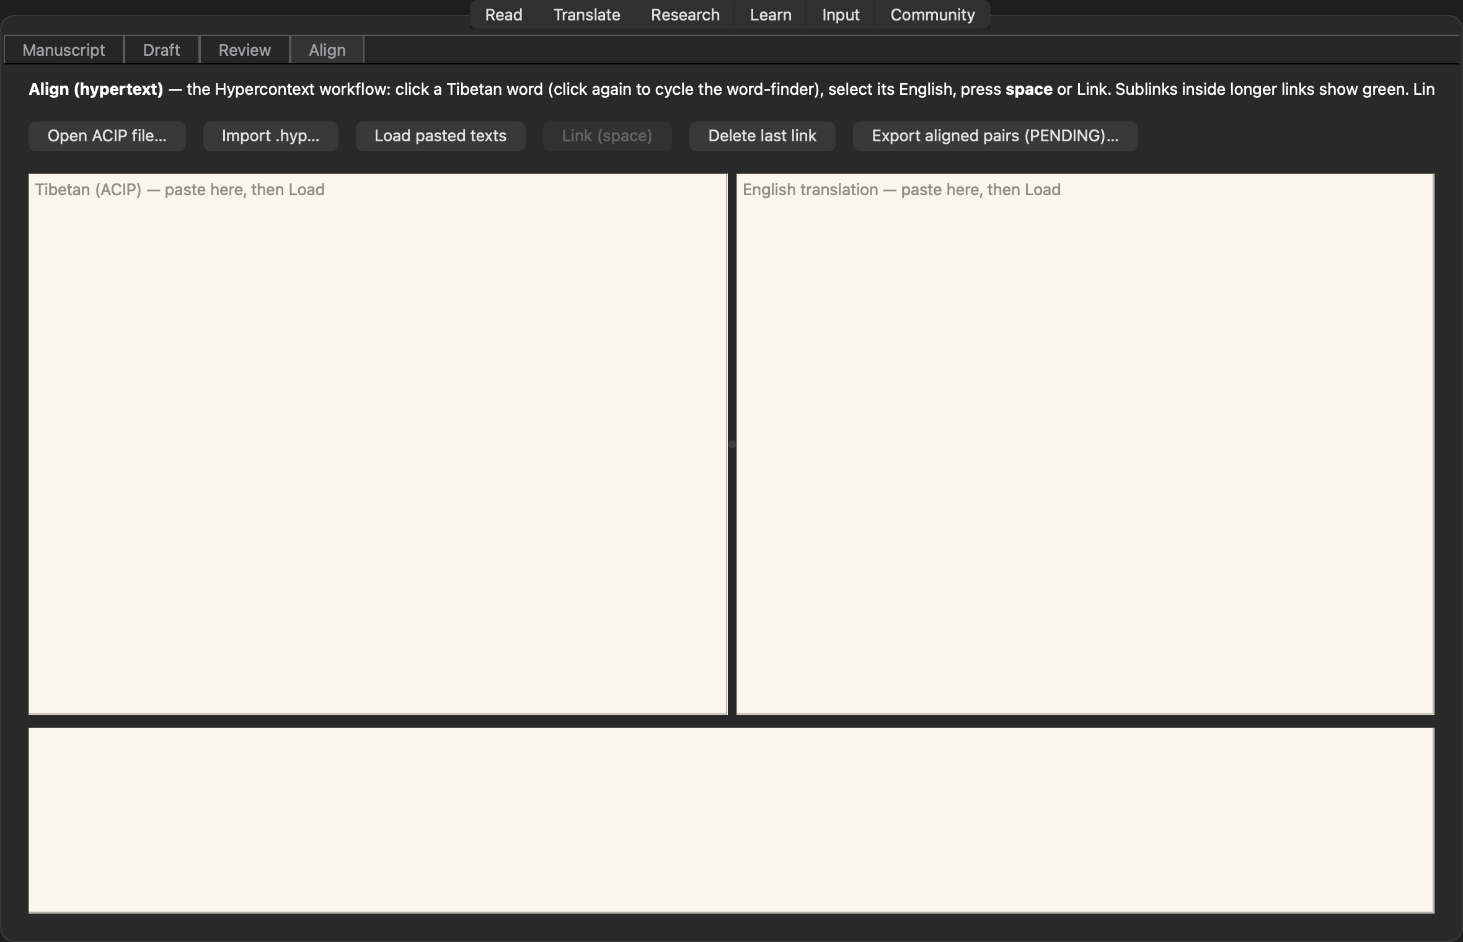
The composition surface: rich text with the corpus search beside it — the master’s attested English one “insert” away — and the publishing tools at hand.
6 Manuscript
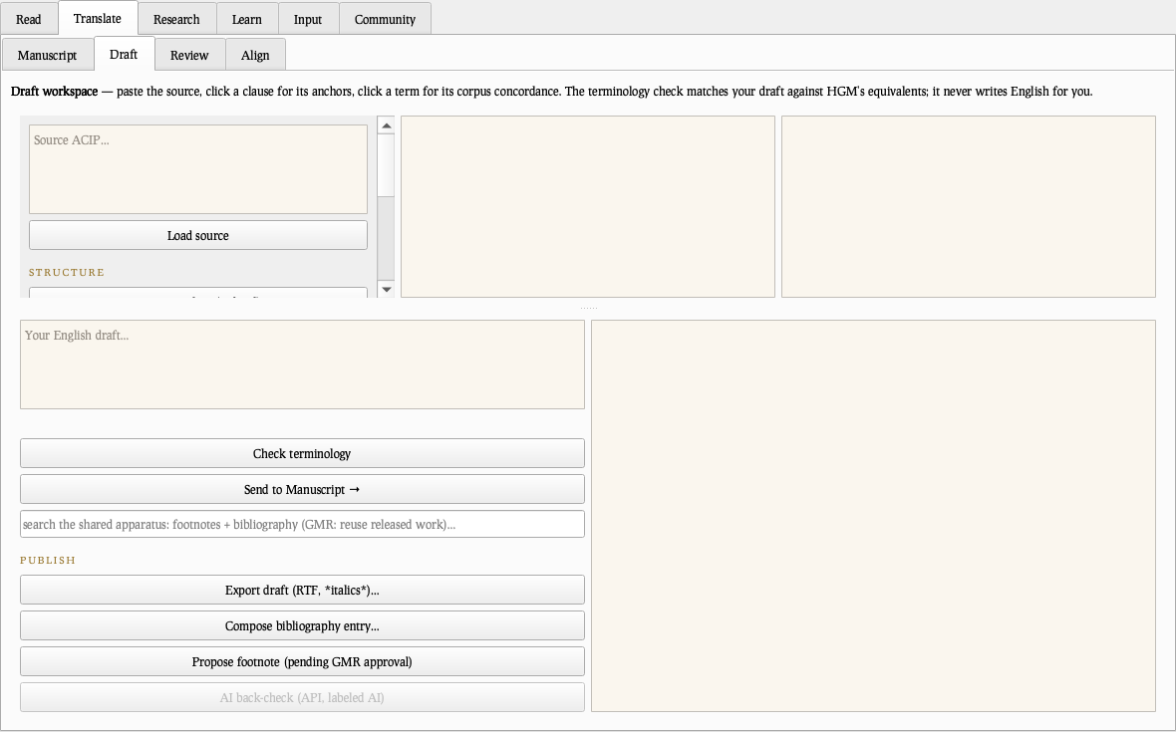
The composition surface: rich text with the corpus search beside it — the master’s attested English one “insert” away — and the publishing tools at hand.
6 Manuscript
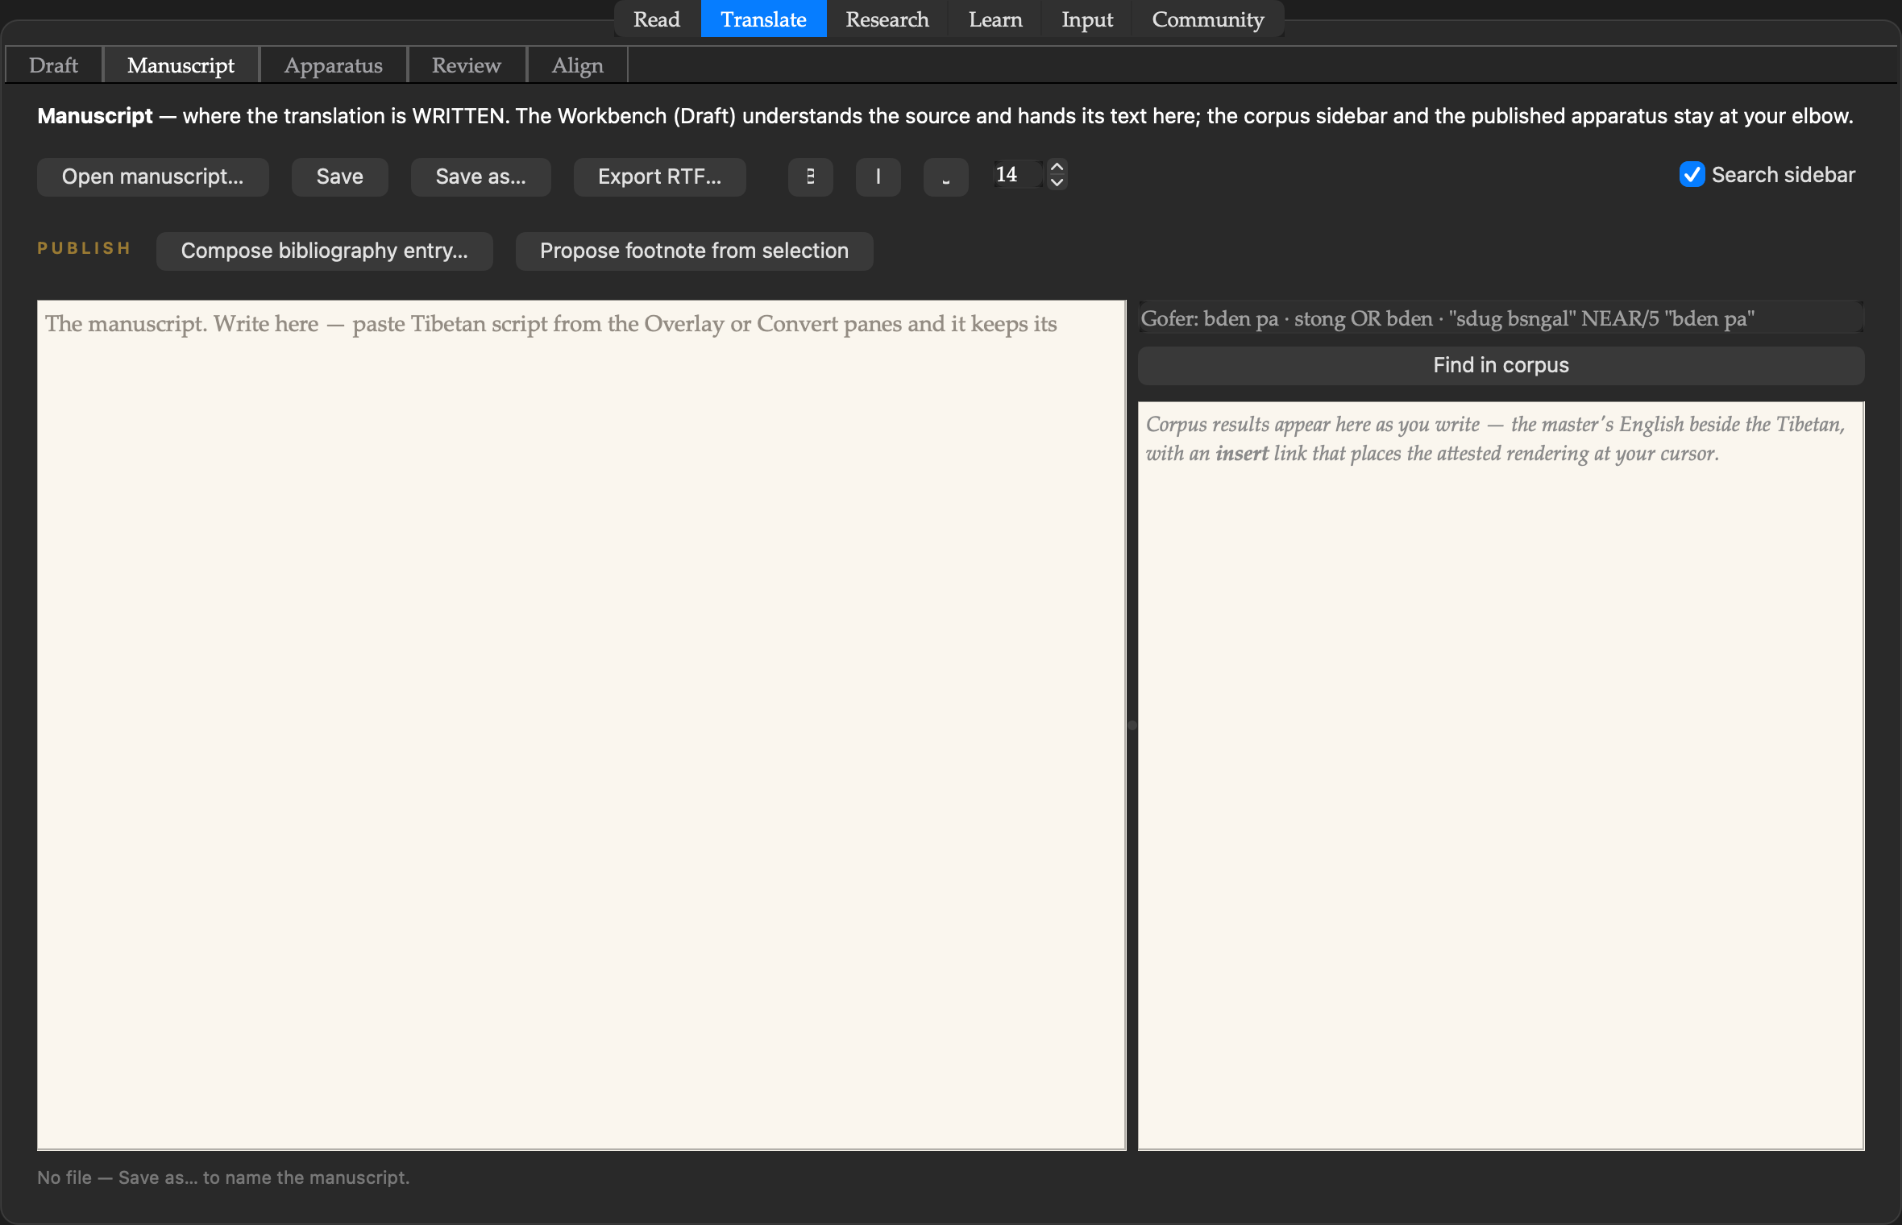
The composition surface: rich text with the corpus search beside it — the master’s attested English one “insert” away — and the publishing tools at hand.
6 Manuscript
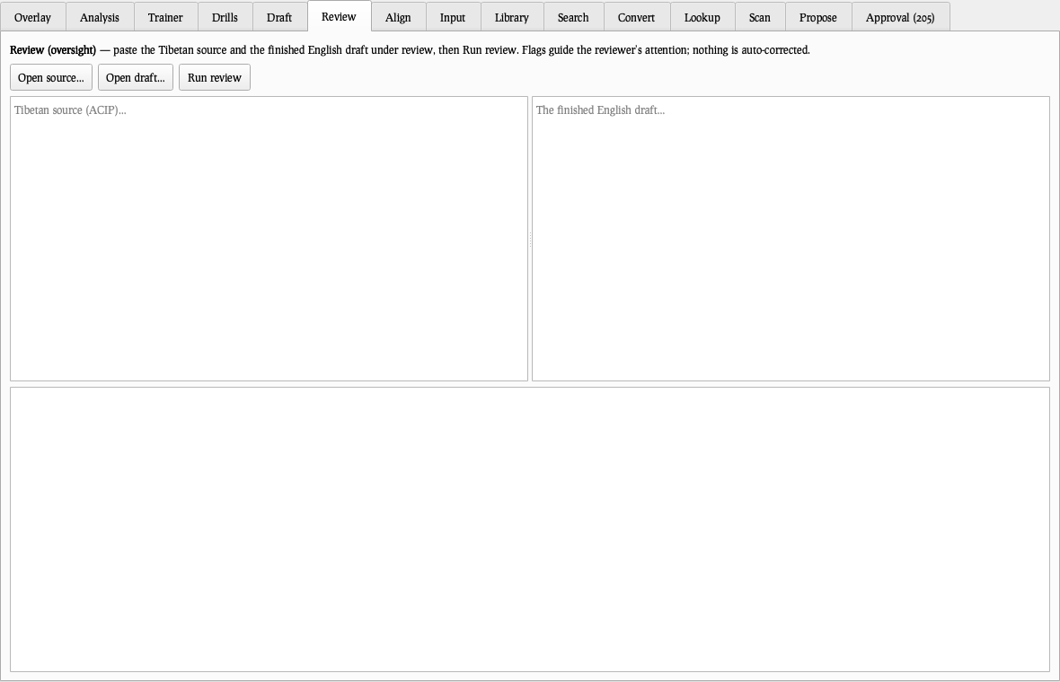
The composition surface: rich text with the corpus search beside it — the master’s attested English one “insert” away — and the publishing tools at hand.
6 Manuscript
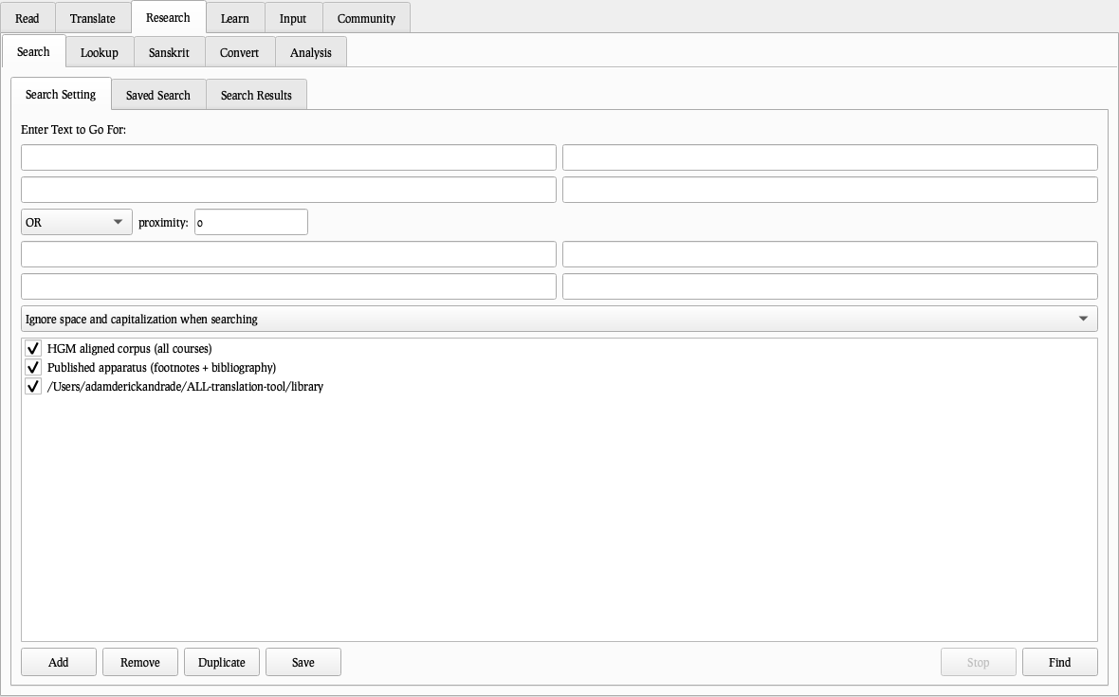
The composition surface: rich text with the corpus search beside it — the master’s attested English one “insert” away — and the publishing tools at hand.
7 Apparatus
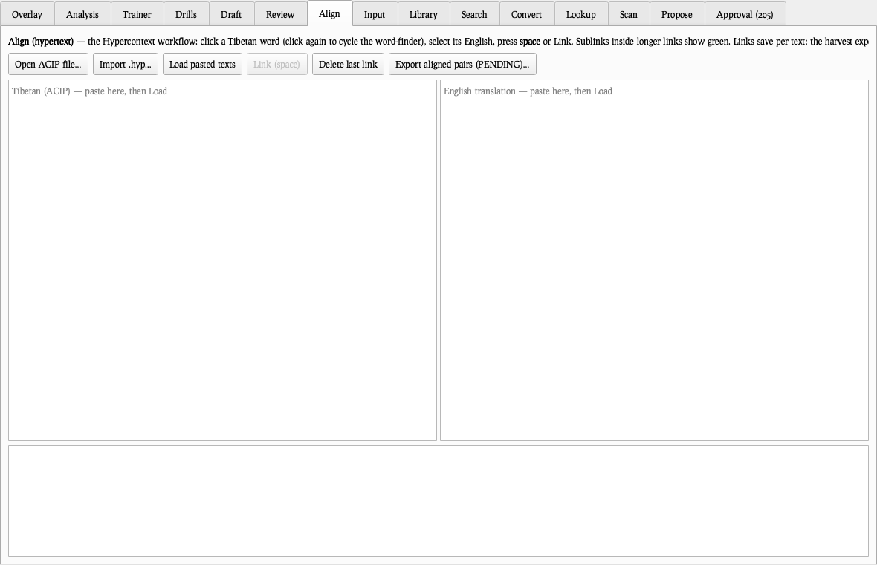
Every published footnote and bibliography entry from the released volumes, sequential and searchable — the official tier only, reusable with one click.
7 Apparatus
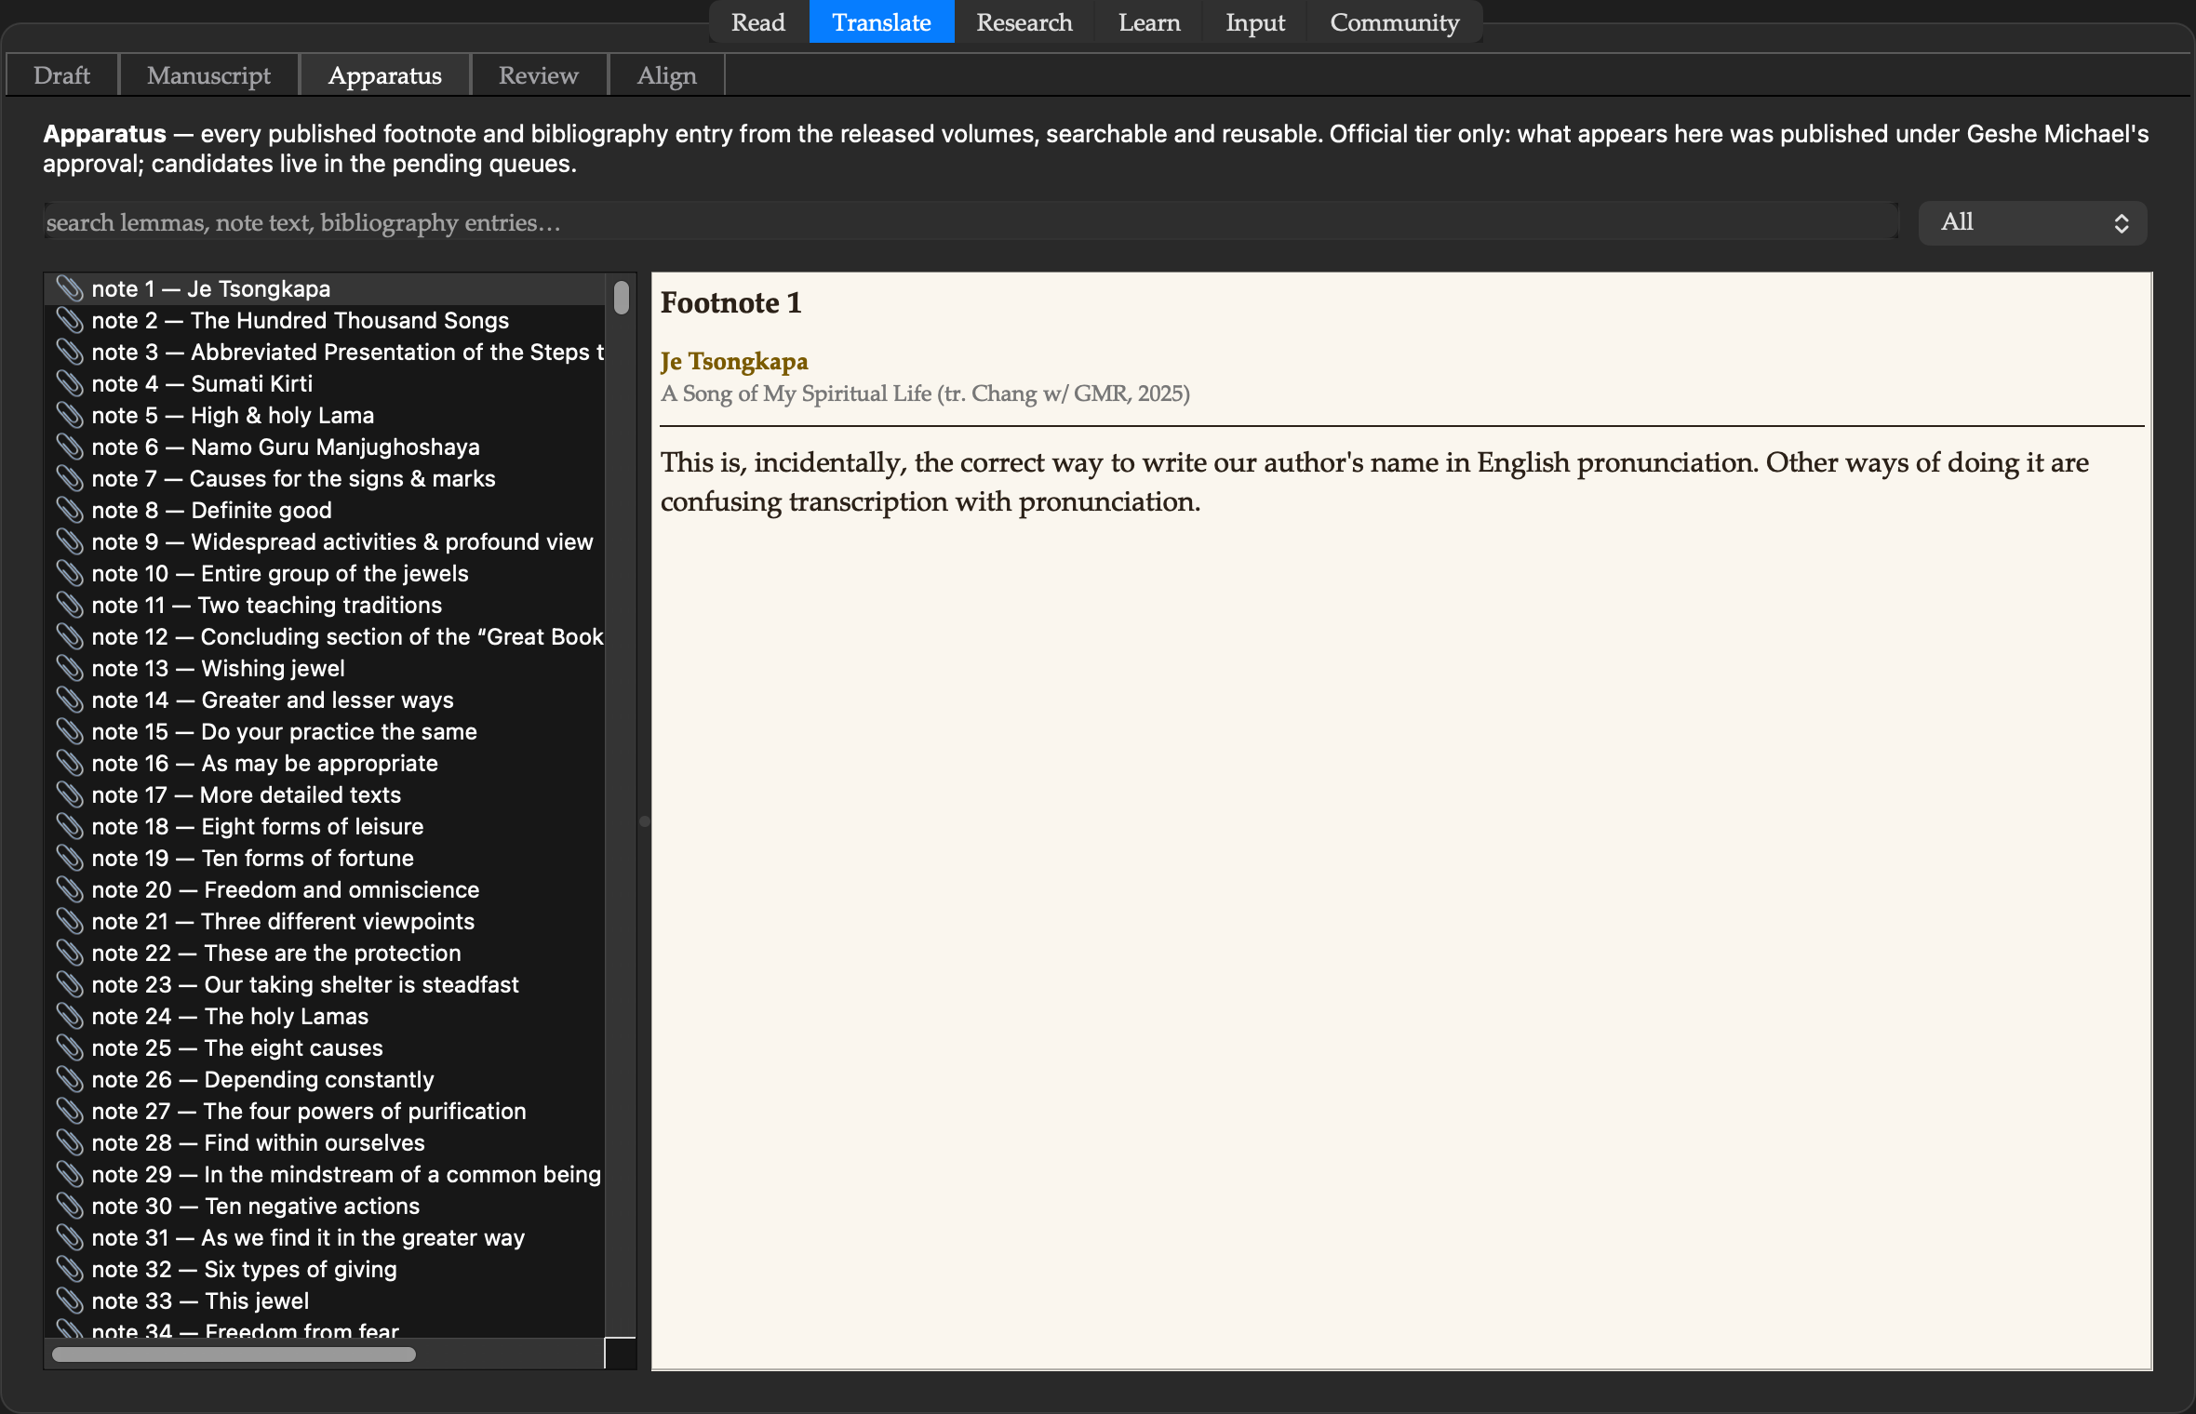
Every published footnote and bibliography entry from the released volumes, sequential and searchable — the official tier only, reusable with one click.
7 Apparatus
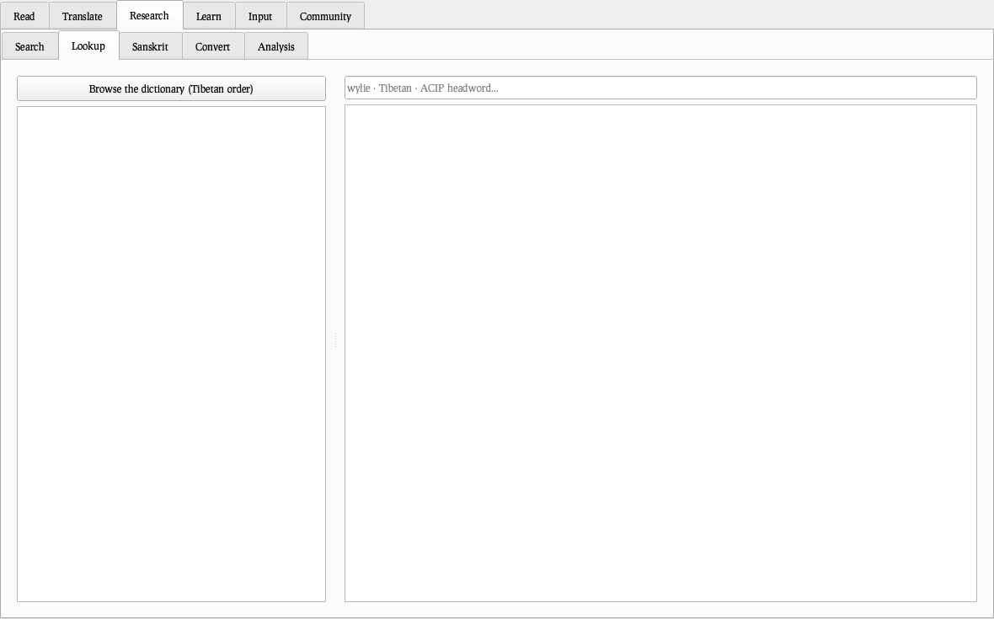
Every published footnote and bibliography entry from the released volumes, sequential and searchable — the official tier only, reusable with one click.
7 Apparatus
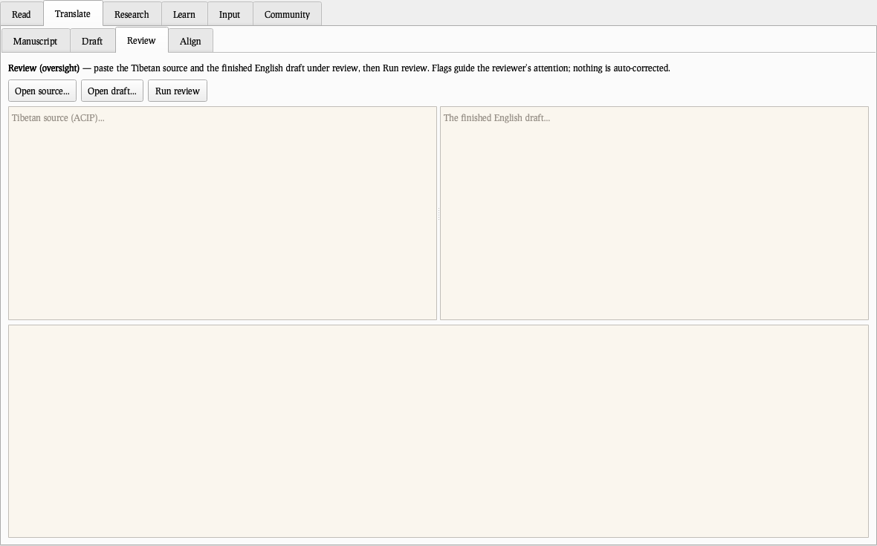
Every published footnote and bibliography entry from the released volumes, sequential and searchable — the official tier only, reusable with one click.
7 Apparatus
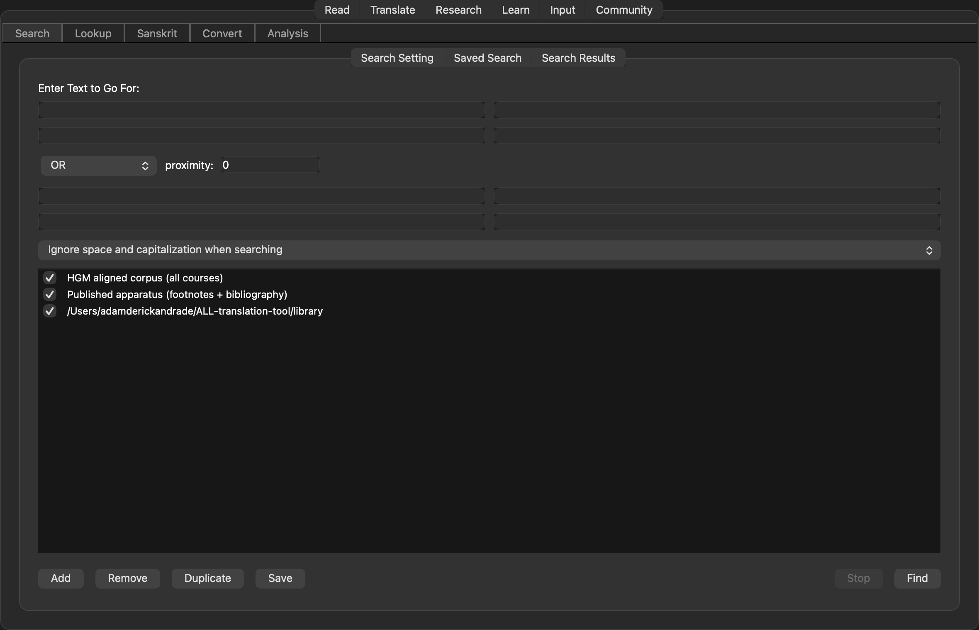
Every published footnote and bibliography entry from the released volumes, sequential and searchable — the official tier only, reusable with one click.
8 Review
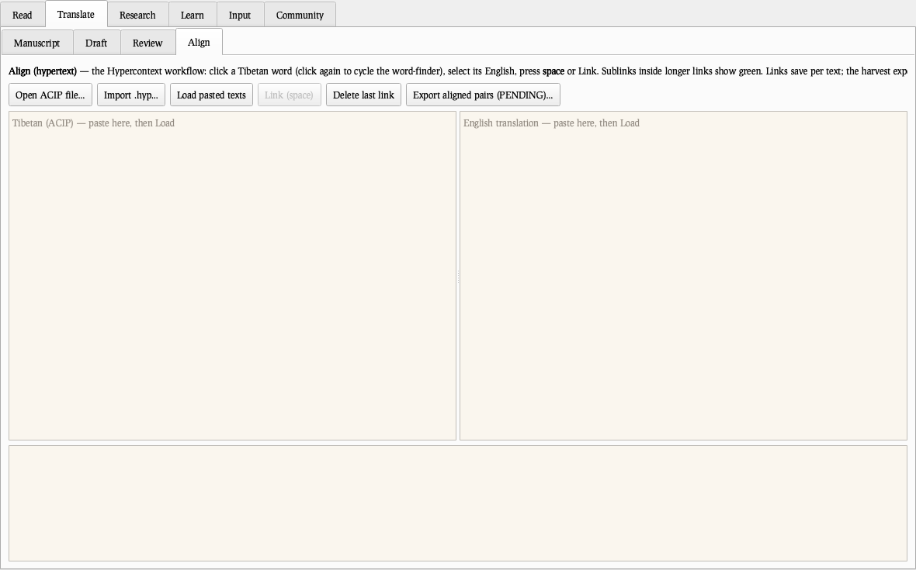
The overseer’s bench: register warnings, provisional-tier cautions, unmatched terms, collapsed distinctions. Guidance, never verdicts.
8 Review
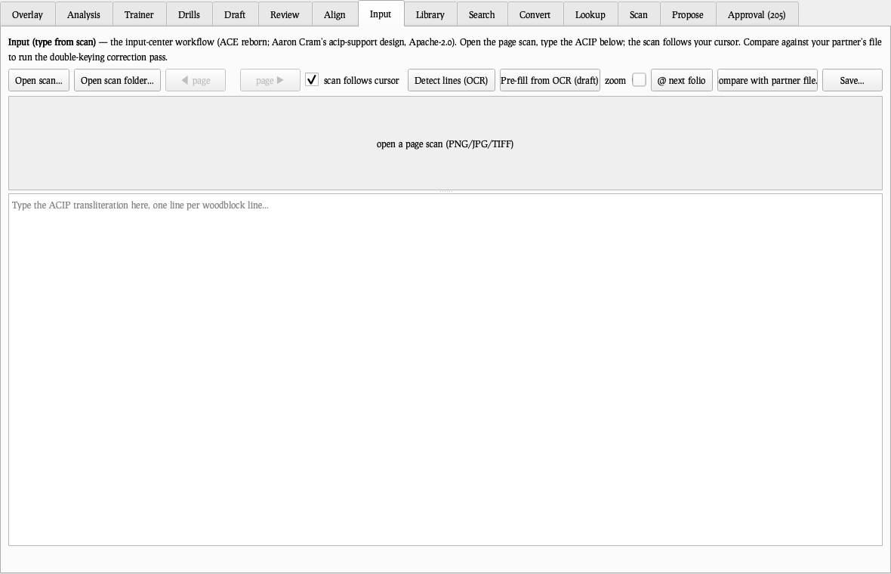
The overseer’s bench: register warnings, provisional-tier cautions, unmatched terms, collapsed distinctions. Guidance, never verdicts.
8 Review
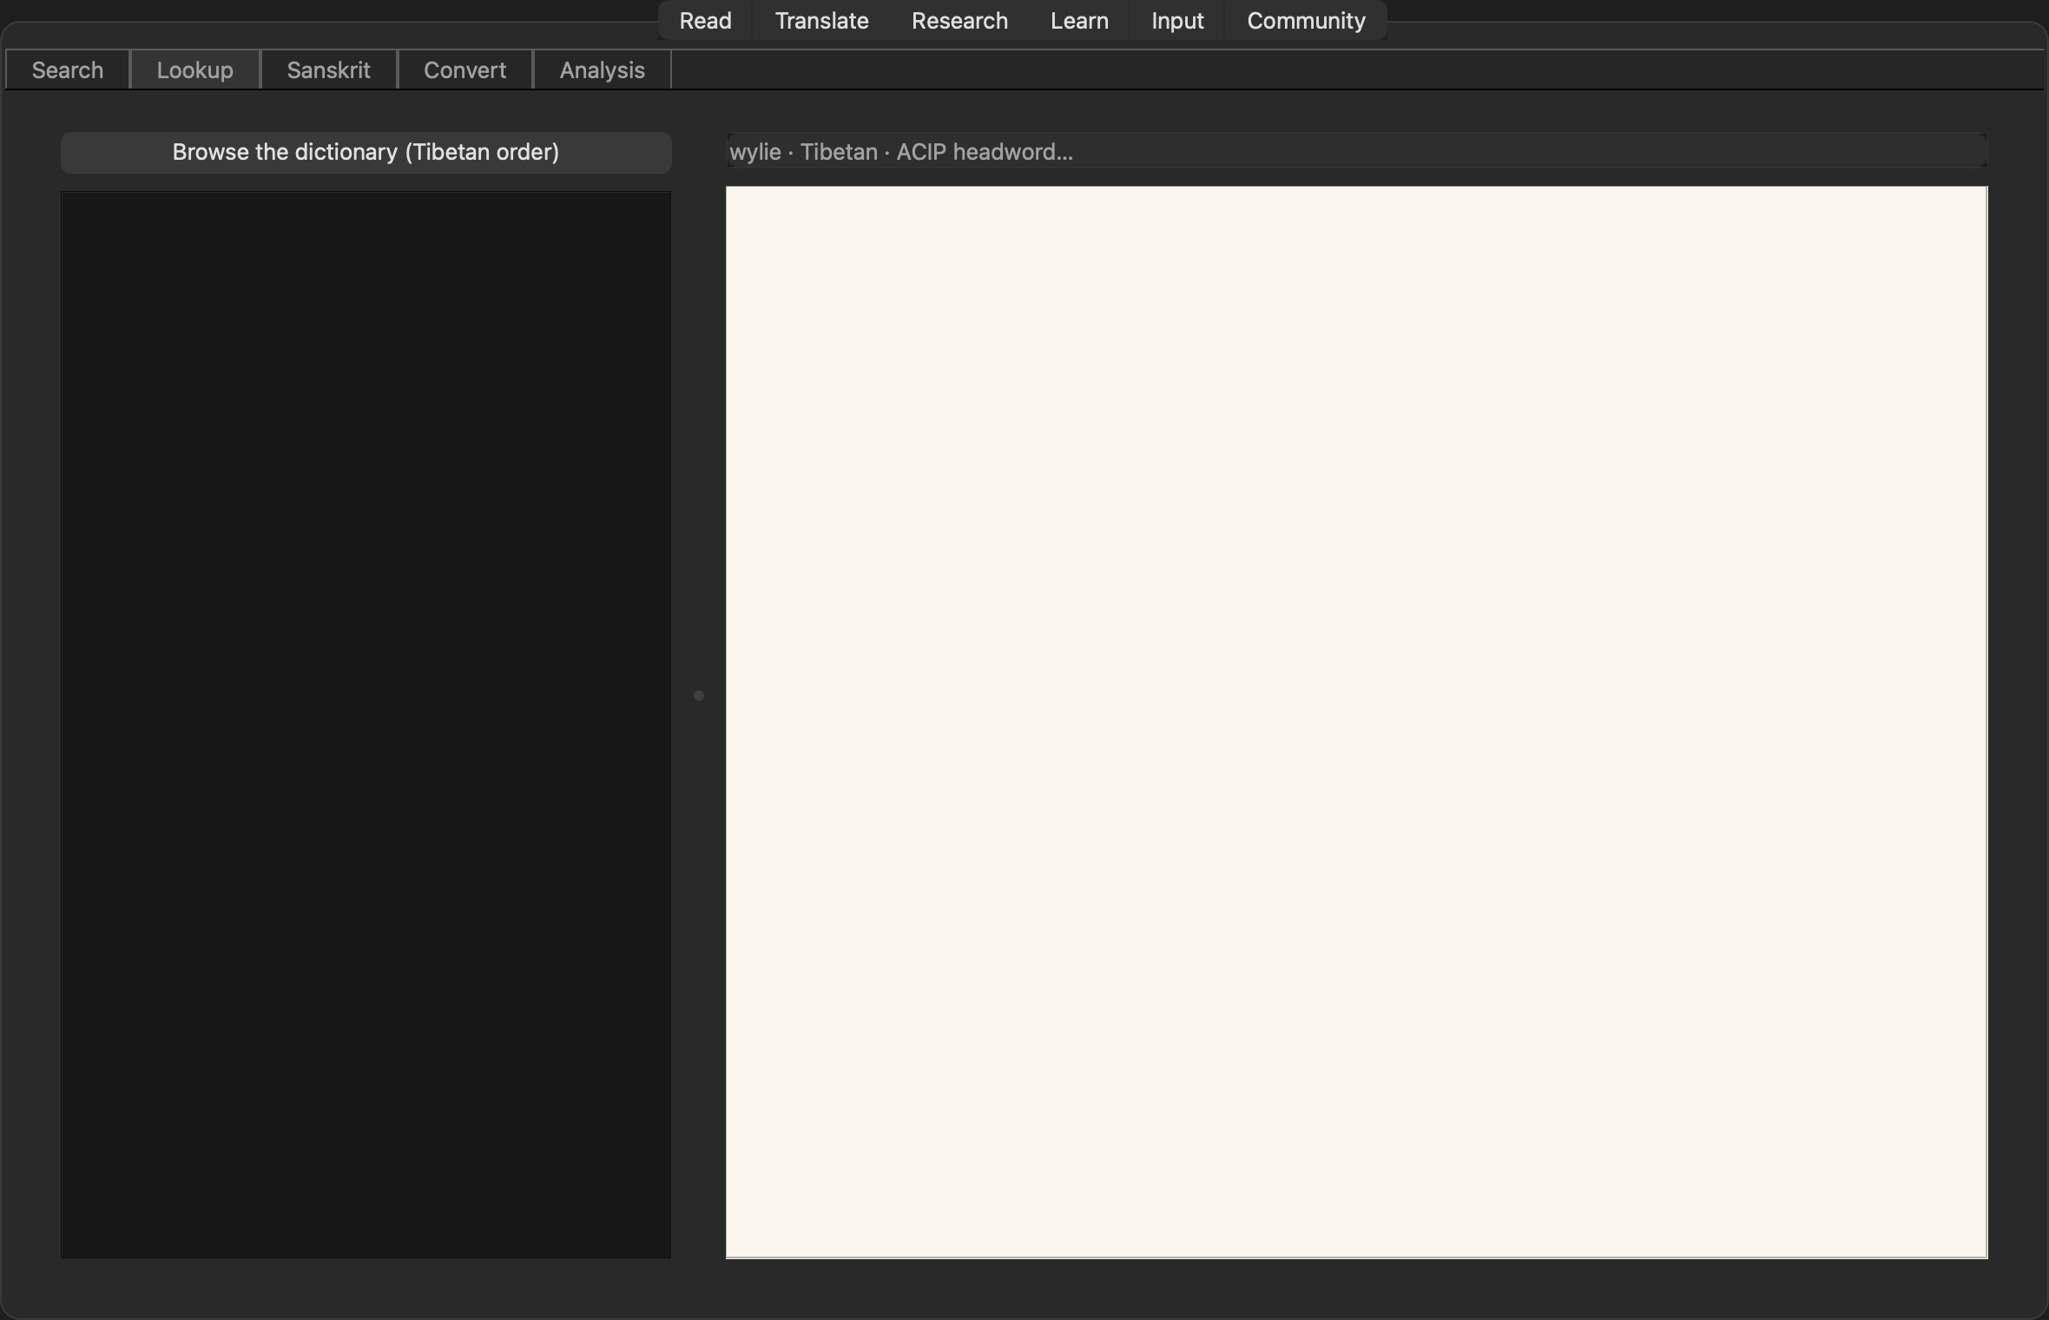
The overseer’s bench: register warnings, provisional-tier cautions, unmatched terms, collapsed distinctions. Guidance, never verdicts.
8 Review
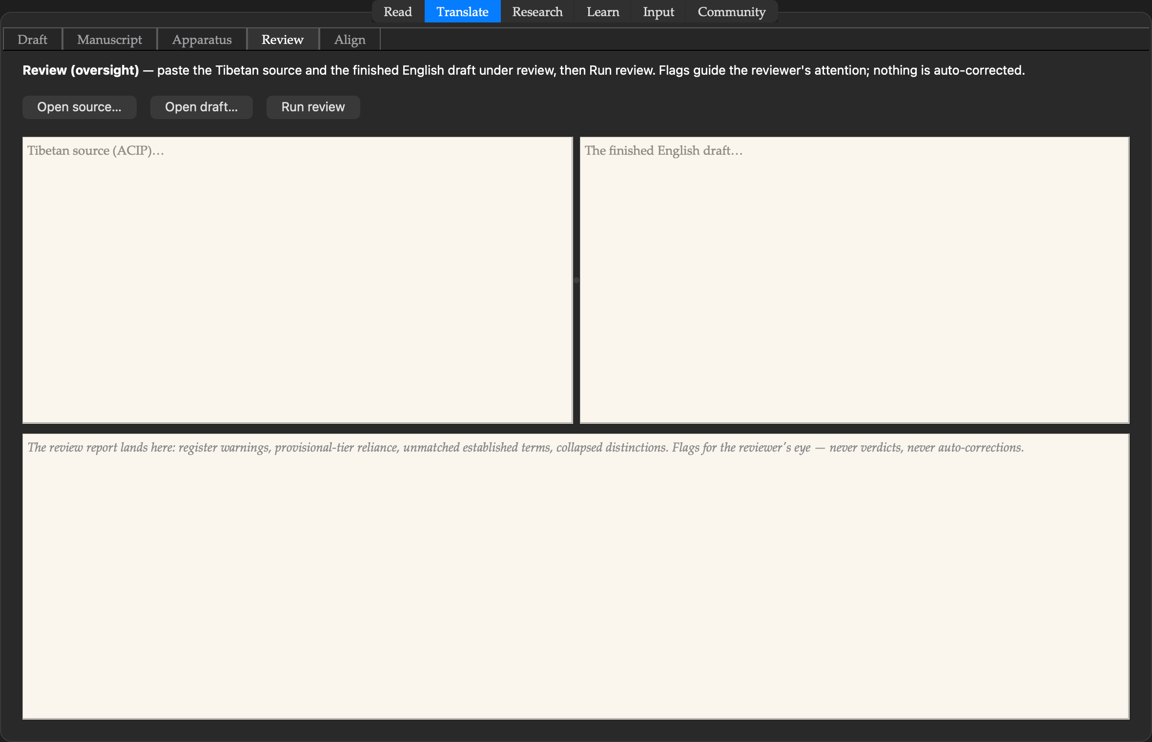
The overseer’s bench: register warnings, provisional-tier cautions, unmatched terms, collapsed distinctions. Guidance, never verdicts.
8 Review
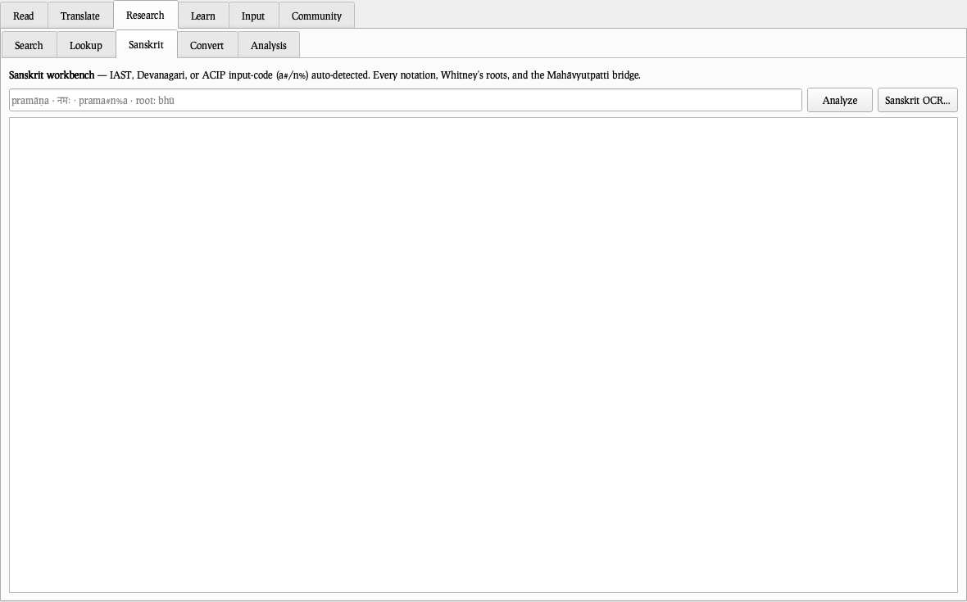
The overseer’s bench: register warnings, provisional-tier cautions, unmatched terms, collapsed distinctions. Guidance, never verdicts.
9 Align
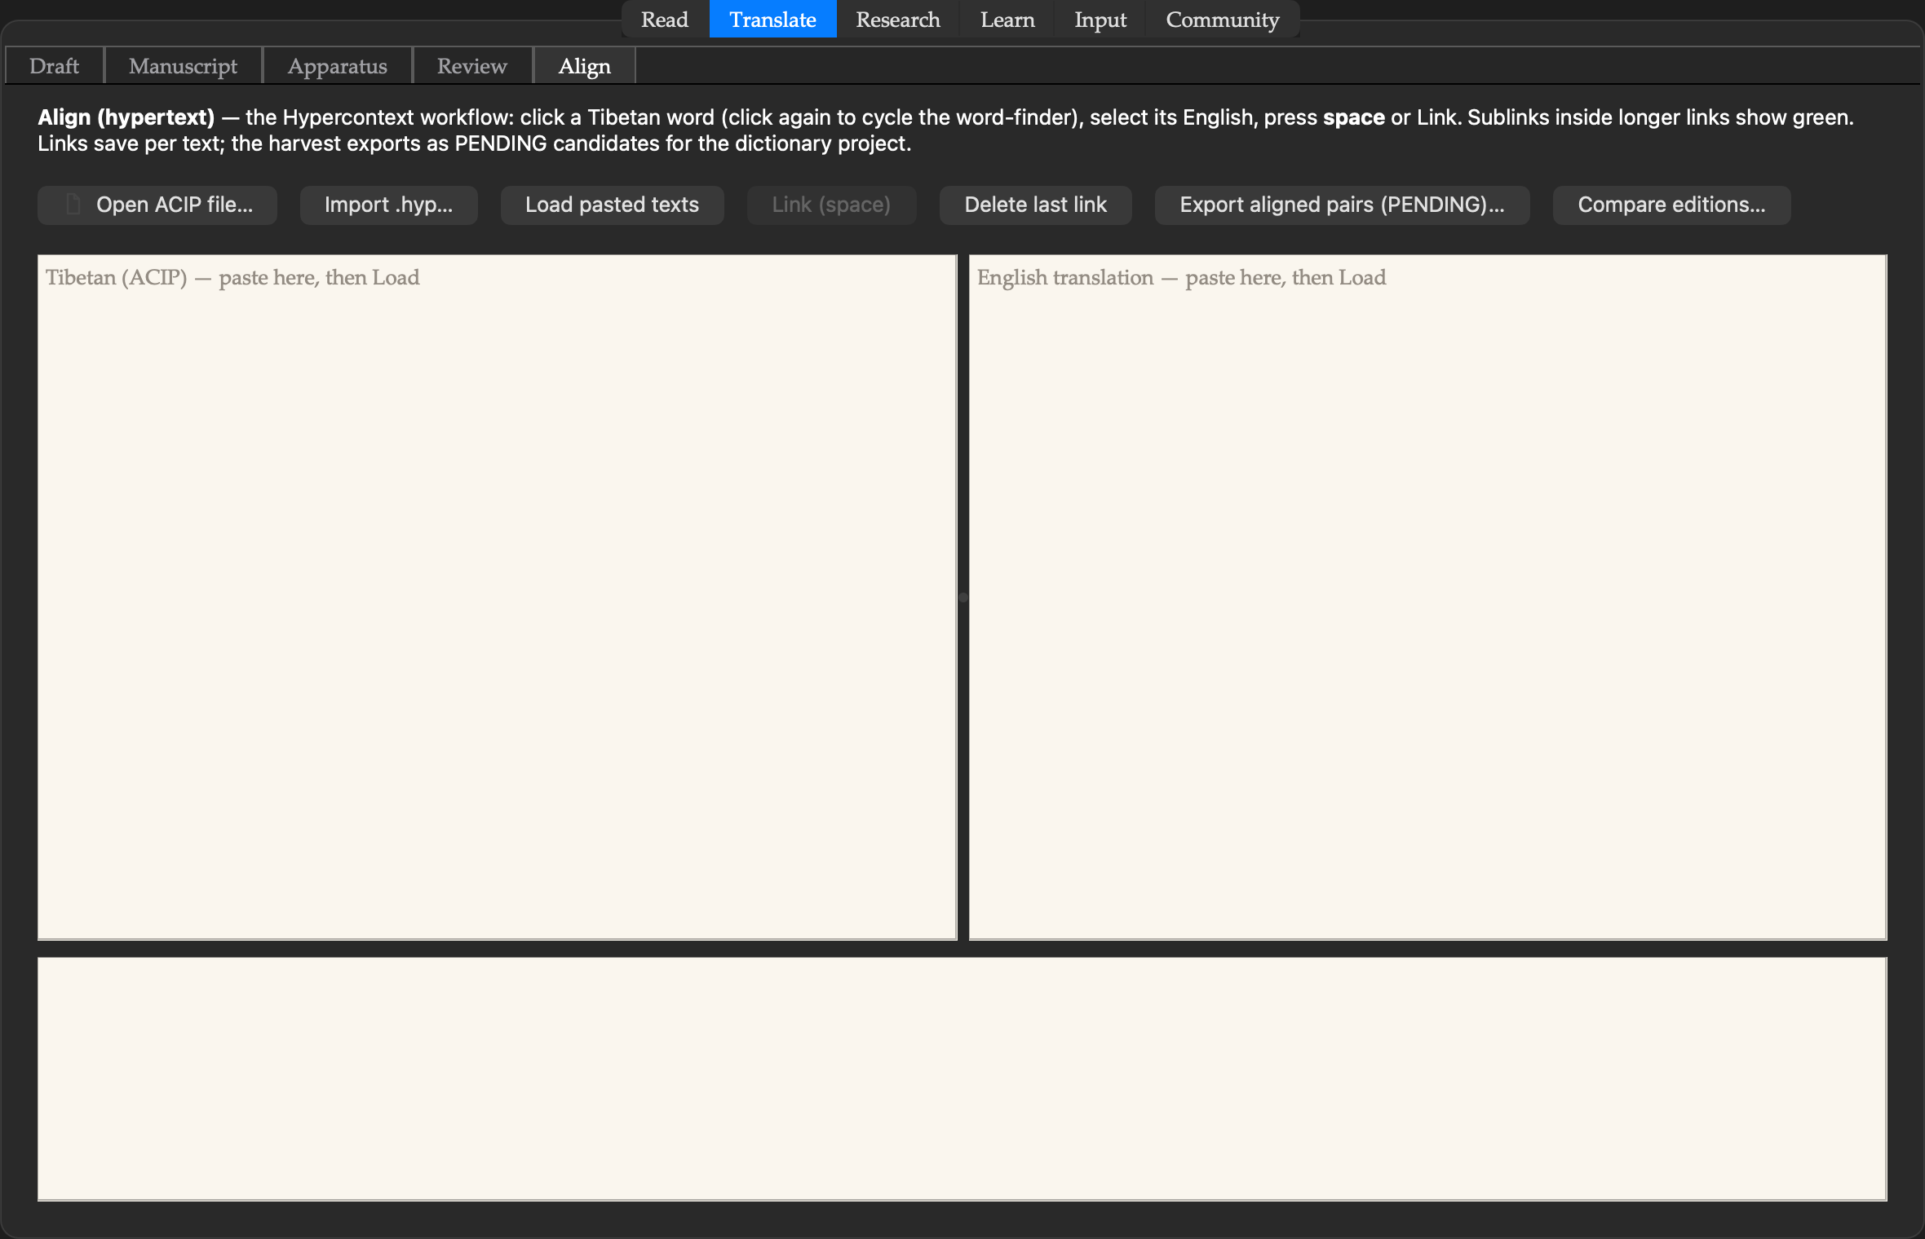
The dictionary-building workflow reborn from the Hypercontext era: align Tibetan and English, harvest PENDING pairs — and collate two editions of a text into a variant apparatus.
9 Align
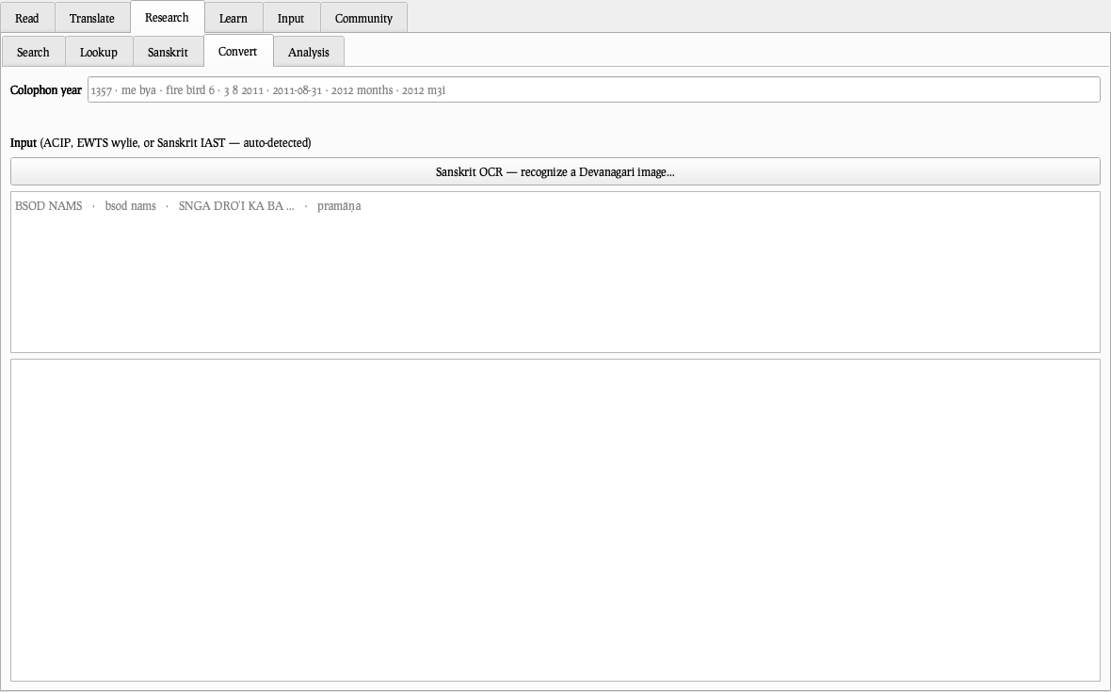
The dictionary-building workflow reborn from the Hypercontext era: align Tibetan and English, harvest PENDING pairs — and collate two editions of a text into a variant apparatus.
9 Align
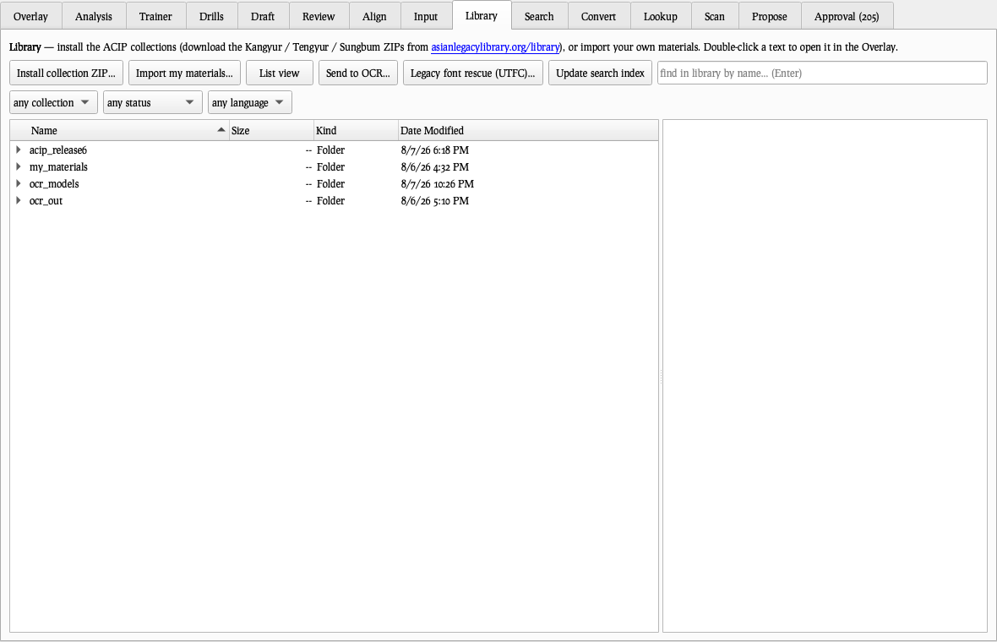
The dictionary-building workflow reborn from the Hypercontext era: align Tibetan and English, harvest PENDING pairs — and collate two editions of a text into a variant apparatus.
9 Align
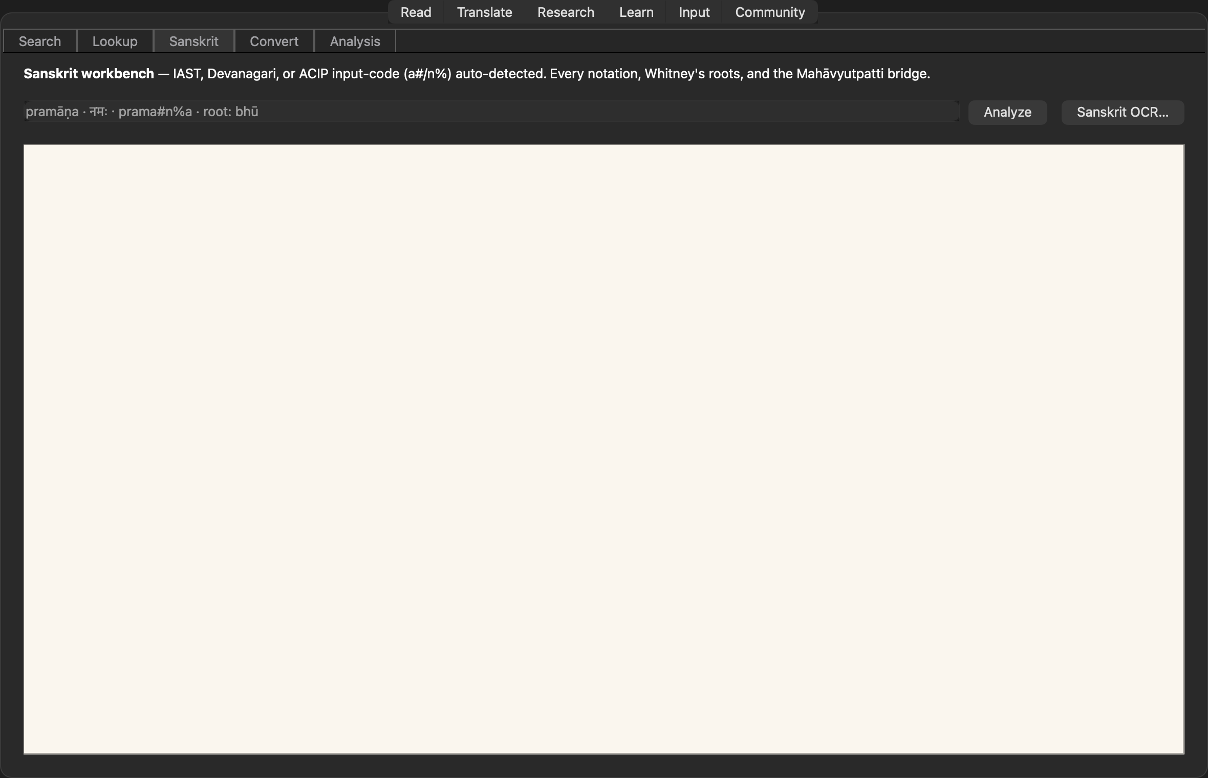
The dictionary-building workflow reborn from the Hypercontext era: align Tibetan and English, harvest PENDING pairs — and collate two editions of a text into a variant apparatus.
9 Align
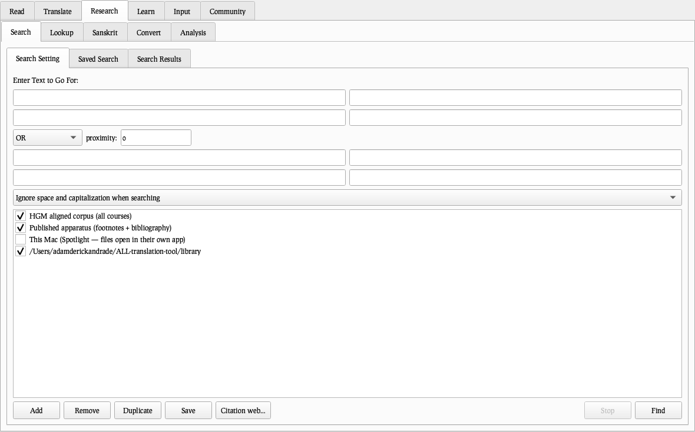
The dictionary-building workflow reborn from the Hypercontext era: align Tibetan and English, harvest PENDING pairs — and collate two editions of a text into a variant apparatus.
10 Search
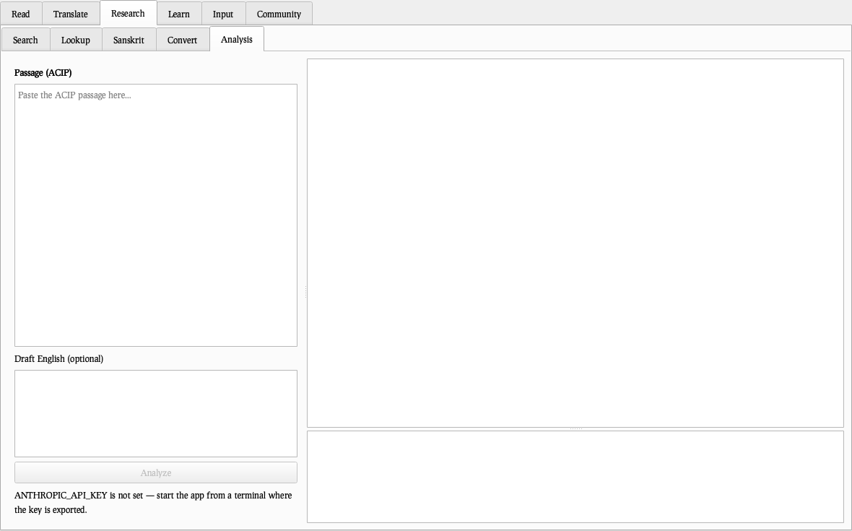
The classic Gofer grammar restored: OR and NEAR-within-N-lines across corpus, apparatus, Spotlight, and your own folders — folder results rolled up per file, one click opening the text at the hit.
10 Search
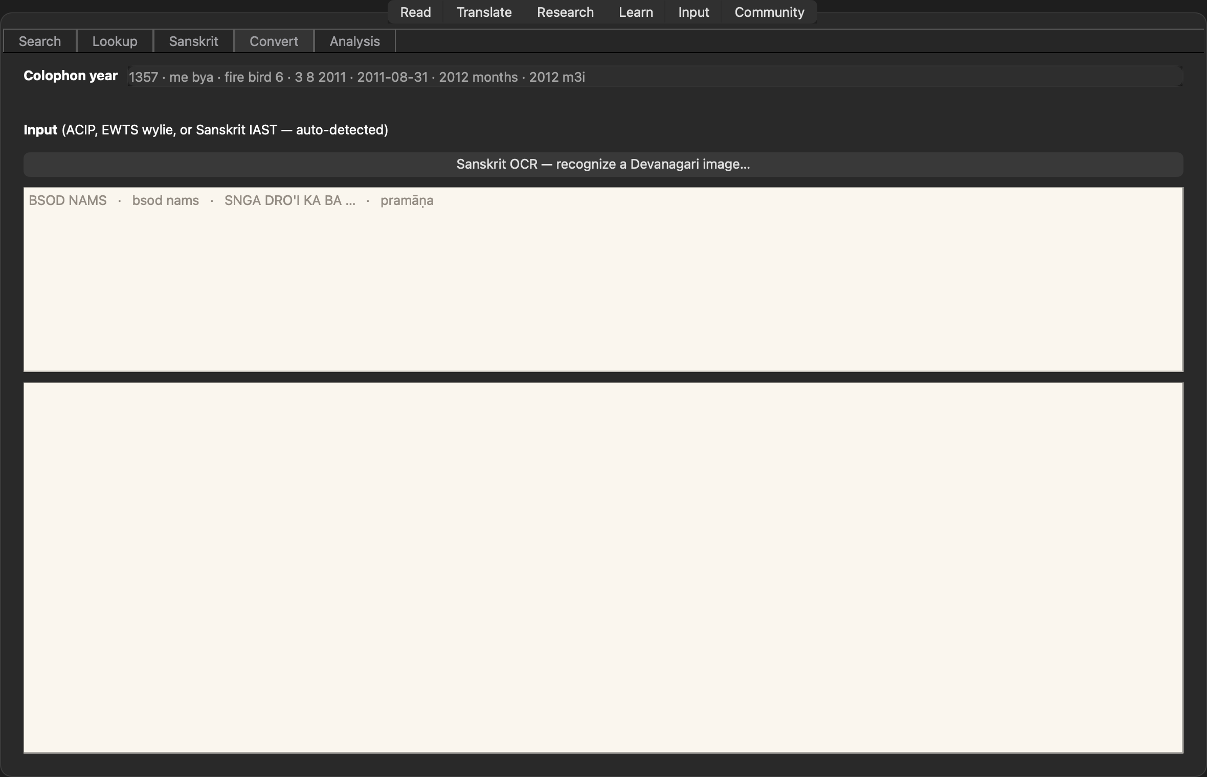
The classic Gofer grammar restored: OR and NEAR-within-N-lines across corpus, apparatus, Spotlight, and your own folders — folder results rolled up per file, one click opening the text at the hit.
10 Search
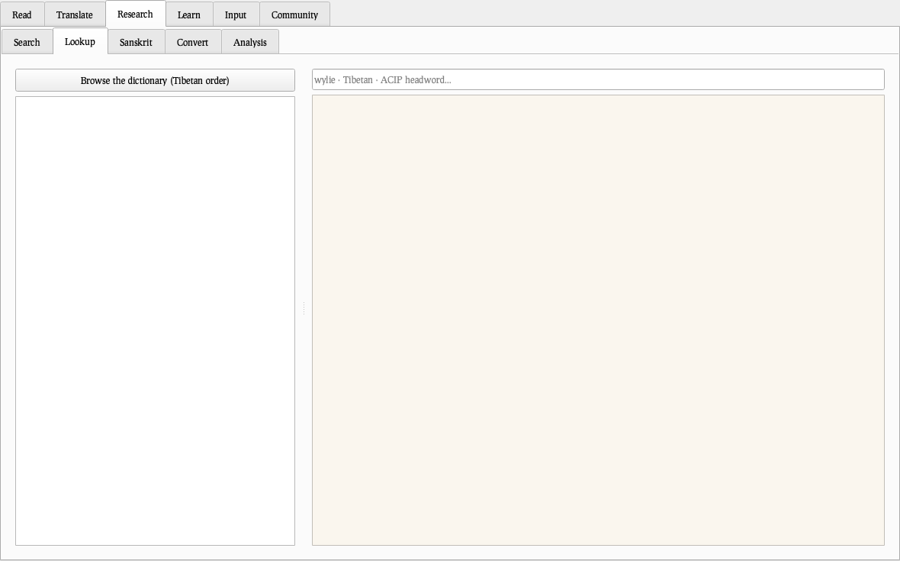
The classic Gofer grammar restored: OR and NEAR-within-N-lines across corpus, apparatus, Spotlight, and your own folders — folder results rolled up per file, one click opening the text at the hit.
10 Search
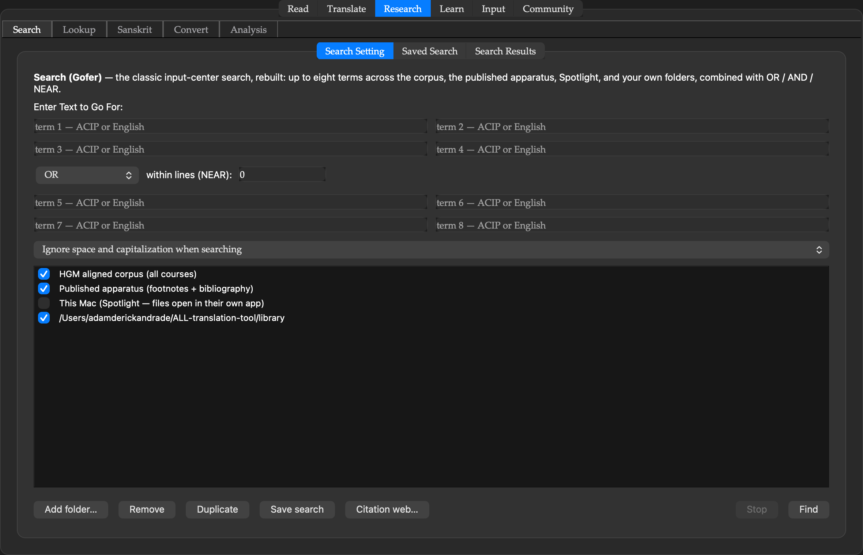
The classic Gofer grammar restored: OR and NEAR-within-N-lines across corpus, apparatus, Spotlight, and your own folders — folder results rolled up per file, one click opening the text at the hit.
11 Lookup
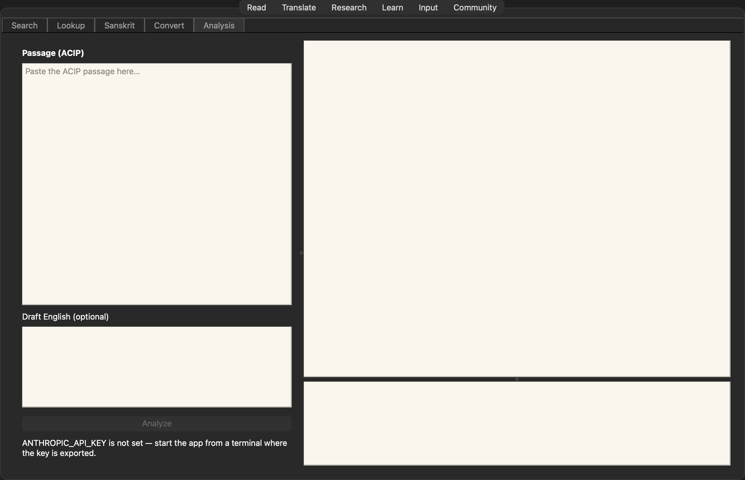
The stacked multi-dictionary: eight ways a query can land (headword, ACIP, English, pronunciation, ruled forms, community spellings, affix-stripped, browse), every layer labeled.
11 Lookup
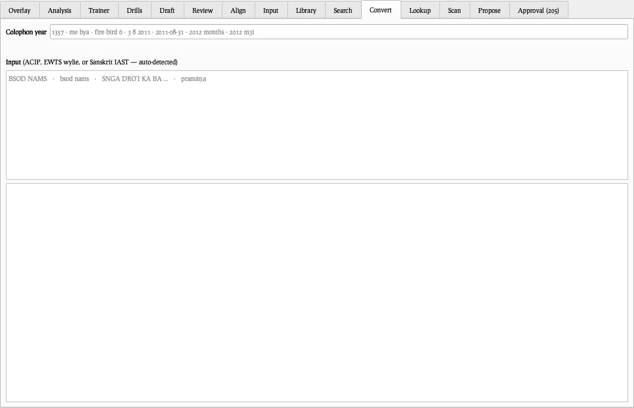
The stacked multi-dictionary: eight ways a query can land (headword, ACIP, English, pronunciation, ruled forms, community spellings, affix-stripped, browse), every layer labeled.
11 Lookup
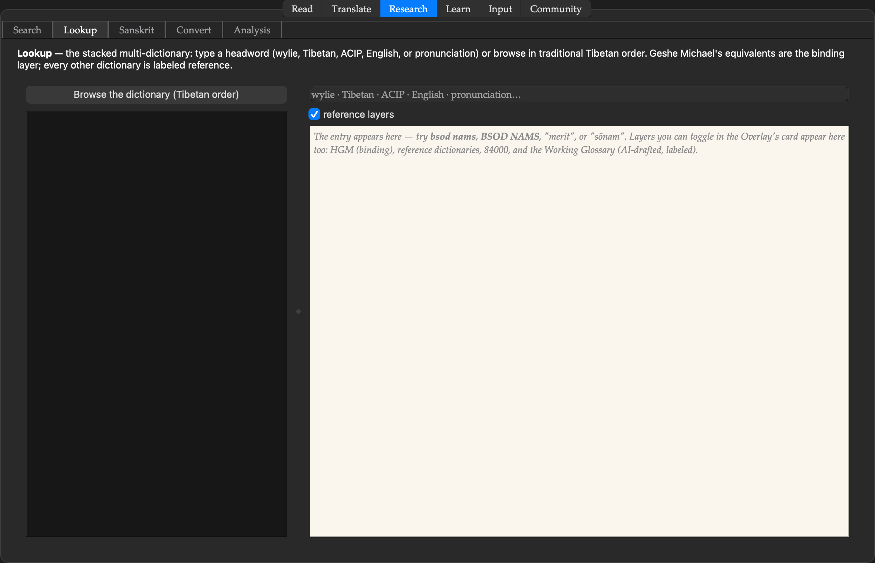
The stacked multi-dictionary: eight ways a query can land (headword, ACIP, English, pronunciation, ruled forms, community spellings, affix-stripped, browse), every layer labeled.
11 Lookup
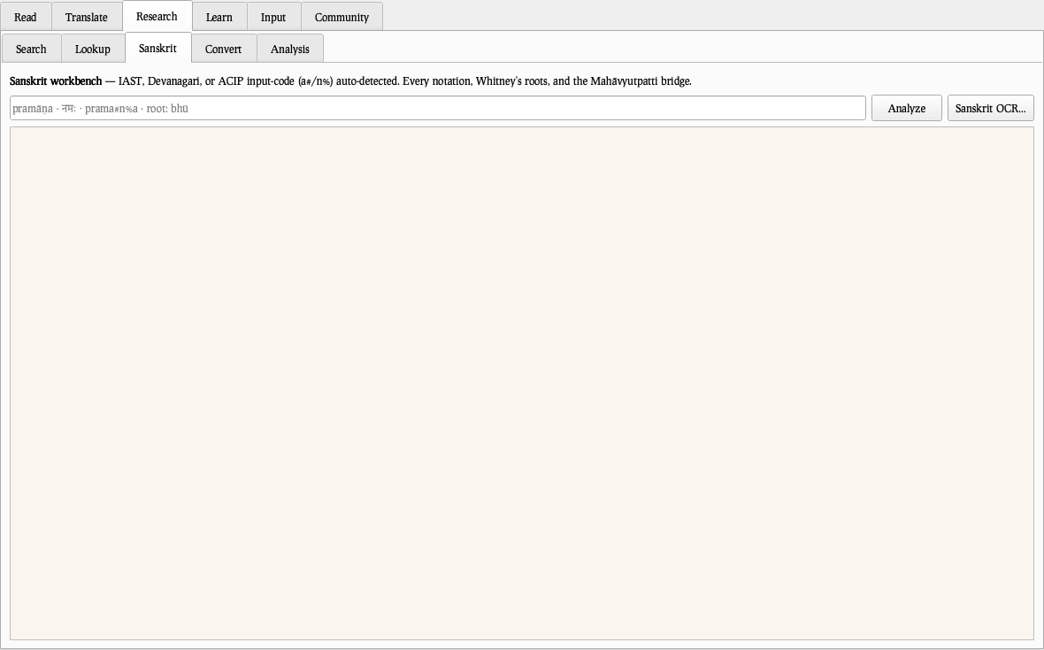
The stacked multi-dictionary: eight ways a query can land (headword, ACIP, English, pronunciation, ruled forms, community spellings, affix-stripped, browse), every layer labeled.
11 Lookup
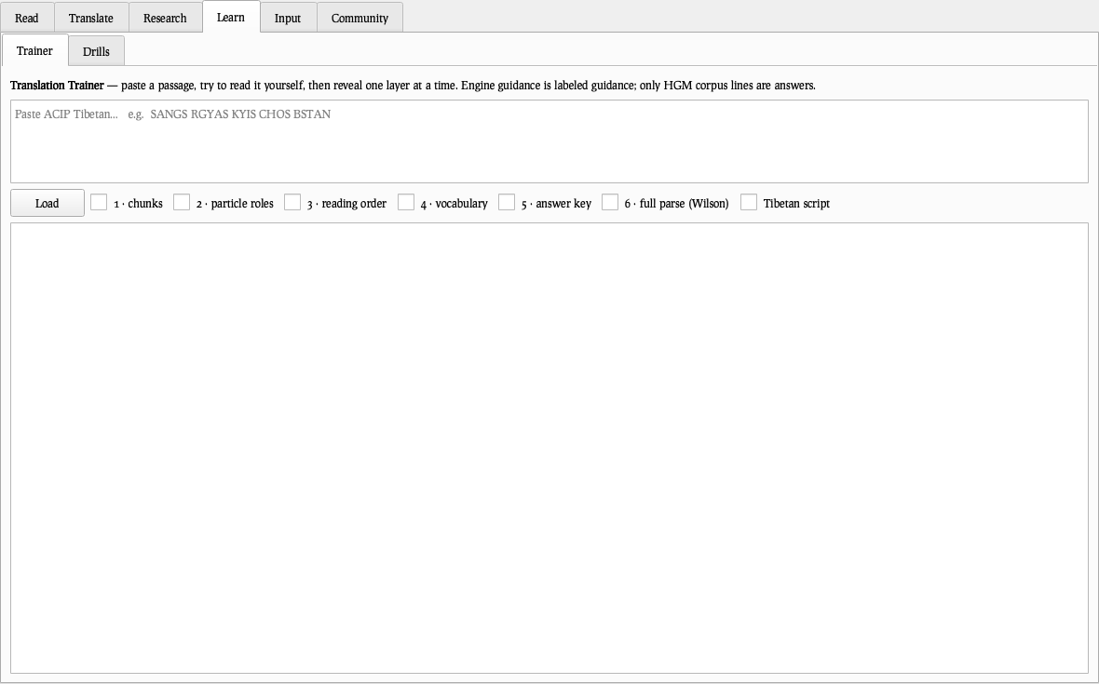
The stacked multi-dictionary: eight ways a query can land (headword, ACIP, English, pronunciation, ruled forms, community spellings, affix-stripped, browse), every layer labeled.
12 Sanskrit
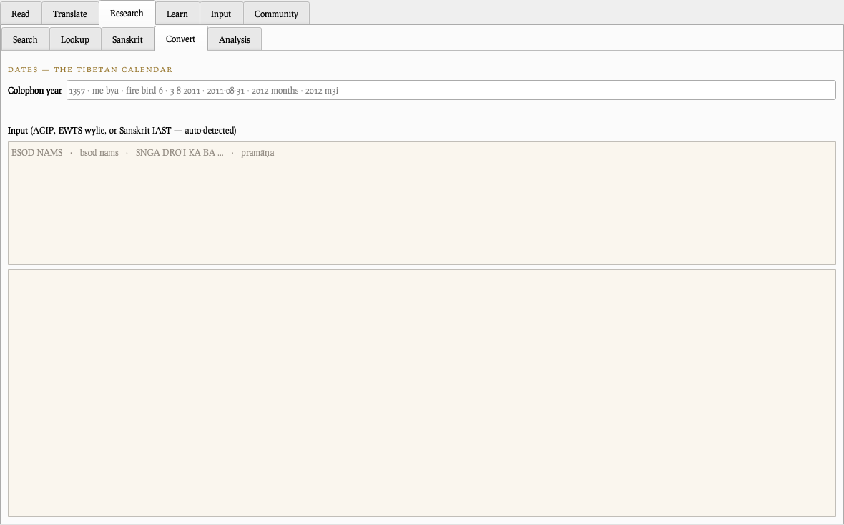
The Sanskrit workbench: every notation, Whitney’s roots and grammar, Monier-Williams deep links, and the Mahāvyutpatti bridge.
12 Sanskrit
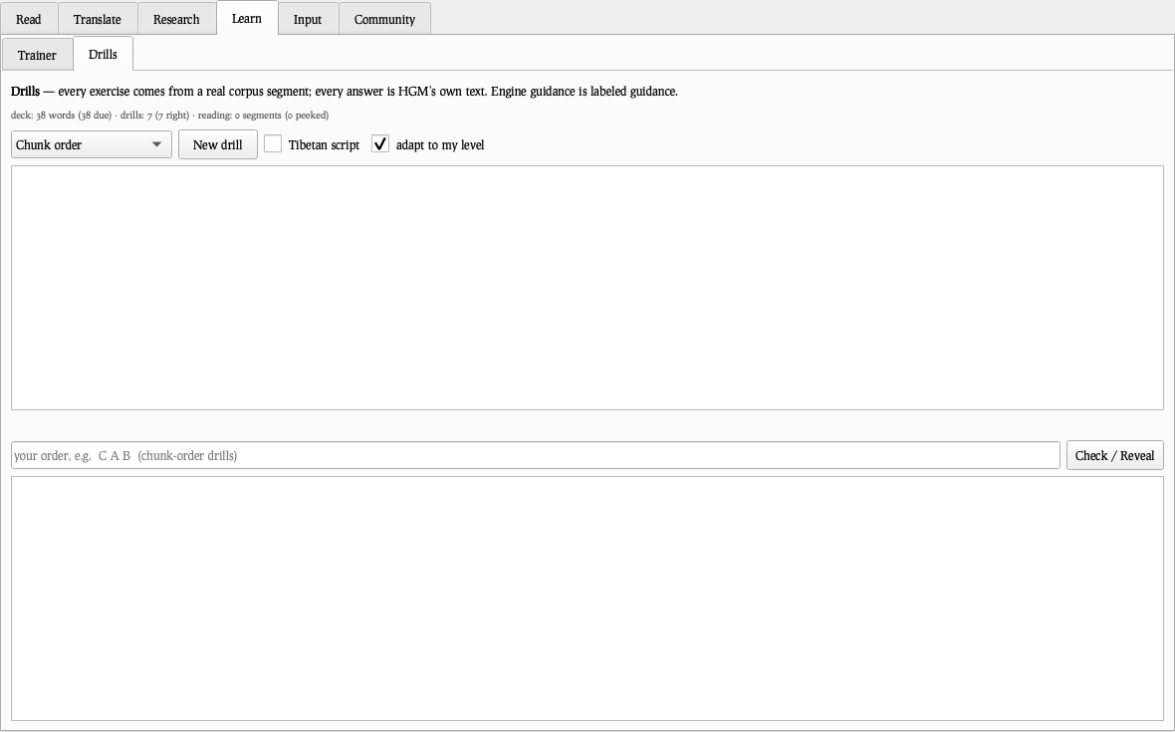
The Sanskrit workbench: every notation, Whitney’s roots and grammar, Monier-Williams deep links, and the Mahāvyutpatti bridge.
12 Sanskrit
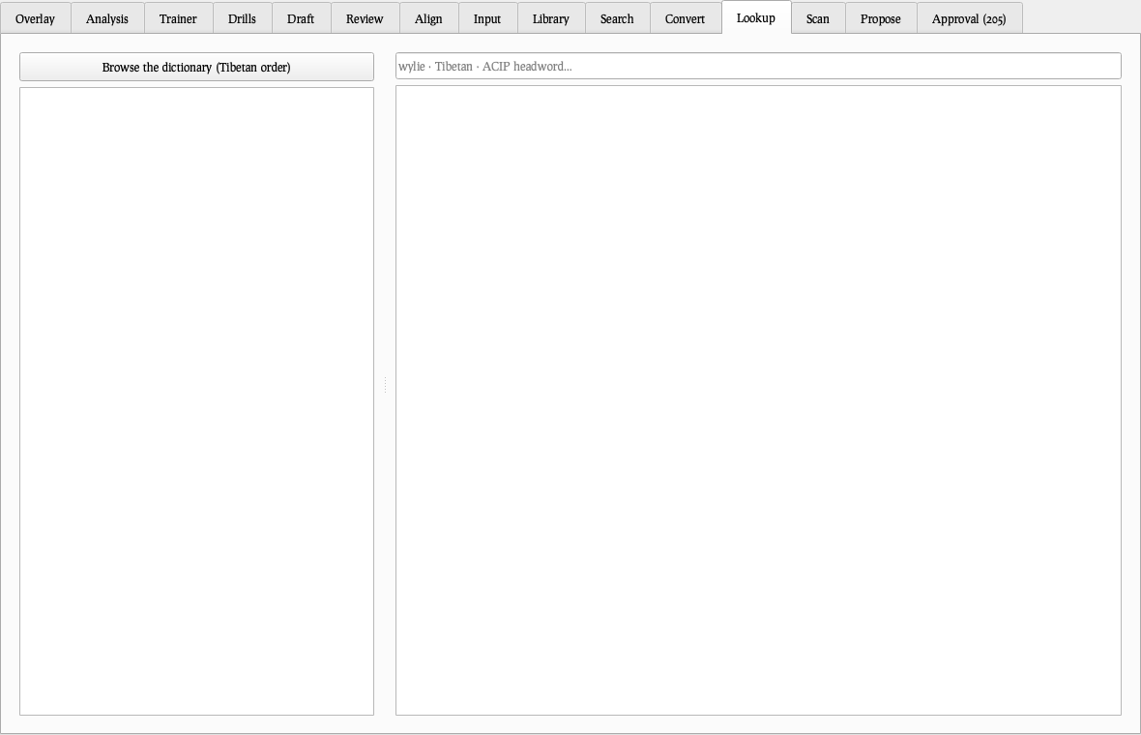
The Sanskrit workbench: every notation, Whitney’s roots and grammar, Monier-Williams deep links, and the Mahāvyutpatti bridge.
12 Sanskrit
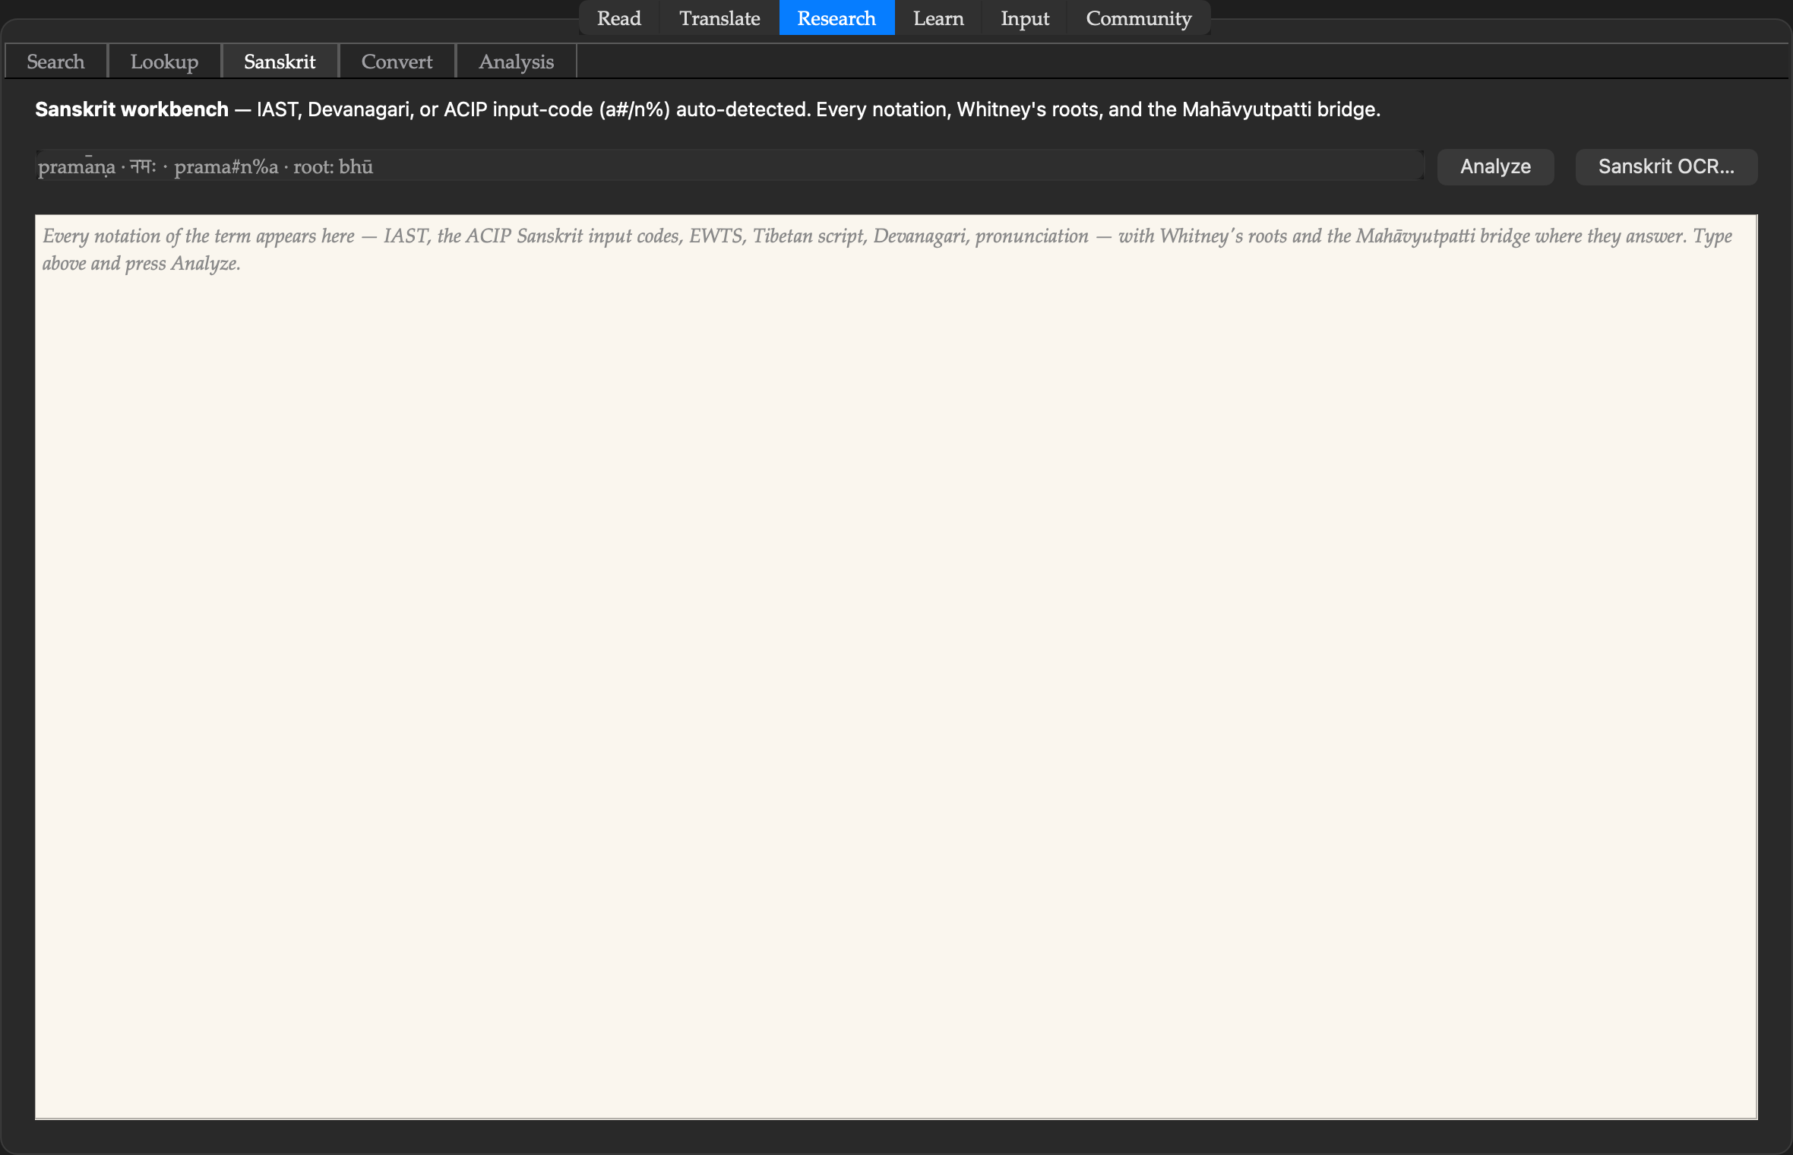
The Sanskrit workbench: every notation, Whitney’s roots and grammar, Monier-Williams deep links, and the Mahāvyutpatti bridge.
12 Sanskrit
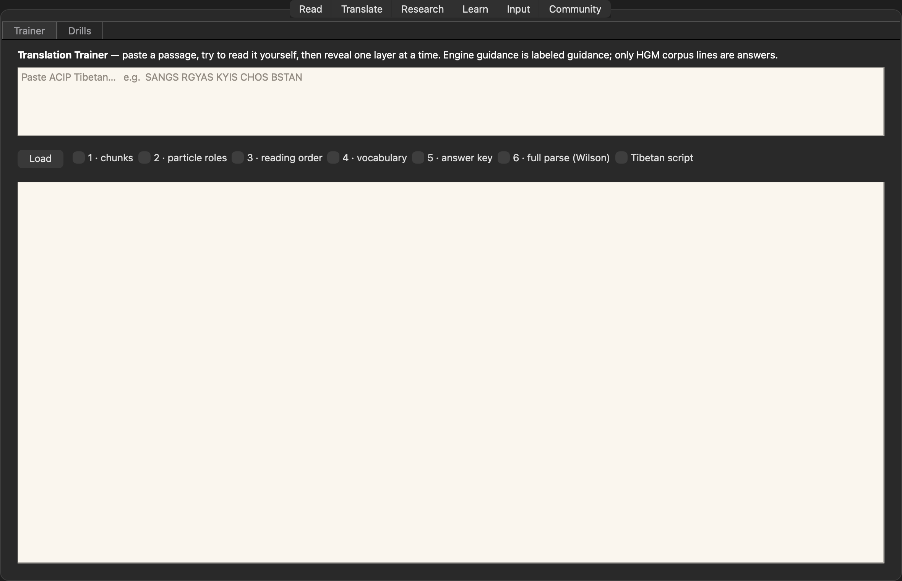
The Sanskrit workbench: every notation, Whitney’s roots and grammar, Monier-Williams deep links, and the Mahāvyutpatti bridge.
13 Convert
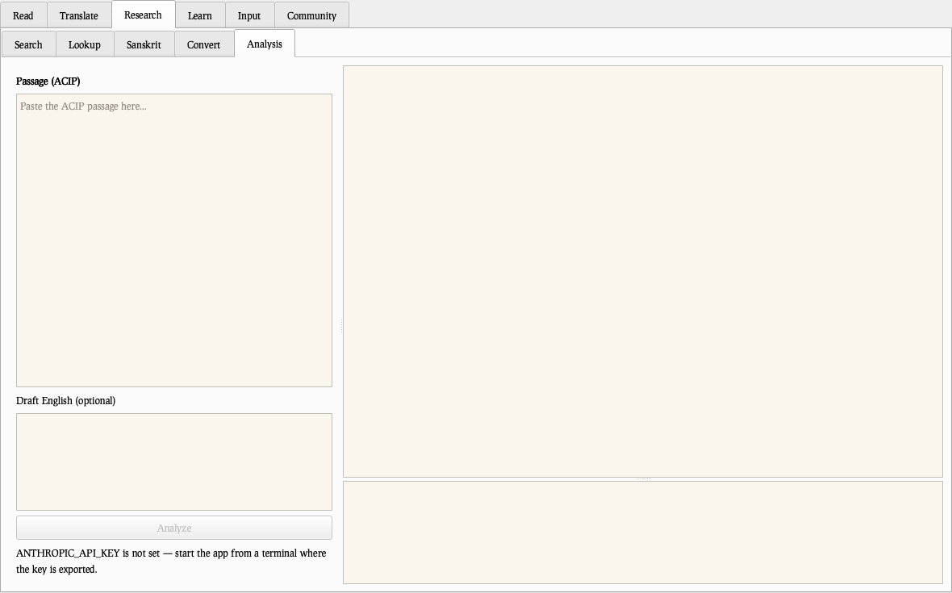
Every writing system live as you type — ACIP ⇄ Wylie ⇄ Tibetan script, both pronunciation conventions side by side, and the full Tibetan calendar.
13 Convert
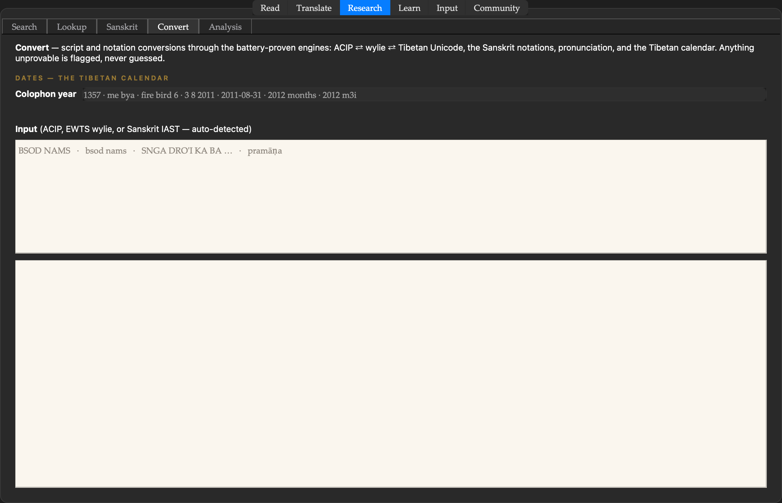
Every writing system live as you type — ACIP ⇄ Wylie ⇄ Tibetan script, both pronunciation conventions side by side, and the full Tibetan calendar.
13 Convert
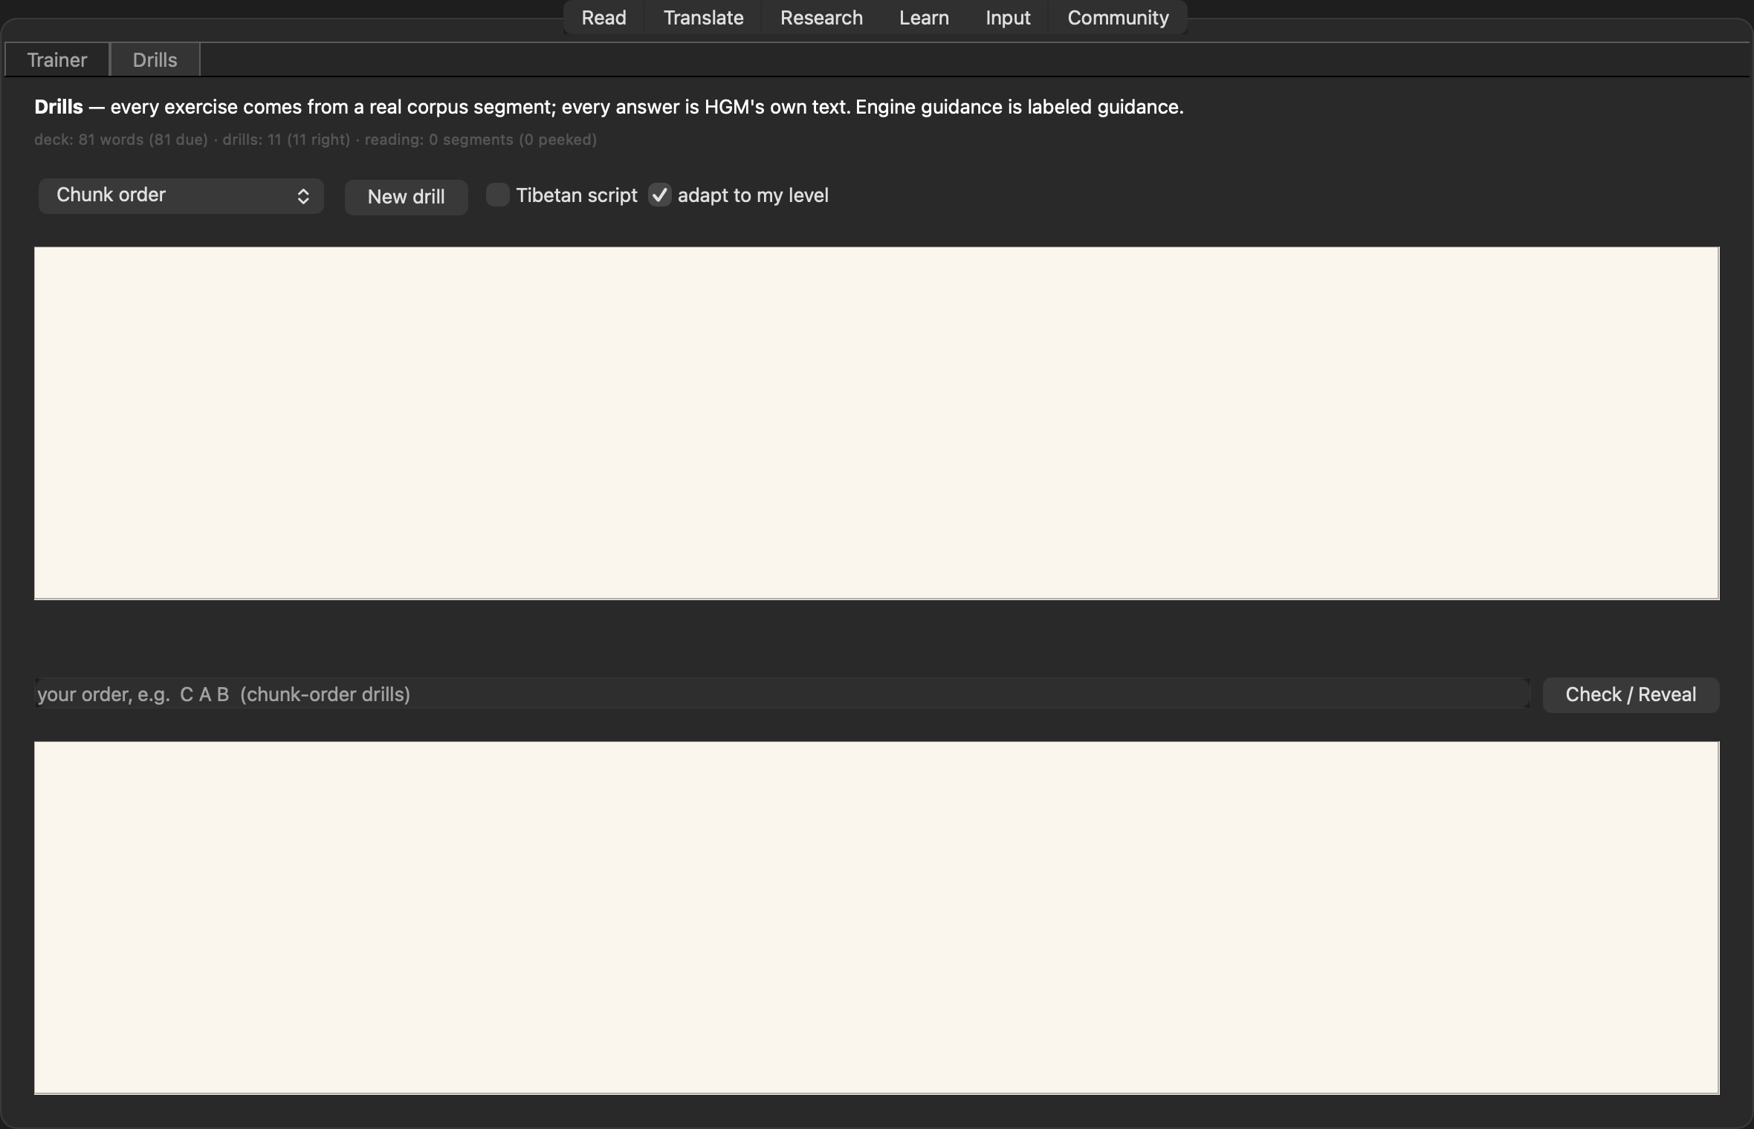
Every writing system live as you type — ACIP ⇄ Wylie ⇄ Tibetan script, both pronunciation conventions side by side, and the full Tibetan calendar.
13 Convert
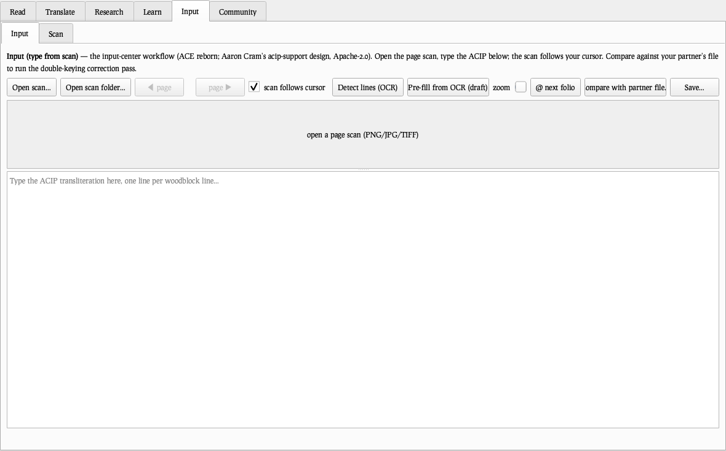
Every writing system live as you type — ACIP ⇄ Wylie ⇄ Tibetan script, both pronunciation conventions side by side, and the full Tibetan calendar.
13 Convert
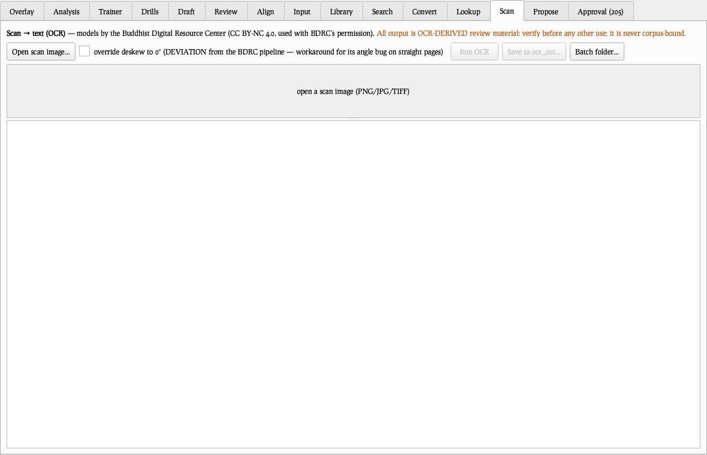
Every writing system live as you type — ACIP ⇄ Wylie ⇄ Tibetan script, both pronunciation conventions side by side, and the full Tibetan calendar.
14 Analysis
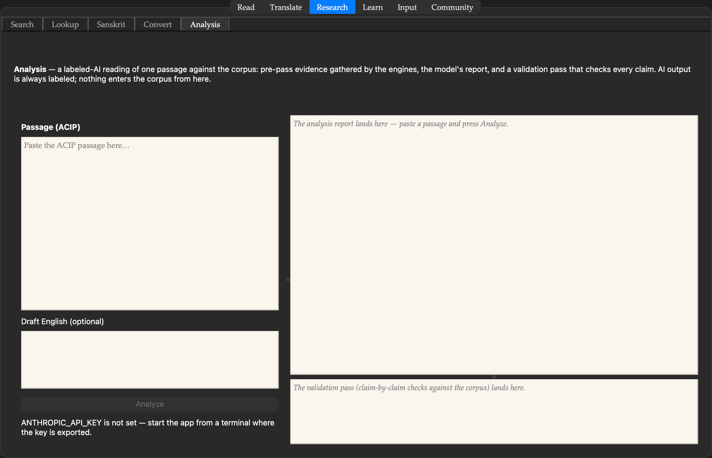
The labeled-AI reading of one passage: engine pre-pass evidence, the model’s report, and a validation pass that re-checks every claim. Always banner-labeled.
14 Analysis
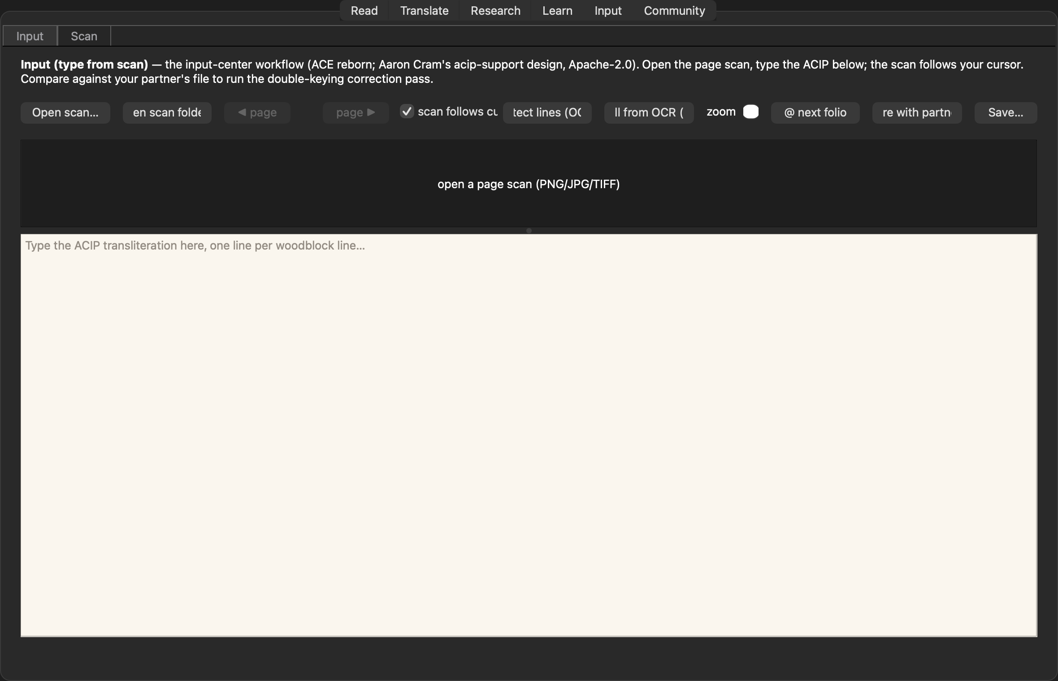
The labeled-AI reading of one passage: engine pre-pass evidence, the model’s report, and a validation pass that re-checks every claim. Always banner-labeled.
14 Analysis
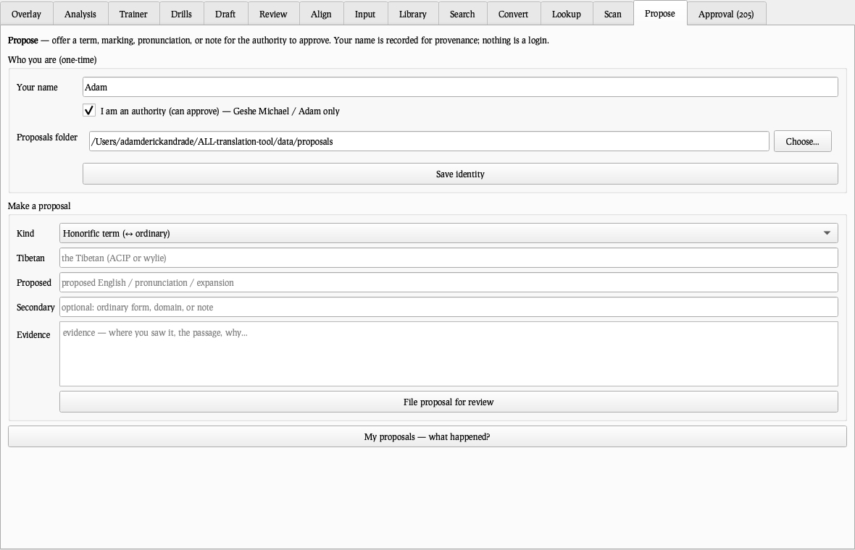
The labeled-AI reading of one passage: engine pre-pass evidence, the model’s report, and a validation pass that re-checks every claim. Always banner-labeled.
14 Analysis
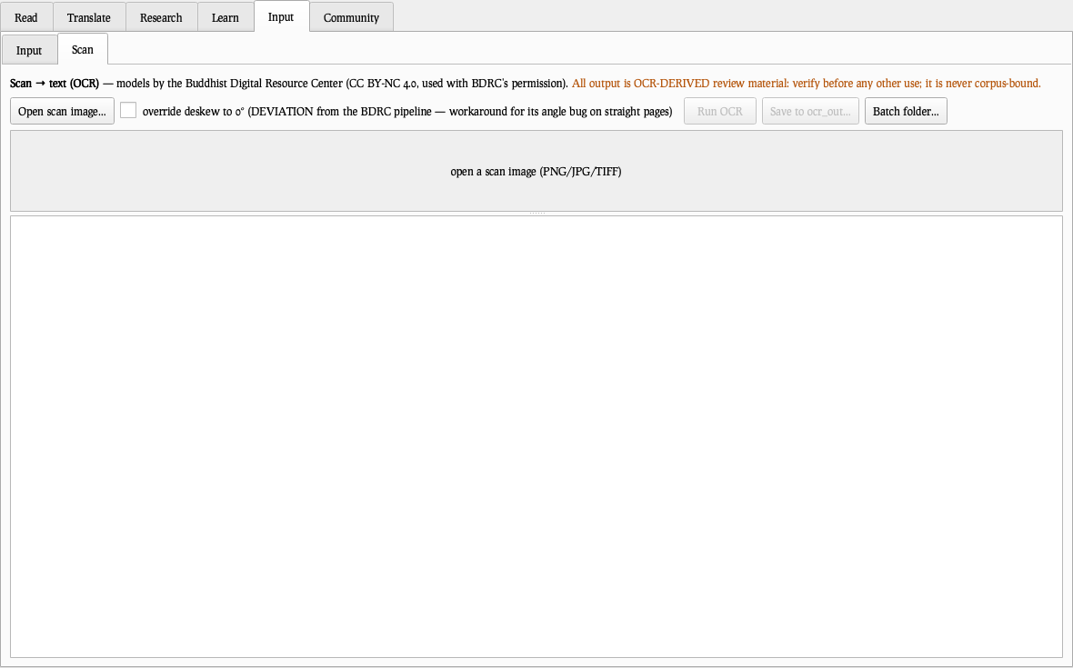
The labeled-AI reading of one passage: engine pre-pass evidence, the model’s report, and a validation pass that re-checks every claim. Always banner-labeled.
14 Analysis
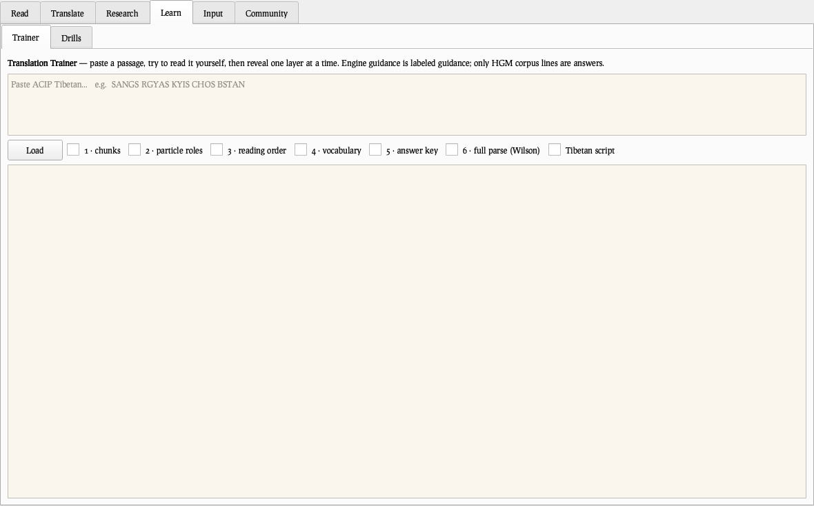
The labeled-AI reading of one passage: engine pre-pass evidence, the model’s report, and a validation pass that re-checks every claim. Always banner-labeled.
15 Trainer
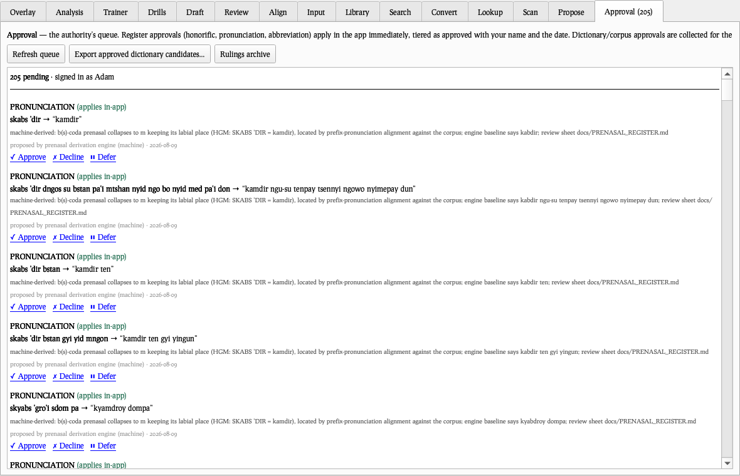
Learning to read, layer by layer: clause boundaries, particle roles, reading order, vocabulary, then the answer key — the master’s own English wherever the passage lives in his corpus.
15 Trainer
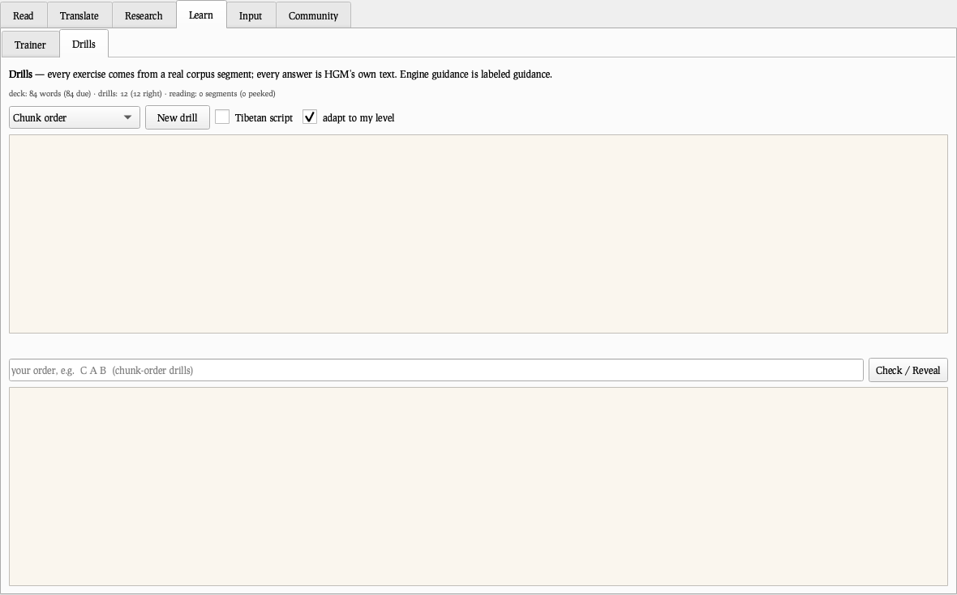
Learning to read, layer by layer: clause boundaries, particle roles, reading order, vocabulary, then the answer key — the master’s own English wherever the passage lives in his corpus.
15 Trainer
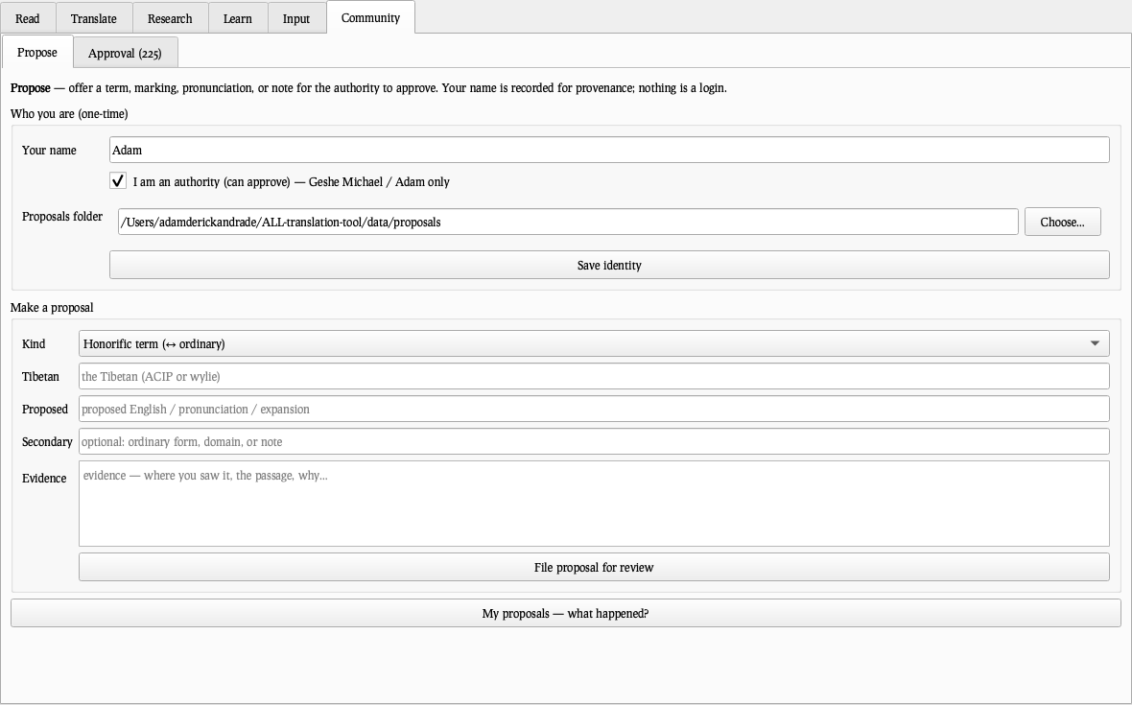
Learning to read, layer by layer: clause boundaries, particle roles, reading order, vocabulary, then the answer key — the master’s own English wherever the passage lives in his corpus.
15 Trainer
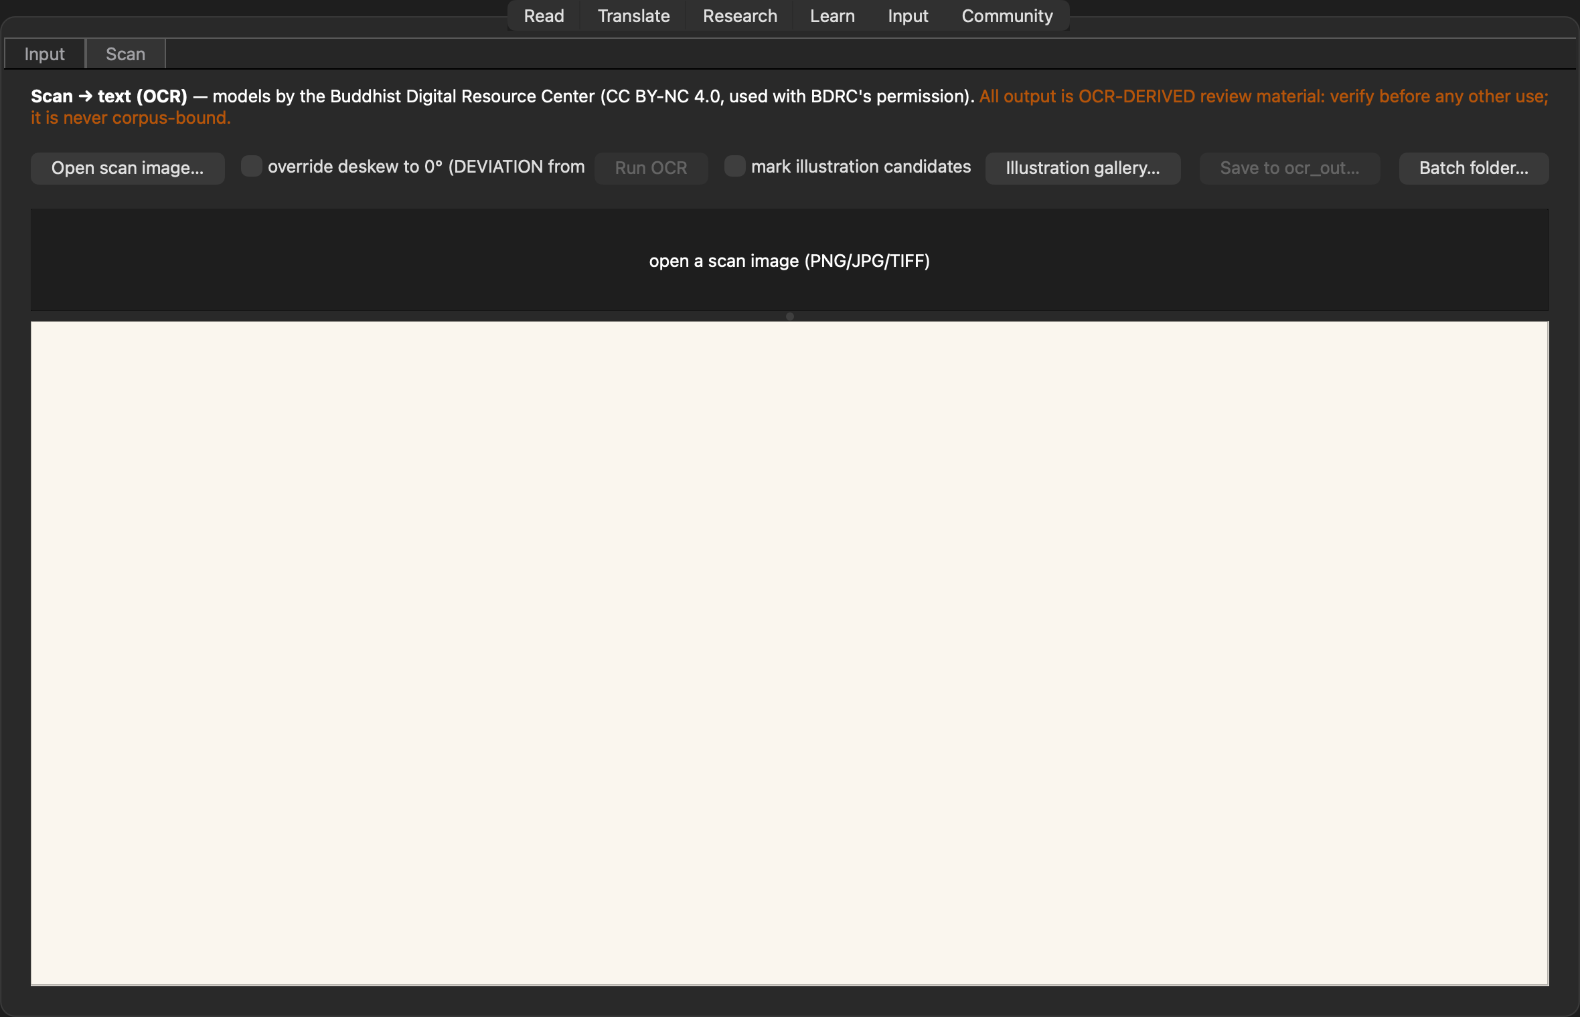
Learning to read, layer by layer: clause boundaries, particle roles, reading order, vocabulary, then the answer key — the master’s own English wherever the passage lives in his corpus.
15 Trainer
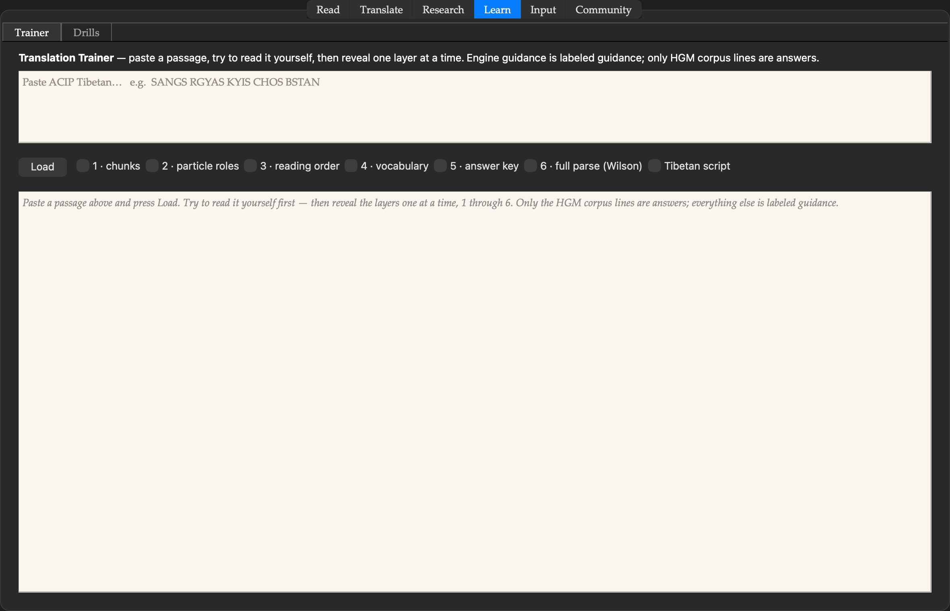
Learning to read, layer by layer: clause boundaries, particle roles, reading order, vocabulary, then the answer key — the master’s own English wherever the passage lives in his corpus.
16 Drills
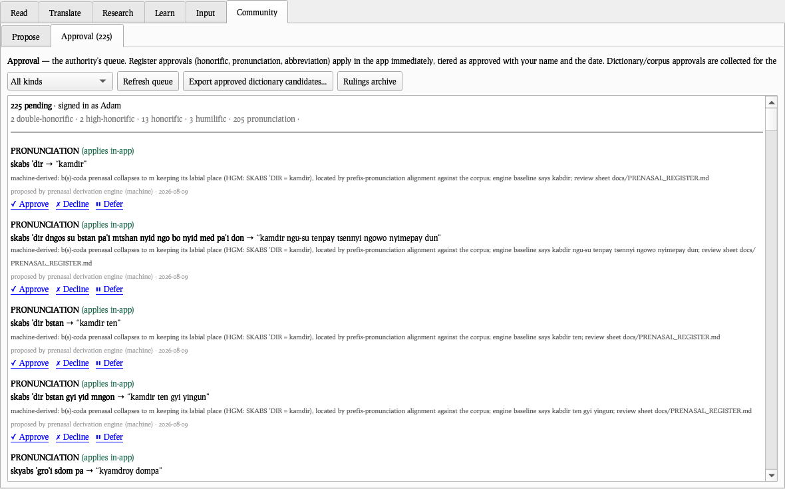
Exercises that write themselves from the corpus — every answer is the master’s own text. Scrambles, fill-ins, particle choices, parallel reading, review.
16 Drills
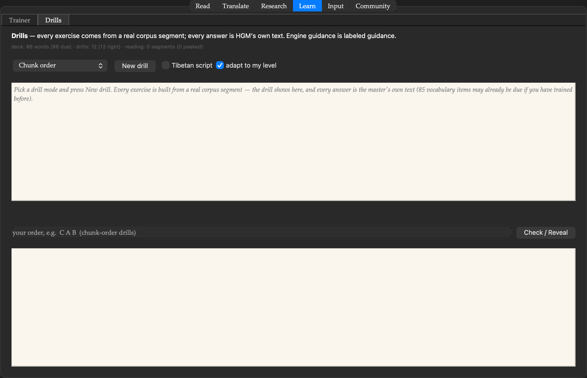
Exercises that write themselves from the corpus — every answer is the master’s own text. Scrambles, fill-ins, particle choices, parallel reading, review.
16 Drills
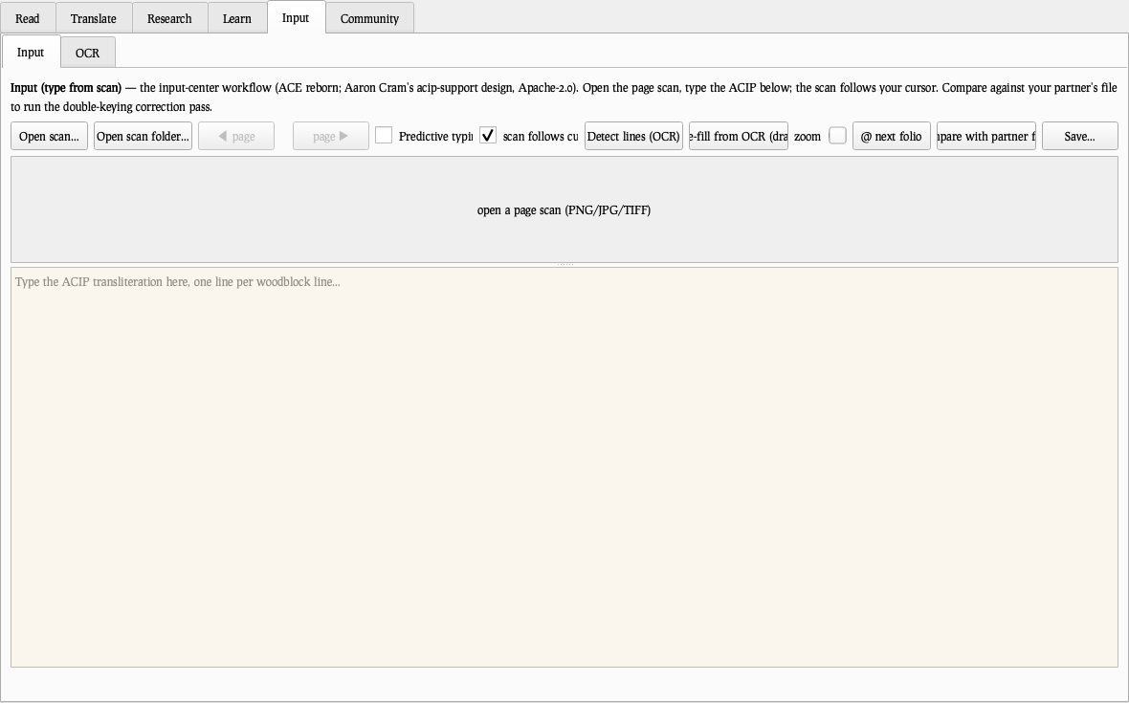
Exercises that write themselves from the corpus — every answer is the master’s own text. Scrambles, fill-ins, particle choices, parallel reading, review.
16 Drills
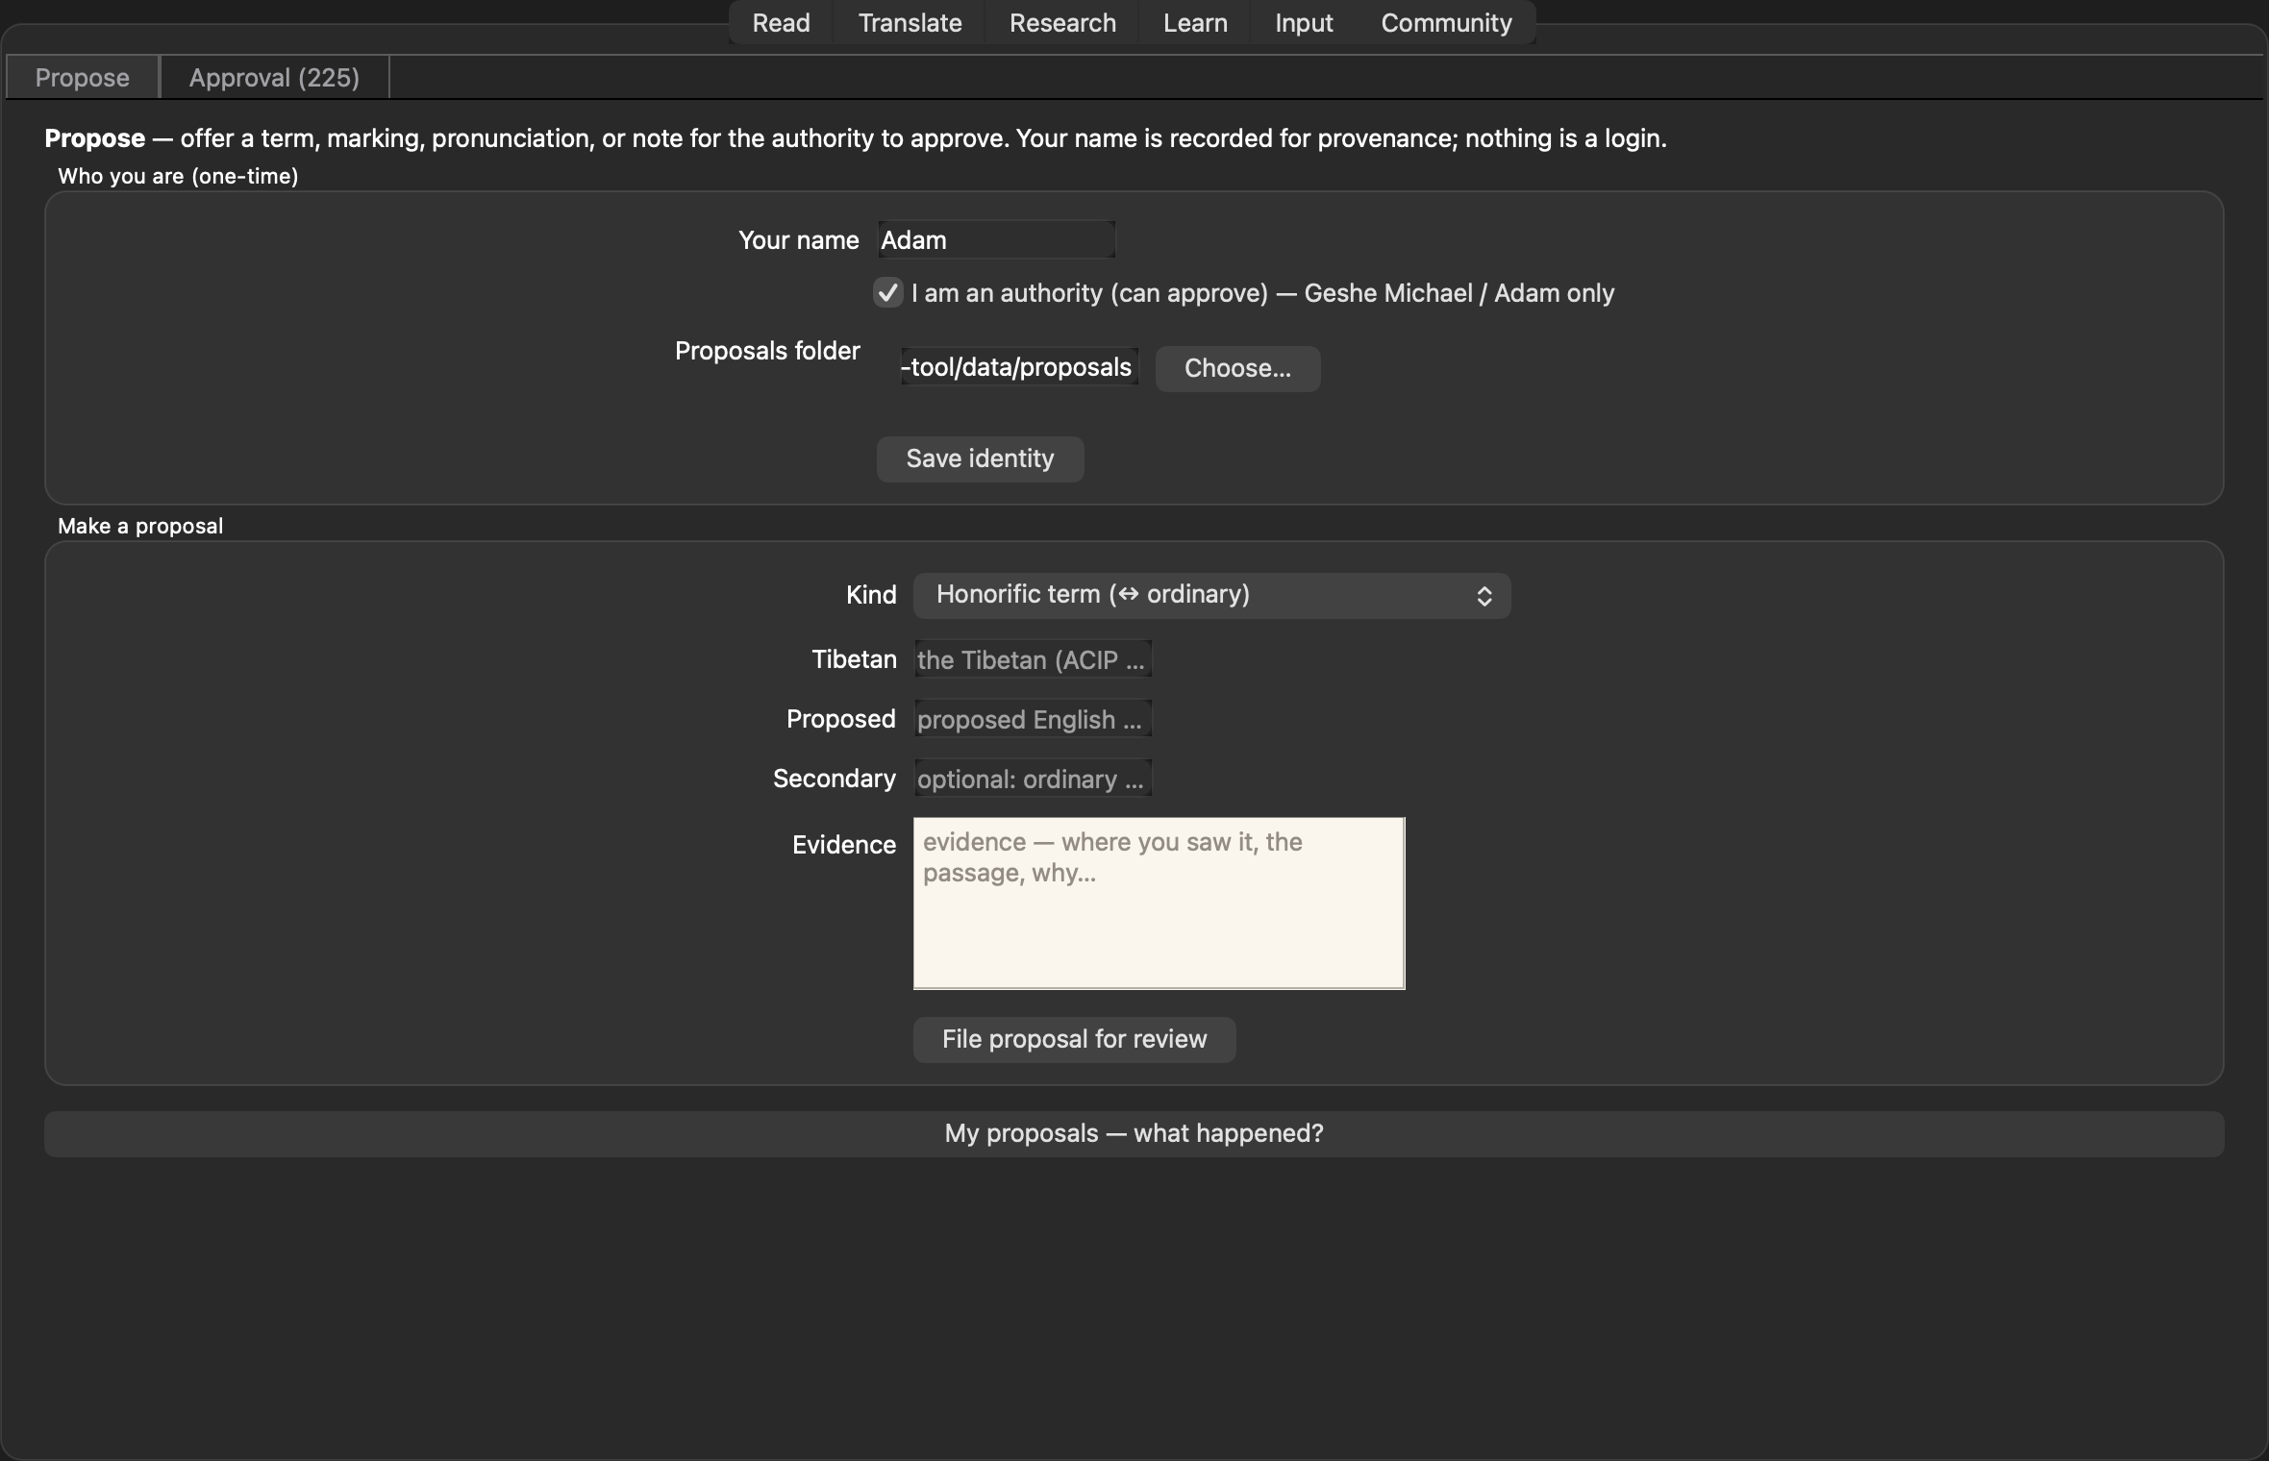
Exercises that write themselves from the corpus — every answer is the master’s own text. Scrambles, fill-ins, particle choices, parallel reading, review.
17 Input
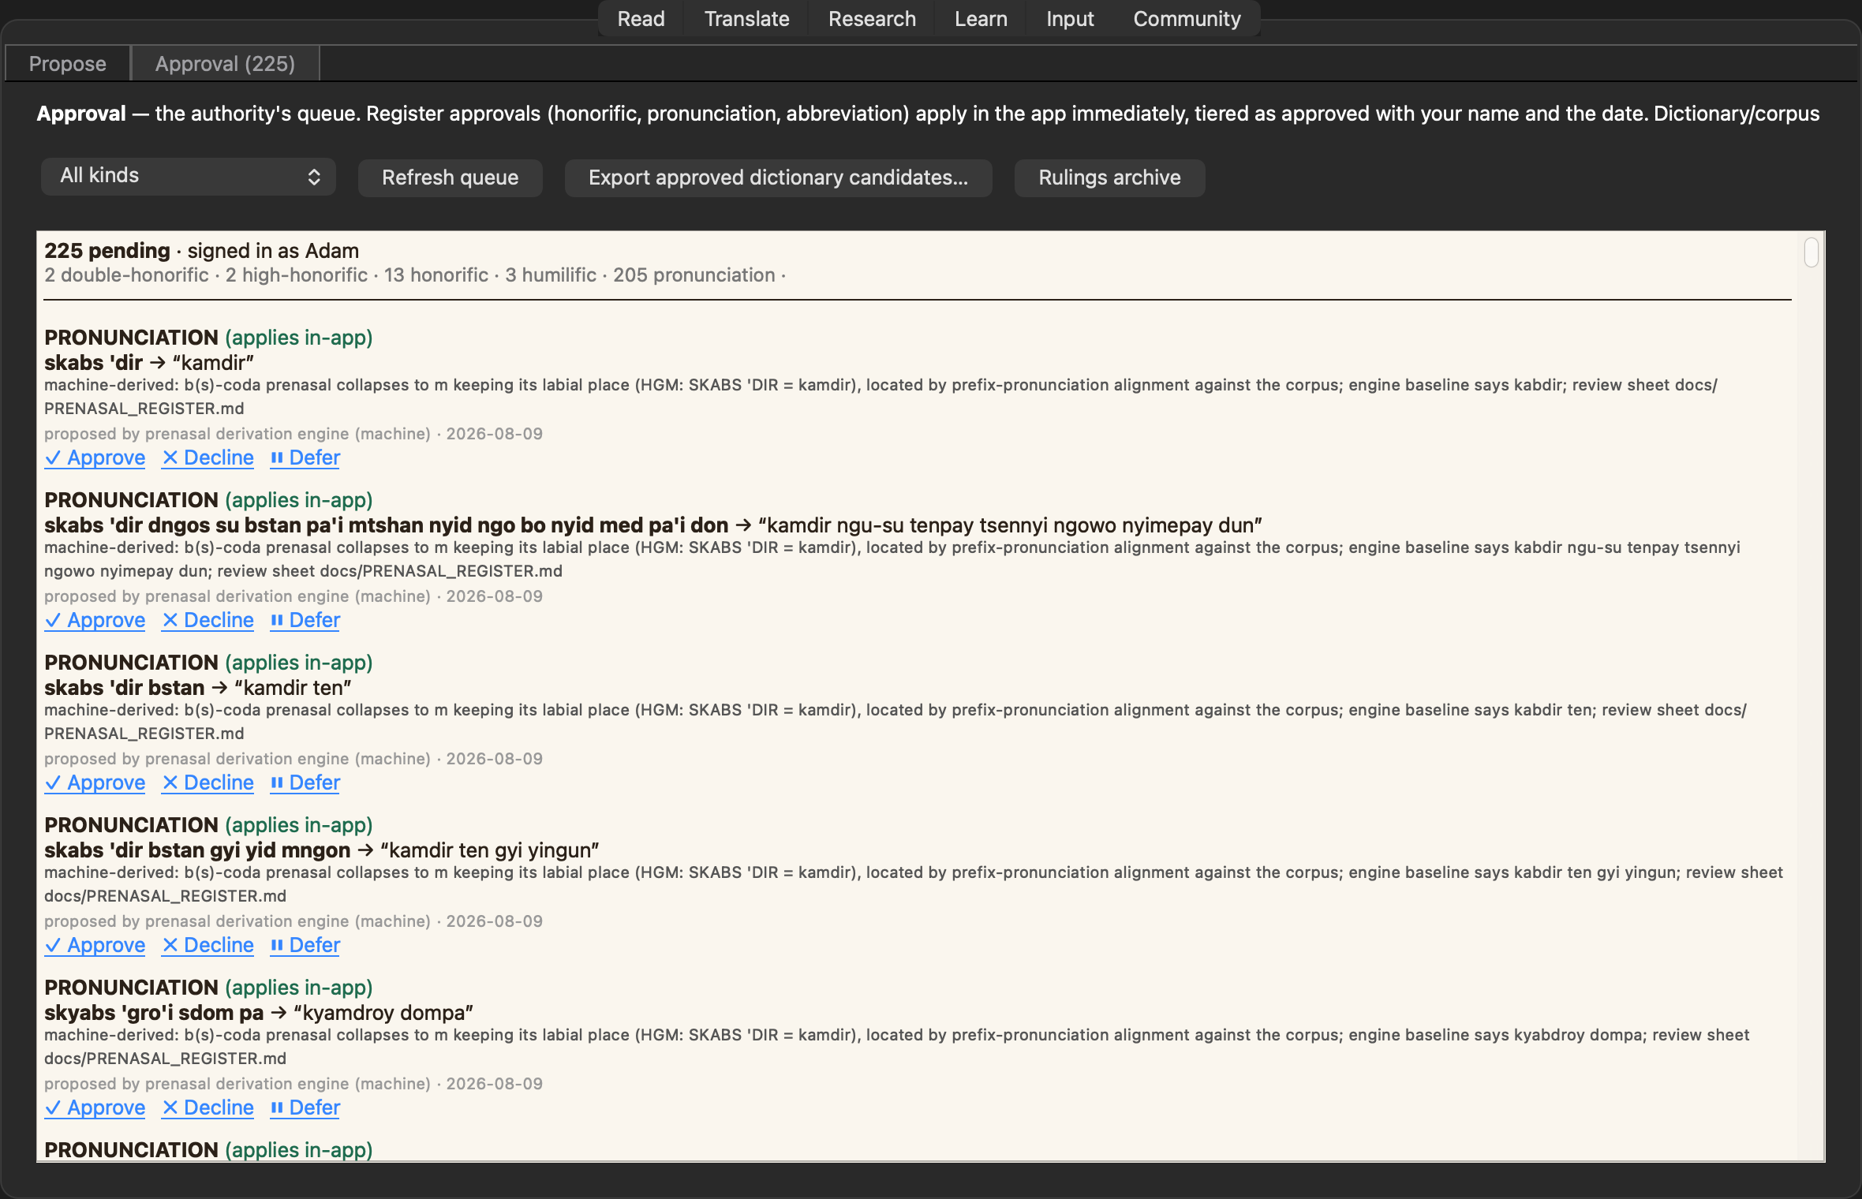
The input-center workstation, ACE reborn: type beside the scan, the image follows your cursor, predictive ACIP completion, OCR pre-fill, double-keying comparison.
17 Input
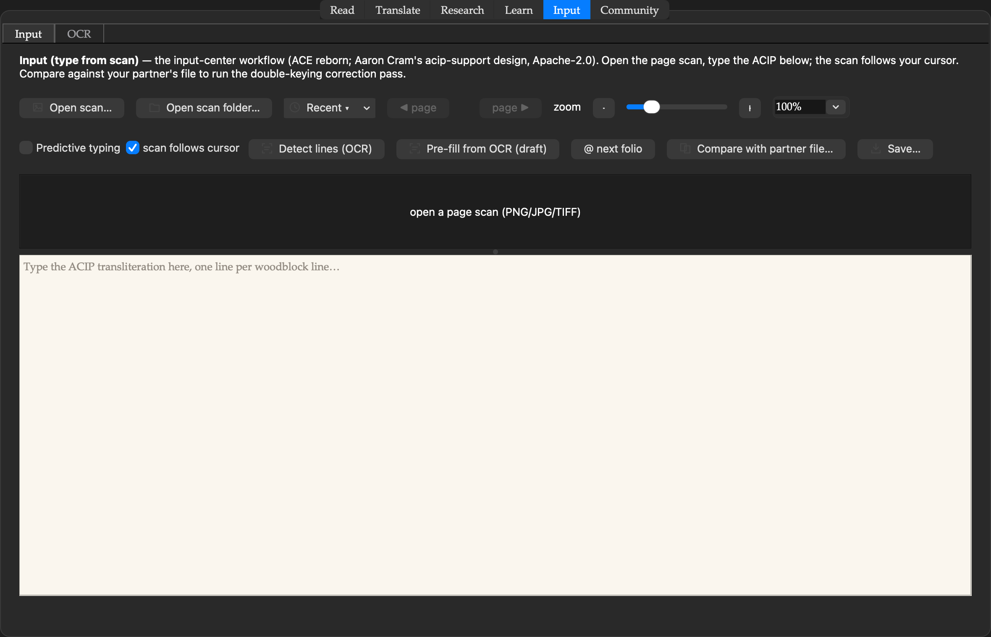
The input-center workstation, ACE reborn: type beside the scan, the image follows your cursor, predictive ACIP completion, OCR pre-fill, double-keying comparison.
17 Input
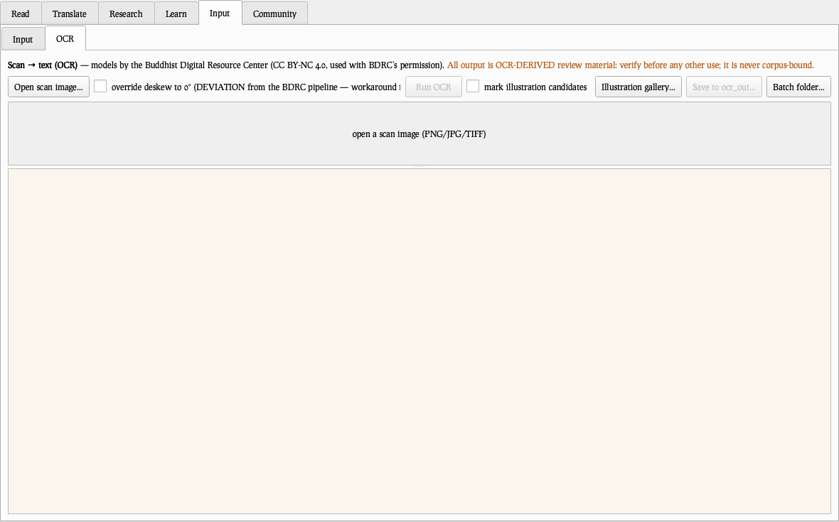
The input-center workstation, ACE reborn: type beside the scan, the image follows your cursor, predictive ACIP completion, OCR pre-fill, double-keying comparison.
18 OCR
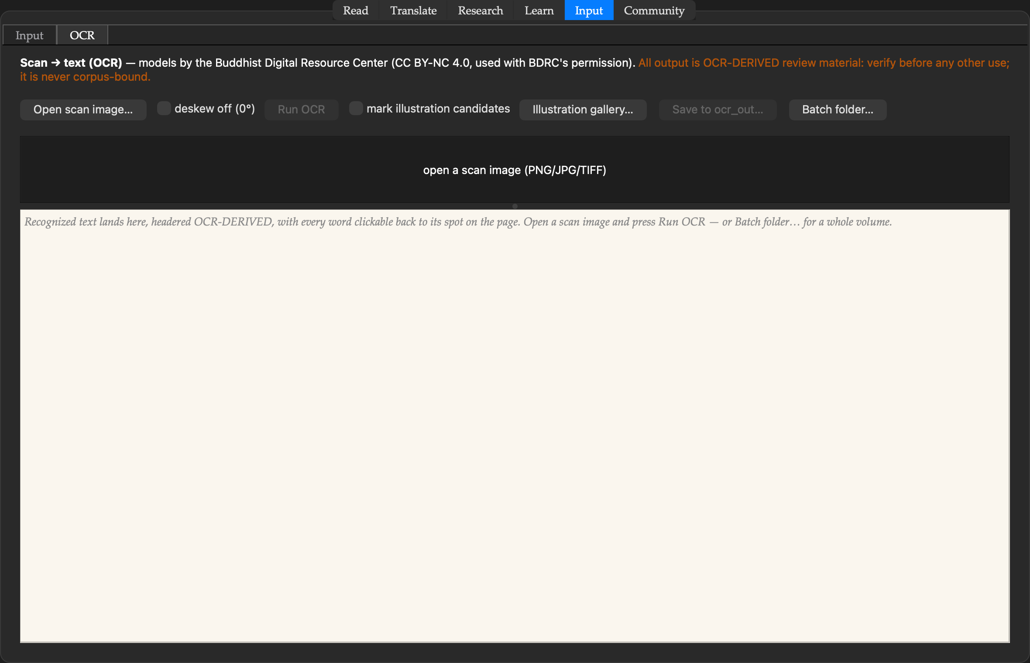
Woodblock pages into text: line detection, recognition, illustration-candidate marking — every output headered OCR-DERIVED, review material only.
18 OCR
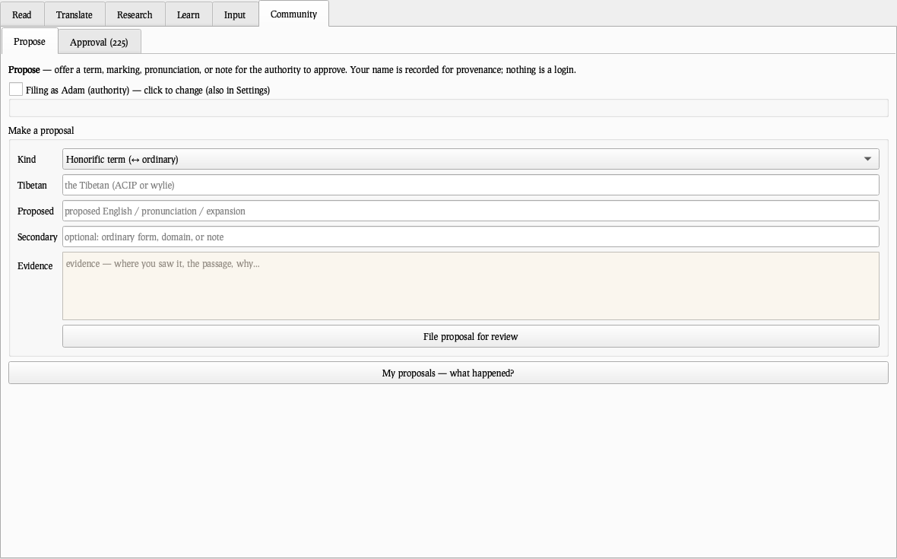
Woodblock pages into text: line detection, recognition, illustration-candidate marking — every output headered OCR-DERIVED, review material only.
19 Propose
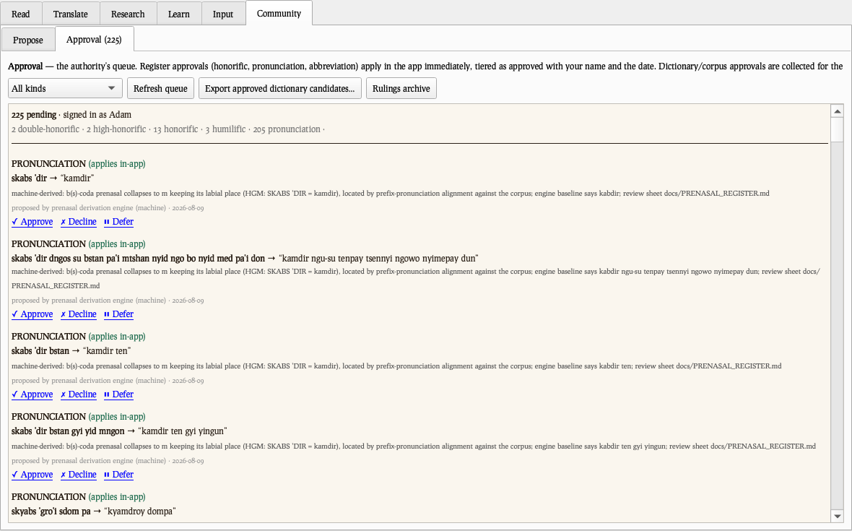
The team’s channel: offer a term, marking, pronunciation, or note — your name recorded, the passage attached as evidence.
19 Propose
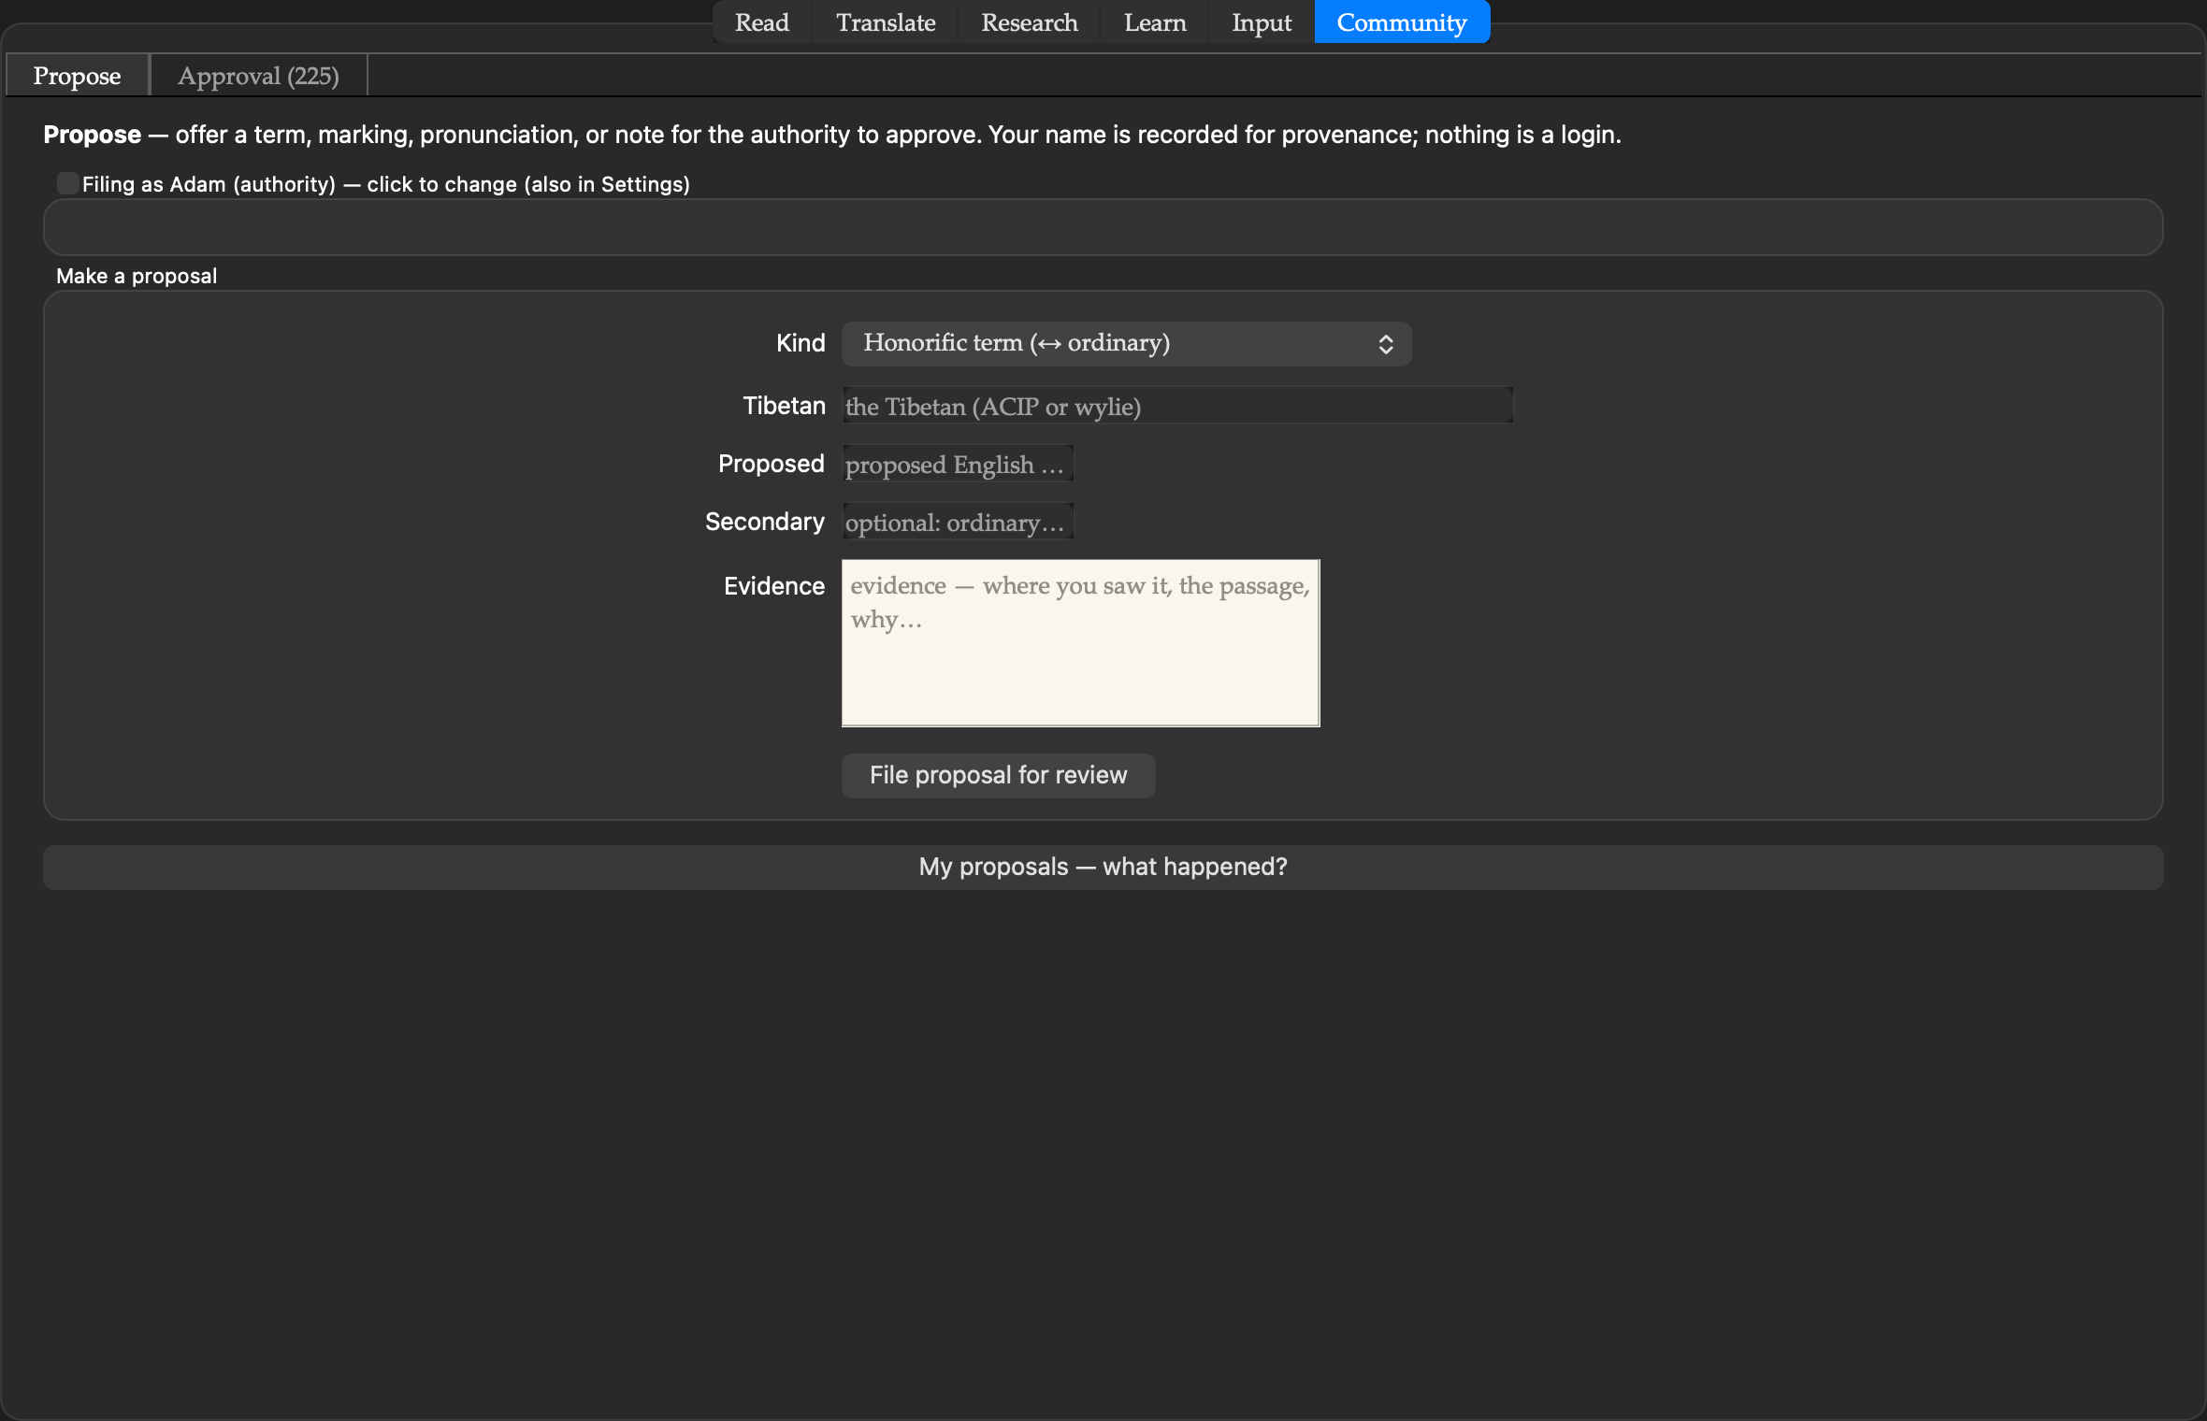
The team’s channel: offer a term, marking, pronunciation, or note — your name recorded, the passage attached as evidence.
20 Approval
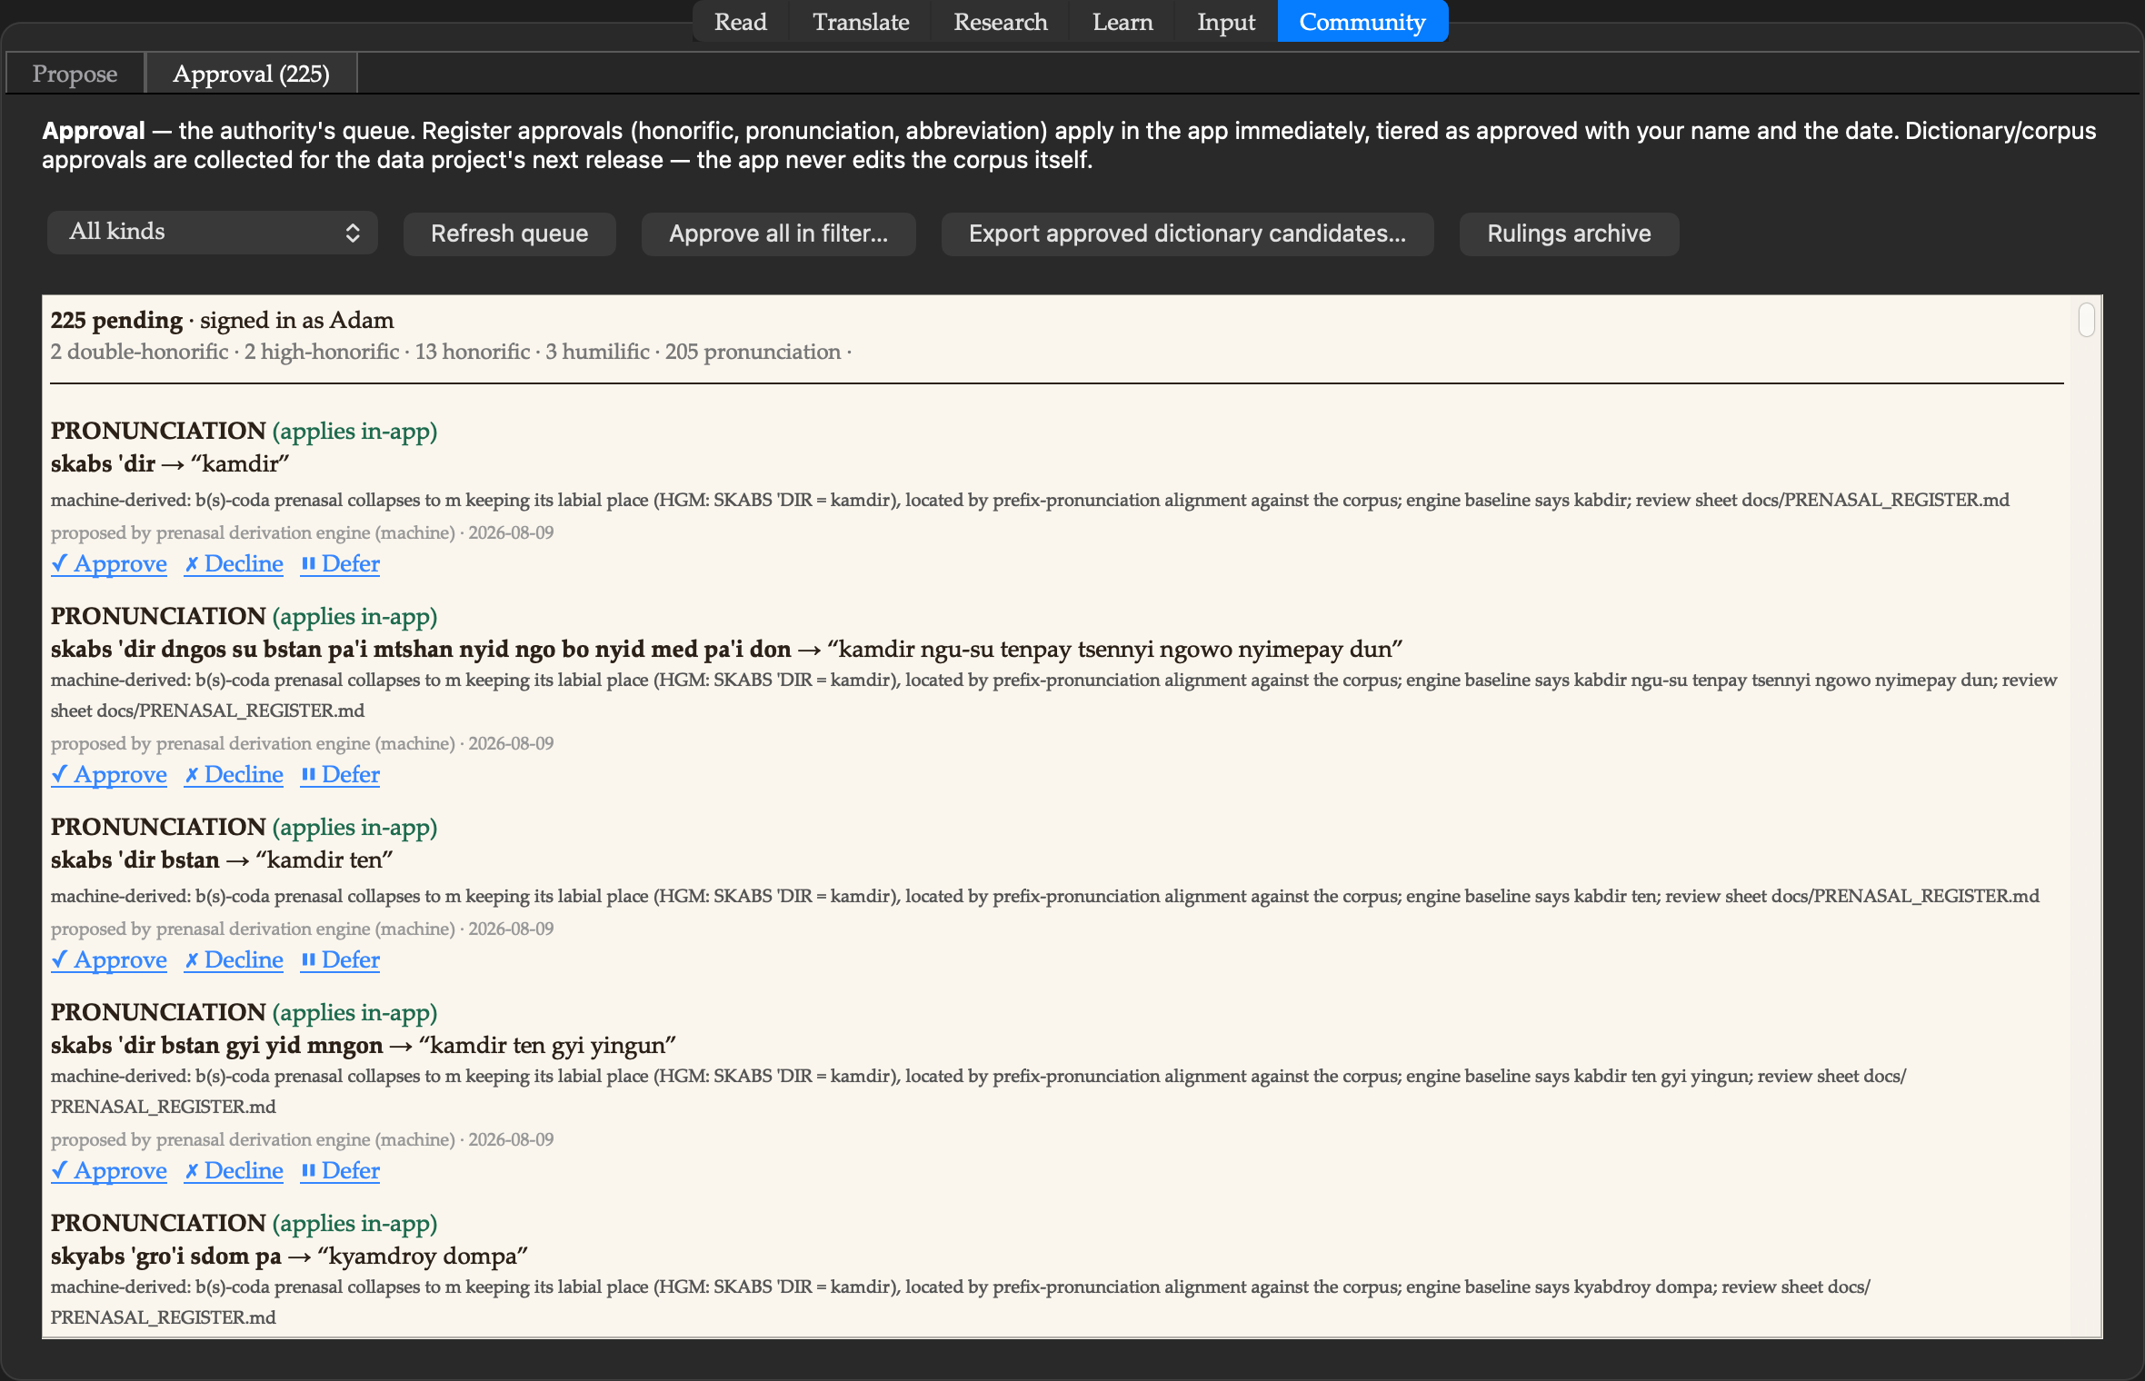
The authority’s queue: every proposal ruled with provenance; register approvals apply in-app immediately; machine-seeded batches ruled in one considered act.
──────────────────── ❖ ────────────────────
Every screen above runs fully offline on a Mac, built on Geshe Michael Roach’s dictionary of 105,634 entries and his corpus of 42,199 aligned passages. The queue in pane 15 is real: 205 machine-derived pronunciations awaiting the authority’s ruling.

