Diamond Cutter Translation Tool — daily digest, Wednesday 9 September 2026 (afternoon, continuing)
Headline. This afternoon was almost entirely made of things I found by using the tool rather than by planning to build them. I hovered over a button and got nothing, so every button in the application now says its own name and what it does. I opened the Draft workspace and could not find the way in, so the way in is now on the screen. I pasted a verse of Nagarjuna into the Sanskrit workbench and it refused the whole passage over a character I could not see. And the dictionary drawn from Geshe Michael Roach’s courses now comes out as a spreadsheet with all of its metadata, every time it is rebuilt, ready to send.
Everything below is finished and tested. The self-test is green at 0 failures, the constitution gate holds, and the engine batteries pass.

Hovering over anything now tells you what it is
I hovered over the Library button and nothing appeared. It turned out the pane switcher buttons carried no description at all, and twenty-six of the buttons on the ribbon carried only their own name.
Both answer the same way now: the name in bold, then a sentence saying what the thing is for. Fourteen of the pane descriptions are lifted word for word from the user manual, so the tooltip and the manual cannot drift apart over time.
A quieter problem sat underneath it. A ribbon button copied its description once, at the moment it joined the ribbon, so a description written any later was silently thrown away. That is the sort of thing that makes a fix look like it did not work. It follows the source now, and two tests hold the line: twenty-four panes and one hundred and twenty-one buttons, none of them silent.

Day now means Day
I had Day selected in Preferences and dark chrome on my screen. Both were behaving exactly as written. The old switch only ever set an appearance when Night was on; with it off, the application left the decision to the Mac, so my Mac overrode a preference that plainly said Day.
Appearance is three ways now: Day, Night, and Match system appearance. It is applied at startup whatever it says, it is in Preferences and under the View menu, and the old setting was migrated once so nobody’s choice was lost. Match system is the answer to the other half of my question, whether night can arrive on its own: it follows the Mac, sunset switch included.
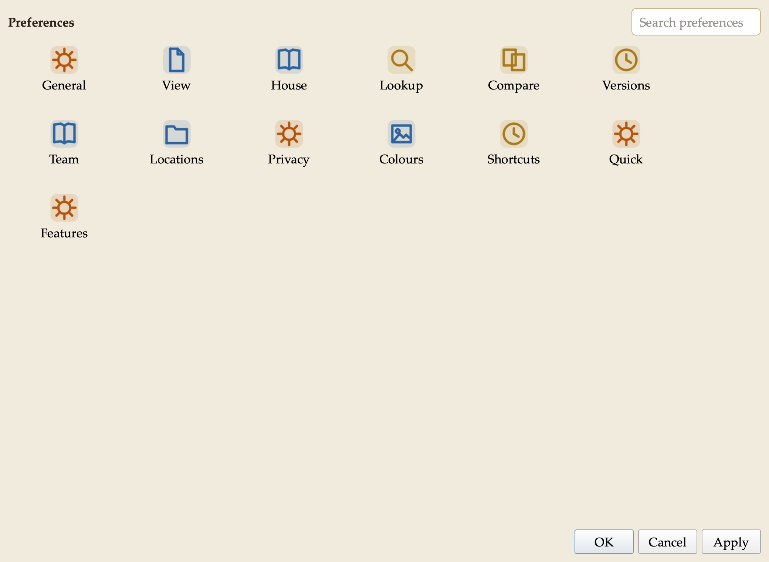
The appearance setting, three ways.

The missing labels under the icons were never missing
They were invisible. An application-wide stylesheet makes the toolkit freeze each panel’s colours the first time it draws them. Switching appearance changed the colours but redrew nothing, so the labels kept their daylight ink on a dark band. The fix had been written days ago and never actually switched on.
The same defect is what made the shading look, in my own words, funky: some panels dark, some half shaded, some not shaded at all. Twenty-five places across eight panes had a manuscript colour written into the text of the style itself, and a written-in colour cannot follow anything. They are all computed from the palette now. Day is unchanged to the pixel. Night is legible for the first time.
The worst of it was the Compare table. Its five row colours are measured against cream paper, but behind a table row they sit on the window, where the row’s own text is nearly white — a contrast of about 1.2 to 1, which is to say invisible. They keep their five meanings at a depth the dark window can carry.
Two things fell out of that work. A damaged autosave in the Versions list was painted warning red and then quiet grey one line later, so the row that most needed to stand out was the only one that lost its colour. And one of our colours clears the accessibility floor on paper at 4.62 but only reaches 4.22 on a light window, so its window sibling is a shade darker. Three new tests hold all of it, including one that fails the build outright if anyone writes a colour into a pane by hand again.

The Draft workspace now shows you the way in
I opened it and said, plainly, that I did not understand how to use it. There was no Load source button anywhere on the screen, and three gold headings — STRUCTURE, EVIDENCE, PUBLISH — introduced nothing at all.
Both complaints were fair. Every verb had migrated to the ribbon over time, leaving those headings labelling empty space. They are gone. The pane now carries its own way in: a Load source button pinned under the source box, outside the scrolling area so it cannot slip below the fold, next to one line saying where the rest of the tools live. The two empty panels beside it now name that route instead of citing a button the reader cannot find.
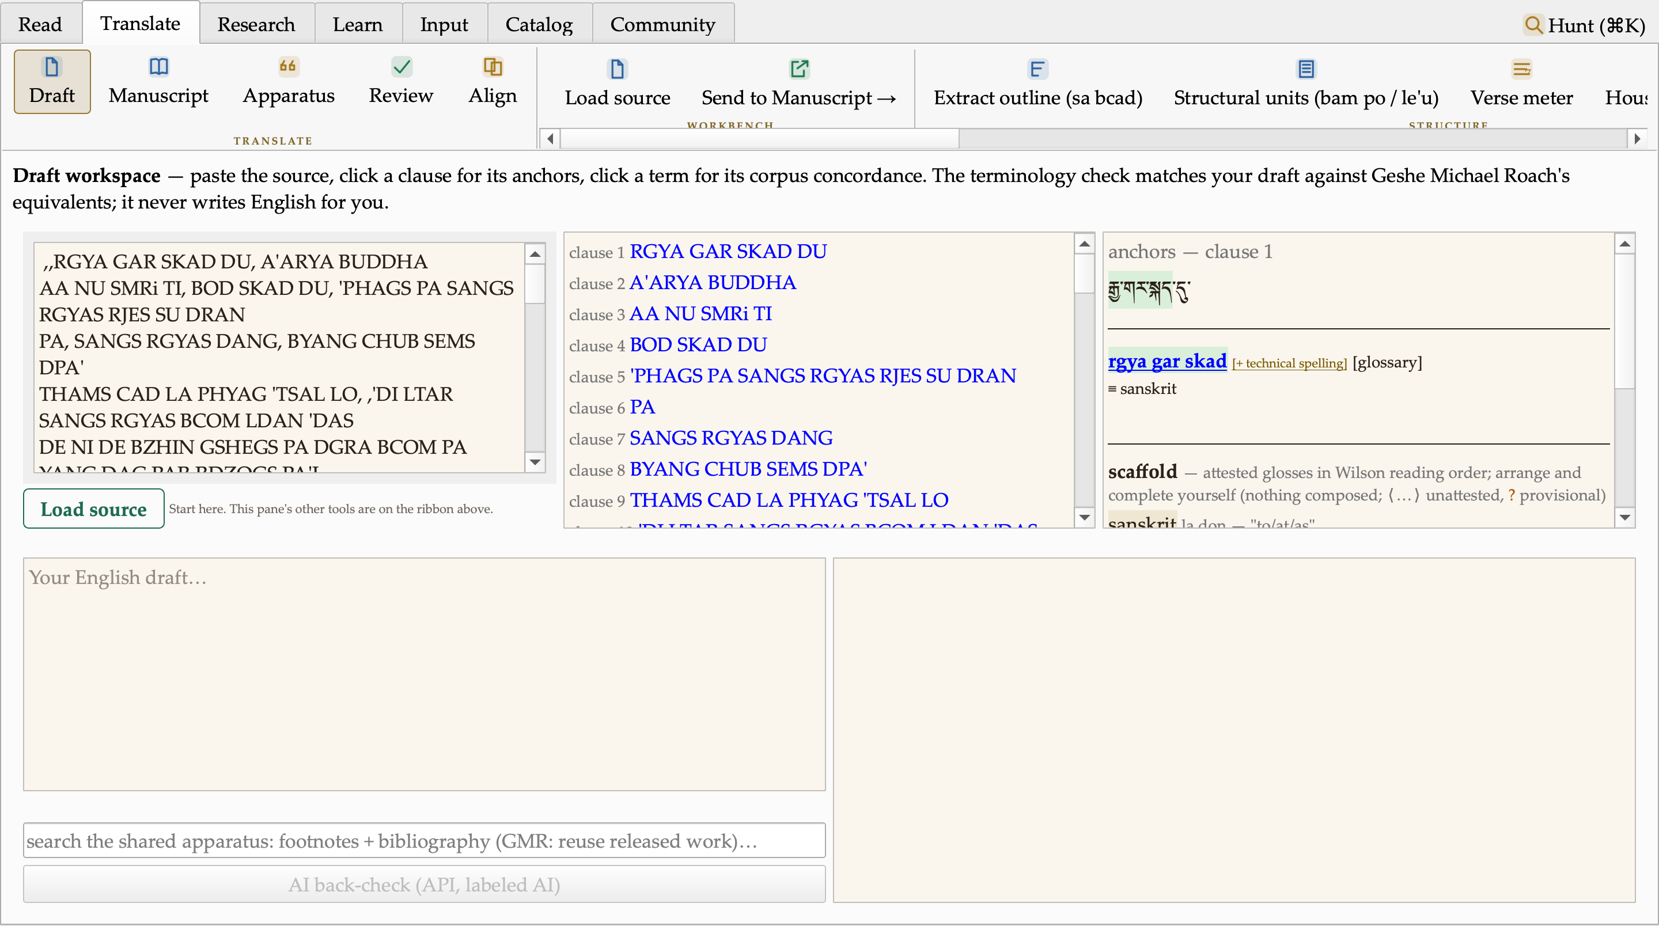
The Draft workspace, with its way in.

The Sanskrit workbench
I pasted a verse from Nagarjuna and four of the six rows showed a warning triangle with nothing beside it.
The refusal was correct in principle — this engine never guesses — but it would not say what it could not read. It does now: the character, its position, its code point, a plain statement that nothing was guessed, and what to do next.
The cause was worse than the symptom. The converter knew only the five ordinary whitespace characters, so a non-breaking space, which is exactly what a word processor or a web page puts on the clipboard, made it refuse an entire passage. A newline did the same. It reads every kind of whitespace now, in both the reference engine and its working port together.
A third fault surfaced while I was testing. Devanagari put its final mark on the last word of a line and no other, so every word ending in a consonant printed bare, with an implied vowel that is not in the Sanskrit. The only Devanagari case in our test battery was the mani mantra, and every word in it ends in a vowel — which is precisely why this survived. Both batteries now carry a word ending in a consonant.
Then I asked for more, and got it. The input is a paste area rather than a single line. There are dropdowns for what you are converting from and what you want it in. Every notation still gives the full analysis of a single term, with Whitney’s roots and the Mahavyutpatti bridge; choosing one notation converts a whole passage line by line.
Here is the first verse of Nagarjuna’s Root Verses on the Middle Way going into Devanagari.
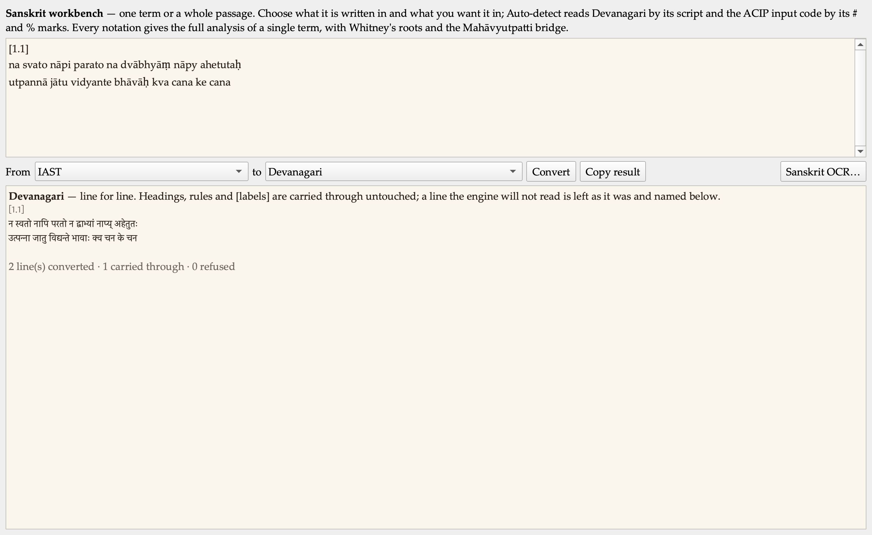
The first verse of Nagarjuna’s Root Verses on the Middle Way, IAST into Devanagari. The bracketed label is carried through untouched.
Pasted documents are not all Sanskrit, so rules, headings and bracketed labels are carried through untouched — on four objective tests, not on a guess about language: a line with no letters at all, a line wholly inside brackets, a line whose words are all capitals, and a line the engine itself refuses. My own test document is now the test, with a control asserting the heading is not itself run through the converter.
I also asked for everything at once, and that is now a mode of its own.
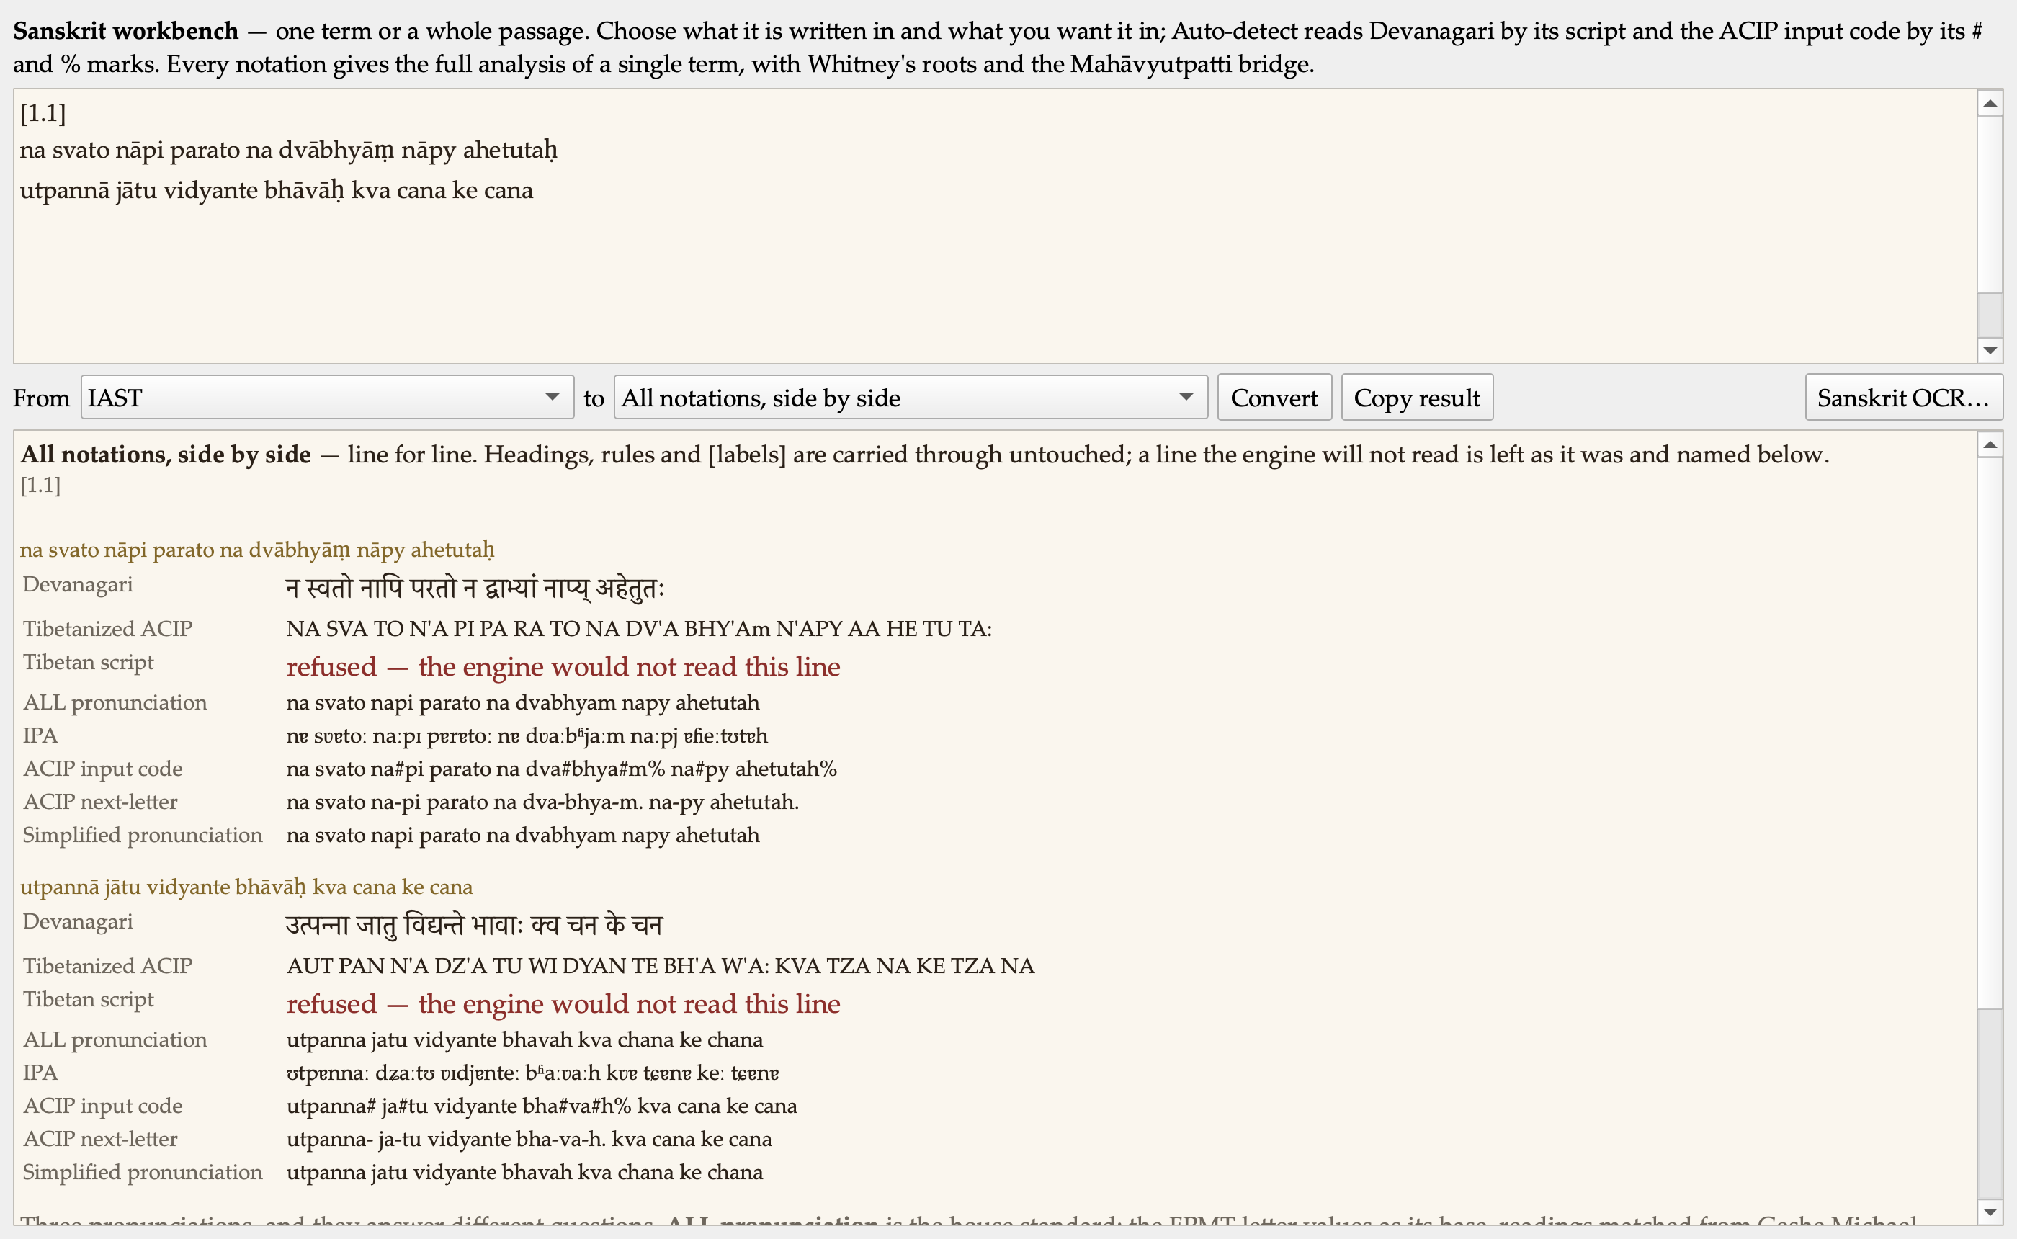
The same verse in every notation at once: Devanagari, Tibetanized ACIP, Tibetan script, IPA, both ACIP input styles, and the simplified pronunciation.

Mantras, read back from the Tibetan letters they are written in
This is the part I am most pleased with today, and it came from a single observation: the mantras in the more esoteric texts are not Tibetan at all. They are Sanskrit, written in Tibetan letters. So the tool should take that script, or the Tibetanized ACIP of it, and give back an accurate phonetic line for reciting.
That path existed only halfway, and every step of it was broken. Three real faults, all found on actual mantras:
- The stack marker and the crescent mark of our Tibetan transliteration reached the Sanskrit intact, so the mani mantra met a converter that rightly refused them and came back with no pronunciation at all.
- The syllable spacing was being thrown away. For a single term that is right, because these notations separate syllables and not words. For a mantra it is exactly wrong: a mantra is recited syllable by syllable, and the spacing is the only guide to where they fall.
- Tibetan script was not an input option at all.
All three are fixed, in the reference engine and its working port together. The mani mantra now reads back as oːm mɐ ɳɪ pɐdmeː ɦuːm, syllable by syllable, and it is now one of our tests, with a control asserting that no stack or crescent mark ever reaches the reader.
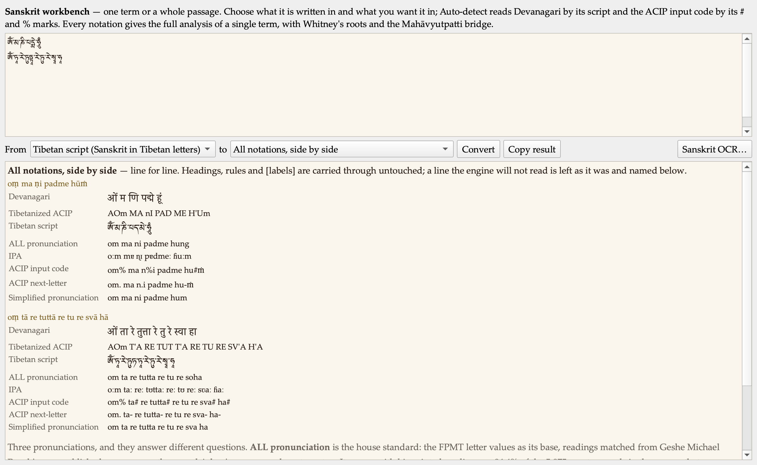
Two mantras in Tibetan script, read back in every notation. The pronunciation line names the authority it follows, and the simplified line is labelled provisional.
On pronunciation I want to be exact about what we are standing on. The IPA line follows the standard Classical Sanskrit mapping together with FPMT Translation Services’ guide to Sanskrit transliteration and pronunciation of November 2020, with the rules for the nasal and the final breath applied in context. That line is trustworthy. The simplified line beneath it is not yet: it is an eighteen-rule table that strips the diacritical marks, which gives a serviceable plain-letter spelling and is not a pronunciation guide. It is labelled PROVISIONAL in the interface for exactly that reason. Building a trustworthy simplified respelling is a real piece of work and I would rather do it properly than quietly.

The Geshe Michael Roach Dictionary, as a spreadsheet
The dictionary drawn from the alignment of Geshe Michael Roach’s courses now exports as CSV every time it is rebuilt, from the same assembled entries the web page renders, so the file and the page cannot disagree about what the dictionary says.
Four files, each answering a different question.
- The full export. 20,933 rows over 10,758 headwords, courses one through five. One row per rendering, with wylie, ACIP, Tibetan script, pronunciation, the English, the depth, the number of occurrences, the courses, and the exact course and segment reference for every one. Each row also carries its own provenance — the tier, the rule the English was gathered under, the corpus, the date — because a spreadsheet gets forwarded and separated from its covering note, and this one will still say what it is.
- English to Tibetan. Whether Geshe Michael Roach has rendered a given word before, and as what. That is the question an editor actually asks, and the web page cannot answer it.
- Each course’s own glossary, ranked by how often each term occurs in that course.
- A change report against the previous export. Nobody re-reads six thousand headwords. Everyone will read the delta.
Two findings came out of building it. The ACIP column has been empty for every entry of the published page, because the index is stored ACIP-to-wylie and was being read the other way round. And the layer holds about fifteen headwords that are English course front matter rather than Tibetan — harmless as text, and fabrication the moment a Tibetan script column is computed from them. So the two computed columns are named for what they are, every row carries a note saying what produced them, and a further column says whether the layer holds that headword at all.
It is ready for Joel and waiting in my drafts.

Decisions I made along the way
Geshe Michael Roach’s title goes with his name. Everywhere: prose, the interface, email, document titles and file names. It is the same courtesy owed a doctor, and dropping it is not a shorthand. The dictionary is the Geshe Michael Roach Dictionary; its four spreadsheets, the web page, the page’s own title and every reference in the tooling were renamed this afternoon.
Digests are centred from now on. Section headers and every screenshot with its caption. Body prose stays left-aligned, because a centred paragraph is harder to read, not easier.
His title goes with his name. Everywhere — prose, the interface, email, document titles and file names. I also retired the internal abbreviation we had been using for him, which stands for a form of address only his close students use and is not how he should be referred to publicly. Sixty-seven places in the application now say his name or a plain three-letter label instead. What I deliberately did not rename are the column names inside the data release itself; those belong to the data project, and changing them here would break reading it.
The ribbon’s width promise held. The idiom bank wanted a ribbon button and would have pushed the ribbon past the width we promised ourselves it would never exceed. It went to a right-click and a menu instead.

Numbers
Automated suites, all green | 113
Application self-test failures | 0
Panes that now describe themselves | 24
Ribbon buttons that now describe themselves | 121
Hand-written colours removed from the panes | 25
Dictionary rows exported | 20,933
Dictionary headwords | 10,758
Courses covered | 1 through 5
Places his title was restored | 67

Open questions for leadership
The dictionary export is ready for Joel and is waiting in my drafts. Everything in it is TENTATIVE: Geshe Michael Roach’s own English, matched to the Tibetan by machine and never composed, and none of it enters his binding dictionary until he rules on it. What I would like to know is the shape he wants for ruling on it — a review queue with a column for his decisions is easy to produce, and would turn the export into something he can work through rather than only read.

The Learn tab, and a phone
The afternoon turned into a long piece of work on the Drills, and then into an iPhone app, because I kept finding the same fault from different angles.
I sent seven screenshots of drills that looked wrong. Three separate faults were behind them, and every one is now measured rather than guessed.
The English did not match the Tibetan in size. The drill picks one clause but printed my English for the whole segment. Measured over three hundred real drills, the clause shown averaged 27.5% of the segment whose English sat above it — a forty-word paragraph over three syllables. It now shows the whole segment, with the answer blanked where it actually stands.
Raw source code was leaking into the Tibetan. Options were rendering as “(RNAMS”, “(GNAS BRTAN)”, “(ZHES”. The converter was being handed each word whole and, when it failed, printing the raw code inline as though it were script. It hit 3.3% of drills.
Title lines were being drilled as if they were sentences, and far more often than chance. This one was the real culprit: the adaptive draw prefers short segments, and the title catalogue is the shortest material we have — ten to fifteen words against a corpus average near thirty-six. Measured: twenty to twenty-five percent of my drills were catalogue entries, and the title course was the single most-drawn of all seventy-five. A quarter of everything I was seeing. All of it now refused at the draw, along with 254 segments that hold English where the Tibetan should be, which had been rendering as convincing nonsense.
I asked for titles to be labelled rather than hidden, and they are — the signal turned out to be structural rather than a guess about the prose.

The one I am most pleased to have caught
Late on I noticed an option beginning with an open parenthesis, against a segment ending in a closing one. The punctuation was telling the learner the answer before they read a word of Tibetan. Gone now: zero options begin with a bracket.
And I said the English still often looked too long to be the equivalent. It was, and the reason is exact. My C15 example measures 4.3 English words per Tibetan word counting the bracketed material, and 1.4 without — 1.4 being the corpus median exactly. The brackets are things I supplied as translator: a restatement of the previous debate move, a gloss, a page number. They have no Tibetan in that segment at all. Three thousand segments carry some. They are now greyed and labelled as supplied, rather than presented as the parallel.

On the phone
The drills and the trainer now run as an iPhone app. The whole core compiled for a real device unchanged — seventy-seven files, no edits — which was the only genuine risk in the estimate. Everything is generated on the Mac, so the phone inherits every refusal above and carries no database at all.
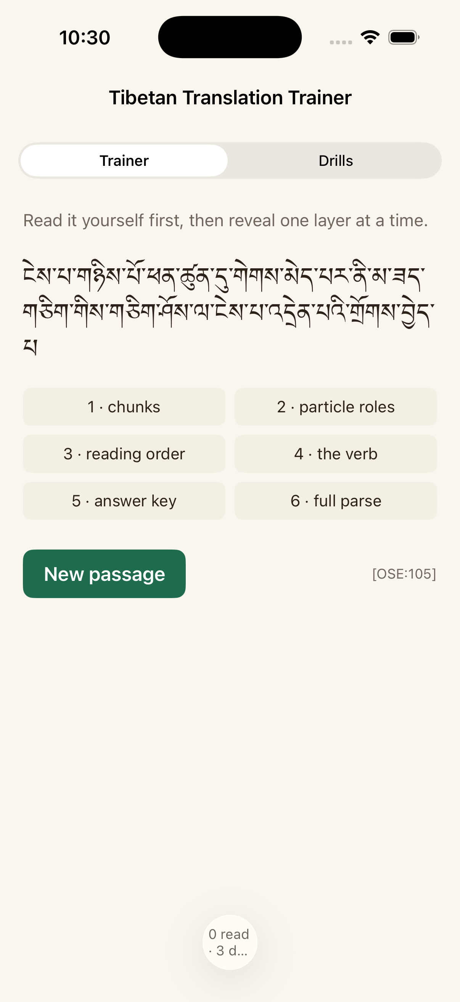
The Trainer on iPhone: read the passage yourself, then reveal one layer at a time.
Seeing it on a small screen immediately exposed something the desktop had been hiding: one segment pairs 5,180 English words with five Tibetan words. The hint was longer than the lesson. There is now a proportion ceiling, set from the measured distribution rather than by eye.
It is going to TestFlight rather than the App Store. My decision, on the recommendation that it reaches our team and the Mixed Nuts students this week without putting machine-aligned renderings of Geshe Michael Roach’s work on a public store before he has ruled on them. Same build, same upload, up to ten thousand testers.

Next
Pressed and installed twice this afternoon; the latest build is on my desktop and the Sanskrit work is in it. Then the theme system, which is designed and waiting on my rulings: eight coordinated colour schemes computed from a small set of seeds, with the honesty colours frozen in meaning across every one of them, so a theme can say what surface you are reading on and is structurally unable to say whose English you are reading.

