Diamond Cutter Translation Tool — daily digest, Tuesday 9 September 2026 (covers everything since Monday’s 13:40 digest)
Headline. Since Monday’s digest the tool gained a complete Compare & Merge suite for Tibetan texts, and then the first working tools built on top of it: every save of a text is now kept and restorable, a corrector’s changes can be applied and checked hunk by hunk, one systematic correction can be made across a whole folder with every occurrence previewed first, and the differences between two drafts can be sent to Geshe Michael as a Word document with real revision marks. The menu bar reached parity with Microsoft Word and Sublime Text, twelve menus and a Word-style Preferences window.
Two things came in today at your request. There is now an idiom register with a bank to work from: it marks which Tibetan forms are fixed expressions, shows how Geshe Michael has rendered them in his own courses, and takes new ones through him for a ruling. And a Features page lets anyone turn off the parts of the tool they do not use, so the window carries only their own work.
Everything ran green: 113 automated suites, 313 checks in the text engines and 712 in the app’s own self-test. The build is pressed, signed and installed.

What I did
- Menus, complete. I modelled the menu bar on Word and Sublime Text, taking each of their menus in turn and keeping what has an honest use on a Tibetan text file: File, Edit, Selection, Find, Insert, Format, Tools, Project, Goto, View, Window and Help. Highlights: a Properties window whose Statistics understand folios, syllables and shads; encodings for legacy input-centre files chosen on open and on save; Paste Special converting between ACIP, Wylie and Tibetan script; Find and Replace with regular expressions, preserved capitalisation and find-in-files; Goto a heading, a line, a folio, a dictionary entry or the concordance; bookmarks in the margin; Insert a folio marker, a Tibetan-symbol palette, the date with the Tibetan year; Format styles and case changes including Tibetan transliteration; Tools for spelling doubts, phrase memory, hand-offs to the Draft and Manuscript, document protection, snippets; a Project menu built on dossiers; a Window menu; Help ▸ Data Status. Items with no meaning here (multi-caret editing, page layout, mail merge, build systems) were skipped and the reasons recorded.
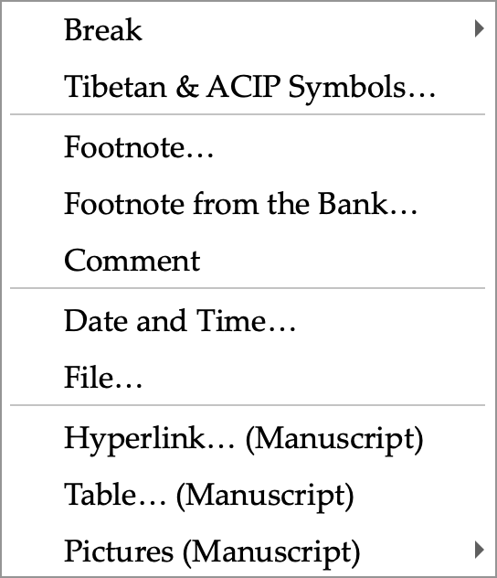
The Insert menu: folio markers, the Tibetan and ACIP symbol palette, footnotes to the Draft, the date with the Tibetan year, and the Manuscript’s rich-text items.
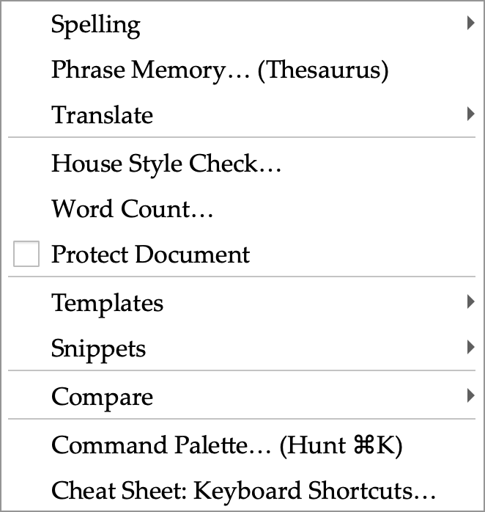
The Tools menu: spelling doubts, phrase memory, hand-offs between panes, word count, document protection, templates, snippets and the new Compare submenu.
- Preferences. A Word-style window of eleven pages behind an icon grid with search: General, View, House Style, Lookup, Compare, Team, Locations, Privacy, Colours, Shortcuts and Quick Access. Every switch drives a real setting; the Shortcuts page lists every menu command and key from the live menu bar.
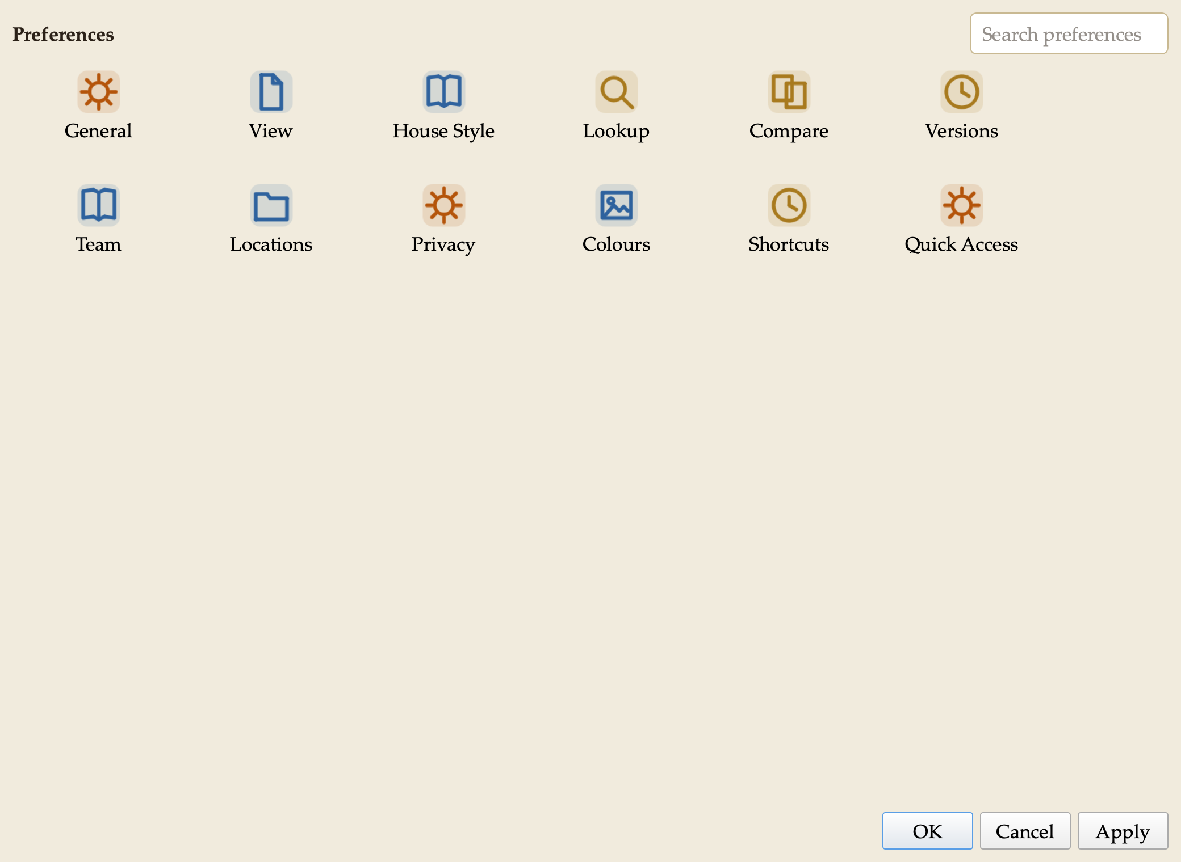
Preferences: the icon grid. Search narrows it; one page opens at a time with Show All to return.
- House style. I made our style sheet’s spacing rules switches on the House Style page: two spaces after a sentence, applied on demand, on save, or as you type — English only, abbreviations left alone. Colon and semicolon rules are there too, off until I confirm them against the sheet.
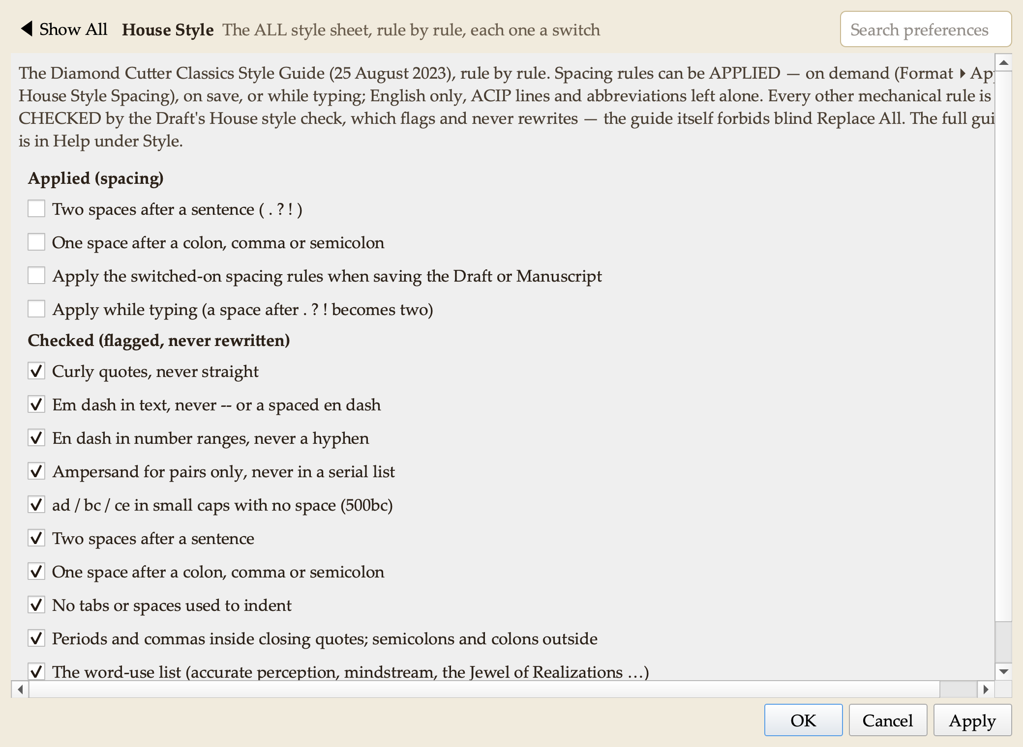
Preferences ▸ House Style: each rule of the style sheet is a switch.
- Compare & Merge suite. I studied Beyond Compare, WinMerge, UltraCompare and Araxis Merge and built their combined functionality into a new Compare pane in the Research group, adapted for our texts. Compare two files, or a text against the clipboard or its saved version; differences are shown line by line with the changed syllables highlighted, in any of ACIP, Wylie or Tibetan script. Rules let the tool ignore spacing, shad variants, folio markers, editorial brackets, or compare across scripts (an ACIP file against a Unicode file). Copy a reading left or right, undo without limit, edit in place, pin lines that must align. Reports: a side-by-side HTML page, a patch file, and an apparatus criticus in Markdown or CSV. Folder Compare classifies two folders and copies only after a preview (it never deletes); snapshots record a folder’s state for later comparison. Three-Way Merge combines two edited copies of one text against the original, resolving conflicts one by one; a file left with conflict markers opens as a two-sided comparison. Command-line comparison for scripted checks.
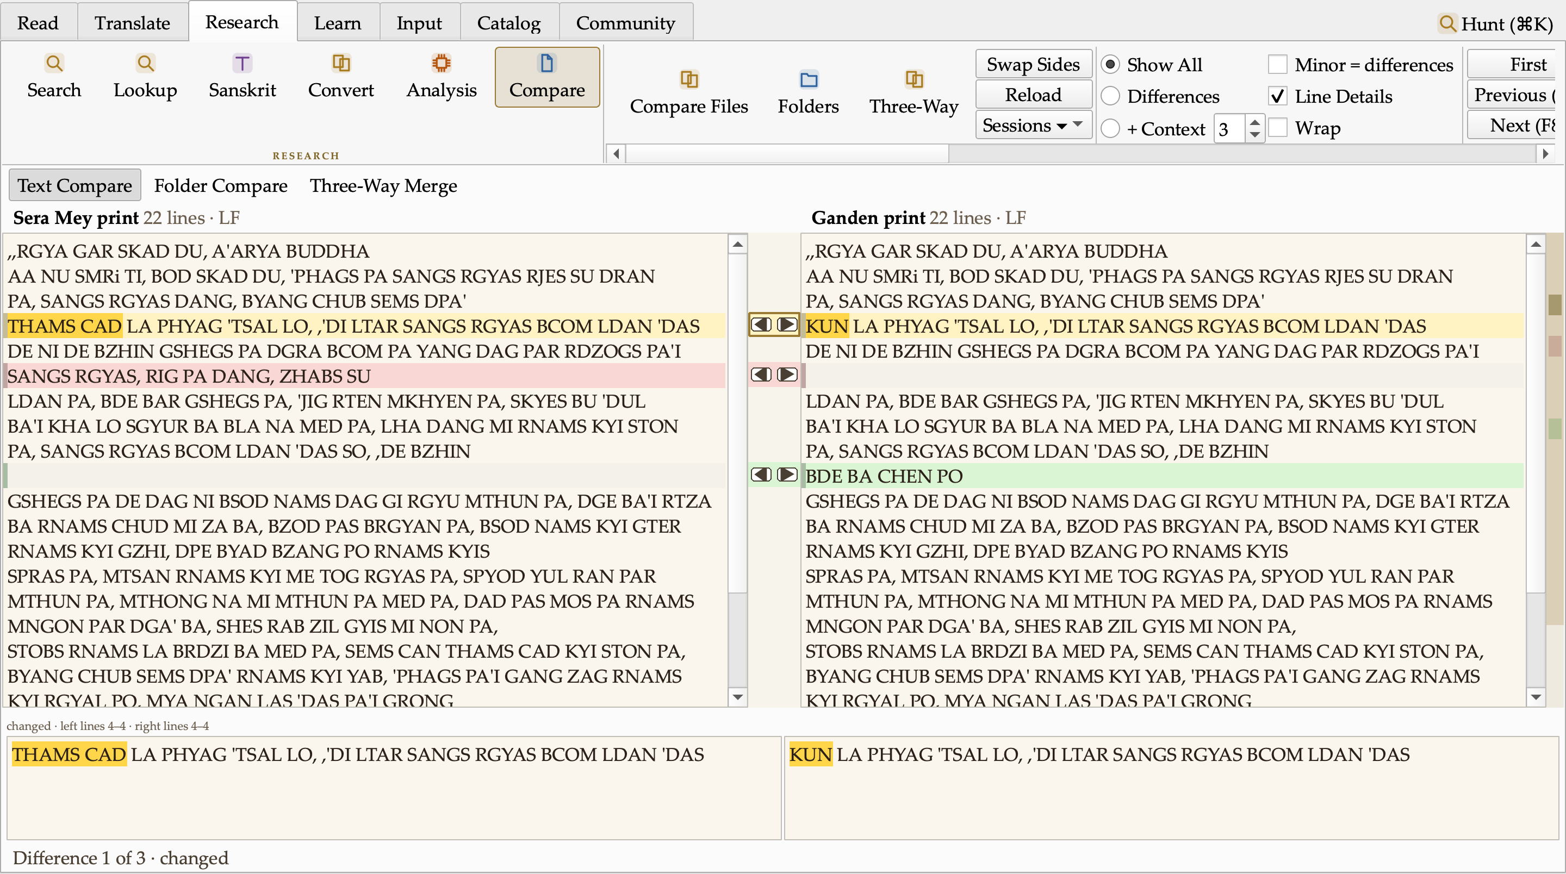
Text Compare: two prints of the opening of the Diamond Cutter. The changed reading (THAMS CAD ↔ KUN) is marked at the syllable, a dropped line shows in red, an added line in green; the arrows between the panes copy a reading across; the map at the right edge shows every difference in the whole text.
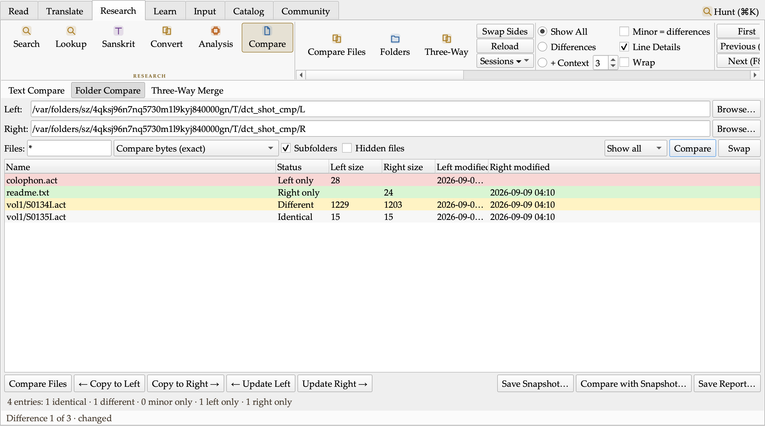
Folder Compare: two batches classified Identical, Different, Left only and Right only, with Copy and Update actions that preview before copying and never delete.
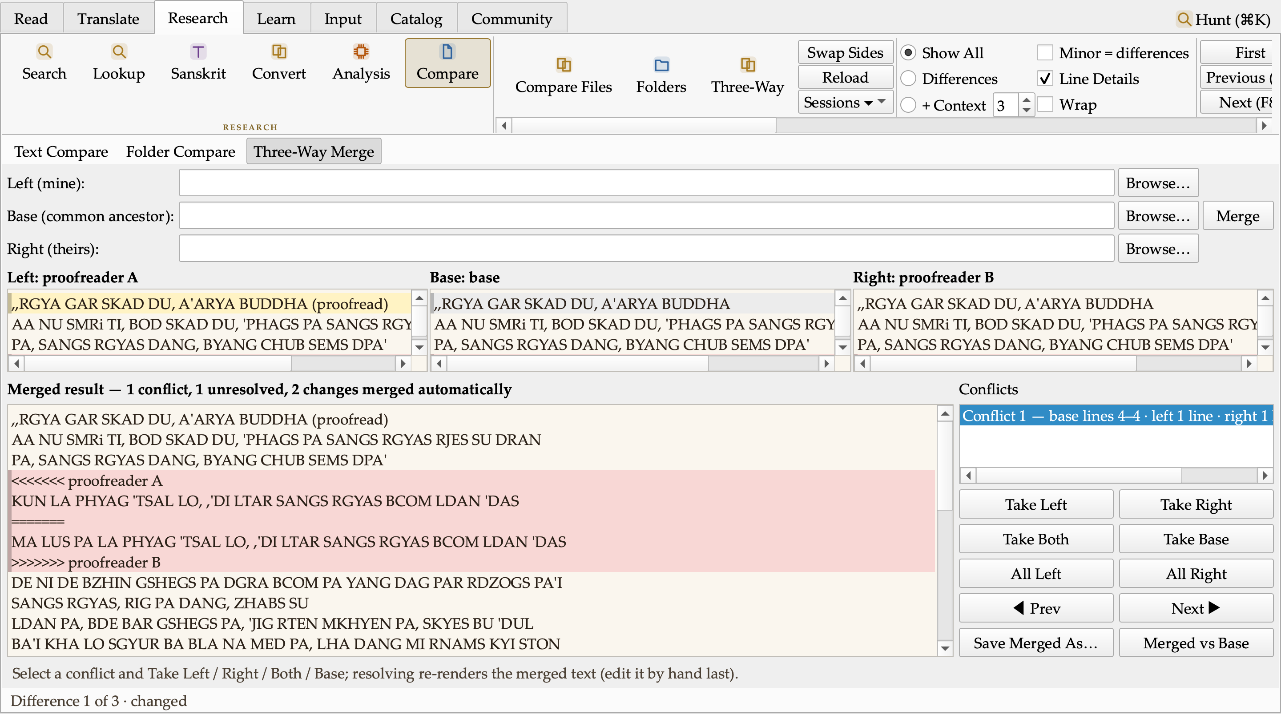
Three-Way Merge: two proofreaders’ corrections of one text against the original. The change both agree on merged itself; the one they disagree on is listed as a conflict for a human to settle.
- Dictionary ordering. Aligned renderings now rank most-attested first with counts (THAMS CAD: all ×30, every ×14, each and every ×10).
- Research written up. I surveyed sixteen text-analysis tool families (diff and merge tools, Word and Acrobat document compare, Draftable, folder sync, version control, find-and-replace suites, near-duplicate detection, TRACER text reuse, Voyant statistics, change tracking, patch tools, structured-data compare) and EndNote and Zotero as models for an in-house reference bank. Each feature has a verdict and a Tibetan- translation use; three follow-on batches are planned: document Versions, Replace in Files with preview, Apply Patch; Repeated Passages and similarity studies, a Statistics study view, Entities in a text, table compare; and a References pane with Insert Citation. Design work on all three began the same evening, alongside a study of the monastery and holy-site maps I collected, toward a Map pane in the Research group.
- Small things. A dharma-wheel busy cursor while the tool works. Two defects found by the battery were fixed the same hour (a false “corrupt image” verdict in packaging; a shutdown crash in a status-bar hook).

The analysis suite, batch 4 — the editing tools the compare engine made possible
With the compare engine in place I built the first batch of the analysis suite in the order the plan’s critic set, one feature at a time, each with its own test battery before I moved to the next.
Versions. Every save of a document, draft or manuscript now keeps a compressed copy with who saved it, when, in which encoding, the revision number and the text statistics of that moment. File ▸ Versions… lists them; a version can be compared with what I am editing or with another version, restored (the text on disk is kept first, even if another program changed it), named and pinned so it is never pruned, or asked which version first introduced a given line. Damaged records are shown red and excluded. Preferences ▸ Versions holds the switch, the caps and the rolling autosave slot. Renaming a file carries its history with it.
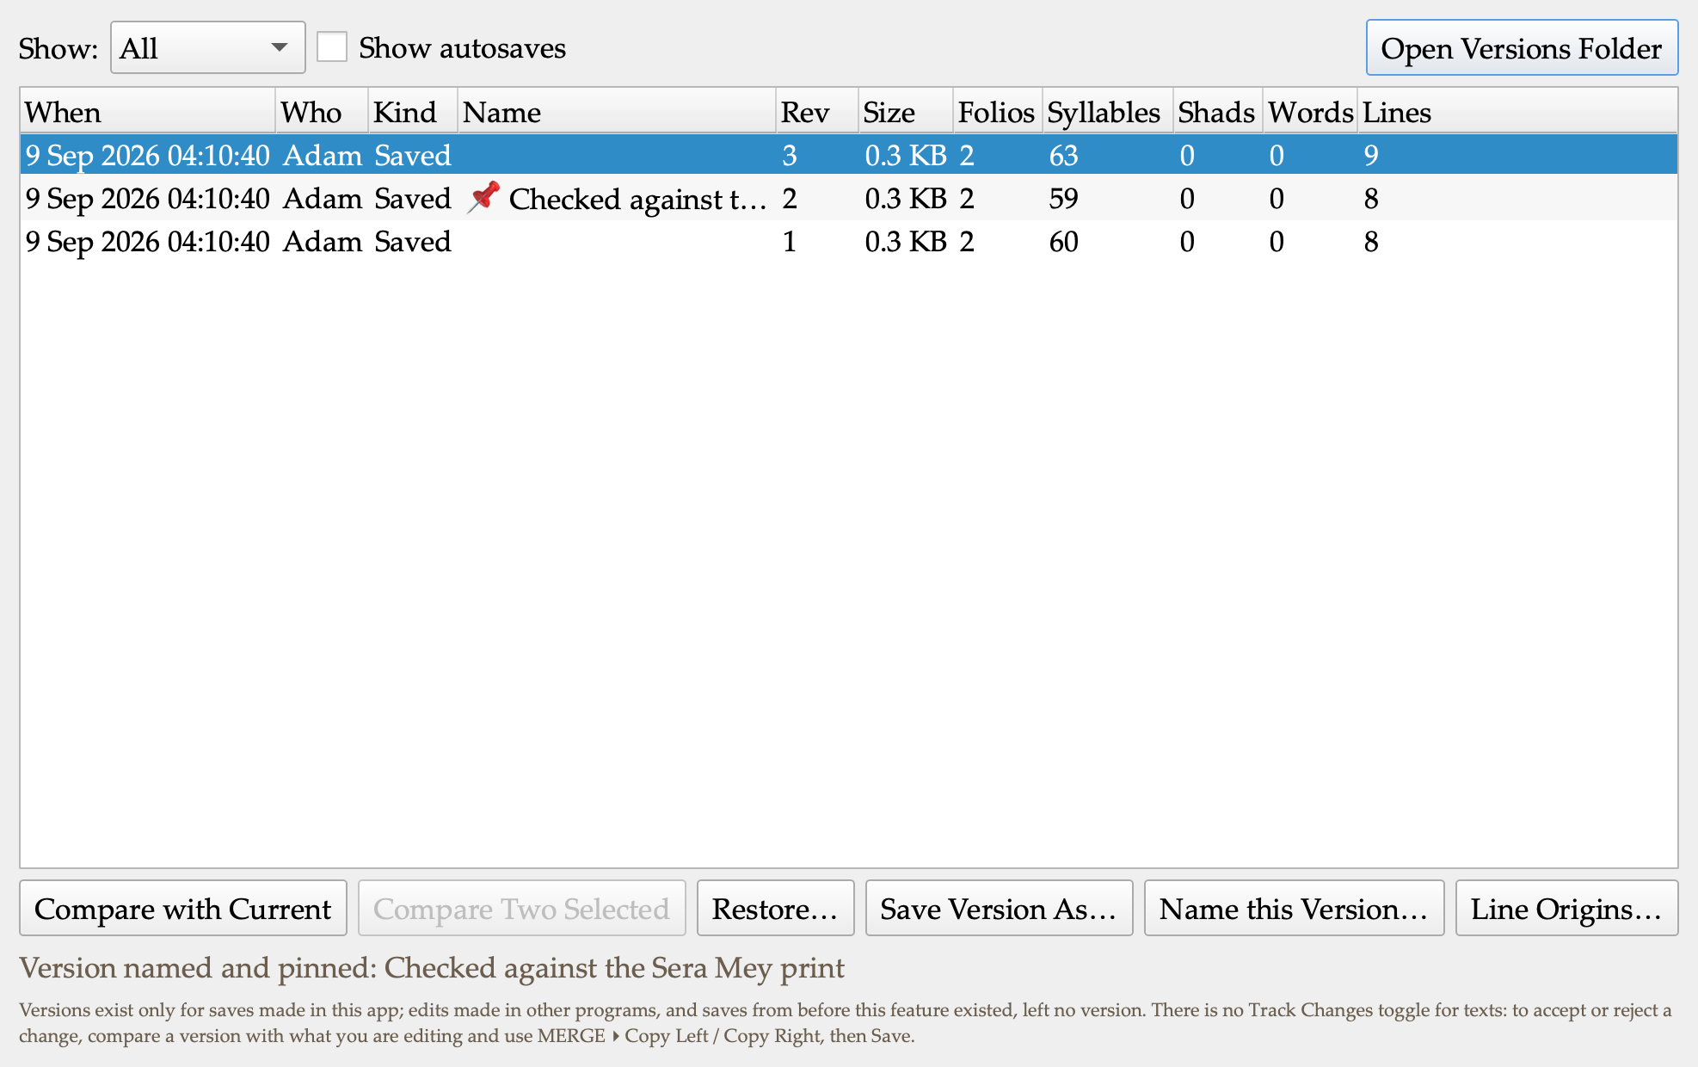
Versions: three saves of one text, the middle one named and pinned. Compare with Current, Compare Two, Restore (two-step), Save Version As, Name, Line Origins.
Changed-folios report. “7 of 143 folios changed”: the apparatus grouped by the left text’s folio markers, as a Markdown table with the readings under each folio, or as CSV. It is a Save Report filter, a Copy Changed Folios action, a fragment on the Compare status line, and a command-line output. The header states every grouping rule, so a reader can reproduce it.
Normalize. The compare rules offered as transformations: collapse spacing, trailing blanks, blank-line runs, the double-shad spelling, spacing around the shad, apparatus spans, folio markers, line endings, a final line break, house-style spacing. Every run previews as a diff in the Compare pane, lists the lines the rules refused and why, and only then applies — the Apply button is dead until a preview exists for exactly these settings and this text. The double-shad form has no default: that is the house’s ruling to make, not mine.
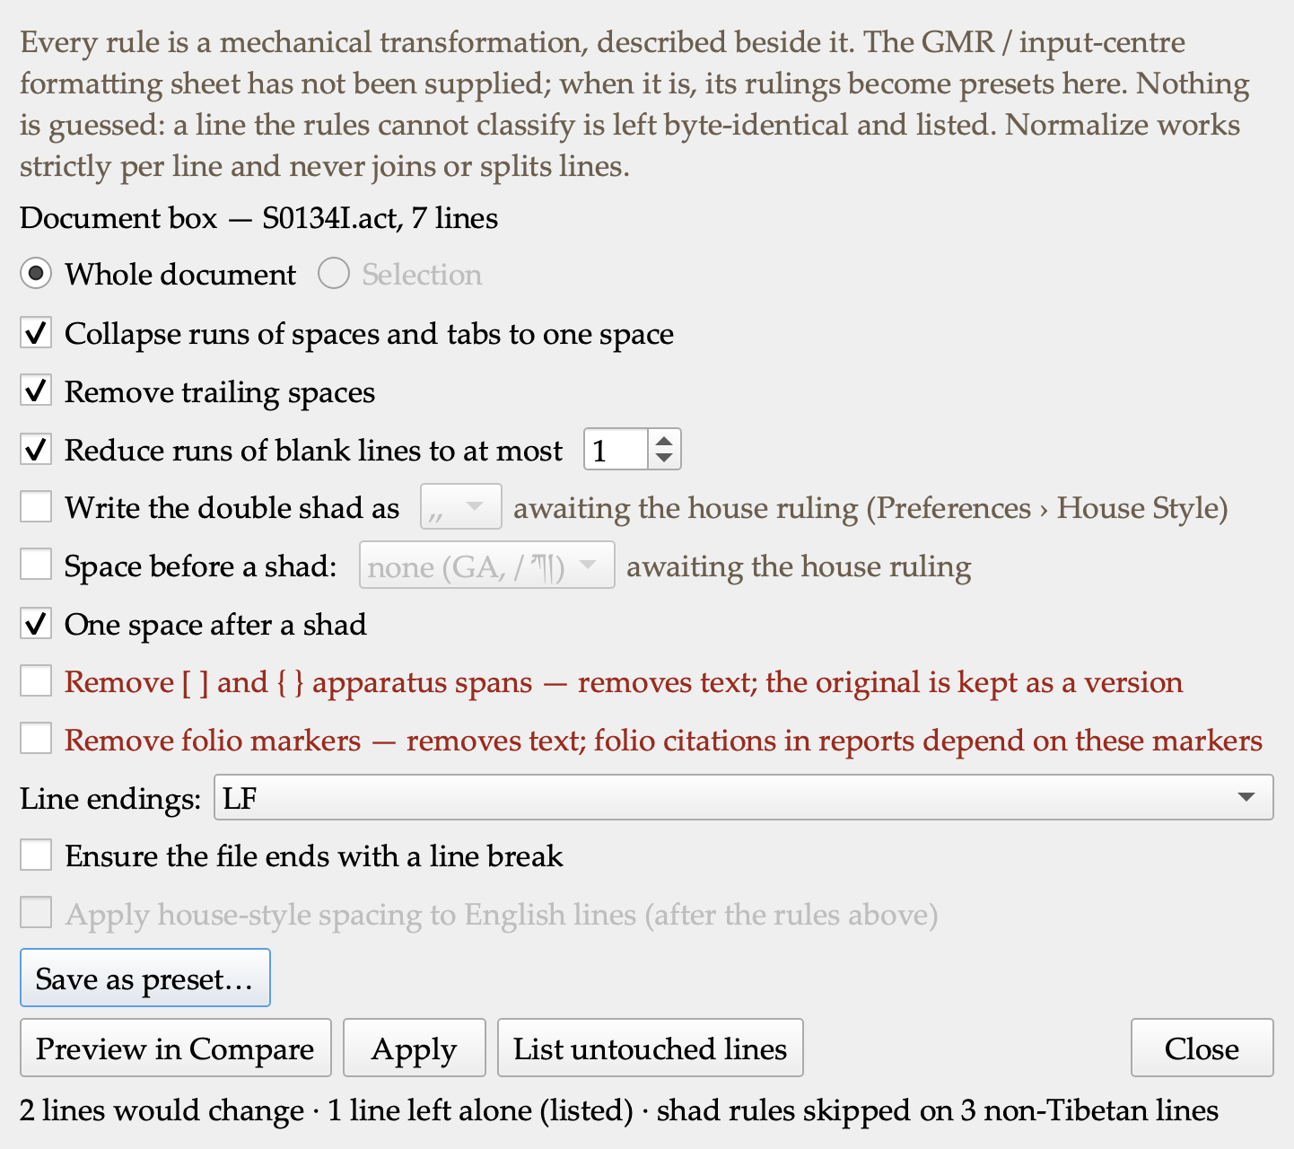
Normalize: the rules as switches, the lossy ones in red, the preview counted from the diff, the refused lines listed.
Replace in Files. One systematic fix across a whole folder, every occurrence listed with its line before and after, tick or untick, then a two-step apply to the ticked files only. Every skipped file is named with its reason (binary, not UTF-8, over the size cap, past the file cap, open with unsaved edits, changed since the preview, a library text without permission). A search text in the wrong script gets a notice, so a count of zero never reads as a clean bill of health. Each run leaves a changeset record and an undo that restores the files from their pre-replace versions and skips any file edited since. Counts come from the files themselves, never from the search index — the footer says so.
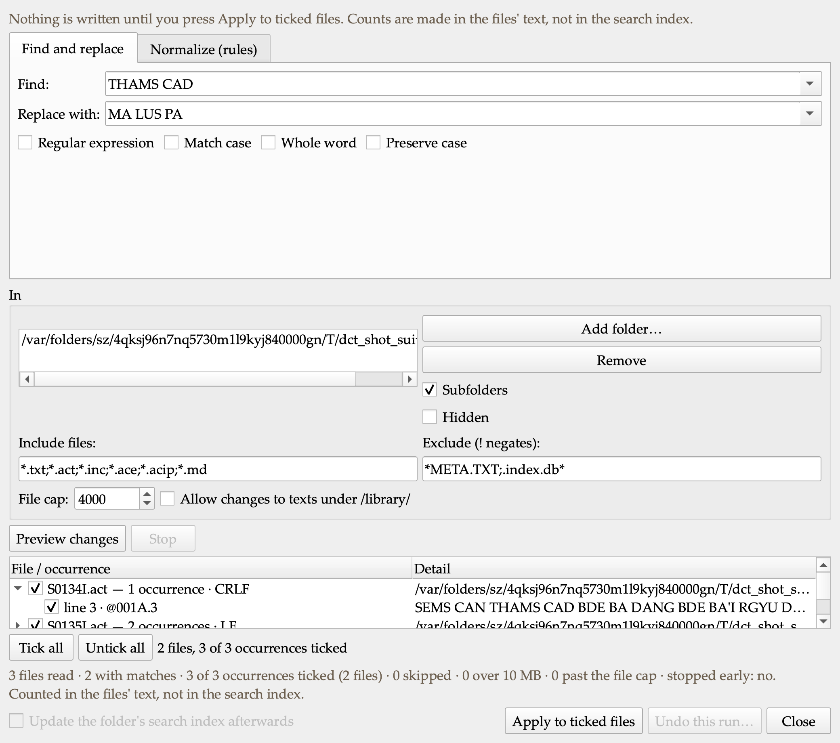
Replace in Files: three occurrences in two files of a small batch, one file expanded to its lines, the honest footer beneath.
Apply Patch (in progress at the time of this draft). A corrector’s unified diff loaded against my copy: each hunk placed exactly, with an offset, with loosened context, already applied, or rejected — five distinct verdicts, never folded into one. The result is a diff in the Compare pane, the rejected hunks go to a .rej file for the corrector, and the previous text is kept as a version before anything is written.
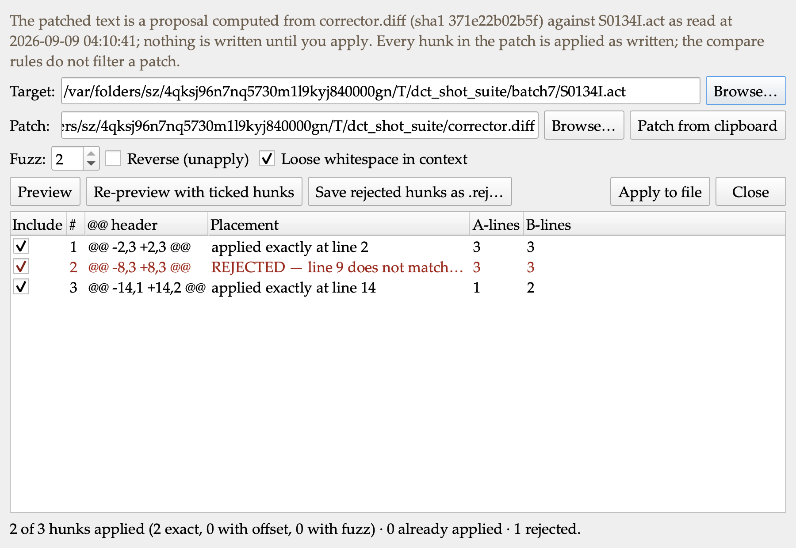
Apply Patch: a corrector’s diff with three hunks against a copy where one line was retyped — two placed exactly, one rejected and named, nothing written until Apply.
Tracked changes for Word (engine in progress). The differences between two drafts written as a Word document with real revision marks, so Geshe Michael can accept or reject each change in Word itself. The first paragraph says what the file compares, under what rules, who ran it, and that the marks are machine-computed. I will not add it to the Save Report menu until I have opened a sample in Word and recorded that Accept All gives text B and Reject All gives text A.

Release audit: eleven of twelve open items closed
The pane-by-pane release audit had left twelve items on the main window needing a ruling. I closed eleven today: the one headless probe that ran outside the safety guard now runs inside it; a dead window-size call is gone; the Sanskrit glyph check, which used to run only by hand, is a test gate (109 suites now); a Quick Access pin whose command was renamed shows as “not in this build” instead of vanishing; the lifecycle log rotates at one megabyte; clearing the scan cache or the search index takes a second, sized click; the Edit menu shows the standard shortcuts the Help advertises; the menu that mirrors every pane’s buttons now skips the destructive ones. Three were verifications, not changes: the press never uses the reduced-battery escape hatch, the data-import hook is wired in every build, and the installed build’s data is release 0.27.2 (105,634 entries, 42,199 corpus segments), read from the database itself. The twelfth — whether both diagnostic reports, with their different privacy profiles, should ship — is a ruling I need from leadership.

Pressed and running
The whole batch is pressed, signed, verified and installed on my desktop (dev-ca74251, then a second press with the audit sweep). Every press ran the full battery, the constitution check and the visual-regression gate over the blessed panes before it was allowed to install.

The idiom register, and a bank to work from
Idioms are the one thing a word-by-word reading gets exactly wrong, and Geshe Michael uses them constantly. We started a register of them in August; nothing read it until today. Now the tool does.
The register marks which Tibetan forms are idioms. It holds no English of its own, and that is deliberate: the English is Geshe Michael’s. The renderings shown beside a form are his, fetched from his own courses and counted, in their own contexts. My English exists in exactly one place, as the payload of a proposal that is waiting for his ruling, and it is labelled as mine everywhere it appears.
Every form carries its status. Approved means he ruled it an idiom. Awaiting his ruling means exactly that, and the tool says so rather than implying the matter is settled. Ruled not an idiom is kept as a record, and the tool stops marking that form, so the same question does not come back a third time.
Proposing one takes a moment: select the Tibetan while translating, right-click, and the form goes into the shared proposals folder with the passage as evidence and my name on it. When he rules, one button brings his approvals and declines into the team register with his name and the date. The five forms in the register today are the ones the corpus calibration put forward in August, and all five are still waiting for him.
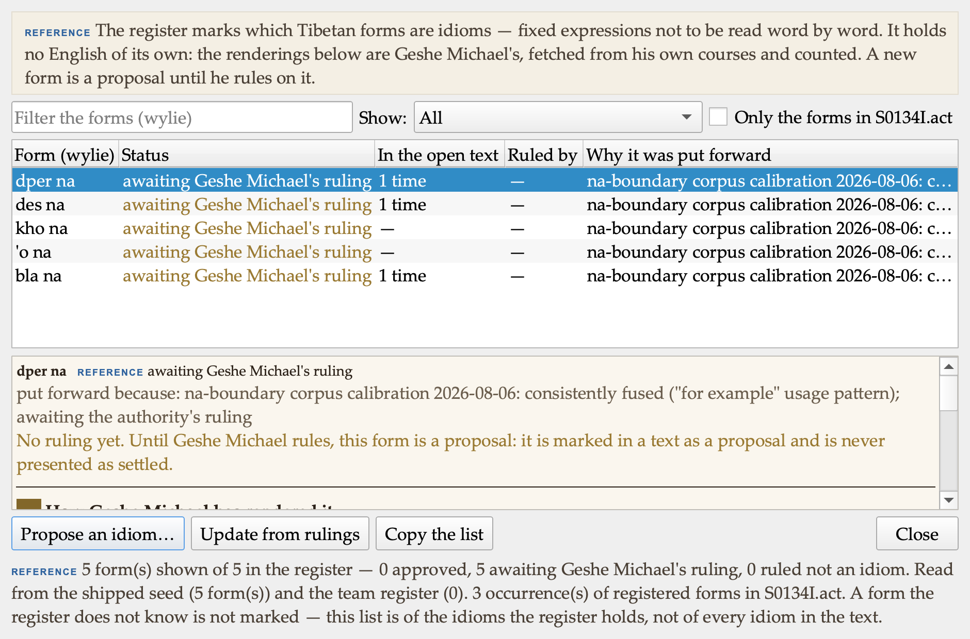
The idiom bank: the five forms put forward in August, all awaiting his ruling, with how often each occurs in the open text. The panel below a form shows why it was put forward and how he has rendered it in his own courses.

Turning off what you do not use
The suite now carries twenty-five panes in seven groups. Someone who only reads and drafts meets twenty surfaces they will never open. So Preferences now has a Features page: every pane and every group is a switch.
Hiding is a view, not a removal. Nothing is deleted, the feature keeps working, its files are untouched, and it stays reachable from the menus, so something used twice a year can still be used twice a year without being switched back on. The list is built from the panes that actually exist when the app runs, so it can never drift from the build. Turning everything off is refused: a window with nothing in it is a fault, not a preference.
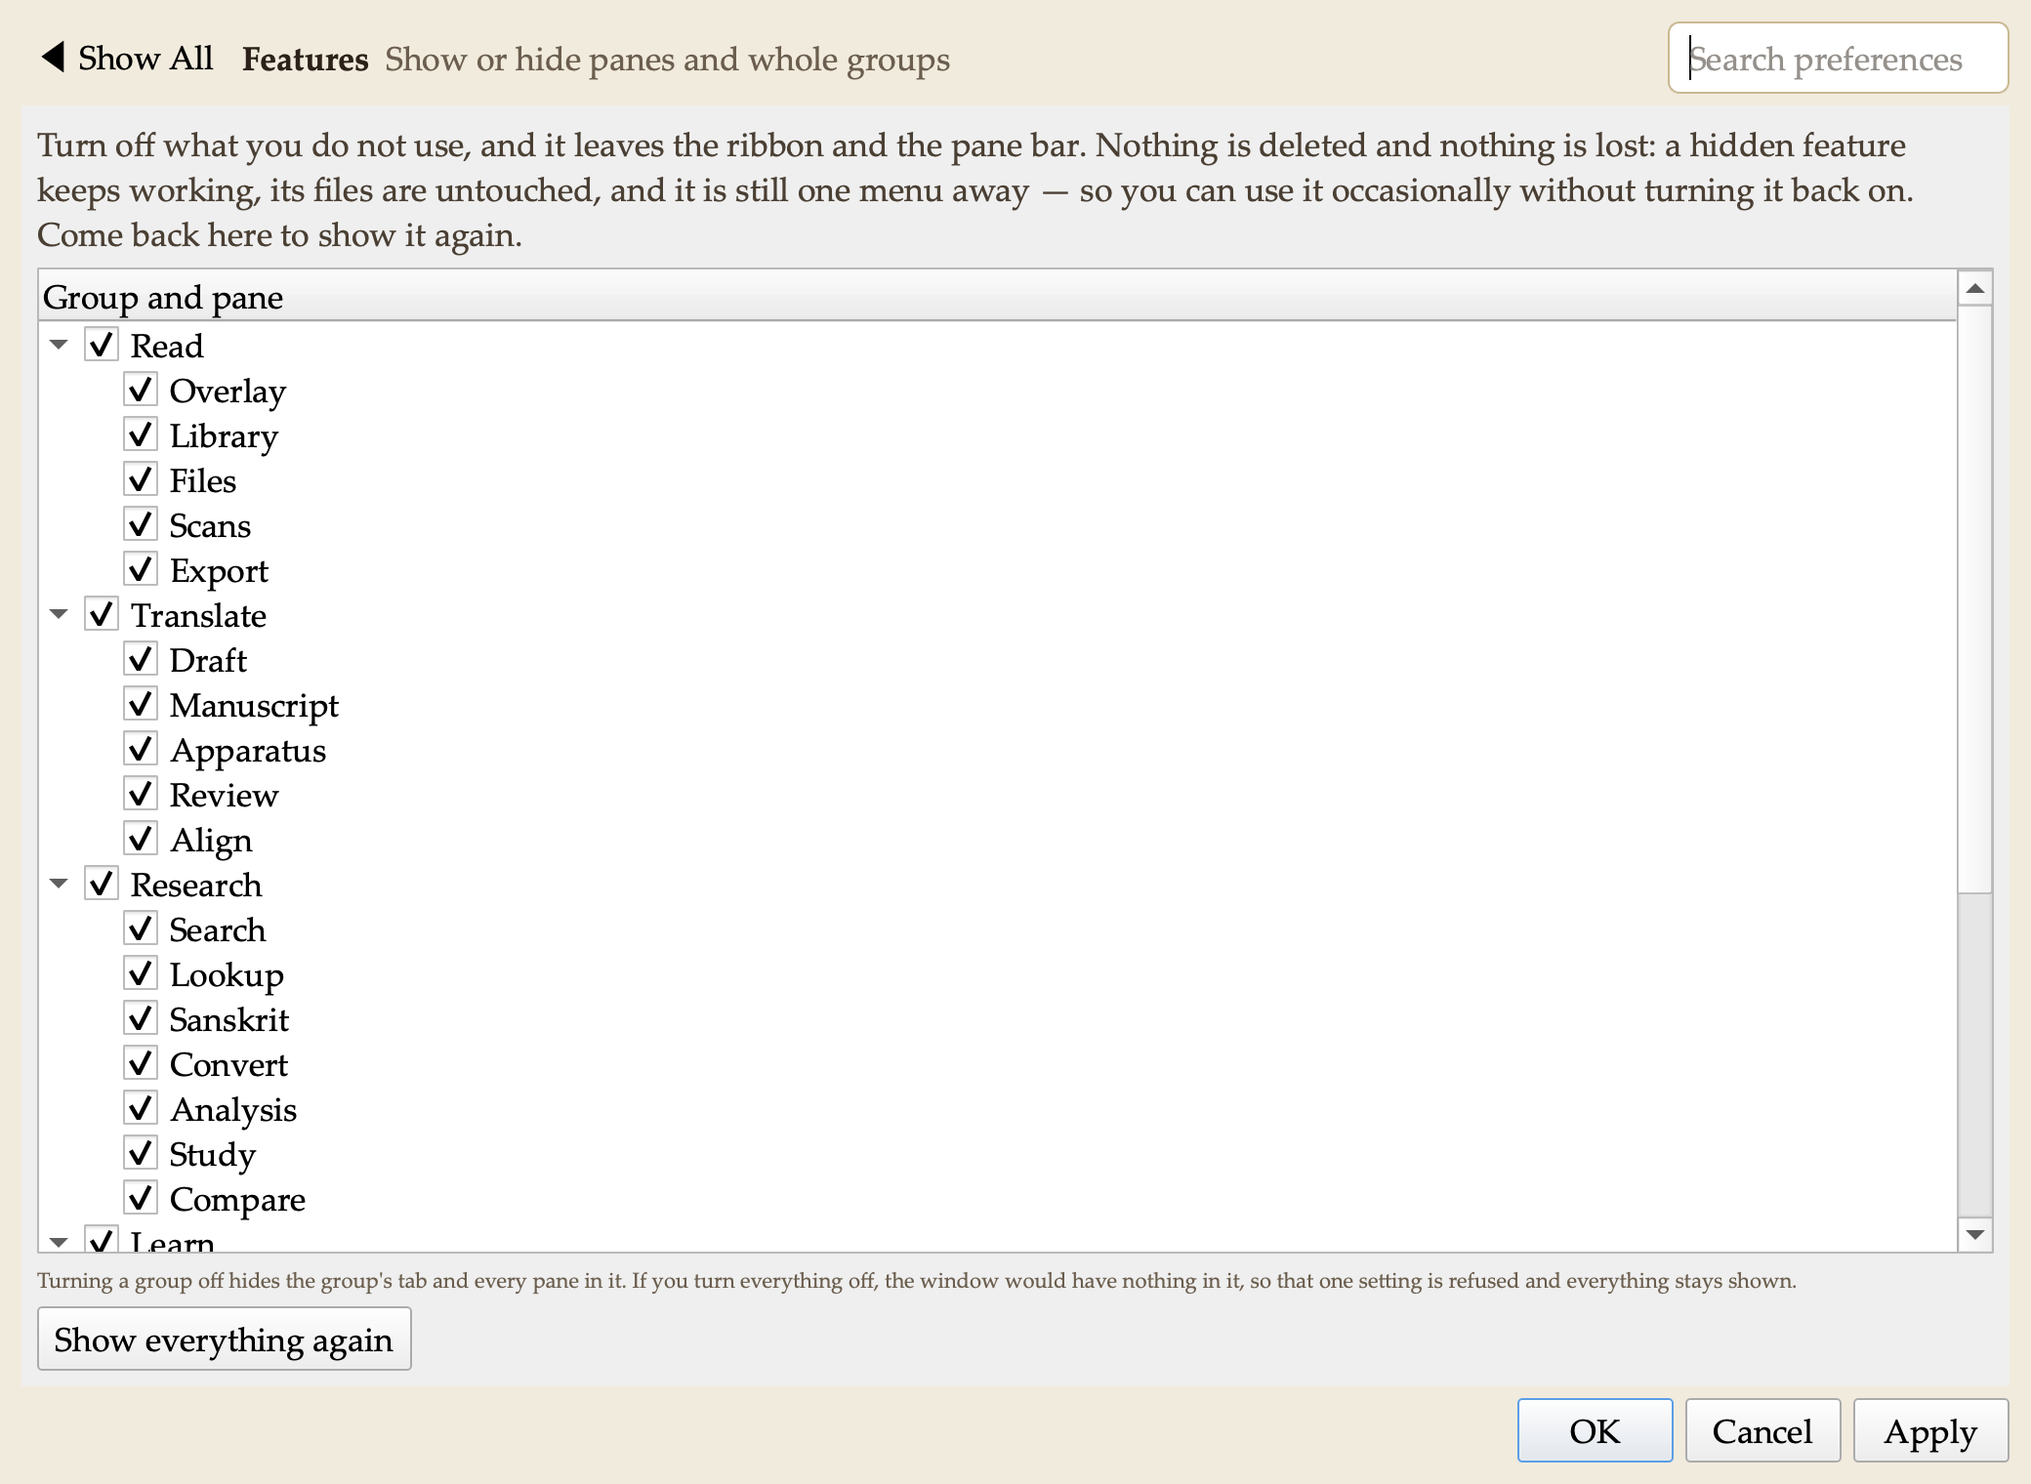
Preferences ▸ Features: every pane and group is a switch, and the first thing the page says is that nothing is deleted.

The next batch of the analysis suite: the foundation, and a first result
The plan’s critic set an order for the second analysis batch, and it begins with work nobody sees. The program had four separate ways of walking folio numbers and its own private syllable splitter buried in one file. Adding a fifth of each was the hazard three of the subsystem maps had already named. Those are now one shared piece of machinery, and the proof that the move was faithful is that the old test batteries passed unchanged.
On top of it, two visible things. Study is a new pane in Research with four pages, each of which will answer a question about a text: what it counts, what it repeats, which other texts share material with it, and which people, works and dates it names. The pages arrive with their engines over the next stretch; today each one states plainly what it will do and that its engine is not in this build, so no number on the screen is a placeholder.
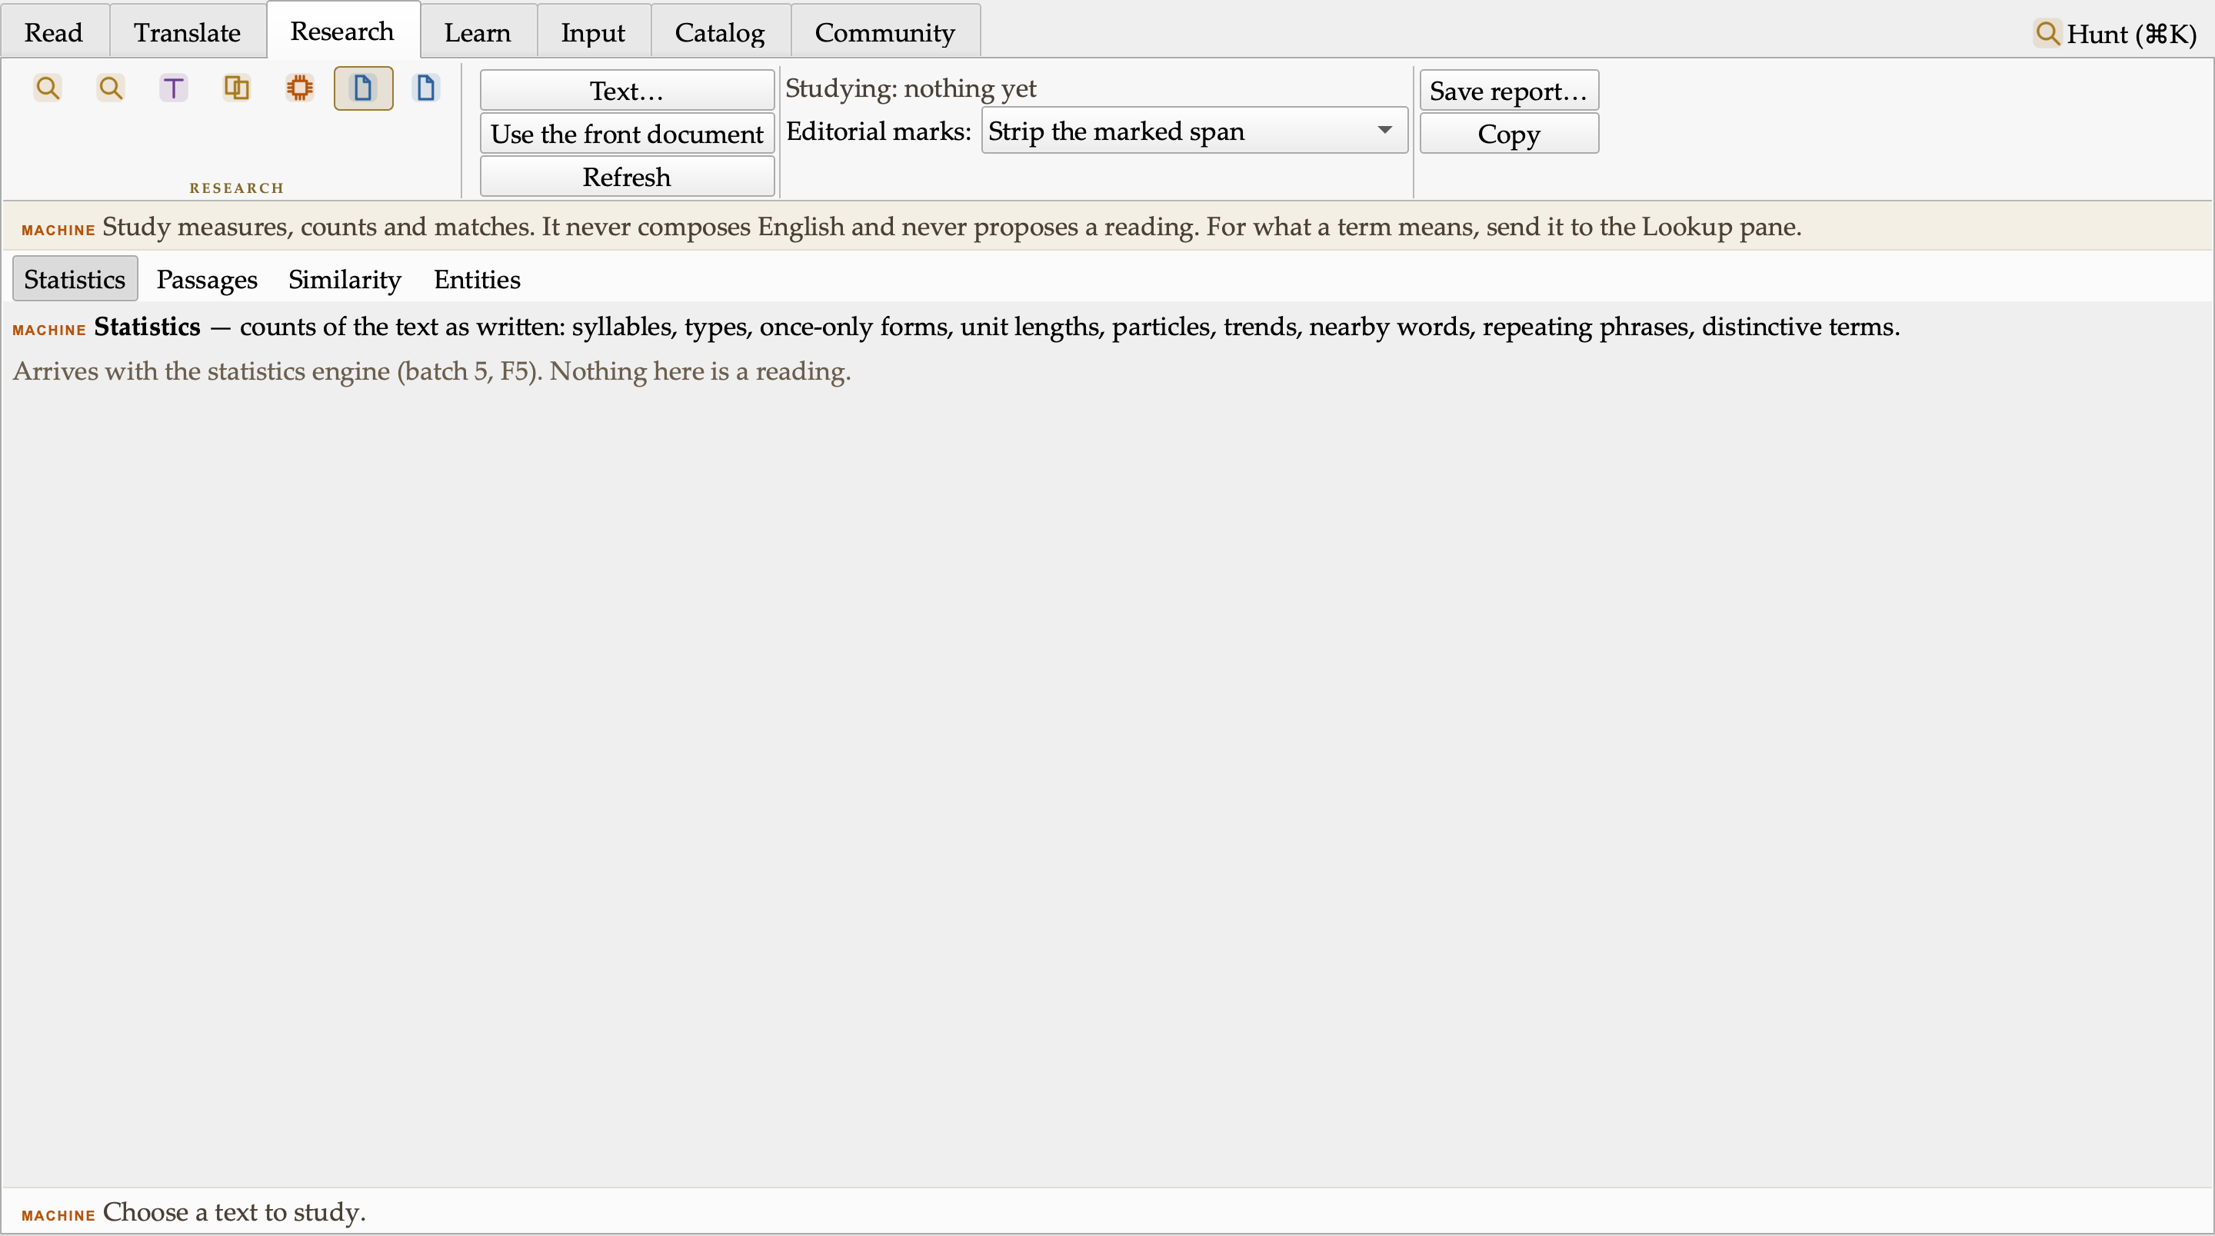
The new Study pane. Each page says what it will answer and, honestly, that its engine has not landed yet.
Table Compare is finished and working now, as a fourth page of the Compare pane. It answers a question the text comparison cannot: when a new dictionary release arrives, which headwords actually changed? Not a sixty-megabyte text difference, but a list of records paired by a key I choose. It refuses to guess: when the same headword appears twice on a side, it says so and never pairs them by position. Run against the real release file, 105,634 rows, it found exactly the 56 duplicated headwords we already knew were there.
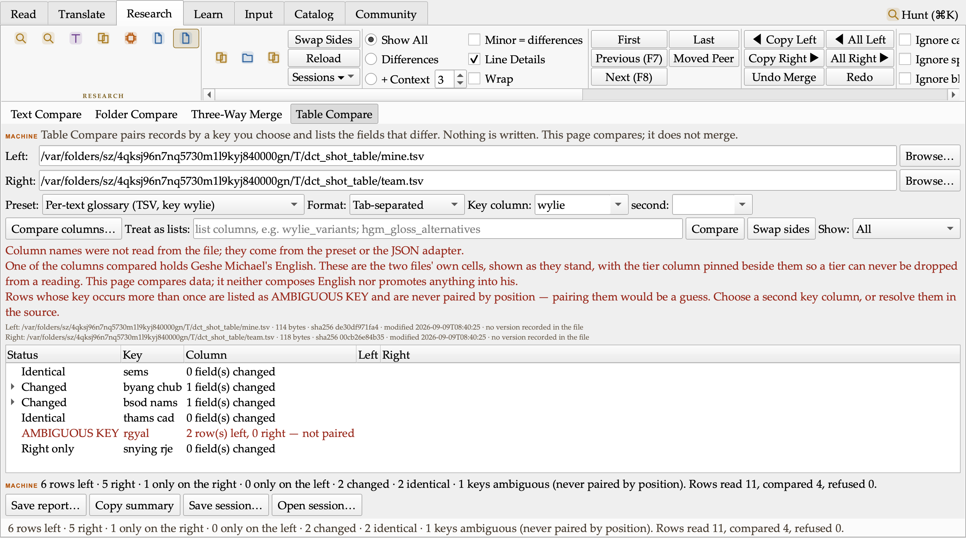
Table Compare: my glossary against the team’s. Two renderings drifted, one term is only in theirs, and the headword that appears twice is refused rather than paired by guesswork.

Decisions I made along the way
- The style sheet’s rules live as switches in Preferences, so any of them can be turned on or off.
- Cover notes for these digests and for technical documents recommend opening the .docx, which is properly formatted, over the .md and .txt.
- Every digest now carries screenshots of what changed and a chart where it explains the numbers, captured by the tool itself so they are reproducible.
- New features may get their own tabs, groups or panes wherever that reads most logically, rather than being crammed into existing ones.
- The desktop build will be re-pressed once the menu work is complete, not after every batch.
- Filed for after the release: a Textual Research workflow (collections, word and variant studies), companion iOS/Android reader apps, Tibetan Buddhist iconography in the interface, and a list of research-suite questions to put to Geshe Michael.
- Versions are deduplicated by content: saving an unchanged text keeps nothing new and says so, and restoring a version does not re-bank a copy that is already kept. Identical bytes are one version.
- The double-shad spelling and the space before a shad have no default in Normalize. Shipping a wrong default would silently re-spell every shad in a volume; the house ruling decides.
- Replace in Files refuses to run when Versions are switched off: without the pre-replace copies there would be no undo, and a batch rewrite without an undo is not something I will offer.
- A search text in one script against files in another gets a notice instead of a zero. A zero must never read as “the text is clean”.
- The idiom register holds no English of its own. English is Geshe Michael’s; the tool shows his renderings from his own courses and labels a translator’s proposed English as the translator’s until he rules.
- Hiding a feature is a view, not a removal: a hidden pane stays reachable from the menus, so occasional use does not mean switching it back on.
- The idiom bank did not get a ribbon button. It would have pushed the widest ribbon eighty pixels past the width limit we set ourselves, so the feature moved to the right-click menu instead of the limit moving.
- The Word redline ships command-line first. The menu filter appears only after I have opened a sample in Word and recorded that Accept All gives text B and Reject All gives text A. No dead control in the meantime.

Numbers
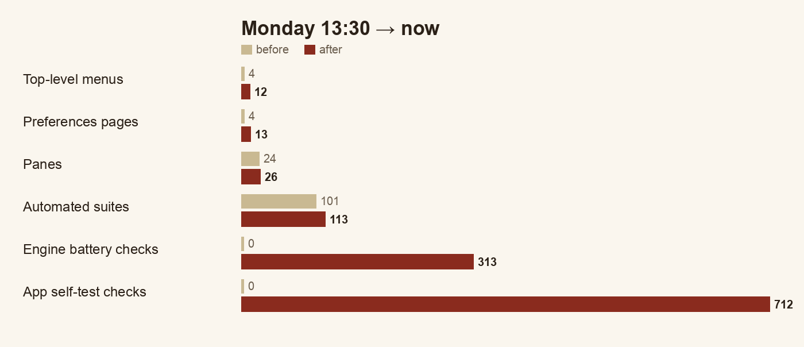
Before and after, Monday 13:30 to now. Every count comes from the build itself: menus and pages from the running app, suites and checks from the test runner.
 | Monday 13:30 | Now
Top-level menus | 4 | 12
Preferences pages | 4 groups in one dialog | 13 pages
Panes | 24 | 26 (Compare, Study)
Automated suites | 101, all green | 113, all green
Checks in the text engines | — | 313 across 11 batteries
Checks in the app’s own self-test | — | 712
Analysis-suite features shipped | 0 | 6 of the first batch, plus the foundation and Table Compare of the second
Headwords whose renderings were out of frequency order | 763 | 0

Open questions for leadership
- Licence for the project’s own code (unchanged; blocks a public release).
- Whether the repository moves to the ALL organisation on GitHub.
- Apple Developer ID for a notarised install.
- The 24 data layers with open terms.
- New: confirmation of the style sheet’s colon and semicolon spacing rules, so I can set the defaults.
- New: I will ask Geshe Michael what he wants from the research suite before it is designed in detail.
- New: the house convention for the double shad (,, or , , in ACIP; །། or ༎ in Tibetan script) and the space before a shad — until ruled, Normalize leaves both alone.
- New: whether canonical library texts may be rewritten in bulk by Replace in Files (today: only with an explicit switch, and every such file is badged and counted).
- New: should a hidden feature also disappear from the menus, or stay reachable there as it does now?
- New: the five idioms in the register are all waiting on Geshe Michael. A short sitting with him would settle them and show the group how the channel works.
- New: a Word verification of the tracked-changes export — ten minutes with a sample in Microsoft Word — before it appears in the menus.

Next
Build out the Study pane’s four engines in the critic’s order; press a fresh build with the whole batch and relaunch it on the desktop; clear the twelve release-audit items that still need a ruling; then the Map pane study and the second analysis batch (repeated passages, collation of many witnesses, the citation and reference bank).

