Diamond Cutter Translation Tool — daily digest, Tuesday 9 September 2026 (DRAFT — covers everything since Monday’s 13:40 digest)
Headline. Since Monday’s digest I brought the tool’s menu bar to parity with Microsoft Word and Sublime Text — twelve menus and a Word-style Preferences window, every item working and tested — and built a full Compare & Merge suite for Tibetan texts: two editions side by side with the differing syllables marked, merging between them, folder comparison with safe synchronisation, three-way merging of two proofreaders’ corrections, and an apparatus criticus that cites every variant by folio and line. Everything ran green on the full automated battery.

What I did
- Menus, complete. I modelled the menu bar on Word and Sublime Text, taking each of their menus in turn and keeping what has an honest use on a Tibetan text file: File, Edit, Selection, Find, Insert, Format, Tools, Project, Goto, View, Window and Help. Highlights: a Properties window whose Statistics understand folios, syllables and shads; encodings for legacy input-centre files chosen on open and on save; Paste Special converting between ACIP, Wylie and Tibetan script; Find and Replace with regular expressions, preserved capitalisation and find-in-files; Goto a heading, a line, a folio, a dictionary entry or the concordance; bookmarks in the margin; Insert a folio marker, a Tibetan-symbol palette, the date with the Tibetan year; Format styles and case changes including Tibetan transliteration; Tools for spelling doubts, phrase memory, hand-offs to the Draft and Manuscript, document protection, snippets; a Project menu built on dossiers; a Window menu; Help ▸ Data Status. Items with no meaning here (multi-caret editing, page layout, mail merge, build systems) were skipped and the reasons recorded.
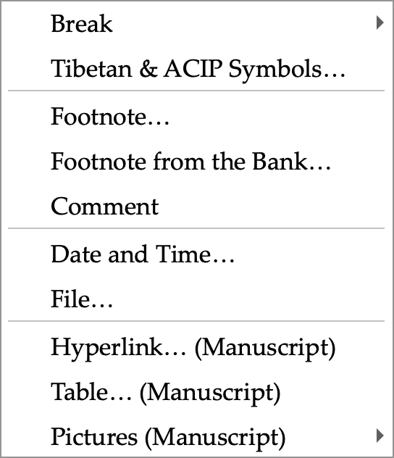
The Insert menu: folio markers, the Tibetan and ACIP symbol palette, footnotes to the Draft, the date with the Tibetan year, and the Manuscript’s rich-text items.
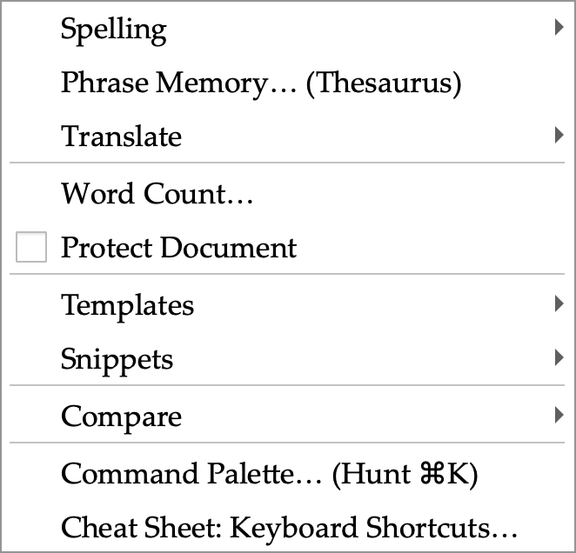
The Tools menu: spelling doubts, phrase memory, hand-offs between panes, word count, document protection, templates, snippets and the new Compare submenu.
- Preferences. A Word-style window of eleven pages behind an icon grid with search: General, View, House Style, Lookup, Compare, Team, Locations, Privacy, Colours, Shortcuts and Quick Access. Every switch drives a real setting; the Shortcuts page lists every menu command and key from the live menu bar.
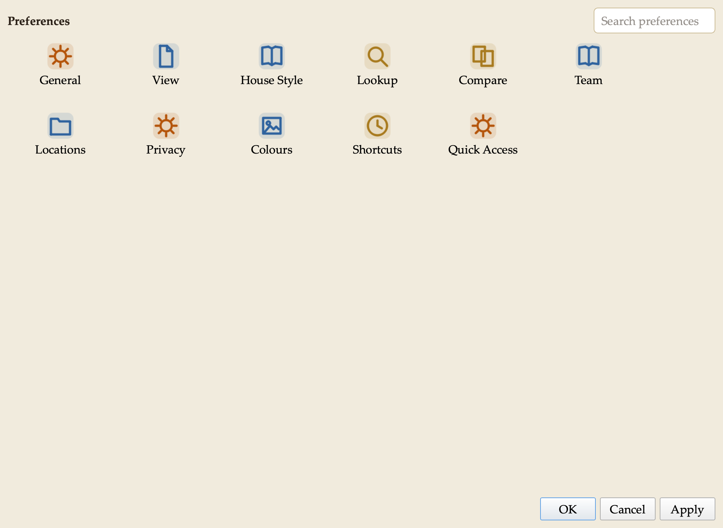
Preferences: the icon grid. Search narrows it; one page opens at a time with Show All to return.
- House style. I made our style sheet’s spacing rules switches on the House Style page: two spaces after a sentence, applied on demand, on save, or as you type — English only, abbreviations left alone. Colon and semicolon rules are there too, off until I confirm them against the sheet.
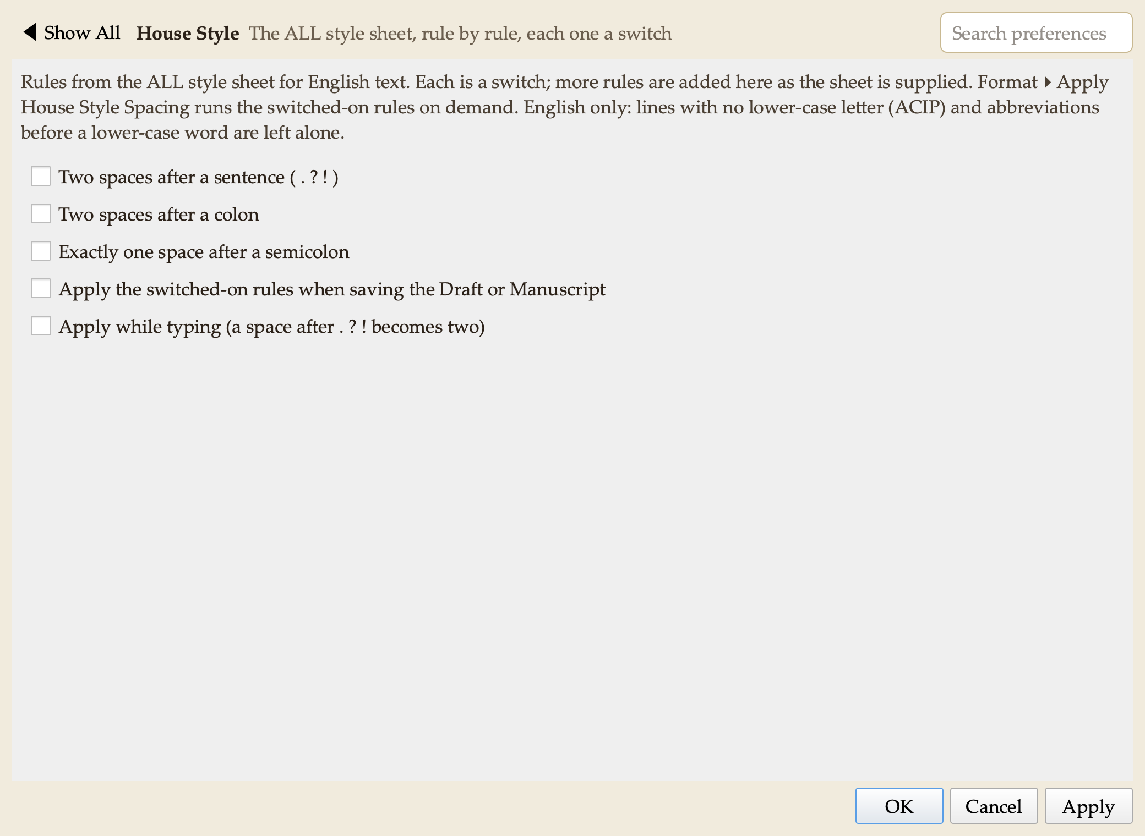
Preferences ▸ House Style: each rule of the style sheet is a switch.
- Compare & Merge suite. I studied Beyond Compare, WinMerge, UltraCompare and Araxis Merge and built their combined functionality into a new Compare pane in the Research group, adapted for our texts. Compare two files, or a text against the clipboard or its saved version; differences are shown line by line with the changed syllables highlighted, in any of ACIP, Wylie or Tibetan script. Rules let the tool ignore spacing, shad variants, folio markers, editorial brackets, or compare across scripts (an ACIP file against a Unicode file). Copy a reading left or right, undo without limit, edit in place, pin lines that must align. Reports: a side-by-side HTML page, a patch file, and an apparatus criticus in Markdown or CSV. Folder Compare classifies two folders and copies only after a preview (it never deletes); snapshots record a folder’s state for later comparison. Three-Way Merge combines two edited copies of one text against the original, resolving conflicts one by one; a file left with conflict markers opens as a two-sided comparison. Command-line comparison for scripted checks.
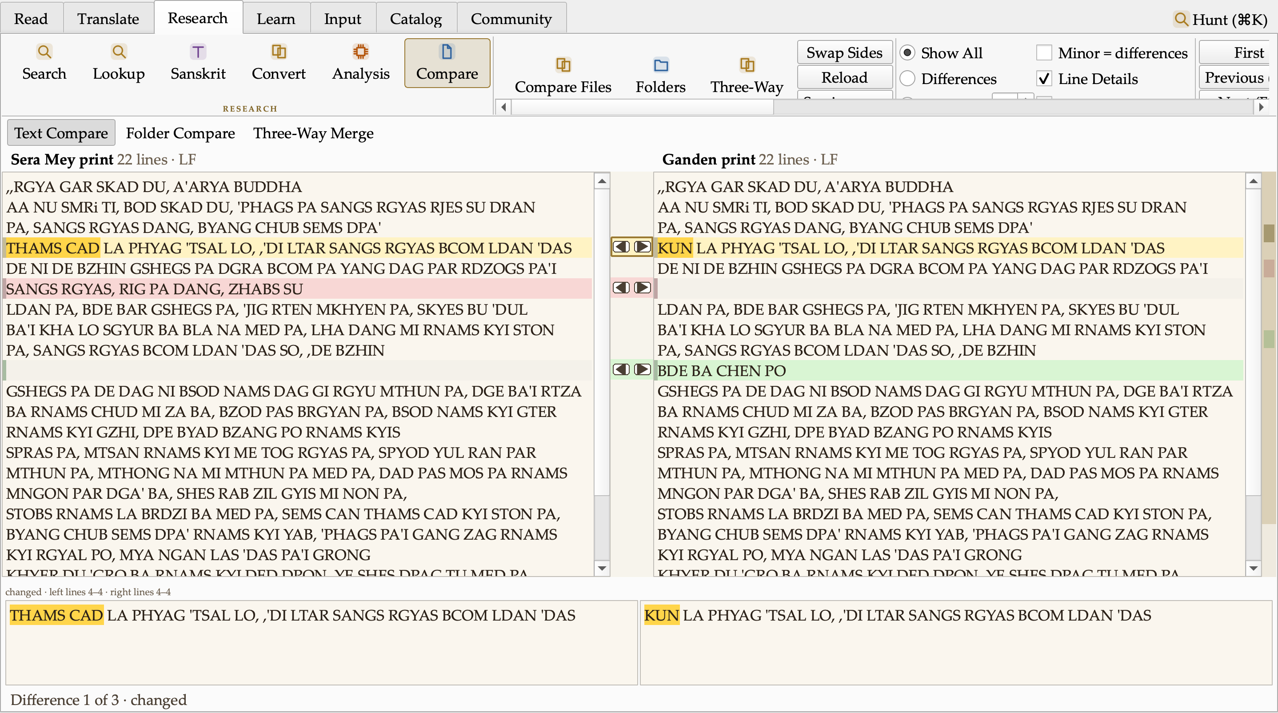
Text Compare: two prints of the opening of the Diamond Cutter. The changed reading (THAMS CAD ↔ KUN) is marked at the syllable, a dropped line shows in red, an added line in green; the arrows between the panes copy a reading across; the map at the right edge shows every difference in the whole text.
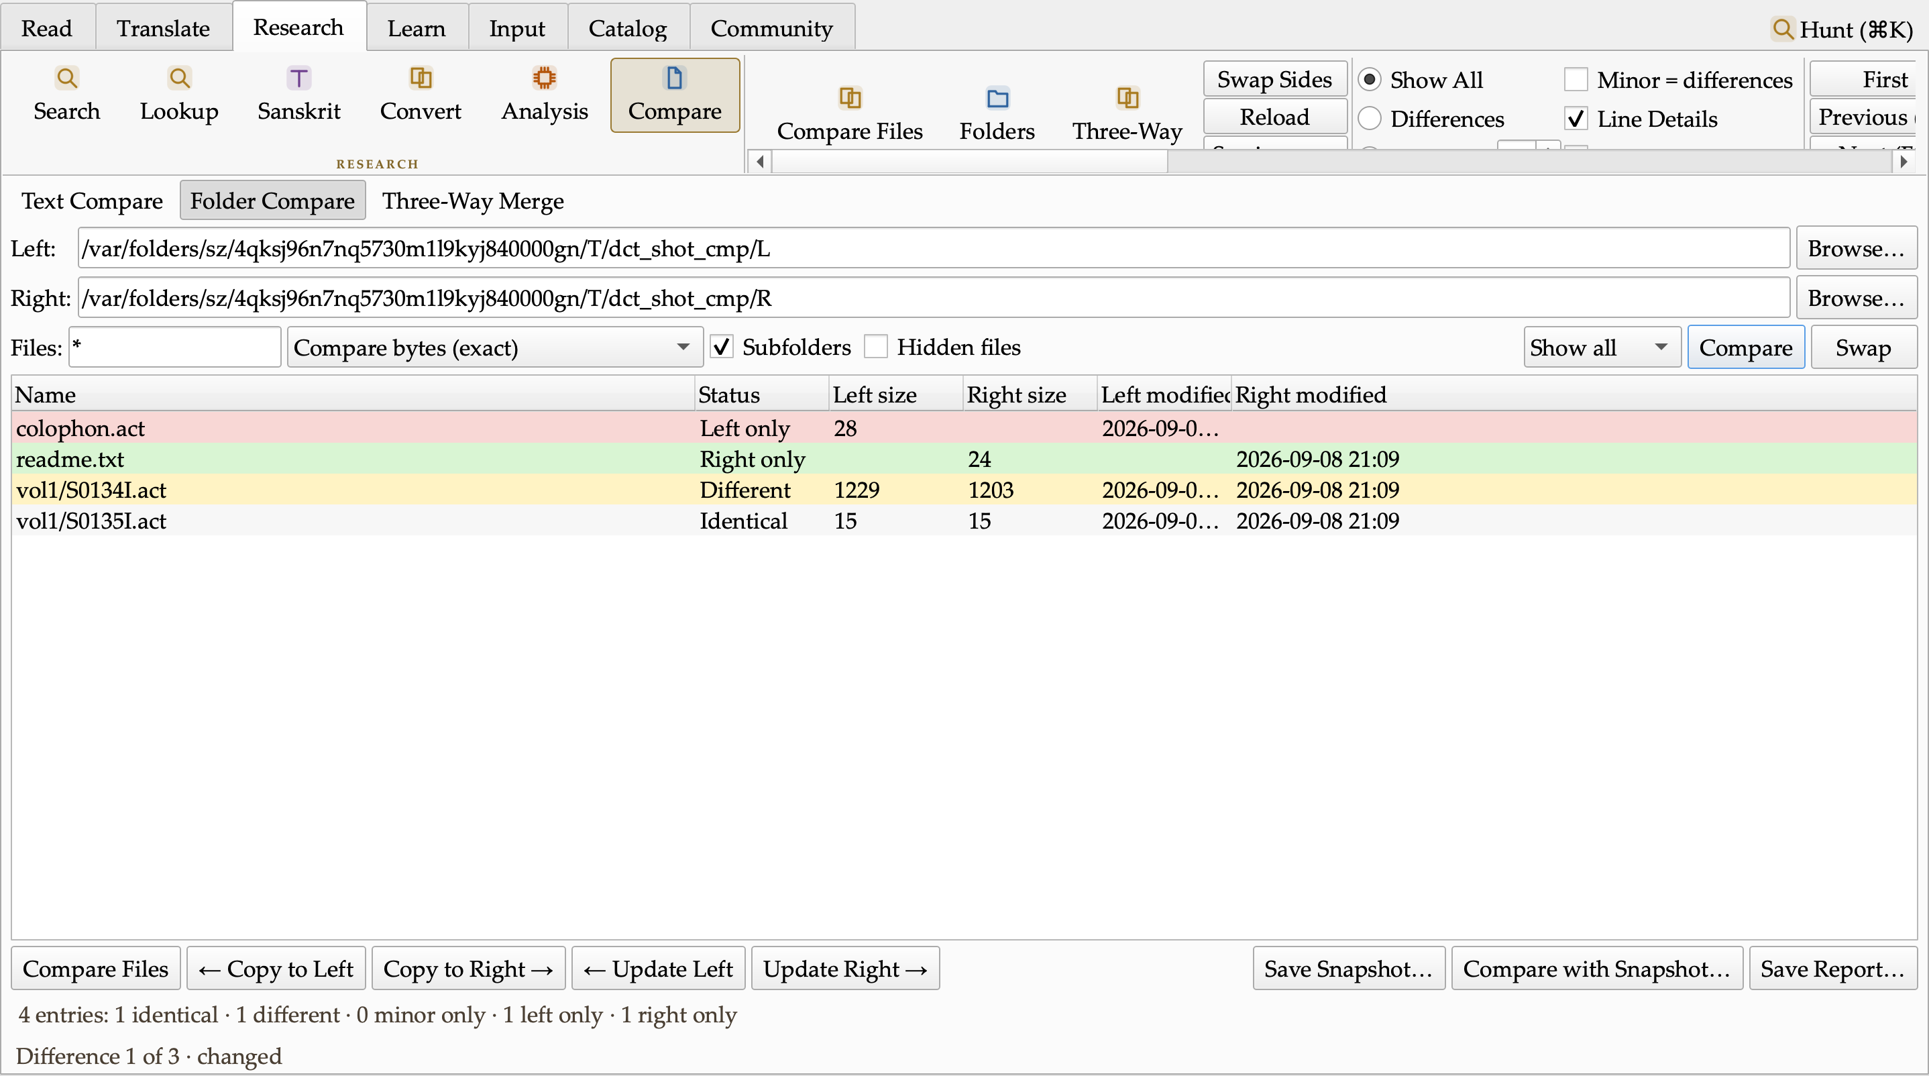
Folder Compare: two batches classified Identical, Different, Left only and Right only, with Copy and Update actions that preview before copying and never delete.
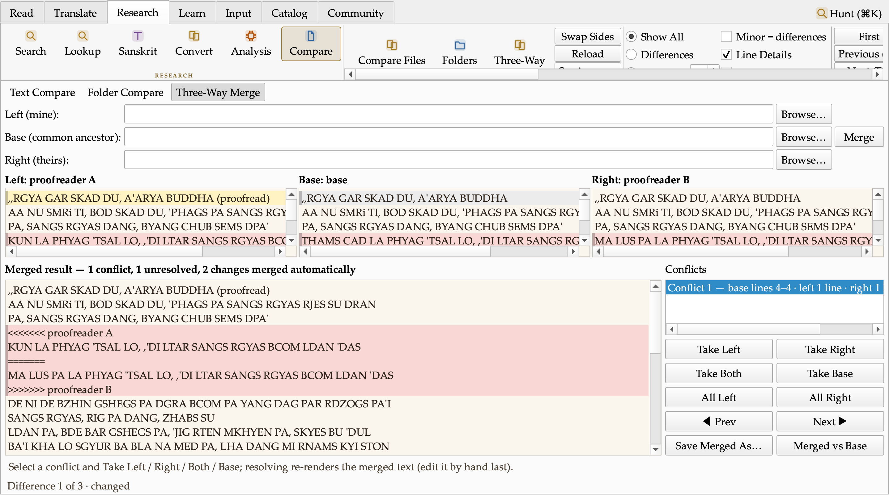
Three-Way Merge: two proofreaders’ corrections of one text against the original. The change both agree on merged itself; the one they disagree on is listed as a conflict for a human to settle.
- Dictionary ordering. Aligned renderings now rank most-attested first with counts (THAMS CAD: all ×30, every ×14, each and every ×10).
- Research written up. I surveyed sixteen text-analysis tool families (diff and merge tools, Word and Acrobat document compare, Draftable, folder sync, version control, find-and-replace suites, near-duplicate detection, TRACER text reuse, Voyant statistics, change tracking, patch tools, structured-data compare) and EndNote and Zotero as models for an in-house reference bank. Each feature has a verdict and a Tibetan- translation use; three follow-on batches are planned: document Versions, Replace in Files with preview, Apply Patch; Repeated Passages and similarity studies, a Statistics study view, Entities in a text, table compare; and a References pane with Insert Citation. Design work on all three began the same evening, alongside a study of the monastery and holy-site maps I collected, toward a Map pane in the Research group.
- Small things. A dharma-wheel busy cursor while the tool works. Two defects found by the battery were fixed the same hour (a false “corrupt image” verdict in packaging; a shutdown crash in a status-bar hook).

Decisions I made along the way
- The style sheet’s rules live as switches in Preferences, so any of them can be turned on or off.
- Cover notes for these digests and for technical documents recommend opening the .docx, which is properly formatted, over the .md and .txt.
- Every digest now carries screenshots of what changed and a chart where it explains the numbers, captured by the tool itself so they are reproducible.
- New features may get their own tabs, groups or panes wherever that reads most logically, rather than being crammed into existing ones.
- The desktop build will be re-pressed once the menu work is complete, not after every batch.
- Filed for after the release: a Textual Research workflow (collections, word and variant studies), companion iOS/Android reader apps, Tibetan Buddhist iconography in the interface, and a list of research-suite questions to put to Geshe Michael.

Numbers
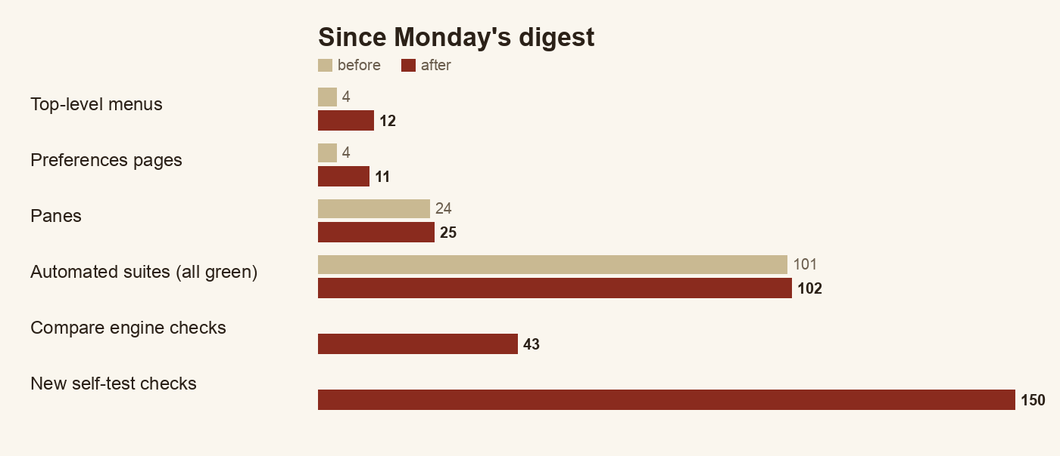
Before and after, Monday 13:30 to now. Every count comes from the build itself: menus and pages from the running app, suites from the test runner.
 | Monday 13:30 | Now
Top-level menus | 4 | 12
Preferences pages | 4 groups in one dialog | 11 pages
Panes | 24 | 25 (Compare)
Automated suites | 101, all green | 102, all green
Compare engine battery | — | 43 checks
New self-test checks since Monday’s digest | — | 150+
Headwords whose renderings were out of frequency order | 763 | 0

Open questions for leadership
- Licence for the project’s own code (unchanged; blocks a public release).
- Whether the repository moves to the ALL organisation on GitHub.
- Apple Developer ID for a notarised install.
- The 24 data layers with open terms.
- New: confirmation of the style sheet’s colon and semicolon spacing rules, so I can set the defaults.
- New: I will ask Geshe Michael what he wants from the research suite before it is designed in detail.

Next
Press a fresh build; resume the pane-by-pane audit at the Overlay’s Document box; begin the first follow-on compare batch (document Versions, Replace in Files with preview, Apply Patch); finish the Map pane study.

