Diamond Cutter Translation Tool — daily digest, Tuesday 9 September 2026 (DRAFT — covers everything since Monday’s 13:40 digest)
Headline. Since Monday’s digest I brought the tool’s menu bar to parity with Microsoft Word and Sublime Text — twelve menus and a Word-style Preferences window, every item working and tested — and built a full Compare & Merge suite for Tibetan texts: two editions side by side with the differing syllables marked, merging between them, folder comparison with safe synchronisation, three-way merging of two proofreaders’ corrections, and an apparatus criticus that cites every variant by folio and line. Everything ran green on the full automated battery.

What I did
- Menus, complete. I modelled the menu bar on Word and Sublime Text, taking each of their menus in turn and keeping what has an honest use on a Tibetan text file: File, Edit, Selection, Find, Insert, Format, Tools, Project, Goto, View, Window and Help. Highlights: a Properties window whose Statistics understand folios, syllables and shads; encodings for legacy input-centre files chosen on open and on save; Paste Special converting between ACIP, Wylie and Tibetan script; Find and Replace with regular expressions, preserved capitalisation and find-in-files; Goto a heading, a line, a folio, a dictionary entry or the concordance; bookmarks in the margin; Insert a folio marker, a Tibetan-symbol palette, the date with the Tibetan year; Format styles and case changes including Tibetan transliteration; Tools for spelling doubts, phrase memory, hand-offs to the Draft and Manuscript, document protection, snippets; a Project menu built on dossiers; a Window menu; Help ▸ Data Status. Items with no meaning here (multi-caret editing, page layout, mail merge, build systems) were skipped and the reasons recorded.
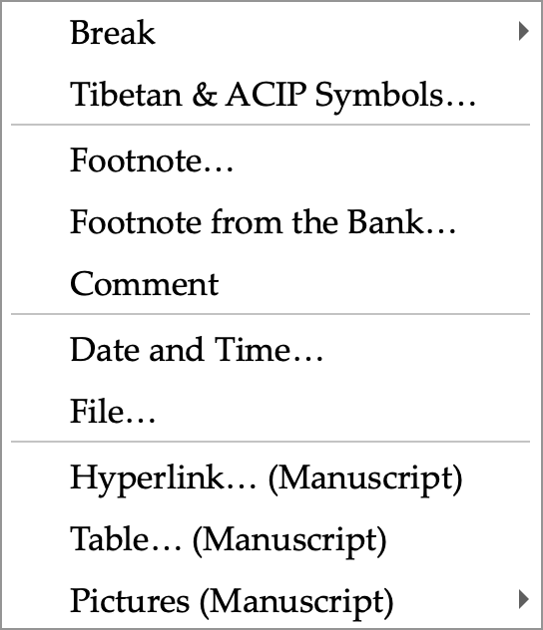
The Insert menu: folio markers, the Tibetan and ACIP symbol palette, footnotes to the Draft, the date with the Tibetan year, and the Manuscript’s rich-text items.
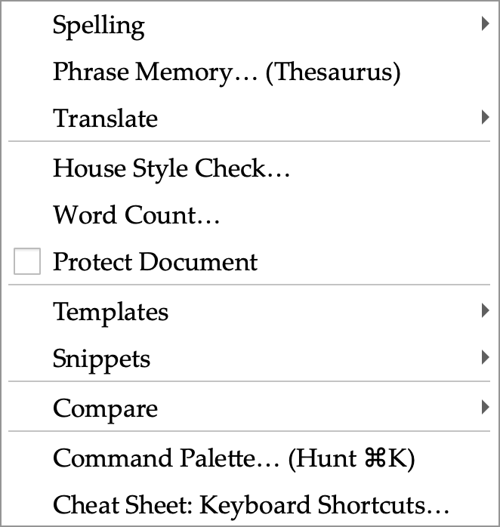
The Tools menu: spelling doubts, phrase memory, hand-offs between panes, word count, document protection, templates, snippets and the new Compare submenu.
- Preferences. A Word-style window of eleven pages behind an icon grid with search: General, View, House Style, Lookup, Compare, Team, Locations, Privacy, Colours, Shortcuts and Quick Access. Every switch drives a real setting; the Shortcuts page lists every menu command and key from the live menu bar.
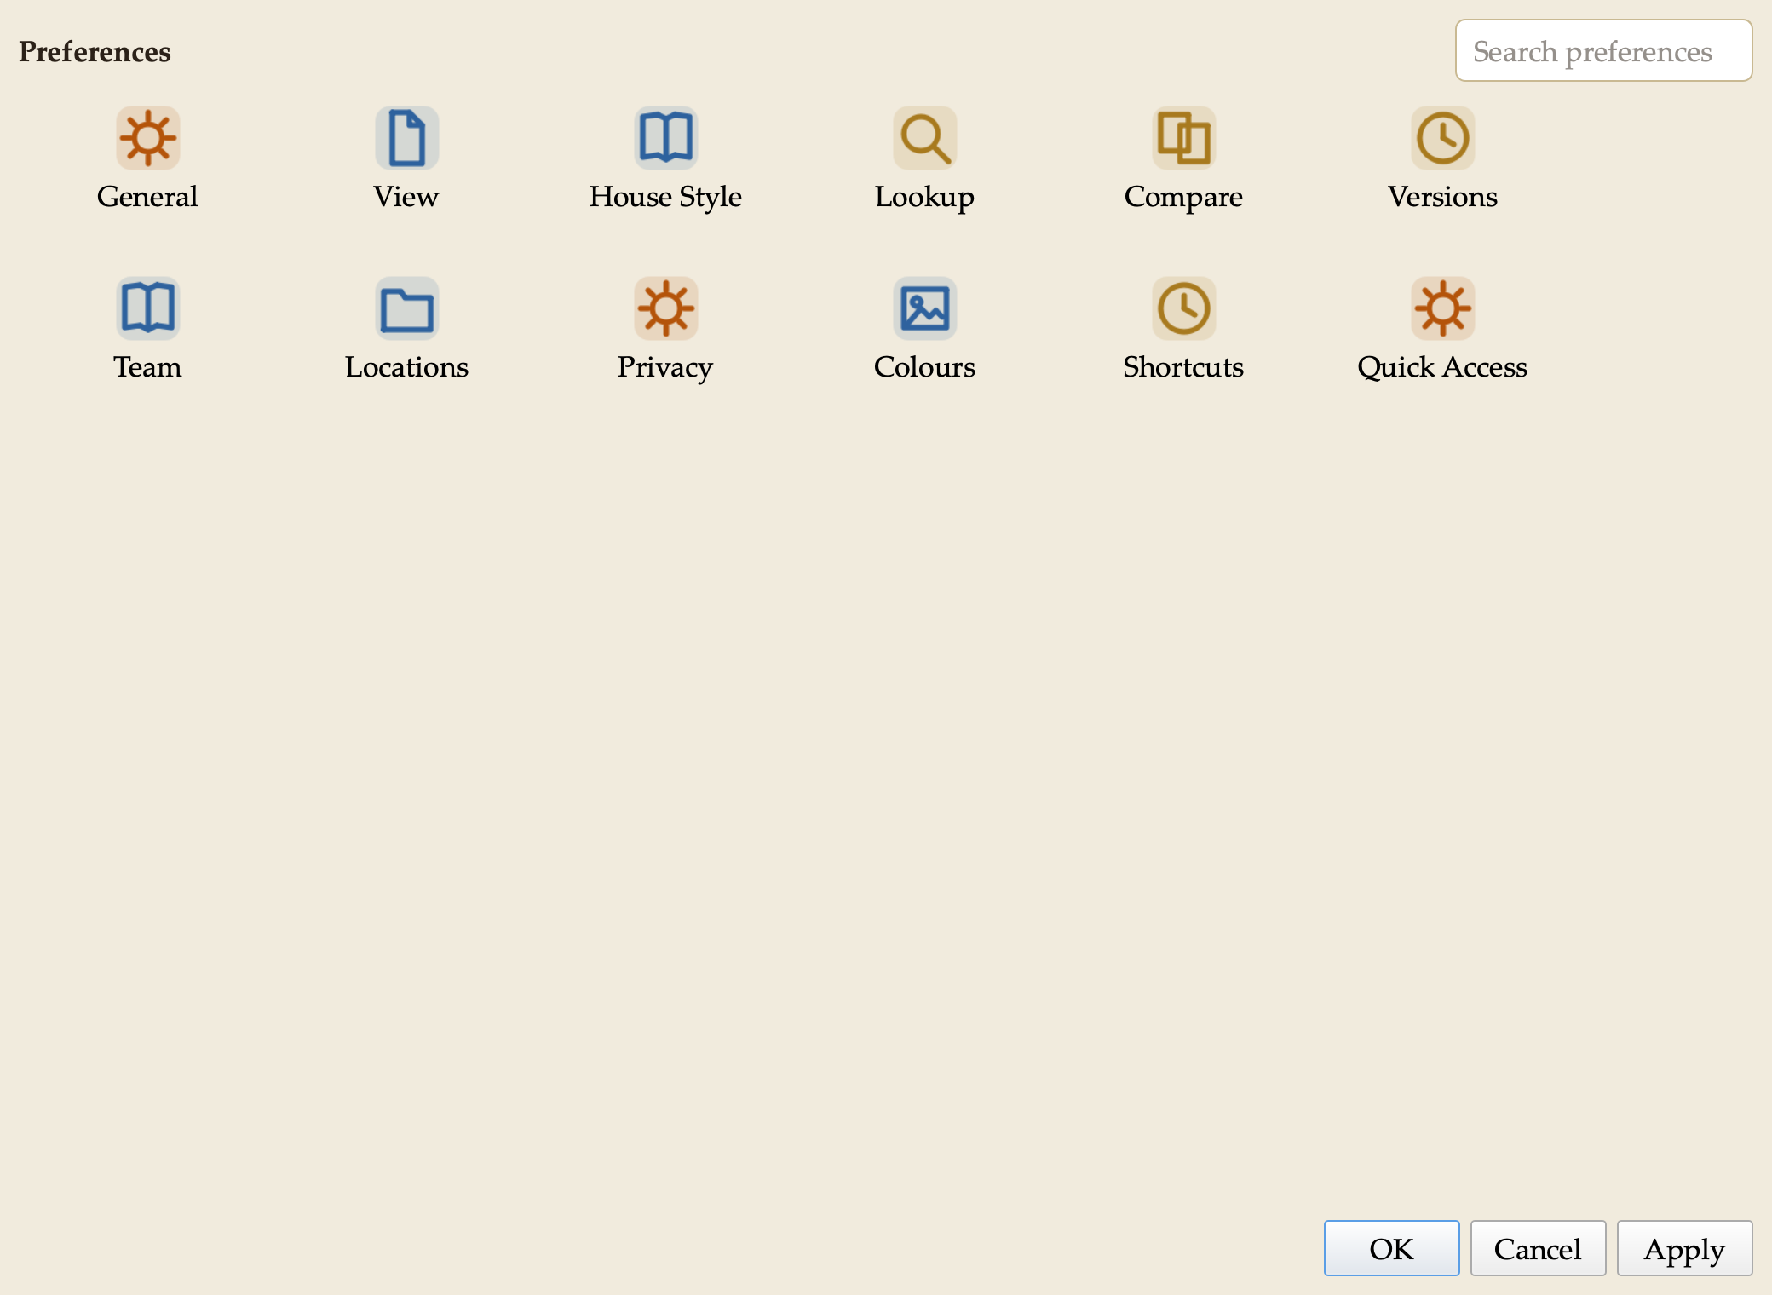
Preferences: the icon grid. Search narrows it; one page opens at a time with Show All to return.
- House style. I made our style sheet’s spacing rules switches on the House Style page: two spaces after a sentence, applied on demand, on save, or as you type — English only, abbreviations left alone. Colon and semicolon rules are there too, off until I confirm them against the sheet.
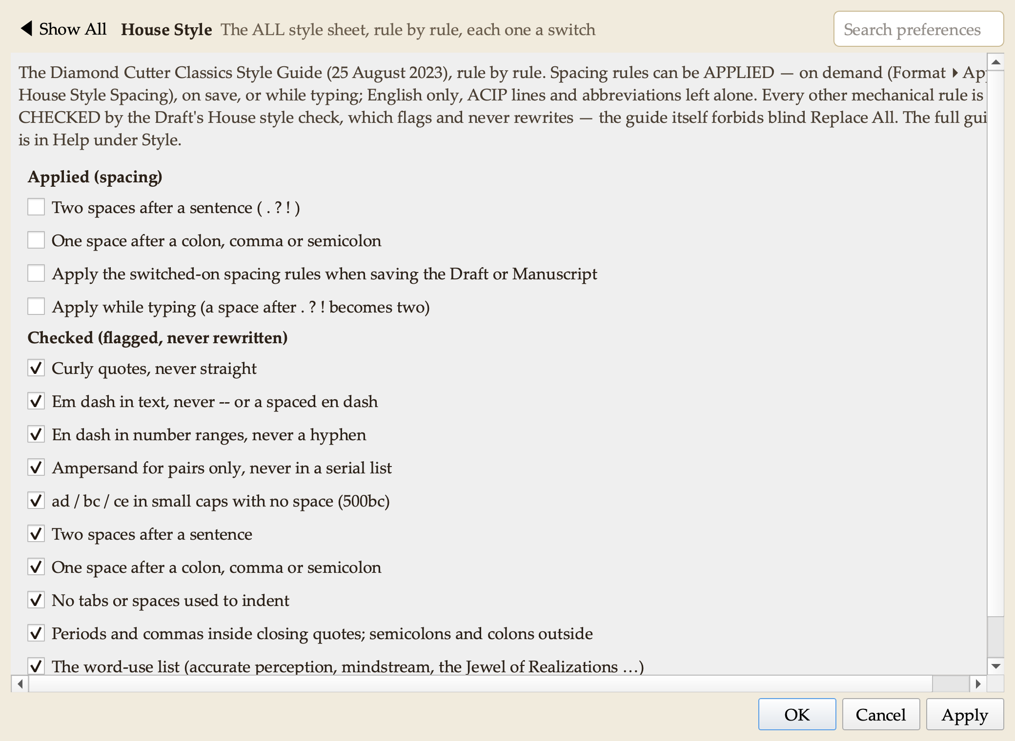
Preferences ▸ House Style: each rule of the style sheet is a switch.
- Compare & Merge suite. I studied Beyond Compare, WinMerge, UltraCompare and Araxis Merge and built their combined functionality into a new Compare pane in the Research group, adapted for our texts. Compare two files, or a text against the clipboard or its saved version; differences are shown line by line with the changed syllables highlighted, in any of ACIP, Wylie or Tibetan script. Rules let the tool ignore spacing, shad variants, folio markers, editorial brackets, or compare across scripts (an ACIP file against a Unicode file). Copy a reading left or right, undo without limit, edit in place, pin lines that must align. Reports: a side-by-side HTML page, a patch file, and an apparatus criticus in Markdown or CSV. Folder Compare classifies two folders and copies only after a preview (it never deletes); snapshots record a folder’s state for later comparison. Three-Way Merge combines two edited copies of one text against the original, resolving conflicts one by one; a file left with conflict markers opens as a two-sided comparison. Command-line comparison for scripted checks.
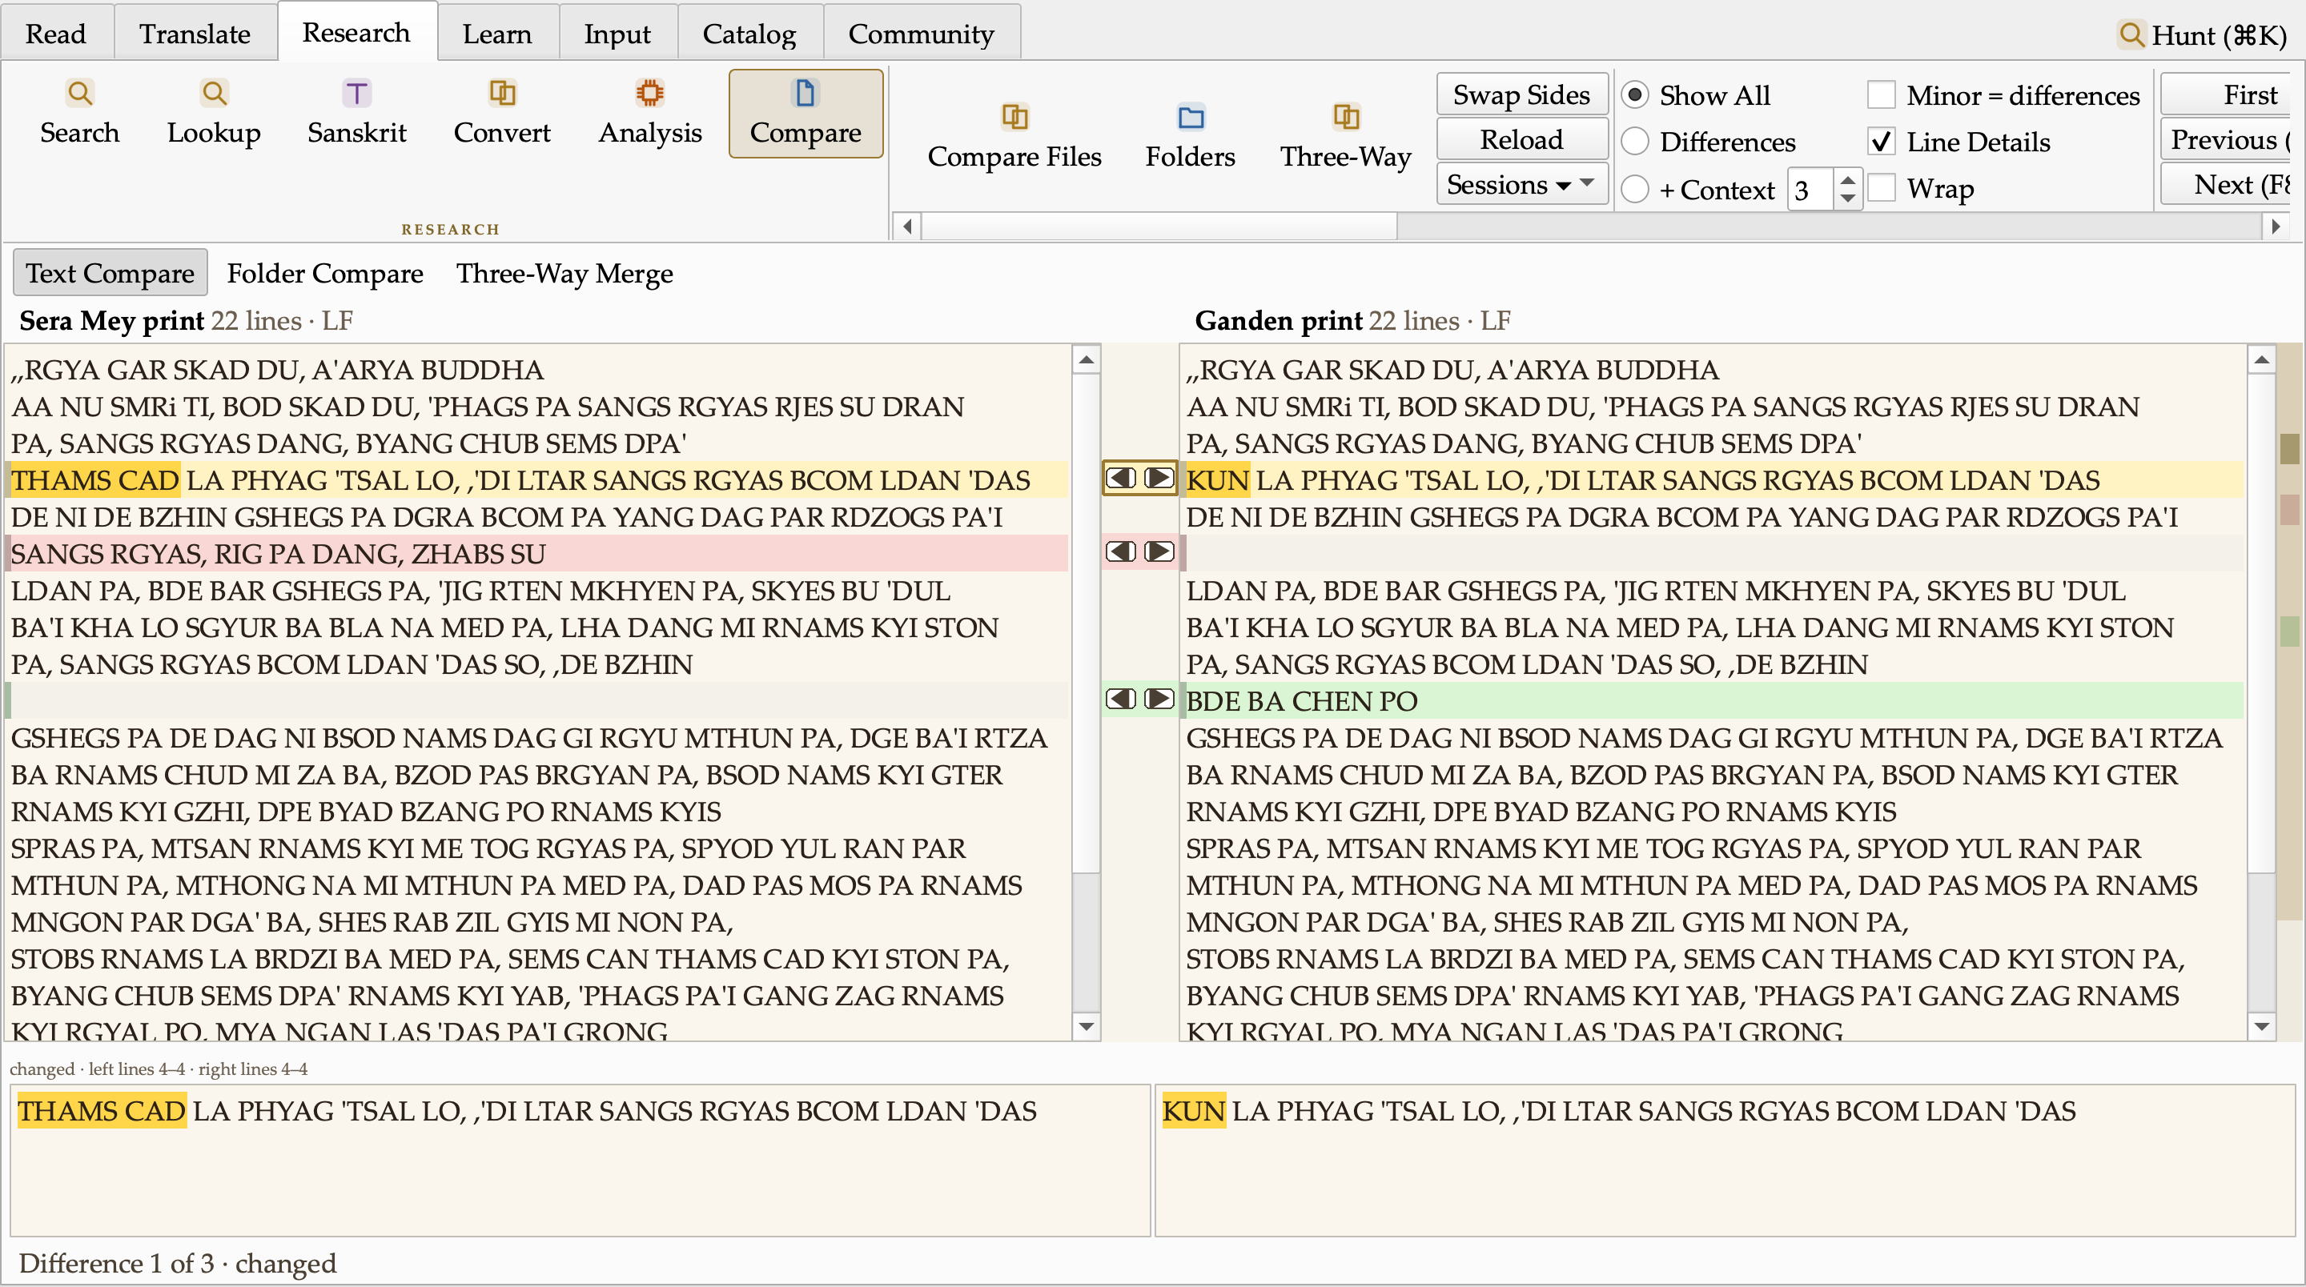
Text Compare: two prints of the opening of the Diamond Cutter. The changed reading (THAMS CAD ↔ KUN) is marked at the syllable, a dropped line shows in red, an added line in green; the arrows between the panes copy a reading across; the map at the right edge shows every difference in the whole text.
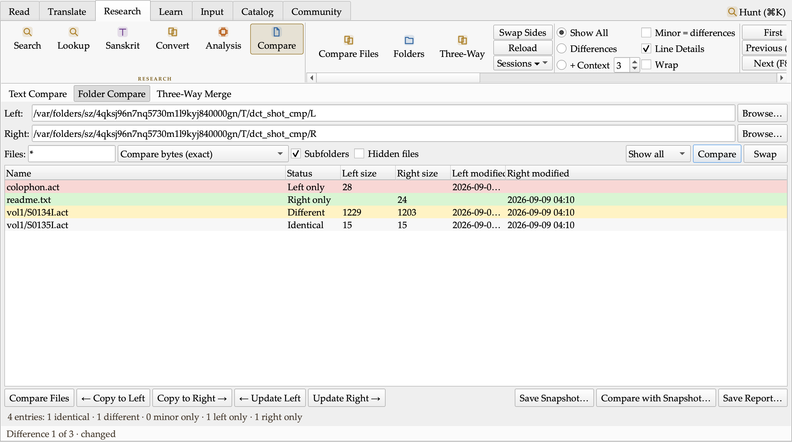
Folder Compare: two batches classified Identical, Different, Left only and Right only, with Copy and Update actions that preview before copying and never delete.
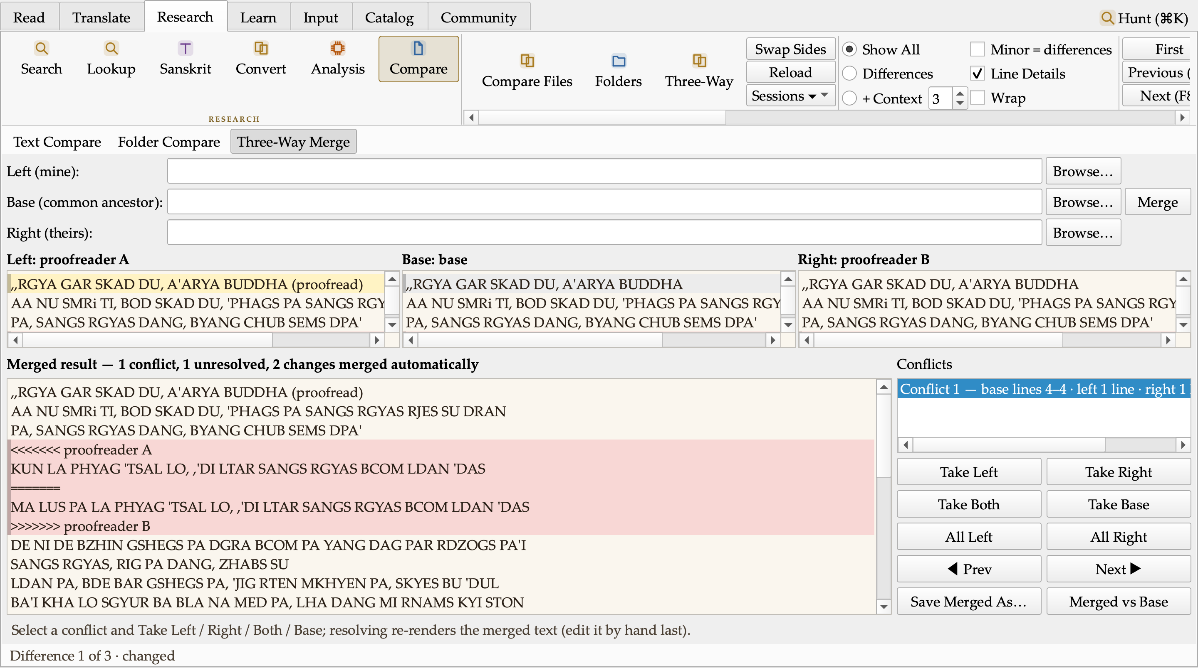
Three-Way Merge: two proofreaders’ corrections of one text against the original. The change both agree on merged itself; the one they disagree on is listed as a conflict for a human to settle.
- Dictionary ordering. Aligned renderings now rank most-attested first with counts (THAMS CAD: all ×30, every ×14, each and every ×10).
- Research written up. I surveyed sixteen text-analysis tool families (diff and merge tools, Word and Acrobat document compare, Draftable, folder sync, version control, find-and-replace suites, near-duplicate detection, TRACER text reuse, Voyant statistics, change tracking, patch tools, structured-data compare) and EndNote and Zotero as models for an in-house reference bank. Each feature has a verdict and a Tibetan- translation use; three follow-on batches are planned: document Versions, Replace in Files with preview, Apply Patch; Repeated Passages and similarity studies, a Statistics study view, Entities in a text, table compare; and a References pane with Insert Citation. Design work on all three began the same evening, alongside a study of the monastery and holy-site maps I collected, toward a Map pane in the Research group.
- Small things. A dharma-wheel busy cursor while the tool works. Two defects found by the battery were fixed the same hour (a false “corrupt image” verdict in packaging; a shutdown crash in a status-bar hook).

The analysis suite, batch 4 — the editing tools the compare engine made possible
With the compare engine in place I built the first batch of the analysis suite in the order the plan’s critic set, one feature at a time, each with its own test battery before I moved to the next.
Versions. Every save of a document, draft or manuscript now keeps a compressed copy with who saved it, when, in which encoding, the revision number and the text statistics of that moment. File ▸ Versions… lists them; a version can be compared with what I am editing or with another version, restored (the text on disk is kept first, even if another program changed it), named and pinned so it is never pruned, or asked which version first introduced a given line. Damaged records are shown red and excluded. Preferences ▸ Versions holds the switch, the caps and the rolling autosave slot. Renaming a file carries its history with it.
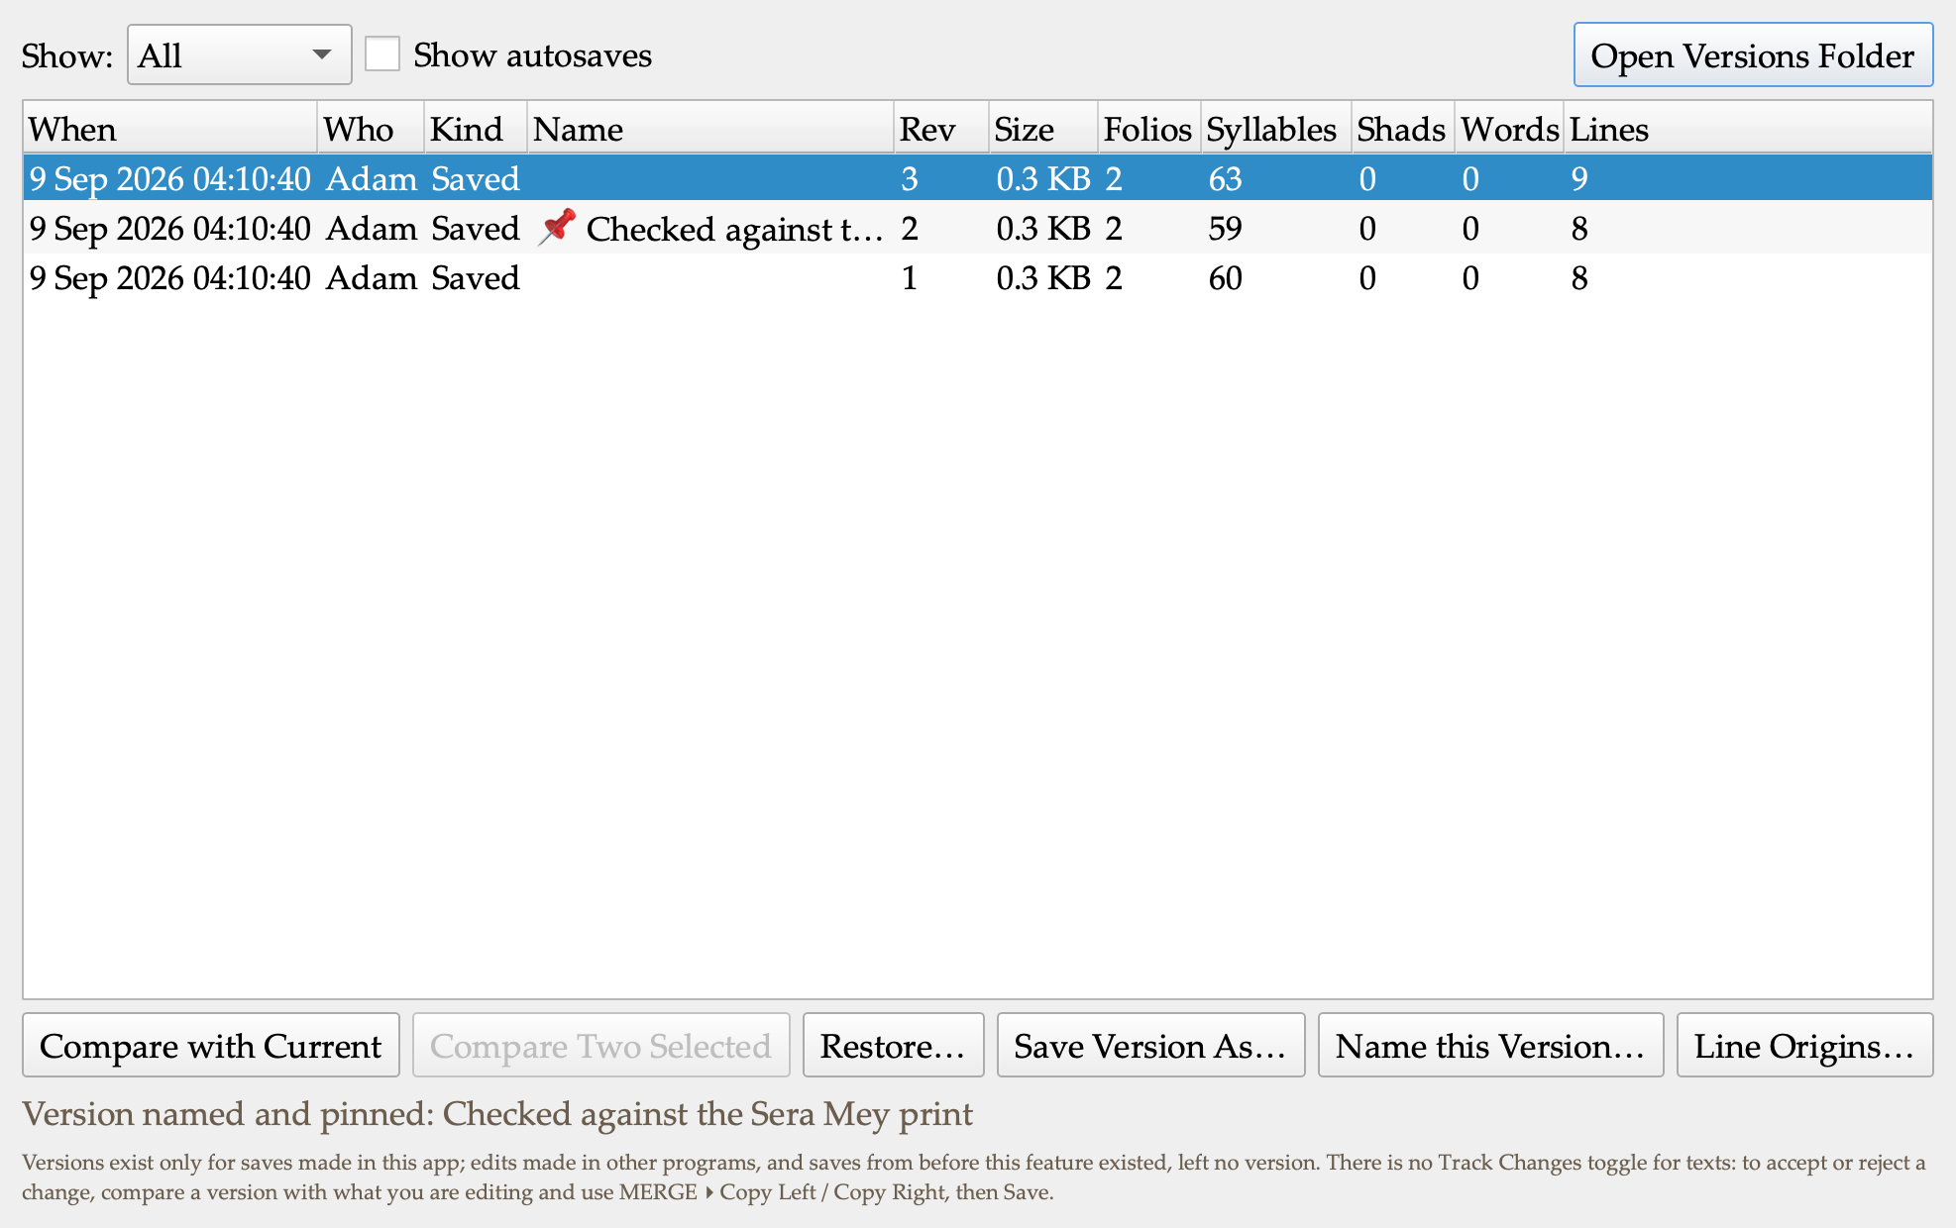
Versions: three saves of one text, the middle one named and pinned. Compare with Current, Compare Two, Restore (two-step), Save Version As, Name, Line Origins.
Changed-folios report. “7 of 143 folios changed”: the apparatus grouped by the left text’s folio markers, as a Markdown table with the readings under each folio, or as CSV. It is a Save Report filter, a Copy Changed Folios action, a fragment on the Compare status line, and a command-line output. The header states every grouping rule, so a reader can reproduce it.
Normalize. The compare rules offered as transformations: collapse spacing, trailing blanks, blank-line runs, the double-shad spelling, spacing around the shad, apparatus spans, folio markers, line endings, a final line break, house-style spacing. Every run previews as a diff in the Compare pane, lists the lines the rules refused and why, and only then applies — the Apply button is dead until a preview exists for exactly these settings and this text. The double-shad form has no default: that is the house’s ruling to make, not mine.
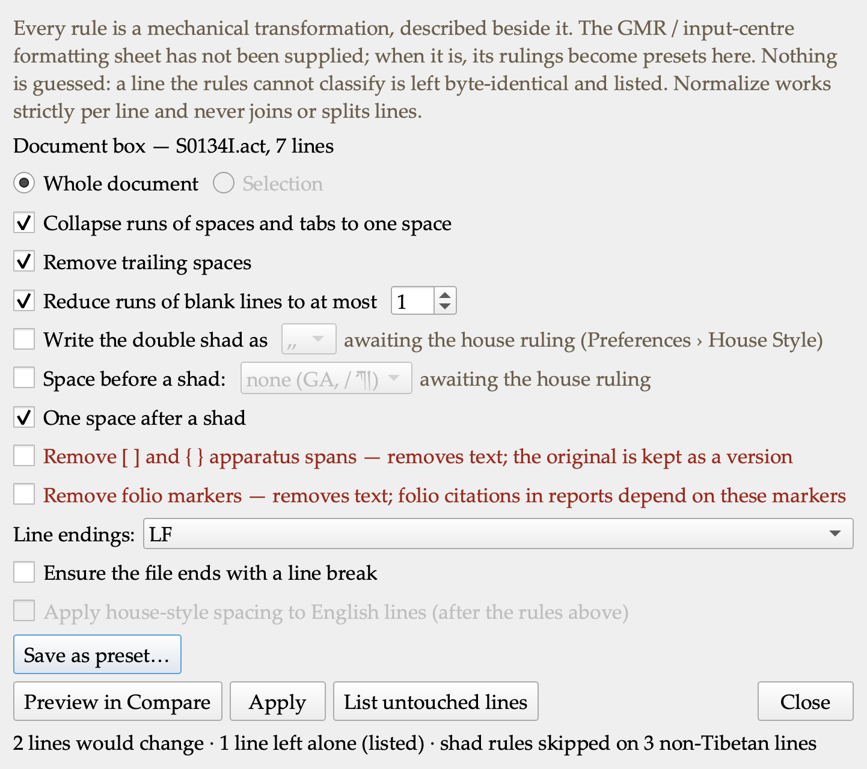
Normalize: the rules as switches, the lossy ones in red, the preview counted from the diff, the refused lines listed.
Replace in Files. One systematic fix across a whole folder, every occurrence listed with its line before and after, tick or untick, then a two-step apply to the ticked files only. Every skipped file is named with its reason (binary, not UTF-8, over the size cap, past the file cap, open with unsaved edits, changed since the preview, a library text without permission). A search text in the wrong script gets a notice, so a count of zero never reads as a clean bill of health. Each run leaves a changeset record and an undo that restores the files from their pre-replace versions and skips any file edited since. Counts come from the files themselves, never from the search index — the footer says so.
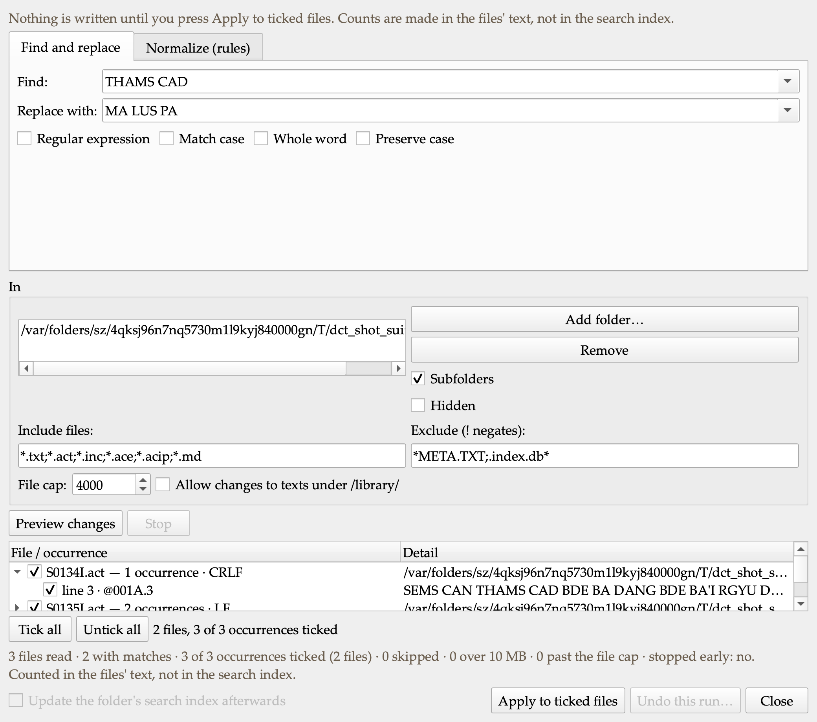
Replace in Files: three occurrences in two files of a small batch, one file expanded to its lines, the honest footer beneath.
Apply Patch (in progress at the time of this draft). A corrector’s unified diff loaded against my copy: each hunk placed exactly, with an offset, with loosened context, already applied, or rejected — five distinct verdicts, never folded into one. The result is a diff in the Compare pane, the rejected hunks go to a .rej file for the corrector, and the previous text is kept as a version before anything is written.
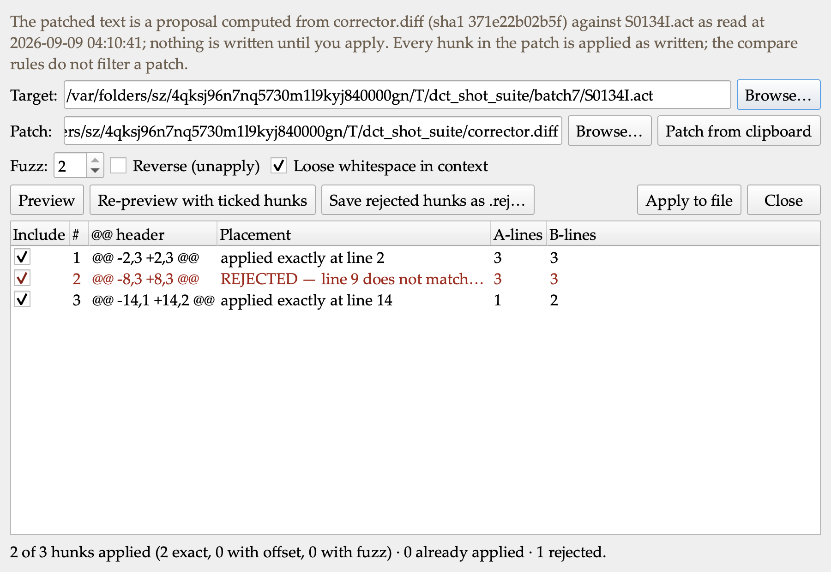
Apply Patch: a corrector’s diff with three hunks against a copy where one line was retyped — two placed exactly, one rejected and named, nothing written until Apply.
Tracked changes for Word (engine in progress). The differences between two drafts written as a Word document with real revision marks, so Geshe Michael can accept or reject each change in Word itself. The first paragraph says what the file compares, under what rules, who ran it, and that the marks are machine-computed. I will not add it to the Save Report menu until I have opened a sample in Word and recorded that Accept All gives text B and Reject All gives text A.

Decisions I made along the way
- The style sheet’s rules live as switches in Preferences, so any of them can be turned on or off.
- Cover notes for these digests and for technical documents recommend opening the .docx, which is properly formatted, over the .md and .txt.
- Every digest now carries screenshots of what changed and a chart where it explains the numbers, captured by the tool itself so they are reproducible.
- New features may get their own tabs, groups or panes wherever that reads most logically, rather than being crammed into existing ones.
- The desktop build will be re-pressed once the menu work is complete, not after every batch.
- Filed for after the release: a Textual Research workflow (collections, word and variant studies), companion iOS/Android reader apps, Tibetan Buddhist iconography in the interface, and a list of research-suite questions to put to Geshe Michael.
- Versions are deduplicated by content: saving an unchanged text keeps nothing new and says so, and restoring a version does not re-bank a copy that is already kept. Identical bytes are one version.
- The double-shad spelling and the space before a shad have no default in Normalize. Shipping a wrong default would silently re-spell every shad in a volume; the house ruling decides.
- Replace in Files refuses to run when Versions are switched off: without the pre-replace copies there would be no undo, and a batch rewrite without an undo is not something I will offer.
- A search text in one script against files in another gets a notice instead of a zero. A zero must never read as “the text is clean”.
- The Word redline ships command-line first. The menu filter appears only after I have opened a sample in Word and recorded that Accept All gives text B and Reject All gives text A. No dead control in the meantime.

Numbers
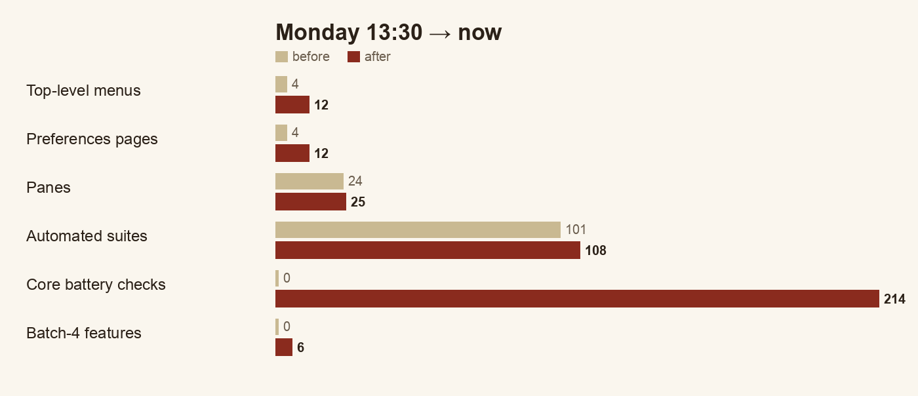
Before and after, Monday 13:30 to now. Every count comes from the build itself: menus and pages from the running app, suites and checks from the test runner.
 | Monday 13:30 | Now
Top-level menus | 4 | 12
Preferences pages | 4 groups in one dialog | 12 pages
Panes | 24 | 25 (Compare)
Automated suites | 101, all green | 108, all green
Core text-engine batteries (compare, versions, normalize, patch, Word redline, zip, file walk) | — | 214 checks in 7 batteries
App self-test checks | — | 670
Analysis-suite features shipped | 0 | 6 of batch 4 (all)
Headwords whose renderings were out of frequency order | 763 | 0

Open questions for leadership
- Licence for the project’s own code (unchanged; blocks a public release).
- Whether the repository moves to the ALL organisation on GitHub.
- Apple Developer ID for a notarised install.
- The 24 data layers with open terms.
- New: confirmation of the style sheet’s colon and semicolon spacing rules, so I can set the defaults.
- New: I will ask Geshe Michael what he wants from the research suite before it is designed in detail.
- New: the house convention for the double shad (,, or , , in ACIP; །། or ༎ in Tibetan script) and the space before a shad — until ruled, Normalize leaves both alone.
- New: whether canonical library texts may be rewritten in bulk by Replace in Files (today: only with an explicit switch, and every such file is badged and counted).
- New: a Word verification of the tracked-changes export — ten minutes with a sample in Microsoft Word — before it appears in the menus.

Next
Finish Apply Patch and the Word redline (engines under test); press a fresh build with the whole batch and relaunch it on the desktop; clear the twelve release-audit items that still need a ruling; then the Map pane study and the second analysis batch (repeated passages, collation of many witnesses, the citation and reference bank).

