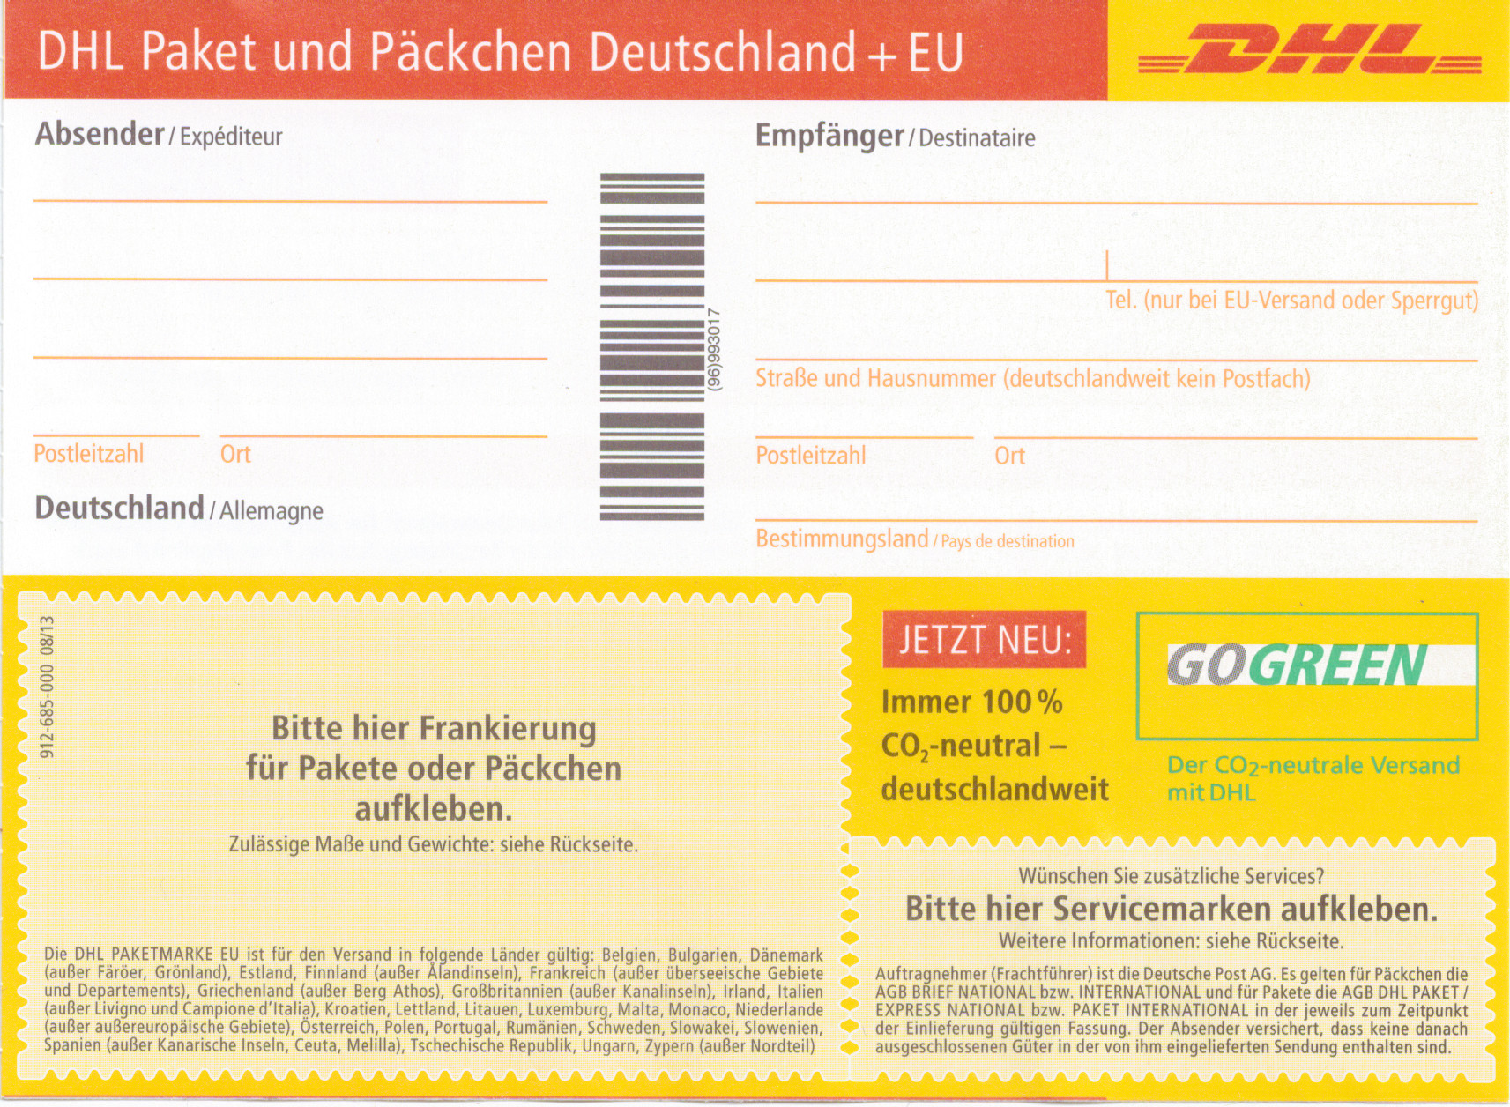
{{source_name }}
{{source_address }}
{{source_post_c}}
{{source_city}}
{{name }}
{{name2 }}
{{phone }}
{{address }}
{{post_c}}
{{city }}
{{country }}

