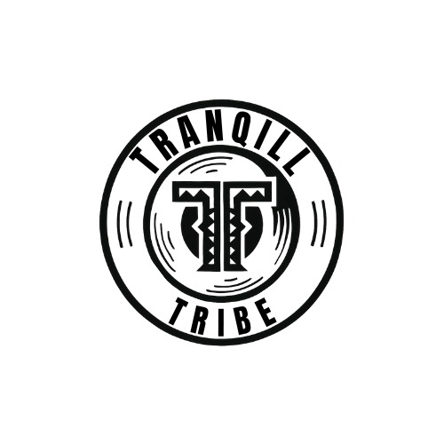

TRANQILL TRIBE
Website Copy

WEBSITE COPY

Music that moves the body.
Sound that wakes the soul.
In an age where music is increasingly shaped by algorithms, attention spans and the endless scroll of digital culture, Tranqill Tribe exists for a different reason.
To make people feel again.
Not momentarily distracted.
Not briefly entertained.
But moved.
Tranqill Tribe is a songwriting, production and performance collective built around a simple but uncompromising philosophy:
timeless music is not accidental — it is engineered through craft, emotion and cultural awareness.
The collective operates across genres, writing and producing records designed to launch new artists, redefine established ones, and reconnect listeners with the emotional core of music itself.
Names and faces remain secondary.
Because in a world increasingly driven by personality and visibility, the music deserves to stand on its own terms.
THE COLLECTIVE
Tranqill Tribe functions less like a traditional production team and more like a creative think tank for sound.
Songwriters, producers and DJs working together to develop records that are melodically addictive, emotionally resonant and culturally scalable.
At the centre of the collective is what members refer to simply as “the formula.”
A carefully developed process that blends:
• Songwriting discipline
• Electronic production innovation
• Crowd psychology
• Melodic architecture
• Rhythmic engineering
The result is music that connects instantly yet reveals deeper layers with every listen.
The goal is simple:
Create records that survive the moment and outlive the trend cycle.
SONGWRITING & PRODUCTION
Great records rarely arrive by accident.
They are built.
Tranqill Tribe specialises in multi-genre songwriting and production designed for streaming and live environments.
Working across electronic, commercial, alternative and hybrid genres, the collective develops records capable of:
• Launching emerging artists into the industry
• Expanding the sonic identity of established artists
• Creating crossover records that move between underground credibility and commercial impact
Every track begins with one guiding question:
What does this music make people feel?
Because before charts, playlists and metrics — music was always about emotion.
PERFORMANCE
While the studio is where records are built, the stage is where music proves itself.
Tranqill Tribe’s live identity is designed for the festival circuit — high-energy DJ and hybrid performance sets built to move thousands in unison.
The sound sits somewhere between multi-genre EDM, melodic electronic and commercial dance music — carrying the emotional intensity and euphoric lift associated with the new wave of genre-fluid electronic music.
Sets are designed not simply to entertain but to orchestrate a collective experience — moments where rhythm, melody and crowd energy converge.
Because the true test of a record has always been the same:
What happens when the bass drops and the crowd feels it together?
THE SOUND
Tranqill Tribe releases under its own name reflect the collective’s full musical spectrum.
Expect records that move effortlessly between:
• Melodic house
• Drum & bass
• Commercial dance
• Electronic soul
• Festival anthems
But genre is not the point.
Feeling is.
Each release is designed with a simple ambition:
To create music that hooks instantly, resonates deeply and stays with listeners long after the final note fades.
A RESPONSE TO THE MODERN MUSIC LANDSCAPE
Streaming culture has given the world access to more music than ever before.
But it has also created a strange paradox:
More sound.
Less connection.
Tranqill Tribe was formed in response to that shift.
Not to reject modern music culture — but to reintroduce intention into it.
The collective believes that the most powerful records still share the same qualities they always have:
• Emotional authenticity
• Sonic craftsmanship
• Cultural awareness
• Melodies people carry with them for years
In other words:
Music that lives beyond the moment it was released.
THE TRIBE
Tranqill Tribe is not a brand built around individuals.
It is a collective philosophy.
A network of creators united by a shared belief that music still has the power to:
Move people
Unite crowds
Shape culture
And create moments that feel larger than life
The identities behind the music are intentionally secondary.
Because if the records are doing their job,
the music will speak loudly enough.
CONTACT
Tranqill Tribe collaborates with artists, labels and creative partners who believe in the long game of music.
For songwriting, production or performance enquiries:
contact@tranqilltribe.com

