**65160250 ธนหทัย คล้ำจีน**

**Lab 3**

1. **Main**

1. **My style**

1. **Aboutme**

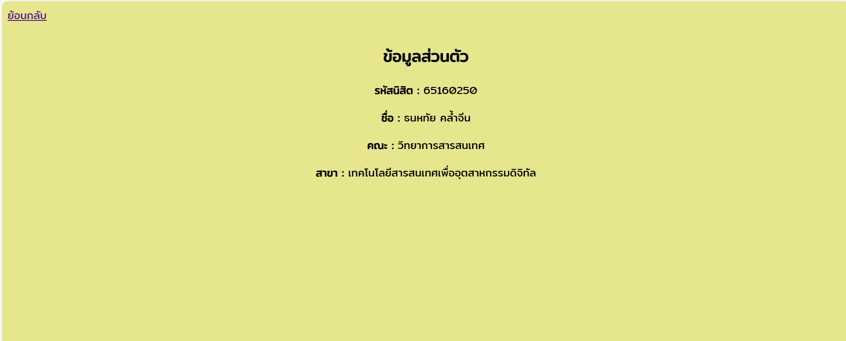

1. **Timetable**

1. **Blog**

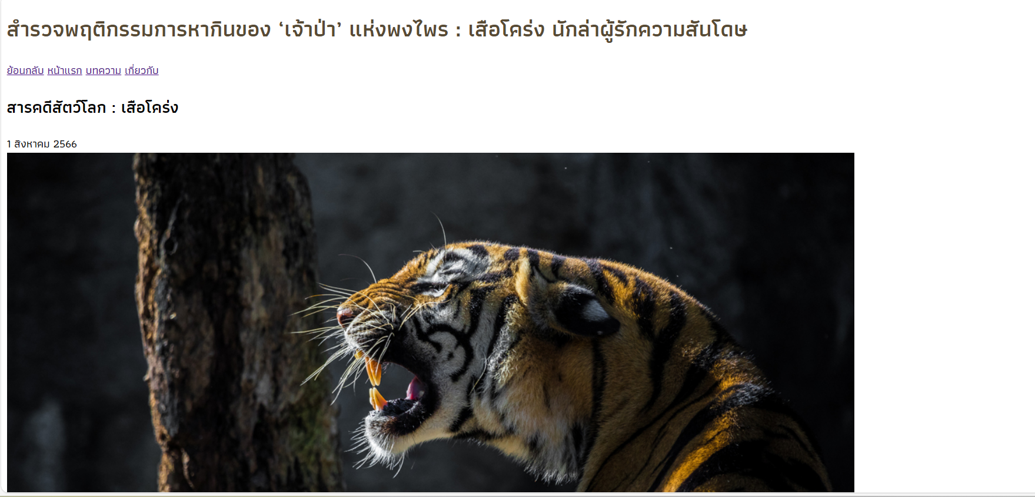

1. **Order**

