Name: vishnu siddheshwar pawar

Roll No: 651

PRN: 202201090084

Division: F(F3)

Assignment 3.1

Input:

import numpy as np array1=np.array([[1,2,3],[4,5,6],[7,8,9]]) array1

Output:

array([[1, 2, 3], [4, 5, 6], [7, 8, 9]])

Input:

|  |  |
| --- | --- |
| array2=np.array([[11,12,13],[14,15,16],[17,18,19]]) array2  Output: | |
| array([[11, 12, 13], [14, 15, 16], [17, 18, 19]]) |  |

#1 Matrix Operation

Input:

#Addition resultarray=array1+array2 print("\nUsing Operator:\n",resultarray) resultarray=np.add(array1,array2) print("\nUsing Numpy Function:\n",resultarray)

Output:

Using Operator:

[[12 14]

[16 18]]

|  |  |
| --- | --- |
| Using Numpy Function: | |
| [[12 14]  [16 18]] |  |

Input:

#Subtraction resultarray=array1-array2 print("\nUsing Operator:\n",resultarray) resultarray=np.subtract(array1,array2)

print("\nUsing Numpy Function:\n",resultarray)

Output:

|  |  |
| --- | --- |
| Using Operator: | |
| [[-10 -10] |  |
| [-10 -10]] |

|  |  |
| --- | --- |
| Using Numpy Function: | |
| [[-10 -10] |  |
| [-10 -10]] |

Input:

#Multiplication resultarray=array1*array2 print("\nUsing Operator:\n",resultarray) resultarray=np.multiply(array1,array2) print("\nUsing Numpy Function:\n",resultarray)

Output:

|  |  |
| --- | --- |
| Using Operator: | |
| [[11 24]  [39 56]] |  |

Using Numpy Function:

[[11 24]

[39 56]]

Input:

#Division resultarry=array1/array2 print("\nUsing Operator:\n",resultarray) resultarray=np.divide(array1,array2)

print("\nUsing Numpy Function:\n",resultarray)

Output:

Using Operator:

[[11 24]

[39 56]]

|  |  |
| --- | --- |
| Using Numpy Function: |  |
| [[0.09090909 0.16666667]  [0.23076923 0.28571429]] | |

Input:

#MOD resultarry=array1%array2 print("\nUsing Operator:\n",resultarray) resultarray=np.mod(array1,array2)

print("\nUsing Numpy Function:\n",resultarray)

Output:

Using Operator: [[1 2 3] [4 5 6] [7 8 9]]

Using Numpy Function: [[1 2 3] [4 5 6] [7 8 9]]

Input:

#Dot Product resultarray=np.dot(array1,array2) print("",resultarray)

Output:

[[ 90 96 102] [216 231 246] [342 366 390]]

Input:

#Transpose resultarray=np.transpose(array1) print(resultarray)

Output:

[[1 3]

[2 4]]

#2 Horizontal and vertical stacking of Numpy

Arrays

Input:

#2.1 Horizontal Stacking resultarray=np.hstack((array1,array2)) resultarray

Output: resultarray=np.hstack((array1,array2)) resultarray array([[ 1, 2, 3, 11, 12, 13], [ 4, 5, 6, 14, 15, 16], [ 7, 8, 9, 17, 18, 19]])

Input:

#2.2 Vertical Stacking resultarray=np.vstack((array1,array2)) reaultarray

Output:

array([[ 1, 2, 3], [ 4, 5, 6], [ 7, 8, 9], [11, 12, 13], [14, 15, 16], [17, 18, 19]])

# #3 Custom sequence generation

Input:

#3.1 Range nparray=np.arange(0,12,1).reshape(3,4)

nparray

Output:

array([[ 0, 1, 2, 3], [ 4, 5, 6, 7], [ 8, 9, 10, 11]])

Input:

#3.2 Linearly Separable nparray=np.linspace(start=0,stop=24,num=12).reshape(3,4) nparray

Output:

array([[ 0. , 2.18181818, 4.36363636, 6.54545455], [ 8.72727273, 10.90909091, 13.09090909,

15.27272727], [ 17.45454545, 19.63636364, 21.81818182, 24. ]]

Input:

#3.3 Empty Array nparray=np.empty((3,3),int) nparray

Output:

array([[ 90, 96, 102], [216, 231, 246], [342, 366, 390]])

Input:

#3.4 Emply like some other array nparray=np.empty_like(array1) nparray

Output:

array([[1, 2, 3], [4, 5, 6], [7, 8, 9]])

Input:

#3.5 Index Matrix nparray=np.identity(3) nparray

Output:

array([[1., 0., 0.], [0., 1., 0.], [0., 0., 1.]])

# #4 Arithmetic and statistical operations,Mathmatical operations,bitwise operators

Input:

#4.1 Arithmatic operation array1=np.array([1,2,3,4,5]) array2=np.array([11,12,13,14,15]) print(array1) print(array2)

Output:

[1 2 3 4 5] [11 12 13 14 15]

Input:

# Addition print(np.add(array1,array2))

# Subtraction print(np.subtract(array1,array2))

# Multiplication print(np.multiply(array1,array2))

# Division

print(np.divide(array1,array2))

Output:

[12 14 16 18 20]

[-10 -10 -10 -10 -10] [11 24 39 56 75]

[0.09090909 0.16666667 0.23076923 0.28571429 0.33333333

Input:

|  |  |
| --- | --- |
| #4.2 Statistical and mathmatical operation array1=np.array([1,2,3,4,5,9,6,7,8,9,9])  # Standard Deviation print(np.std(array1))  #Minimum print(np.min(array1))  #Summation print(np.sum(array1))  #Median print(np.median(array1)) | |
| #Mean print(np.mean(array1))  #Mode from scipy import stats print("Most Frequent element=",stats.mode(array1)[0]) print("Number of Occarances=",stats.mode(array1)[1])  # Variance print(np.var(array1)) | |

Output:

2.7990553306073913

1

63 6.0

5.7272727272727275

Most Frequent element= [9]

Number of Occarances= [3]

Input:

|  |
| --- |
| #4.3 Bitwise Operator array1=np.array([1,2,3],dtype=np.uint8) array2=np.array([4,5,6])  # AND resultarray=np.bitwise_and(array1,array2) print(resultarray)  # OR resultarray=np.bitwise_or(array1,array2) print(resultarray)  #LeftShift resultarray=np.left_shift(array1,2) print(resultarray) #RightShift resultarray=np.right_shift(array1,2) print(resultarray) |

Output:

[0 0 2]

[5 7 7]

[ 4 8 12] [0 0 0]

Input:

print(np.binary_repr(10,8)) resultarray=np.left_shift(10,2) print(resultarray)

print(np.binary_repr(np.left_shift(10,2),8))

Output:

00001010

40

00101000

# #5 Copying and viewing array

Input:

#5.1 Copy array1=np.arange(1,10) print(array1) newarray=array1.copy() print(newarray)

##modification in Original Array array1[0]=100 print(array1)

print(newarray)

Output:

[1 2 3 4 5 6 7 8 9]

[1 2 3 4 5 6 7 8 9]

[100 2 3 4 5 6 7 8 9]

[1 2 3 4 5 6 7 8 9]

Input:

#5.2 View array1=np.arange(1,10) print(array1) newarray=array1.view() print(newarray)

##modification in Original Array array1[0]=100 print(array1)

print(newarray)

Output:

[1 2 3 4 5 6 7 8 9]

[1 2 3 4 5 6 7 8 9]

[100 2 3 4 5 6 7 8 9] [100 2 3 4 5 6 7 8 9]

# #6 Serching

Input:

#6 Serching array1=np.array([[1,2,3,12,5,7],[94,5,6,7,89,44],[7,8,9,11,13,14]]) print(array1)

Output:

[[ 1 2 3 12 5 7]

[94 5 6 7 89 44] [ 7 8 9 11 13 14]]

Input:

np.sort(array1,axis=0)#Horizontally Sort

Output:

array([[ 1, 2, 3, 7, 5, 7], [ 7, 5, 6, 11, 13, 14], [94, 8, 9, 12, 89, 44]])

Input:

np.sort(array1,axis=1)# Vertically Sort

Output:

array([[ 1, 2, 3, 5, 7, 12], [ 5, 6, 7, 44, 89, 94], [ 7, 8, 9, 11, 13, 14] 7]])

# #7 Searching

Input:

#7 Searching array1=np.array([1,2,3,12,5,7])

np.searchsorted(array1,7,side="left")#Perform Search After sorting

Output:

3

# #8 Counting

Input:

#8 Counting array1=np.array([1,2,3,12,5,7,0]) print(np.count_nonzero(array1))#Return total Non Zero element print(np.nonzero(array1))#Return Index

print(array1.size)#Total Element

Output:

6 (array([0, 1, 2, 3, 4, 5]),) 7

# #9 Data Stacking

Input:

#9 Data Stacking array1=np.array(np.arange(1,5).reshape(2,2)) print(array1) array2=np.array(np.arange(11,15).reshape(2,2)) print(array2)

Output:

[[1 2] [3 4]] [[11 12] [13 14]]

Input:

nwearray=np.stack([array1,array2],axis=0) print(newarray)

Ouput:

[[[ 1 2] [ 3 4]]

[[11 12] [13 14]]]

Input:

newarray=np.stack([array1,array2],axis=1) print(newarray)

Output:

[[[ 1 2]

[11 12]]

[[ 3 4]

[13 14]]]

# #10 Append

Input:

#10 Append array1=np.arange(1,10).reshape(3,3) print(array1) array2=np.arange(21,30).reshape(3,3) print(array2)

Output:

[[1 2 3] [4 5 6] [7 8 9]] [[21 22 23] [24 25 26] [27 28 29]]

Input:

np.append(array1,array2,axis=0)

Output:

array([[ 1, 2, 3], [ 4, 5, 6], [ 7, 8, 9], [21, 22, 23], [24, 25, 26], [27, 28, 29]])

Input:

np.append(array1,array2,axis=1)

Output:

array([[ 1, 2, 3, 21, 22, 23], [ 4, 5, 6, 24, 25, 26], [ 7, 8, 9, 27, 28, 29]])

# #11 Concat

Input:

#11 Concat array1=np.arange(1,10).reshape(3,3) print(array1) array2=np.arange(21,30).reshape(3,3) print(array2)

Output:

[[1 2 3] [4 5 6] [7 8 9]] [[21 22 23] [24 25 26] [27 28 29]]

Assignment 3.2

Input:

|  |
| --- |
| import numpy as np d1=np.genfromtxt("/content/testmarks1.csv",delimiter=",") print(d1)  EDS=d1[:,1] print(type(EDS)) print(max(EDS)) |

Output:

[[ nan nan nan nan nan] [801. 43.05 27.79 28.7 27.79]

[802. 43.47 28.52 28.98 27.89] [803. 42.24 28.16 28.16 25.63] [804. 39.24 26.16 26.16 26.16] [805. 40.9 26.03 27.27 25.65] [806. 39.47 26.31 26.31 25.21]



1. 41.68 25.63 27.79 25.46]
2. 42.19 27.61 28.13 26.21]
3. 44.75 28.35 29.83 28.21]
4. 46.95 28.88 31.3 28.53]]

<class 'numpy.ndarray'>

Nan Input:

import numpy as np d2=np.genfromtxt("/content/testmarks2.csv",delimiter=",") print(d2) EDS=d1[:,1] print(type(EDS)) print(max(EDS))

Output:

[[ nan nan nan nan nan]

1. 28.48 34.18 30.56 22.23]
2. 28.1 33.72 30.68 22.82]
3. 26.16 31.39 28.2 22.53]
4. 26.16 31.39 28.78 20.93]
5. 26.1 31.32 28.22 20.82]
6. 25.45 30.54 27.73 21.05]
7. 26.16 31.39 28.01 20.51]
8. 27.44 32.93 28.83 22.08]
9. 28.63 34.35 31.03 22.68]
10. 30.35 36.42 31.38 23.1 ]]

<class 'numpy.ndarray'> Nan input:

import numpy as np d1=np.genfromtxt("/content/testmarks1.csv",delimiter=",") print(d1) EDS=d1[1:,1] print(type(EDS))

print(max(EDS))

Output:

[[ nan nan nan nan nan] [801. 43.05 27.79 28.7 27.79] [802. 43.47 28.52 28.98 27.89] [803. 42.24 28.16 28.16 25.63] [804. 39.24 26.16 26.16 26.16] [805. 40.9 26.03 27.27 25.65]



[806. 39.47 26.31 26.31 25.21] [807. 41.68 25.63 27.79 25.46]

1. 42.19 27.61 28.13 26.21]
2. 44.75 28.35 29.83 28.21]
3. 46.95 28.88 31.3 28.53]]

<class 'numpy.ndarray'>

46.95

Input:

|  |
| --- |
| import numpy as np d1=np.genfromtxt("/content/testmarks2.csv",delimiter=",") print(d2)  EDS=d1[1:,1] print(type(EDS)) print(max(EDS)) |

Output:

[[ nan nan nan nan nan]

1. 28.48 34.18 30.56 22.23]
2. 28.1 33.72 30.68 22.82]
3. 26.16 31.39 28.2 22.53]
4. 26.16 31.39 28.78 20.93]
5. 26.1 31.32 28.22 20.82]
6. 25.45 30.54 27.73 21.05]
7. 26.16 31.39 28.01 20.51]
8. 27.44 32.93 28.83 22.08]
9. 28.63 34.35 31.03 22.68]
10. 30.35 36.42 31.38 23.1 ]]

<class 'numpy.ndarray'>

30.35

Input:

d1=np.genfromtxt("/content/testmarks1.csv",delimiter=",") print(d1) EDS=d1[1:,1] print(type(EDS)) print(max(EDS)) np.count_nonzero(EDS>40)

Output:

[[ nan nan nan nan nan]

1. 43.05 27.79 28.7 27.79]
2. 43.47 28.52 28.98 27.89] [803. 42.24 28.16 28.16 25.63]
3. 39.24 26.16 26.16 26.16]
4. 40.9 26.03 27.27 25.65]
5. 39.47 26.31 26.31 25.21]
6. 41.68 25.63 27.79 25.46]



class

<

'numpy.ndarray'>

46.95

[808.

42.19

27.61

28.13

26.21]

[809.

44.75

28.35

29.83

28.21]

[810.

46.95

28.88

31.3

28.53]]

Input:

d1=np.genfromtxt("/content/testmarks2.csv",delimiter=",") print(d2) EDS=d1[1:,1] print(type(EDS)) print(max(EDS))

np.count_nonzero(EDS>40)

Output:

|  |
| --- |
| [[ nan nan nan nan nan]   1. 28.48 34.18 30.56 22.23] 2. 28.1 33.72 30.68 22.82] [803. 26.16 31.39 28.2 22.53] 3. 26.16 31.39 28.78 20.93] 4. 26.1 31.32 28.22 20.82] 5. 25.45 30.54 27.73 21.05] 6. 26.16 31.39 28.01 20.51] 7. 27.44 32.93 28.83 22.08] 8. 28.63 34.35 31.03 22.68] [810. 30.35 36.42 31.38 23.1 ]]   <class 'numpy.ndarray'>  30.35 |

Input:

#Addition result=d1+d2 print("\nUsing Operator:\n",result) resultarray=np.add(d1,d2)

print("\nUsing Numpy Function:\n",result)

Output:

Using Operator:

[[ nan nan nan nan nan]

[1602. 56.96 68.36 61.12 44.46]

[1604. 56.2 67.44 61.36 45.64]

[1606. 52.32 62.78 56.4 45.06]

[1608. 52.32 62.78 57.56 41.86]

[1610. 52.2 62.64 56.44 41.64]

[1612. 50.9 61.08 55.46 42.1 ]

[1614. 52.32 62.78 56.02 41.02]

[1616. 54.88 65.86 57.66 44.16]

[1618. 57.26 68.7 62.06 45.36]

[1620. 60.7 72.84 62.76 46.2 ]]

Using Numpy Function:

[[ nan nan nan nan nan]

[1602. 56.96 68.36 61.12 44.46] [1604. 56.2 67.44 61.36 45.64]

[1606. 52.32 62.78 56.4 45.06]

[1608. 52.32 62.78 57.56 41.86]

[1610. 52.2 62.64 56.44 41.64]

[1612. 50.9 61.08 55.46 42.1 ]

[1614. 52.32 62.78 56.02 41.02]

[1616. 54.88 65.86 57.66 44.16]

[1618. 57.26 68.7 62.06 45.36] [1620. 60.7 72.84 62.76 46.2 ]]



Input:

#Subtraction resul=d1-d2 print("\nUsing Operator:\n",resul) resultarray=np.subtract(d1,d2) print("\nUsing Numpy Function:\n",result)

Output:

Using Operator:

[[nan nan nan nan nan]

[ 0. 0. 0. 0. 0.]

[ 0. 0. 0. 0. 0.]

[ 0. 0. 0. 0. 0.]

[ 0. 0. 0. 0. 0.] [ 0. 0. 0. 0. 0.]

[ 0. 0. 0. 0. 0.]

[ 0. 0. 0. 0. 0.]

[ 0. 0. 0. 0. 0.]

[ 0. 0. 0. 0. 0.]

[ 0. 0. 0. 0. 0.]]

Using Numpy Function:

[[ nan nan nan nan nan]

[1602. 56.96 68.36 61.12 44.46]

[1604. 56.2 67.44 61.36 45.64] [1606. 52.32 62.78 56.4 45.06]

[1608. 52.32 62.78 57.56 41.86]

[1610. 52.2 62.64 56.44 41.64]

[1612. 50.9 61.08 55.46 42.1 ]

[1614. 52.32 62.78 56.02 41.02]

[1616. 54.88 65.86 57.66 44.16]

[1618. 57.26 68.7 62.06 45.36] [1620. 60.7 72.84 62.76 46.2 ]]

Input:

#Multiplication resultarray=d1*d2 print("\nUsing Operator:\n",result) resultarray=np.multiply(d1,d2) print("\nUsing Numpy Function:\n",result)

Output:

Using Operator:

[[ nan nan nan nan nan]

[1602. 56.96 68.36 61.12 44.46]

[1604. 56.2 67.44 61.36 45.64] [1606. 52.32 62.78 56.4 45.06]

[1608. 52.32 62.78 57.56 41.86]

[1610. 52.2 62.64 56.44 41.64]

[1612. 50.9 61.08 55.46 42.1 ]

[1614. 52.32 62.78 56.02 41.02]

[1616. 54.88 65.86 57.66 44.16]

[1618. 57.26 68.7 62.06 45.36]

[1620. 60.7 72.84 62.76 46.2 ]]

Using Numpy Function:

[[ nan nan nan nan nan]

[1602. 56.96 68.36 61.12 44.46]

[1604. 56.2 67.44 61.36 45.64]

[1606. 52.32 62.78 56.4 45.06]

[1608. 52.32 62.78 57.56 41.86]

[1610. 52.2 62.64 56.44 41.64]

[1612. 50.9 61.08 55.46 42.1 ]

[1614. 52.32 62.78 56.02 41.02]

[1616. 54.88 65.86 57.66 44.16]

[1618. 57.26 68.7 62.06 45.36] [1620. 60.7 72.84 62.76 46.2 ]]

Input:

#Division resultarry=d1/d2 print("\nUsing Operator:\n",result) resultarray=np.divide(d1,d2)

print("\nUsing Numpy Function:\n",result)

Output:

Using Operator:

[[ nan nan nan nan nan]

[1602. 56.96 68.36 61.12 44.46]

[1604. 56.2 67.44 61.36 45.64] [1606. 52.32 62.78 56.4 45.06]

[1608. 52.32 62.78 57.56 41.86]

[1610. 52.2 62.64 56.44 41.64]

[1612. 50.9 61.08 55.46 42.1 ]

[1614. 52.32 62.78 56.02 41.02]

[1616. 54.88 65.86 57.66 44.16]

[1618. 57.26 68.7 62.06 45.36]

[1620. 60.7 72.84 62.76 46.2 ]]

Using Numpy Function:

[[ nan nan nan nan nan] [1602. 56.96 68.36 61.12 44.46]

|  |  |  |  |  |
| --- | --- | --- | --- | --- |
| [1604. | 56.2 | 67.44 | 61.36 | 45.64] |
| [1606. | 52.32 | 62.78 | 56.4 | 45.06] |
| [1608. | 52.32 | 62.78 | 57.56 | 41.86] |
| [1610. | 52.2 | 62.64 | 56.44 | 41.64] |
| [1612. | 50.9 | 61.08 | 55.46 | 42.1 ] |
| [1614. | 52.32 | 62.78 | 56.02 | 41.02] |
| [1616. | 54.88 | 65.86 | 57.66 | 44.16] |
| [1618. | 57.26 | 68.7 | 62.06 | 45.36] |
| [1620. | 60.7 | 72.84 | 62.76 | 46.2 ]] |

Input:

#MOD resultarry=d1%d2 print("\nUsing Operator:\n",result) resultarray=np.mod(d1,d2) print("\nUsing Numpy Function:\n",result)

Output:

Using Operator:

[[ nan nan nan nan nan]

[1602. 56.96 68.36 61.12 44.46]

[1604. 56.2 67.44 61.36 45.64]

[1606. 52.32 62.78 56.4 45.06]

[1608. 52.32 62.78 57.56 41.86]

[1610. 52.2 62.64 56.44 41.64]

[1612. 50.9 61.08 55.46 42.1 ]

[1614. 52.32 62.78 56.02 41.02]

[1616. 54.88 65.86 57.66 44.16]

[1618. 57.26 68.7 62.06 45.36]

[1620. 60.7 72.84 62.76 46.2 ]]

Using Numpy Function:

[[ nan nan nan nan nan]

[1602. 56.96 68.36 61.12 44.46]

[1604. 56.2 67.44 61.36 45.64] [1606. 52.32 62.78 56.4 45.06]

[1608. 52.32 62.78 57.56 41.86]

[1610. 52.2 62.64 56.44 41.64]

[1612. 50.9 61.08 55.46 42.1 ]

[1614. 52.32 62.78 56.02 41.02]

[1616. 54.88 65.86 57.66 44.16]

[1618. 57.26 68.7 62.06 45.36] [1620. 60.7 72.84 62.76 46.2 ]]

Input:

#Dot Product resultarray=np.dot(d1,d2) print("",resultarray)

Output:

Input:

#Transpose

resultarray=np.transpose(d1)

print(resultarray)

Output:

[[ nan 801. 802. 803. 804. 805. 806. 807. 808. 809.

810. ]

[ nan 28.48 28.1 26.16 26.16 26.1 25.45 26.16 27.44 28.63 30.35]

[ nan 34.18 33.72 31.39 31.39 31.32 30.54 31.39 32.93 34.35 36.42]

[ nan 30.56 30.68 28.2 28.78 28.22 27.73 28.01 28.83 31.03

31.38]

[ nan 22.23 22.82 22.53 20.93 20.82 21.05 20.51 22.08 22.68

23.1 ]]

Input:

|  |
| --- |
| #Mean resultd=d1+d2/2  print("\nUsing Operator:\n",resultd) resultd=np.add(d1,d2) print("\nUsing NumpyFunction:\n",resultd) |

Output:

Using Operator:

[[ nan nan nan nan nan]

[1201.5 42.72 45.84 33.345] [1203. 42.15 46.02 34.23 ]

[1204.5 39.24 47.085 42.3 33.795]

[1206. 39.24 31.395] [1207.5 39.15 31.23 ]

[1209. 38.175 45.81 41.595 31.575]

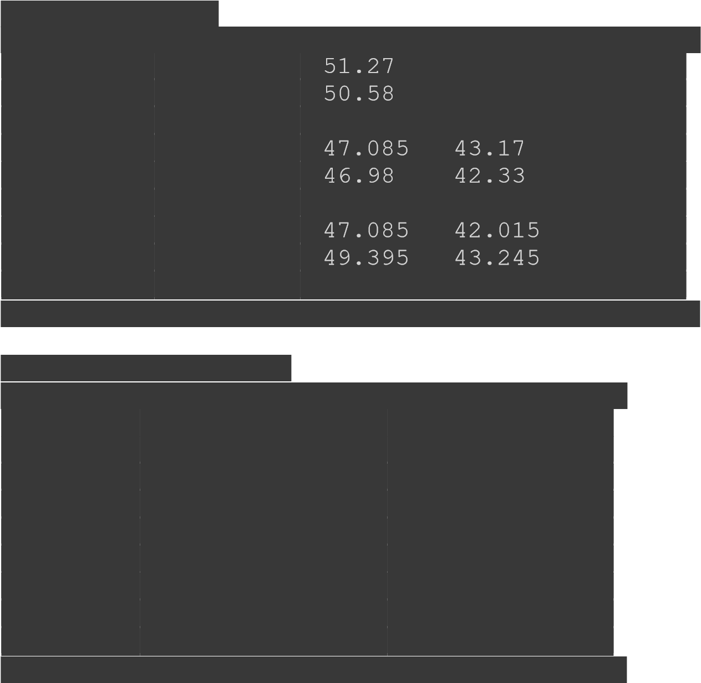[1210.5 39.24 30.765] [1212. 41.16 33.12 ]

[1213.5 42.945 51.525 46.545 34.02 ]

[1215. 45.525 54.63 47.07 34.65 ]]

Using NumpyFunction:

[[ nan nan nan nan nan]

[1602. 56.96 68.36 61.12 44.46]

[1604. 56.2 67.44 61.36 45.64]

[1606. 52.32 62.78 56.4 45.06]

[1608. 52.32 62.78 57.56 41.86]

[1610. 52.2 62.64 56.44 41.64]

[1612. 50.9 61.08 55.46 42.1 ]

[1614. 52.32 62.78 56.02 41.02]

[1616. 54.88 65.86 57.66 44.16]

[1618. 57.26 68.7 62.06 45.36] [1620. 60.7 72.84 62.76 46.2 ]]

Input:

#Horizontal Stacking resultarray=np.hstack((d1,d2))

resultarray

Output:

array([[ nan, nan, nan, nan, nan, nan, nan, nan, nan, nan], [801. , 28.48, 34.18, 30.56, 22.23, 801. , 28.48, 34.18, 30.56, 22.23], [802. , 28.1 , 33.72, 30.68, 22.82, 802. , 28.1 , 33.72, 30.68, 22.82], [803. ,

26.16, 31.39, 28.2 , 22.53, 803. , 26.16, 31.39, 28.2 , 22.53], [804. ,

26.16, 31.39, 28.78, 20.93, 804. , 26.16, 31.39, 28.78, 20.93], [805. ,

26.1 , 31.32, 28.22, 20.82, 805. , 26.1 , 31.32, 28.22, 20.82], [806. ,

25.45, 30.54, 27.73, 21.05, 806. , 25.45, 30.54, 27.73, 21.05], [807. ,

26.16, 31.39, 28.01, 20.51, 807. , 26.16, 31.39, 28.01, 20.51], [808. ,

27.44, 32.93, 28.83, 22.08, 808. , 27.44, 32.93, 28.83, 22.08], [809. ,

28.63, 34.35, 31.03, 22.68, 809. , 28.63, 34.35, 31.03, 22.68], [810. ,

30.35, 36.42, 31.38, 23.1 , 810. , 30.35, 36.42, 31.38, 23.1 ]])

Input:

#2.2 Vertical Stacking resultarray=np.vstack((d1,d2)) resultarray

Output: array([[ nan, nan, nan, nan, nan], [801. , 28.48, 34.18, 30.56, 22.23],



28.22, 20.82], [806. , 25.45, 30.54, 27.73, 21.05], [807. , 26.16,

31.39, 28.01, 20.51], [808. , 27.44, 32.93, 28.83, 22.08], [809. , 28.63, 34.35, 31.03, 22.68], [810. , 30.35, 36.42, 31.38, 23.1 ], [ nan, nan, nan, nan, nan], [801. , 28.48, 34.18, 30.56, 22.23], [802. , 28.1 , 33.72, 30.68, 22.82], [803. , 26.16, 31.39, 28.2 , 22.53], [804.

, 26.16, 31.39, 28.78, 20.93], [805. , 26.1 , 31.32, 28.22, 20.82],

[806. , 25.45, 30.54, 27.73, 21.05], [807. , 26.16, 31.39, 28.01,

20.51], [808. , 27.44, 32.93, 28.83, 22.08], [809. , 28.63, 34.35,

31.03, 22.68], [810. , 30.35, 36.42, 31.38, 23.1 ]])

Input:

#3.1 Range nparray=np.arange(0,12,1).reshape(3,4) nparray

Output:

array([[ 0, 1, 2, 3], [ 4, 5, 6, 7], [ 8, 9, 10, 11]])

Input:

#3.2 Linearly Separable nparray=np.linspace(start=0,stop=24,num=12).reshape(3,4) nparray

Output:

array([[ 0. , 2.18181818, 4.36363636, 6.54545455], [ 8.72727273,

10.90909091, 13.09090909, 15.27272727], [17.45454545, 19.63636364,

21.81818182, 24. ]])

Input:

#3.3 Empty Array nparray=np.empty((3,3),int) nparray

Input:

#3.4 Emply like some other array nparray=np.empty_like(d1) nparray

Output:

array([[nan, nan, nan, nan, nan],

[ 0., 0., 0., 0., 0.], [ 0., 0., 0., 0., 0.],

[ 0., 0., 0., 0., 0.],

[ 0., 0., 0., 0., 0.],

[ 0., 0., 0., 0., 0.],

[ 0., 0., 0., 0., 0.],

[ 0., 0., 0., 0., 0.],

[ 0., 0., 0., 0., 0.],

[ 0., 0., 0., 0., 0.],

[ 0., 0., 0., 0., 0.]])

Input:

#3.5 Index Matrix nparray=np.identity(3) nparray

Output:

array([[1., 0., 0.], [0., 1., 0.], [0., 0., 1.]])

Input:

#4.1 Arithmatic operation array1=np.array([1,2,3,4,5]) array2=np.array([11,12,13,14,15]) print(d1) print(d2)

Output:

[[ nan nan nan nan nan]

[801. 28.48 34.18 30.56 22.23]

|  |
| --- |
| 1. 28.1 33.72 30.68 22.82] 2. 26.16 31.39 28.2 22.53] 3. 26.16 31.39 28.78 20.93] |
| [805. 26.1 31.32 28.22 20.82] |
| 1. 25.45 30.54 27.73 21.05] 2. 26.16 31.39 28.01 20.51] 3. 27.44 32.93 28.83 22.08] |
| [809. 28.63 34.35 31.03 22.68] |
| [810. 30.35 36.42 31.38 23.1 ]] |
| [[ nan nan nan nan nan]  [801. 28.48 34.18 30.56 22.23] |
| [802. 28.1 33.72 30.68 22.82] |
| 1. 26.16 31.39 28.2 22.53] 2. 26.16 31.39 28.78 20.93] 3. 26.1 31.32 28.22 20.82] |
| [806. 25.45 30.54 27.73 21.05] |
| [807. 26.16 31.39 28.01 20.51] |
| [808. 27.44 32.93 28.83 22.08] |
| [809. 28.63 34.35 31.03 22.68] |
| [810. 30.35 36.42 31.38 23.1 ]] |

Input:

# Addition print(np.add(d1,d2)) # Subtraction print(np.subtract(d1,d2)) # Multiplication print(np.multiply(d1,d2)) # Division

print(np.divide(d1,d2))

Output:

[[ nan nan nan nan nan]

[1602. 56.96 68.36 61.12 44.46]

[1604. 56.2 67.44 61.36 45.64]

[1606. 52.32 62.78 56.4 45.06]

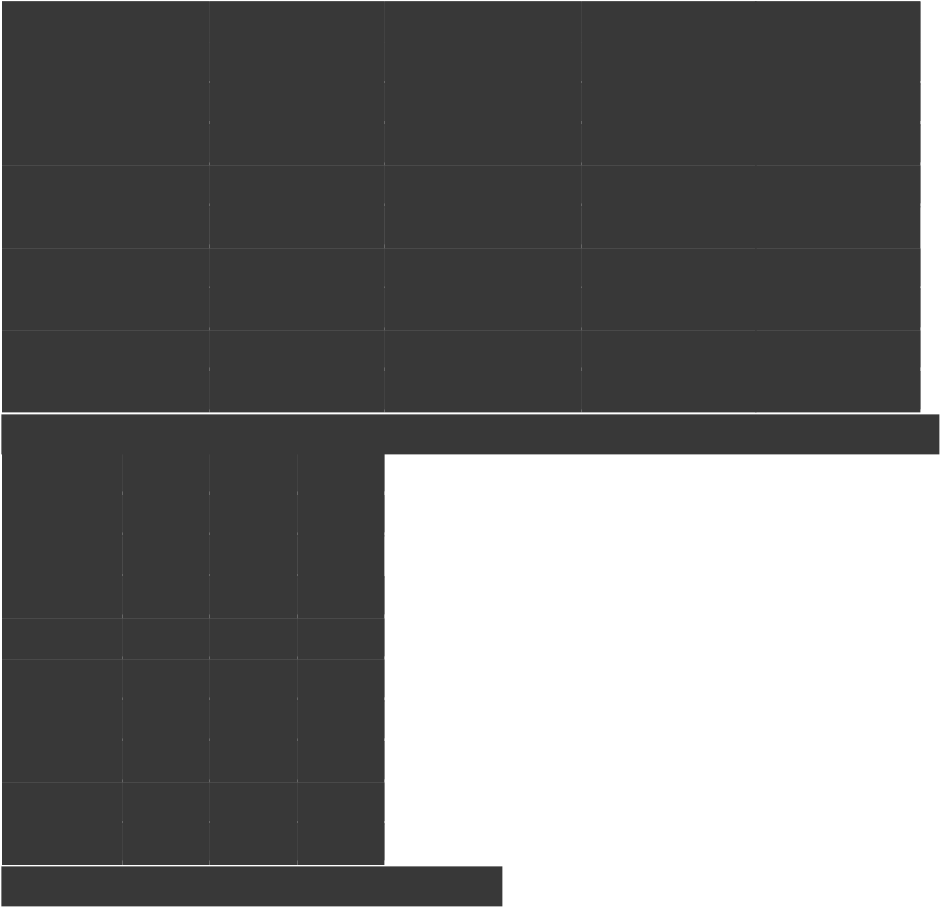[1608. 52.32 62.78 57.56 41.86] [1610. 52.2 62.64 56.44 41.64] [1612. 50.9 61.08 55.46 42.1 ]

[1614. 52.32 62.78 56.02 41.02]

[1616. 54.88 65.86 57.66 44.16]

[1618. 57.26 68.7 62.06 45.36]

[1620. 60.7 72.84 62.76 46.2 ]]

[[nan nan nan nan nan]

[ 0. 0. 0. 0. 0.]

[ 0. 0. 0. 0. 0.]

[ 0. 0. 0. 0. 0.]

[ 0. 0. 0. 0. 0.]

[ 0. 0. 0. 0. 0.]

[ 0. 0. 0. 0. 0.]

[ 0. 0. 0. 0. 0.]

[ 0. 0. 0. 0. 0.]

[ 0. 0. 0. 0. 0.]

[ 0. 0. 0. 0. 0.]]

|  |  |
| --- | --- |
| [[ nan nan nan nan | |
| nan] |  |
| 8.1111040e+02 1.1682724e+03 9.3391360e+02 | |

|  |  |
| --- | --- |
| [6.4320400e+05 7.8961000e+02 1.1370384e+03 9.4126240e+02 | |
| 5.2075240e+02] |  |
| [6.4480900e+05 6.8434560e+02 9.8533210e+02 7.9524000e+02 | |
| 5.0760090e+02] |  |
| 6.8434560e+02 9.8533210e+02 8.2828840e+02 | |

|  |  |
| --- | --- |
| [6.4802500e+05 6.8121000e+02 9.8094240e+02 7.9636840e+02 | |
| 4.3347240e+02] |  |
| [6.4963600e+05 6.4770250e+02 9.3269160e+02 7.6895290e+02 | |
| 4.4310250e+02] |  |
| 6.8434560e+02 9.8533210e+02 7.8456010e+02 | |

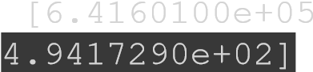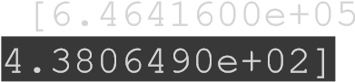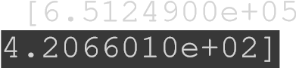 [6.5286400e+05 7.5295360e+02 1.0843849e+03 8.3116890e+02

4.8752640e+02]

[6.5448100e+05 8.1967690e+02 1.1799225e+03 9.6286090e+02

5.1438240e+02]

[6.5610000e+05 9.2112250e+02 1.3264164e+03 9.8470440e+02

5.3361000e+02]]

[[nan nan nan nan nan] [ 1. 1. 1. 1. 1.]

[ 1. 1. 1. 1. 1.]

[ 1. 1. 1. 1. 1.]

[ 1. 1. 1. 1. 1.]

[ 1. 1. 1. 1. 1.]

[ 1. 1. 1. 1. 1.]

[ 1. 1. 1. 1. 1.]

[ 1. 1. 1. 1. 1.]

[ 1. 1. 1. 1. 1.] [ 1. 1. 1. 1. 1.]]

Input:

|  |
| --- |
| # Standard Deviation print(np.std(d1))  #Minimum print(np.min(d1)) #Summation print(np.sum(d1))  #Median print(np.median(d1))  #Mean print(np.mean(d1))  #Mode from scipy import stats print("Most Frequent element=",stats.mode(d1)[0]) print("Number of Occarances=",stats.mode(d1)[1])  # Variance print(np.var(d1)) |

Output:

nan nan nan nan nan Most Frequent element= [[801. 39.24 25.63 26.16 25.21]] Number of Occarances= [[1 1 1 1 1]]