
PROJECT PROPOSAL

AI-Based Encrypted Traffic Threat Detection

Group Members:
Syed Muhammad Bilal (58514)
Muhammad Zayan Amjad (65427) Instructor’s Name: Sir Rizwan Ahmed
Department: BSCS
Room No: 207

1. Introduction
Over 90% of modern network traffic is now encrypted (HTTPS/TLS, VPN, and similar protocols), which protects user privacy but also blinds traditional security tools that rely on inspecting packet payloads for known malicious signatures. Attackers exploit this by hiding malware command-and-control traffic, data exfiltration, and other malicious activity inside ordinary-looking encrypted connections. This project proposes an AI-based system that detects threats within encrypted traffic without decrypting it instead relying on statistical and metadata features of network flows (packet sizes, timing patterns, connection duration, TLS handshake metadata) that remain visible even when the payload itself is encrypted.

2. Problem Statement
Traditional intrusion detection systems (IDS) rely heavily on deep packet inspection (DPI) and payload signature matching, both of which fail once traffic is encrypted. Decrypting traffic for inspection (e.g., via TLS interception) raises serious privacy and performance concerns and is not always feasible or legal. As a result, organizations need a way to identify malicious behavior — such as malware communication, botnets, or data exfiltration using only the metadata that remains observable in encrypted flows, without breaking encryption or user privacy. This project addresses that gap by building a machine learning model that learns to distinguish benign from malicious encrypted traffic purely from flow-level statistical patterns.

3. Objectives
- Build a machine learning pipeline that classifies encrypted network traffic flows as benign or malicious without inspecting packet payloads.
- Extract and engineer flow-level features (packet length statistics, inter-arrival times, flow duration, byte/packet counts, and TLS handshake metadata) that remain observable under encryption.
- Handle the significant class imbalance typical of network intrusion datasets (benign traffic vastly outnumbers attack traffic) using techniques such as SMOTE or class weighting.
- Train and compare multiple models — Random Forest and XGBoost as strong baselines, with an optional deep learning extension (LSTM for sequential flow behavior, or an Autoencoder for unsupervised anomaly/zero-day detection).
- Evaluate models using metrics appropriate for imbalanced security data (precision, recall, F1-score, ROC-AUC) rather than accuracy alone, since a high false-negative rate is dangerous in a security context.
- Build a simple dashboard or CLI tool where a network flow (or a set of flows extracted from a pcap file) can be submitted and a threat verdict returned in real time.

4. Proposed Solution
The proposed system follows a supervised machine learning pipeline built on flow-based network traffic datasets. Because the traffic is encrypted, the system deliberately avoids relying on payload content and instead uses only metadata and statistical properties of each flow — an approach commonly used in real-world encrypted traffic analysis (ETA) research and products.
4.1 Pipeline Overview
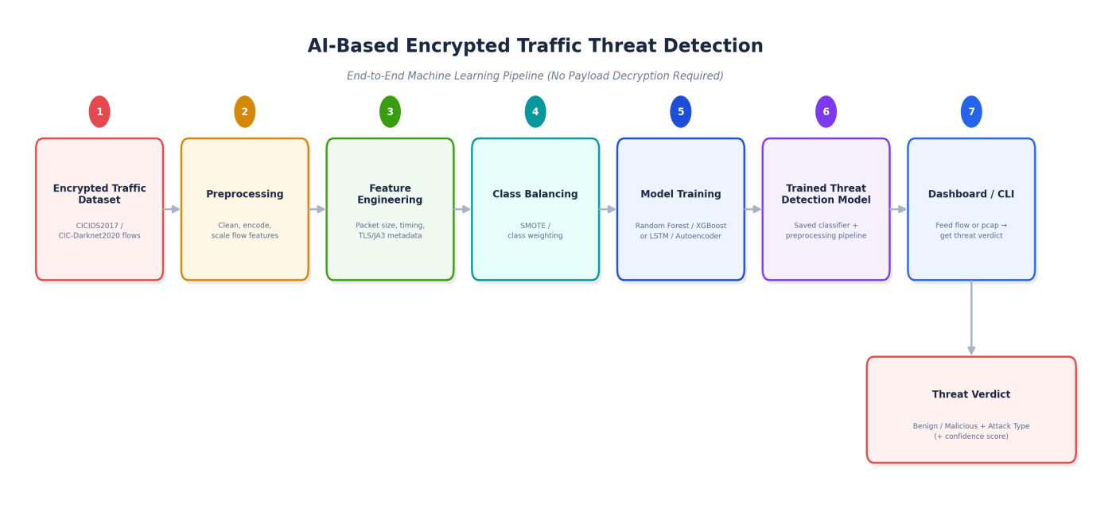
4.2 Stage-by-Stage Description
- Encrypted Traffic Dataset — Publicly available, pre-labeled flow datasets (e.g., CICIDS2017, CIC-Darknet2020) provide statistical flow features already extracted from real encrypted/VPN traffic captures, so no raw decryption is ever needed.
- Preprocessing — Handle missing/infinite values, encode categorical fields (protocol, port ranges), and scale numerical features so all algorithms train reliably.
- Feature Engineering — Focus on features that survive encryption: packet size distributions, flow duration, inter-arrival time (IAT) statistics, byte/packet rate, and where available, TLS handshake metadata such as JA3/JA3S fingerprints and SNI (Server Name Indication).
- Class Balancing — Apply SMOTE (Synthetic Minority Oversampling) or class-weighted loss functions to prevent the model from simply predicting 'benign' for everything, since attack traffic is typically a small minority of real-world flows.
- Model Training — Train Random Forest and XGBoost classifiers as interpretable, fast baselines; optionally extend to an LSTM (to model the sequential nature of packet timing within a flow) or an Autoencoder (to flag anomalous flows that don't resemble any known attack type, useful for zero-day detection).
- Trained Threat Detection Model — The final trained classifier and its preprocessing pipeline (scaler, encoders) are saved together so they can be reloaded and applied to new flows consistently.
- Dashboard / CLI — A lightweight interface accepts either a single flow's feature values or a pcap file (processed into flow features using a tool such as CICFlowMeter) and returns a verdict.
- Threat Verdict — The system outputs Benign or Malicious, the predicted attack category if malicious (e.g., DoS, port scan, botnet), and a confidence score.

5. Scope
In scope: a flow-metadata-based classification system trained on existing public datasets, covering the complete pipeline from raw flow features to a usable threat-verdict interface. The core deliverable is a binary (benign/malicious) and, where dataset labels allow, multi-class (attack-type) classifier.
Out of scope (for this version): live, in-line deployment on production network hardware; real-time packet capture and analysis at line-rate; decrypting or inspecting payload content under any circumstance; and detection of attacks that leave no observable flow-level signature. These are noted as potential future extensions rather than part of the initial deliverable.

6. Dataset
Several suitable datasets are available on Kaggle for this project:
Dataset | Details
CICIDS2017 (Kaggle mirrors) | Flow-based features (~80 columns) extracted with CICFlowMeter from 5 days of real traffic, covering benign traffic plus DoS, DDoS, Brute Force, Botnet, Port Scan, Web Attack, and Infiltration classes. Multiple ready-to-use Kaggle mirrors exist, including cleaned/preprocessed versions.
CIC-Darknet2020 / ISCX VPN-nonVPN | Combines Tor and VPN encrypted traffic captures, labeled by traffic category (browsing, chat, streaming, file transfer, VoIP, P2P) — useful if the project is framed around VPN/Darknet traffic specifically rather than intrusion attacks.
HTTPS Traffic Classification (Kaggle) | 145,671 flows with 88 numeric features across 6 traffic classes, purpose-built for encrypted HTTPS traffic classification research — directly aligned with this project's goal.
Encrypted and Unencrypted Network Traffic Dataset (Kaggle) | Provides a labeled mix of encrypted vs. unencrypted flows, useful as a supplementary dataset or for an encryption-detection preprocessing step.

Recommended starting point: CICIDS2017, since it is the most widely used benchmark in academic encrypted-traffic/intrusion-detection research, has multiple attack categories for multi-class evaluation, and has several clean, ready-to-use versions already hosted on Kaggle.

7. Tools and Technologies to be Used
Category | Tool / Technology
Programming Language | Python 3
Data Handling | pandas, NumPy
Machine Learning | scikit-learn (Random Forest), XGBoost
Class Imbalance Handling | imbalanced-learn (SMOTE)
Deep Learning (optional) | TensorFlow / PyTorch (LSTM, Autoencoder)
Flow Feature Extraction | CICFlowMeter (pcap → flow-level CSV features)
Traffic Inspection (dev/testing only) | Wireshark (metadata-level inspection, not decryption)
Interface | Streamlit or Flask (dashboard) — or a simple Python CLI script
Visualization | Matplotlib, Seaborn (confusion matrix, ROC curves, feature importance)
Development Environment | Jupyter Notebook / VS Code
Version Control | Git and GitHub

8. Methodology and Work Plan
Phase | Task | Deliverable
Phase 1 | Acquire the CICIDS2017 (or chosen) dataset; perform exploratory data analysis (class distribution, feature correlations, missing values) | Cleaned, understood dataset with EDA notes
Phase 2 | Preprocess data: handle missing/infinite values, encode categorical fields, scale numeric features | Reusable preprocessing pipeline
Phase 3 | Apply class balancing (SMOTE / class weighting) and split into training/testing sets | Balanced, split dataset ready for training
Phase 4 | Train baseline models (Random Forest, XGBoost) and tune hyperparameters | Trained baseline models with initial metrics
Phase 5 | (Optional) Train a deep learning model (LSTM or Autoencoder) and compare against the baseline | Deep-learning model and comparison results
Phase 6 | Build the dashboard/CLI interface for submitting flow data and receiving a verdict | Working demo interface
Phase 7 | Final evaluation, documentation, and report/demo preparation | Final report and live/recorded demonstration

9. Expected Outcomes
- A trained classifier capable of distinguishing benign from malicious encrypted traffic flows using only metadata, with reasonable accuracy and, more importantly, a low false-negative rate on the held-out test set.
- A reusable feature-engineering and preprocessing pipeline that can be applied to new, unseen flow data extracted from pcap captures.
- A working dashboard/CLI demo where a flow's feature values (or an uploaded pcap) can be submitted to receive an instant threat verdict with confidence score.
- (If the deep-learning extension is completed) a comparison of classical ML (Random Forest/XGBoost) versus deep learning (LSTM/Autoencoder) approaches for this task.
- A clear understanding of which flow-level features are most informative for detecting threats in encrypted traffic, and the practical limitations of metadata-only detection (e.g., sophisticated attackers mimicking benign traffic patterns).

10. Evaluation Metrics
- Precision — of the flows flagged as malicious, how many actually were (important to avoid alert fatigue from false positives)
- Recall (Detection Rate) — of all actually malicious flows, how many the model correctly caught (critical in security, where missed attacks are costly)
- F1-score — balanced measure combining precision and recall
- ROC-AUC — overall ability of the model to separate benign from malicious flows across all thresholds
- Confusion matrix — per-class breakdown, especially useful for the multi-class attack-type version of the task

11. Future Enhancements
- Real-time, in-line deployment that scores live network flows as they occur rather than offline batches
- Integration with SIEM/SOC alerting pipelines for automated incident response
- Federated or continual learning to adapt to evolving attack patterns without full retraining
- Explainability tooling (e.g., SHAP values) to show analysts why a specific flow was flagged
- Extending detection to encrypted DNS (DoH/DoT) and QUIC traffic, which are increasingly common and harder to analyze than traditional TLS

12. Conclusion
The AI-Based Encrypted Traffic Threat Detection project tackles a practical, real-world security challenge: identifying malicious activity in a world where most traffic is encrypted by default. By relying solely on flow-level metadata rather than payload content, the system respects user privacy while still providing meaningful security value. The project demonstrates a complete, end-to-end machine learning workflow — from public benchmark datasets through feature engineering, imbalanced-data handling, and model evaluation, to a usable detection interface — with a clear path to a deep-learning extension for courses that require one.

References
- Canadian Institute for Cybersecurity (CIC): CICIDS2017 and CIC-Darknet2020 datasets, University of New Brunswick.
- Draper-Gil, G., et al. Characterization of Encrypted and VPN Traffic Using Time-Related Features. ICISSP, 2016 (ISCX VPN-nonVPN dataset).
- Chen, T. & Guestrin, C. XGBoost: A Scalable Tree Boosting System. KDD, 2016.
- Chawla, N. V., et al. SMOTE: Synthetic Minority Over-sampling Technique. JAIR, 2002.

