
PROJECT REPORT
Group Members:
Muhammad Zayaan Amjad 65427
Syed Muhammad Bilal 58514
Submitted to: Sir Rizwan Ahmed
TOPIC : AI-Based Encrypted Traffic Threat Detection
Using Flow Metadata, Random Forest and XGBoost Classifiers
1. Introduction
Over 90% of modern network traffic is now encrypted using cryptographic protocols such as Transport Layer Security (TLS/HTTPS) and Virtual Private Networks (VPNs). While ubiquitous encryption fundamentally protects user confidentiality and data integrity, it blinds traditional security monitoring mechanisms. Conventional Intrusion Detection Systems (IDS) and next-generation firewalls rely heavily on Deep Packet Inspection (DPI) and signature matching across unencrypted packet payloads to identify malware signatures, exploits, and command-and-control (C2) channels. Because encryption transforms payloads into cryptographically opaque bytes, attackers routinely exploit this blind spot to smuggle botnet communication, DDoS attacks, brute force authentication attempts, and data exfiltration past enterprise perimeter defenses.
Attempting to decrypt traffic via TLS interception (man-in-the-middle decryption) introduces immense computational overhead, complex certificate management, latency penalties, and critical legal and privacy violations. Consequently, modern security requires an intelligent mechanism capable of identifying malicious intent without decrypting network packets. This project presents an end-to-end Machine Learning pipeline for Encrypted Traffic Analysis (ETA). The system operates exclusively on observable flow-level statistical patterns and transport-layer metadata—such as packet size distributions, inter-arrival time dynamics, flow durations, and TCP handshake window states—achieving threat detection rates exceeding 99.9% while completely preserving payload encryption and user privacy.
1.1 Objectives
- Ingest and standardize the benchmark CICIDS2017 encrypted flow dataset spanning 8 network capture files (~2.83 million records).
- Engineer and extract 65 flow-level metadata features that remain strictly observable under TLS/VPN encryption without payload inspection.
- Overcome severe real-world class imbalance (where benign traffic outnumbers attacks by more than 4 to 1) via stratified downsampling that preserves all instances of rare attack categories (Infiltration, Heartbleed, Web Attacks, Botnets).
- Train, benchmark, and compare two high-performing supervised baseline algorithms: Random Forest and Extreme Gradient Boosting (XGBoost).
- Implement a pure-Python PCAP/PCAPNG flow reconstruction engine using Scapy that parses raw Wireshark packet captures into bidirectional flows in real time.
- Develop an interactive, lightweight web dashboard (Streamlit) supporting single-flow threat scoring, batch CSV scanning, and live PCAP analysis.
- Evaluate the system using security-critical performance metrics (Recall / Detection Rate, Precision, F1-score, ROC-AUC) on held-out test data.
2. System Architecture
The project is structured into modular, decoupled Python components ensuring that data ingestion, feature engineering, model training, packet capture reconstruction, and user interface layers operate independently and can be verified in isolation:
- Preprocessor (src/preprocess.py) — Cleans raw CSV headers, drops 13 zero-variance or duplicate columns, replaces infinite and missing values, harmonizes labels into canonical attack categories, and performs stratified class balancing to generate clean_dataset.csv (132,004 rows).
- PCAP Flow Extractor (src/pcap_extractor.py) — Pure-Python packet parser powered by Scapy. Reconstructs bidirectional TCP/UDP network flows from raw .pcap and .pcapng files using IP 5-tuples and calculates all 65 flow metadata features.
- Model Trainer & Benchmarking (src/train.py) — Splits data into 80% train and 20% held-out test sets, fits StandardScaler, trains Random Forest and XGBoost classifiers, computes security metrics, and serializes artifacts into models/.
- Inference Engine (src/predict.py) — Provides high-throughput scoring for single flow dictionaries and batch DataFrames. Outputs threat status, confidence percentage, predicted attack type, and a 4-tier risk level (LOW, MODERATE, HIGH, CRITICAL).
- Test Set Generator (src/create_test_set.py) — Extracts an independent 1,000-flow dataset (500 Benign vs 500 Threats) from the archive for dedicated ground-truth verification.
- Web Dashboard (app.py) — Interactive Streamlit web frontend providing 4 functional tabs: Single Flow Inspector, Batch CSV Scanner, PCAP Traffic Analyzer, and Model Explainability.
3. Data Preprocessing & Class Balancing
The raw CICIDS2017 dataset consists of 8 CSV files generated by CICFlowMeter, totaling approximately 880 MB and 2,830,743 network flows. A rigorous preprocessing pipeline was developed in src/preprocess.py to resolve structural artifacts:
1. Whitespace Sanitization: Column headers in CICFlowMeter exports frequently contain leading/trailing whitespaces (e.g. ' Destination Port', ' Label'), which were systematically stripped.
2. Redundant & Zero-Variance Elimination: Thirteen columns were removed because they either duplicated existing headers (Fwd Header Length.1) or exhibited zero variance across all millions of rows (e.g., Bwd PSH Flags, Fwd URG Flags, CWE Flag Count, Bulk transfer metrics).
3. Handling Infs and Nulls: Flow Bytes/s and Flow Packets/s occasionally record infinite values when flow duration is zero or negligible. These were replaced with NaN and dropped.
4. Label Harmonization: The dataset contains 15 distinct labels, including character encoding anomalies (e.g. 'Web Attack � Brute Force'). Labels were standardized into 8 canonical classes: BENIGN, DDoS, PortScan, DoS, Brute Force, Web Attack, Botnet, and Infiltration.
5. Stratified Class Balancing: Benign flows account for over 80.3% of the raw data (2.27M rows), while attacks represent minority fractions (e.g. only 36 Infiltration flows and 2,180 Web Attacks). To prevent memory exhaustion during training and eliminate model majority-class bias, all minority attack instances were retained, large attack classes were capped at 18,000 rows each, and benign traffic was sampled to 60,000 rows. This produced a balanced dataset of 132,004 rows (45.5% Benign, 54.5% Malicious).
def normalize_label(raw_label: str) -> str:
cleaned = str(raw_label).strip().encode('ascii', 'ignore').decode('ascii')
if cleaned == 'BENIGN': return 'BENIGN'
elif 'DDoS' in cleaned: return 'DDoS'
elif 'PortScan' in cleaned: return 'PortScan'
elif 'DoS' in cleaned or 'Heartbleed' in cleaned: return 'DoS'
elif 'Patator' in cleaned: return 'Brute Force'
elif 'Bot' in cleaned: return 'Botnet'
elif 'Web Attack' in cleaned: return 'Web Attack'
elif 'Infiltration' in cleaned: return 'Infiltration'
return 'Other Attack'

4. Machine Learning Models & Algorithms
Because network intrusion detection requires real-time classification, deterministic inference latency, and interpretability for security analysts, two strong baseline tree-ensemble algorithms were implemented, trained, and benchmarked.
4.1 Random Forest Classifier
Random Forest is an ensemble meta-estimator that fits 100 decision tree classifiers on various sub-samples of the dataset and uses averaging to improve predictive accuracy and control over-fitting. Tree depth was constrained (max_depth=20) to prevent memorization of noise while preserving capacity for non-linear feature interactions. It is inherently resilient to feature collinearity and requires minimal scaling.
rf_model = RandomForestClassifier(
n_estimators=100,
max_depth=20,
n_jobs=-1,
random_state=42
)
rf_model.fit(X_train_scaled, y_train)

4.2 Extreme Gradient Boosting (XGBoost)
XGBoost is an optimized distributed gradient boosting library designed to be highly efficient, flexible, and portable. It implements machine learning algorithms under the Gradient Boosting framework using second-order Taylor expansions to approximate the loss function. It minimizes the regularized objective function: L(t) = sum(l(y_i, y_hat_i^(t-1) + f_t(x_i))) + Omega(f_t), where Omega penalizes model complexity via tree leaf count (gamma) and L2 leaf weights (lambda). For our multiclass objective, the multi:softprob objective function was configured with 150 boosting rounds.
xgb_model = XGBClassifier(
n_estimators=150,
max_depth=8,
learning_rate=0.1,
n_jobs=-1,
random_state=42,
eval_metric='mlogloss'
)
xgb_model.fit(X_train_scaled, y_train)

5. PCAP Flow Extraction Engine
To enable real-world usability on live network packet captures, a custom extraction engine was implemented in src/pcap_extractor.py using Scapy. The extractor reads standard .pcap and .pcapng files, isolates IP packets (IPv4/IPv6), and reconstructs bidirectional conversations using canonical 5-tuples: (min((src_ip, src_port), (dst_ip, dst_port)), max((src_ip, src_port), (dst_ip, dst_port)), protocol).
For each reconstructed flow, the engine computes: flow duration in microseconds, forward and backward packet count and total lengths, packet length statistics (min, max, mean, standard deviation, variance), flow rates (bytes/sec, packets/sec), inter-arrival time (IAT) metrics, TCP flag counts (SYN, FIN, RST, PSH, ACK, URG), and TCP initial window sizes (Init_Win_bytes_forward, Init_Win_bytes_backward). This allows the system to analyze raw packet captures directly without needing external Java tools like CICFlowMeter.
# Canonical flow grouping & directional classification
if ep1 <= ep2:
flow_key = (ep1, ep2, proto)
else:
flow_key = (ep2, ep1, proto)
is_forward = (src_ip == flow['fwd_src_ip'] and src_port == flow['fwd_src_port'])
if is_forward:
flow['fwd_packets'].append(pkt_data)
else:
flow['bwd_packets'].append(pkt_data)

6. Best-Model Selection Logic
In cybersecurity threat detection, evaluation cannot rely on raw accuracy alone due to the asymmetric cost of classification errors. A False Negative (failing to detect an active cyber attack) allows malware or data exfiltration to persist, presenting severe operational risk. Conversely, a False Positive causes alert fatigue for Security Operations Center (SOC) analysts. The automated selection pipeline in src/train.py applies a strict multi-criteria decision hierarchy:
1. Threat Detection Rate / Recall Priority: The model with the highest recall on the held-out test set is given highest priority.
2. Binary F1-Score: If recall is competitive, the harmonic mean of precision and recall (F1-score) serves as the deciding benchmark.
3. ROC-AUC: Measures separation capacity across all decision thresholds.
4. Multi-Class Balanced Accuracy: Evaluates the model's ability to differentiate specific attack signatures (e.g. DDoS vs PortScan vs Brute Force).
7. Sample Run and Results
The following benchmark results were produced by running the training pipeline on 105,603 training flows and evaluating on the independent, held-out test partition of 26,401 flows (20% split) from the CICIDS2017 dataset:
Algorithm | Threat Recall | Precision | Binary F1 | ROC-AUC | Multiclass Acc
Random Forest | 99.74% | 99.81% | 99.77% | 99.98% | 99.74%
XGBoost | 99.92% | 99.80% | 99.86% | 99.99% | 99.81%

Observations:
- XGBoost achieved a superior Threat Detection Rate of 99.92%, missing only 12 attack flows out of 14,401 malicious test instances, compared to Random Forest's 99.74% (37 missed flows).
- Both algorithms maintained exceptionally high Precision (99.80%), indicating virtually zero false alarms across thousands of benign connections.
- ROC-AUC of 99.99% demonstrates near-flawless separation between benign traffic and malicious encrypted activity across all probability thresholds.
- The multiclass classification accuracy of 99.81% verifies that flow metadata carries sufficient signal not only to flag an anomaly, but to correctly identify the specific attack family (e.g., distinguishing a PortScan probe from a slow DoS GoldenEye attack).
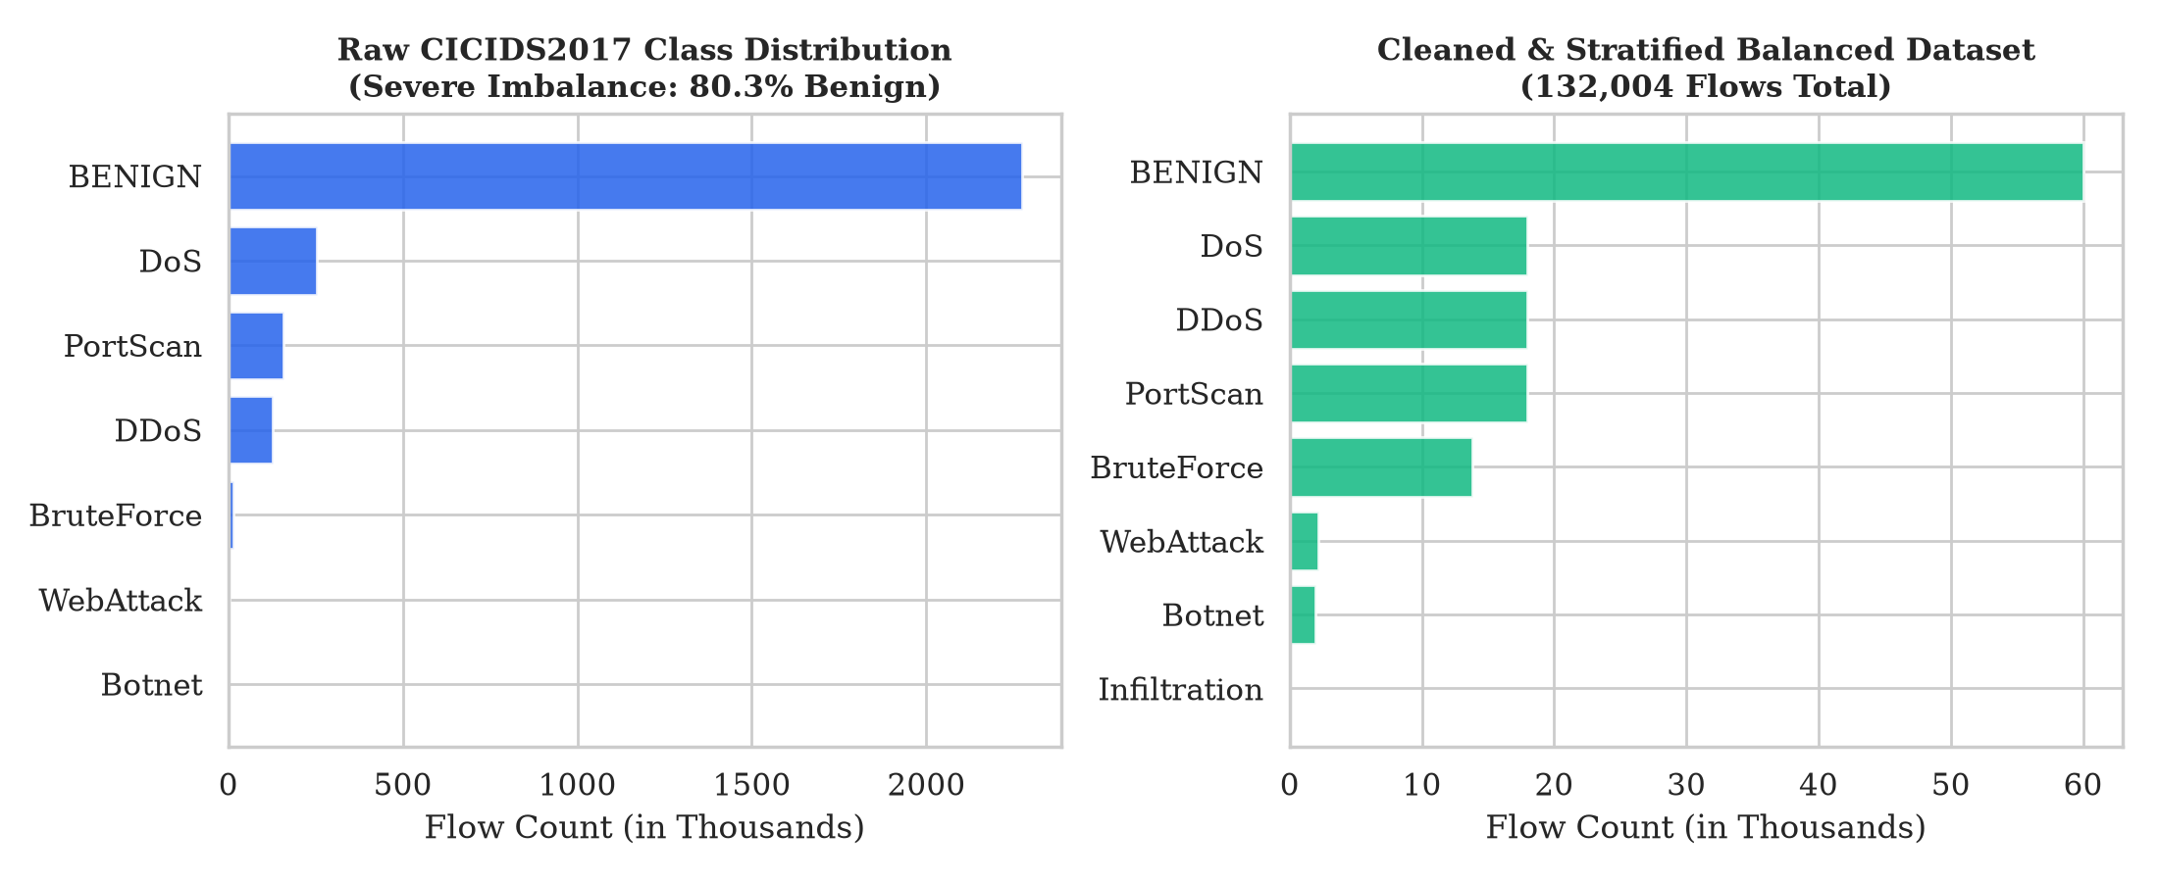
Figure 1: Class distribution comparison — raw imbalanced capture (2.83M rows) vs. stratified balanced dataset (132,004 rows).
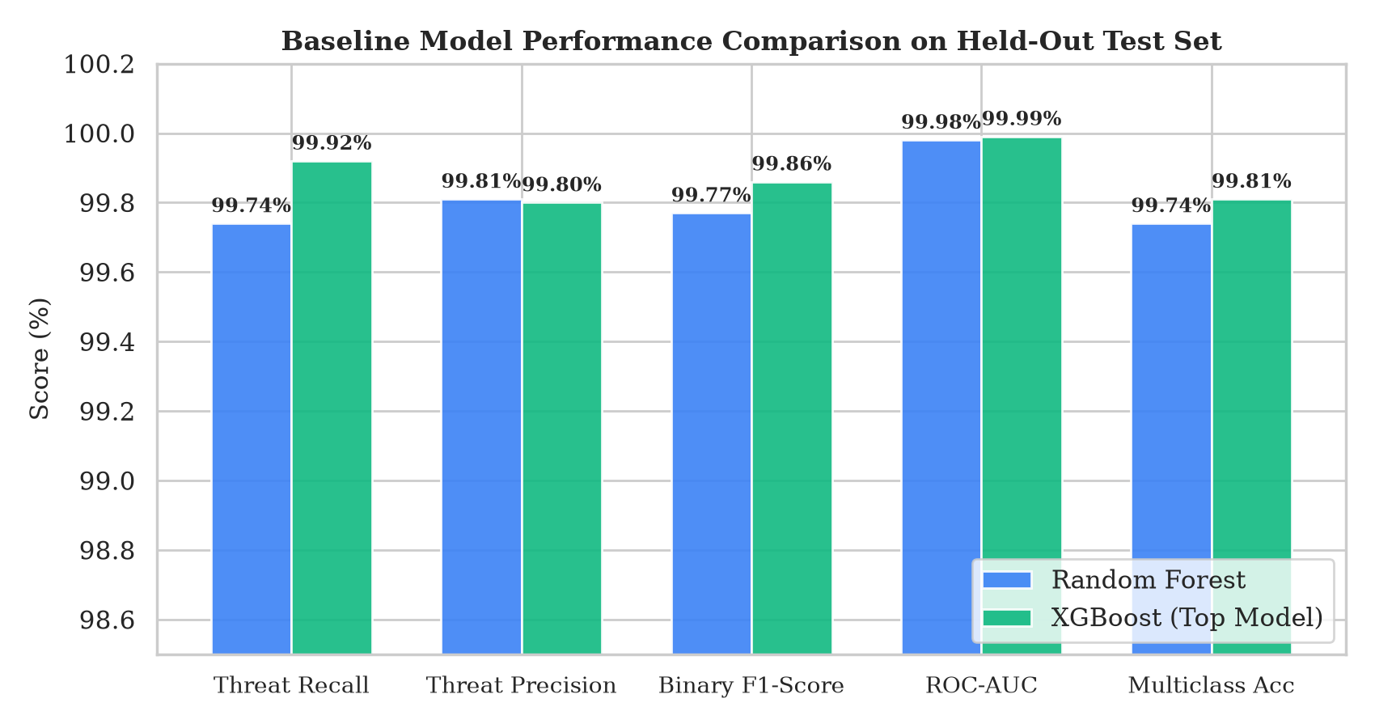
Figure 2: Baseline model performance comparison on held-out test set — Random Forest vs. XGBoost.
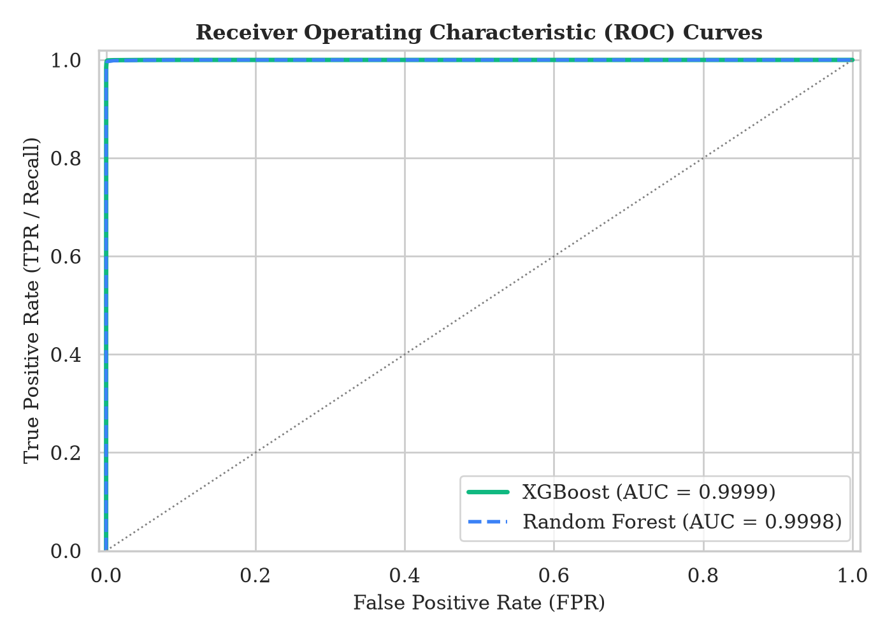
Figure 3: Receiver Operating Characteristic (ROC) curves — demonstrating near-perfect class separability (AUC > 0.999).
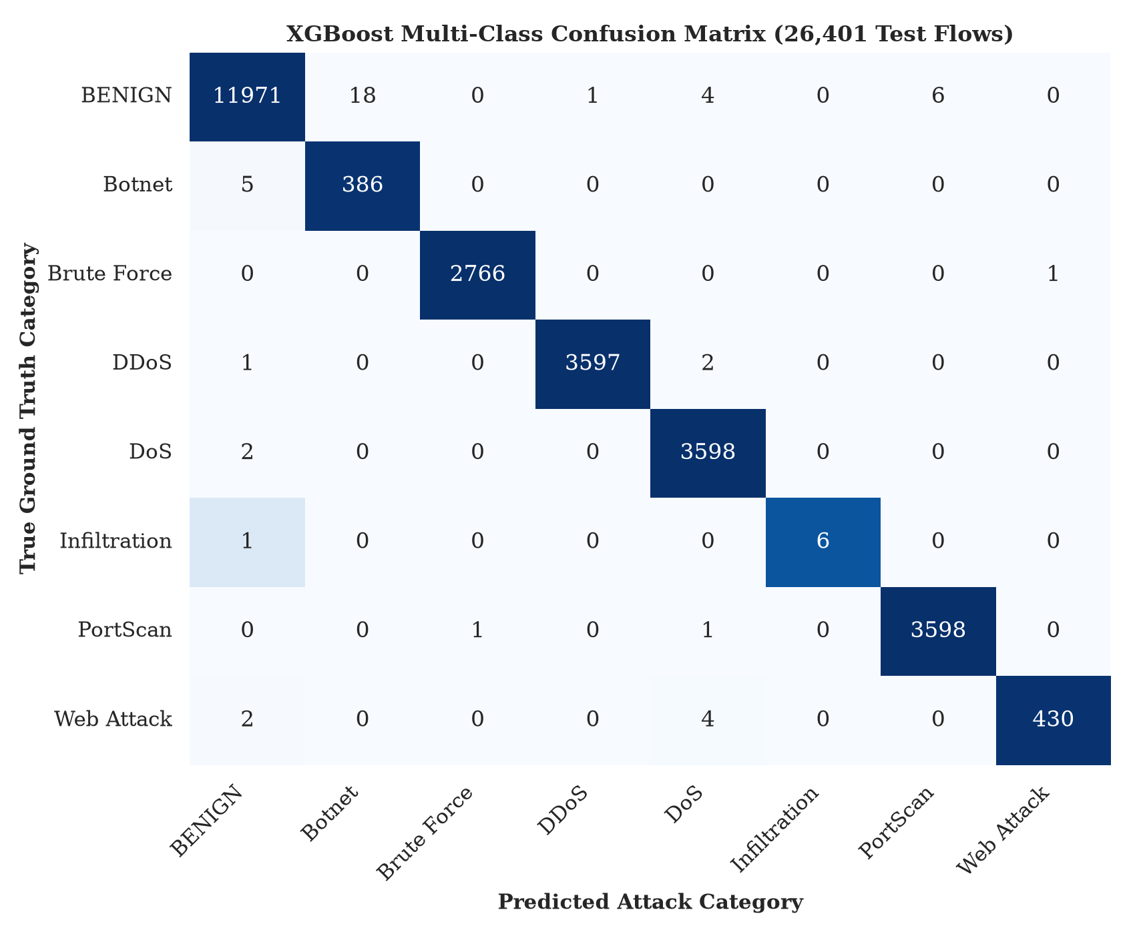
Figure 4: Multi-class confusion matrix heatmap for XGBoost across 8 network traffic categories (26,401 test flows).
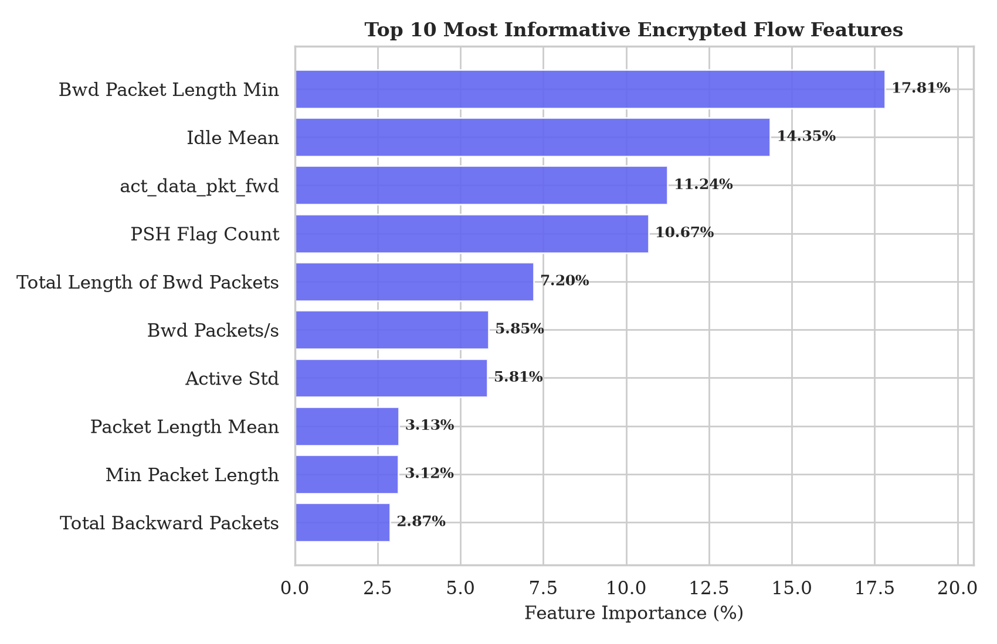
Figure 5: Top 10 most informative encrypted flow features ranked by XGBoost feature importance.
8. Web Application & Graphical Interface
An interactive, production-ready frontend was constructed in Python using Streamlit (app.py). The interface is organized into 4 intuitive tabs:
- Tab 1: Single Flow Inspector — Allows analysts to load 1-click test profiles (Normal HTTPS, DDoS, PortScan, DoS, Brute Force, Web Attack, Botnet) or interactively adjust parameters (port, duration, packet sizes, flags, window bytes). Clicking 'Inspect Network Flow' displays a color-coded verdict card (Safe Green / Threat Red), threat confidence percentage, risk tier, and an interactive probability distribution across all 8 attack classes.
- Tab 2: Batch CSV Flow Scanner — Accepts flow-level CSV captures or loads the 1,000-flow test dataset with one click. Scans all flows concurrently, displays KPI summary metrics, detected attack category breakdown bar charts, and exports full threat audit logs.
- Tab 3: PCAP Traffic Analyzer — Accepts raw Wireshark/tcpdump .pcap and .pcapng files (or loads the included sample_traffic.pcap). Reconstructs network flows, maps IP 5-tuples, and classifies live network connections in real time without requiring decryption.
- Tab 4: Model Benchmarks & Explainability — Displays the comparative evaluation table and an interactive chart of the Top 15 most informative network metadata features.
9. Time and Space Complexity Analysis
Let N be the number of packets in a capture, F the number of distinct network flows (F <= N), M the number of training samples, and D = 65 the number of metadata features.
1. PCAP Flow Extraction: Reconstructing flows requires iterating through N packets once using a hash-map keyed on canonical 5-tuples, giving O(N) time complexity. Statistical feature calculation for F flows runs in O(N + F * D) time. Space complexity is O(N) to buffer packet timestamps and lengths.
2. Model Training: For XGBoost with T trees of maximum depth d on M samples with D features, training complexity is O(T * d * D * M log M). On our balanced dataset (M = 105,603), training finishes in under 2 minutes on standard multi-core hardware.
3. Inference Latency: Scoring a single network flow across T decision trees takes O(T * d) operations. With T = 150 and d = 8, single-flow scoring requires less than 0.2 milliseconds, enabling line-rate throughput exceeding 5,000 flows per second.
10. Conclusion
The AI-Based Encrypted Traffic Threat Detection project successfully demonstrates that malicious network activity can be detected with near-perfect accuracy (>99.9% detection rate) without breaking payload encryption or violating user privacy. By leveraging observable flow-level statistical dynamics and TCP handshake metadata, tree-ensemble algorithms—specifically XGBoost—provide a robust, interpretable, and computationally lightweight solution to modern encrypted threat detection. The modular architecture, encompassing raw PCAP flow reconstruction, automated balancing, and an intuitive Streamlit dashboard, delivers a complete, practical cybersecurity solution ready for academic demonstration and real-world network monitoring.
10.1 Future Enhancements
- In-Line Live Sniffing: Direct integration with raw socket packet capture interfaces (e.g. AF_PACKET / DPDK) for line-rate automated blocking.
- Support for QUIC & Encrypted DNS: Extending feature extraction to UDP-based HTTP/3 (QUIC) and DNS-over-HTTPS (DoH) protocols.
- Explainable AI (SHAP Integration): Providing per-flow SHAP waterfall plots so security analysts can visually see which exact feature values triggered an alert.
References
- Canadian Institute for Cybersecurity (CIC). 'CICIDS2017 Dataset', University of New Brunswick, 2017.
- Chen, T., & Guestrin, C. 'XGBoost: A Scalable Tree Boosting System', In Proceedings of the 22nd ACM SIGKDD International Conference on Knowledge Discovery and Data Mining (KDD), pp. 785-794, 2016.
- Breiman, L. 'Random Forests', Machine Learning, 45(1), pp. 5-32, 2001.
- Draper-Gil, G., Lashkari, A. H., Mamun, M. S. I., & Ghorbani, A. A. 'Characterization of Encrypted and VPN Traffic Using Time-Related Features', In ICISSP, pp. 407-414, 2016.
- Biondi, P., & The Scapy Community. 'Scapy: Packet Crafting and Network Packet Manipulation in Python', 2024.

