#########################################################################

Name: Aditya Singh Sandhu

Course: CSC500-1

Module 4: Portfolio Milestone

#########################################################################

# COPY THIS LINE OF CODE - BEGINNING

class ItemToProcure:

def __init__(self, product_name="none", dollar_value_of_item=0, numerical_quantity_of_product=0):

self.product_name = product_name

self.dollar_value_of_item = dollar_value_of_item

self.numerical_quantity_of_product = numerical_quantity_of_product

def console_log_item_cost(self):

total_cost = self.dollar_value_of_item * self.numerical_quantity_of_product

print(f"{self.product_name} {self.numerical_quantity_of_product} @ ${self.dollar_value_of_item} = ${total_cost}")

def main():

print("Item 1")

item1_name = input("Whats the name of item1:\n")

item1_dollar_value = float(input("Whats the dollar_value of item1:\n"))

item1_quantity = int(input("Whats the quantity of item1:\n"))

item1 = ItemToProcure(item1_name, item1_dollar_value, item1_quantity)

print("\nItem 2")

item2_name = input("Whats the name of item2:\n")

item2_dollar_value = float(input("Whats the dollar_value of item2:\n"))

item2_quantity = int(input("Whats the quantity of item2:\n"))

item2 = ItemToProcure(item2_name, item2_dollar_value, item2_quantity)

print("\nHERE IS THE TOTAL COST OF THE TWO ITEMS")

item1.console_log_item_cost()

item2.console_log_item_cost()

total_cost = (item1.dollar_value_of_item * item1.numerical_quantity_of_product) + (item2.dollar_value_of_item * item2.numerical_quantity_of_product)

print(f"\nTotal: ${total_cost}")

if __name__ == "__main__":

main()

# COPY THIS LINE OF CODE - ENDING Figure 1 - Class Items to Purchase and Print Item cost Function.

This code defines a Python class named ItemToProcure, which models an item that someone might want to purchase. The class has a constructor method (__init__) and a method to print the cost of the item (console_log_item_cost). A class in Python is a blueprint, and objects created by instantiating them are called instances of classes. Methods inside classes are called functions.

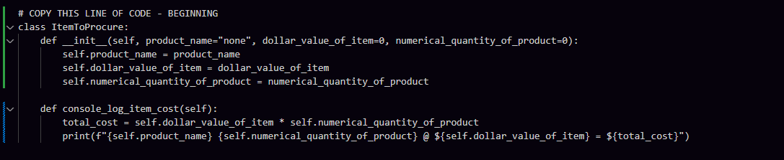

Figure 2 – The main function in this code snippet prompts the user to input details for two items, creates instances of the ItemToProcure class for these items, and then calculates and prints the total cost.

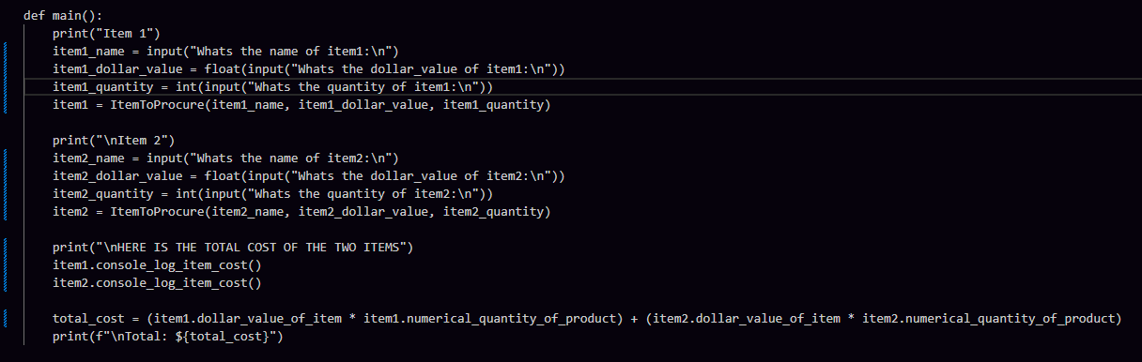

Figure 3 – Conditional Execution of the Script

Named to main when the script is not being imported anywhere, it ensures that the main function is only executed when the script is called directly. Ie, when the script, in this case module4-portfolio-assignmnet.py is run directly, like ‘python module4-portfolio-assignmnet.py’, the the __name__ is set to __main__, and the main() function is executed.

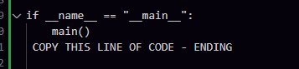

Figure 4 – Output of Program, that asks for input from user for 2 items and runs calculations on input name, prices and quantity. Then the program prints the total cost for and for each item combines, name, quantity and total cost.

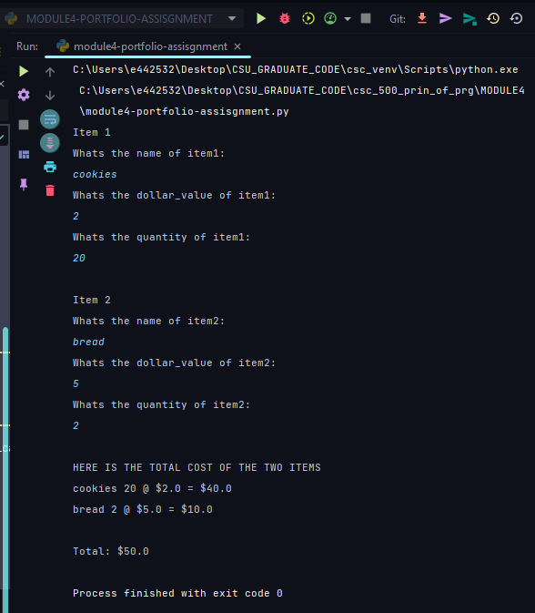

Process finished with exit code 0 This line indicates that the program ran successfully without any errors. The exit code 0 is a standard way to signal that the program completed successfully.

In Summary, The program collects the name, price, and quantity for two items from the user.

It then calculates and prints the total cost for each item. Finally, it calculates and prints the combined total cost of both items. The program ends successfully, as indicated by the exit code 0.

***Githublink -*** [***https://github.com/65AR645ASAN/csc_500_prin_of_prg/blob/main/MODULE4/Module4-PortfolioAssignment-CSC500-1-AdityaSandhu.docx***](https://github.com/65AR645ASAN/csc_500_prin_of_prg/blob/main/MODULE4/Module4-PortfolioAssignment-CSC500-1-AdityaSandhu.docx)

***Work Cited***

Programiz. (n.d.). Python Classes and Objects. Programiz. https://www.programiz.com/python-programming/class