###############################################################

Student: Aditya Singh Sandhu

Course: CSC 500 – Principles of Programming

Module: 5 - Critical Thinking Assignment

###############################################################

Python3 Code ~

# Copy this line - Beginning of Program

# Part 1: Mean Rainfall Calculation

years = int(input("Years to Break Up into Months: "))

cumulative_rainfall_in_inches_ = 0

cumulative_months = 0

for year in range(1, years + 1):

print(f"Year >>> {year}:")

for month in range(1, 13):

rainfall = float(input(f"Inches of Rain per month >>> {month}: "))

cumulative_rainfall_in_inches_ += rainfall

cumulative_months += 12

# Calculate the Mean rainfall

Mean_rainfall = cumulative_rainfall_in_inches_ / cumulative_months

print(f"\nCumulative Number of months: {cumulative_months}")

print(f"Cumulative inches of rainfall: {cumulative_rainfall_in_inches_:.2f}")

print(f"Mean rainfall per month: {Mean_rainfall:.2f} inches")

# Part 2: Bookstore Points Calculation

number_of_books_procured = int(input("How Many Books are Procured This Month: "))

if number_of_books_procured == 0:

numeral_of_points_earned = 0

elif number_of_books_procured == 2:

numeral_of_points_earned = 5

elif number_of_books_procured == 4:

numeral_of_points_earned = 15

elif number_of_books_procured == 6:

numeral_of_points_earned = 30

elif number_of_books_procured >= 8:

numeral_of_points_earned = 60

else:

numeral_of_points_earned = 0

print(f"Total Amount of Points Awarded: {numeral_of_points_earned}")

# Copy this line - End of Program

"Screenshot 1," "Average Rainfall Calculation: A Python Program Utilizing Nested Loops for Data Collection and Analysis"

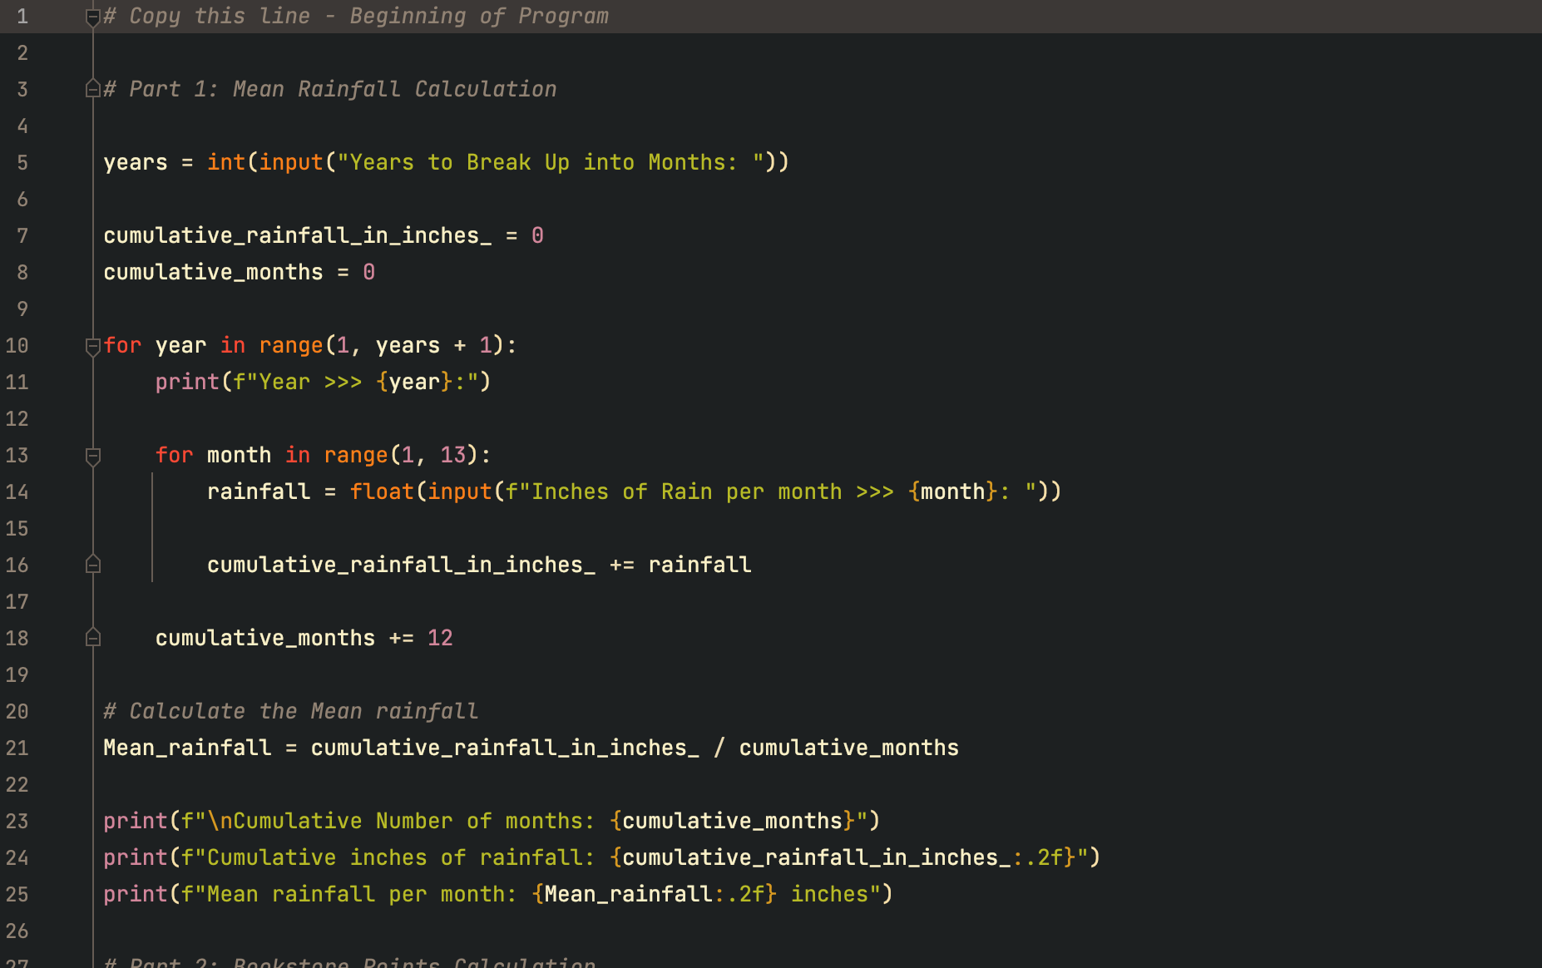

This Python program is designed to calculate the average rainfall over a specified period, with data collection occurring on a monthly basis across multiple years. The program operates in the following steps:

User Input for Years: The program begins by asking the user to input the number of years over which rainfall data will be collected. This input defines the number of iterations for the outer loop.

'cumulative_rainfall_in_inches_', this variable is initialized to store the total rainfall collected over the entire period. 'cumulative_months', this variable is initialized to store the total number of months across all years. The Outer Loop (Yearly Iteration), this outer loop runs once for each year specified by the user. In each iteration of the outer loop, the program prints the current year number. The Inner Loop (Monthly Iteration). Within each year, the inner loop iterates 12 times, corresponding to the 12 months in a year. For each iteration (representing a month), the program prompts the user to input the inches of rainfall for that month. This value is then added to the cumulative rainfall total. Calculation of Cumulative Months: After each year, the program adds 12 to the 'cumulative_months' variable, accounting for all the months of that year. Calculation of Mean Rainfall: After the loops have completed, the program calculates the mean rainfall per month by dividing the total rainfall by the total number of months ('Mean_rainfall = cumulative_rainfall_in_inches_ / cumulative_months').

"Screenshot 2," Display of Results

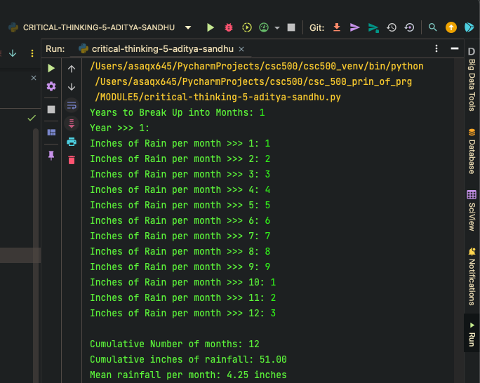

The program then outputs the total number of months, the cumulative rainfall in inches, and the average rainfall per month, all formatted to two decimal places.

"Screenshot 3", Python Code for Bookstore Points Calculation

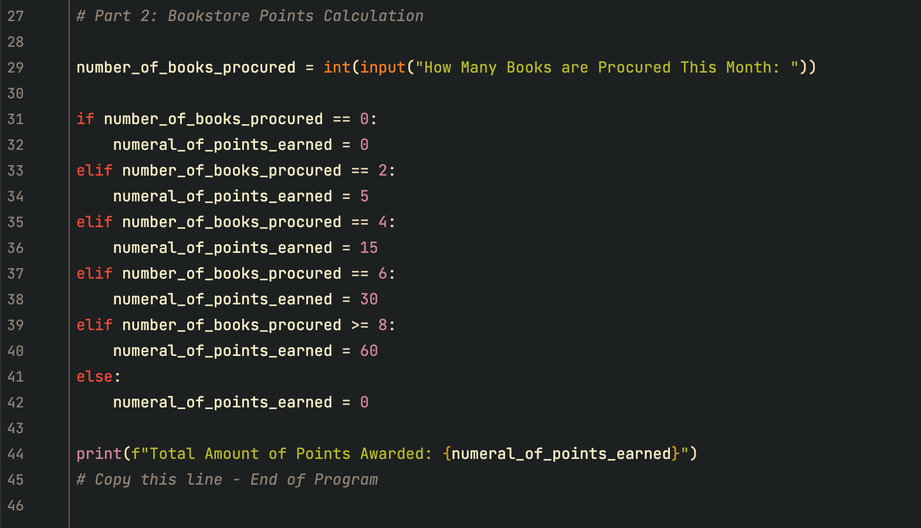

This presents the code that calculates the number of points awarded by a bookstore based on the number of books purchased in a month. The code works as follows:

First the Program Part 2, Prompts the User for Input: "How Many Books are Procured This Month:".

After the Input the code checks the number of books using a series of 'if', 'elif', and 'else' statements. Depending on the number of books procured, the code assigns a specific number of points ('numeral_of_points_earned').

If the input is

- 0 books -> 0 points

- 2 books -> 5 points

- 4 books -> 15 points

- 6 books -> 30 points

- 8 or more books -> 60 points

- And If the number of books does not match any of the specified conditions, the program defaults to 0 points.

Finally, the program prints the total number of points awarded using the label "Total Amount of Points Awarded: {numeral_of_points_earned}".

Screenshot 4 displays the result of running the program with the input "7" for the number of books procured.

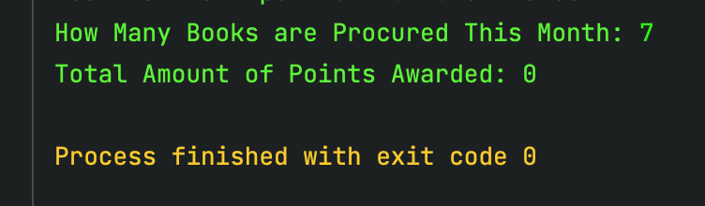

The program mistakenly awarded 0 points instead of the expected number of points. This indicates a potential logic issue in the program, specifically in the conditional statement that should have awarded 30 points for 7 books. The condition for awarding 30 points ('number_of_books_procured == 6') did not account for 7 books, leading to the final 'else' clause, which assigns 0 points.

GITHUB LINK - <https://github.com/65AR645ASAN/csc_500_prin_of_prg/blob/main/MODULE5/critical-thinking-assignment-module5.docx>

**APA citations**

1. GeeksforGeeks. (n.d.). *Python if...else*. GeeksforGeeks. Retrieved August 16, 2024, from [https://www.geeksforgeeks.org/python-if-else/](https://www.geeksforgeeks.org/python-if-else/)

2. Corey Schafer. (2018, January 19). *Python Tutorial: If __name__ == '__main__'*. [Video]. YouTube. [https://www.youtube.com/watch?v=lQzurQm_YKU](https://www.youtube.com/watch?v=lQzurQm_YKU)

3. DataCamp. (n.d.). *How to use elif statements in Python*. DataCamp. Retrieved August 16, 2024, from [https://www.datacamp.com/tutorial/elif-statements-python](https://www.datacamp.com/tutorial/elif-statements-python)

4. w3resource. (n.d.). *Python if...else statements*. w3resource. Retrieved August 16, 2024, from [https://www.w3resource.com/python/python-if-else-statements.php#if-statement](https://www.w3resource.com/python/python-if-else-statements.php#if-statement)