###############################################################

Student: Aditya Singh Sandhu

Course: CSC 500 – Principles of Programming

Module: 6 – Portfolio Assignment

###############################################################

Python3 Code ~

# COPY THIS LINE OF CODE - BEGINNING

class ItemToProcure:

def __init__(self, product_name="none", dollar_value_of_item=0, numerical_quantity_of_product=0):

self.product_name = product_name

self.dollar_value_of_item = dollar_value_of_item

self.numerical_quantity_of_product = numerical_quantity_of_product

def console_log_item_cost(self):

total_cost = self.dollar_value_of_item * self.numerical_quantity_of_product

print(f"{self.product_name} {self.numerical_quantity_of_product} @ ${self.dollar_value_of_item} = ${total_cost}")

def initial_item_to_cart(cart):

print("Enter the details of the first item:")

item_name = input("Whats the name of the item:\n")

item_dollar_value = float(input(f"Whats the dollar value of the {item_name}:\n"))

item_quantity = int(input(f"Whats the quantity of the {item_name}:\n"))

item = ItemToProcure(item_name, item_dollar_value, item_quantity)

cart.add_item(item)

print("\nHERE IS THE TOTAL COST OF THE ITEM")

item.console_log_item_cost()

total_cost = cart.get_cost_of_cart()

print(f"\nTotal: ${total_cost}")

class ShoppingCart:

def __init__(self, grocery_shoppers_name="none", todays_shopping_date="January 1, 2020"):

self.grocery_shoppers_name = grocery_shoppers_name

self.todays_shopping_date = todays_shopping_date

self.cart_items = []

def add_item(self, item: ItemToProcure):

self.cart_items.append(item)

def remove_item(self, product_name: str):

found = False

for item in self.cart_items:

if item.product_name == product_name:

self.cart_items.remove(item)

found = True

break

if not found:

print("The Item to be Removed, wasn't found in the cart, So nothing was REMOVED.")

def modify_item(self, item_to_modify: ItemToProcure):

found = False

for item in self.cart_items:

if item.product_name == item_to_modify.product_name:

if item_to_modify.dollar_value_of_item != 0:

item.dollar_value_of_item = item_to_modify.dollar_value_of_item

if item_to_modify.numerical_quantity_of_product != 0:

item.numerical_quantity_of_product = item_to_modify.numerical_quantity_of_product

found = True

break

if not found:

print("The Item to be Modified, wasn't found in the cart, So nothing was MODIFIED.")

def get_num_items_in_cart(self) -> int:

total_quantity = sum(item.numerical_quantity_of_product for item in self.cart_items)

return total_quantity

def get_cost_of_cart(self) -> float:

total_cost = sum(item.dollar_value_of_item * item.numerical_quantity_of_product for item in self.cart_items)

return total_cost

def print_total(self):

print(f"{self.grocery_shoppers_name}'s Shopping Cart - {self.todays_shopping_date}")

if not self.cart_items:

print("THERE IS NOTHING IN THE SHOPPING CART, IT IS EMPTY!")

else:

print(f"Total Number of Items in the Shopping Cart: {self.get_num_items_in_cart()}")

for item in self.cart_items:

item.console_log_item_cost()

print(f"\nTotal Cost of the Cart: ${self.get_cost_of_cart()}")

def print_descriptions(self):

print(f"{self.grocery_shoppers_name}'s Shopping Cart - {self.todays_shopping_date}")

print("Item Descriptions")

for item in self.cart_items:

print(f"{item.product_name}: {item.dollar_value_of_item}")

def print_menu(cart: ShoppingCart):

menu = """

MENU

ADD - Add item to cart

REMOVE - Remove item from cart

MODIFY - Modify item quantity

IDENTIFY - Output items' descriptions

OUTPUT - Output shopping cart

QUIT - Quit

"""

while True:

print(menu)

choice = input(f"{cart.grocery_shoppers_name}, choose an option to edit your shopping cart:\n")

if choice == 'QUIT':

break

elif choice == 'ADD':

name = input(f"{cart.grocery_shoppers_name}, what's the name of the item to add to the existing shopping cart:\n")

price = float(input(f"{cart.grocery_shoppers_name}, what's the price of the {name} being added to the existing shopping cart:\n"))

quantity = int(input(f"{cart.grocery_shoppers_name}, what's the quantity of the {name} being added to the existing shopping cart:\n"))

new_item = ItemToProcure(name, price, quantity)

cart.add_item(new_item)

elif choice == 'REMOVE':

name = input(f"{cart.grocery_shoppers_name}, what's the name of the item to remove from the existing shopping cart:\n")

cart.remove_item(name)

elif choice == 'MODIFY':

name = input(f"{cart.grocery_shoppers_name}, what's the name of the item to modify in the existing shopping cart:\n")

price = float(input(f"{cart.grocery_shoppers_name}, what's the new price of {name} (or 0 to leave unchanged):\n"))

quantity = int(input(f"{cart.grocery_shoppers_name}, what's the new quantity of {name} (or 0 to leave unchanged):\n"))

modified_item = ItemToProcure(name, price, quantity)

cart.modify_item(modified_item)

elif choice == 'IDENTIFY':

cart.print_descriptions()

elif choice == 'OUTPUT':

cart.print_total()

def main():

grocery_shoppers_name = input("What's the Grocery Shoppers Name:\n")

todays_shopping_date = input("What's the Date of the Grocery Shopping [Format ex: Aug 20, 2024]:\n")

cart = ShoppingCart(grocery_shoppers_name, todays_shopping_date)

initial_item_to_cart(cart) # Only one item is initially added

print_menu(cart) # Proceed with the menu

if __name__ == "__main__":

main()

# COPY THIS LINE OF CODE – ENDING

"Screenshot 1," "Main Function Line one and two execution, Input Prompt from user”



Asking for the Grocery Shoppers Name and the format of the data when the shopping is occurring

“Screenshot 2”, “Output of the Name and Date Input from Shopper”

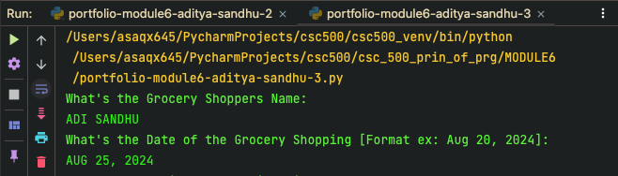

“Screenshot 3”, “The ItemToProcure Function and its Cart Creation Logic”

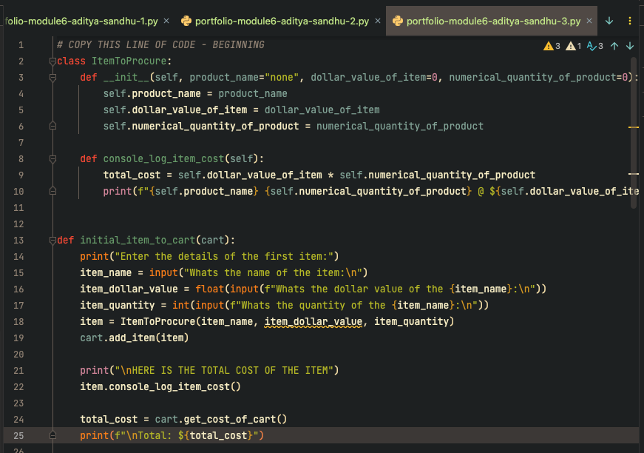

“Screenshot 4”, “Output on the Concole of the Class ItemToProcure”

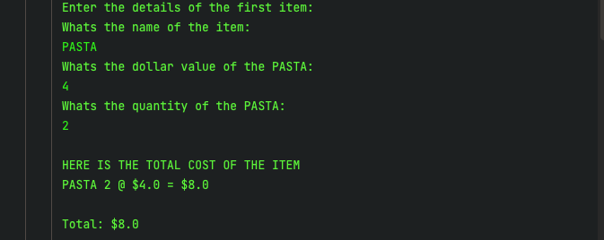

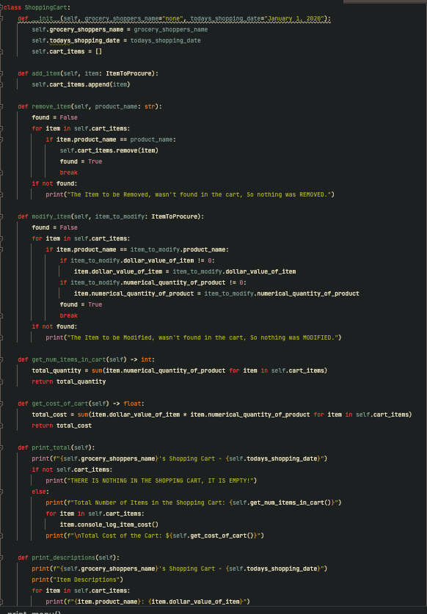

“Screenshot 5”, “The Class ShoppingCart, that is subsequently passed to print_menu function”

GITHUB LINK - <https://github.com/65AR645ASAN/csc_500_prin_of_prg/blob/main/MODULE5/critical-thinking-assignment-module5-aditya-sandhu.docx>

**APA citations**

1. GeeksforGeeks. (n.d.). *Python if...else*. GeeksforGeeks. Retrieved August 16, 2024, from [https://www.geeksforgeeks.org/python-if-else/](https://www.geeksforgeeks.org/python-if-else/)

2. Corey Schafer. (2018, January 19). *Python Tutorial: If __name__ == '__main__'*. [Video]. YouTube. [https://www.youtube.com/watch?v=lQzurQm_YKU](https://www.youtube.com/watch?v=lQzurQm_YKU)

3. DataCamp. (n.d.). *How to use elif statements in Python*. DataCamp. Retrieved August 16, 2024, from [https://www.datacamp.com/tutorial/elif-statements-python](https://www.datacamp.com/tutorial/elif-statements-python)

4. w3resource. (n.d.). *Python if...else statements*. w3resource. Retrieved August 16, 2024, from [https://www.w3resource.com/python/python-if-else-statements.php#if-statement](https://www.w3resource.com/python/python-if-else-statements.php#if-statement)