###############################################################

Student: Aditya Singh Sandhu

Course: CSC 500 – Principles of Programming

Module: 6 – Portfolio Assignment

###############################################################

Python3 Code ~

# COPY THIS LINE OF CODE - BEGINNING

def main():

room_numbers = {

'CSC101': '3004',

'CSC102': '4501',

'CSC103': '6755',

'NET110': '1244',

'COM241': '1411'

}

instructors = {

'CSC101': 'Haynes',

'CSC102': 'Alvarado',

'CSC103': 'Rich',

'NET110': 'Burke',

'COM241': 'Lee'

}

meeting_times = {

'CSC101': '8:00 a.m.',

'CSC102': '9:00 a.m.',

'CSC103': '10:00 a.m.',

'NET110': '11:00 a.m.',

'COM241': '1:00 p.m.'

}

course_number = input("Enter a course number (e.g., CSC101): ")

if course_number in room_numbers:

print(f"Course Number: {course_number}")

print(f"Room Number: {room_numbers[course_number]}")

print(f"Instructor: {instructors[course_number]}")

print(f"Meeting Time: {meeting_times[course_number]}")

else:

print("Sorry, the course number entered does not exist.")

if __name__ == "__main__":

main()

# COPY THIS LINE OF CODE – ENDING

"Screenshot 1" "Main Function and within it, in subject_number built-in input call and dictionary variables university_instruction_rooms professors and, instruction_time_slots.”

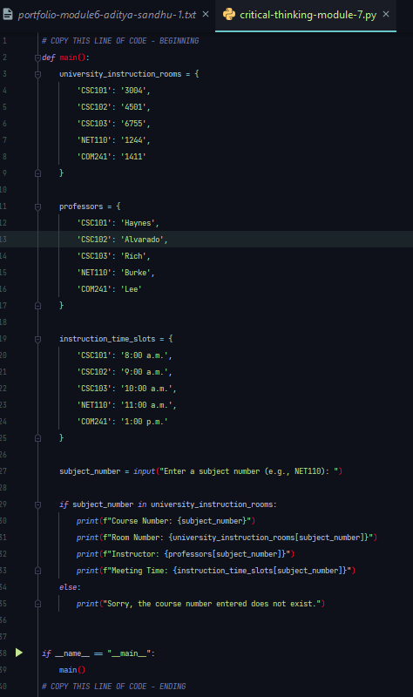

"Screenshot 2" "output of main function via the if ­­­­__name__ == “__main__“: function call of main() with Incorrect Input CSC241”

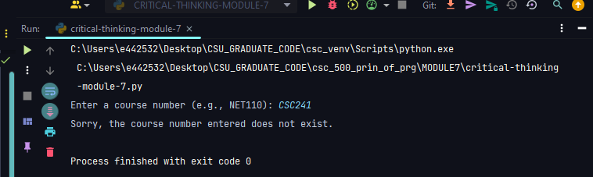

"Screenshot 3" "output of main function via the if ­­­­__name__ == “__main__“: function call of main() with correct Entry COM241”

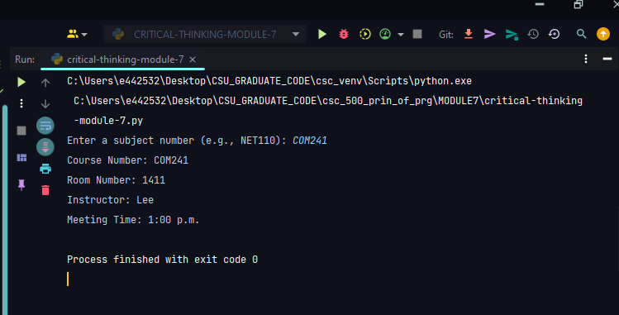

Git hub link: