Name : Shukla Khush Dipeshbhai

Enroll no. : 2402030430106

Step 1 : create github account

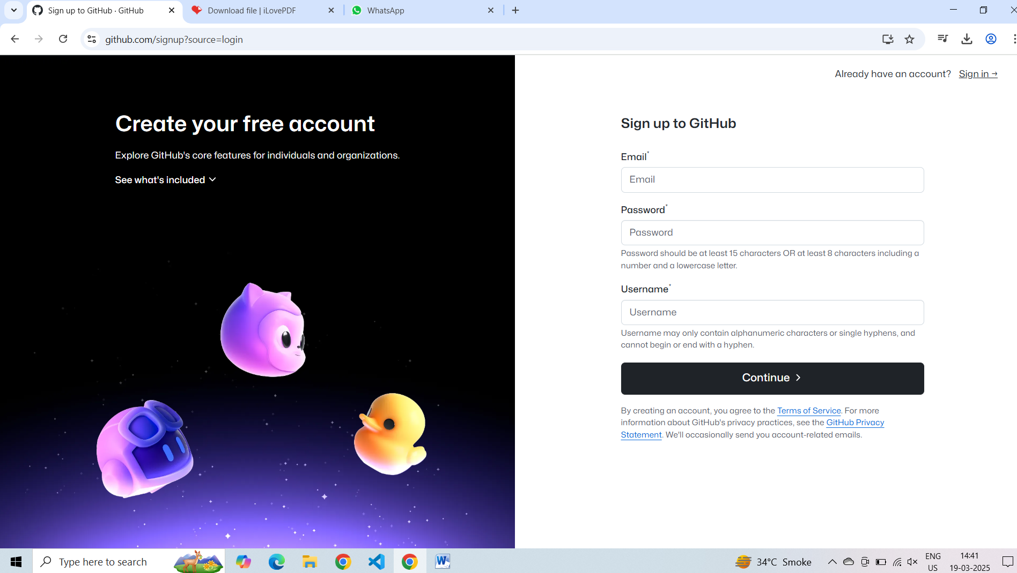

Step 2 : Click on repository

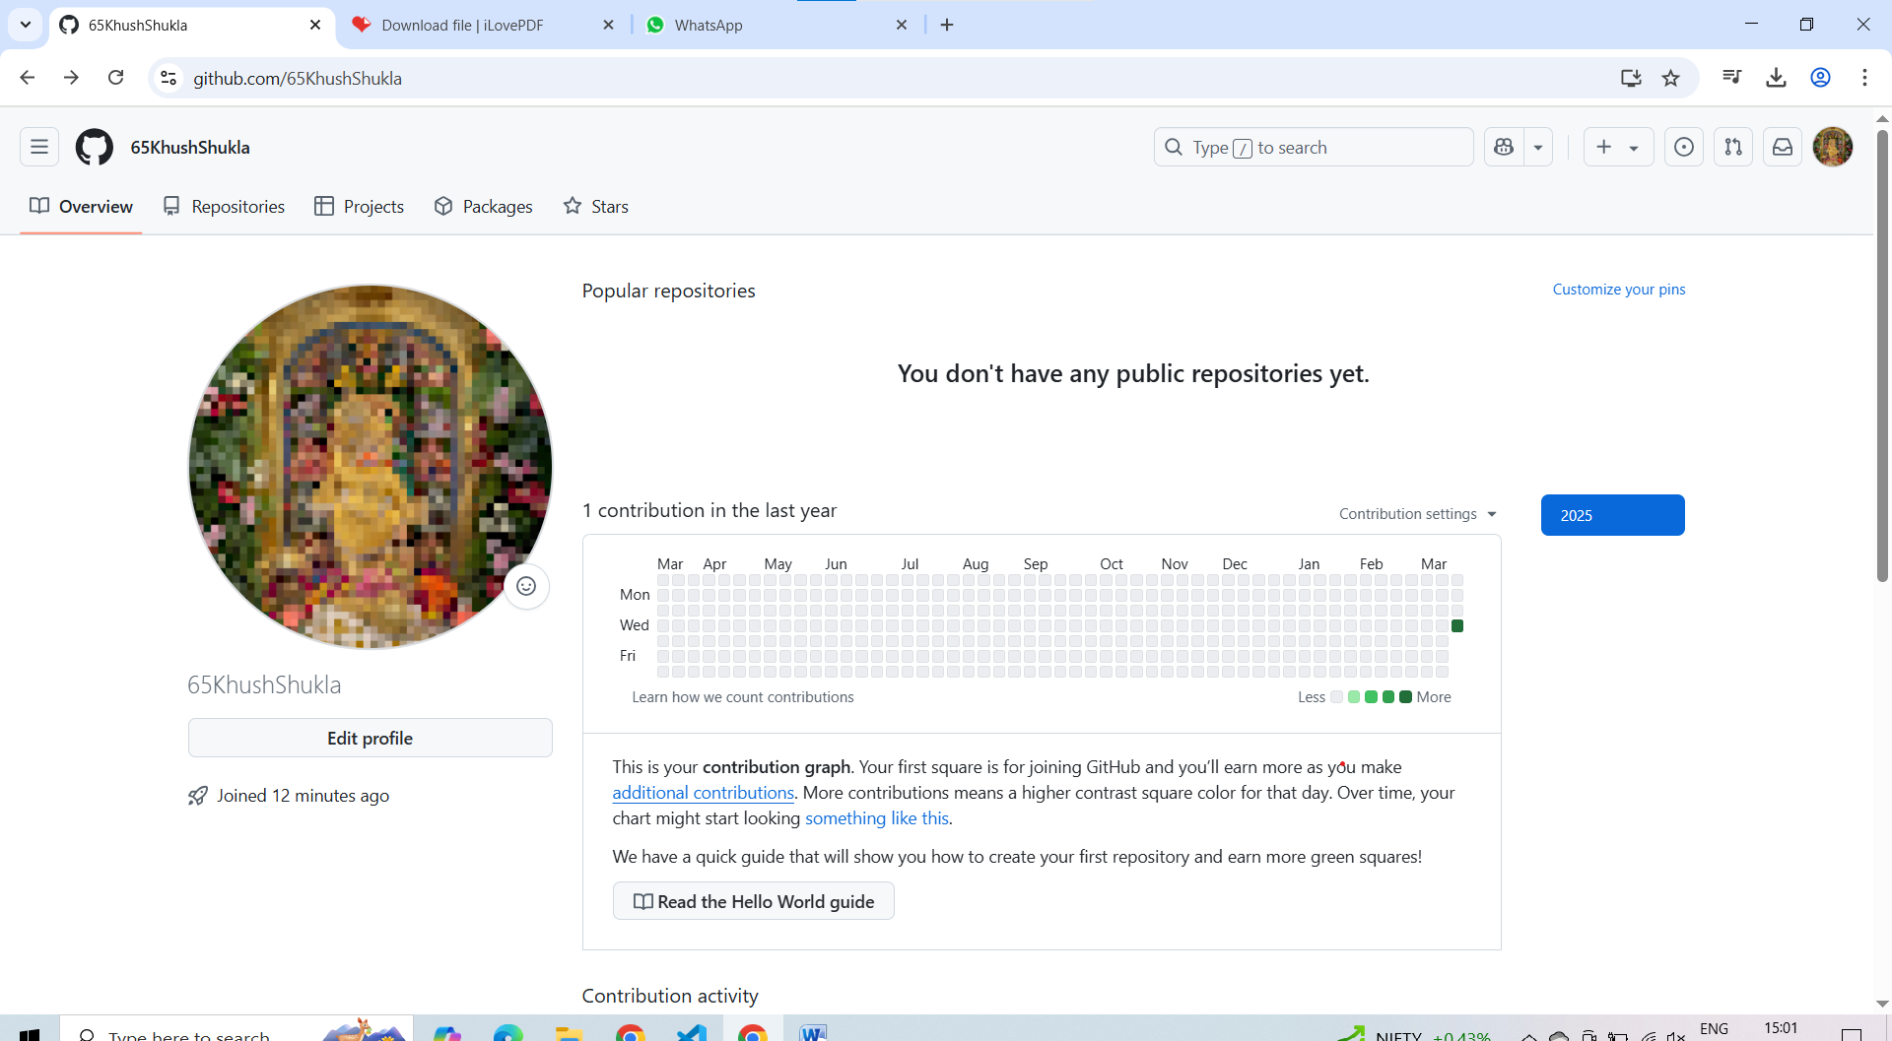

Step 3 : click on new repository

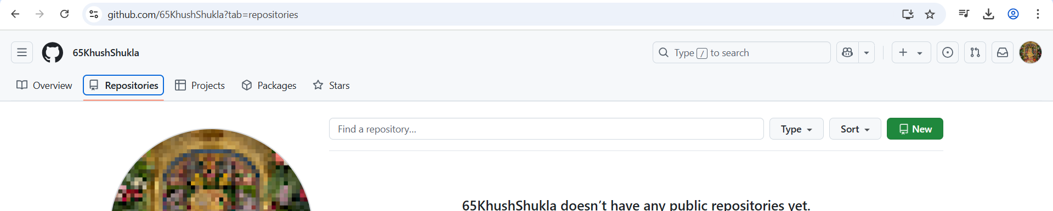

step 4 : create the new repository on github

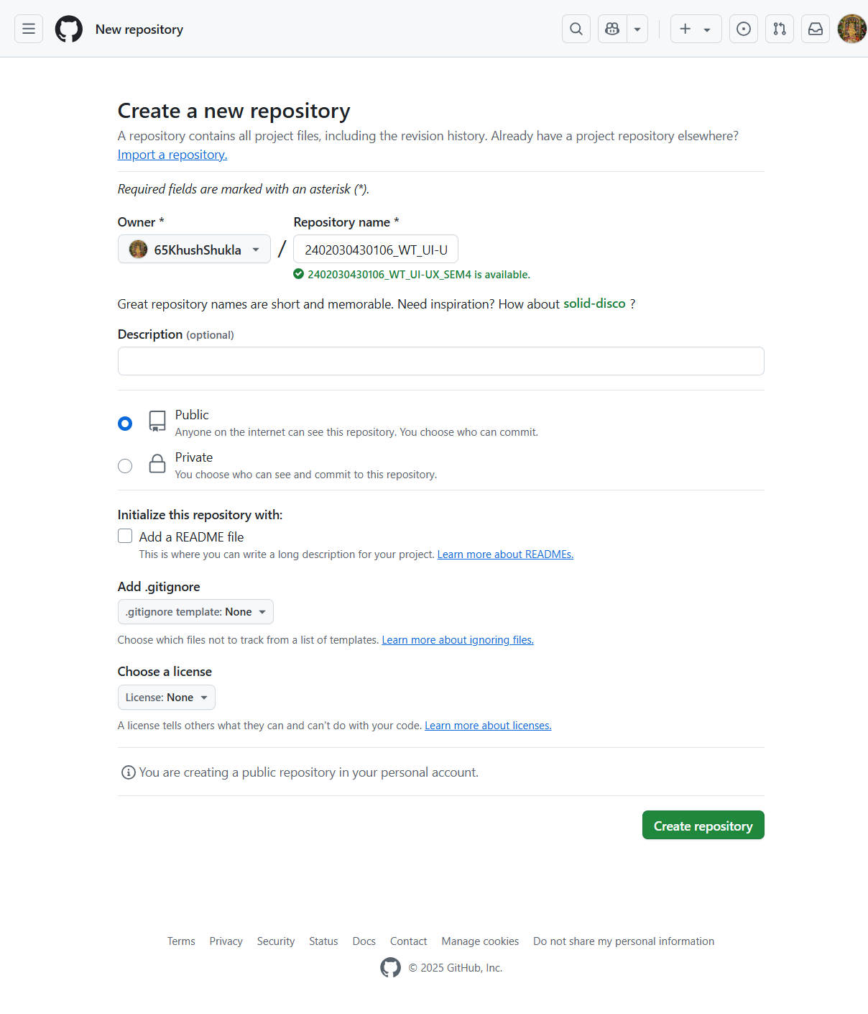

step 5 : copy the code and paste in to terminal or shell

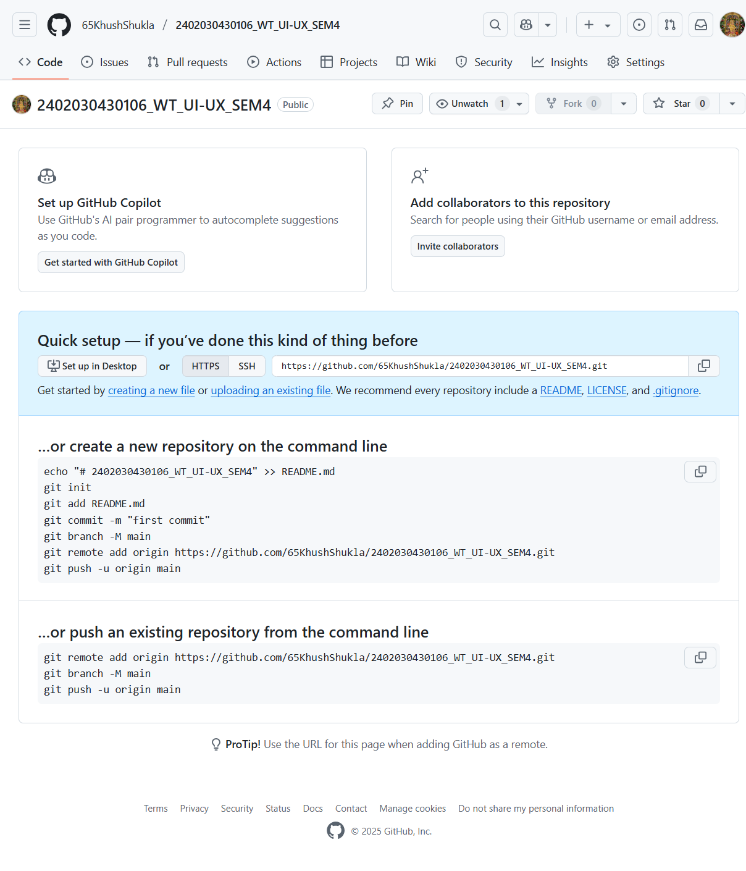

step 6 : paste the code in to vs code terminal

