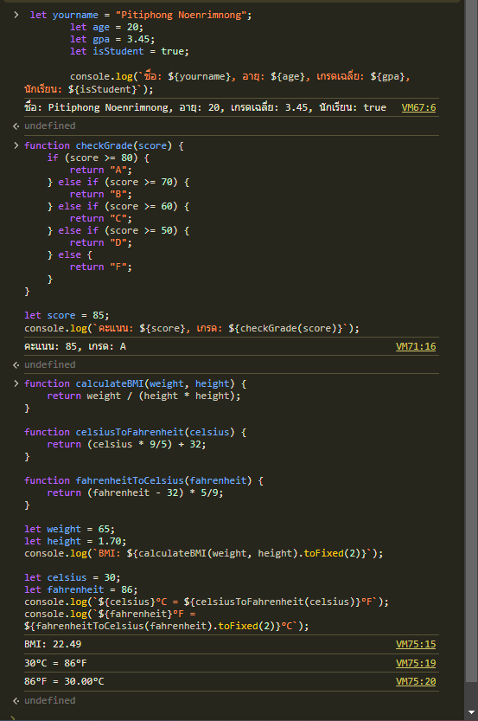[https://github.com/66160137-Pitiphong/lab6-66160137.git](https://github.com/66160137-Pitiphong/lab6-66160137.git)

<!DOCTYPE html>

<html lang="en">

<head>

    <meta charset="UTF-8">

    <meta name="viewport" content="width=device-width, initial-scale=1.0">

    <title>Lab 6</title>

</head>

<body>

    <h1>Lab 6</h1>

    <p>กด F12 เพิ่มดูผลลัพธ์</p>

    <script>

        let yourname = "Pitiphong Noenrimnong";

        let age = 20;

        let gpa = 3.45;

        let isStudent = true;

        console.log(`ชื่อ: ${yourname}, อายุ: ${age}, เกรดเฉลี่ย: ${gpa}, นักเรียน: ${isStudent}`);

        function checkGrade(score) {

    if (score >= 80) {

        return "A";

    } else if (score >= 70) {

        return "B";

    } else if (score >= 60) {

        return "C";

    } else if (score >= 50) {

        return "D";

    } else {

        return "F";

    }

}

let score = 85;

console.log(`คะแนน: ${score}, เกรด: ${checkGrade(score)}`);

function calculateBMI(weight, height) {

    return weight / (height * height);

}

function celsiusToFahrenheit(celsius) {

    return (celsius * 9/5) + 32;

}

function fahrenheitToCelsius(fahrenheit) {

    return (fahrenheit - 32) * 5/9;

}

let weight = 65;

let height = 1.70;

console.log(`BMI: ${calculateBMI(weight, height).toFixed(2)}`);

let celsius = 30;

let fahrenheit = 86;

console.log(`${celsius}°C = ${celsiusToFahrenheit(celsius)}°F`);

console.log(`${fahrenheit}°F = ${fahrenheitToCelsius(fahrenheit).toFixed(2)}°C`);

    </script>

</body>

</html>

