Graduation Registration and Attendance Management Using Browser-Based Face Recognition
Thitirat Chuaypetch  Mae Fah Luang University  Thailand  Student ID: 6631501031  Email: ____________________ | Nattanicha Bunchuen  Mae Fah Luang University  Thailand  Student ID: 6631501033  Email: ____________________ | Kwankamolsri Jandee  Mae Fah Luang University  Thailand  Student ID: 6631501015  Email: ____________________
Teerasak Jeefu  Mae Fah Luang University  Thailand  Student ID: 6631501057  Email: ____________________ | Nataporn Dibdee  Mae Fah Luang University  Thailand  Student ID: 6631501034  Email: ____________________

Project advisor, if required: ____________________

Abstract—This paper presents a web application for graduate registration, ceremony arrangements, face enrollment, and attendance management. Students provide employment questionnaire responses, personal and academic information, participation preferences, certificate delivery details, and food allergy information. Administrators search and edit registration records, inspect summaries, and access rehearsal and ceremony attendance views. The application uses Vue, Node.js, Express, and MongoDB, with MediaPipe for enrollment capture guidance and a face-api.js integration for browser-side identity matching. Source inspection and targeted regression tests were used to assess the current implementation. Twenty-three frontend tests and nine backend tests passed; the automatic check-in frontend suite could not initialize because its face-api.js dependency was unavailable. Inspection also identified incompatible recognition helper exports and different client and server matching thresholds. The results support selected registration and persistence behaviors while identifying integration work required before live automatic attendance can be validated. No biometric accuracy or event-scale performance claim is made.
Keywords—graduation registration, face recognition, attendance management, web application, food allergy reporting

Introduction
Graduation administration involves several related tasks: collecting graduate information, recording participation intentions, arranging certificate delivery, preparing assistance and dietary requirements, and confirming attendance. A system that stores these details together can support staff preparation and reduce repeated entry between registration and event operations. However, combining the workflows also creates dependencies: a graduate should provide the required information before enrolling a reference image, and an attendance action should not overwrite that image.
This project implements a graduation registration and face recognition application for the Mae Fah Luang University context. The available repository contains a Vue application, a Node.js application programming interface (API), MongoDB models, identity integration, import utilities, deployment configuration, and automated tests [1]. The implementation was examined directly because some inherited documentation still describes a generic agreement-management template. This paper distinguishes implemented registration and persistence features from the automatic recognition integration that remains incomplete in this snapshot.
The project has three objectives. First, it provides a guided student workflow for questionnaire completion, graduate information, ceremony preferences, and reference-image enrollment. Second, it provides administrators with searchable records, editable registration details, operational summaries, and an actionable food allergy list. Third, it connects browser-side face matching to persistent attendance receipts for rehearsal and ceremony activities. The contribution is the integration of these functions and their consistency checks, rather than a new face recognition model.

Technical Background and System Scope

Face Detection and Identity Matching
Face detection locates a face in an image; it does not establish whose face is present. MediaPipe provides a web face detector that returns face locations and facial key points [2]. The enrollment module uses its short-range BlazeFace model as part of capture guidance and quality assessment. The administrator scanner uses face-api.js, whose documentation describes face detection, landmarks, and 128-value descriptors for identity comparison [3]. Keeping these purposes separate avoids interpreting a successful enrollment detection as a successful identity match.
The project uses existing model assets and browser inference. No training pipeline or newly trained model is demonstrated in the examined source. Matching thresholds and repeated observations are application decisions. Their presence can reject certain invalid or ambiguous inputs, but does not by itself demonstrate a calibrated false-acceptance rate or real-world recognition accuracy.

Actors and Functional Boundaries
Students enter through the login page and work on their own graduation information. Administrators use the registration roster, check-in dashboard, and camera scanner. The student navigation is intentionally different from the administrator navigation. A stored session does not automatically redirect a visit to the login page, and a legacy student dashboard URL redirects to the student registration workflow. Student records display a full name, while the existing administrator name presentation is retained.
The operational scope includes contact and academic information, name pronunciation, addresses, employment questionnaire responses, ceremony status, assistance details, certificate delivery, food allergy notes, face enrollment, and attendance. The repository also includes account, permission, audit, notification, backup, and business-operation components inherited from its platform. Those components support the surrounding application infrastructure; this paper does not claim that every platform screen is part of the tested graduation workflow.
- TABLE I. PRINCIPAL APPLICATION MODULES
Actor / module | Implemented responsibility
Student questionnaire | Employment status and additional questionnaire notes
Student registration | Names, pronunciation, contact, school, program, and addresses
Ceremony preferences | Participation, assistance, certificate delivery, and allergies
Face enrollment | Guided capture and persistence of a reference photograph
Admin registration | Search, filters, editing, statistics, and allergy roster
Attendance operations | Continuous matching and separate rehearsal / ceremony receipts

System Design

Architecture
The frontend uses Vue 2, Vue Router, Vuex, CoreUI components, and an API service layer. The backend uses Node.js and Express routes with Mongoose models. MongoDB stores registration records and attendance fields. Local development serves the frontend on port 8080 and the backend on port 8206. Docker and server deployment scripts are included, but their presence is not evidence of a completed production deployment. Table I summarizes the user-facing modules. Fig. 1 shows the main logical paths.
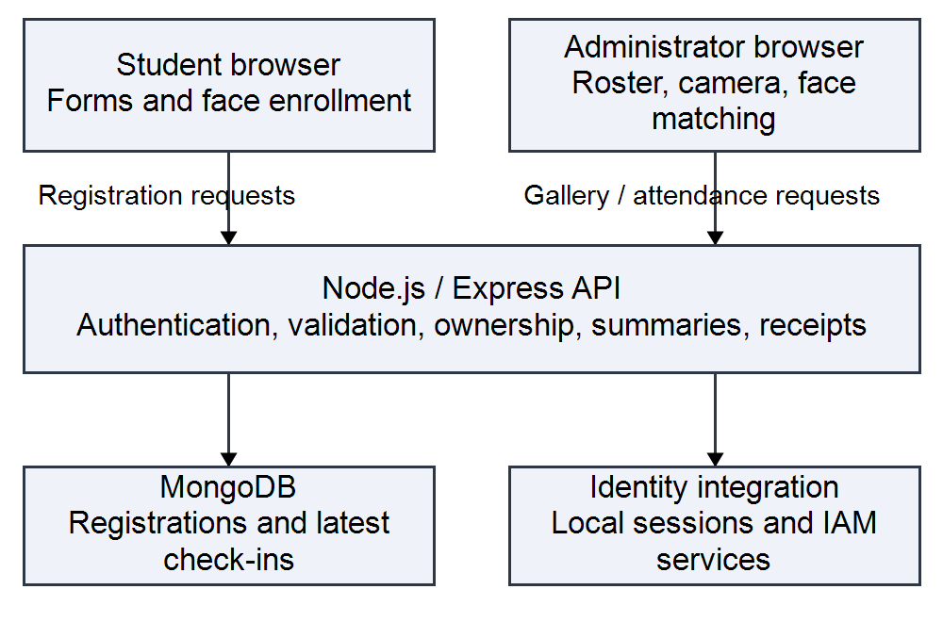
- Fig. 1. Logical application architecture. Face matching executes in the administrator browser; the backend validates requests and stores receipts.
The student browser sends questionnaire, registration, preference, and enrollment changes through the API. The administrator browser obtains the roster and aggregate summaries from the backend. The intended recognition path retrieves reference images, computes descriptors locally, and submits a registration identifier, activity mode, and distance to the check-in endpoint. The backend validates the request and returns a persisted receipt. The browser recognition integration has unresolved interface dependencies, as detailed in the implementation and verification sections.

Registration Data Model
The Graduate_Registration document stores student and barcode identifiers, names, pronunciation fields, phone and email, school and program labels, and home, current, and work addresses. It also stores ceremony status, assistance type and notes, certificate-delivery method and destination, allergy flags and notes, questionnaire responses, reference-photo metadata, and audit information. Separate latestCheckIns.rehearsal and latestCheckIns.ceremony fields retain the latest attendance receipt for each activity.
The reference photograph and attendance receipts serve different purposes. Enrollment establishes the image used for later comparison; check-in records the time and source of an accepted attendance event. The check-in mutation updates the selected activity field and audit information, without replacing the enrollment photograph or the other activity receipt. This separation prevents passing camera frames from progressively changing the reference image. The examined schema stores latest receipts, not a complete immutable history of all attendance events.

Workflow and Navigation
The student sequence is questionnaire, registration information, ceremony preferences, and conditional face enrollment. Client-side workflow progress is stored per profile identity and is used for completion indicators and route checks. Attempts to reach later steps without the required earlier state redirect to the appropriate form. Face enrollment is enabled when the questionnaire, registration, and preferences are complete and the ceremony status belongs to an attendance category: 10, 20, 30, or 40. Non-attending arrangements can end after the preference step.
Statuses 50 and 60 require a certificate-receipt method. Postal delivery introduces a shipping service and destination address, while assistance-related choices expose their corresponding details. Allergy information is independent of the particular food entered. Client-side progress makes navigation understandable, but local browser state is not a substitute for server-side ownership and authorization checks.

Access and Identity Boundaries
The backend applies authentication middleware and permission or local-session rules to graduation routes. Student update routes include ownership checks, and some operations bind the submitted identity to the authenticated student code. Administrative gallery and check-in routes use administrative or delegated-permission checks. The source also contains domain-based administrative shortcuts. These are implementation details requiring review before deployment; a displayed name or an email domain alone should not be treated as proof of an appropriate production authorization policy.

Implementation

Registration, Search, and Administrative Editing
The registration page presents names, pronunciation, contact details, academic information, and addresses alongside the saved face image. The administrative roster supports text search and school, program, and ceremony-status filters. Search actions start at page one, and the roster displays ten records per page. The frontend binds CoreUI select controls through their update:value contract so that the submitted filter matches the visible selection. Legacy ceremony values are normalized in the backend when selected statuses have historical equivalents.
A shared ceremony editor loads the selected graduate and updates supported administrative fields. The update flow preserves unrelated questionnaire, address, face, and attendance data. The student page retrieves saved registration values so that administrative corrections are not silently replaced by older account defaults. Aggregate cards are computed from the full registration dataset and remain independent of the currently displayed table page and filters. This distinction is necessary when a short visible list represents thousands of stored records.

Food Allergy Summary and Drill-Down
The allergy card counts each registration once when hasFoodAllergy is yes or when a trimmed allergy note is nonempty and is not the placeholder hyphen. It does not require a predefined food vocabulary. A note such as several foods still contributes one person, rather than several allergy events. This rule matches the requested operational question: how many graduates have reported an allergy? It does not interpret severity or verify medical accuracy.
Selecting the card opens a dialog listing student identifier, full name, and the submitted allergy detail. The server applies the same flag-or-note rule to the filtered roster. Both the dialog and its API request use a page size of ten, with previous and next controls for larger lists. Loading, empty-result, and error states are handled separately. The implementation uses text interpolation for notes. The summary and drill-down are intended for preparation by authorized staff and are not a medical decision system.

Reference Image Enrollment
The enrollment helper checks face count, confidence, relative face size, centering, head orientation, and brightness. Its configured minimum score is 0.6, acceptable face coverage is 0.26 to 0.80, and brightness limits are 42 to 242. Additional limits constrain horizontal and vertical offset, roll, and yaw. The interface provides capture guidance when a face is absent, multiple faces appear, or positioning and lighting are unsuitable. These are code-level settings rather than empirically optimized thresholds.
MediaPipe assets are loaded from local paths with fallback locations available in the helper. The saved record includes the photograph and associated capture information. Although geometric and lighting checks improve input consistency, this implementation should not be described as a validated liveness detector. The examined evidence does not establish protection against printed photographs or replayed video.

Continuous Recognition and Attendance
The automatic scanner component is designed to load recognition models, retrieve reference photographs in batches of twenty-five, prepare a descriptor gallery, and process camera frames continuously. It imports loadRecognition, describeFaces, referenceDescriptor, matchFace, and createConfirmationTracker. However, the current recognition helper exports loadFaceRecognitionModels, buildFaceRosterDescriptors, matchFaceDataUrl, and MATCH_THRESHOLD instead. This interface mismatch prevents the intended automatic pipeline from being treated as an operationally verified feature.
The available helper extracts a face descriptor using TinyFaceDetector and face landmarks, then selects the gallery entry with the smallest Euclidean distance. Its default matching threshold is 0.55. The backend check-in service accepts finite distances only in the range 0 to 0.50, so a client match above 0.50 can be rejected during persistence. The helper does not implement the ambiguity margin or confirmation tracker expected by the scanner tests. Threshold alignment and a shared recognition interface are required before end-to-end evaluation. For descriptors q and g with 128 components, the distance is defined in (1).
d(q, g) = sqrt(sum from i = 1 to 128 of (q_i - g_i)^2) (1)
The scanner source anticipates a confirmation tracker, excludes identities that occur more than once among the matches in a frame, and schedules the next processing cycle after 250 milliseconds. The expected tracker is absent from the current helper, so repeated-observation confirmation cannot be verified in this snapshot. The scheduling delay is not a measured frame rate; model inference and request latency would also contribute to cycle time.
The browser suppresses repeated submissions per identity and activity during the active scanner session. The backend independently validates the identifier, activity mode, and finite distance within the accepted range, and applies an atomic sixty-second duplicate window for that activity. A duplicate request returns the prior receipt. Failed writes do not create a successful local receipt and can be retried. Leaving the scanner stops media tracks and invalidates pending recognition work.

Verification and Findings

Method
Verification examined the current local main working tree on September 26, 2026. Three frontend suites were invoked with Jest: automatic check-in, ceremony administration, and permission landing. Two backend suites were run with the Node.js test runner: automatic check-in and ceremony administration [4]. Twenty-three frontend tests and nine backend tests passed. The frontend automatic check-in suite failed during initialization because face-api.js could not be resolved. Table II distinguishes executed passing tests from the blocked suite. These checks do not constitute a complete application or deployment audit.
- TABLE II. TARGETED VERIFICATION RESULTS
Suite | Observed result
Frontend: automatic check-in | Initialization failed
Frontend: ceremony administration | 14 / 14
Frontend: permission landing | 9 / 9
Backend: automatic check-in | 4 / 4
Backend: ceremony administration | 5 / 5
Verification total | 32 passed; 1 suite blocked

The passing frontend tests covered administrative editing, preservation of unrelated registration fields, backend-derived totals, the allergy-card interaction, status selection, and permission-based navigation. The passing backend tests covered check-in input validation, atomic attendance writes, duplicate receipts, stable attendance pagination, and administrative registration updates. The automatic scanner test source contains additional matching and camera scenarios, but none of those assertions ran in this verification because the suite failed to initialize.

Summary Semantics and Data Evaluation
Source inspection found that both the allergy roster filter and aggregate summary include records with an affirmative allergy flag or a meaningful allergy note. The summary counts registrations rather than individual foods. The administrative interface requests paginated results independently of the aggregate totals. No live database query was performed for this manuscript revision, so no current population size, allergy count, or attendance total is reported.
The response summary classifies a record as responded when its ceremony status is nonempty and is not 80. This is a stored-data rule, rather than proof that a graduate personally completed every current web form. Imported or administratively updated statuses can affect the displayed percentage. Operational evaluation should compare aggregate values with independently prepared fixtures and record the dataset version used.

Limits of the Evidence
Thirty-two targeted tests passed, while one frontend suite failed to initialize. The results support the tested registration, navigation, and backend persistence behaviors only. They do not establish that browser recognition works end to end. No labeled face-image dataset, user study, or live-event benchmark was supplied; false acceptance, false rejection, latency, throughput, and demographic performance therefore remain unmeasured.
Several operational limitations remain. Gallery preparation computes descriptors from downloaded reference images and may grow costly as enrollment increases. Browser-generated recognition results are trusted by the backend after request and range validation; the backend does not independently recompute the descriptor match. A review-required dashboard counter exists, but the examined check-in write path does not set its reviewRequired flag. Consequently, a zero review count cannot establish that all recognitions were independently verified.

Discussion and Future Work
The project brings preparation data and attendance administration into one application. Its allergy roster links a summary with a staff-readable list, and separate receipt fields distinguish rehearsal from ceremony. The present verification also shows why source-level integration matters: passing persistence tests do not compensate for an unavailable recognition dependency or incompatible frontend interfaces. The immediate priority is to restore a consistent scanner/helper contract, provide the required dependency, align acceptance thresholds, and rerun the scanner tests before conducting live trials.
Before operational deployment, evaluation should use a consented, labeled dataset with separate enrollment and test captures. Trials should include unregistered people, similar appearances, multiple camera and lighting conditions, occlusion, and presentation attacks. False-acceptance and false-rejection rates, enrollment failure rate, latency distributions, and sustained throughput should be reported separately. Threshold selection should be performed on development data and then evaluated on held-out captures.
Further engineering work should review authorization shortcuts and the student authentication mechanism, define photo and attendance retention, limit access to health-related notes, and provide staff review and correction procedures. Improving gallery initialization, maintaining an append-only attendance history where required, and synchronizing workflow completion from server records are additional priorities. These are future tasks, not capabilities verified by the current test results.

Conclusion
This project provides a graduation registration and attendance application covering student information, questionnaires, ceremony arrangements, food allergy reporting, reference-image enrollment, and administrative records. The data model separates enrollment photographs from rehearsal and ceremony receipts. Thirty-two targeted tests passed, supporting selected workflow and persistence behaviors. Automatic browser recognition remains integration-incomplete in the reviewed snapshot because of an unavailable dependency and incompatible helper interfaces. The project provides a basis for further development, but live recognition, biometric performance, presentation-attack resistance, and event-scale operation require additional implementation and evaluation.

References
[1] Graduation Registration and Face Recognition Project, "Application source snapshot," unpublished software, frontend-vue and backend-node directories, inspected Sep. 26, 2026.
[2] Google, "Face detection guide for Web," Google AI Edge. [Online]. Available: https://developers.google.com/edge/mediapipe/solutions/vision/face_detector/web_js. Accessed: Sep. 26, 2026.
[3] V. Muehlemann, "face-api.js: JavaScript API for face detection and face recognition," project documentation. [Online]. Available: https://github.com/justadudewhohacks/face-api.js. Accessed: Sep. 26, 2026.
[4] Graduation Registration and Face Recognition Project, "Targeted regression verification," unpublished local test run, Sep. 26, 2026: ceremony-admin and permission-landing frontend suites, 23 passing tests; graduate-auto-checkin and graduate-ceremony-admin backend suites, 9 passing tests; frontend automatic-checkin suite blocked at initialization.

