AI-Augmented Backend Development Project : AI FAQ ASSISTANT

TITLE :

Project Description

In a Single Paragraph
AI FAQ Assistant is an AI-Augmented backend Web Application developed using the (MongoDB, Express.js,Node.js) integrated with Artificial Intelligence capabilities such as Large Language Models (LLMs), Semantic Search, Vector Search, and Intelligent Recommendations. The system enables users to interact with data through natural language, receive AI-generated insights, perform semantic searches, upload and analyze documents, and automate decision-making processes. By combining traditional backend development with modern AI technologies, the platform delivers an intelligent, scalable, and user-friendly experience that improves productivity, accessibility, and operational efficiency.

Scenario

Many organizations, colleges, and institutions receive a large number of frequently asked questions from students, employees, customers, or users regarding services, procedures, rules, timings, documents, and other information. In a traditional system, users have to search through documents, websites, FAQs, or contact staff members to find answers. This manual process can be time-consuming, repetitive, and sometimes leads to delayed or inconsistent responses. The organization also has to spend significant time answering the same questions repeatedly.

The need for Artificial Intelligence arises because traditional keyword-based FAQ systems may not understand the actual meaning or context of a user's question. An AI-based system can understand natural language and provide more relevant answers. AI FAQ Assistant uses an AI chatbot and Question Answering capabilities to understand user queries and generate appropriate responses. It can use semantic search and vector search to identify information based on the meaning of the question rather than only matching exact keywords.

The proposed AI FAQ Assistant acts as an intelligent support system that allows users to ask questions in natural language and receive quick, context-aware answers. The system can analyze stored FAQ documents and organizational information using AI-powered document analysis, retrieve relevant content through vector-based search, and generate understandable responses using AI. This reduces repetitive manual work, improves accessibility of information, and provides users with a faster and more intelligent way to obtain answers.

System Requirements :
To ensure smooth development, deployment, and usage of the < Project Name > AI-Augmented Backend Application, certain system prerequisites must be met.

1. Software Requirements

Operating System
- Windows 10/11
- macOS
- Linux

Node.js (v18 or above)
Provides a runtime environment for frontend and backend development.

npm (v9 or above)
Package manager used for dependency installation.

Express.js
Backend framework used for API development.

MongoDB Community Server / MongoDB Atlas
NoSQL database used to store:
- User Information
- Chat History
- Documents
- Embeddings
- AI Interactions
- Application Data

MongoDB Atlas Search
Provides full-text search functionality.

MongoDB Atlas Vector Search
Enables semantic search using vector embeddings.

AI Service Provider
- OpenAI API
- Gemini API
- Claude API
- Azure OpenAI (Optional) …etc

LangChain / AI SDK
Used for orchestration of AI workflows.

Browser
- Google Chrome
- Mozilla Firefox

Postman
API Testing

Visual Studio Code
Development Environment

Git & GitHub
Version Control

2. Hardware Requirements

Processor
Intel Core i5 (8th Gen+) / AMD Ryzen 5+

RAM
Minimum 8 GB
Recommended 16 GB

Storage
Minimum 5 GB Free Space

Internet Connection
Required for AI API communication

Display
1366 × 768 or above

Project Architecture

Technical Architecture :

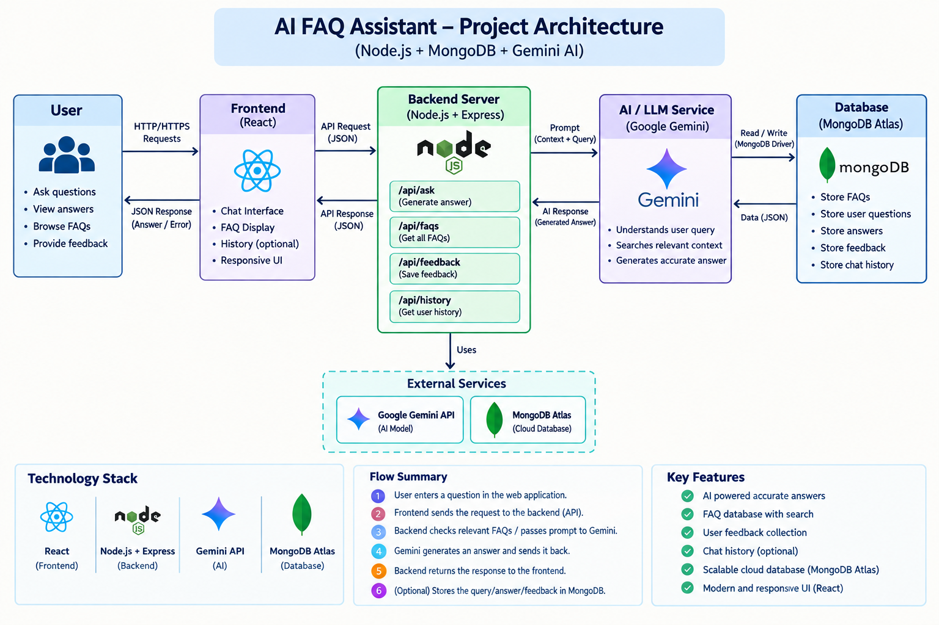Backend Layer
- Node.js
- Express.js
- JWT Authentication
- REST APIs

Database Layer
- MongoDB
- Atlas Search
- Atlas Vector Search

AI Layer
- LLM APIs
- Embedding Models
- RAG Pipeline
- Prompt Engineering

Storage Layer
- MongoDB Collections
- File Upload Storage

Security Layer
- JWT Authentication
- Protected Routes
- Input Validation
- Role-Based Access Control

ER Diagram

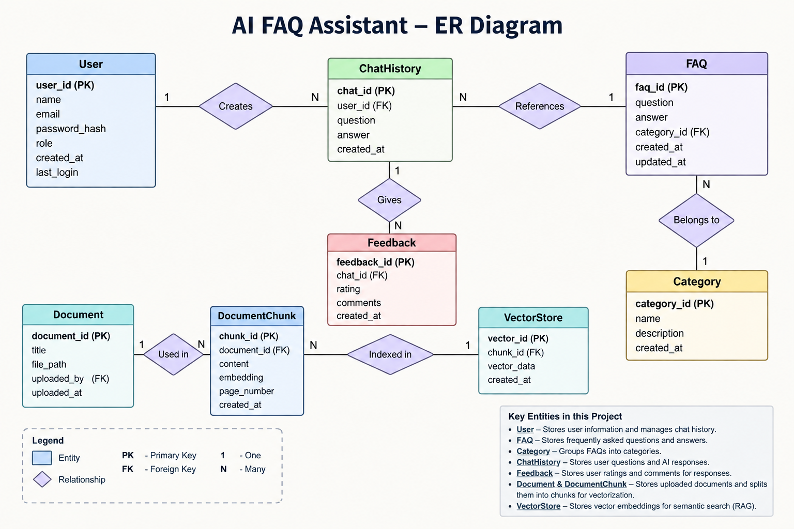Collections

Users
- _id
- name
- email
- password
- role

Documents
- _id
- title
- content
- uploadedBy
- createdAt

Embeddings
- _id
- documentId
- vectorData

Chats
- _id
- userId
- prompt
- response
- timestamp

ActivityLogs
- _id
- userId
- activity
- createdAt

ER Diagram Explanation
Users can upload documents and interact with AI features. Uploaded documents are processed into vector embeddings and stored in MongoDB. Chat interactions and AI responses are logged for future reference and analytics. Activity logs maintain user actions across the system.

Features

Core Backend Features
- User Registration
- User Login
- JWT Authentication
- Protected Routes
- Middleware
- CRUD API
- File Upload
- Role-Based Access Control

AI Features
- AI Chat Assistant
- Semantic Search
- Vector Search
- Document Question Answering
- Text Summarization
- Content Generator
- RAG (Retrieval Augmented Generation)
- Intelligent Insights
- Natural Language Queries

Roles and Responsibilities

Admin
- Manage Users
- Manage Documents
- Monitor AI Usage
- View Analytics
- Configure System

User
- Register/Login
- Upload Documents
- Ask Questions
- Search Content
- View AI Recommendations
- Manage Personal Data

User Flow
- User Registration
- User Login
- JWT Authentication
- Dashboard Access
- Upload Documents
- Generate Embeddings
- Store Vectors in MongoDB
- User Query Submission
- Semantic Search Execution
- AI Response Generation
- Display Results
- Store Chat History

MVC Pattern
The backend follows the MVC (Model-View-Controller) architecture.

Model Layer
Responsible for:
- User Schema
- Chat Schema
- Document Schema
- Embedding Schema
- Activity Schema
Implemented using Mongoose.

Controller Layer
Responsible for:
- Authentication Logic
- AI API Integration
- Document Processing
- Embedding Generation
- Search Operations
- CRUD Operations

View Layer (Routes)
Defines REST API endpoints:

Authentication Routes
- Register
- Login
- Logout

AI Routes
- Chat
- Summarization
- Semantic Search

Document Routes
- Upload
- View
- Delete

User Routes
- Profile
- Dashboard

Advantages of MVC
- Separation of Concerns
- Better Maintainability
- Easy Scalability
- Reusable Components
- Team Collaboration
- Easier Testing

Project Setup and Configuration

Project Structure
Create Project Folder
Inside Project Folder:

Server Folder
Backend Application

Server Setup
mkdir server

cd server

npm init -y
Create:
server.js

models/
controllers/
routes/
middlewares/
config/
services/
utils/


Install Backend Packages
npm install express mongoose cors dotenv bcryptjs jsonwebtoken

npm install openai

npm install multer

npm install nodemon --save-dev


Backend Development
Include:
- Authentication APIs
- JWT Implementation
- AI Service Integration
- Vector Search APIs
- CRUD APIs
- Document Upload APIs
- Chat APIs
Note:
Proper explanation must be provided for every AI API consumed, including:
- Purpose
- Request Structure
- Response Structure
- Cost Considerations
- Security Practices

Database Development
Include:
- MongoDB Collections
- Relationships
- Atlas Search Index
- Vector Search Index
- Sample Documents
Provide screenshots and explanation.

Project Execution

Step 1: Backend
cd server

npm install


Step 2: Configure Environment Variables
Create .env
PORT=8000

MONGO_URI=mongodb://localhost:27017/ai_augmented_db

JWT_SECRET=your_secret_key

OPENAI_API_KEY=your_api_key


Step 3: Run Backend
nodemon server.js
Backend URL:
http://localhost:8000


Output Screenshots with Explanation
- API Testing
- LLM Integration
- AI Chat Interface
- Document Upload
- Search Results
- Recommendation Engine

Demo Video Link
https://drive.google.com/drive/folders/10avF_pNJy5FGKpAOq5AaBm2EDALZsl8P?usp=sharing

Source Code Drive Link
https://drive.google.com/drive/folders/1s1G1OEQire92p5ljZnmrBSs3VF_vSyzd?usp=sharing

Mandatory Functionalities
- MVC Architecture
- JWT Authentication
- Semantic Search
- MongoDB Atlas Search
- MongoDB Atlas Vector Search
- Prompt Engineering
- AI API Integration
- Role-Based Access Control

