云计算技术与应用赛题库解读

2019年5月

目录
一.OpenStack超融合部署 3
（一）构建Ceph的分布式存储系统 3
任务描述 3
任务实施 3
（二）构建超融合基础架构 24
任务描述 24
任务实施 24
二.自定义Rancher应用商店 41
（一）rancher应用商店增加Nginx服务 41
任务描述 41
任务实施 41
三.自定义Ambari服务 50
（一）Ambari服务增加自定义服务 50
任务描述 50
任务实施 50
四.小程序后台服务开发 56
（一）微信小程序后台接口开发 56
任务实施 56

一.OpenStack超融合部署

（一）构建Ceph的分布式存储系统

任务描述
1. 了解Ceph文件系统的构架和使用环境。
2. 使用3台服务器搭建1个Ceph文件系统。
3. 实现基于Ceph文件系统的集群存储。

任务实施

1.基础环境配置
创建3个CentOS 7系统虚拟机，并修改hostname叫ceph-node1、ceph-node2和ceph-node3。
[root@ceph-node1 ~]# hostnamectl set-hostname ceph-node1
[root@ceph-node1 ~]# hostnamectl
Static hostname: ceph-node1
Icon name: computer-vm
Chassis: vm
Machine ID: dae72fe0cc064eb0b7797f25bfaf69df
Boot ID: b5805a7f0cce470bac5aeacf294edfc0
Virtualization: kvm
Operating System: CentOS Linux 7 (Core)
CPE OS Name: cpe:/o:centos:centos:7
Kernel: Linux 3.10.0-229.el7.x86_64
Architecture: x86_64

[root@ceph-node2 ~]# hostnamectl set-hostname ceph-node2
[root@ceph-node2 ~]# hostnamectl
Static hostname: ceph-node2
Icon name: computer-vm
Chassis: vm
Machine ID: dae72fe0cc064eb0b7797f25bfaf69df
Boot ID: 1e86c3bde22440209176cb6fbb062fe2
Virtualization: kvm
Operating System: CentOS Linux 7 (Core)
CPE OS Name: cpe:/o:centos:centos:7
Kernel: Linux 3.10.0-229.el7.x86_64
Architecture: x86_64

[root@ceph-node3 ~]# hostnamectl set-hostname ceph-node3
[root@ceph-node3 ~]# hostnamectl
Static hostname: ceph-node3
Icon name: computer-vm
Chassis: vm
Machine ID: dae72fe0cc064eb0b7797f25bfaf69df
Boot ID: 44966891972e48f19d60049ed7c68e27
Virtualization: kvm
Operating System: CentOS Linux 7 (Core)
CPE OS Name: cpe:/o:centos:centos:7
Kernel: Linux 3.10.0-229.el7.x86_64
Architecture: x86_64
这三台虚拟机各需要有50G的空闲硬盘。可以使用lsblk命令进行验证。
[root@ceph-node1 ~]# lsblk
NAME MAJ:MIN RM SIZE RO TYPE MOUNTPOINT
vda 253:0 0 40G 0 disk
└─vda1 253:1 0 40G 0 part /
vdb 253:16 0 50G 0 disk
配置3台虚拟机的IP分别为192.168.1.101、192.168.1.102和192.168.1.103，为了方便起见，修改三台虚拟机的/etc/hosts文件，修改主机名地址映射关系。
192.168.1.101 ceph-node1
192.168.1.102 ceph-node2
192.168.1.103 ceph-node3
在ceph-node1节点生成Root SSH密钥，并将它复制到ceph-node2和ceph-node3上。这些虚拟机的root（用户）的密码都是000000。在使用ssh-copy-id命令时如果要输入该密码。
# ssh-keygen
# ssh-copy-id root@ceph-node2
# ssh-copy-id root@ceph-node3
复制密钥到ceph-node2和ceph-node3之后，ceph-node1就可以无密钥登录到另外两台虚拟机上了。
关闭3台虚拟机上的防火墙。
# systemctl stop firewalld.service
禁用3台虚拟机上的SELinux。
临时禁用。
# setenforce 0
永久禁用。
# vi /etc/selinux/config 把selinux改成disablesd
# reboot //生效需要重启虚拟机
在所有虚拟机上安装并配置NTP服务和网络的时钟服务器同步时间。
# yum install -y ntp ntpdate
# ntpdate pool.ntp.org
# systemctl enable ntpd.service
在所有Ceph节点上修改YUM源，均使用本地FTP服务器源。（软件包需要CentOS-7-x86_64-DVD-1511.iso和XianDian-IaaS-v2.2.iso）
在服务器上制作本地源，安装vsftp服务
# yum install -y vsftpd
在配置文件中添加一条语句
# yum install -y vsftpd
# vi /etc/vsftpd.conf
anon_root=/opt/
# systemctl restart vsftpd.service
将软件包挂在到/opt/目录下
# mkdir /opt/centos
# mkdir /opt/iaas
# mount CentOS-7-x86_64-DVD-1511.iso /opt/centos
# mount XianDian-IaaS-v2.2.iso /opt/iaas
首先将/etc/yum.repos.d下面的repo文件移走
[root@ceph-node1 yum.repos.d]# mv * /media/
[root@ceph-node1 yum.repos.d]# vi local.repo
[root@ceph-node1 yum.repos.d]# cat local.repo
[centos]
name=centos
baseurl=ftp://172.30.14.10/centos
gpgcheck=0
enabled=1
[iaas]
name=iaas
baseurl=ftp://172.30.14.10/iaas/iaas-repo
gpgcheck=0
enabled=1
[root@ceph-node1 yum.repos.d]# scp local.repo root@ceph-node2:/etc/yum.repos.d/
local.repo 100% 151 0.2KB/s 00:00
[root@ceph-node1 yum.repos.d]# scp local.repo root@ceph-node3:/etc/yum.repos.d/
local.repo 100% 151 0.2KB/s 00:00

2.安装和配置Ceph
要部署这个集群，需要使用ceph-deploy工具在3台虚拟机上安装和配置Ceph。ceph-deploy是Ceph软件定义存储系统的一部分，用来方便地配置和管理Ceph存储集群。

（1）创建Ceph集群
首先，在ceph-node1上安装Ceph，并配置它为Ceph monitor和OSD节点。

① 在ceph-node1上安装ceph-deploy。
[root@ceph-node1 ~]# yum install ceph-deploy -y

② 通过在cep-node1上执行以下命令，用ceph-deploy创建一个Ceph集群。
[root@ceph-node1 ~]# mkdir /etc/ceph
[root@ceph-node1 ~]# cd /etc/ceph
[root@ceph-node1 ceph]# ceph-deploy new ceph-node1
执行命令成功的截图如下：
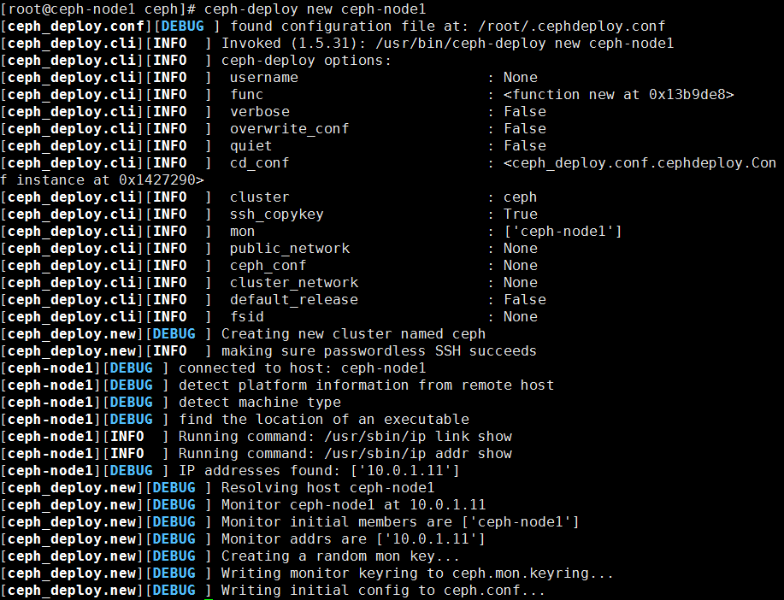
图3-1-4创建Ceph集群

③ ceph-deploy的new子命令能够部署一个默认名称为Ceph的新集群，并且它能生成集群配置文件和密钥文件。列出当前的工作目录，可以查看到ceph.conf和ceph.mon.keying文件。
[root@ceph-node1 ceph]# ll
total 12
-rw-r--r-- 1 root root 229 Sep 20 16:20 ceph.conf
-rw-r--r-- 1 root root 2960 Sep 20 16:20 ceph.log
-rw------- 1 root root 73 Sep 20 16:20 ceph.mon.keyring

④ 在ceph-node1上执行以下命令，使用ceph-deploy工具在所有节点上安装Ceph二进制软件包。
[root@ceph-node1 ceph]# ceph-deploy install ceph-node1 ceph-node2 ceph-node3
[ceph_deploy.conf][DEBUG ] found configuration file at: /root/.cephdeploy.conf
[ceph-node1][DEBUG ] connected to host: ceph-node1
[ceph-node1][DEBUG ] detect platform information from remote host
[ceph-node1][DEBUG ] detect machine type

[ceph-node3][DEBUG ] Upgrade 2 Packages (+14 Dependent packages)
[ceph-node3][DEBUG ]
[ceph-node3][DEBUG ] Total download size: 47 M
[ceph-node3][DEBUG ] Downloading packages:
[ceph-node3][DEBUG ] Delta RPMs disabled because /usr/bin/applydeltarpm not installed.
[ceph-node3][WARNIN] No data was received after 300 seconds, disconnecting...
[ceph-node3][INFO ] Running command: ceph --version
[ceph-node3][DEBUG ] ceph version 0.94.5 (9764da52395923e0b32908d83a9f7304401fee43)

⑤ ceph-deploy工具包首先会安装Ceph组件所有的依赖包。命令成功完成后，检查所有节点上Ceph的版本信息。
[root@ceph-node1 ceph]# ceph -v
ceph version 0.94.5 (9764da52395923e0b32908d83a9f7304401fee43)
[root@ceph-node2 ~]# ceph -v
ceph version 0.94.5 (9764da52395923e0b32908d83a9f7304401fee43)
[root@ceph-node3 ~]# ceph -v
ceph version 0.94.5 (9764da52395923e0b32908d83a9f7304401fee43)

⑥ 在ceph-node1上创建第一个Ceph monitor。
[root@ceph-node1 ceph]# ceph-deploy --overwrite-conf mon create-initial
[ceph_deploy.conf][DEBUG ] found configuration file at: /root/.cephdeploy.conf
[ceph_deploy.cli][INFO ] Invoked (1.5.31): /usr/bin/ceph-deploy --overwrite-conf mon create-initial
[ceph_deploy.cli][INFO ] ceph-deploy options:
[ceph_deploy.cli][INFO ] username : None
[ceph_deploy.cli][INFO ] verbose : False
[ceph_deploy.cli][INFO ] overwrite_conf : True
[ceph_deploy.cli][INFO ] subcommand : create-initial
[ceph_deploy.cli][INFO ] quiet : False
[ceph_deploy.cli][INFO ] cd_conf : <ceph_deploy.conf.cephdeploy.Conf instance at 0x10bf248>
[ceph_deploy.cli][INFO ] cluster : ceph
[ceph_deploy.cli][INFO ] func : <function mon at 0x10b1a28>
[ceph_deploy.cli][INFO ] ceph_conf : None
[ceph_deploy.cli][INFO ] default_release : False
[ceph_deploy.cli][INFO ] keyrings : None
[ceph_deploy.mon][DEBUG ] Deploying mon, cluster ceph hosts ceph-node1
[ceph_deploy.mon][DEBUG ] detecting platform for host ceph-node1 ...
[ceph-node1][DEBUG ] connected to host: ceph-node1
[ceph-node1][DEBUG ] detect platform information from remote host
[ceph-node1][DEBUG ] detect machine type
[ceph-node1][DEBUG ] find the location of an executable

[ceph-node1][DEBUG ] connected to host: ceph-node1
[ceph-node1][DEBUG ] detect platform information from remote host
[ceph-node1][DEBUG ] detect machine type
[ceph-node1][DEBUG ] fetch remote file
[ceph_deploy.gatherkeys][DEBUG ] Got ceph.bootstrap-mds.keyring key from ceph-node1.
[ceph_deploy.gatherkeys][DEBUG ] Checking ceph-node1 for /var/lib/ceph/bootstrap-rgw/ceph.keyring
[ceph-node1][DEBUG ] connected to host: ceph-node1
[ceph-node1][DEBUG ] detect platform information from remote host
[ceph-node1][DEBUG ] detect machine type
[ceph-node1][DEBUG ] fetch remote file
[ceph_deploy.gatherkeys][DEBUG ] Got ceph.bootstrap-rgw.keyring key from ceph-node1.

⑦ Monitor创建成功后，检查集群的状态，这个时候Ceph集群并不处于健康状态。
[root@ceph-node1 ceph]# ceph -s
cluster 418b5790-5c70-44a6-9b74-cba31a1d6a44
health HEALTH_ERR
64 pgs stuck inactive
64 pgs stuck unclean
no osds
monmap e1: 1 mons at {ceph-node1=10.0.1.11:6789/0}
election epoch 2, quorum 0 ceph-node1
osdmap e1: 0 osds: 0 up, 0 in
pgmap v2: 64 pgs, 1 pools, 0 bytes data, 0 objects
0 kB used, 0 kB / 0 kB avail
64 creating

（2）创建OSD

① 列出ceph-node1上所有的可用磁盘。
[root@ceph-node1 ceph]# ceph-deploy disk list ceph-node1
[ceph_deploy.conf][DEBUG ] found configuration file at: /root/.cephdeploy.conf
[ceph_deploy.cli][INFO ] Invoked (1.5.36): /usr/bin/ceph-deploy disk list ceph-node1
[ceph_deploy.cli][INFO ] ceph-deploy options:
[ceph_deploy.cli][INFO ] username : None
[ceph_deploy.cli][INFO ] verbose : False
[ceph_deploy.cli][INFO ] overwrite_conf : False
[ceph_deploy.cli][INFO ] subcommand : list
[ceph_deploy.cli][INFO ] quiet : False
[ceph_deploy.cli][INFO ] cd_conf : <ceph_deploy.conf.cephdeploy.Conf instance at 0x7f3a3ee9d6c8>
[ceph_deploy.cli][INFO ] cluster : ceph
[ceph_deploy.cli][INFO ] func : <function disk at 0x7f3a3ee8fb90>
[ceph_deploy.cli][INFO ] ceph_conf : None
[ceph_deploy.cli][INFO ] default_release : False
[ceph_deploy.cli][INFO ] disk : [('ceph-node1', None, None)]
[ceph-node1][DEBUG ] connected to host: ceph-node1
[ceph-node1][DEBUG ] detect platform information from remote host
[ceph-node1][DEBUG ] detect machine type
[ceph-node1][DEBUG ] find the location of an executable
[ceph_deploy.osd][INFO ] Distro info: CentOS Linux 7.3.1611 Core
[ceph_deploy.osd][DEBUG ] Listing disks on ceph-node1...
[ceph-node1][DEBUG ] find the location of an executable
[ceph-node1][INFO ] Running command: /usr/sbin/ceph-disk list
[ceph-node1][DEBUG ] /dev/vda :
[ceph-node1][DEBUG ] /dev/vda1 other, xfs, mounted on /

② 创建共享磁盘，3个节点都要执行。首先对系统上的空闲硬盘进行分区、格式化、挂载的操作。
[root@ceph-node1 ceph]# parted /dev/vdb
GNU Parted 3.1
Using /dev/vdb
Welcome to GNU Parted! Type 'help' to view a list of commands.
(parted) p
Model: Virtio Block Device (virtblk)
Disk /dev/vdb: 53.7GB
Sector size (logical/physical): 512B/512B
Partition Table: loop
Disk Flags:

Number Start End Size File system Flags
1 0.00B 53.7GB 53.7GB fat32

(parted) mklabel
New disk label type? gpt
Warning: The existing disk label on /dev/vdb will be destroyed and all data on this disk
will be lost. Do you want to continue?
Yes/No? yes
(parted) p
Model: Virtio Block Device (virtblk)
Disk /dev/vdb: 53.7GB
Sector size (logical/physical): 512B/512B
Partition Table: gpt
Disk Flags:

Number Start End Size File system Name Flags

(parted) mkpart
Partition name? []?
File system type? [ext2]?
Start? 0%
End? 100%
(parted) p
Model: Virtio Block Device (virtblk)
Disk /dev/vdb: 53.7GB
Sector size (logical/physical): 512B/512B
Partition Table: gpt
Disk Flags:

Number Start End Size File system Name Flags
1 1049kB 53.7GB 53.7GB

(parted) q
Information: You may need to update /etc/fstab.
以上的操作是使用parted工具，对/dev/vdb进行分区，首先使用mklabel命令改变该盘的卷标为gpt，然后使用mkpart命令，将所有的空间都分给/dev/vdb1，
可以使用lsblk命令，查看分区情况
[root@ceph-node1 ceph]# lsblk
NAME MAJ:MIN RM SIZE RO TYPE MOUNTPOINT
vda 253:0 0 40G 0 disk
└─vda1 253:1 0 40G 0 part /
vdb 253:16 0 50G 0 disk
└─vdb1 253:17 0 50G 0 part
接下来使用命令对分区进行格式化，创建一个目录叫/opt/osd1，挂载分区到目录，最后将该目录的权限提升到777。
[root@ceph-node1 ceph]# mkfs.xfs /dev/vdb1
meta-data=/dev/vdb1 isize=256 agcount=4, agsize=3276672 blks
= sectsz=512 attr=2, projid32bit=1
= crc=0 finobt=0
data = bsize=4096 blocks=13106688, imaxpct=25
= sunit=0 swidth=0 blks
naming =version 2 bsize=4096 ascii-ci=0 ftype=0
log =internal log bsize=4096 blocks=6399, version=2
= sectsz=512 sunit=0 blks, lazy-count=1
realtime =none extsz=4096 blocks=0, rtextents=0
[root@ceph-node1 ceph]# mkdir /opt/osd1
[root@ceph-node1 ceph]# mount /dev/vdb1 /opt/osd1
[root@ceph-node1 ceph]# df -h
Filesystem Size Used Avail Use% Mounted on
/dev/vda1 40G 1.1G 39G 3% /
devtmpfs 2.0G 0 2.0G 0% /dev
tmpfs 2.0G 0 2.0G 0% /dev/shm
tmpfs 2.0G 17M 2.0G 1% /run
tmpfs 2.0G 0 2.0G 0% /sys/fs/cgroup
/dev/vdb1 50G 33M 50G 1% /opt/osd1
[root@ceph-node1 ceph]# chmod 777 /opt/osd1/
在另外两个节点做相同的操作。
[root@ceph-node1 ceph]# ll /opt/
total 0
drwxrwxrwx 2 root root 6 Sep 20 17:40 osd1
[root@ceph-node1 ceph]# lsblk
NAME MAJ:MIN RM SIZE RO TYPE MOUNTPOINT
vda 253:0 0 40G 0 disk
└─vda1 253:1 0 40G 0 part /
vdb 253:16 0 50G 0 disk
└─vdb1 253:17 0 50G 0 part /opt/osd1
[root@ceph-node2 ~]# ll /opt/
total 0
drwxrwxrwx 2 root root 6 Sep 20 17:49 osd2
[root@ceph-node2 ~]# lsblk
NAME MAJ:MIN RM SIZE RO TYPE MOUNTPOINT
vda 253:0 0 40G 0 disk
└─vda1 253:1 0 40G 0 part /
vdb 253:16 0 50G 0 disk
└─vdb1 253:17 0 50G 0 part /opt/osd2
[root@ceph-node3 ~]# ll /opt/
total 0
drwxrwxrwx 2 root root 6 Sep 20 17:51 osd3
[root@ceph-node3 ~]# lsblk
NAME MAJ:MIN RM SIZE RO TYPE MOUNTPOINT
vda 253:0 0 40G 0 disk
└─vda1 253:1 0 40G 0 part /
vdb 253:16 0 50G 0 disk
└─vdb1 253:17 0 50G 0 part /opt/osd3

③ 在node1节点使用ceph-deploy工具创建OSD节点。
[root@ceph-node1 ceph]# ceph-deploy osd prepare ceph-node1:/opt/osd1 ceph-node2:/opt/osd2 ceph-node3:/opt/osd3

④ 在node1节点使用ceph-deploy工具激活OSD节点。在激活OSD节点前，把创建的三个节点上的osd1、osd2、osd3目录中的文件权限改为777。
[root@ceph-node1 ceph]# cd /opt/osd1/
[root@ceph-node1 osd1]# ll
total 12
-rw-r--r-- 1 root root 37 Sep 20 17:52 ceph_fsid
-rw-r--r-- 1 root root 37 Sep 20 17:52 fsid
-rw-r--r-- 1 root root 21 Sep 20 17:52 magic
[root@ceph-node1 osd1]# chmod 777 *
[root@ceph-node1 osd1]# ll
total 12
-rwxrwxrwx 1 root root 37 Sep 20 17:52 ceph_fsid
-rwxrwxrwx 1 root root 37 Sep 20 17:52 fsid
-rwxrwxrwx 1 root root 21 Sep 20 17:52 magic
接下来开始激活osd节点
[root@ceph-node1 ceph]# ceph-deploy osd activate ceph-node1:/opt/osd1 ceph-node2:/opt/osd2 ceph-node3:/opt/osd3
[ceph_deploy.conf][DEBUG ] found configuration file at: /root/.cephdeploy.conf
[ceph_deploy.cli][INFO ] cluster : ceph
[ceph-node1][WARNIN] DEBUG:ceph-disk:OSD uuid is 6c5cd76e-f68c-48b2-b4b9-97d550970e65
[ceph-node1][WARNIN] DEBUG:ceph-disk:Allocating OSD id...

[ceph-node2][WARNIN] DEBUG:ceph-disk:Cluster uuid is 06b91a6e-8faf-4992-b95c-84d192f30096

[ceph-node3][WARNIN] DEBUG:ceph-disk:OSD uuid is 70b154fa-fa5e-4e78-9d83-bcc18e09b9b6
[ceph-node3][WARNIN] a requirement dependency on it.
[ceph-node3][WARNIN] 3) A unit may be started when needed via activation (socket, path, timer,
[ceph-node3][WARNIN] D-Bus, udev, scripted systemctl call, ...).

⑤ 检查Ceph集群的状态。此时，集群是HEALTH_OK状态。
[root@ceph-node1 ceph]# ceph -s
cluster 418b5790-5c70-44a6-9b74-cba31a1d6a44
health HEALTH_OK
monmap e1: 1 mons at {ceph-node1=10.0.1.11:6789/0}
election epoch 2, quorum 0 ceph-node1
osdmap e14: 3 osds: 3 up, 3 in
pgmap v23: 64 pgs, 1 pools, 0 bytes data, 0 objects
15459 MB used, 134 GB / 149 GB avail
64 active+clean

⑥ 开放权限给其他节点，进行灾备处理。
# ceph-deploy admin ceph-node{1,2,3}
[ceph_deploy.conf][DEBUG ] found configuration file at: /root/.cephdeploy.conf
[ceph_deploy.cli][INFO ] Invoked (1.5.31): /usr/bin/ceph-deploy admin ceph-node1 ceph-node2 ceph-node3
[ceph_deploy.admin][DEBUG ] Pushing admin keys and conf to ceph-node1
[ceph_deploy.admin][DEBUG ] Pushing admin keys and conf to ceph-node2
[ceph-node2][DEBUG ] connected to host: ceph-node2
[ceph-node2][DEBUG ] detect platform information from remote host
[ceph_deploy.admin][DEBUG ] Pushing admin keys and conf to ceph-node3
[ceph-node3][DEBUG ] connected to host: ceph-node3
[ceph-node3][DEBUG ] write cluster configuration to /etc/ceph/{cluster}.conf
# chmod +r /etc/ceph/ceph.client.admin.keyring

（3）Ceph集群运维
有了可运行的Ceph集群后，现在可以用一些简单的命令来体验Ceph。

① 检查Ceph的安装状态。
# ceph status
cluster 9e167f7f-ed37-473d-838a-6aebea41bbb0
health HEALTH_OK
monmap e1: 1 mons at {ceph-node1=10.32.24.167:6789/0}
election epoch 1, quorum 0 ceph-node1
osdmap e13: 3 osds: 3 up, 3 in
pgmap v20: 64 pgs, 1 pools, 0 bytes data, 0 objects
15459 MB used, 164 GB / 179 GB avail
64 active+clean
② 观察集群的健康状况。
# ceph -w

③ 检查Ceph monitor仲裁状态。
# ceph quorum_status --format json-pretty
{
"election_epoch": 1,
"quorum": [
0
],
"quorum_names": [
"ceph-node1"
],
"quorum_leader_name": "ceph-node1",
"monmap": {
"epoch": 1,
"fsid": "9e167f7f-ed37-473d-838a-6aebea41bbb0",
"modified": "0.000000",
"created": "0.000000",
"mons": [
{
"rank": 0,
"name": "ceph-node1",
"addr": "10.32.24.167:6789\/0"
}
]
}
}

④ 导出Ceph monitor信息。
# ceph mon dump
dumped monmap epoch 1
epoch 1
fsid 9e167f7f-ed37-473d-838a-6aebea41bbb0
last_changed 0.000000
created 0.000000
0: 10.32.24.167:6789/0 mon.ceph-node1

⑤ 检查集群使用状态。
# ceph df
GLOBAL:
SIZE AVAIL RAW USED %RAW USED
179G 164G 15459M 8.39
POOLS:
NAME ID USED %USED MAX AVAIL OBJECTS
rbd 0 0 0 56254M 0

⑥ 检查Ceph Monitor、OSD和PG（配置组）状态。
# ceph mon stat
e1: 1 mons at {ceph-node1=10.32.24.167:6789/0}, election epoch 1, quorum 0 ceph-node1
# ceph osd stat
osdmap e13: 3 osds: 3 up, 3 in
# ceph pg stat
v20: 64 pgs: 64 active+clean; 0 bytes data, 15459 MB used, 164 GB / 179 GB avail

⑦ 列表PG。
# ceph pg dump

⑧ 列表Ceph存储池。
# ceph osd lspools

⑨ 检查OSD的CRUSH。
# ceph osd tree

⑩ 列表集群的认证密钥。
# ceph auth list
installed auth entries:

osd.0
key: AQACb9RcZhH7DBAA+j55dwCVSpXLwkyyU5s/XQ==
caps: [mon] allow profile osd
caps: [osd] allow *
osd.1
key: AQCkbtRcDaVJHBAAzF9vNB/N/W/hj+5PDO8E5A==
caps: [mon] allow profile osd
caps: [osd] allow *
osd.2
key: AQD+idRcnxhhBxAA9AcnerGMQGnagUhVWe9MiQ==
caps: [mon] allow profile osd
caps: [osd] allow *
client.admin
key: AQAQa9Rc/mrsNxAADCj1mpeJprsP/Wj2VyFWhQ==
caps: [mds] allow
caps: [mon] allow *
caps: [osd] allow *
client.bootstrap-mds
key: AQARa9Rctv7EJBAAizOiE9vXfdvfxUkfBf2R9g==
caps: [mon] allow profile bootstrap-mds
client.bootstrap-osd
key: AQARa9Rczz7kCRAAemd9CY9x9WKAn1u0oG19fw==
caps: [mon] allow profile bootstrap-osd
client.bootstrap-rgw
key: AQARa9RcpYHTFxAA5V110kAUo9UkKJQcoYBQAw==
caps: [mon] allow profile bootstrap-rgw

3.Ceph的使用
安装Ceph客户端
创建一台centos7系统的虚拟机，名字叫ceph-client，并配置好yum源。
[root@ceph-client ~]# hostnamectl set-hostname ceph-client
[root@ceph-client ~]# hostnamectl
Static hostname: ceph-client
Icon name: computer-vm
Chassis: vm
Machine ID: dae72fe0cc064eb0b7797f25bfaf69df
Boot ID: 3db7ec8e4709477a814c21ae0a1986ec
Virtualization: kvm
Operating System: CentOS Linux 7 (Core)
CPE OS Name: cpe:/o:centos:centos:7
Kernel: Linux 3.10.0-229.el7.x86_64
Architecture: x86_64
[root@ceph-client yum.repos.d]# cat local.repo
[centos]
name=centos
baseurl=ftp://172.30.14.10/centos
gpgcheck=0
enabled=1
[iaas]
name=iaas
baseurl=ftp://172.30.14.10/iaas-repo
gpgcheck=0
enabled=1
回到ceph-node1节点通过 ceph-deploy 把 Ceph 安装到 ceph-client 节点。首先要在/etc/hosts中，加入ceph-client的IP和主机名，然后执行命令安装ceph客户端。
[root@ceph-node1 ceph]# cat /etc/hosts
127.0.0.1 localhost localhost.localdomain localhost4 localhost4.localdomain4
::1 localhost localhost.localdomain localhost6 localhost6.localdomain6

10.0.1.11 ceph-node1
10.0.1.12 ceph-node2
10.0.1.13 ceph-node3
10.0.1.14 ceph-client
[root@ceph-node1 ceph]# ceph-deploy install ceph-client
[ceph-client][DEBUG ] Dependency Updated:
[ceph-client][DEBUG ] cryptsetup-libs.x86_64 0:1.6.7-1.el7
[ceph-client][DEBUG ]
[ceph-client][DEBUG ] Complete!
[ceph-client][INFO ] Running command: ceph --version
[ceph-client][DEBUG ] ceph version 0.94.5 (9764da52395923e0b32908d83a9f7304401fee43)
在ceph-node1上，用 ceph-deploy 把 Ceph 配置文件和 ceph.client.admin.keyring 拷贝到 ceph-client 。ceph-deploy 工具会把密钥环复制到 /etc/ceph 目录，要确保此密钥环文件有读权限（如 sudo chmod +r /etc/ceph/ceph.client.admin.keyring ）。
[root@ceph-node1 ceph]# ceph-deploy admin ceph-client
[ceph_deploy.admin][DEBUG ] Pushing admin keys and conf to ceph-client
[ceph-client][DEBUG ] connected to host: ceph-client
[ceph-client][DEBUG ] detect platform information from remote host
[ceph-client][DEBUG ] detect machine type
[ceph-client][DEBUG ] write cluster configuration to /etc/ceph/{cluster}.conf
回到ceph-client节点，在客户端，创建块设备。
[root@ceph-client ceph]#rbd create foo --size 4096 -m 10.0.1.11 -k /etc/ceph/ceph.client.admin.keyring
[root@ceph-client ceph]# rbd map foo --name client.admin -m 10.0.1.11 -k /etc/ceph/ceph.client.admin.keyring
/dev/rbd0
[root@ceph-client ceph]# lsblk
NAME MAJ:MIN RM SIZE RO TYPE MOUNTPOINT
vda 253:0 0 40G 0 disk
└─vda1 253:1 0 40G 0 part /
rbd0 252:0 0 4G 0 disk
[root@ceph-client ceph]# mkfs.ext4 /dev/rbd0
mke2fs 1.42.9 (28-Dec-2013)
Discarding device blocks: done
Filesystem label=
OS type: Linux
Block size=4096 (log=2)
Fragment size=4096 (log=2)
Stride=1024 blocks, Stripe width=1024 blocks
262144 inodes, 1048576 blocks
52428 blocks (5.00%) reserved for the super user
First data block=0
Maximum filesystem blocks=1073741824
32 block groups
32768 blocks per group, 32768 fragments per group
8192 inodes per group
Superblock backups stored on blocks:
32768, 98304, 163840, 229376, 294912, 819200, 884736

Allocating group tables: done
Writing inode tables: done
Creating journal (32768 blocks): done
Writing superblocks and filesystem accounting information: done

[root@ceph-client ceph]# mount /dev/rbd0 /mnt/
[root@ceph-client ceph]# df -h
Filesystem Size Used Avail Use% Mounted on
/dev/vda1 40G 1.1G 39G 3% /
devtmpfs 2.0G 0 2.0G 0% /dev
tmpfs 2.0G 0 2.0G 0% /dev/shm
tmpfs 2.0G 17M 2.0G 1% /run
tmpfs 2.0G 0 2.0G 0% /sys/fs/cgroup
/dev/rbd0 3.9G 16M 3.6G 1% /mnt
创建块设备的顺序是，在 ceph-client 节点上使用rbd create命令创建一个块设备 image，然后用rbd map命令把image 映射为块设备，最后对映射出来的/dev/rbd0格式化并挂载。就可以当成普通了块设备使用了。
下面学习如何调整块设备的大小。
Ceph 块设备映像是精简配置，只有在你开始写入数据时它们才会占用物理空间。然而，它们都有最大容量，就是你设置的 --size 选项。如果你想增加（或减小） Ceph 块设备映像的最大尺寸，执行下列命令：查看foo的大小，调整foo的大小，使用resize2fs命令调整文件系统的大小，查看。
[root@ceph-client ceph]# rbd info foo
rbd image 'foo':
size 4096 MB in 1024 objects
order 22 (4096 kB objects)
block_name_prefix: rb.0.101c.238e1f29
format: 1
[root@ceph-client ceph]# rbd resize --size 8192 foo
Resizing image: 100% complete...done.
[root@ceph-client ceph]# rbd info foo
rbd image 'foo':
size 8192 MB in 2048 objects
order 22 (4096 kB objects)
block_name_prefix: rb.0.101c.238e1f29
format: 1
[root@ceph-client ceph]# resize2fs /dev/rbd0
resize2fs 1.42.9 (28-Dec-2013)
Filesystem at /dev/rbd0 is mounted on /mnt; on-line resizing required
old_desc_blocks = 1, new_desc_blocks = 1
The filesystem on /dev/rbd0 is now 2097152 blocks long.

[root@ceph-client ceph]# df -h
Filesystem Size Used Avail Use% Mounted on
/dev/vda1 40G 1.1G 39G 3% /
devtmpfs 2.0G 0 2.0G 0% /dev
tmpfs 2.0G 0 2.0G 0% /dev/shm
tmpfs 2.0G 17M 2.0G 1% /run
tmpfs 2.0G 0 2.0G 0% /sys/fs/cgroup
/dev/rbd0 7.8G 18M 7.4G 1% /mnt
删除块设备，先卸载设备，再删除
[root@ceph-client ceph]# umount /mnt/
[root@ceph-client ceph]# rbd rm foo
Removing image: 100% complete...done.

（二）构建超融合基础架构

任务描述
1. 配置OpenStack的Ceph客户端。
2. 配置OpenStack Glance服务对接Ceph。
3. 配置OpenStack Nova 服务对接Ceph。

任务实施

1.配置OpenStack作为Ceph客户端

（1）安装All-in-one节点。
安装一台All-in-one的OpenStack节点作为Ceph的客户端。（关于如何安装All-in-one的OpenStack平台，这边不再赘述）。
这边我们使用一台All-in-one的节点名字叫xiandian。配置xiandian节点的yum源，使用之前的ftp源，如下所示。
[root@xiandian ~]# cat /etc/yum.repos.d/local.repo
[centos]
name=centos
baseurl=ftp://172.30.14.10/centos
gpgcheck=0
enabled=1
[iaas]
name=iaas
baseurl=ftp://172.30.14.10/iaas/iaas-repo
gpgcheck=0
enabled=1

（2）配置xiandian节点为Ceph的客户端。
配置ceph-node1节点的/etc/hosts文件，将xiandian节点加进去。
[root@ceph-node1 ceph]# cat /etc/hosts
127.0.0.1 localhost localhost.localdomain localhost4 localhost4.localdomain4
::1 localhost localhost.localdomain localhost6 localhost6.localdomain6

10.0.1.11 ceph-node1
10.0.1.12 ceph-node2
10.0.1.13 ceph-node3
10.0.1.14 ceph-client
10.0.1.15 xiandian
在ceph-node1节点执行命令，安装xiandian节点的客户端。
ceph-deploy install xiandian
等待命令执行完毕后，执行命令，将配置文件拷贝到xiandian节点。
ceph-deploy admin xiandian
现在xiandian节点就成为了ceph集群的一个客户端。

（3）配置存储池。
为Cinder、Glance、Nova创建Ceph存储池。开发者也可以使用任何可用的存储池，这里会创建三个存储池作为3种存储的后端存储池，创建完成后可以检查当前的存储池信息。首先看下默认存储池的信息。
# ceph osd pool stats
pool rbd id 0
nothing is going on
//创建images池，对应Glance服务
ceph osd pool create images 128
pool 'images' created
// 创建vms池，对应Nova服务
ceph osd pool create vms 128
pool 'vms' created
//创建volumes池，对应Cinder服务
ceph osd pool create volumes 128
pool 'volumes' created
查看创建的存储池。
[root@xiandian ~]# ceph osd pool stats
pool rbd id 0
nothing is going on

pool volumes id 1
nothing is going on

pool images id 2
nothing is going on

pool vms id 3
nothing is going on

（4）创建Ceph用户。
为存储池创建认证用户。在ceph-node1节点上执行。
[root@ceph-node1 ceph]# ceph auth get-or-create client.glance mon 'allow r' osd 'allow class-read object_prefix rbd_children, allow rwx pool=images'
[client.glance]
key = AQBIVaVbC057GxAAeYLdlvKp2DzjHFyeiA82lg==

（5）拷贝keyring
创建xiandian节点的keyring。在ceph-node1节点上执行。
[root@ceph-node1 ceph]# ceph auth get-or-create client.glance | ssh xiandian tee /etc/ceph/ceph.client.glance.keyring
[client.glance]
key = AQBIVaVbC057GxAAeYLdlvKp2DzjHFyeiA82lg==

（6）修改权限。
修改xiandian节点的keyring权限。在ceph-node1节点上执行。
[root@ceph-node1 ceph]# ssh xiandian chown glance:glance /etc/ceph/ceph.client.glance.keyring

2.配置Glance服务
现在已经完成了Ceph侧所需的配置，接下来通过配置OpenStack Glance，将Ceph用作后端存储，配置OpenStack Glance模块来将其虚拟机镜像存储在Ceph RDB中。

（1）修改Glance配置文件。
登录到xiandian节点，然后编辑/etc/glance/glance-api.conf文件的[DEFAULT]和[glance_store]的配置并做如下修改。
# vi /etc/glance/glance-api.conf
[DEFAULT]
rpc_backend = rabbit
show_image_direct_url = True
[glance_store]
#stores = file,http
#file =
#filesystem_store_datadir = /var/lib/glance/images/
stores = rbd
default_store = rbd
rbd_store_pool = images
rbd_store_user = glance
rbd_store_ceph_conf = /etc/ceph/ceph.conf
rbd_store_chunk_size = 8

（2）重新启动服务。
重新启动OpenStack Glance服务。
[root@xiandian ~]# openstack-service restart glance-api

（3）检查结果。

① 转换镜像。
要在Ceph中启动虚拟机，Glance镜像的格式必须为RAW。这里可以利用本教材提供的cirros-0.3.4-x86_64-disk.img镜像，将镜像类型从QCOW2转换成RAW格式。这里也可以使用任何RAW格式的其他镜像。
# qemu-img convert -p -f qcow2 -O raw cirros-0.3.4-x86_64-disk.img cirros.raw

② 上传镜像。
将修改的镜像上传到系统。
[root@xiandian ~]# glance image-create --name="CirrOS-ceph" --disk-format=raw --container-format=bare < /root/cirros.raw
+------------------+----------------------------------------------------------------------------------+
| Property | Value |
+------------------+----------------------------------------------------------------------------------+
| checksum | 56730d3091a764d5f8b38feeef0bfcef |
| container_format | bare |
| created_at | 2018-09-21T21:53:20Z |
| direct_url | rbd://418b5790-5c70-44a6-9b74-cba31a1d6a44/images/e27ba20e- |
| | 51e5-4e74-9ba8-90bd7b002aae/snap |
| disk_format | raw |
| id | e27ba20e-51e5-4e74-9ba8-90bd7b002aae |
| min_disk | 0 |
| min_ram | 0 |
| name | CirrOS-ceph |
| owner | 0ab2dbde4f754b699e22461426cd0774 |
| protected | False |
| size | 41126400 |
| status | active |
| tags | [] |
| updated_at | 2018-09-21T21:53:25Z |
| virtual_size | None |
| visibility | private |
+------------------+----------------------------------------------------------------------------------+

③ 在Ceph的镜像池中查询镜像。
开发者可以在Ceph的镜像池中查询镜像ID来验证新添加的镜像。
[root@xiandian ~]# rbd ls images
e27ba20e-51e5-4e74-9ba8-90bd7b002aae
可以发现存储在ceph存储池中的id与我们创建的镜像id一致。而原本glance的默认存储路径中没有镜像，如下所示。
[root@xiandian ~]# ll /var/lib/glance/images/
total 0
现在已经将Glance的默认存储后端配置改为Ceph，所有上传的Glance镜像都将存储在Ceph中。

3.配置Cinder块存储服务

（1）创建cinder认证
在ceph-node1节点上执行（nova使用cinder用户，就不单独创建了）
[root@ceph-node1 ceph]# ceph auth get-or-create client.cinder mon 'allow r' osd 'allow class-read object_prefix rbd_children, allow rwx pool=volumes, allow rwx pool=vms, allow rx pool=images'
[client.cinder]
key = AQC+a6VbHREEHhAAZ2Cz/EKHEe3rvUHTa94Jow==

（2）拷贝keyring
在ceph-node1节点上执行
[root@ceph-node1 ceph]# ceph auth get-or-create client.cinder | ssh xiandian tee /etc/ceph/ceph.client.cinder.keyring
[client.cinder]
key = AQC+a6VbHREEHhAAZ2Cz/EKHEe3rvUHTa94Jow==

（3）修改权限
在ceph-node1节点上执行
[root@ceph-node1 ceph]# ssh xiandian chown cinder:cinder /etc/ceph/ceph.client.cinder.keyring

（4） 在OpenStack的计算节点（xiandian节点）上生成UUID，定义secret.xml文件，设置密钥给Libvirt，这里在xiandian节点上进行操作。

① 使用如下代码生成UUID。
[root@xiandian ceph]# uuidgen
83656c02-e3cc-4e98-9aa0-b22a897bf78d

② 创建密钥文件，并将UUID设置给它。
[root@xiandian ~]# cat > secret.xml <<EOF
<secret ephemeral='no' private='no'>
<uuid>83656c02-e3cc-4e98-9aa0-b22a897bf78d</uuid>
<usage type='ceph'>
<name>client.cinder secret </name>
</usage>
</secret>
EOF

③ 定义（define）密钥文件，并保证生成的保密字符串是安全的。在接下来的步骤中需要使用这个保密的字符串值。
[root@xiandian ~]# virsh secret-define --file secret.xml
Secret 83656c02-e3cc-4e98-9aa0-b22a897bf78d created

④ 在virsh里设置好最后一步生成的保密字符串值，创建完成后查看系统的密钥文件。
[root@xiandian ~]# ceph auth get-key client.cinder > ./client.cinder.key
[root@xiandian ~]# virsh secret-set-value --secret 83656c02-e3cc-4e98-9aa0-b22a897bf78d --base64 $(cat ./client.cinder.key)
Secret value set
[root@xiandian ~]# virsh secret-list
UUID Usage
--------------------------------------------------------------------------------
83656c02-e3cc-4e98-9aa0-b22a897bf78d ceph client.cinder secret

（5）修改配置文件
OpenStack 需要一个驱动和 Ceph 块设备交互。还得指定块设备所在的存储池名。编辑 xiandian节点上的 /etc/cinder/cinder.conf ，改成如下内容：rbd_secret_uuid就是上面生成的秘钥值。
[DEFAULT]
rpc_backend = rabbit
auth_strategy = keystone
my_ip = 127.0.0.1
#enabled_backends = lvm
enabled_backends = ceph
glance_api_servers = http://xiandian:9292

[ceph]
volume_driver = cinder.volume.drivers.rbd.RBDDriver
rbd_pool = volumes
rbd_ceph_conf = /etc/ceph/ceph.conf
rbd_flatten_volume_from_snapshot = false
rbd_max_clone_depth = 5
rbd_store_chunk_size = 4
rados_connect_timeout = -1
glance_api_version = 2
rbd_user = cinder
rbd_secret_uuid = 83656c02-e3cc-4e98-9aa0-b22a897bf78d

（6）重启服务
[root@xiandian ~]# systemctl restart openstack-cinder-volume.service

（7）创建块设备并验证
[root@xiandian ~]# cinder create --name ceph-block1 1
+--------------------------------+--------------------------------------+
| Property | Value |
+--------------------------------+--------------------------------------+
| attachments | [] |
| availability_zone | nova |
| bootable | false |
| consistencygroup_id | None |
| created_at | 2018-09-22T14:39:29.000000 |
| description | None |
| encrypted | False |
| id | 15792bdd-3829-4851-99fc-a1a08e5b906b |
| metadata | {} |
| migration_status | None |
| multiattach | False |
| name | ceph-block1 |
| os-vol-host-attr:host | None |
| os-vol-mig-status-attr:migstat | None |
| os-vol-mig-status-attr:name_id | None |
| os-vol-tenant-attr:tenant_id | 0ab2dbde4f754b699e22461426cd0774 |
| replication_status | disabled |
| size | 1 |
| snapshot_id | None |
| source_volid | None |
| status | creating |
| updated_at | None |
| user_id | 53a1cf0ad2924532aa4b7b0750dec282 |
| volume_type | None |
+--------------------------------+--------------------------------------+
[root@xiandian ~]# cinder list
+--------------------------------------+-----------+-------------+------+-------------+----------+-------------+
| ID | Status | Name | Size | Volume Type | Bootable | Attached to |
+--------------------------------------+-----------+-------------+------+-------------+----------+-------------+
| 15792bdd-3829-4851-99fc-a1a08e5b906b | available | ceph-block1 | 1 | - | false | |
+--------------------------------------+-----------+-------------+------+-------------+----------+-------------+
[root@xiandian ~]# rbd ls volumes
volume-15792bdd-3829-4851-99fc-a1a08e5b906b

4.配置Nova服务
其实 nova compute 使用 RBD 有两种功能：
一种是将 cinder volume 挂接给虚拟机；
另一种是从 cinder volume 上启动虚拟机，此时 nova 需要创建一个 RBD image，把 glance image 的内容导入，再交给 libvirt。
这边我们就验证第一种nova使用ceph的情况。

（1）修改配置文件
修改/etc/nova/nova.conf配置文件，并重启nova-compute服务。
[libvirt]
virt_type = qemu
inject_key = True
rbd_user = cinder
rbd_secret_uuid =83656c02-e3cc-4e98-9aa0-b22a897bf78d

（2）创建虚拟机
net-id可以通过neutron net-list查询。
[root@xiandian ceph]# nova boot --flavor m1.tiny --image "CirrOS-ceph" --nic net-id=bd923693-d9b1-4094-bd5b-22a038c44827 ceph-vm1
+--------------------------------------+----------------------------------------------------+
| Property | Value |
+--------------------------------------+----------------------------------------------------+
| OS-DCF:diskConfig | MANUAL |
| OS-EXT-AZ:availability_zone | |
| OS-EXT-SRV-ATTR:host | - |
| OS-EXT-SRV-ATTR:hostname | ceph-vm1 |
| OS-EXT-SRV-ATTR:hypervisor_hostname | - |
| OS-EXT-SRV-ATTR:instance_name | instance-00000005 |
| OS-EXT-SRV-ATTR:kernel_id | |
| OS-EXT-SRV-ATTR:launch_index | 0 |
| OS-EXT-SRV-ATTR:ramdisk_id | |
| OS-EXT-SRV-ATTR:reservation_id | r-67j8gksb |
| OS-EXT-SRV-ATTR:root_device_name | - |
| OS-EXT-SRV-ATTR:user_data | - |
| OS-EXT-STS:power_state | 0 |
| OS-EXT-STS:task_state | scheduling |
| OS-EXT-STS:vm_state | building |
| OS-SRV-USG:launched_at | - |
| OS-SRV-USG:terminated_at | - |
| accessIPv4 | |
| accessIPv6 | |
| adminPass | BrkmHwKTL39e |
| config_drive | |
| created | 2018-09-22T15:27:24Z |
| description | - |
| flavor | m1.tiny (1) |
| hostId | |
| host_status | |
| id | 090c35c1-9af7-43d2-905c-dcece07f0ed2 |
| image | CirrOS-ceph (e27ba20e-51e5-4e74-9ba8-90bd7b002aae) |
| key_name | - |
| locked | False |
| metadata | {} |
| name | ceph-vm1 |
| os-extended-volumes:volumes_attached | [] |
| progress | 0 |
| security_groups | default |
| status | BUILD |
| tenant_id | 0ab2dbde4f754b699e22461426cd0774 |
| updated | 2018-09-22T15:27:26Z |
| user_id | 53a1cf0ad2924532aa4b7b0750dec282 |
+--------------------------------------+----------------------------------------------------+

（3）挂载云硬盘
[root@xiandian ceph]# nova volume-attach 090c35c1-9af7-43d2-905c-dcece07f0ed2 d0fb7440-47c3-4f16-801c-88df8333afa4
+----------+--------------------------------------+
| Property | Value |
+----------+--------------------------------------+
| device | /dev/vdb |
| id | d0fb7440-47c3-4f16-801c-88df8333afa4 |
| serverId | 090c35c1-9af7-43d2-905c-dcece07f0ed2|
| volumeId | d0fb7440-47c3-4f16-801c-88df8333afa4 |
+----------+--------------------------------------+

（4）查看挂载
[root@xiandian ceph]# cinder list
+--------------------------------------+--------+-------------+------+-------------+----------+--------------------------------------+
| ID | Status | Name | Size | Volume Type | Bootable | Attached to |
+--------------------------------------+--------+-------------+------+-------------+----------+--------------------------------------+
| d0fb7440-47c3-4f16-801c-88df8333afa4 | in-use | ceph-block1 | 1 | - | false | 090c35c1-9af7-43d2-905c-dcece07f0ed2 |
+--------------------------------------+--------+-------------+------+-------------+----------+--------------------------------------+
挂载成功，此验证可以通过dashboard页面上的操作来验证。

二.自定义Rancher应用商店

（一）rancher应用商店增加Nginx服务

任务描述
1.创建模板文件
2.搭建本地git仓库
3.配置git仓库免密访问
4.上传文件至git仓库
5.添加应用商店
6.成果验证

任务实施

1.环境介绍
本实验是在rancher平台的应用商店中自定义一个Nginx应用。
镜像源：CentOS7-1511； XianDian-PaaS-v2.2.iso
两个节点：192.168.233.157 server ；192.168.233.166 client
Docker Version：1.12.6
Rancher Version：1.6.5

2.开始

（1）创建模板文件
基本目录层级是这样的：
# cd ./definecatalog
# tree .

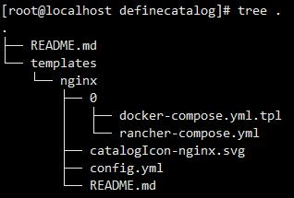

说明几个文件的作用：
- README.md 帮助别人快速了解你的项目。
- 0代表这是我的第一个版本，后续如果有更新，每个版本加1。
- docker-compose.yml.tpl和rancher-compose.yml是在rancher中使用Docker Compose启动服务必须提供的两个文件，这两个文件被保存在版本文件夹中（即0）。
- docker-compose.yml为一个可以使用 docker-compose up来启动的文件。该服务 遵循docker-- compose格式。
- rancher-compose.yml将包含帮助你自定义应用模板的其他信息。
- catalogIcon-*.svg是为应用选择一个好看的logo。
- config.yml包含了此应用的一些基本信息。

下面贴出docker-compose.yml.tpl和rancher-compose.yml文件：
# cat docker-compose.yml.tpl
version: '2'
services:
nginx:
image: nginx:latest
{{- if ne .Values.db_link ""}}
external_links:
- ${db_link}:db
{{- else}}
links:
- db:db
ports:
- ${http_port}:80
db:
image: mysql:8.0
environment:
MYSQL_ROOT_PASSWORD: ${mysql_password}
MYSQL_USER: ${mysql_user}
MYSQL_PASSWORD: ${mysql_password}
MYSQL_DATABASE: ${mysql_db}
volumes:
- nginx-db:/var/lib/mysql
{{- end}}
volumes:
nginx-data:
driver: ${volume_driver}
{{- if eq .Values.db_link ""}}
nginx-db:
driver: ${volume_driver}
{{- end}}

# cat rancher-compose.yml
version: '2'
catalog:
name: "nginx"
version: "v0.0.1"
description: "A web service."
minimum_rancher_version: v0.51.0
questions:
- variable: http_port
description: "http port to access nginx"
label: "Http Port"
required: true
default: "9999"
type: "int"
- variable: "volume_driver"
description: "Volume driver to associate with this service"
label: "Volume Driver"
required: true
default: "local"
type: enum
options: # List of options if using type of `enum`
- local
- rancher-nfs
- rancher-efs
- rancher-ebs
- variable: "db_link"
description: |
DB external service link cluster.
label: "External db service"
default: ""
required: false
type: "service"
- variable: mysql_db
description: "mysql db"
label: "Mysql db"
required: true
default: "nginx"
type: "string"
- variable: mysql_user
description: "mysql user"
label: "Mysql User"
required: true
default: "nginx"
type: "string"
- variable: mysql_password
description: "mysql root password"
label: "Mysql Password"
required: true
default: "default_pass"
type: "password"
services:
nginx:
scale: 1
retain_ip: true
health_check:
response_timeout: 2000
healthy_threshold: 2
port: 80
unhealthy_threshold: 3
initializing_timeout: 300000
interval: 2000
strategy: recreate
request_line: GET "/" "HTTP/1.0"
reinitializing_timeout: 120000

（2）搭建本地git仓库
在server节点完成搭建内容。
安装git
# yum -y install git
创建用户
# useradd git
# passwd git
创建本地仓库目录
# mkdir /home/git/project/
# cd /home/git/project/
# git init --bare definecatalog.git
Initialized empty Git repository in /home/git/project/definecatalog.git/
# chown -R git:git /home/git/project/

（3）配置git仓库免密访问
# cat /etc/ssh/sshd_config
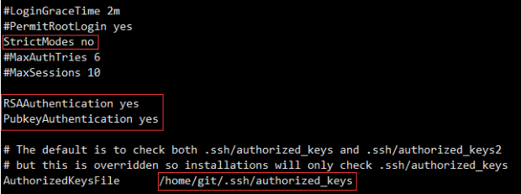
# systemctl restart sshd
登录rancher容器生成密钥对：
# docker exec -it e02a22da13a9 /bin/bash
root@e02a22da13a9:/# ssh-keygen -t rsa
一路回车即可。
拷贝公钥至server节点的authorized_keys文件中：
root@e02a22da13a9:/# scp /root/.ssh/id_rsa.pub 192.168.233.157:/home/git/.ssh/authorized_keys

查看：
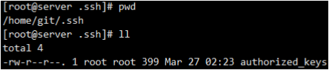
在server节点修改权限，注意此处必须修改为这样的权限，不然会访问不了：
# chmod 700 /home/git/.ssh/
# chmod 600 /home/git/.ssh/authorized_keys
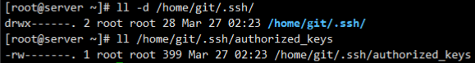

（4）上传文件至git仓库
将模板文件夹拷贝到本地git仓库目录中：
# cp -r definecatalog/* /home/git/project/definecatalog.git/
上传文件
# cd /home/git/project/definecatalog.git/
# git init
# git add .
# git remote add origin git@192.168.233.157:/home/git/project/definecatalog.git/
# git config --global user.email "yormng@yormng.com"
# git config --global user.name "yormng"
# git commit -m "first commit"
# git push origin master
看到如下字样即为成功：
Everything up-to-date

（5）添加应用商店
系统管理——系统设置——添加应用商店
填写如下：
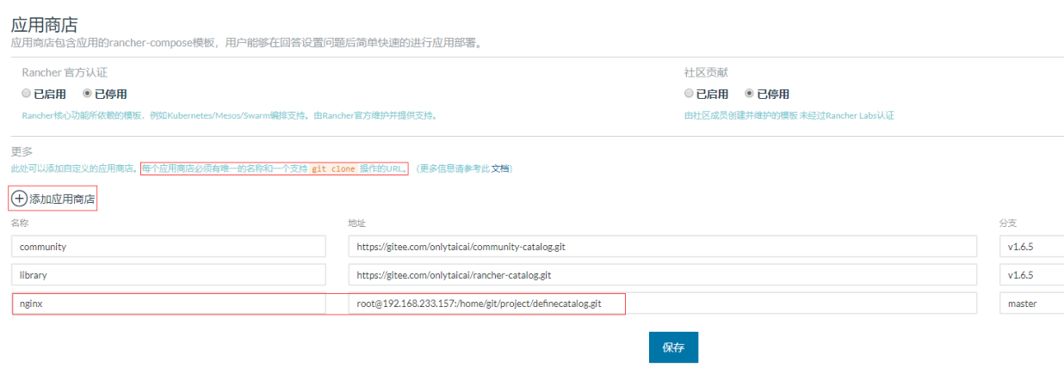
根据提示，地址应该填写一个可以git clone操作的url。
刷新界面，即可看到新添加的应用：
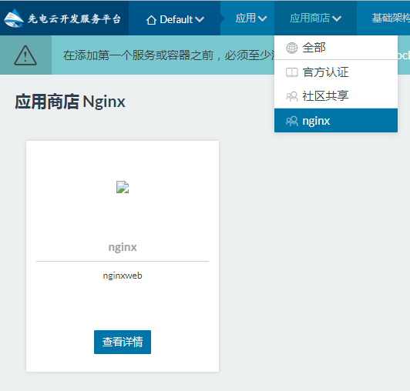
Note：我这里没有给catalogIcon-*.svg内容，所以没有logo显示出来。

（6）成果验证
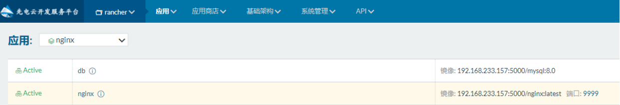

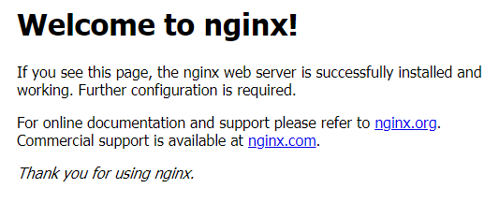
可以看到应用里的两个容器正常启动，9999端口也可以正常访问。
并且数据库容器中已链接到nginx：
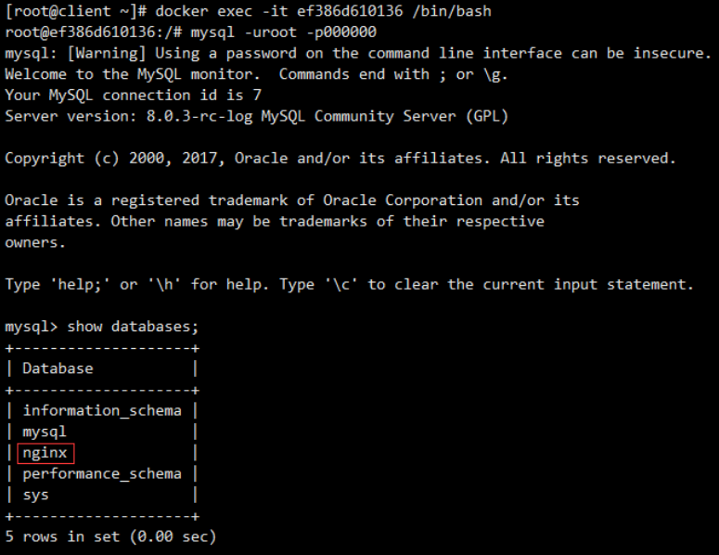

三.自定义Ambari服务

（一）Ambari服务增加自定义服务

任务描述
1.创建服务目录结构
2.编辑metainfo.xml
3.编写Master组件生命周期回调脚本
4.编写Slave组件生命周期回调脚本
5.重启ambari-server
6.页面添加服务

任务实施

1.环境介绍
知识讲解：Ambari Server 会读取 Stack 和 Service 的配置文件。当用 Ambari 创建服务的时候，Ambari Server 传送 Stack 和 Service 的配置文件以及 Service 生命周期的控制脚本到Ambari Agent。Agent 拿到配置文件后，会下载安装公共源里软件包（Redhat，就是使用 yum 服务）。安装完成，Ambari Server 会通知 Agent 去启动 Service。之后Ambari Server 会定期发送命令到 Agent 检查 Service 的状态，Agent 上报给 Server，并呈现在 Ambari 的 GUI 上。
镜像源：centos 7-1511 ；XianDian-BigData-v2.2.iso
两个节点：192.168.233.131 master；192.168.233.132 slave1

2.开始
在master节点完成所有内容。

（1）创建服务目录结构
# cd /var/lib/ambari-server/resources/stacks/HDP/2.6/services
# mkdir MYSERVICE
# cd MYSERVICE
# tree .
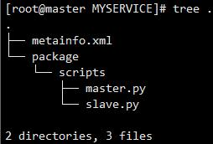

（2）编辑metainfo.xml
# cat metainfo.xml
<?xml version="1.0"?>
<metainfo>
<schemaVersion>2.0</schemaVersion>
<services>
<service>
<!-- -->
<!-- 编写Service名称和Service信息 -->
<name>MYSERVICE</name>
<displayName>My Service</displayName>
<comment>this is comment</comment>
<version>1.0</version>
<components>
<component>
<!-- 编写Master组件 -->
<name>MYMASTER</name>
<displayName>My Master</displayName>
<category>MASTER</category>
<cardinality>1</cardinality>
<commandScript>
<script>scripts/master.py</script>
<scriptType>PYTHON</scriptType>
<timeout>5000</timeout>
</commandScript>
</component>
<component>
<!-- 编写Slave组件 -->
<name>MYSALVE</name>
<displayName>My Slave</displayName>
<category>SLAVE</category>
<cardinality>1+</cardinality>
<commandScript>
<script>scripts/slave.py</script>
<scriptType>PYTHON</scriptType>
<timeout>5000</timeout>
</commandScript>
</component>
</components>
<osSpecifics>
<osSpecific>
<osFamily>any</osFamily>
</osSpecific>
</osSpecifics>
</service>
</services>
</metainfo>

几个标签的说明：
- components 下编写多个组件。
- category 为组件的角色，支持Master、Slave、和Client
- cardinality 为节点数量，可以为1、1+、或数值范围1-2
- commandScript 为组件生命周期回调的脚本

（3）编写Master组件生命周期回调脚本
# cat master.py
import sys, os
from resource_management import *
from resource_management.core.exceptions import ComponentIsNotRunning
from resource_management.core.environment import Environment
from resource_management.core.logger import Logger

class Master(Script):
def install(self, env):
print "Install My Master"

def configure(self, env):
print "Configure My Master"

def start(self, env):
print "Start My Master"

def stop(self, env):
print "Stop My Master"

def status(self, env):
print "Status..."

if __name__ == "__main__":
Master().execute()

（4）编写Slave组件生命周期回调脚本
# cat slave.py
import sys, os
from resource_management import *
from resource_management.core.exceptions import ComponentIsNotRunning
from resource_management.core.environment import Environment
from resource_management.core.logger import Logger

class Slave(Script):
def install(self, env):
print "Install My Slave"

def configure(self, env):
print "Configure My Slave"

def start(self, env):
print "Start My Slave"

def stop(self, env):
print "Stop My Slave"

def status(self, env):
print "Status..."

if __name__ == "__main__":
Slave().execute()

（5）重启ambari-server
# ambari-server restart

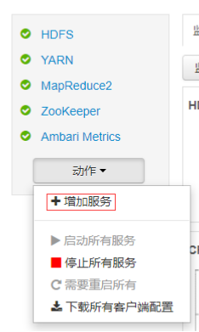

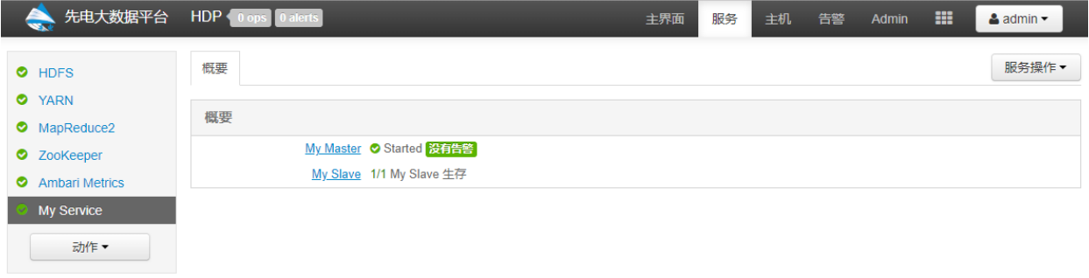
验证新添加My Service成功。

四.小程序后台服务开发

（一）微信小程序后台接口开发

任务实施

1.商品列表接口示例（在xueqing-client工程中开发）
案例界面实现详见《先电云计算软件服务-O2O商城小程序应用开发手册》手册，手册说明实现商品列表的的wxml、wxss、js的文件编写方法。以下说明本功能实现对接数据库的后台服务开发过程，本案例利用xueqing-client项目基础之上的参考实现，也可以使用PC的开发环境自己构建。

2.建表
Sql如下；
/*
MySQL Data Transfer
Source Host: 192.168.0.108
Source Database: wachat_mini_program
Target Host: 192.168.0.108
Target Database: wachat_mini_program
Date: 2019/5/5 15:41:00
*/

SET FOREIGN_KEY_CHECKS=0;
-- ----------------------------
-- Table structure for commodity
-- ----------------------------
CREATE TABLE `commodity` (
`id` bigint(20) NOT NULL AUTO_INCREMENT,
`content` varchar(255) DEFAULT NULL,
`flag` int(11) DEFAULT NULL,
`img` varchar(255) DEFAULT NULL,
`imgs` varchar(255) DEFAULT NULL,
`name` varchar(255) DEFAULT NULL,
`price` varchar(255) DEFAULT NULL,
PRIMARY KEY (`id`)
) ENGINE=MyISAM AUTO_INCREMENT=12 DEFAULT CHARSET=utf8;

-- ----------------------------
-- Records
-- ----------------------------
INSERT INTO `commodity` VALUES ('1', 'Android云存储客户端开发', '0', '/imgs/android-down.jpg', '/imgs/android-down.jpg,/imgs/android-down.jpg', 'Android云存储客户端开发', '48.00');
INSERT INTO `commodity` VALUES ('2', 'Docker容器技术与应用', '0', '/imgs/docker-down.jpg', '/imgs/docker-down.jpg,/imgs/docker-down.jpg', 'Docker容器技术与应用', '60.00');
INSERT INTO `commodity` VALUES ('3', 'Hadoop大数据平台构建和应用', '0', '/imgs/hadoop-down.jpg', '/imgs/android-down.jpg,/imgs/hadoop-down.jpg', 'Hadoop大数据平台构建和应用', '75.00');
INSERT INTO `commodity` VALUES ('4', '云存储技术与应用', '0', '/imgs/ycc-down.jpg', '/imgs/ycc-down.jpg,/imgs/ycc-down.jpg', '云存储技术与应用', '40.00');
INSERT INTO `commodity` VALUES ('5', '软件定义网络（SDN）技术与应用', '0', '/imgs/sdn-down.jpg', '/imgs/sdn-down.jpg,/imgs/sdn-down.jpg', '软件定义网络（SDN）技术与应用', '56.00');

在数据库添加表commodity，表结构如下图：
字段 | 类型 | 备注
id | BIGINT NOT NULL | 主键
content | VARCHAR(255) | 简介
img | VARCHAR(255) | 图片
name | VARCHAR(255) | 名称
price | VARCHAR(255) | 价格
imgs | VARCHAR(255) | 轮播图片

3.后端接口开发
在com.xiandian.cloud.entity.core包下新建Commodity.java文件，如下：
package com.xiandian.cloud.entity.core;

import javax.persistence.Entity;
import javax.persistence.Table;

import com.xiandian.cloud.entity.BaseEntity;

@Entity
@Table(name = "commodity")
public class Commodity extends BaseEntity {
private String content;
private int flag;
private String img;
private String imgs;
private String name;
private String price;

public String getContent() {
return content;
}

public void setContent(String content) {
this.content = content;
}

public int getFlag() {
return flag;
}

public void setFlag(int flag) {
this.flag = flag;
}

public String getImg() {
return img;
}

public void setImg(String img) {
this.img = img;
}

public String getImgs() {
return imgs;
}

public void setImgs(String imgs) {
this.imgs = imgs;
}

public String getName() {
return name;
}

public void setName(String name) {
this.name = name;
}

public String getPrice() {
return price;
}

public void setPrice(String price) {
this.price = price;
}

}

在com.xiandian.cloud.dao.core包下新建CommodityDao.java文件，如下：
package com.xiandian.cloud.dao.core;

import java.util.List;

import org.springframework.stereotype.Repository;

import com.xiandian.cloud.dao.BaseDao;
import com.xiandian.cloud.entity.core.Commodity;

@Repository
public class CommodityDao extends BaseDao<Commodity> {
public List<Commodity> getAll() {
String hql = "from Commodity";
return find(hql);

}
}

在com.xiandian.cloud.service包下新建CommodityService.java文件，如下：
package com.xiandian.cloud.service;

import java.util.List;

import org.springframework.beans.factory.annotation.Autowired;
import org.springframework.stereotype.Service;

import com.xiandian.cloud.dao.core.CommodityDao;
import com.xiandian.cloud.entity.core.Commodity;

@Service
public class CommodityService {
@Autowired
private CommodityDao commodityDao;

public List<Commodity> getAll(){
return commodityDao.getAll();
}
}

在com.xiandian.cloud.web包下新建WechatController.java文件，如下：
package com.xiandian.cloud.web;

import org.springframework.beans.factory.annotation.Autowired;
import org.springframework.stereotype.Controller;
import org.springframework.web.bind.annotation.RequestMapping;
import org.springframework.web.bind.annotation.ResponseBody;

import com.xiandian.cloud.common.bean.MessageBean;
import com.xiandian.cloud.service.CommodityService;

@Controller
@RequestMapping("/wetchat")
public class WechatController {
@Autowired
private CommodityService commodityService;

@RequestMapping("/commodity/list")
@ResponseBody
public MessageBean getCommodityList() {
return new MessageBean(true, "", commodityService.getAll());

}
}

运行结果如下：
{"success":true,"msg":"","other":[
{"id":1,"content":"Android云存储客户端开发","flag":0,"img":"/imgs/android-down.jpg","imgs":"/imgs/android-down.jpg,/imgs/android-down.jpg","name":"Android云存储客户端开发","price":"48.00"},
{"id":2,"content":"Docker容器技术与应用","flag":0,"img":"/imgs/docker-down.jpg","imgs":"/imgs/docker-down.jpg,/imgs/docker-down.jpg","name":"Docker容器技术与应用","price":"60.00"},
{"id":3,"content":"Hadoop大数据平台构建和应用","flag":0,"img":"/imgs/hadoop-down.jpg","imgs":"/imgs/android-down.jpg,/imgs/hadoop-down.jpg","name":"Hadoop大数据平台构建和应用","price":"75.00"},
{"id":4,"content":"云存储技术与应用","flag":0,"img":"/imgs/ycc-down.jpg","imgs":"/imgs/ycc-down.jpg,/imgs/ycc-down.jpg","name":"云存储技术与应用","price":"40.00"},
{"id":5,"content":"软件定义网络（SDN）技术与应用","flag":0,"img":"/imgs/sdn-down.jpg","imgs":"/imgs/sdn-down.jpg,/imgs/sdn-down.jpg","name":"软件定义网络（SDN）技术与应用","price":"56.00"},
{"id":6,"content":"JavaWeb云应用开发","flag":0,"img":"/imgs/javaweb-down.jpg","imgs":"/imgs/javaweb-down.jpg,/imgs/javaweb-down.jpg","name":"JavaWeb云应用开发","price":"92.00"},
{"id":7,"content":"云计算综合运维管理","flag":0,"img":"/imgs/yjszhywgl-down.jpg","imgs":"/imgs/yjszhywgl-down.jpg,/imgs/yjszhywgl-down.jpg","name":"云计算综合运维管理","price":"51.00"},
{"id":8,"content":"视频直播APP应用开发","flag":0,"img":"/imgs/videoapp.jpg","imgs":"/imgs/videoapp.jpg,/imgs/videoapp.jpg","name":"视频直播APP应用开发","price":"45.00"},
{"id":9,"content":"微信小程序应用开发","flag":0,"img":"/imgs/wechat-down.jpg","imgs":"/imgs/wechat-down.jpg,/imgs/wechat-down.jpg","name":"微信小程序应用开发","price":"26.00"},
{"id":10,"content":"人脸识别和美化应用开发","flag":0,"img":"/imgs/rlsb.jpg","imgs":"/imgs/rlsb.jpg,/imgs/rlsb.jpg","name":"人脸识别和美化应用开发","price":"29.00"},
{"id":11,"content":"大数据分析应用开发","flag":0,"img":"/imgs/dsjfx.jpg","imgs":"/imgs/dsjfx.jpg,/imgs/dsjfx.jpg","name":"大数据分析应用开发","price":"120.00"}]}

4.小程序端
数据请求，在list.js代码如下：
const app = getApp()
Page({
data:{
url:'',
goods:[],
imgUrls: [
{
url: '/res/manager/tabs/bg1.jpg'
}, {
url: '/res/manager/tabs/bg2.jpg'
}
],
indicatorDots: true,
autoplay: true,
interval: 5000,
duration: 1000,
searchValue:'',
isLogin:false
},

// 链接到详情页
detail:function(e){
var data = e.target.dataset;
wx.navigateTo({ url: '/pages/store/products/detail/detail?id=' + data.id });
},

// 链接到搜索页
search: function (e) {
var datas = this.data.searchValue;
wx.navigateTo({ url: '/pages/store/products/search/search?key=' + datas });
},

inputeidt: function (e) {
console.log(e)
this.setData({
searchValue: e.detail.value,
})
},

// 获取商品列表
getlist: function (e) {
var that = this
wx.request({
url: app.globalData.url + "/wechat/commodity/list",
method: "post",
success: function (res) {
console.log(res)
if (res.data. success== true) {
let list = res.data.other //此处res.data为后端返回值，前端可以此处进行数据的处理
that.setData({
goods: list,
})
console.log(that.data.goods[0].corver)
}
else {
wx.showToast({
title: '加载失败',
icon: 'loading'
})
}
}
})
},

onShow: function () {
this.getlist()
this.setData({
url: app.globalData.url,
isLogin: app.globalData.hasLogin,
})
console.log(this.data.isLogin)
},
onHide: function () {
console.log("onHide")
},
});
app.js添加如下代码：
App({
onLaunch: function () {
console.log('App Launch')
},
onShow: function () {
console.log('App Show')
},
onHide: function () {
console.log('App Hide')
},
globalData: {
hasLogin: false,
url: 'http://127.0.0.1:8080',
userId:'',
userName:'',
homeaddress:'',
companyaddress:'',
Name:'',
balance:'0',
cardnumber:'',
phone:''
},

})

效果如下图：
