**Spike 02 outcomes**

**Name: Achieve connectivity between pc and esp8266 chip**

**Goals:**

Example: The goal is for the team to be able to wire the correct pins to power the chip and connect i/o with pc.

**Personnel:**

primary – Edward

secondary - Adam

**Technologies, Tools, and Resources used:**

* **https://github.com/geekscape/nodemcu_esp8266/tree/master/workshop_1**
* **Vcc 3.3v serial USB interface**
* **Esptool:** [**https://github.com/themadinventor/esptool**](https://github.com/themadinventor/esptool)
* **Pytool:** [**http://pyserial.sourceforge.net/**](http://pyserial.sourceforge.net/)
* **Esplorer:** [**http://esp8266.ru/esplorer**](http://esp8266.ru/esplorer)

**Tasks undertaken:**

Using a freetronics USB-Serial adaptor, a laptop and an ESP12 full evaluation board:

IMPORTANT Make sure voltage on adaptor is set to 3.3V to avoid damaging the chip.

Used male-to-female jumper leads to connect: Rx to Rx, Tx to Tx, GND to GND and VOUT to VCC. (Rx and Tx are labelled wrongly on the evaluation board, so the above wiring arrangement which would normally be wrong was needed to have a serial communication).

Started ESPlorer (an open source IDE for the ESP8266) and used the serial connection to send commands and view output on the device.

**What we found out:**

Gained valuable hands-on experience with the device.

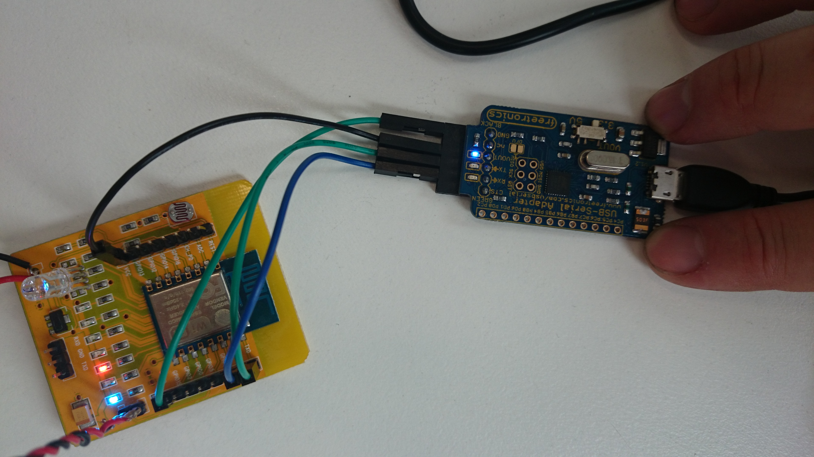

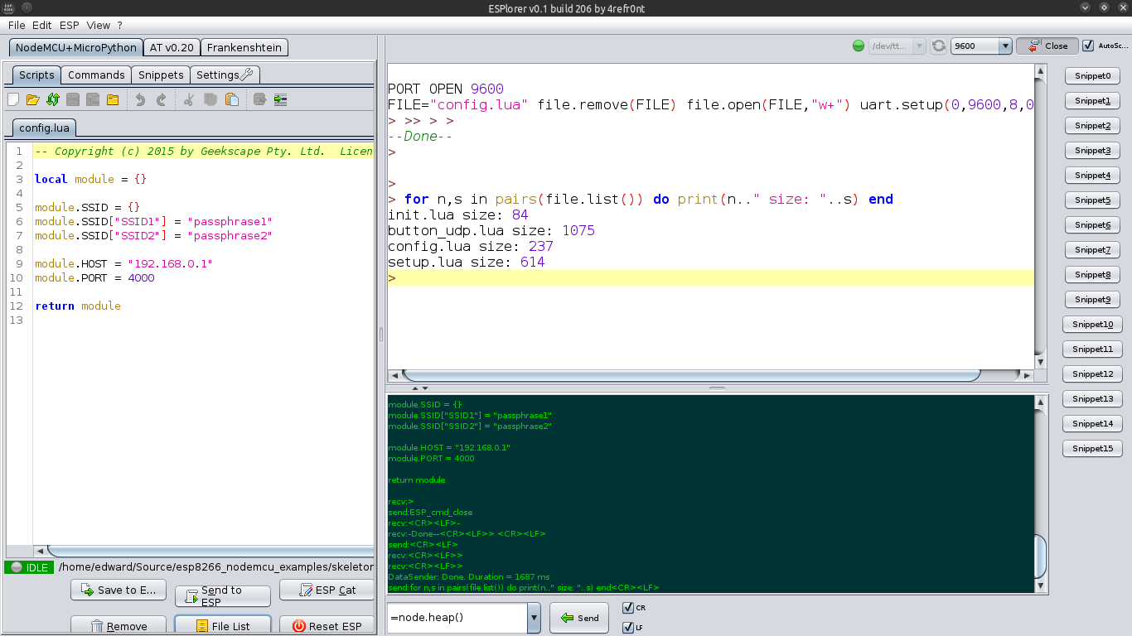

**Open issues/risks [Optional]:**

* We observed a problem where having a particular button attached would prevent the serial connection from working. This is something to be aware of in the future.