Screenshot
Assignment 2 Technical Analysis using R, Preliminary Stage
Step1
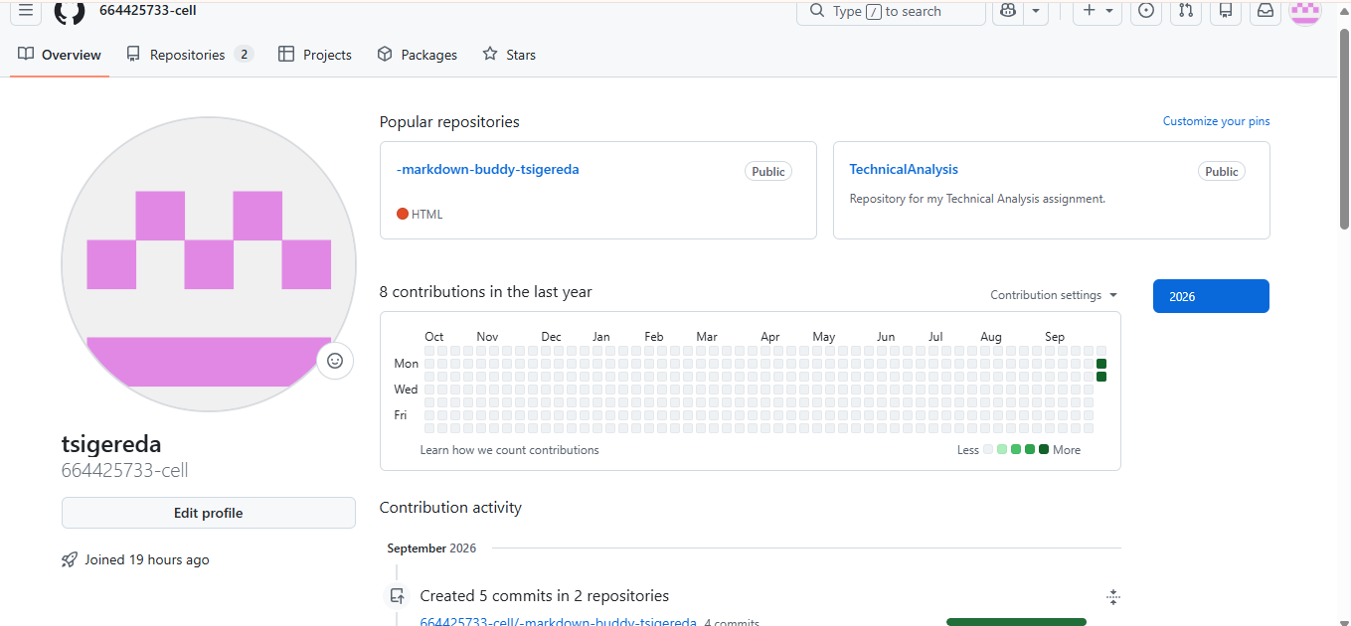
were already installed on my computer
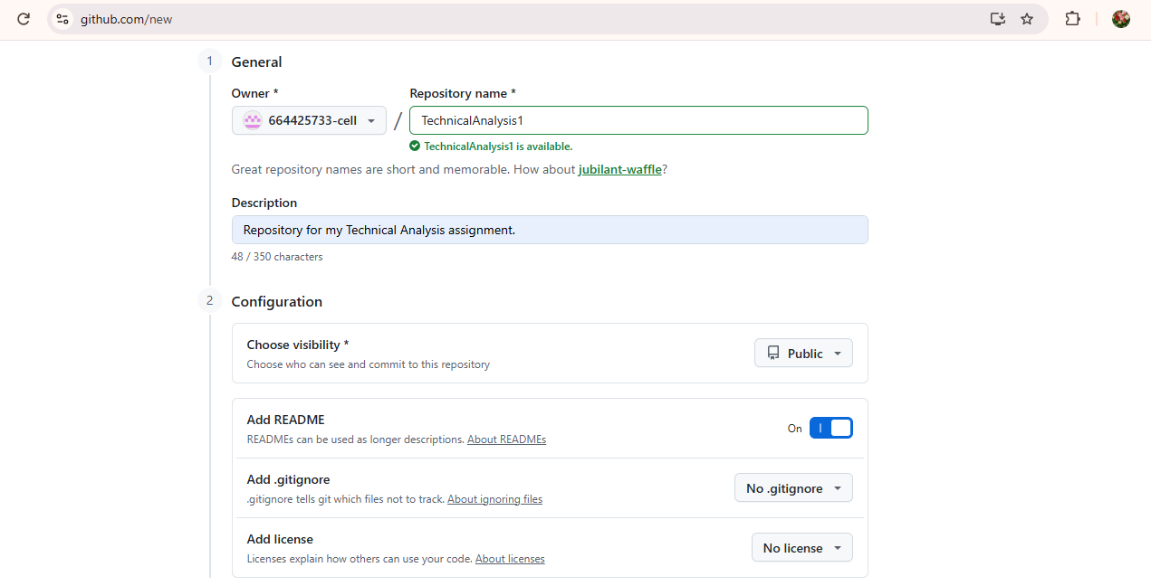

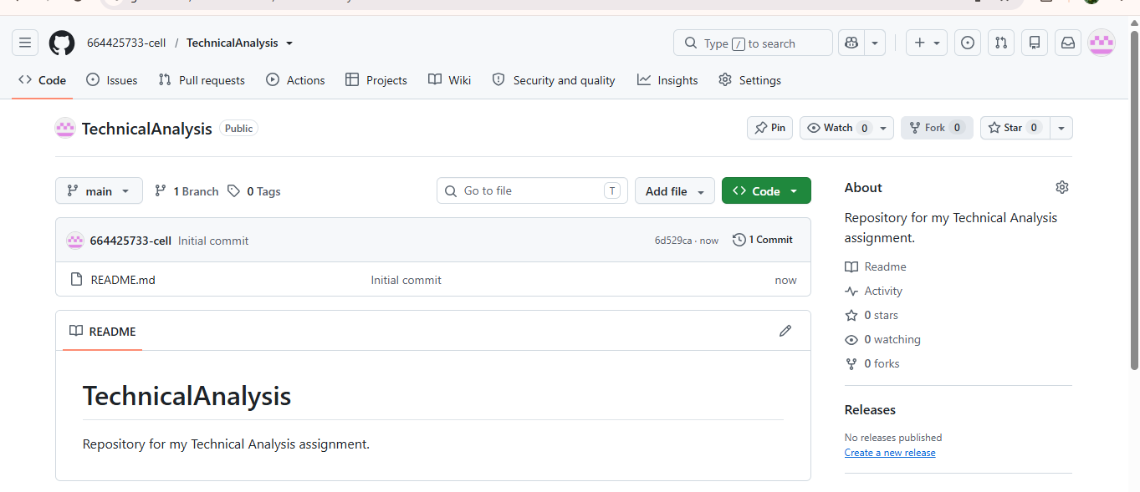
Shows that I Create a new repository named 'TechnicalAnalysis'

Step 2
R and RStudio were already installed on my computer. To verify the installation, I opened RStudio and ran the version command in the console. The output confirmed that R version 4.6.1 (‘Happy Hop’) is installed and configured correctly. The screenshots below demonstrate that both applications are ready for use in this assignment.”
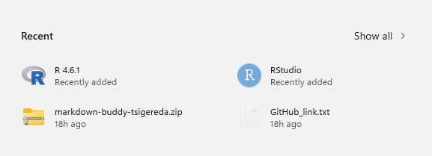 Screenshot showing R and RStudio successfully installed on my computer.
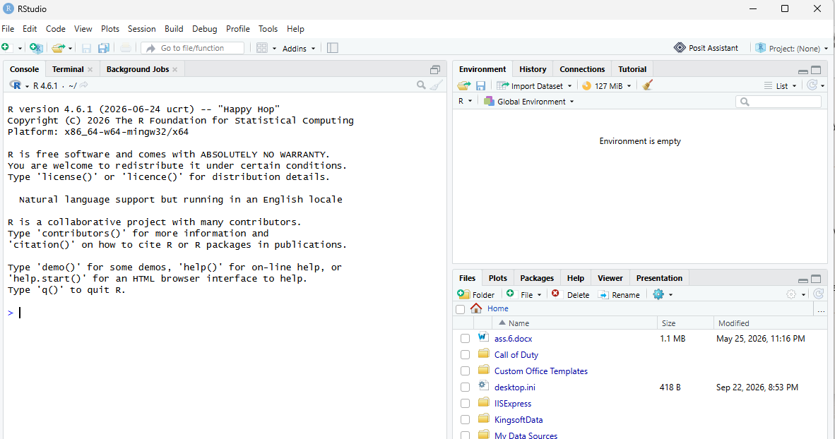
RStudio interface confirming successful installation.
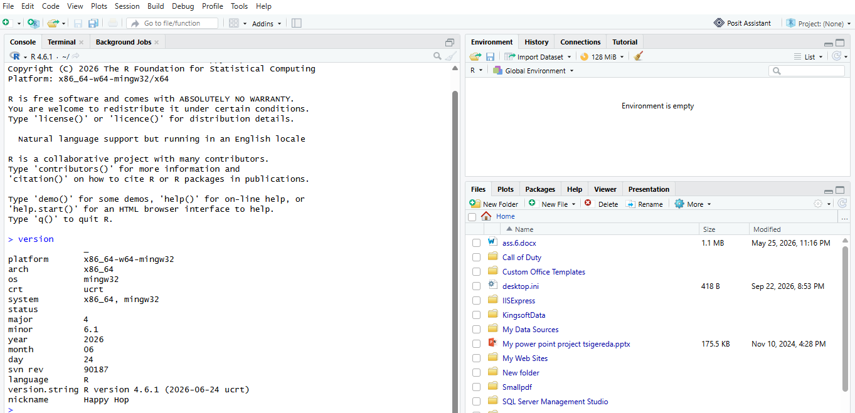
Verification of R version 4.6.1 using the version command.
Step 3
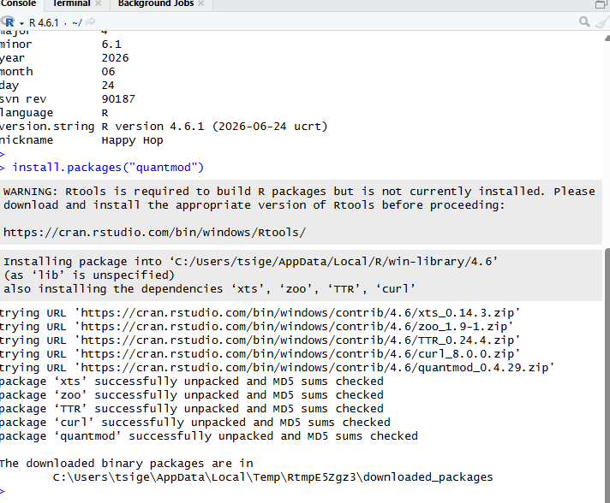
Installing R packages for technical analysis using install. Packages("quantmod"). Dependencies ‘xts,’ ‘zoo,’ ‘TTR,’ and ‘curl’ were automatically installed.”
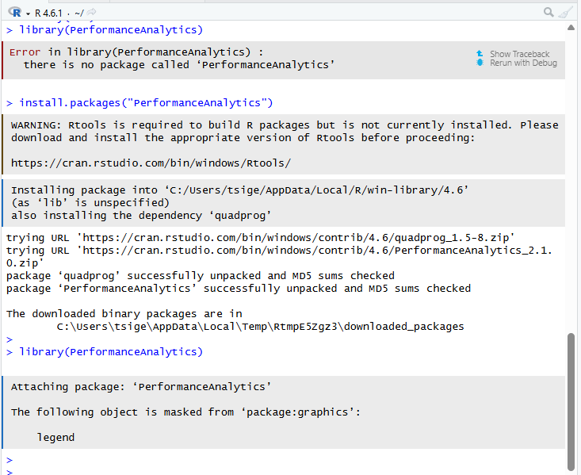
Installing and verifying the ‘Performance Analytics’ package for technical analysis in R.”
Step 4
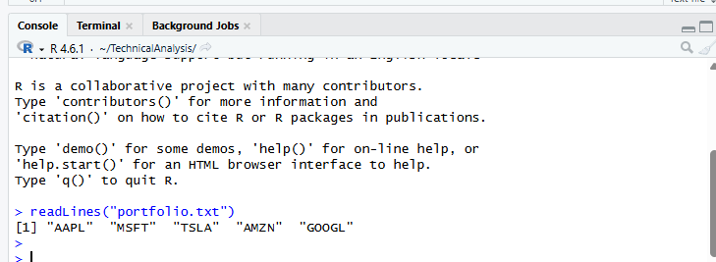
After creating the portfolio.txt file inside the TechnicalAnalysis project, I verified its contents using the readLines() function in RStudio. The output displayed the stock symbols AAPL, MSFT, TSLA, AMZN, and GOOGL, confirming that the file was correctly saved and accessible within the project environment.
Step 5
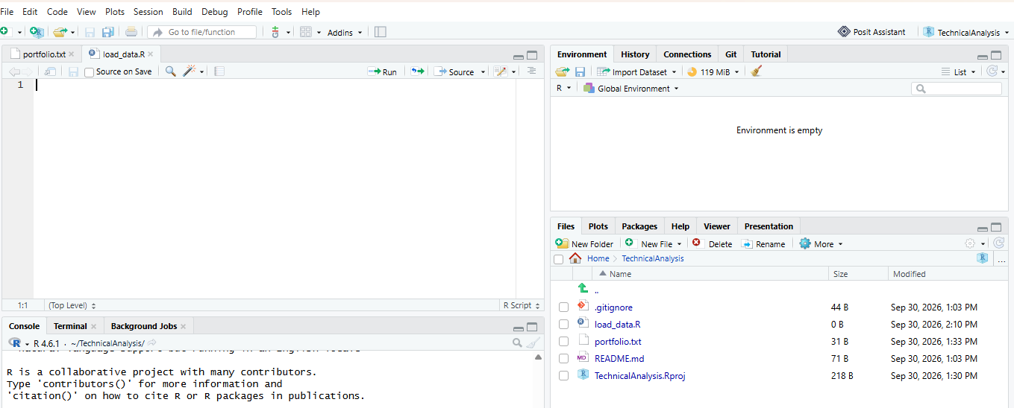

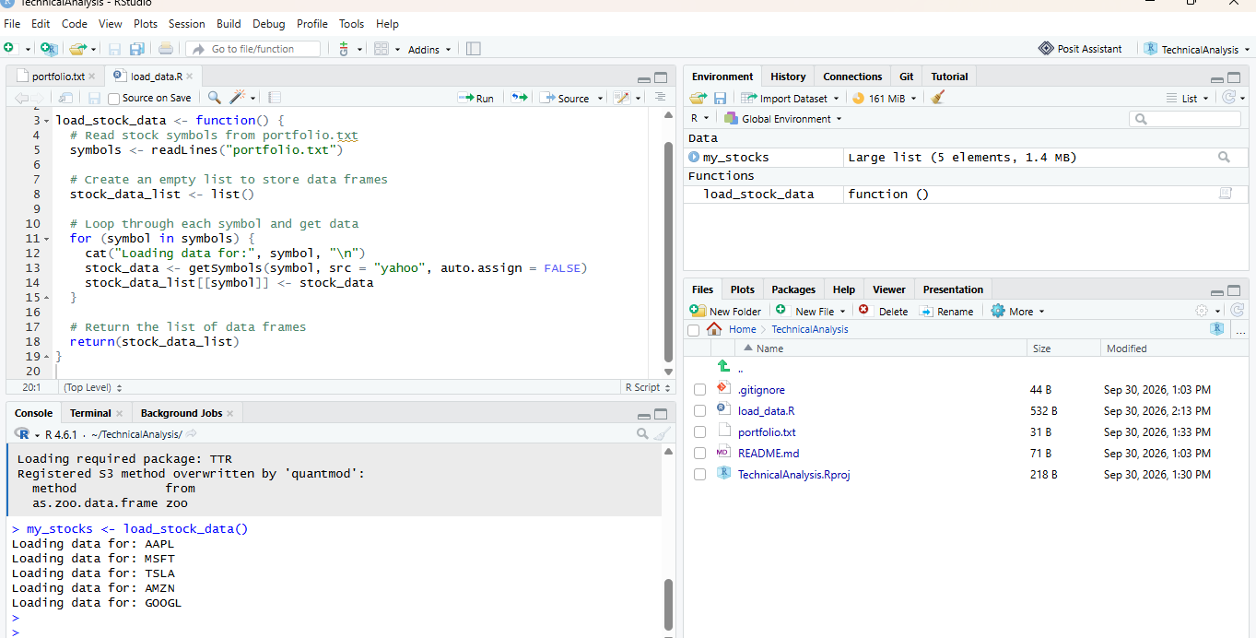
Execution of load_stock_data() function in RStudio. The function successfully imported stock data for all symbols listed in portfolio.txt.
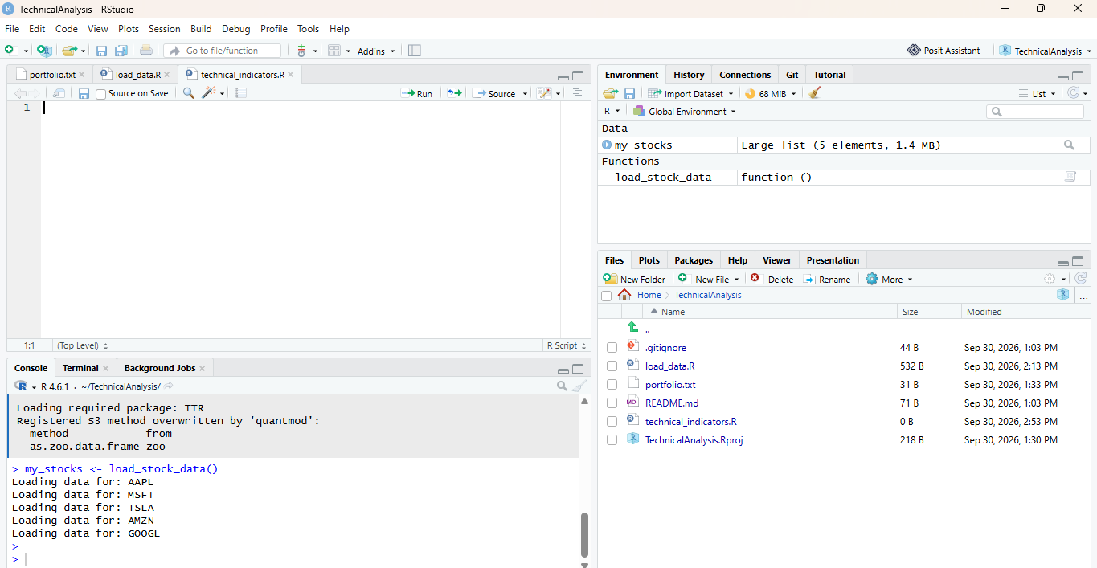

Step 6
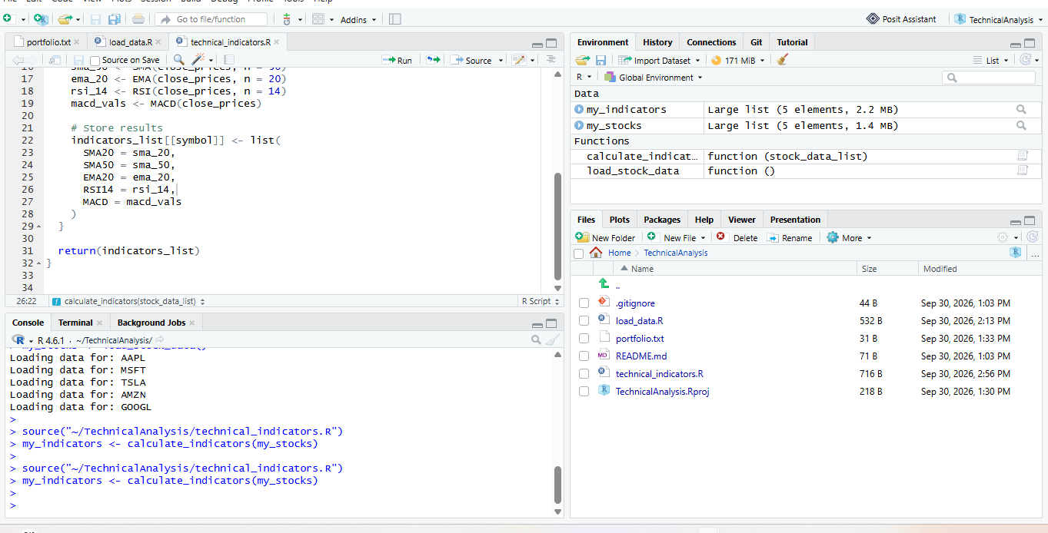
Execution of calculate indicators() function in RStudio. The function successfully computed technical indicators (SMA, EMA, RSI, MACD) for all portfolio stocks.”
Step7
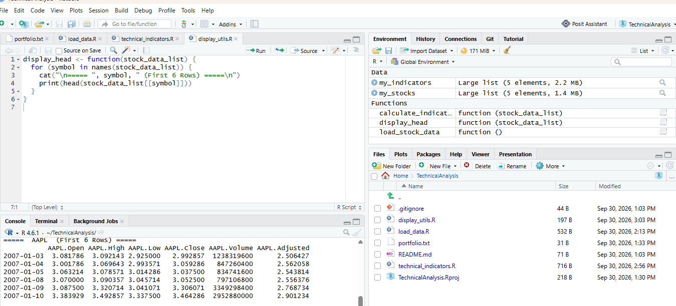
Use the images showing the console output for each stock (AAPL).
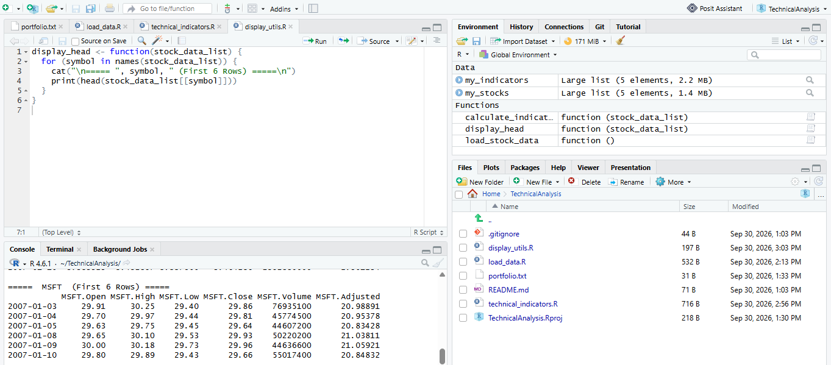
Use the images showing the console output for each stock ( MSFT).
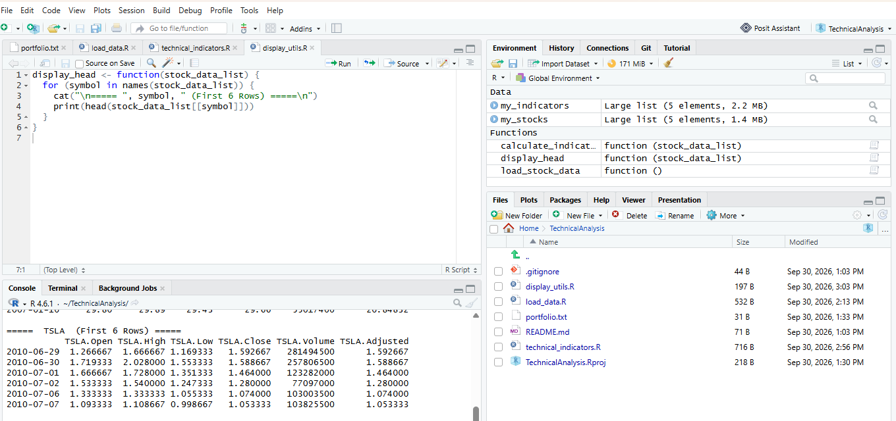
Use the images showing the console output for each stock ( TSLA ).
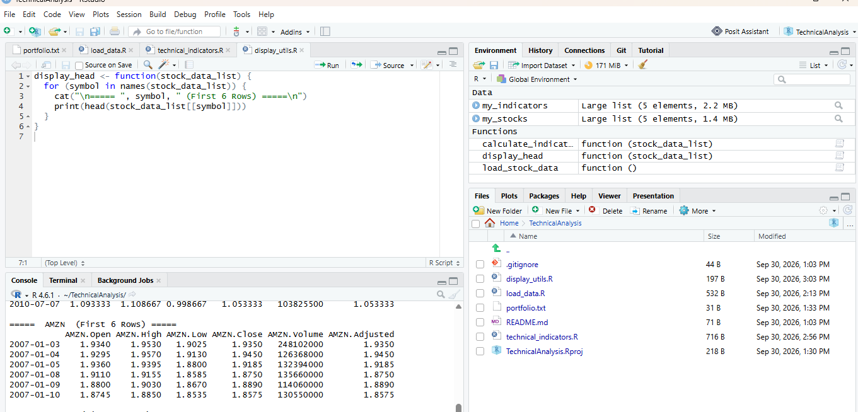
Use the images showing the console output for each stock (AMZN).
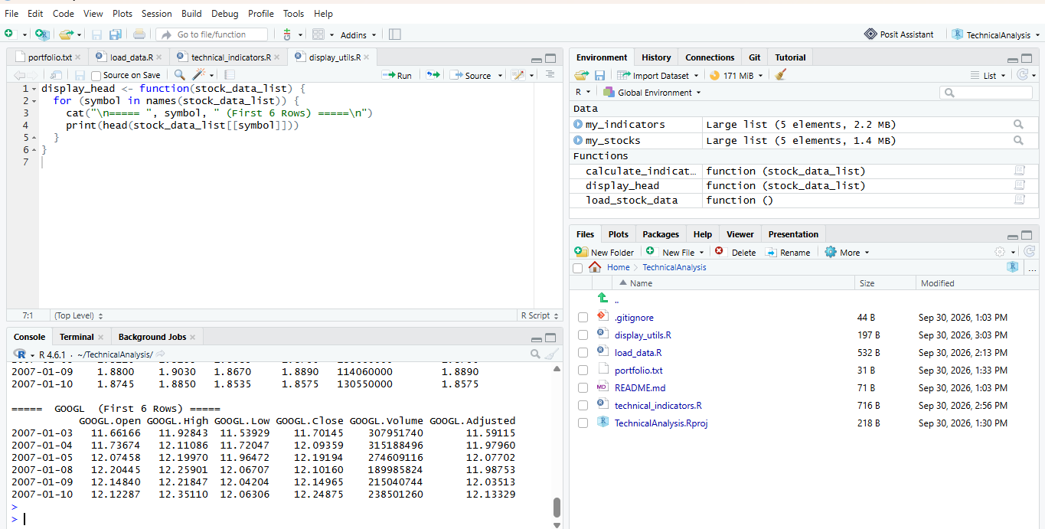
Use the images showing the console output for each stock ( GOOGL).
Purpose
To create customized functions that display the loaded stock data frames for each symbol, showing their respective information in a clear, tabular format similar to Yahoo Finance.
Explanation
In Step 7, I developed a utility function named display_head() to display the first six rows of each stock’s dataset. This function loops through all stock symbols stored in my_stocks and prints their respective data frames, including columns for Open, High, Low, Close, Volume, and Adjusted prices. The output provides a concise overview of each stock’s historical data, similar to how Yahoo Finance presents market information.

