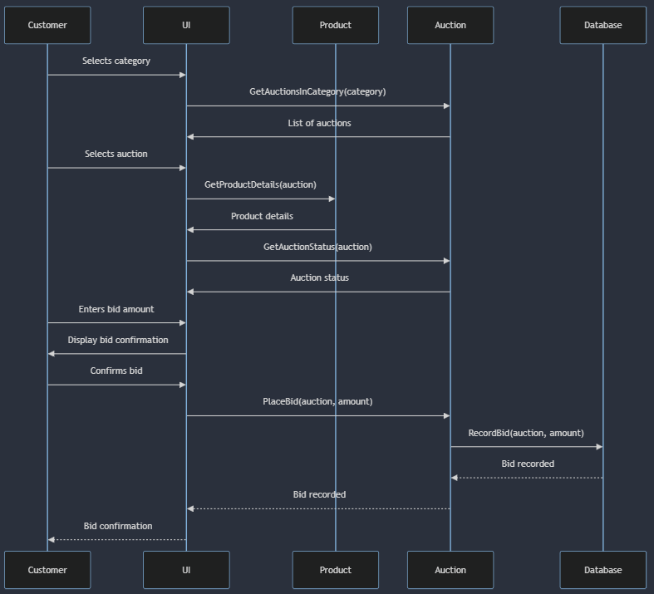Without Extension Scenario

Extension Scenario A: No open auctions

2a. System does not find any open auctions in the category the user has chosen.

3a. System asks the user to choose a different category.

