|  |  |  |  |  |  |
| --- | --- | --- | --- | --- | --- |
|  | each A 对应 _ B | each B 对应 _ A | _A 对应 _B | relationship primary key | table |
| A -- <> -- B | 0..* | 0..* | many-to-many | A.pk∪B.pk | A, A.pk∪B.pk(∪r.attr), B |
| A -- <> --> B | 0..1 | 0..* | many-to-one | A.pk | A∪B.pk(∪r.attr), B |
| A <-- <> --> B | 0..1 | 0..1 | one-to-one | A.pk / B.pk | extra added to either |
| A == <> -- B | 1..* | 0..* |  |  |  |
| A == <> --> B | 1..1 | 0..* |  |  |  |
| A -- <> ==> B | 0..1 | 1..* |  |  |  |
| A == <> ==> B | 1..1 | 1..* |  |  |  |
| ||A||== <<>> --> B | 1..1 | 0..* |  | A.pk∪B.pk | A∪B.pk, B |
| B <--<<>>==||A||== <> --> C |  |  |  |  | B, (A∪B.pk)∪C.pk, C |
|  |  |  |  |  |  |
| specialization  A<|-B1, <|-B2 |  |  |  |  | 1. A, A.pk∪B1, A.pk∪B2  2. A, A∪B1, A∪B2 |
| aggregation  [B1 B2 B3 <r1>] --<r2>-- A |  |  |  |  | r2: A.pk∪B1.pk∪B2.pk∪B3.pk(∪r2.attr) |

left1..right1 <> left2..right2

left:

|  |  |
| --- | --- |
|  | left i |
| -- | 0 |
| == | 1 |

right

|  |  |  |
| --- | --- | --- |
|  | right 1 | right 2 |
| -, > | 1 | * |
| -, - | * | * |
| <, - | * | 1 |
| <, > | 1 | 1 |

区别：A -- <> --> B:

(1)

0..1 0..*

1个A对应0-1个B

1个B对应0-many个A

(2)

many-to-one

many个A对应1个B

# 小作业

Please modify the ER diagram of University as on p43 of chapter6 ppt, by enforcing the following requirements:

a) Each instructor can work for multiple departments.

b) Each section can only have one instructor to teach.

c) Each instructor can only have at most one student to advise, and each student can only have at most one instructor as his adviser.

d) Each course can only have at most one prerequisite course.

Please give the revised ER diagram, and translate the ER diagram into **EER diagram (the table diagram) using workbench**.

答案会放在文档最后一页

# 小作业原图和修改过后的图

a) Each instructor can work for multiple departments.

b) Each section can only have one instructor to teach.

c) Each instructor can only have at most one student to advise, and each student can only have at most one instructor as his adviser.

d) Each course can only have at most one prerequisite course.

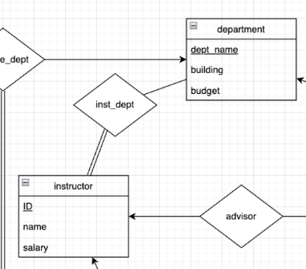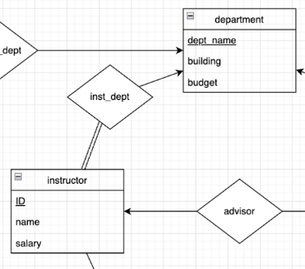a) Each instructor can work for multiple departments.

instructor: { i1, i2 }

|  |  |
| --- | --- |
| instructor | department |
| i1 | d1 |
| i2 | d1 |
| 0 | d2 |

|  |  |
| --- | --- |
| instructor | department |
| i1 | d1 |
| i1 | d2 |
| i2 | d1 |
| i2 | d2 |
| 0 | d3 |

i == <> --> d : 1..1 0..*

i1: {d1}, i2: {d2}

d1: {i1, i2}, d2: 0

i == <> -- d : 1..* 0..*

i1: {d1, d2}, i2: {d1, d2}

d1: {i1, i2}, d2: {i1, i2}, d3: 0

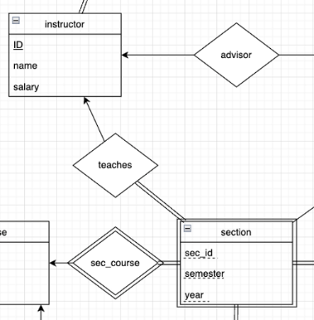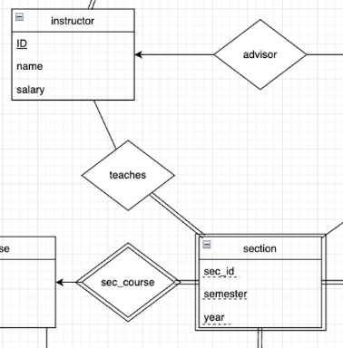b) Each section can only have one instructor to teach.

section: { cs1, cs2 }

|  |  |
| --- | --- |
| course_section | instructor |
| cs1 | i1 |
| cs1 | i2 |
| cs2 | i1 |
| cs2 | i2 |
| 0 | i3 |

|  |  |
| --- | --- |
| course_section | instructor |
| cs1 | i1 |
| cs2 | i1 |
| 0 | i2 |

cs == <> -- i : 1..* 0..*

cs1: {i1, i2}, cs2: {i1, i2}

i1: {cs1, cs2}, i2: {cs1, cs2}, i3: 0

cs == <> --> i : 1..1 0..*

cs1: {i1}, cs2: {i1}

i1: {cs1, cs2}, i2: 0

c <--<<>>==||s||== <> --> i

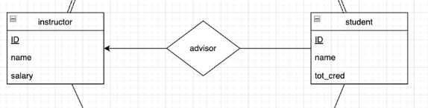c) Each instructor can only have at most one student to advise, and each student can only have at most one instructor as his adviser.

|  |  |
| --- | --- |
| instructor | student |
| i1 | s1 |
| i1 | s2 |
| i2 | 0 |
| 0 | s3 |

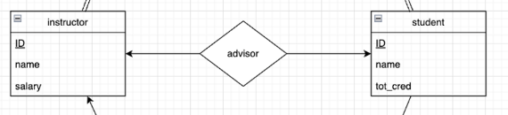

|  |  |
| --- | --- |
| instructor | student |
| i1 | s1 |
| i2 | 0 |
| 0 | s2 |

i <-- <> -- s : 0..* 0..1

i1: {s1, s2}, i2: 0

s1: {i1}, s2: {i1}, s3: 0

i <-- <> --> s : 0..1 0..1

i1: {s1, s2}, i2: 0

s1: {i1}, s2: {i1}, s3: 0

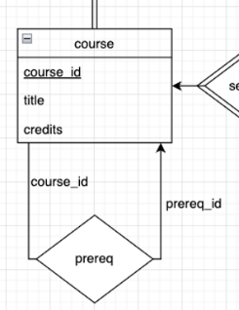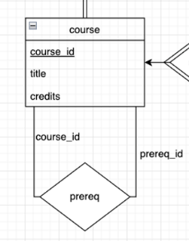d) Each course can only have at most one prerequisite course.

|  |  |
| --- | --- |
| course | pre_course |
| c1 | p1 |
| c1 | p2 |
| c2 | p1 |
| c2 | p2 |
| c3 | 0 |
| 0? | p2 |

|  |  |
| --- | --- |
| course | pre_course |
| c1 | p1 |
| c2 | p1 |
| c3 | 0 |
| 0 | p2 |

c -- <> -- p : 0..* 0..*

c1: {p1, p2}, c2:{p1, p2}, c3: 0

p1: {c1, c2}, p2: {c1, c2}, p3: 0

c -- <> --> p : 0..1 0..*

c1: {p1}, c2:{p1}, c3: 0

p1: {c1, c2}, p2: 0

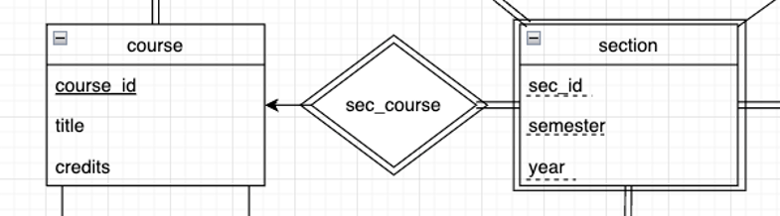

(e) ?

|  |  |
| --- | --- |
| course | section |
| c1 | s1 |
| c1 | s2 |
| c2 | 0 |

c <--<<>>==||s : 0..* 1..1

s||==<<>>--> c : 1..1 0..*

c1: {s1, s2}, c2: 0

s1: {c1}, s2: {c1}

A -- <> -- B : 0..* 0..* many-to-many r.pk: A.pk∪B.pk A, A.pk∪B.pk, B

A -- <> --> B : 0..1 0..* many-to-one r.pk: A.pk A∪B.pk, B

A <-- <> --> B : 0..1 0..1 one-to-one r.pk: A.pk / B.pk

A == <> -- B : 1..* 0..*

A == <> --> B : 1..1 0..*

||A||==<<>>--> B : 1..1 0..* r.pk: A.pk∪B.pk A∪B.pk, B

A <--<<>>==||B||== <> --> C A, (B∪A.pk)∪C.pk, C

|  |  |
| --- | --- |
| attribute | table |
| composite attr  A  A_id  b  b1  b2  c  c1  c11  c12  c2 | A(A_id, b1, b2, c11, c12, c2) |
| multivalued attr  A  A_id  {mva} | A(A_id, …), AM(A_id, mva) |
| derived attr  A  A_id  b  c_CompFrom_b() |  |
|  |  |

# 基本元素

对一、对多 Cardinality

部分参与、全部参与 participation

全部可能有16种情况

# 经典例题

Instructor can advise 0 or more students. A student must have 1 advisor; cannot have multiple advisors

一位老师可以指导多位学生，也可以不指导学生。

每位学生都必须有一位指导老师，但不能有多位指导老师。

可以用下面两种写法，推荐第二种

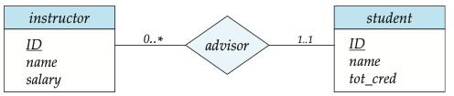

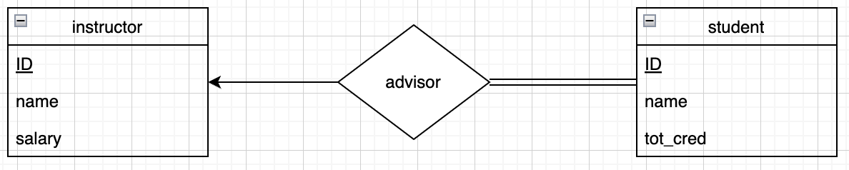（推荐）

课本还额外提及了下面两种写法，但是 **别 用** （附录3，4）

