Flight Ticket Price Predictor

In this project we have implemented all modules given by you like dataset collection, cleaning, training and price prediction. We have collected price dataset from KAGGLE which can be downloaded from below URL

<https://www.kaggle.com/datasets/jillanisofttech/flight-price-prediction-dataset>

Above dataset contains all required columns like travel date, airline name, source and destination city etc. in below screen displaying dataset details

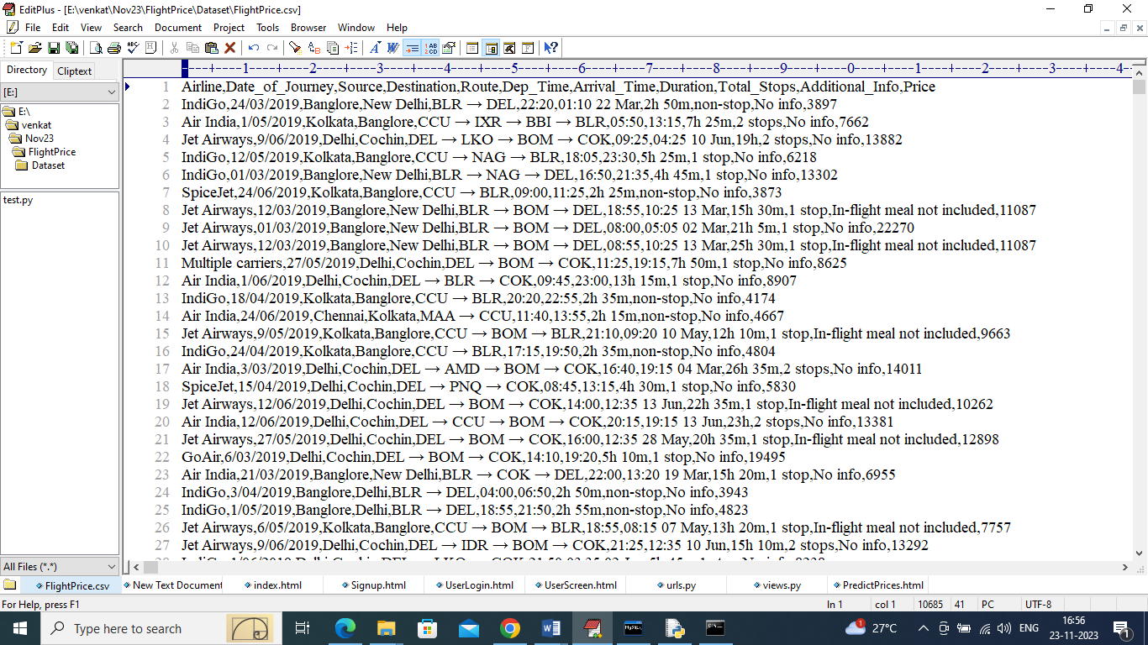

In above dataset screen first row contains dataset column names and remaining rows contains dataset values and by using above dataset we have trained Random Forest Regression algorithm to predict future prices.

We have implemented above topic using DJANGO framework and contains following modules

1. New User Signup Here: using this module user can sign up with the application
2. User Login: using this module user can login to application
3. Dataset Collection & Visualization: using this module user can load and view dataset values and can visualize prices of different airline for source city
4. Cleaning: using this module we will clean dataset like converting non-numeric values to numeric values, shuffling and normalization and then split dataset into train and test. 80% dataset using for training and 20% for testing
5. Train Random Forest: random forest get trained on training data and can predict prices on 20% test data and then visualize graph between predicted and true prices
6. Predict Prices: using this module user can select travel date, airline, source and destination and then application predict flight prices

SCREEN SHOTS

To run project double click on ‘run.bat’ file to start python server and get below page

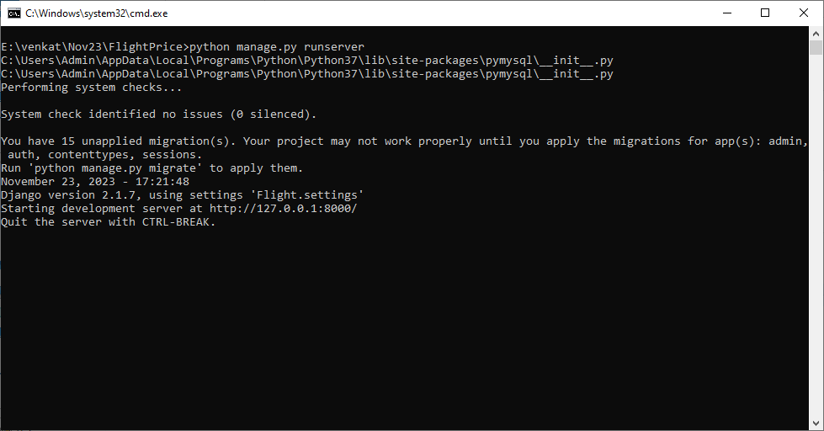

In above screen python DJANGO web server started and now open browser and enter URL as <http://127.0.0.1:8000/index.html> and press enter key to get below page

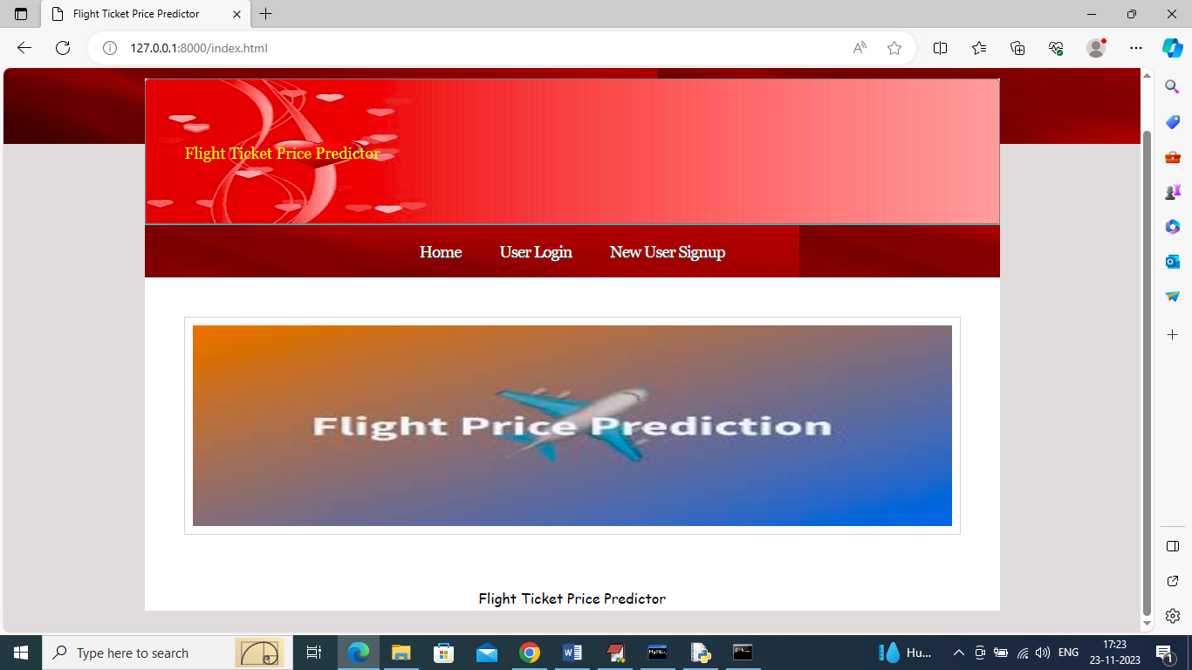

In above screen click on ‘New User Signup’ link to get below signup page

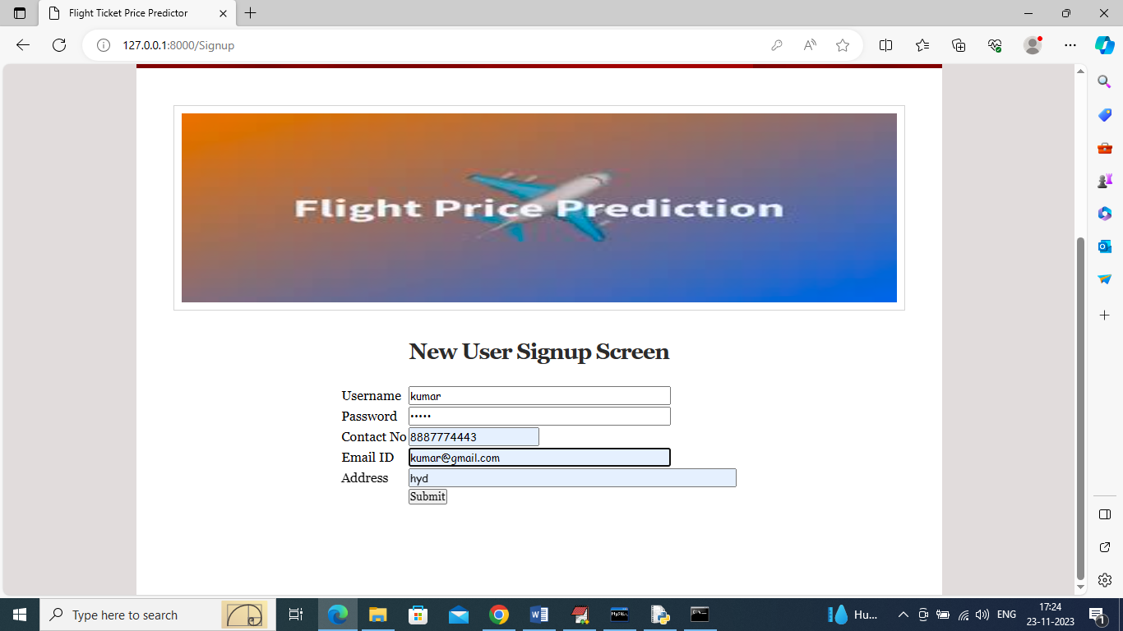

In above screen user is entering signup details and then press button to get below page

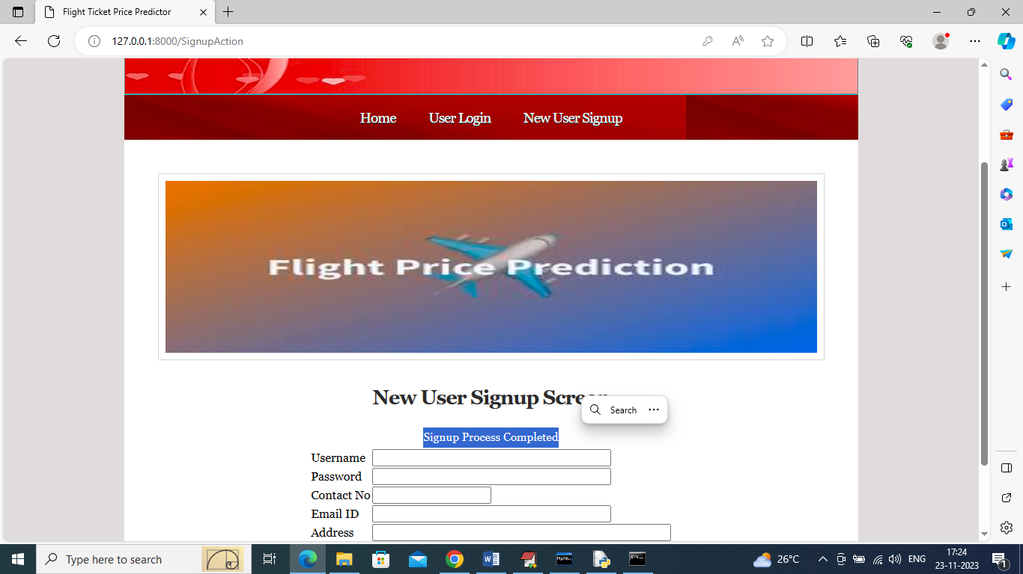

In above screen signup process completed and now click on ‘User Login’ link to get below page

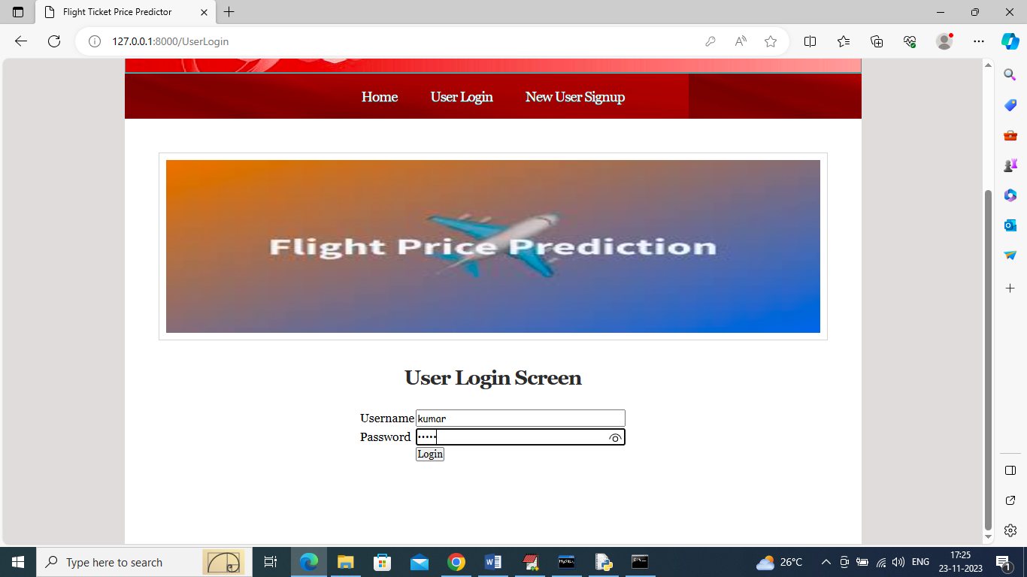

In above screen user is login and after login will get below page

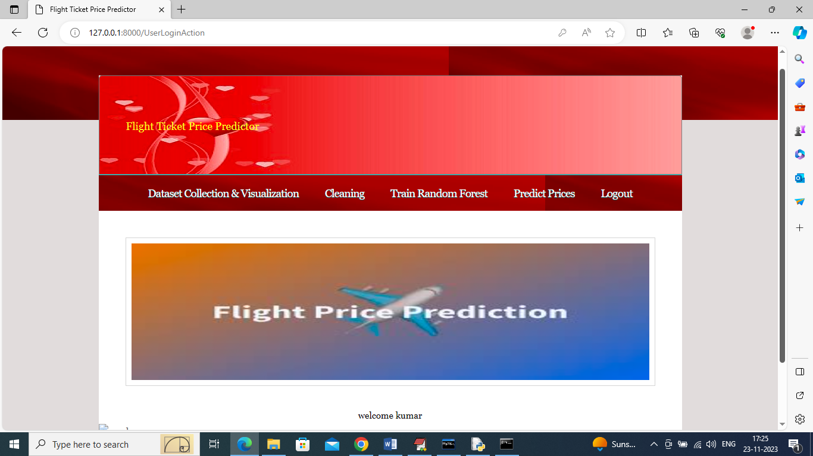

In above screen user can click on ‘Dataset Collection & Visualization’ link to load and visualize prices

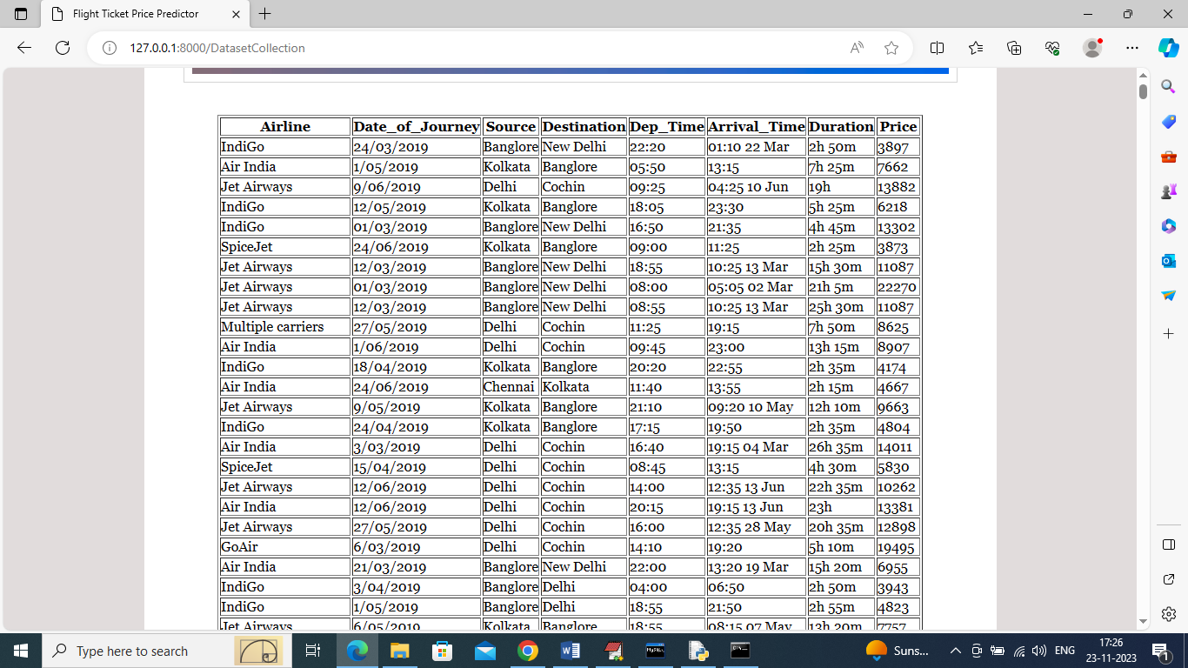

In above screen dataset loaded and dataset contains both numeric and non-numeric values and ML algorithms accept only numeric values so by cleaning we can convert all non-numeric data to numeric data and now go down to get below graph

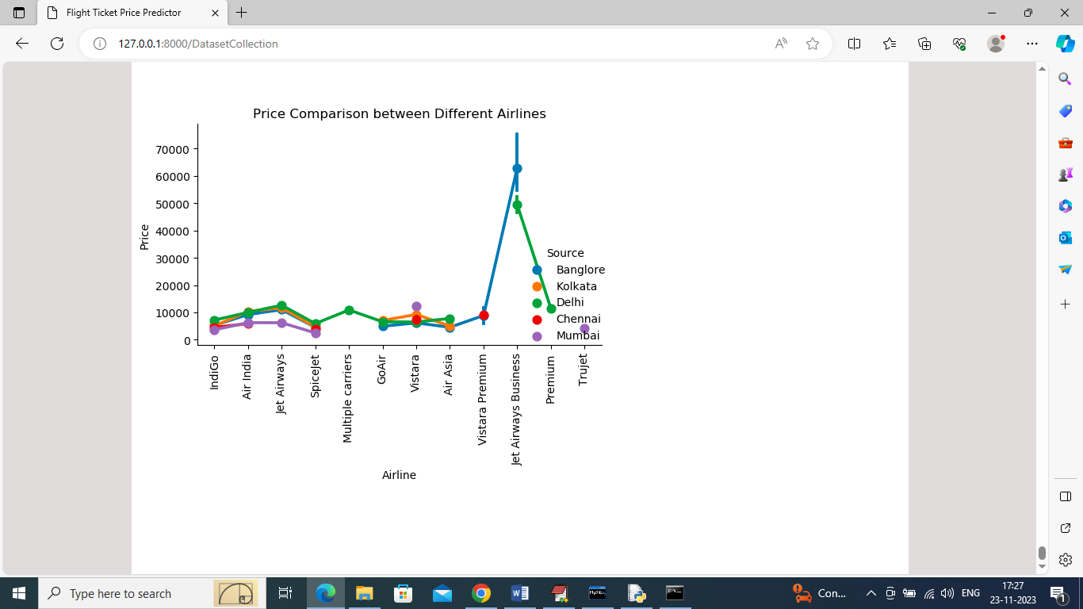

In above graph we are visualizing prices from different airlines for same city and in above graph x-axis represents Air Lines and y-axis represents prices and different line represents CITIES and by using above graph we can know difference in prices from different airlines and now click on ‘Cleaning’ link to get below clean data

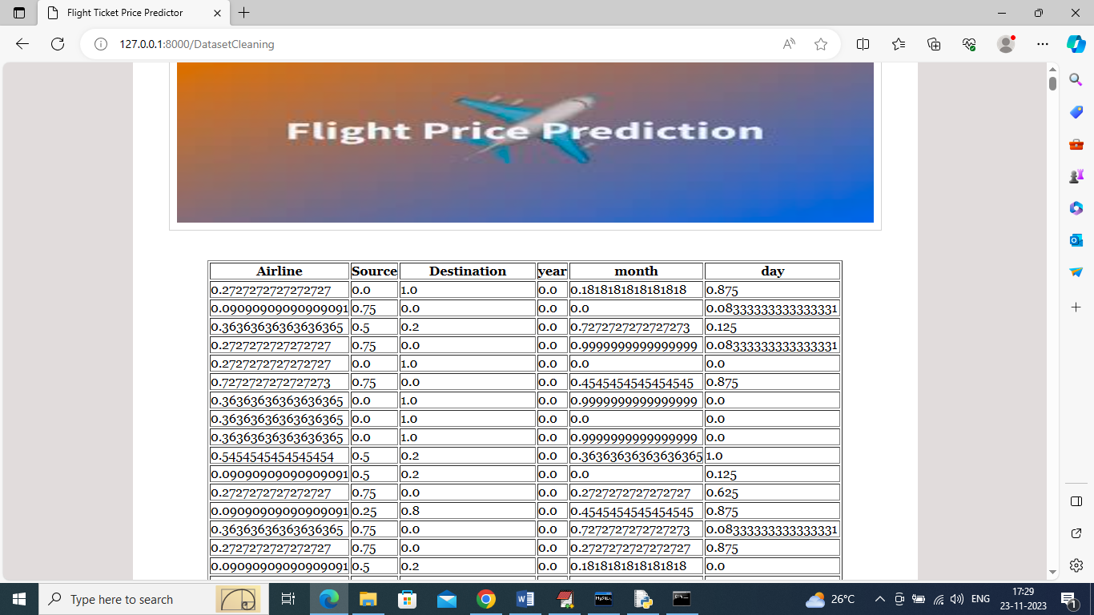

In above screen can see all values converted to numeric and normalized format and now click on ‘Train Random Forest’ algorithm to get below predicted process from test data

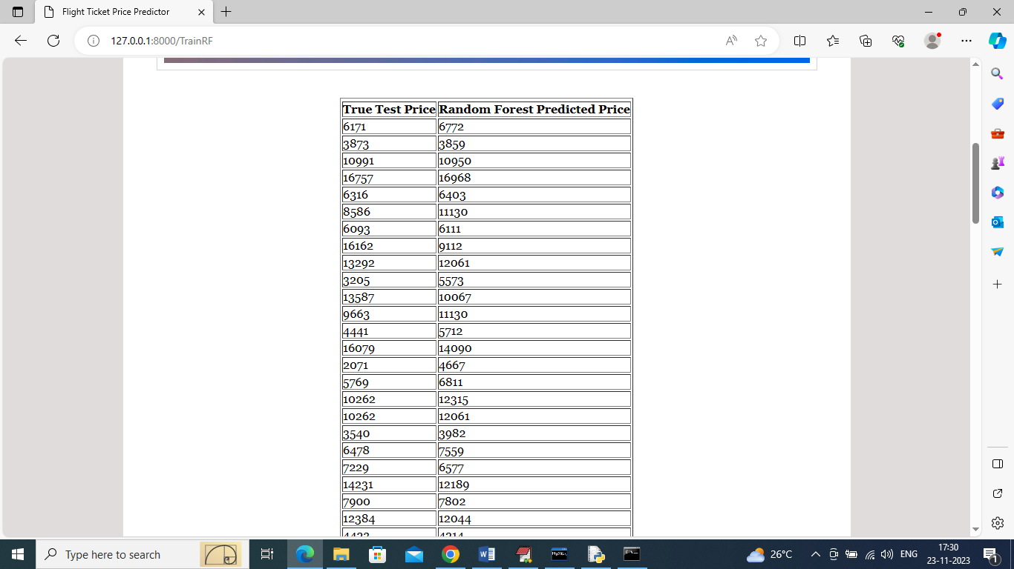

In above screen in first column we can see Test data original prices and in second column can see Random Forest predicted prices and go down in above screen to view below graph

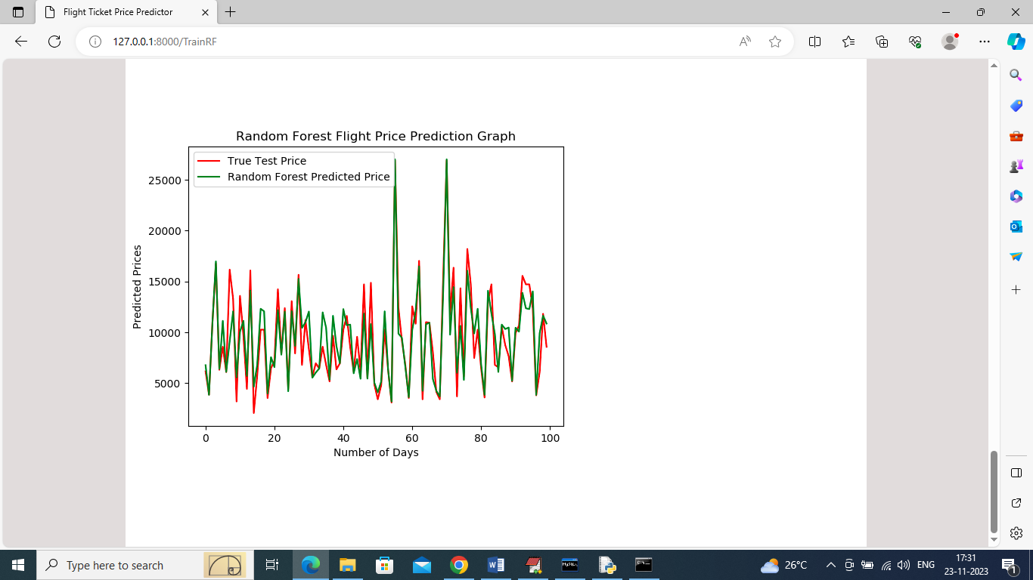

In above graph x-axis represents ‘Number of days’ and y-axis represents PRICES and red line represents True test prices and green line represents Random Forest predicted prices and in above graph can see both lines are fully overlapping with little gap so we can say Random Forest predicted prices are accurate. Now click on ‘Predict Prices’ link to get below page

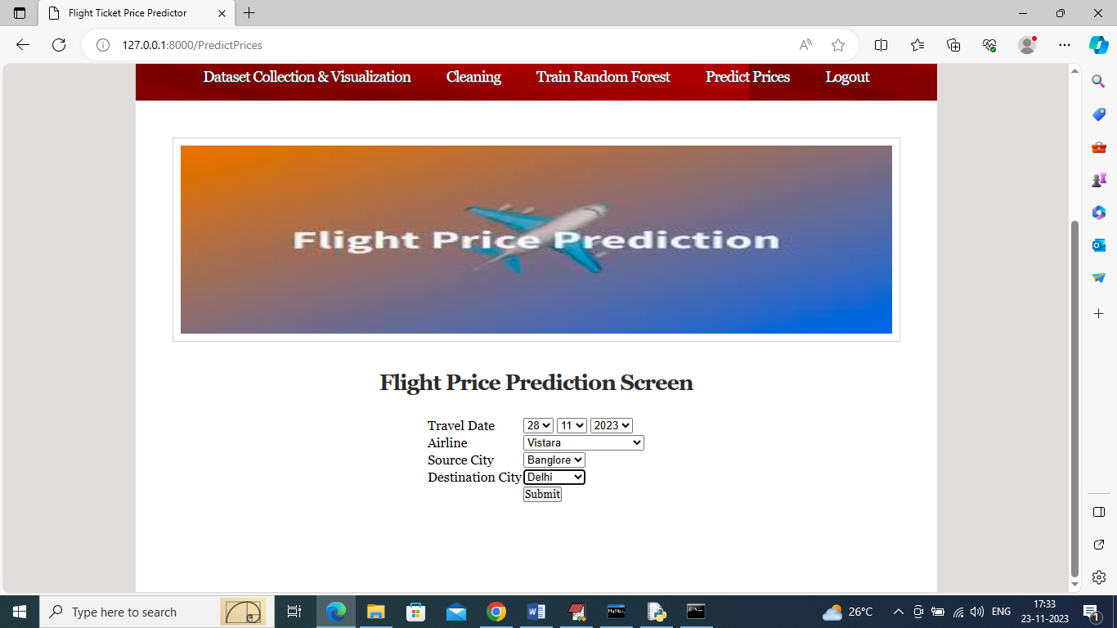

In above screen I selected travel date, airline with source and destination and then press button to get below output

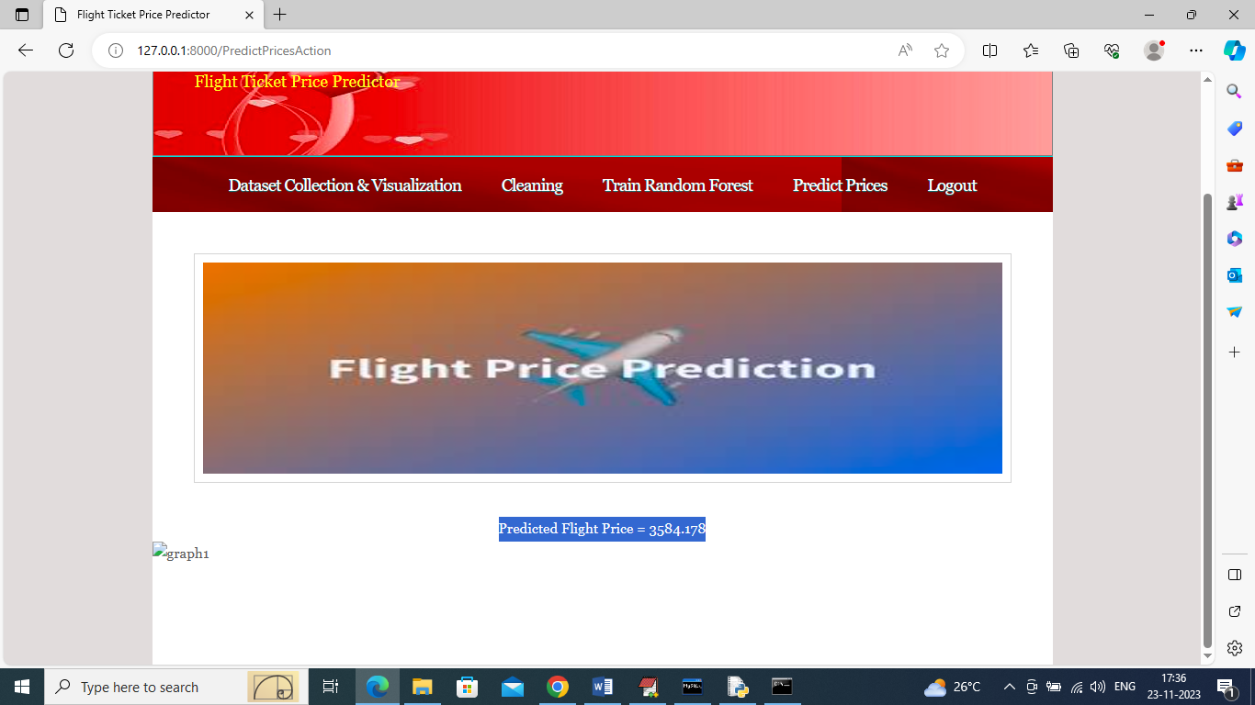

In above screen in blue colour text can see predicted prices and in below screen showing prices for same cities with different airline

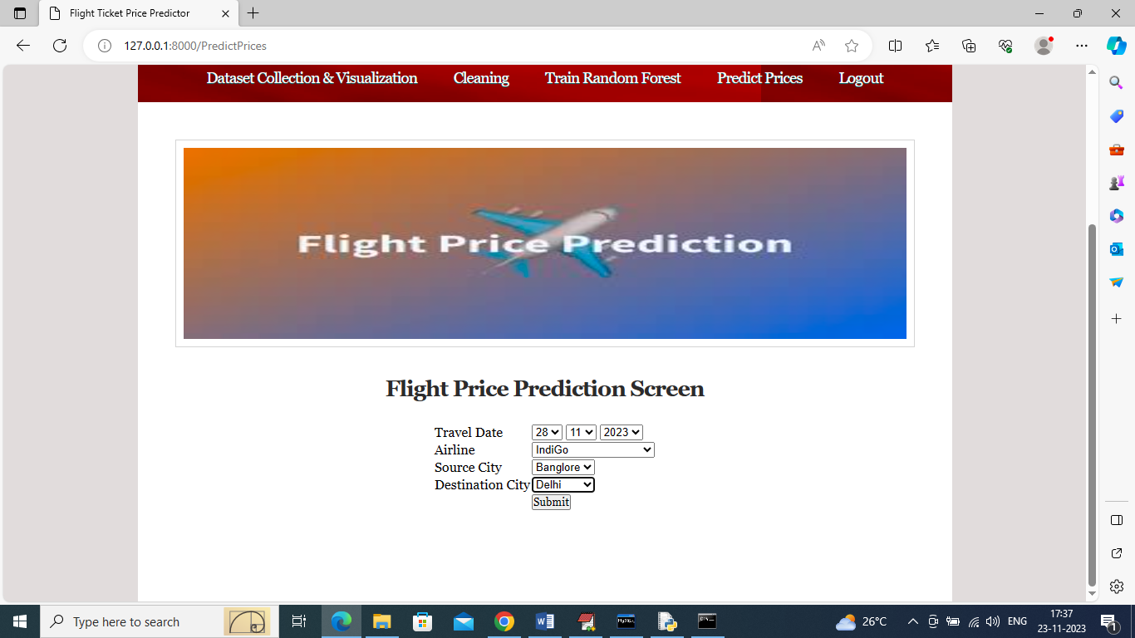

In above screen selected ‘Indigo Airline’ and below is the output

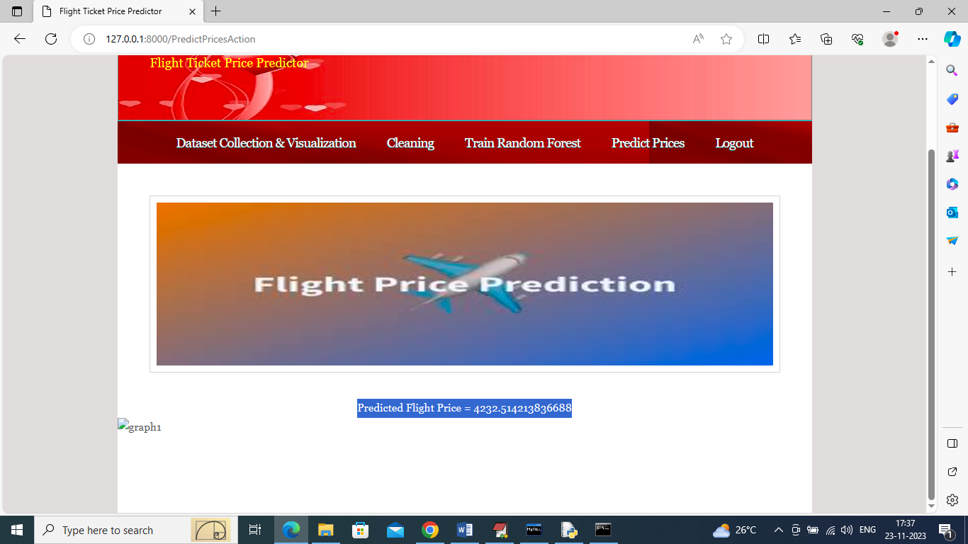

In above screen can see predicted prices for Indigo airline and similarly by selecting airline and travel date you can get predicted prices