红色：分类调度，黄色：method3

# 下面是根据打的label获得的结果，每种size选择10个工作流

# Workflow2label2(真实)

没有归一化——C、M的cost比其他工作流大很多，占主导地位，结果错

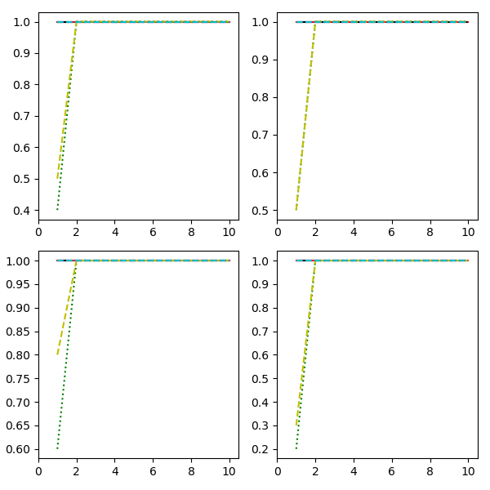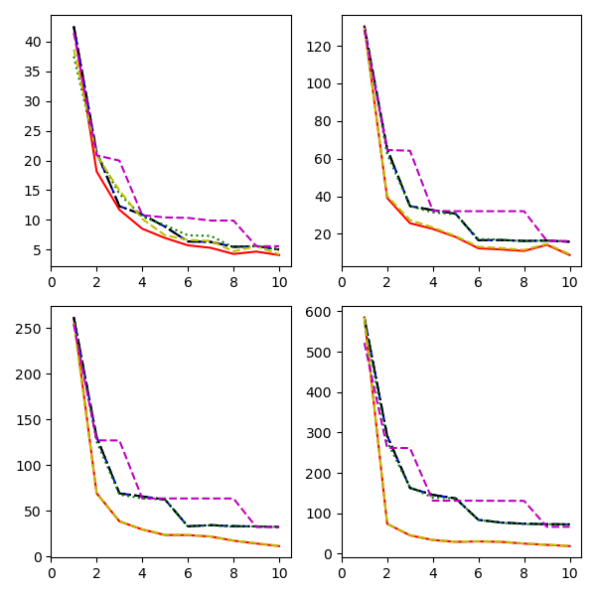

归一化——

每个算法运行五次，取平均

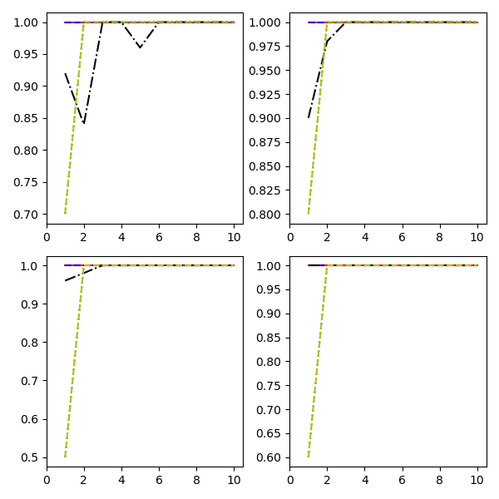 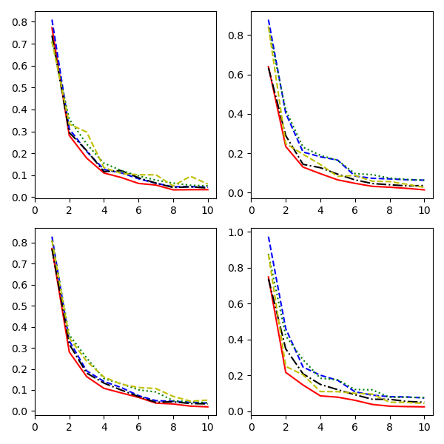

size30:

方法Method1uRank: 4.61%, 9.60%, 14.79%, 12.86%, 19.14%, 25.56%, 12.97%, 29.43%, 28.81%, 25.57%, 平均提高率18.34%

方法Method2ProLiS: 100.00%, 100.00%, 16.18%, 5.72%, 100.00%, 29.28%, 14.22%, 24.40%, 27.89%, 18.46%, 平均提高率43.62%

方法Method6: 100.00%, 20.89%, 26.58%, 28.94%, 26.36%, 35.59%, 29.02%, 48.09%, 37.39%, 34.09%, 平均提高率38.69%

方法Method3: 100.00%, 15.59%, 39.99%, 18.27%, 17.17%, 38.68%, 45.89%, 35.27%, 64.30%, 42.82%, 平均提高率41.80%

size50:

方法Method1uRank: 27.17%, 41.92%, 37.19%, 47.19%, 60.79%, 43.96%, 56.29%, 60.70%, 67.17%, 77.93%, 平均提高率52.03%

方法Method2ProLiS: 100.00%, 100.00%, 9.85%, 24.03%, 30.87%, 27.22%, 30.95%, 31.43%, 37.03%, 61.18%, 平均提高率45.25%

方法Method6: 100.00%, 44.19%, 43.82%, 49.26%, 60.58%, 51.24%, 65.17%, 62.82%, 67.95%, 77.96%, 平均提高率62.30%

方法Method3: 100.00%, 5.95%, 33.59%, 32.61%, 21.38%, 46.04%, 44.92%, 51.09%, 49.19%, 47.71%, 平均提高率43.25%

size100:

方法Method1uRank: 6.83%, 15.94%, 14.30%, 23.37%, 22.94%, 11.12%, 23.75%, 27.71%, 43.75%, 47.35%, 平均提高率23.71%

方法Method2ProLiS: 100.00%, 100.00%, 9.28%, 18.86%, 13.60%, 5.70%, 9.97%, 23.81%, 34.59%, 41.59%, 平均提高率35.74%

方法Method6: 100.00%, 22.50%, 35.23%, 30.05%, 33.61%, 35.55%, 58.49%, 32.37%, 46.12%, 50.13%, 平均提高率44.41%

方法Method3: 100.00%, 19.32%, 30.94%, 33.34%, 32.57%, 41.95%, 64.94%, 51.81%, 50.45%, 61.78%, 平均提高率48.71%

size1000:

方法Method1uRank: 23.14%, 53.05%, 40.77%, 57.47%, 54.71%, 44.08%, 58.02%, 65.69%, 68.04%, 67.39%, 平均提高率53.24%

方法Method2ProLiS: -1.33%, 37.77%, 30.04%, 42.86%, 35.09%, 33.94%, 43.59%, 58.18%, 52.90%, 51.68%, 平均提高率38.47%

方法Method6: 100.00%, 48.49%, 49.22%, 53.56%, 55.48%, 50.03%, 68.46%, 64.28%, 67.38%, 68.18%, 平均提高率62.51%

方法Method3: 100.00%, 13.37%, 28.16%, 22.05%, 28.31%, 39.32%, 60.77%, 44.30%, 47.93%, 44.29%, 平均提高率42.85%

Process finished with exit code 0