基于IPv6地址的三层交换的VLAN划分和VLAN间通信

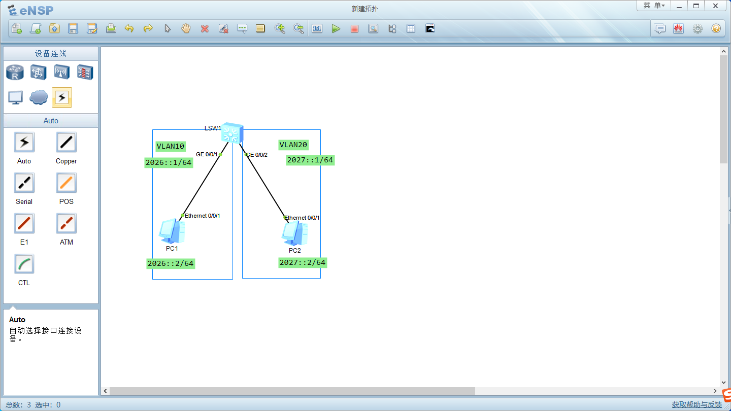
<Huawei>
<Huawei>system-view
[Huawei]undo inf enable
[Huawei]vlan batch 10 20
[Huawei]ipv6
[Huawei]interface g0/0/1
[Huawei-GigabitEthernet0/0/1]port link-type access
[Huawei-GigabitEthernet0/0/1]port default vlan 10
[Huawei-GigabitEthernet0/0/1]quit
[Huawei]interface g0/0/2
[Huawei-GigabitEthernet0/0/2]port link-type access
[Huawei-GigabitEthernet0/0/2]port default vlan 20
[Huawei-GigabitEthernet0/0/2]quit
[Huawei]
[Huawei]interface vlan 10
[Huawei-Vlanif10]ipv6 enable
[Huawei-Vlanif10]ipv6 address 2026::1 64
[Huawei-Vlanif10]quit
[Huawei]interface vlan 20
[Huawei-Vlanif20]ipv6 enable
[Huawei-Vlanif20]ipv6 address 2027::1 64
[Huawei-Vlanif20]quit
[Huawei]

PC1地址：
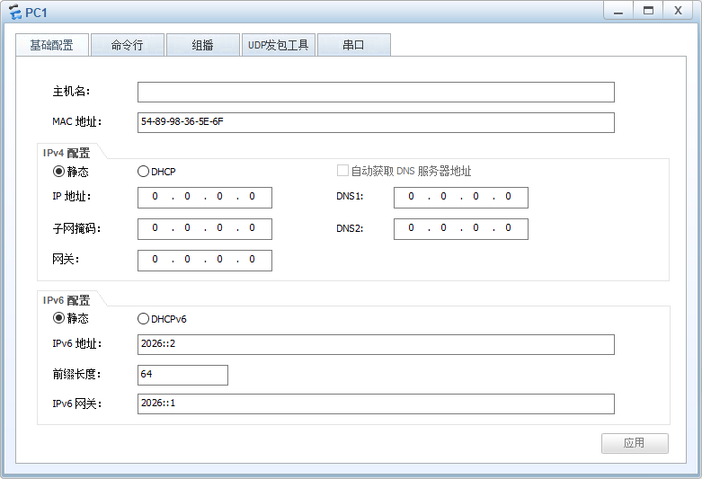
PC2地址：
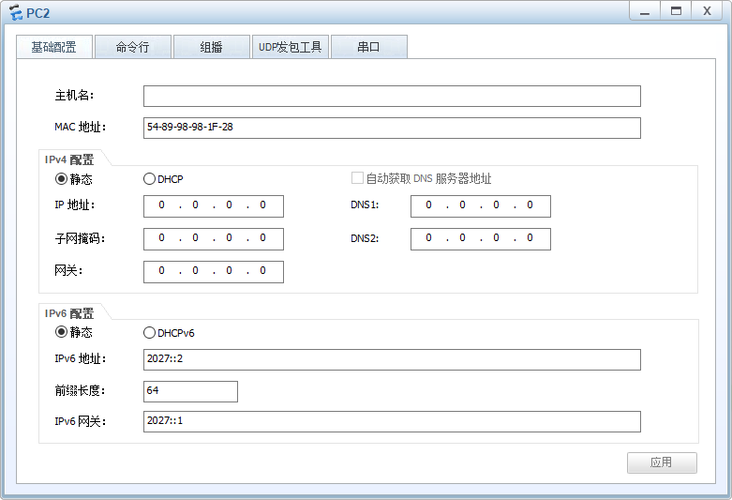
VLAN间通信测试：
