Helpdesk × Maintenance Integration Proposal
Team 14 (Helpdesk) → Team 10 (Maintenance) · Draft v0.3 · Nov 8, 2026 · @Team 14

Purpose
Team 14 proposes linking Helpdesk Tickets to Team 10 Maintenance Work Orders, so a reporter can follow repair progress from their Helpdesk ticket. This is a required flow in the course platform PRD: "Maintenance publishes status changes to Helpdesk."
The integration has two parts:
- REST (Helpdesk → Maintenance): Helpdesk reads a Work Order to confirm it exists before linking it to a Ticket.
- Webhook (Maintenance → Helpdesk): Maintenance sends a signed maintenance.status_changed event whenever a Work Order's status changes.
This webhook also serves as the required inter-team event for both teams.

Data ownership
Each team keeps its own records and stores only the other team's ID as a reference.
Data | Owner | What the other team stores
Ticket (subject, requester, comments, status) | Helpdesk (Team 14) | Maintenance stores only ticketRef, e.g. TKT-00012
Work Order (location, assignment, status history) | Maintenance (Team 10) | Helpdesk stores only maintenance_work_order_id, e.g. WO-0045
- Neither team reads or writes the other team's database.
- Helpdesk never copies Work Order records. It fetches details live when it needs to show them.
- A Ticket links to at most one active Work Order.

Use case: a broken air conditioner
A student reports "Air conditioner in classroom B-204 is not working" in Helpdesk and follows the repair there.
- The student creates ticket TKT-00012 in Helpdesk.
- A Helpdesk agent triages it and decides it needs Maintenance.
- The agent reports the repair in Maintenance's report screen and enters TKT-00012 as the ticket reference. Maintenance creates Work Order WO-0045.
- The agent links TKT-00012 to WO-0045 in Helpdesk. Helpdesk calls Maintenance to confirm the Work Order exists.
- A technician moves WO-0045 through its statuses. Maintenance sends a maintenance.status_changed event for each change.
- Helpdesk updates the ticket so the student sees "Repair in progress" or "Repair completed".
- A Helpdesk agent confirms the repair with the student and resolves the ticket.
The student never has to check the Maintenance system. Each team keeps control of its own workflow.

Integration flow
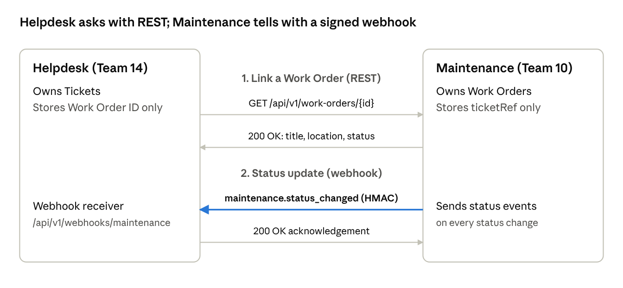
Helpdesk × Maintenance integration · REST link + webhook
Helpdesk calls Maintenance only when an agent links a Work Order. After that, Maintenance pushes every status change, and Helpdesk acknowledges each event.

REST contract
The endpoints follow each team's course PRD, under a versioned /api/v1 base path. Every request carries an X-Correlation-Id header.
Direction | Endpoint | Purpose | Auth
Helpdesk → Maintenance | GET /api/v1/work-orders/{id} | Confirm a Work Order exists before linking; show its title, location and current status | Service credential (to agree)
Maintenance → Helpdesk | POST /api/v1/webhooks/maintenance | Receive maintenance.status_changed events (next section) | HMAC signature
Helpdesk calls GET /api/v1/work-orders/{id} once, when a Helpdesk agent links a ticket to a Work Order ID. It reads the title, location and status from the response.
If Maintenance returns 404, Helpdesk rejects the link with 400. If Maintenance is unreachable after a 3-second timeout, Helpdesk rejects it with 503, and the agent can retry later.
Out of scope for the first version: Helpdesk creating Work Orders through POST /work-orders. We can add it later if both teams want it.

Event contract: maintenance.status_changed
The event uses the course's shared webhook envelope. Maintenance sends it to POST /api/v1/webhooks/maintenance on every Work Order status change.
{
"eventId": "7f3c2a9e-1b4d-4c8e-9a21-5d6e7f8a9b01",
"type": "maintenance.status_changed",
"occurredAt": "2026-11-20T09:15:00Z",
"source": "maintenance",
"subject": "work-order:WO-0045",
"data": {
"workOrderId": "WO-0045",
"ticketRef": "TKT-00012",
"previousStatus": "assigned",
"status": "in_progress",
"changedAt": "2026-11-20T09:15:00Z"
}
}
- ticketRef is optional. Helpdesk always finds the ticket by workOrderId.
- No personal data (names, emails, phone numbers) goes in the event.
Helpdesk responses (the acknowledgement):
Response | Meaning | Should Maintenance retry?
200 OK | Event accepted, or already processed (duplicate eventId) | No
202 Accepted | Valid event, but no ticket is linked to this Work Order | No
400 Bad Request | Malformed envelope or unknown status | No
401 Unauthorized | Signature missing or invalid | No
5xx | Helpdesk error | Yes, with backoff
Proposed status mapping. The left column lists Team 10's Work Order statuses (our guesses, to be confirmed). The right column shows what Helpdesk does to its own Ticket:
Work Order status | Ticket effect in Helpdesk
reported, assigned | Ticket shows "Sent to Maintenance"
in_progress | Ticket status becomes in_progress
completed, closed | Ticket is flagged "ready to resolve". A Helpdesk agent confirms and resolves it
cancelled | Ticket goes back to the agent queue with an internal note

Security and reliability
- Signature: Maintenance sends two headers. X-Timestamp is the Unix time of sending, in seconds. X-Signature is the hex HMAC-SHA256 of <X-Timestamp>.<raw body> using a shared secret. Helpdesk rejects any event with a missing or wrong signature.
- Replay window: Helpdesk rejects events whose X-Timestamp is more than 5 minutes from its own clock. Each retry is signed again with a fresh timestamp, while occurredAt keeps the original time.
- Idempotency: Helpdesk stores each processed eventId. A repeated event returns 200 and changes nothing.
- Retries: Maintenance retries on 5xx or timeout with exponential backoff, for example after 1, 5 and 30 minutes.
- Timeouts: Each side waits at most 3 seconds for the other.
- Failure isolation: If Maintenance is down, Helpdesk ticket creation, assignment and resolution keep working. Only linking and live status are unavailable.
- Secrets: The HMAC secret is shared privately, never by chat or in Git. Each team stores it as an environment secret, e.g. wrangler secret put.
- Data minimisation: Only IDs and statuses cross the boundary. No student names, emails or ticket descriptions.

Joint test plan
Each test uses its own correlation ID (team14-t10-01 to team14-t10-08). Each team captures its own request or log line as evidence.
# | Test | Expected result | Correlation ID
1 | Link an existing Work Order | Helpdesk 200; ticket shows WO-0045 | team14-t10-01
2 | Link an unknown Work Order | Maintenance 404; Helpdesk 400 | team14-t10-02
3 | Status change event | Helpdesk 200; ticket status updated | team14-t10-03
4 | Same event sent twice | Second call 200; no second update | team14-t10-04
5 | Invalid signature | Helpdesk 401; ticket unchanged | team14-t10-05
6 | Event for an unlinked Work Order | Helpdesk 202; no change | team14-t10-06
7 | Maintenance unavailable during linking | Helpdesk 503; ticket CRUD still works | team14-t10-07
8 | Work Order completed | Ticket flagged "ready to resolve" | team14-t10-08
Test 5 also covers Team 10's required "webhook signature" test.

Helpdesk status as of 8 Nov 2026
The Helpdesk ticket system runs end to end today; the Maintenance link and webhook are being built to this contract and need your answers below.
What affects you | Status
Ticket number format TKT-00012 (the ticketRef you store) | Ready
Linking: Helpdesk calls your GET /api/v1/work-orders/{id} | In progress, finished once we have your base URL
Webhook receiver POST /api/v1/webhooks/maintenance with HMAC check and duplicate-event protection | In progress, finished once we agree the shared secret
Your Work Order statuses mapped to our ticket statuses | Waiting on your status list
A mock of your webhook, so we can test before your side is live | Ready
Maintenance is the only team Helpdesk connects to in this project.

Questions for Team 10
- ☐ What is your deployed base URL, and when will GET /api/v1/work-orders/{id} be live?
- ☐ What format do Work Order IDs use, e.g. WO-0045 or a UUID?
- ☐ What are your exact Work Order status values and allowed transitions?
- ☐ Can a Work Order store an optional ticketRef field (our ticket number) when it is created?
- ☐ Would you rather Helpdesk create the Work Order directly through POST /work-orders, instead of the agent using your report screen?
- ☐ Can you send signed webhooks with retries? If not, Helpdesk can poll GET /work-orders/{id} instead.
- ☐ Is HMAC-SHA256 with X-Timestamp and X-Signature headers OK? How should we exchange the secret?
- ☐ Which service credential should Helpdesk use when calling your API?
- ☐ When can we run the joint tests together?
Next step: after your answers, we will freeze this as contract v1.0 and both teams will sign it off.

