桥接模式
定义：将抽象部分与实现部分分离，使他们独立地进行变化。
其实就是，一个类存在两个维度的变化，且这两个维度都需要进行扩展。

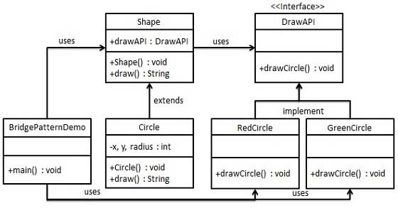

public interface DrawAPI {
public void drawCircle(int radius, int x, int y);
}

public class RedCircle implements DrawAPI {
@Override public void drawCircle(int radius, int x, int y) {
System.out.println("Drawing Circle[ color: red, radius: " + radius +", x: " +x+", "+ y +"]");
}
}

public class GreenCircle implements DrawAPI {
@Override public void drawCircle(int radius, int x, int y) {
System.out.println("Drawing Circle[ color: green, radius: " + radius +", x: " +x+", "+ y +"]");
}
}

public abstract class Shape {
protected DrawAPI drawAPI;
protected Shape(DrawAPI drawAPI){
this.drawAPI = drawAPI;
}
public abstract void draw();
}

public class Circle extends Shape {
private int x, y, radius;
public Circle(int x, int y, int radius, DrawAPI drawAPI) {
super(drawAPI);
this.x = x;
this.y = y;
this.radius = radius;
}
public void draw() {
drawAPI.drawCircle(radius,x,y);
}
}

public class BridgePatternDemo {
public static void main(String[] args) {
Shape redCircle = new Circle(100,100, 10, new RedCircle());
Shape greenCircle = new Circle(100,100, 10, new GreenCircle());
redCircle.draw();
greenCircle.draw();
}
}

Drawing Circle[ color: red, radius: 10, x: 100, 100]
Drawing Circle[ color: green, radius: 10, x: 100, 100]

在Android中桥接模式用的很多，WindowManager就是使用桥接模式。举个例子，对于一个View来说，它有两个维度的变化，一个是它的描述比如Button、TextView等等他们是View的描述维度上的变化，另一个维度就是将View真正绘制到屏幕上，这跟Display、HardwareLayer和Canvas有关。这两个维度可以看成是桥接模式的应用。

