备忘录模式
定义：在不破坏封闭的前提下，捕获一个对象的内部状态，并在对象之外保存这个状态，这样，以后就可将对象恢复到原先保存的状态中。
其实就是相当于一个提前备份，一旦出现啥意外，能够恢复。像我们平时用的word软件，意外关闭了，它能帮我们恢复。其实就是它自动帮我们备份过。
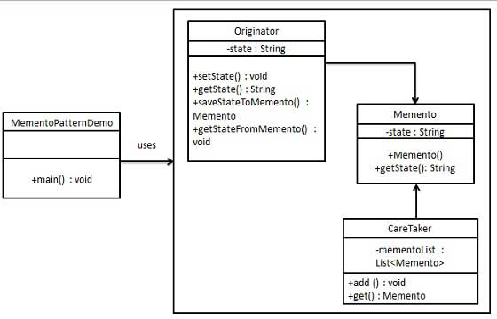
public class Memento {
private String state;
public Memento(String state){
this.state = state;
}
public String getState(){
return state;
}
}
public class Originator {
private String state;
public void setState(String state){
this.state = state;
}
public String getState(){
return state;
}
public Memento saveStateToMemento(){
return new Memento(state);
}
public void getStateFromMemento(Memento Memento){
state = Memento.getState();
}
}
import java.util.ArrayList;
import java.util.List;
public class CareTaker {
private List<Memento> mementoList = new ArrayList<Memento>();
public void add(Memento state){
mementoList.add(state);
}
public Memento get(int index){
return mementoList.get(index);
}
}
public class MementoPatternDemo {
public static void main(String[] args) {
Originator originator = new Originator();
CareTaker careTaker = new CareTaker();
originator.setState("State #1");
originator.setState("State #2");
careTaker.add(originator.saveStateToMemento());
originator.setState("State #3");
careTaker.add(originator.saveStateToMemento());
originator.setState("State #4");
System.out.println("Current State: " + originator.getState()); originator.getStateFromMemento(careTaker.get(0));
System.out.println("First saved State: " + originator.getState()); originator.getStateFromMemento(careTaker.get(1));
System.out.println("Second saved State: " + originator.getState());
}
}

Current State: State #4
First saved State: State #2
Second saved State: State #3

那么Android哪里用到了备忘录模式呢？Activity的onSaveInstanceState和onRestoreInstanceState就是用到了备忘录模式，分别用于保存和恢复。

